# Department of Software Engineering

**SE-210: Software Design and Architecture**

**Class: BESE-12**

**Lab 03: Sequence Diagrams and Activity**

**CLO2: SELECT APPROPRIATE DESIGN PATTERN AND ARCHITECTURAL PATTERN FOR A GIVEN PROBLEM.**

**Date: February 15, 2022**

# Instructor: Zunera Zahid

# 

# Lab 3: Sequence Diagrams and Activity Diagrams

**Introduction**

In this lab, students will learn how to draw sequence and activity diagrams according to a given scenario.

**Objectives**

After the completion of this lab, students will be able to draw following:

* Sequence Diagram
* Activity Diagram

**Tools/Software Requirement**

* Papyrus/Rational Rose

**Description**

An activity diagram is essentially a flowchart that shows activities performed by a system.

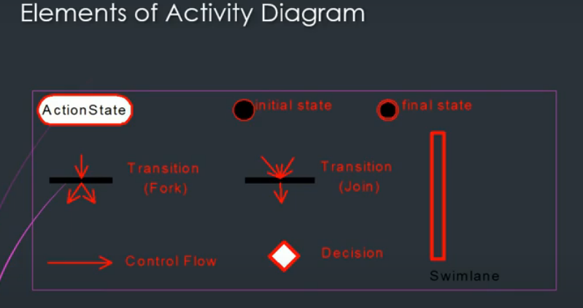

A sequence diagram is an interaction diagram that shows how objects operate with one another and in what order. It is a construct of a message sequence chart. A sequence diagram shows object interactions arranged in time sequence.

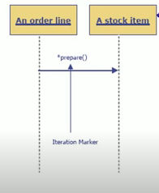

**Lab Task**

**Task 1**

This week’s task is to draw Sequence diagram of the ATM system for the following use cases:

* Transaction Sequence Diagram
* System Startup Sequence Diagram
* System Shutdown Sequence Diagram

Additional information about the use cases is given below.

Actors involved:

* Operator
* Customer
* Bank

Following are the names and brief description of each of the use cases of the ATM system

System Startup Use Case

The system is started up when the operator turns the switch to "on" position. The operator will be asked to enter the amount of money currently in the cash dispenser, and a connection to the bank will be established. Customers can then use the ATM machine.

System Shutdown Use Case

Before shutting down the ATM system, the operator makes sure that no customer is using the machine. He then turns the switch to the "off" position. The connection to the bank will be shut down. The operator can then freely to remove deposited envelopes, replenish cash and paper, etc.

Invalid PIN Use Case

This use case extends the transaction use case.

Session Use Case

A session is started when a customer inserts an ATM card into the card reader slot of the machine. The ATM pulls the card into the machine and reads it. (If the reader cannot read the card due to improper insertion or a damaged stripe, the card is ejected, an error screen is displayed, and the session is aborted.) The customer is asked to enter his/her PIN, and is then allowed to perform one or more transactions, choosing from a menu of possible types of transaction in each case. After each transaction, the customer is asked whether he/she would like to perform another transaction. When the customer is finished with the transactions, the card is ejected from the machine and the session ends. If a transaction is aborted due to too many invalid PIN entries, the session is also aborted, with the card being retained in the machine.

Transaction Use Case

Note: the session use case includes transaction use case.

A transaction use case is started within a session when the customer chooses a transaction type from a menu of options. The customer will be asked to provide appropriate details (e.g. account(s) involved, amount). The transaction will then be sent to the bank, along with information from the customer's card and the PIN the customer entered.

If the bank approves the transaction, any steps needed to complete the transaction (e.g. dispensing cash or accepting an envelope) will be performed, and then a receipt will be printed. Then the customer will be asked whether he/she wishes to do another transaction.

If the bank reports that the customer's PIN is invalid, the Invalid PIN extension will be performed and then an attempt will be made to continue the transaction. If the customer's card is retained due to too many invalid PINs, the transaction will be aborted, and the customer will not be offered the option of doing another.

If a transaction is cancelled by the customer, or fails for any reason other than repeated entries of an invalid PIN, a screen will be displayed informing the customer of the reason for the failure of the transaction, and then the customer will be offered to do another transaction.

The customer may cancel a transaction by pressing the Cancel key as described for each individual type of transaction below, also following use cases use transaction use case.

* Transfer Transaction Use Case
* Deposit Transaction Use Case
* Invalid PIN Extension

**Task 2**

Based on the scenario discussed in Task1, draw an activity diagram of withdrawing money from the ATM.

**Answer:**

|  |
| --- |
| Solution |
| Task 1 System Startup  System Shutdown    System Transaction    Task 2 |

**Deliverables**

Compile a single word document by filling in the solution part and submit this Word file on LMS. This lab grading policy is as follows: The lab is graded between 0 to 10 marks. The submitted solution can get a maximum of 5 marks. At the end of each lab or in the next lab, there will be a viva related to the tasks. The viva has a weightage of 5 marks. Insert the solution/answer in this document. You must show the implementation of the tasks in the designing tool, along with your completed Word document to get your work graded.