**EC-2 Daily Tasks:**

1. Launch one ec2 using amazon linux 2 image and add a script in user data to install apache**.**

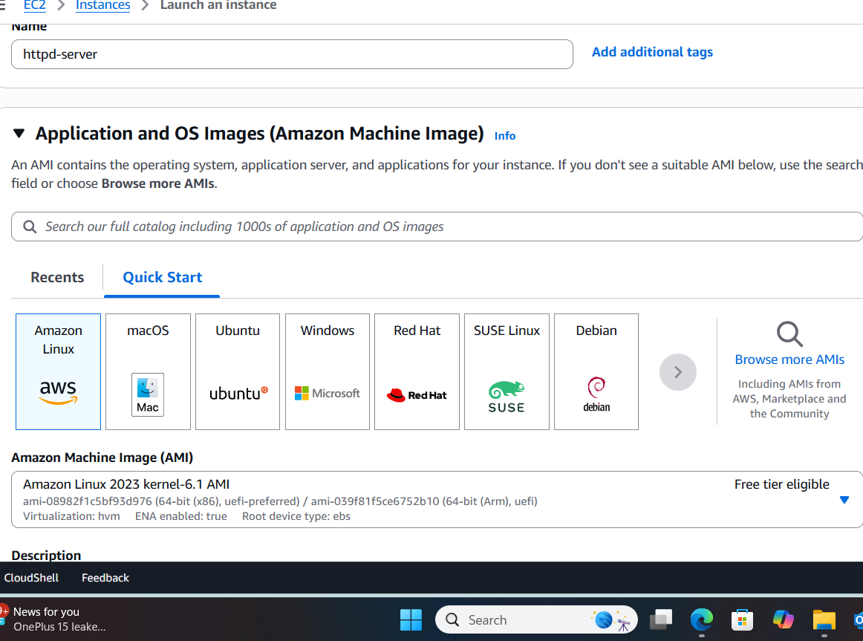

* Go to aws console login to your account.
* Click on launch instance.
* Give the nametag to your instance
* Select the amazon linux 2023
* Select instance type t3.micro : can be changed according to the requirement.
* Give the key pair you have already created or create new key pair.
* In network setting allow all traffic
* Configure the storage volume required
* Scroll down and click on advanced details scroll down
* You will find user data i.e boot strapping where you can add a script to run after launching you can also write script to install services.
* Write there a script to install apache (httpd)

#!/bin/bash

# Update package list

sudo yum -y update

# Install Apache HTTP Server

sudo yum -y install httpd

# Enable and start the service

sudo systemctl enable httpd

sudo systemctl start httpd

# Confirm status

sudo systemctl status httpd

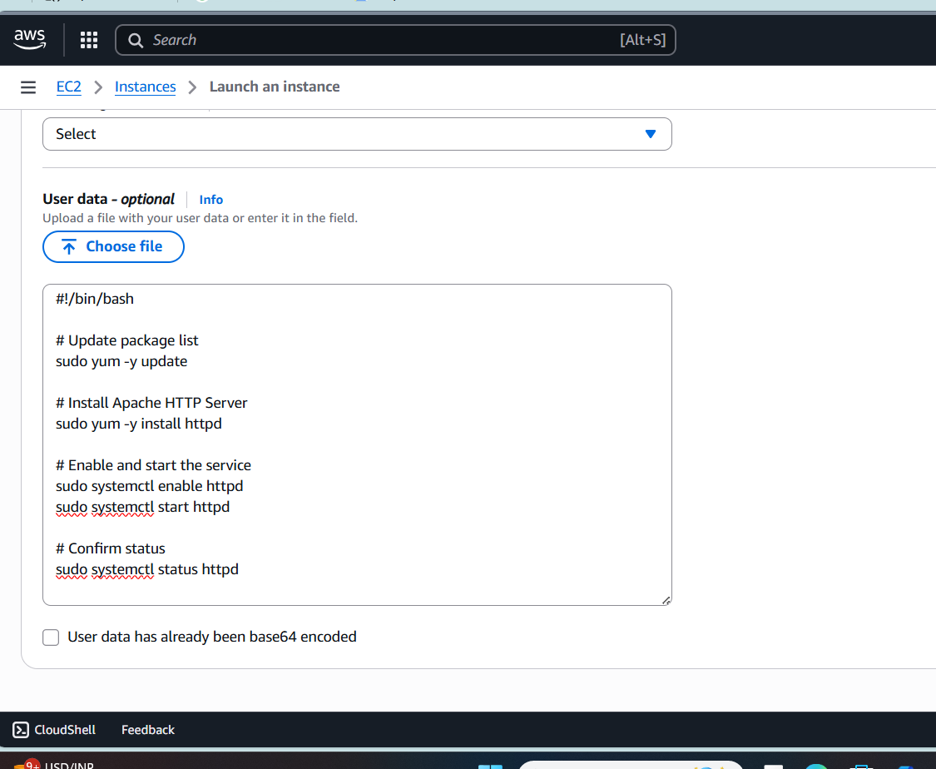

* Then click on launch instance
* Instance is successfully launched
* Copy the ipv4 public address of the instance
* Go to the location where you have downloaded the key
* Right click and run git bash here.
* Connect to the instance : ssh -i “keypair.pem” ec2-user@ “ipv4 public”- address of the instance
* You can see the connected to instance and httpd (apache) is also running.

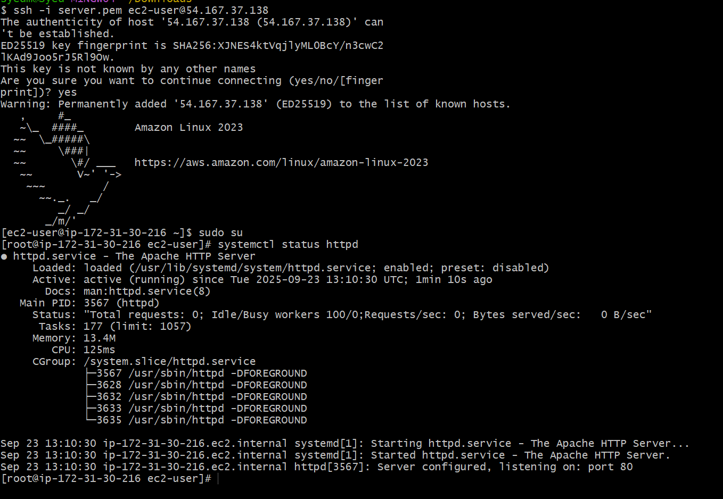

### Launch one Ec2 Using Ubuntu Image and Add A Script In User Data to Install Nginx.

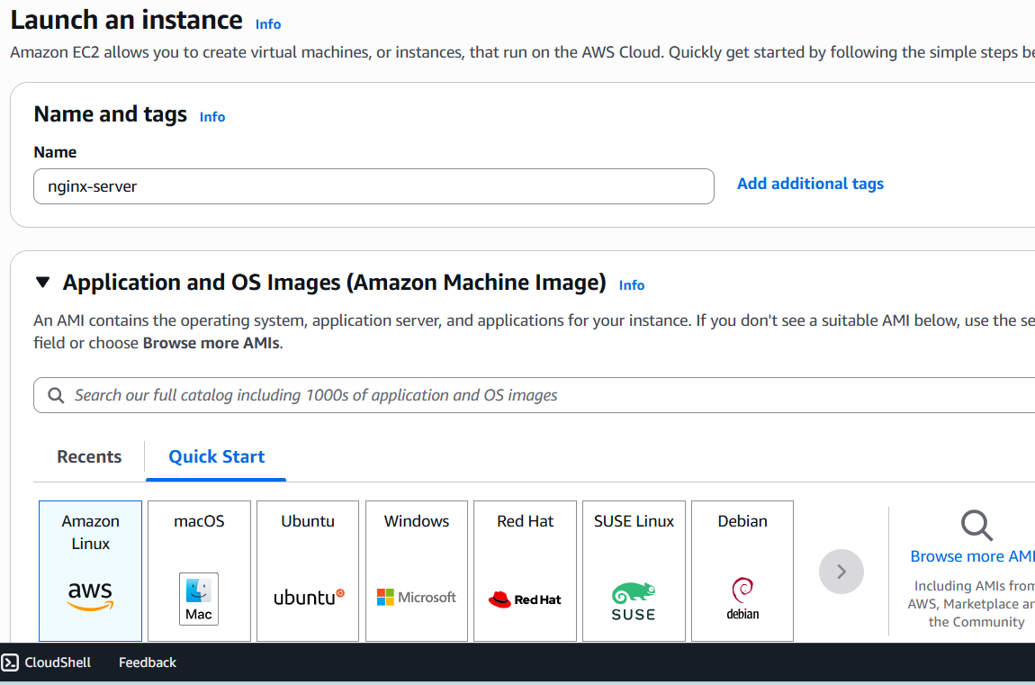

* Click on launch instance.
* Give the nametag to your instance
* Select the ubuntu AMI
* Select instance type t3.micro : can be changed according to the requirement.
* Give the key pair you have already created or create new key pair.
* In network setting allow all traffic
* Configure the storage volume required
* Scroll down and click on advanced details scroll down
* You will find user data i.e boot strapping where you can add a script to run after launching you can also write script to install services.

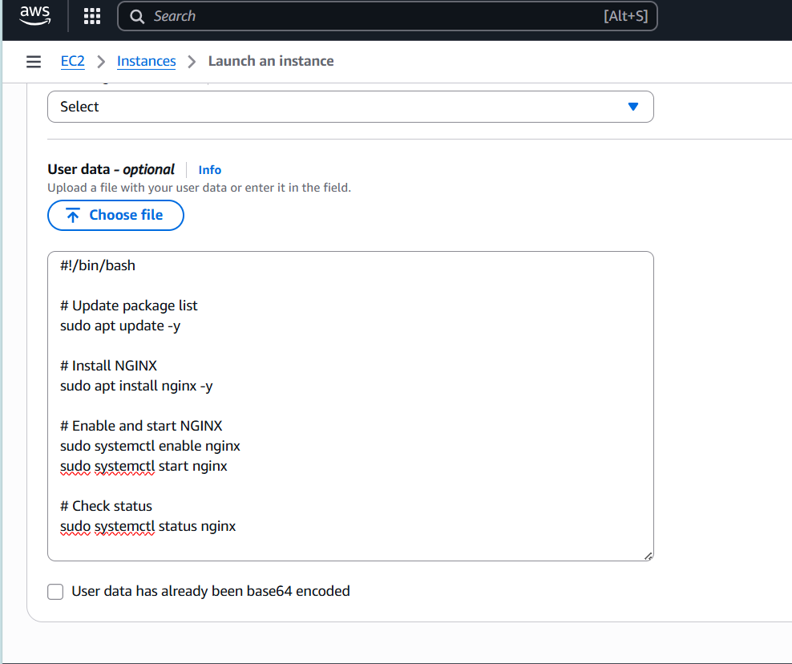

* Write there a script to install nginx
* #!/bin/bash
* # Update package list
* sudo apt update -y
* # Install NGINX
* sudo apt install nginx -y
* # Enable and start NGINX
* sudo systemctl enable nginx
* sudo systemctl start nginx
* # Check status
* sudo systemctl status nginx

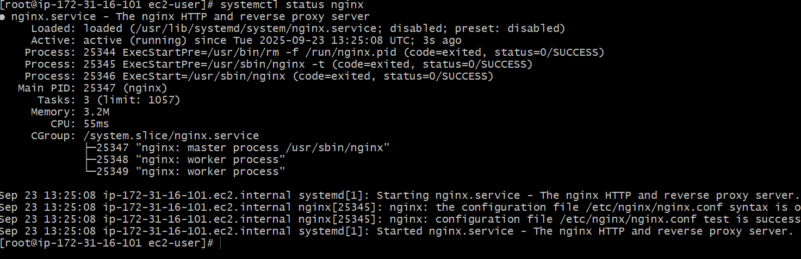

* Then click on launch instance
* Instance is successfully launched
* Click on connect, at top click on ssh ,copy the command to connect to instance.
* Copy the ipv4 public address of the instance
* Go to the location where you have downloaded the key
* Right click and run git bash here.
* Connect to the instance : ssh -i "aws_challenge.pem" ubuntu@ec2-13-61-174-130.eu-north-1.compute.amazonaws.com
* You can see the connected to instance and nginx is also running.

### Launch One Windows Server And Install Tomcat On Windows.

* Click on launch instance.
* Give the nametag to your instance
* Select the windows AMI
* Select instance type t3.micro : can be changed according to the requirement.
* Give the key pair you have already created or create new key pair.

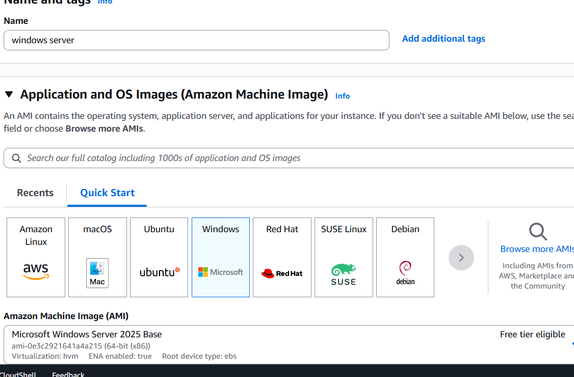

* In network setting allow all traffic
* Configure the storage volume required
* Then click on launch instance
* Instance is successfully launched
* Click on connect, download remote desktop file



* Go to location where the file is downloaded and right click and connect
* Upload the pem key file to get the password
* Copy password and paste it to connect
* You can see the ec instance has been connected.

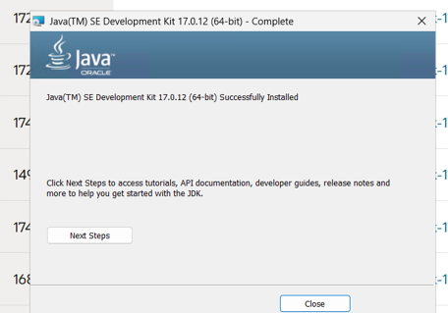

* It might take time as it is slow
* Go to microsoft edge browser .
* Download java 11 or 17 for windows 32/64bit as per the system.
* Then download tomcat for windows
* Install and give the port no.
* In edge browser search local host :8080
* Then you can see the tom cat is running.

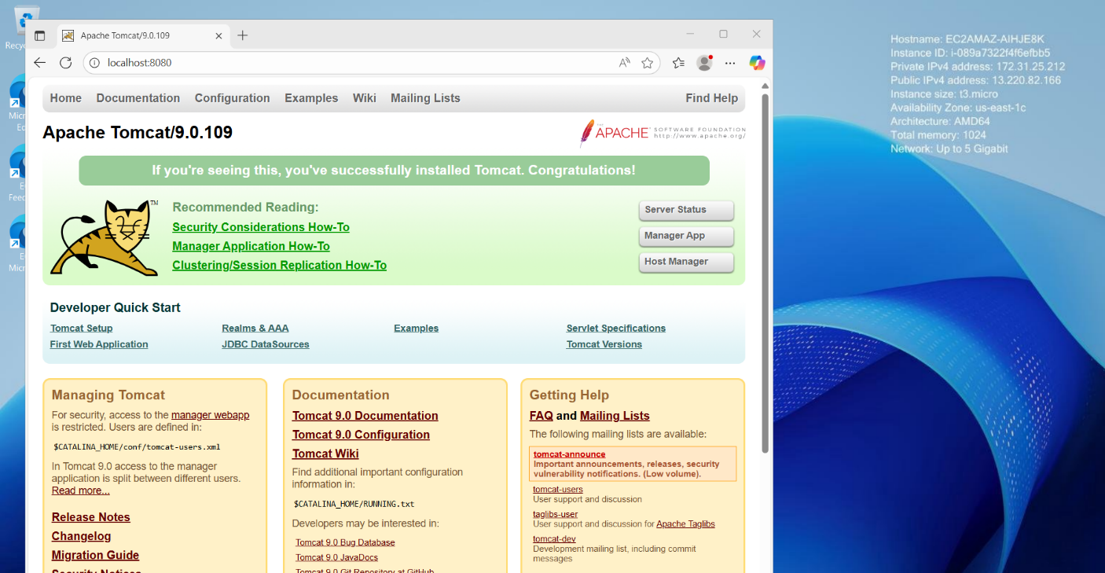

1. Take A Snapshot of the Instance Created In Task 1.

* Go to ec2 console on left side click On snapshot
* Click on create snapshot.

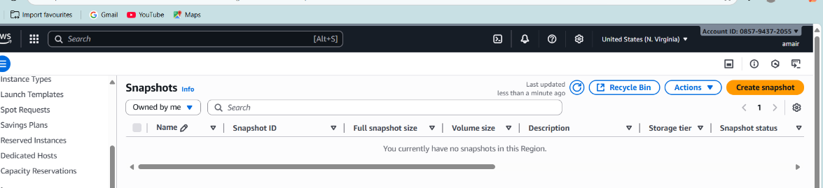

* Select instance and the instance you want to create the snap shot.
* Provide key name
* Then click on create snapshot.
* Snapshot is successfully created

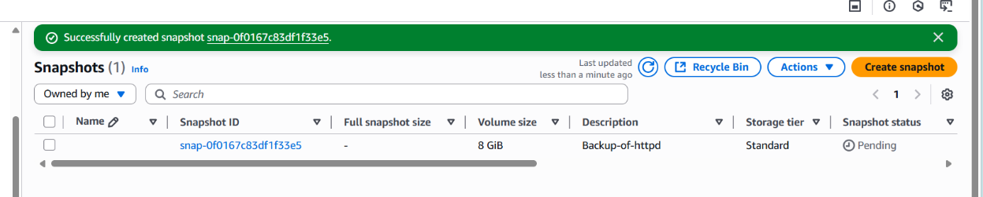

* Select that instance

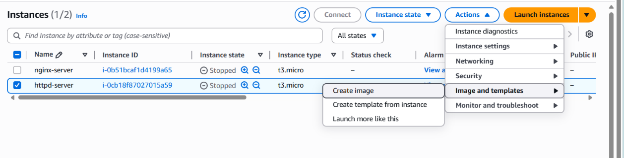

* Got to actions image – click on create image
* The image to the instance is created.

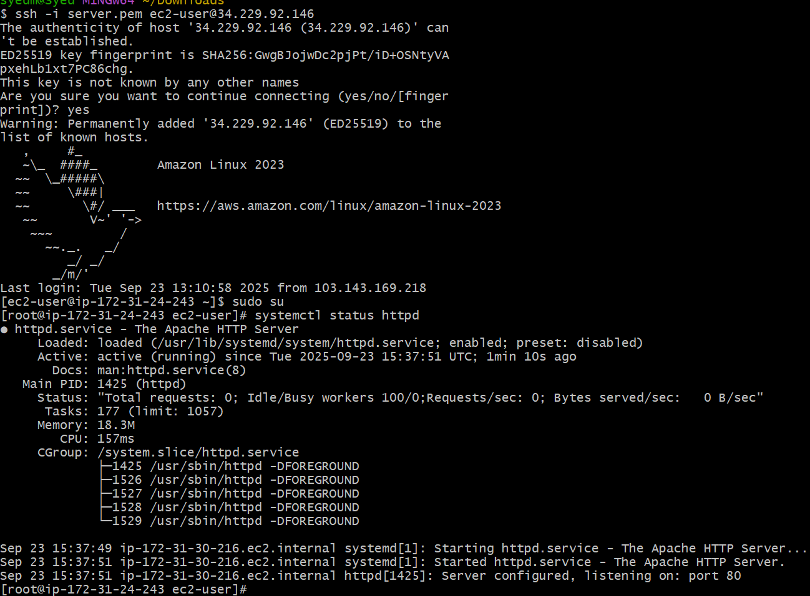

## Assign Passwordless Authentication for the Ec2 Created In Task 2.

* Open git bash

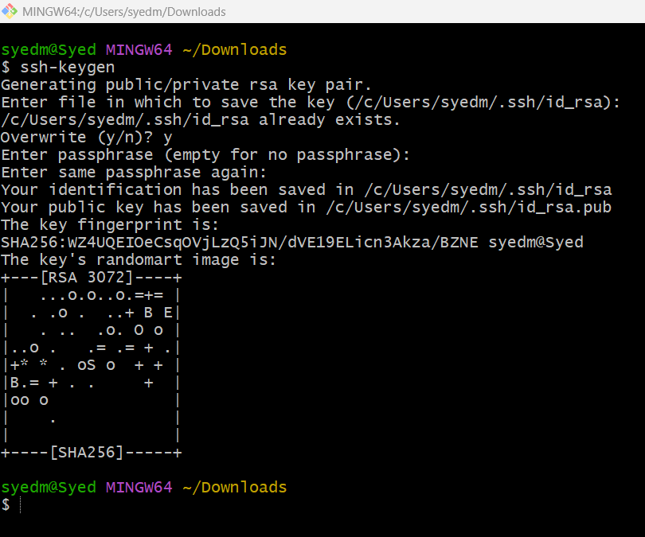

* Enter ssh-key gen to create key to connect.

. 

* It will show the key has been generated to the file path.
* Copy the path and use cat to show the key copy the key

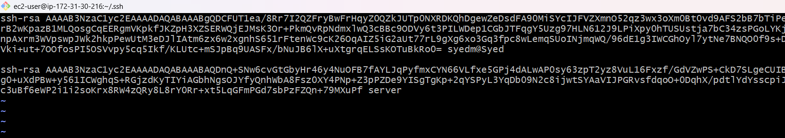

* Then connect to the instance : ssh -i “keypair.pem” ec2-user@ipv4 adress
* Go to ssh directory – vi authorized keys –paste the copied ssh key you have generated then save the file and exit
* open git bash and give : ssh ubuntu@<ipv4adress>
* then you can see you areconnected to instance without using the key.

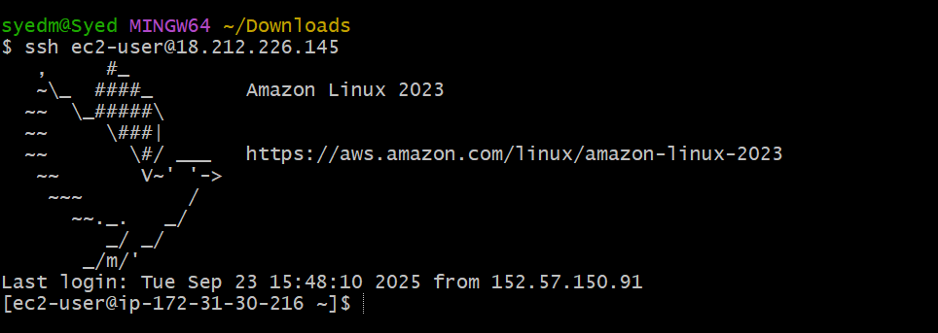

1. LAUNCH ANY EC2 USING THE SPOT PURCHASING OPTION.
2. Launch instance
3. Select ami image
4. Select instance type
5. Go to advanced options
6. Go to advanced options at the last
7. Find the purchasing options.
8. EC2 Purchasing Options

* On-Demand Instances – Pay, by the second, for the instances that you launch.
* Savings Plans – Reduce your Amazon EC2 costs by making a commitment to a consistent amount of usage, in USD per hour, for a term of 1 or 3 years.
* Reserved Instances – Reduce your Amazon EC2 costs by making a commitment to a consistent instance configuration, including instance type and Region, for a term of 1 or 3 years.
* Spot Instances – Request unused EC2 instances, which can reduce your Amazon EC2 costs significantly.
* Dedicated Hosts – Pay for a physical host that is fully dedicated to running your instances, and bring your existing per-socket, per-core, or per-VM software licenses to reduce costs.
* Dedicated Instances – Pay, by the hour, for instances that run on single-tenant hardware.
* Capacity Reservations – Reserve capacity for your EC2 instances in a specific Availability Zone.

1. You can explore these in more detail on [AWS's official EC2 purchasing guide](https://docs.aws.amazon.com/AWSEC2/latest/UserGuide/instance-purchasing-options.html).
2. 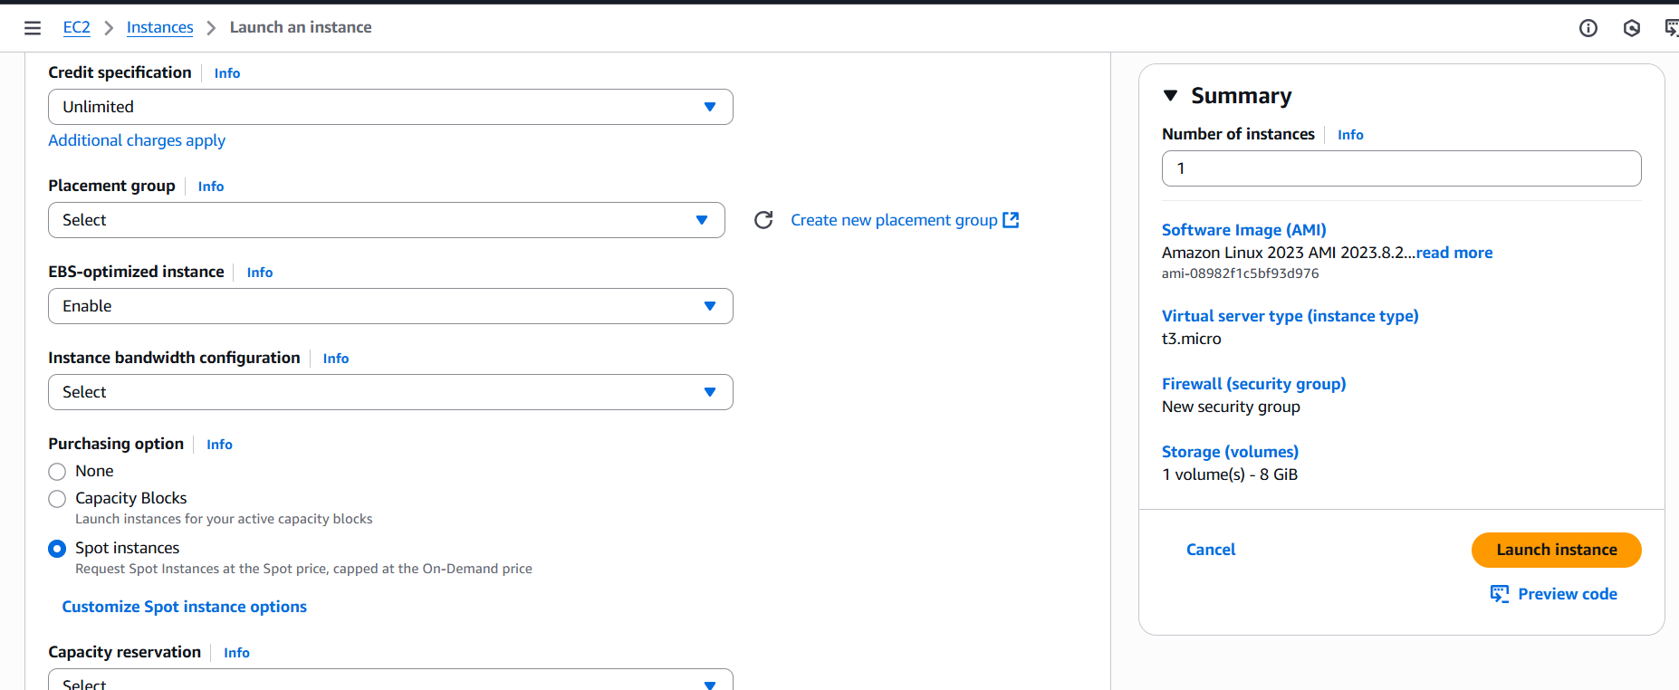Select your purchasing option as per the project requirement and lauch the instance.
3. ENABLE TERMINATION POLICY ON THE EC2 CREATED IN TASK 2.

* Go to instance
* Got to actions – instance setings – change termination protection.
* Enable and save it.
* Then the termination policy will be created for the instance.

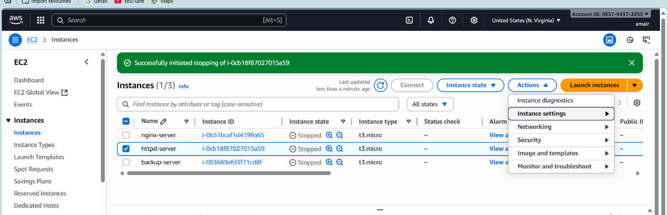

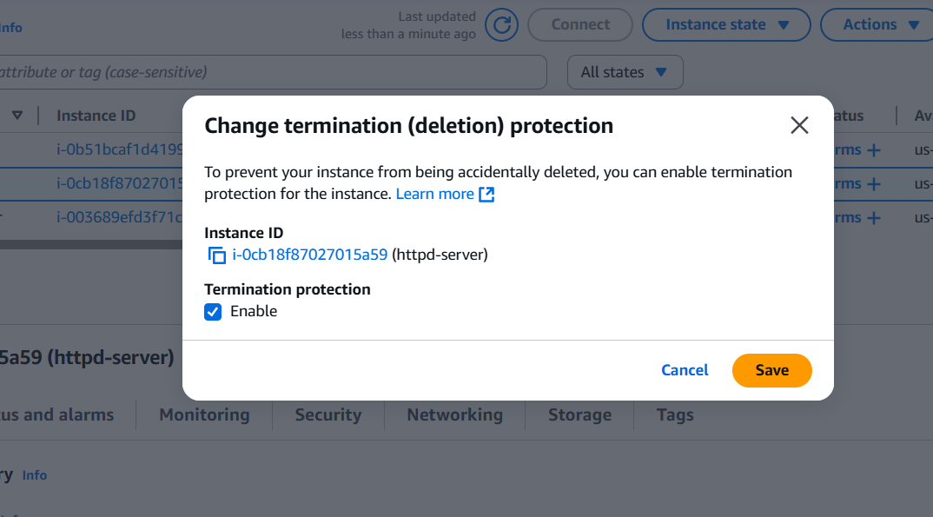

## LAUNCH ONE EC2 USING AWS CLI.

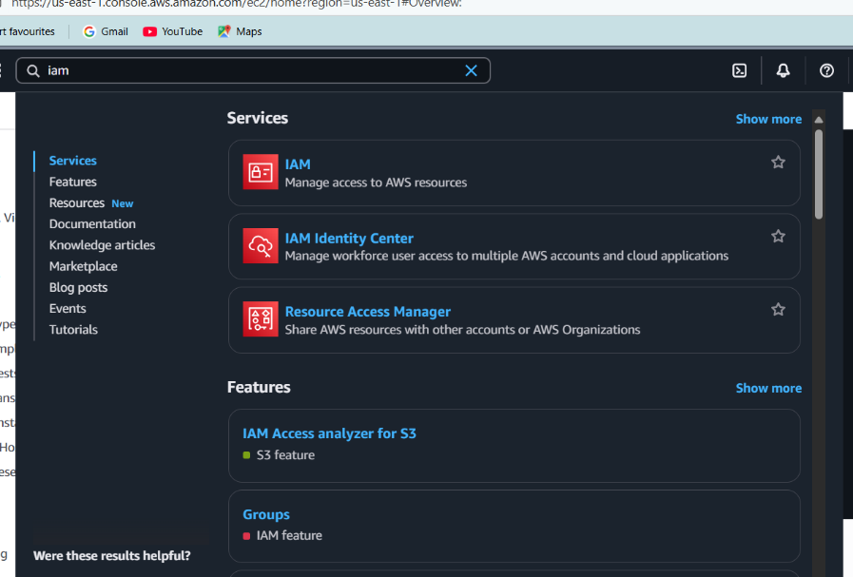

* Go to aws console login
* Search iam
* Go to iam user – my security credentials – create acess key

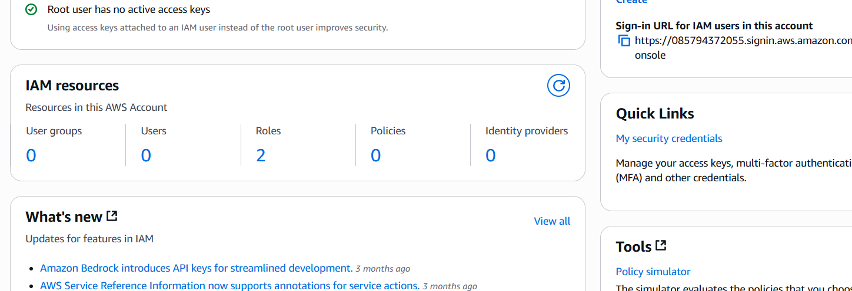

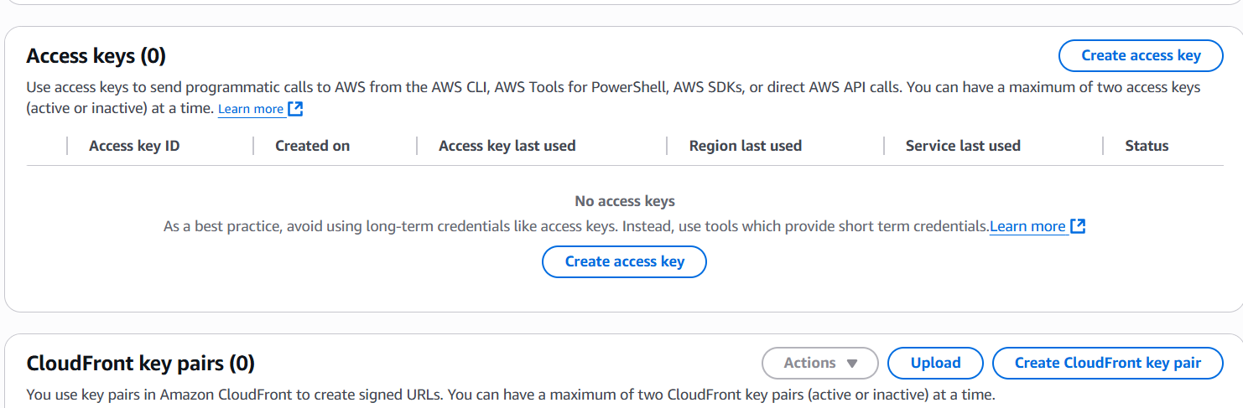

* Launch instance
* Connect to the instance
* Wget “url” – to download the aws cli for linux
* Aws configure
* Give the acess key – secret acess key tat you have created
* Give the region – output type
* You can get the details of the instances.

