# Refactoring from project source code

We have refactor our project code in order to clean code form unused code and extract it into methods and classes. Doing so, will gives high adaptability to futures changes.

## Before refactor:

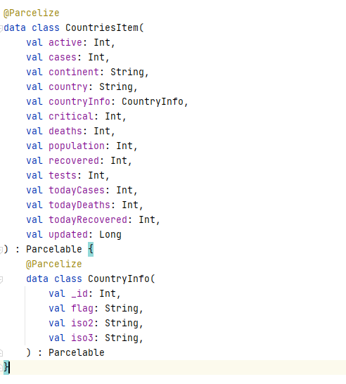

## After refactor:

