

LAB#03

Name :-Syed Ali Ahmed Shah

Reg No:- 200901071

Subject:- Data Structure And Algorithum

Batch :- CS 01-A

Teacher:- Muhammad Nadeem

Lab task # 01:

Write a program to let the user enter a string of his own choice. Check whether the given string is a palindrome or not.

Code:

from collections import deque

strng=input("enter the string :")

stk=deque()

for x in strng:

  stk.append(x)

rev = ''

while(len(stk)!=0):

 rev += stk.pop()

print(rev)

if strng==rev:

  print("The string is a palindrome.")

else:

  print("The string is not a palindrome.")

Outputs :

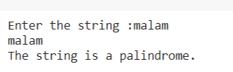

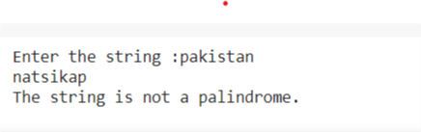

Lab Task # 02:

Write a program to check the balanced parenthesis in the expression or not using stack

Code :

charac=input("Enter the character")

stack=[]

count=0

for i in charac:

 if(i=='[' or i=='(' or i=='{'):

    stack.append(i)

 if(i==']' or i==')' or i=='}'):

   if(len(stack)==0):

      print("Unbalanced")

      count=count+1;

   else:

    print(stack.pop())

if ((len(stack)==0) and count==0):

  print("Expression balanced")

else:

  print("Expression unbalanced")

Output :

