
TechKreative

YOUR ALL-IN-ONE DIGITAL PARTNER

Presented To:
- Ms. Ramsha Khalid.

Course Name:
- Application of Information and Communication Technologies Lab (AICTL).

Group Members:
- Moeez Ahmad 2025-GA-102
- Husnain Ali 2025-GA-86
- Syed Ali Asjad 2025-GA-68
- Alishba Mehmood 2025-GA-76
- Fatima Batool 2025-GA-116
- Muhammad Arham 2025-GA-102

Project Topic:
“Tech Startup Portfolio”.

Group Number:
Group Number 1.

Startup Name:
“TechKreative”.

Date of Submission:
5th of January 2026.

Table of Contents:

Introduction: 4
Why we choose this Topic? 4
Summary: 4
Project Objectives and Scopes: ….….………………………………………………….…………………………………….4
Objectives: …..………………………….……………………………………………………………………………………….4 Scope: …………………………………………………………..…………………………………………………………………4
Procedure: 4
Website: 4
GitHub: 5
Exel: 7
Canva: 8
Reflection: 9
What we learn: 9
Improvements: 9

Introduction:
TECHKREATIVE is a dynamic startup founded in mid 2025, dedicated to providing innovative solutions to all kind of business. At TechKreative, we believe in bringing your ideas to life by offering wide range of services, including SEO, social media management, and video editing, all under one roof to ensure your digital growth.

Why we choose this Topic?
As our group member Moeez Ahmad is web developer and he owns tech agency TechKreative, so we find very easy to work on this as our teammate having expertise about it. He offers many services like web development, SEO service, video editing, graphic designing and many more. Our group find very easy to work on this, so we finally decide tech startup portfolio for our final’s project.

Summary:
This project includes a professional website using HTML/CSS, an Exel budget panner and a detailed report about how company works. Our main goal is to help our clients and businesses to grow digitally and succeed in the digital world.

Project Objective and Scope:
- Objectives: The main goal is to build a professional brand for our startup, TechKreative. We want to show our skills in web design and data management using Microsoft Office and GitHub.
- Scope: This project covers the creation of a 5-page website, a financial budget in Excel, and a presentation for investors.

Procedure:
As our instructor share the list of the topics, first we decide our topic and made the numbering and short deadlines to meet our objective.

Website:
First, we make out website by using HTML and CSS. We use Teal and White combination in our site which gains user’s attention and trust and use sans-serif font which makes readability better. We make portions to separate the things, what we offer and sales and many more, which makes the website more beautiful and attention grabbing. Here’s the detail about it,
- In home page/main page we talk about the agency’s agenda on which the team is working and introduce our team and inform the new users about the projects we have done and many other things.
- In about section we talk about us, our background and we talk about our goal on which we are working.
- In service page we talk about services, what we offer and show our successful projects on services section.
- Last but not the least on contact section we make form that the user fills for any service he wants or want to connect with us.
Here’s the link of our website:
- https://moeezahmad-tech.github.io/first_aict/ (Moeez Ahmad)
- https://moeezahmad-tech.github.io/first_aict/ (Husnain Virk)
- https://moeezahmad-tech.github.io/first_aict/ (Syed Ali Asjad)
- https://alishbah20.github.io/Group_1-Tech_Startup_Portfolio/ (Alishba)
- https://moeezahmad-tech.github.io/first_aict/ (Fatima Batool)
- https://moeezahmad-tech.github.io/first_aict/ (M. Arham)
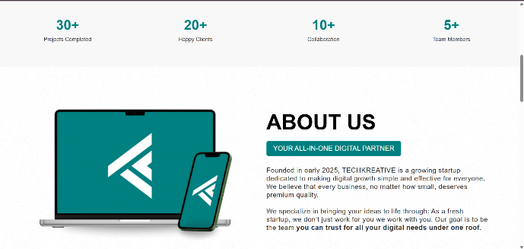
Here are some screenshots of our website:
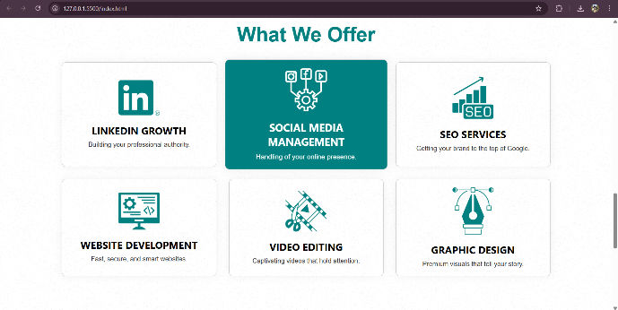
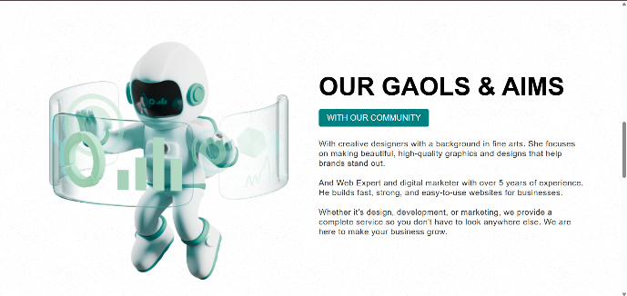
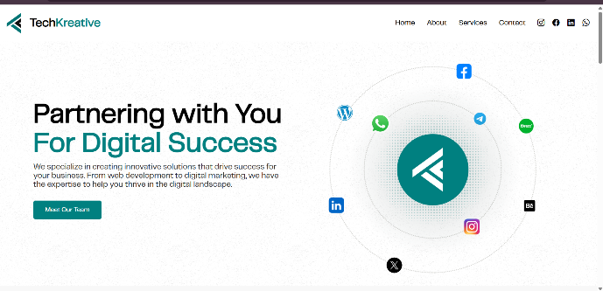
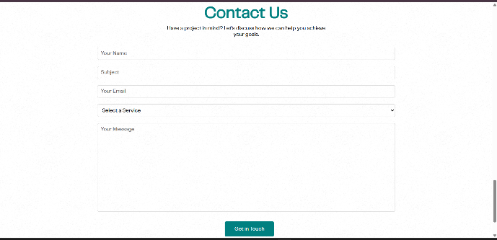
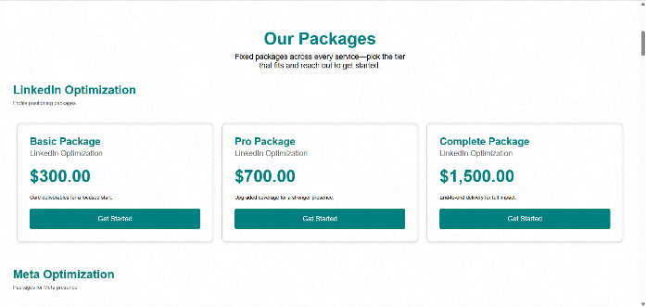

GitHub:
According to the instructions of the manual we must publish our website on GitHub. First, we create a public repository on GitHub name Group_1-Tech_startup_portfolio / Group_1-Tech_startup_portfolio / Group_1-Tech_startup_portfolio / Group_1-Tech_startup_portfolio / Group_1-Tech_startup_portfolio / Group_1-Tech_startup_portfolio to store all our project safely. Throughout the project we make regular commits every time we added a new feature or want to fix a bug. Our repository contains all essential files including index.html for the structure and style.css for the design and images for brand set. The step-by-step detail is below:
- First, we organized all our project files in a local folder. This included the index.html file for the main structure, the style.css file for the design, and an images folder containing our logos and assets.
- We logged into GitHub and created a new public repository named Group_1-Tech_startup_portfolio. We made sure to keep it public so that the website could be hosted freely.
- We uploaded all our code and assets to the repository. We also added a README.md file that contains a short introduction to our project and links to our report and presentation.
- To publish the site, we went to the Settings tab of our repository, clicked on Pages, and selected the main/master branch as the source.
- After saving the settings, GitHub generated a live link for us. We tested this URL to ensure that our "TechKreative" website was working correctly on both desktop and mobile devices.
Here’s the link of our Hosted website on GitHub pages:
- https://github.com/moeezahmad-tech/Group_1-Tech_Startup_Portfolio (Moeez Ahmad)
- https://github.com/moeezahmad-tech/first_aict/tree/main (Husnain Virk)
- https://github.com/SyedAliAsjad1214/Group_1_Tech_Startup_Portfolio (Syed Ali Asjad)
- https://github.com/alishbah20/Group_1-Tech_Startup_Portfolio (Alishba)
- https://github.com/fatimabatool2219-svg/Group_1-Tech-Startup-Portfolio (Fatima Batool)
- https://github.com/Muhammad-Arham-06/Group_1-Tech_Startup_Portfolio (M. Arham)
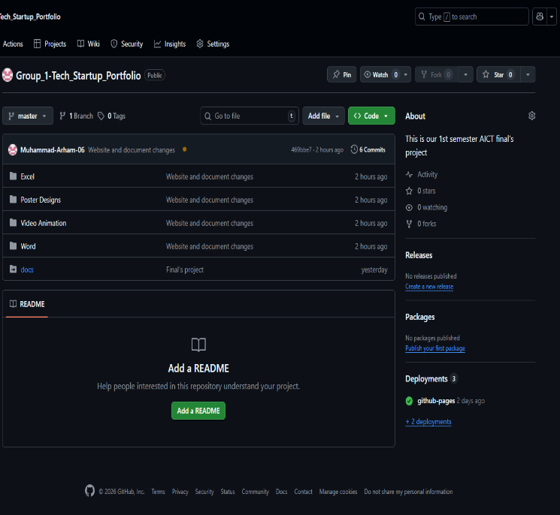
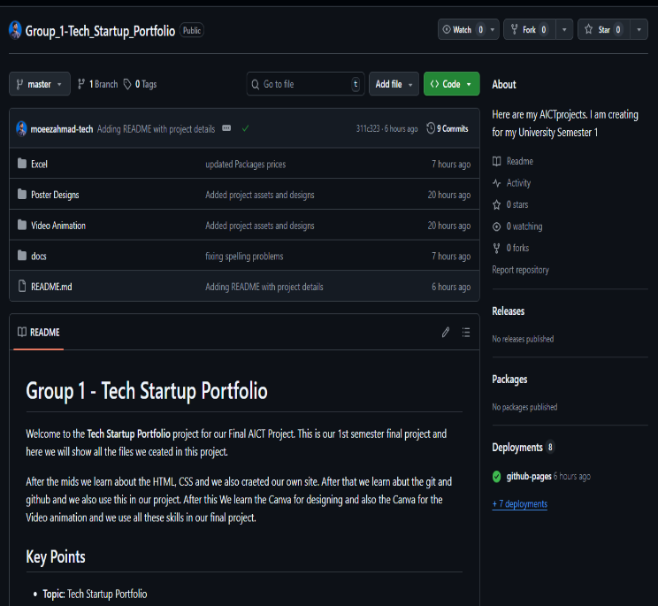
Here are some screenshots of our GitHub repositories:
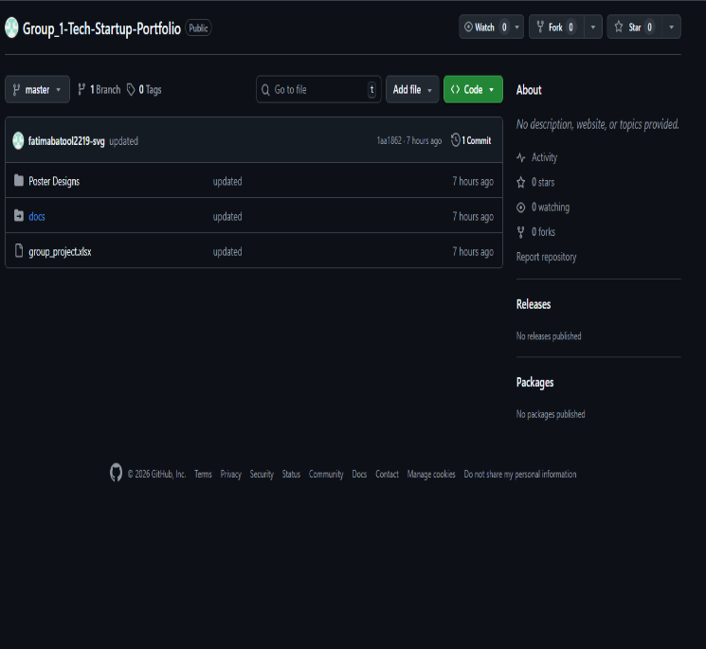
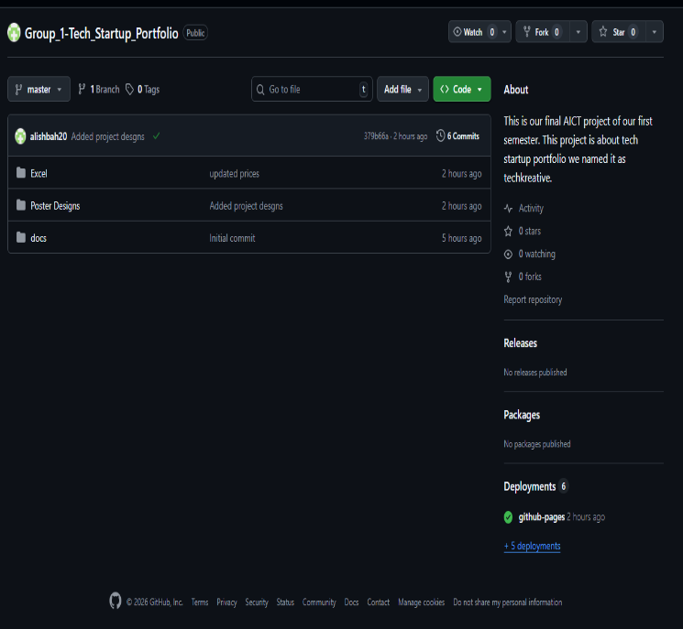

Exel:
The main purpose of using Microsoft Exel was to manage business data for TechKreative. We created an organised system to track our expenses and services. We created a sheet that lists all our services that we offered to our clients and make the record of our sales. Secondly, we make a sheet of our monthly budget and expenses to keep our financial records clear, we use many Exel formulas like SUM to calculate the total earnings and AVERAGE to calculate the average or our records. The detail summary of Exel is below:
- On first sheet we show our team members and their working hours and Salary.
- On second sheet we show all our services we offer and their prices.
- On third page we shoe all the expenses that we have to bear every month.
- On fourth sheet we show all the projects that are delivered and their sales.
- On last we show financial suumary of all these.
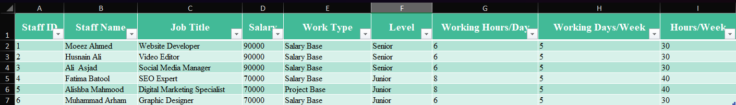
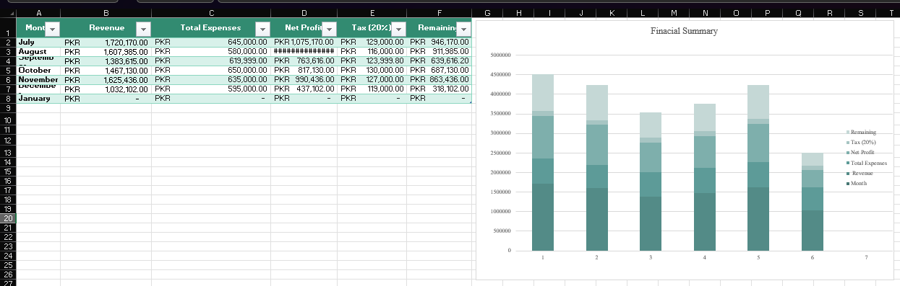
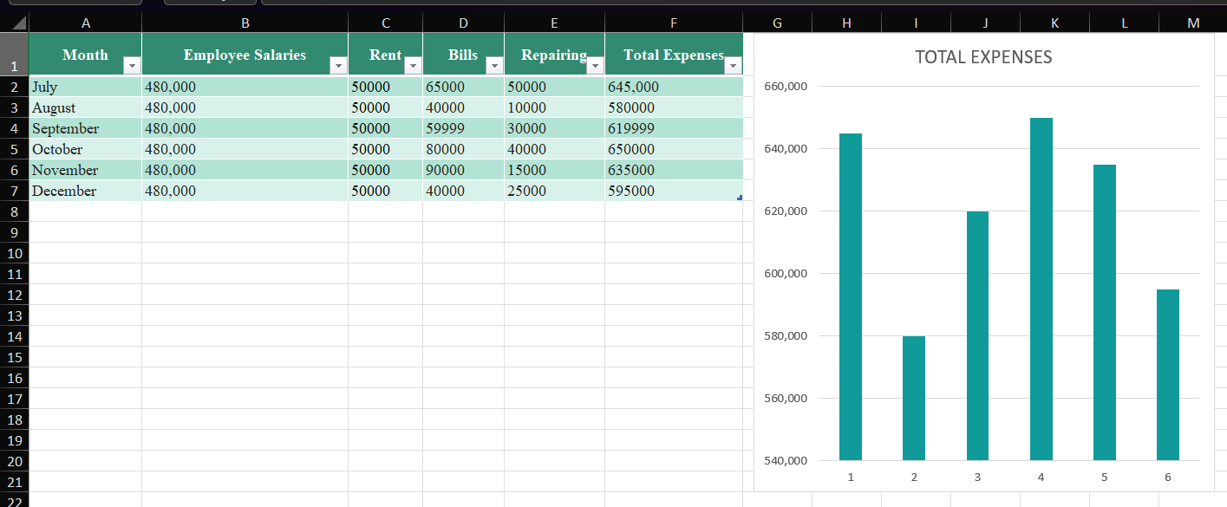
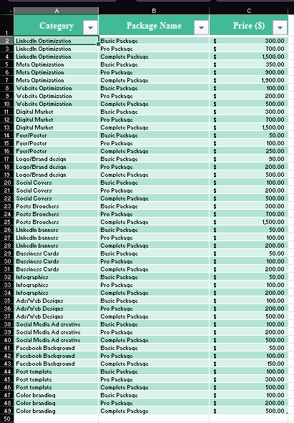
Here are some screenshots of our Exel sheets:

Canva:
According to the instructions we created a short, animated video and agency’s brochure to showcase our project. The video includes all the essential details about the project. The video covers everything from the project title and objectives to the conclusion.
Here are some screenshots from Canva:


Brochures
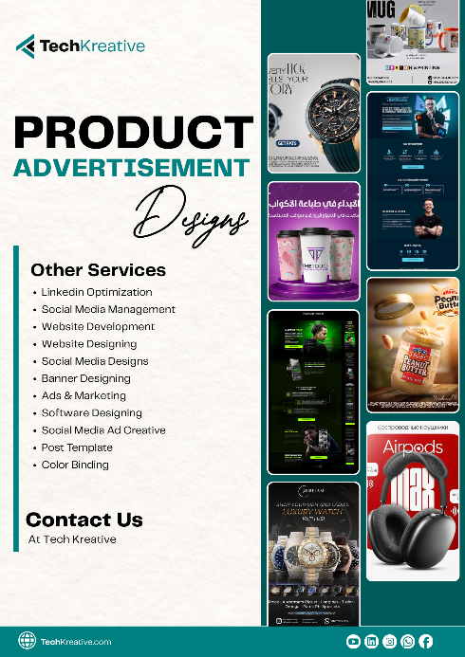
Video
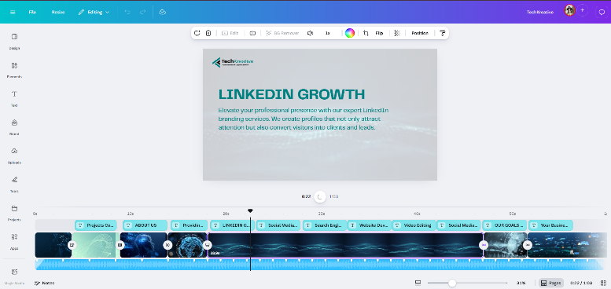
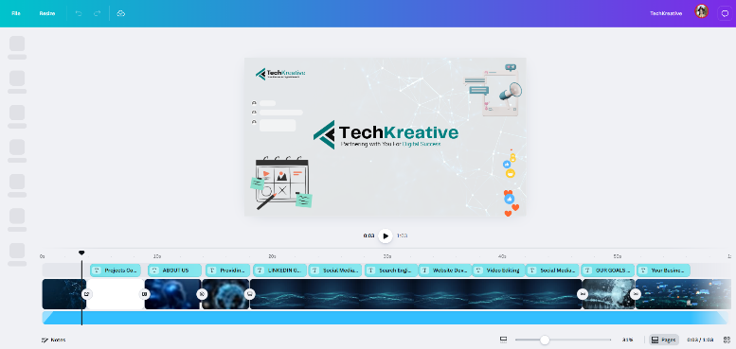
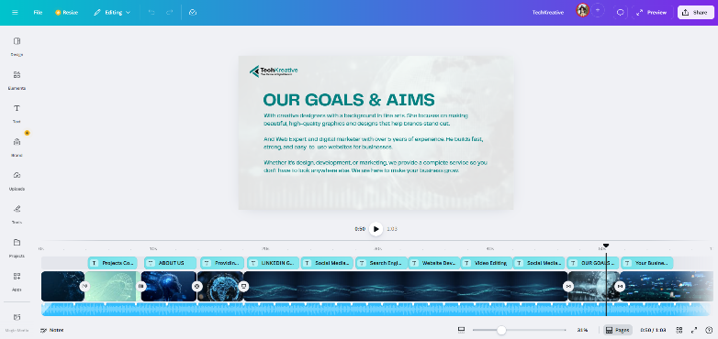

Reflection:

What we learn:
This AICT semester project was a complete learning experience for our group. It taught us how to connect different technical skills into a single workflow. We learned that building a website is not enough; documenting it in MS Word and backing it up with data in MS Excel is equally important. The most valuable skill we gained was using GitHub for version control and hosting, which was something new for us. We also learned how to present our hard work professionally through a video demonstration and a LinkedIn post.

Improvements:
We used basic HTML and CSS, but in the future, we would like to add JavaScript to make the website more interactive. We can use more advanced Excel formulas and macros to make our budget planning even more automatic. We realized that version control requires regular updates, so we plan to commit our changes more frequently in future projects.

