AI-Driven Answering Machine Detection
Complete Setup & Deployment Guide
For VICIdial, FreeSWITCH, and Asterisk Integration

Whisper-small (Fine-tuned) + TF-IDF Text Classification

Table of Contents
1. Introduction and Overview
2. System Requirements
3. Project Structure
4. Installation Guide
5. Data Preparation
6. Training the Whisper Model
7. Training the Text Classifier
8. Running the WebSocket Server
9. Testing with the Client
10. VICIdial/Asterisk Integration
11. Bulk Evaluation
12. Production Deployment
13. Troubleshooting
14. Code Reference

1. Introduction and Overview
This guide provides comprehensive instructions for setting up an AI-driven Answering Machine Detection (AMD) system using Whisper for speech-to-text and a TF-IDF text classifier to distinguish human vs machine responses.

1.1 What This System Does
- 2-second early decision: Buffer first 2.0s of audio for quick classification
- Full-transcript decision: Transcribe entire audio on flush command
- Whisper fine-tuning: Train on your audio data clipped to 2s at 16kHz
- Text classifier: TF-IDF + Logistic Regression on text/label pairs
- Low-latency inference: CTranslate2 for fast GPU/CPU decoding
- Live streaming: WebSocket server receives PCM16 16kHz mono frames

1.2 Why AI-Based AMD?
Traditional AMD uses acoustic heuristics that fail across carriers, codecs, and languages. This approach transcribes audio and classifies text, achieving up to ~98% accuracy on real campaign data.

1.3 System Architecture
Audio Input → WebSocket receives PCM16 mono frames (8kHz or 16kHz)
ASR Processing → Fine-tuned Whisper-small transcribes audio
Text Classification → TF-IDF + Logistic Regression classifies transcript
JSON Response → Returns label, confidence, probability, and transcript

2. System Requirements

2.1 Hardware Requirements
Component | Requirement
GPU (Recommended) | NVIDIA GPU with CUDA 12, cuDNN 9 (8GB+ VRAM)
CPU | Multi-core processor (4+ cores)
RAM | 16GB minimum (32GB for training)
Storage | 50GB+ SSD

2.2 Software Requirements
Software | Version
Python | 3.10 or higher
CUDA (GPU) | CUDA 12 + cuDNN 9
FFmpeg | Latest version
OS | Ubuntu 20.04+ / CentOS 7+ / Windows 10+

3. Project Structure
Project layout:
arc-ml-stt-whisper-amd/
├── client/ws_client.py # WebSocket test client
├── data/ # Sample audio files
├── models/
│ ├── text_cls_balanced_tfidf.joblib # Text classifier
│ ├── whisper-ct2/ # CTranslate2 model
│ └── whisper-small-finetuned/ # Fine-tuned Whisper
├── scripts/
│ ├── bulk_ws_eval.py # Batch evaluation
│ ├── finetune_whisper_small.py
│ ├── train_text_classifier.py
│ └── utils.py
├── server/ws_server.py # FastAPI WebSocket server
├── sample_stt.csv # STT training data
├── sample_text_labels.csv # Classifier data
└── requirements.txt

4. Installation Guide

4.1 Extract the Project
unzip arc-ml-stt-whisper-amd.zip
cd arc-ml-stt-whisper-amd

4.2 Create Virtual Environment
python -m venv .venv
source .venv/bin/activate # Linux/Mac
.venv\Scripts\activate # Windows

4.3 Install Dependencies
pip install --upgrade pip
pip install -r requirements.txt

4.4 Core Dependencies

Inference Stack
- faster-whisper==1.0.3 - Optimized Whisper inference
- ctranslate2==4.5.0 - Fast transformer inference
- torch>=2.1.0, torchaudio>=2.1.0 - PyTorch

Audio Processing
- soundfile==0.12.1 - Audio file I/O
- librosa==0.10.2.post1 - Audio analysis
- pydub==0.25.1 - Audio manipulation

Text Classification
- scikit-learn==1.5.2 - Machine learning
- joblib==1.4.2 - Model serialization

Web Service
- fastapi==0.115.0 - Web framework
- uvicorn[standard]==0.30.6 - ASGI server
- websockets==12.0 - WebSocket protocol

4.5 GPU Setup
For GPU support:
sudo apt-get install libcudnn9-cuda-12

5. Data Preparation

5.1 ASR Fine-tune Data Format
CSV format with path,transcription columns:
path,transcription
data/sample1.wav,I'm sorry.
data/sample2.wav,Hello. Please leave a message.
data/sample3.wav,Hello.

Audio Requirements
- Format: WAV (16-bit PCM) or any librosa-readable format
- Sample Rate: Auto-normalized to 16kHz mono
- Duration: Clipped/padded to 2.0 seconds for training

5.2 Text Classifier Data Format
CSV format with transcript,label columns:
transcript,label
Hello.,HUMAN
Please leave your name and number,MACHINE
Hello?,HUMAN

Label Values
- HUMAN: Live person (greetings, questions)
- MACHINE: Voicemail/IVR (automated messages)

6. Training the Whisper Model

6.1 Fine-tuning Whisper-small
python scripts/ text_cls_balanced_tfidf.joblib \
--csv /path/to/data.csv \
--out_dir models/whisper-small-finetuned \
--batch 4 --num_workers 4

Script Parameters
Parameter | Description
--csv | Path to CSV with path,transcription columns
--out_dir | Output directory for fine-tuned model
--batch | Batch size (default: 8)
--num_workers | Data loader workers (default: 4)
--epochs | Training epochs (default: 3)
--base_model | Base model (default: openai/whisper-small)

6.2 Export to CTranslate2
ct2-transformers-converter \
--model models/whisper-small-finetuned \
--output_dir models/whisper-ct2 \
--copy_files tokenizer.json tokenizer_config.json \
preprocessor_config.json special_tokens_map.json \
vocab.json merges.txt normalizer.json \
generation_config.json \
--quantization float16
Note: Use --quantization int8_float16 for CPU-only deployment.

7. Training the Text Classifier

7.1 Train the Classifier
python scripts/ text_cls_balanced_tfidf.joblib \
--csv /path/to/text_data.csv \
--out models/text_cls.joblib \
--word_ngrams 1,2

Script Parameters
Parameter | Description
--csv | Path to CSV with transcript,label columns
--out | Output path for joblib model file
--word_ngrams | Word n-gram range (default: 1,2)

7.2 Expected Output
Classification report on held-out split:
precision recall f1-score
MACHINE 0.99 0.98 0.98
HUMAN 0.98 0.99 0.99
accuracy 0.98

8. Running the WebSocket Server

8.1 Environment Variables
export WHISPER_MODEL_DIR=models/whisper-ct2
export DEVICE=cuda # or 'cpu'
export COMPUTE_TYPE=float16 # or 'int8_float16'
export CLASSIFIER_PATH=models/text_cls_balanced_tfidf.joblib
export EARLY_SEC=2.0 # 0 to disable early decision

Environment Variable Reference
Variable | Description
WHISPER_MODEL_DIR | Path to CTranslate2 Whisper model
DEVICE | 'cuda' for GPU or 'cpu'
COMPUTE_TYPE | 'float16' for GPU, 'int8_float16' for CPU
CLASSIFIER_PATH | Path to text classifier joblib
EARLY_SEC | Seconds for early decision (0 to disable)

8.2 Start the Server
uvicorn server.ws_server:app --host 0.0.0.0 --port 8080
WebSocket endpoint: ws://<host>:8080/ws/amd

8.3 Response Format
{
"type": "final", // "early" or "final"
"label": "machine", // "human" or "machine"
"confidence": 0.98,
"proba_human": 0.02,
"transcript": "please leave your name...",
"elapsed_ms": 150
}

9. Testing with the Client

9.1 Basic Test
python client/ws_client.py --wav /path/to/test.wav

Client Parameters
Parameter | Description
--url | WebSocket URL (default: ws://localhost:8080/ws/amd)
--wav | Path to WAV file (16kHz, 16-bit PCM, mono)
--chunk_ms | Chunk size in ms (default: 20)

9.2 Audio Format Requirements
- Sample Rate: 16000 Hz (16kHz)
- Bit Depth: 16-bit PCM
- Channels: Mono (single channel)
- Format: WAV

10. VICIdial/Asterisk Integration

10.1 Install Dependencies
apt-get install -y python3-pip
pip3 install websocket-client asterisk-agi

10.2 Deploy EAGI Script
install -m 0755 amd.py /var/lib/asterisk/agi-bin/amd.py
chown asterisk:asterisk /var/lib/asterisk/agi-bin/amd.py

10.3 Configure Dialplan
Add to extensions.conf:
; VICIdial auto_dialer AMD
exten => 8370,1,AGI(agi://127.0.0.1:4577/call_log)
exten => 8370,n,Playback(sip-silence)
exten => 8370,n,EAGI(/var/lib/asterisk/agi-bin/amd.py)
exten => 8370,n,AGI(VD_amd.agi,${EXTEN})
exten => 8370,n,Hangup()

10.4 EAGI (JSON-aware) Environment Variables
Variable | Default Value
AMD_WS_URL | ws://127.0.0.1:8080/ws/amd
AMD_SAMPLE_RATE | 8000 (or 16000 if 16kHz media)
AMD_EARLY_MIN_CONF | 0.90

; VICIDIAL_auto_dialer transfer script AMD (load-balanced)
exten => 8370,1,AGI(agi://127.0.0.1:4577/call_log)
exten => 8370,n,Playback(sip-silence)
exten => 8370,n,EAGI(/var/lib/asterisk/agi-bin/amd.py)
exten => 8370,n,AGI(VD_amd.agi,${EXTEN})
exten => 8370,n,AGI(agi-VDAD_ALL_outbound.agi,NORMAL-----LB-----${CONNECTEDLINE(name)})
exten => 8370,n,Hangup()

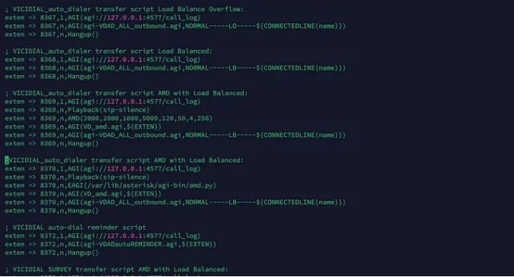



EAGI (JSON-aware): /var/lib/asterisk/agi-bin/amd.py

#!/usr/bin/env python3
import os, fcntl, json, time
from websocket import create_connection
from asterisk.agi import AGI
AUDIO_FD = 3
WS_URL = os.getenv("AMD_WS_URL", "ws://127.0.0.1:8080/ws/amd")
SAMPLE_RATE = int(os.getenv("AMD_SAMPLE_RATE", "8000")) # EAGI audio usually 8kHz
EARLY_MIN_CONF = float(os.getenv("AMD_EARLY_MIN_CONF", "0.90"))
def set_human(agi, cause="HUMAN", stats=None):
agi.set_variable("AMDSTATUS", "HUMAN")
agi.set_variable("AMDCAUSE", cause)
if stats: agi.set_variable("AMDSTATS", stats)
def set_machine(agi, cause="MACHINE", stats=None):
agi.set_variable("AMDSTATUS", "MACHINE")
agi.set_variable("AMDCAUSE", cause)
if stats: agi.set_variable("AMDSTATS", stats)
def should_stop_on(msg):
if not isinstance(msg, dict): return None
typ = str(msg.get("type", "")).lower()
label = str(msg.get("label", "")).lower()
conf = float(msg.get("confidence", 0.0) or 0.0)
if typ == "final":
return label
if typ == "early" and conf >= EARLY_MIN_CONF:
return label
return None
def process_json_and_set_vars(agi, msg):
label = str(msg.get("label", "")).upper() # HUMAN/MACHINE
conf = msg.get("confidence", "")
ph = msg.get("proba_human", "")
tr = msg.get("transcript", "")
typ = msg.get("type", "")
cause = f"{typ}|p_human={ph}|conf={conf}"
stats = f"{label}|{cause}|{tr[:120]}"
(set_human if label == "HUMAN" else set_machine if label == "MACHINE" else set_human)(
agi, cause if label in ("HUMAN","MACHINE") else "UNKNOWN", stats
)
def startAGI():
agi = AGI()
chan = agi.env.get("agi_channel","")
ani = agi.env.get("agi_callerid","")
did = agi.env.get("agi_extension","")
vid = agi.env.get("agi_calleridname","")
agi.verbose(f"AMD: answered from {ani} to {did} on {chan} VID={vid}")
try:
ws = create_connection(WS_URL, timeout=5)
ws.send(json.dumps({"config": {"sample_rate": SAMPLE_RATE, "VID": f"{vid}"}}))
agi.verbose(f"AMD: WS connected {WS_URL} (sr={SAMPLE_RATE})")
except Exception as e:
agi.verbose(f"AMD: WS connect error {e} → default HUMAN")
set_human(agi, cause="NETERR"); return
fcntl.fcntl(AUDIO_FD, fcntl.F_SETFL, os.O_NONBLOCK)
last_msg = None
total_bytes = 0
buf = b""
start = time.time()
try:
while True:
try:
time.sleep(0.2)
chunk = os.read(AUDIO_FD, 9500)
if not chunk:
ws.send(json.dumps({"type":"flush"}))
for _ in range(5):
try:
res = ws.recv()
msg = json.loads(res) if isinstance(res, str) else {}
last_msg = msg or last_msg
stop = should_stop_on(msg)
if stop:
process_json_and_set_vars(agi, msg); return
except Exception:
break
if last_msg: process_json_and_set_vars(agi, last_msg)
else: set_human(agi, cause="NOAUDIO")
return
buf += chunk
if len(buf) >= 6400: # ~0.4s at 8kHz
ws.send_binary(buf)
total_bytes += len(buf)
buf = b""
try:
ws.settimeout(0.01)
res = ws.recv()
msg = json.loads(res) if isinstance(res, str) else {}
last_msg = msg or last_msg
stop = should_stop_on(msg)
if stop:
process_json_and_set_vars(agi, msg); return
except Exception:
pass
finally:
ws.settimeout(5)
if (time.time() - start) > 5 and total_bytes == 0:
ws.send(json.dumps({"type":"flush"}))
try:
res = ws.recv()
msg = json.loads(res) if isinstance(res, str) else {}
process_json_and_set_vars(agi, msg)
except Exception:
set_human(agi, cause="TIMEOUT")
return
except OSError as err:
if getattr(err, "errno", None) == 11:
continue
set_human(agi, cause="AUDIOERR"); return
except Exception as e:
set_human(agi, cause="NETERR")
finally:
try: ws.send(json.dumps({"type":"flush"}))
except Exception: pass
try: ws.close()
except Exception: pass
if __name__ == "__main__":
startAGI()

10.5 Channel Variables Set
- AMDSTATUS: HUMAN or MACHINE
- AMDCAUSE: Short string (e.g., final|p_human=0.02)
- AMDSTATS: Compact log with transcript snippet

11. Bulk Evaluation

11.1 Run Bulk Evaluation
python scripts/bulk_ws_eval.py \
--audio_dir /path/to/folder \
--csv_out results.csv \
--url ws://127.0.0.1:8080/ws/amd \
--concurrency 4 --resume

Parameters
Parameter | Description
--audio_dir | Root folder with audio files (recursive)
--csv_out | Output CSV path
--concurrency | Parallel WebSocket connections (default: 4)
--resume | Skip files already in CSV

11.2 Output CSV Format
file,type,label,confidence,proba_human,transcript,elapsed_ms

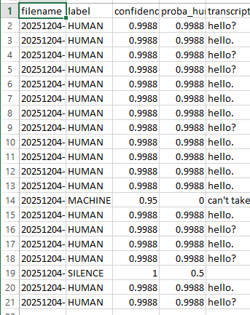
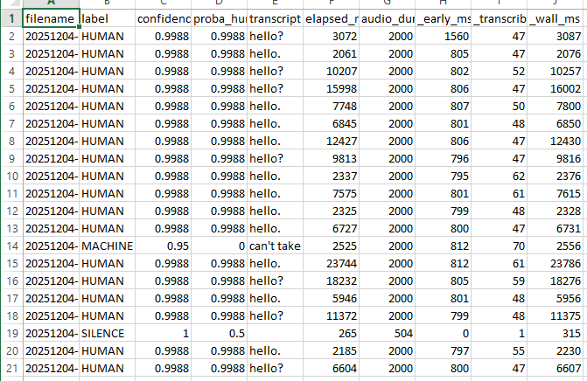

12. Production Deployment

12.1 Performance Optimization
- GPU: Use compute_type=float16, beam_size=1
- Chunks: Keep at 20ms for optimal latency
- CPU: Use COMPUTE_TYPE=int8_float16

12.2 Scaling
- Run multiple Uvicorn workers behind WS-capable LB
- Each worker loads its own model instance
- Start with 4-8 concurrent streams per worker

12.3 Reliability
- Add /healthz route for health checks
- Enable structured logging
- Use systemd units for process management

12.4 Threshold Tuning
- Favor machine recall: Require proba_human > 0.55-0.65
- Favor human precision: Lower threshold or wait for final

12.5 Security
- Run behind TLS termination (wss://)
- Validate origins if exposed publicly
- Implement rate limiting as needed

13. Troubleshooting

13.1 Common Issues

CUDA/cuDNN Errors
Symptom: libcudnn_ops.so.9: cannot open shared object file
Solution: Install cuDNN 9: apt-get install libcudnn9-cuda-12

WebSocket Connection Failed
Symptom: Connection refused or timeout
Solution: Verify server running, check port/firewall

Audio Format Mismatch
Symptom: Assertion error: Expect 16kHz
Solution: Convert: ffmpeg -i input.wav -ar 16000 -ac 1 output.wav

Out of Memory
Symptom: CUDA out of memory during training
Solution: Reduce batch size (--batch 2 or 1)

13.2 Latency Issues
- Check if GPU is being used (DEVICE=cuda)
- Verify compute_type is float16
- Reduce chunk_ms if network allows
- Monitor GPU utilization

14. Code Reference

14.1 Server Code (ws_server.py)
- Accepts binary PCM16 frames at 16kHz
- Buffers audio, triggers early decision after EARLY_SEC
- Responds to 'flush' with final classification
- Supports 'reset' to clear buffer

14.2 Client Code (ws_client.py)
- Reads 16-bit PCM WAV at 16kHz mono
- Streams in configurable chunks (default 20ms)
- Sends flush command after streaming

14.3 Training Scripts

finetune_whisper_small.py
- Loads audio clipped/padded to 2.0 seconds
- Uses lazy transforms for large datasets
- Enables gradient checkpointing

train_text_classifier.py
- TF-IDF with configurable n-gram ranges
- Logistic Regression with balanced weights
- Stratified 15% test split

14.4 Utility Functions (utils.py)
- normalize_text(): Lowercase and clean whitespace
- wav_bytes_to_float32(): Convert PCM16 to float32
- ensure_2s(): Pad/clip audio to 2.0 seconds

