REPORT

1. Introduction and Problem
Insurance depends on trust between a customer and a company. Today, a claim moves through several people and systems: the customer, the agent, a loss assessor, the insurer's back office and the bank. Each one keeps its own records, so a claim is slow and easy to dispute.
This project designs a blockchain solution for insurance claims. A smart contract acts as a neutral middle layer between the policyholder (sender) and the insurer (receiver). It holds the rules, records every step, and pays out automatically once a claim is approved.

2. How the Current System Works and What Blockchain Changes
Area | Current system | Blockchain solution
Records | Kept separately by each party; can differ or be edited | One shared ledger; entries cannot be changed after they are written
Claim speed | Days to weeks of manual checking and paperwork | Rules run in code; payout happens in one transaction after approval
Fraud | Fake or reused documents are hard to detect | Evidence hash is time-stamped; one open claim per policy is enforced
Trust | Customer must trust the insurer's decision and timing | Customer can read the contract rules and see every step
Cost | High admin and reconciliation cost | Fewer middlemen and less manual work
Audit | Slow, paper based | Instant: all events are public on the chain
The disruptive effect is that the process owner changes. Instead of each company controlling its own database, the shared contract controls the process and everyone sees the same truth.

3. Proposed Solution and Business Model

3.1 Actors
- Policyholder (sender): buys a policy by paying the premium, then submits a claim with a hash of the evidence.
- Insurer (receiver): funds the payout pool, receives premiums, and pays approved claims.
- Assessor: independent party who checks the evidence and approves or rejects the claim.
- Smart contract: the middle layer. It enforces the rules, holds the money and records events.

3.2 Claim flow
- Insurer deploys the contract and funds the pool.
- Policyholder calls buyPolicy and pays the exact premium (5% of cover).
- Policyholder calls submitClaim with the amount and the SHA-256 hash of the photos and reports.
- Assessor checks the evidence off-chain, then calls approveClaim or rejectClaim.
- Insurer calls payClaim; the contract sends the money straight to the policyholder.
- Every step emits an event, so the full history is auditable.

3.3 Business model
- The insurer earns the premium and saves on admin, paperwork and fraud losses.
- A small platform or service fee per policy can cover running costs.
- Customers get faster, clearer claims, which helps the insurer keep them.
- The model can grow into parametric products, where a trusted data feed (an oracle) triggers payout automatically, for example for flight delay or crop weather.

4. Recent Advancements in Blockchain Used or Relevant Here
- Cheaper scaling: Ethereum's Fusaka upgrade went live in December 2025. It added PeerDAS data sampling, which is reported to lower data costs for Layer 2 networks. Cheaper Layer 2 fees make small insurance transactions realistic.
- Oracles and parametric cover: Insurance products on-chain increasingly use oracles to feed real-world data (weather, flight status) into contracts for automatic parametric payouts.
- Privacy tools: Zero-knowledge proofs let a person prove a fact (for example, that they are insured and over a limit) without revealing private data. This helps meet privacy law.
- Hybrid storage: This prototype keeps documents off-chain and stores only the hash, the common pattern for sensitive data.
Note: the prototype runs on a local Ganache chain and in Remix. A production version would target a Layer 2 network.

5. Benefits and Challenges

5.1 Benefits
- Transparency: all parties see the same record.
- Speed: payout is automatic after approval.
- Security: records cannot be altered after the fact.
- Lower cost: less manual checking and reconciliation.
- Fraud reduction: time-stamped evidence hashes and one open claim per policy.

5.2 Challenges
- Privacy and GDPR: personal data must not be stored on a public chain, so only hashes are stored.
- Smart contract bugs are costly because code cannot easily be changed; audits and testing are needed.
- Oracle trust: a wrong data feed leads to a wrong payout.
- Regulation: insurers need a licence, and the legal status of smart contract decisions is still developing.
- User experience: customers need a wallet and basic crypto knowledge.
- Volatility and fees: a stablecoin and a Layer 2 network would reduce price risk and cost.

6. Most Suitable Cryptographic Method
The most suitable method for this use case is a cryptographic hash function, SHA-256 (Ethereum itself uses Keccak-256 inside the network), used together with digital signatures (ECDSA).

6.1 Why hashing
- A claim depends on evidence such as photos and reports. Storing them on-chain would be costly and would expose personal data.
- A hash is a fixed 32-byte fingerprint of the file. Any change to the file, even one pixel, produces a completely different hash.
- The hash is stored with the claim in the contract. Later, anyone can hash the file again and call verifyEvidence to prove it has not been changed.
- A hash cannot be reversed, so private information is not revealed.

6.2 How digital signatures add security
- Every transaction is signed with the sender's private key (ECDSA). The contract knows who is calling through msg.sender.
- This is why only the policyholder can file a claim, only the assessor or insurer can approve, and only the insurer can pay.
- Blocks are linked by hashes, so changing an old record would break every later block.
Together, hashing protects the integrity of the evidence and signatures protect the identity of each party.

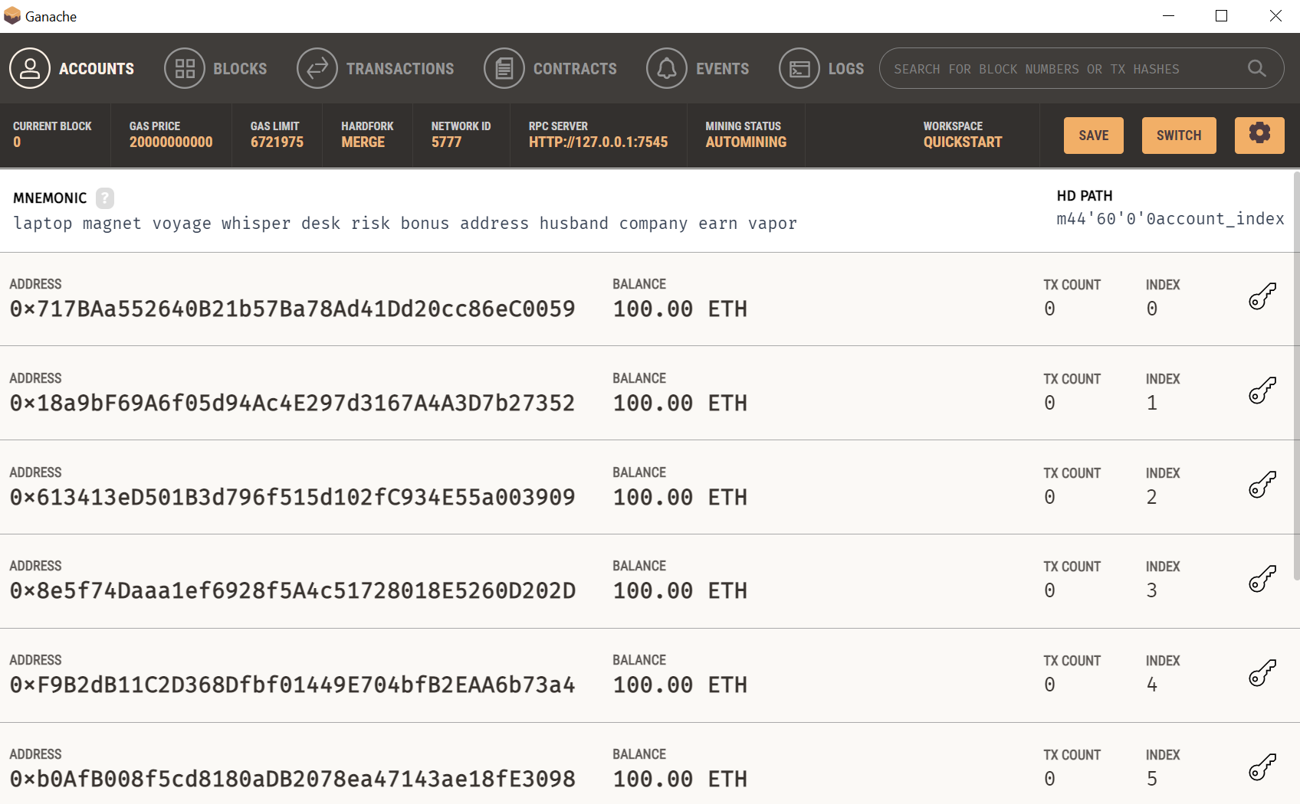

7. Smart Contract Implementation Summary
The contract InsuranceClaims.sol is written in Solidity 0.8.20. Main parts:
Function | Purpose
constructor(assessor) | Sets the insurer (deployer) and the assessor
fundPool() | Insurer adds ether to the payout pool
buyPolicy(coverage, days) | Policyholder pays the exact premium and a policy is created
submitClaim(id, amount, hash) | Policyholder files a claim with the evidence hash
approveClaim / rejectClaim | Assessor or insurer decides the claim
payClaim(claimId) | Insurer pays the approved amount to the policyholder
verifyEvidence(claimId, hash) | Anyone can check a file against the stored hash
Safety measures in the code:
- Role checks with modifiers (onlyInsurer, onlyAssessorOrInsurer).
- Status checks so a claim can only move in the correct order and cannot be paid twice.
- State is updated before the payment is sent, which prevents reentrancy attacks.
- The contract rejects stray ether sent directly to it.

8. Testing Procedure
The contract was tested in two ways. Add your screenshots under each step.
- Remix: Remix IDE (Remix VM): deploy, fund pool, buy policy, submit claim, approve, pay, and a failed unauthorized approval.
- Ganache and Python: Python script test_insurance.py with web3.py on a local Ganache chain, run through run.sh.
Expected results from the test run: the claim status moves Submitted (1), Approved (2), Paid (4); the policyholder receives the claim amount; the evidence check returns true; an unauthorized approval is rejected; a second payment of the same claim is rejected.
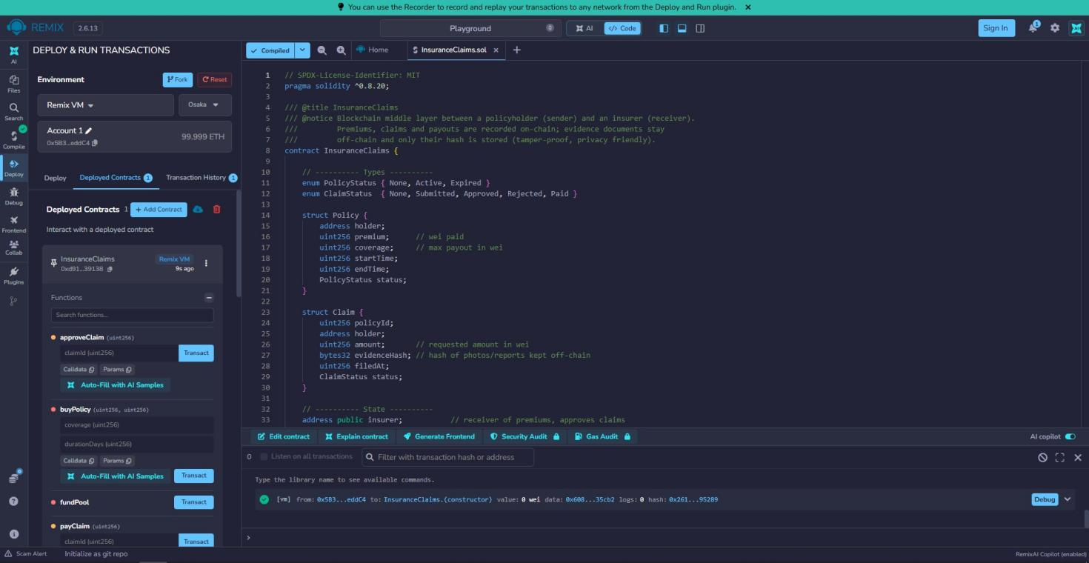

9. Conclusion
A smart contract can make insurance claims faster, clearer and harder to cheat by acting as a shared, trusted middle layer. Hashing keeps evidence tamper-proof without exposing private data, and signatures prove who did what. The main challenges are privacy law, regulation and user experience, which can be reduced with Layer 2 networks, stored hashes only, and proper audits.

References
- Ethereum Fusaka upgrade goes live on mainnet (CoinMarketCap Academy)
- Ethereum launches Fusaka upgrade to make network more scalable (The Defiant)
- Ethereum Fusaka upgrade: what you need to know (QuickNode)
- Tokenized insurance and parametric products on blockchain (Coinpaprika)
- Solidity documentation

