# A. Output:

## Section 1: Data Collection:

### linksscrapper.py

After running linksscrapper.py me get this output on console

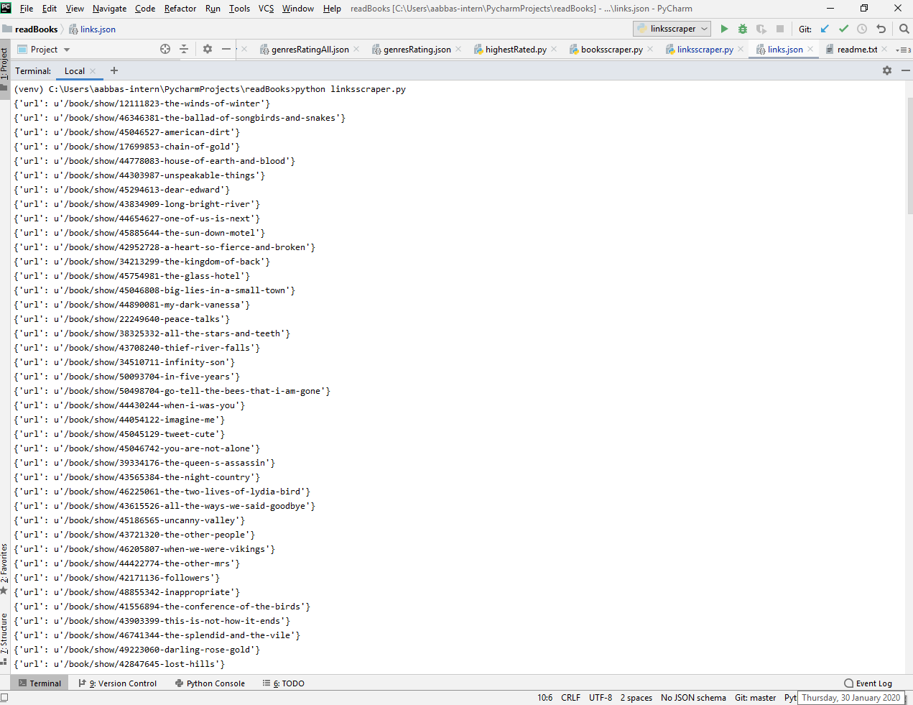

All the popular books links are stored in the json file

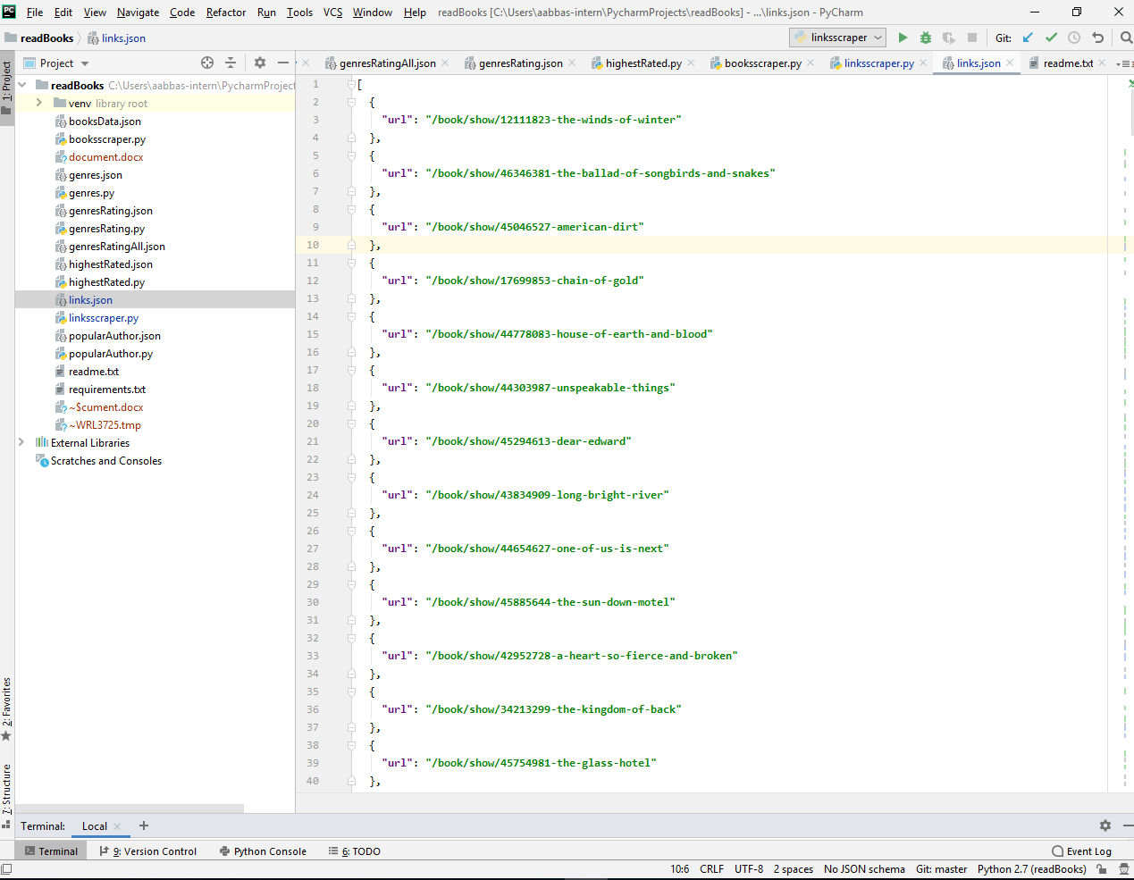

### booksscraper.py

Console output was

The data stored in booksData .json was

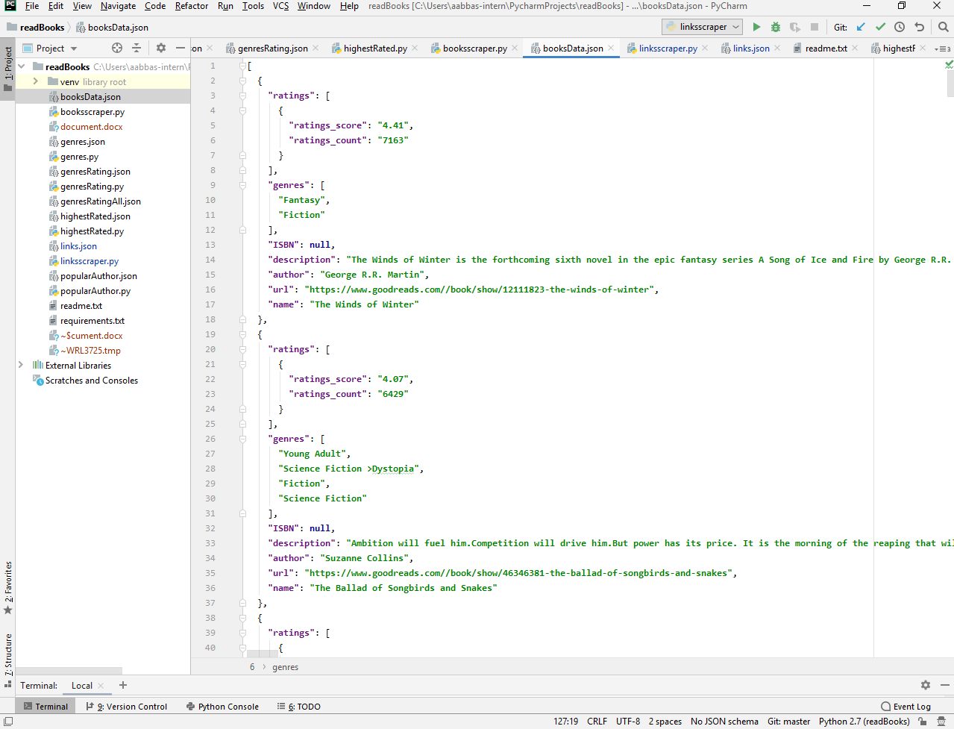

## Section 2: Data Analysis:

### highestRated.py

console output was

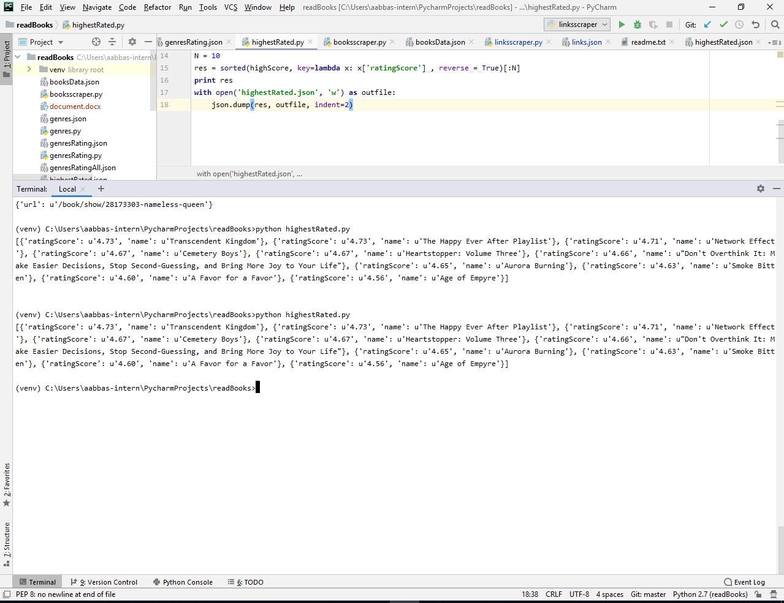

data stored in highestRated.json was

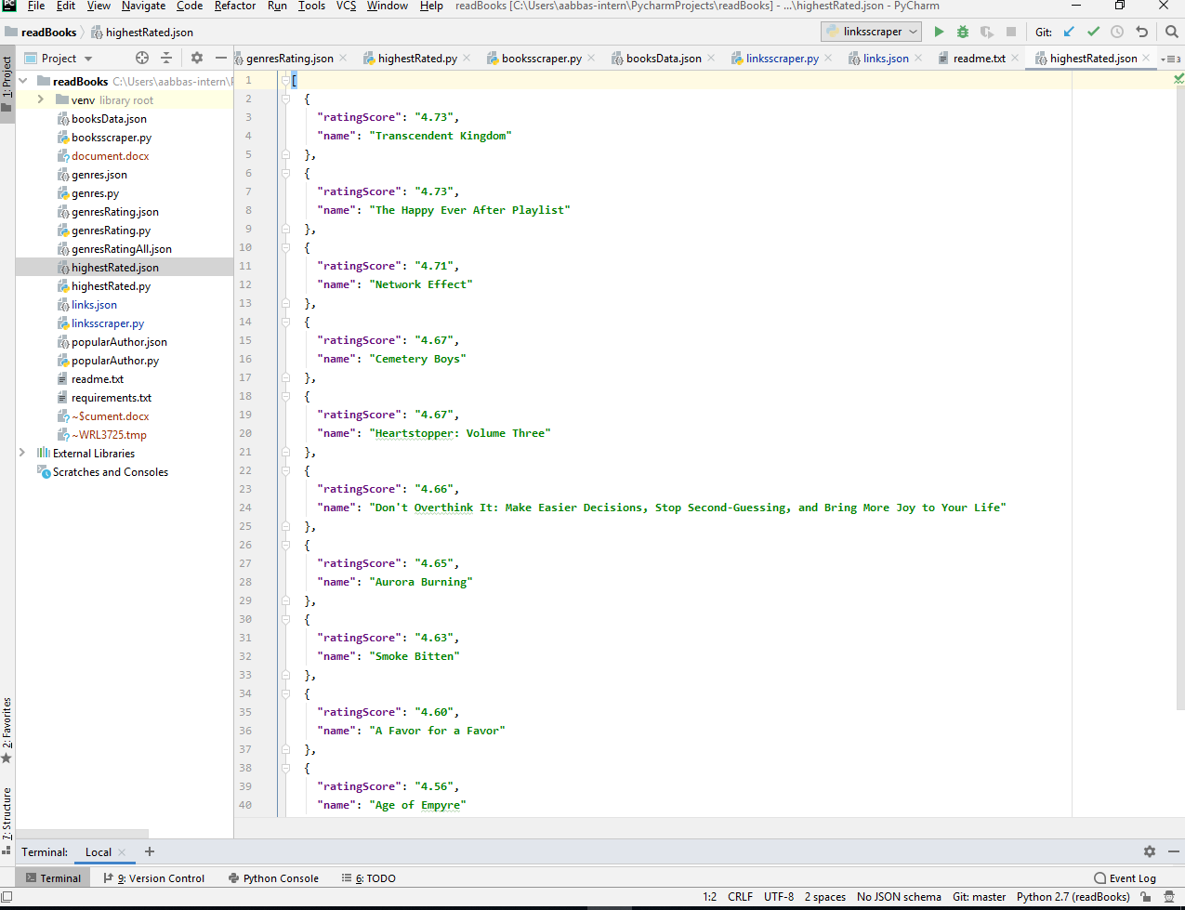

### popularAuthor.py

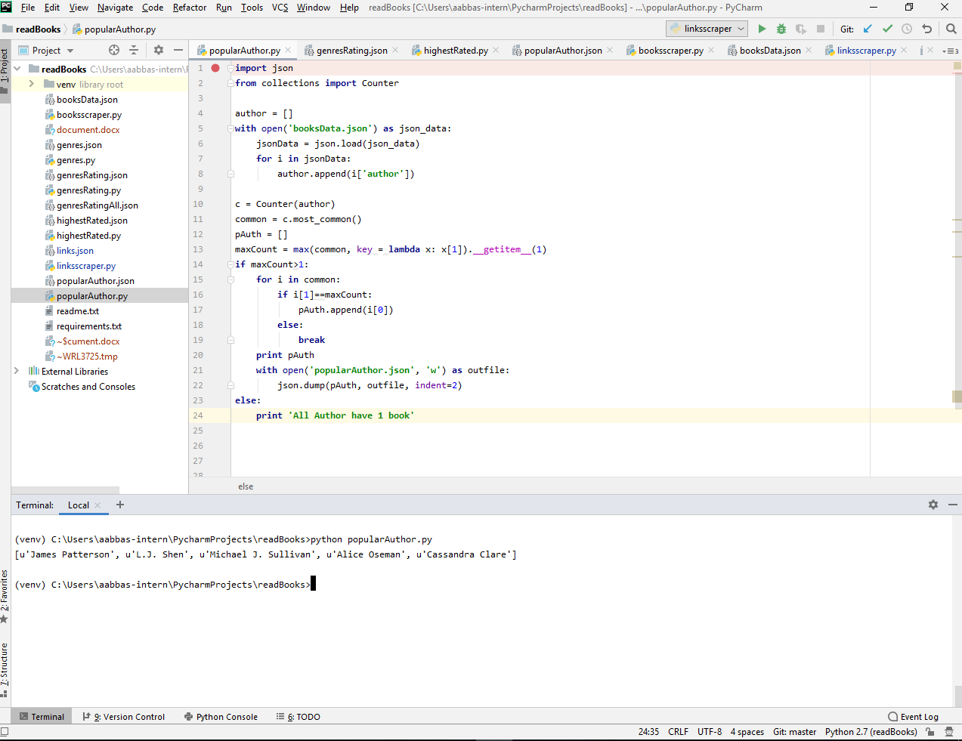

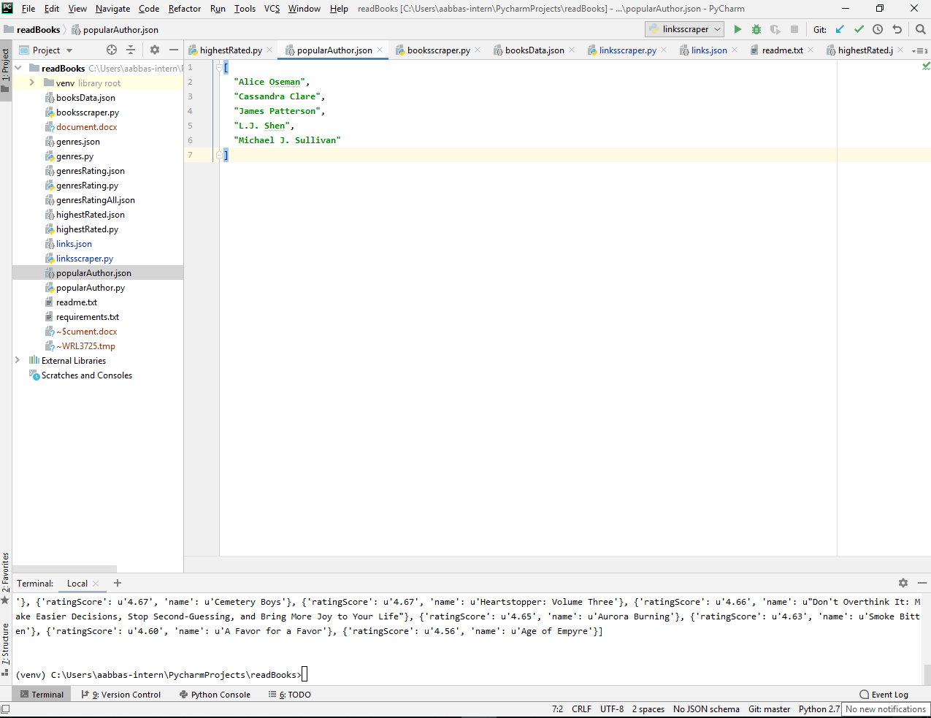

### genres.py

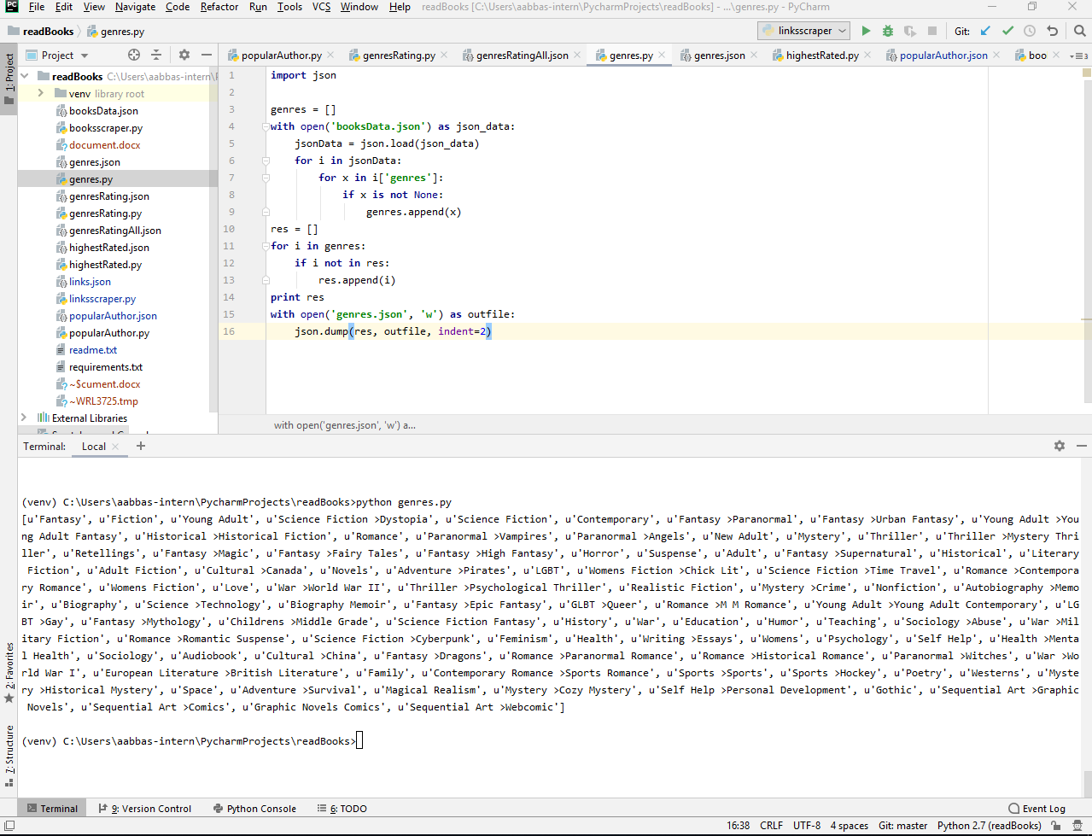

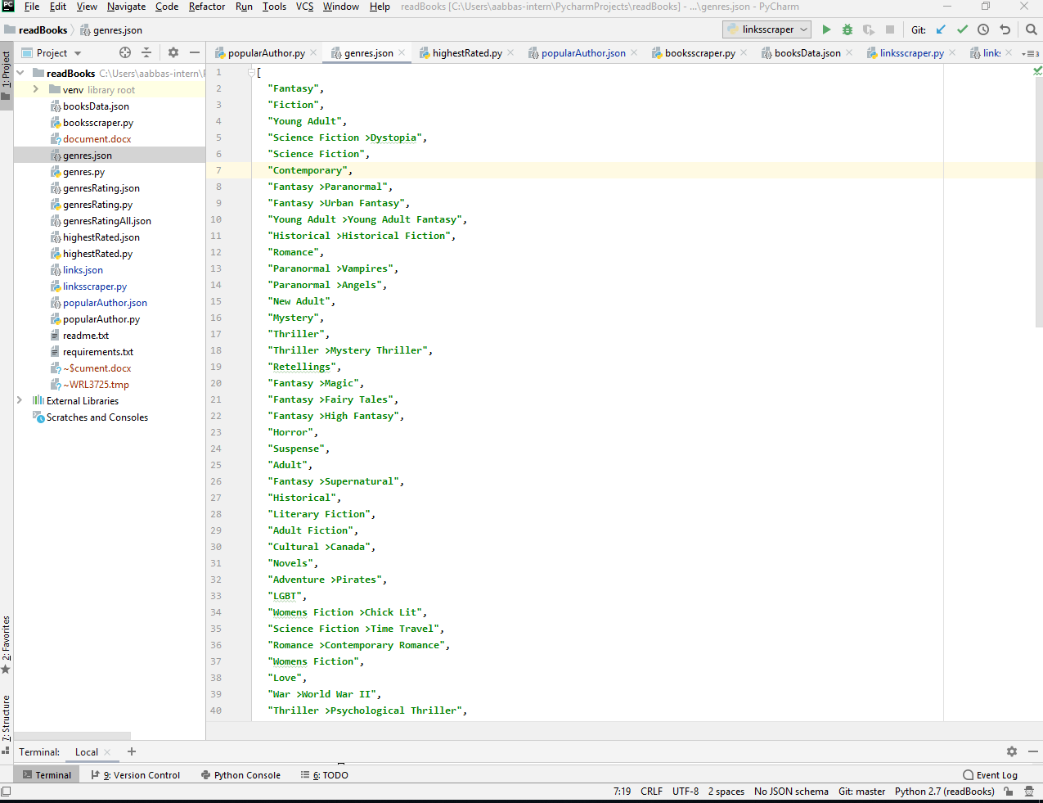

### genresRating.py

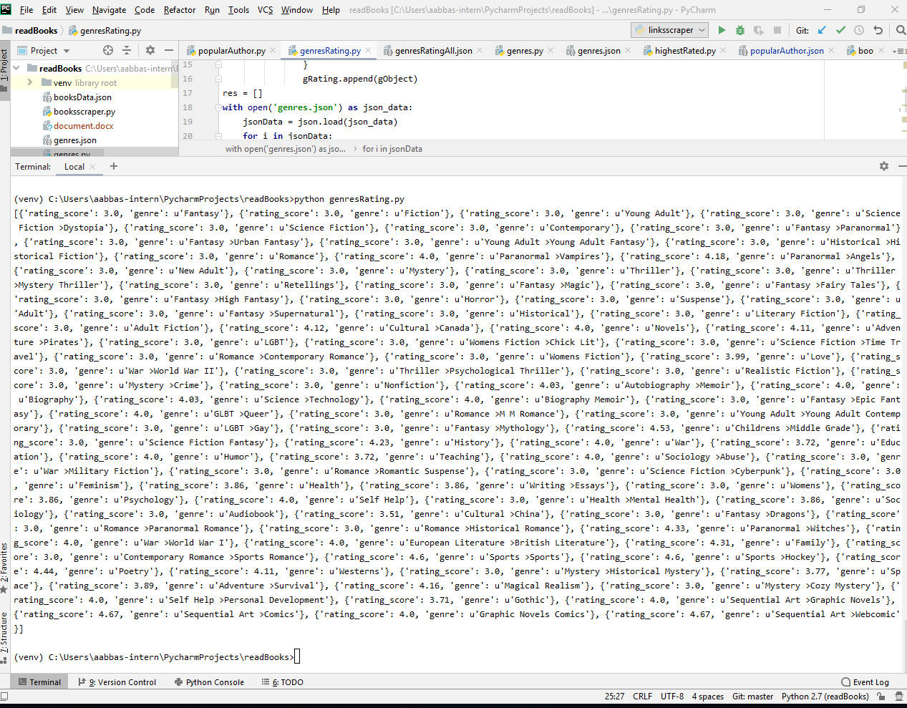

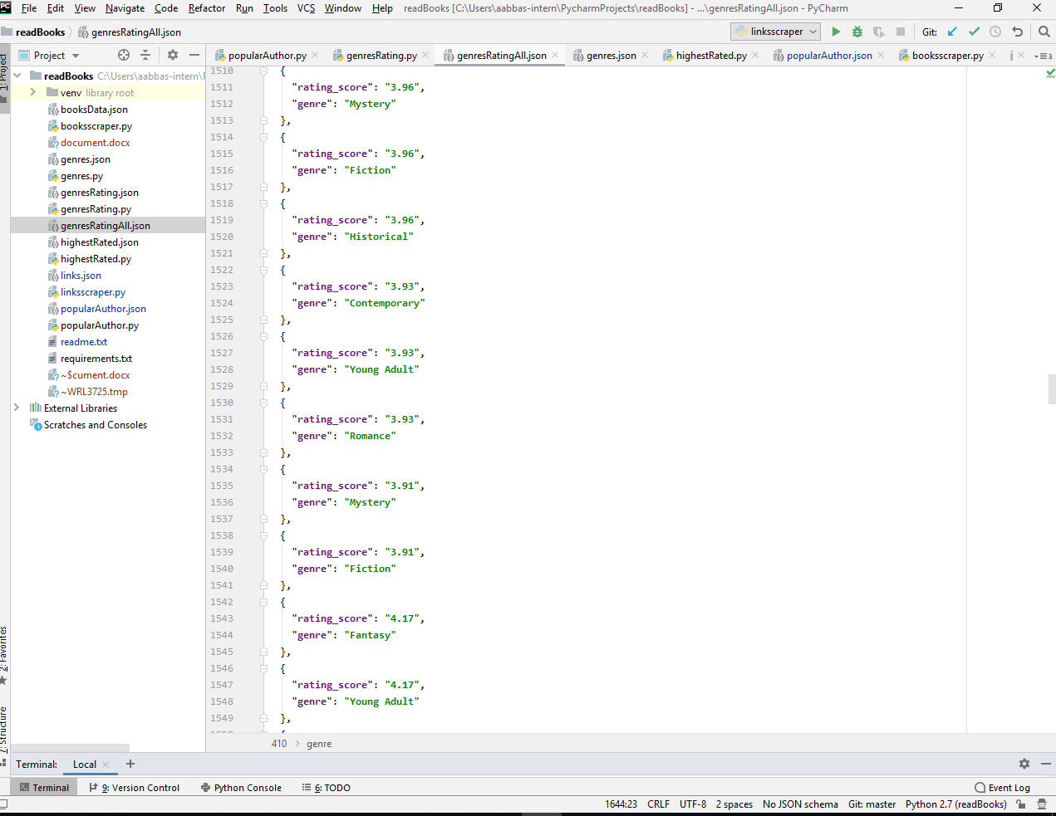

# B. Technology Stack used and Reason:

The technology stack used for this assignment is python and IDE used is pycharm. As this assignment is regarding collecting data from the internet and doing analysis on that data. The data is collected through web scraping and python is most popular language for web scraping, it has advanced web scraping libraries like Beautiful Soup which I have used in my project also.

# C. Hours took to Complete:

It was my first experience with python and I learned a lot

R&D: 12 hrs

Environment Setup: 2hrs

Section 1: 5hrs

Section 2

Part 1: 2hrs

Part 2: 2hrs

Part 3: 2hrs

Part 4: 2hrs

# D. Improvements if I had a time:

If I had more time I would had make a web based Graphical User Interface, instead of running python code on terminal or console. Using a user interface it would have been more convenient for normal user to interact and get the desired results just by clicking and tapping few buttons and options.