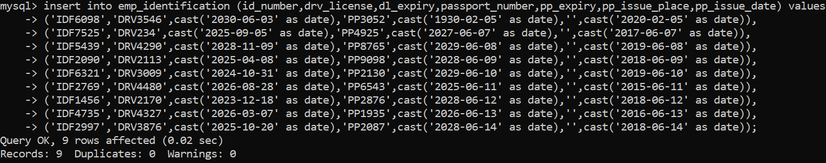

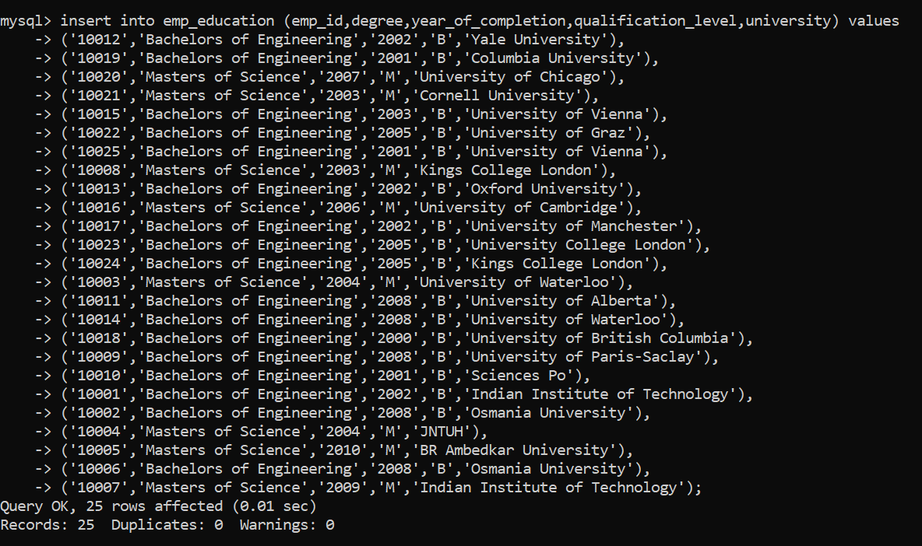

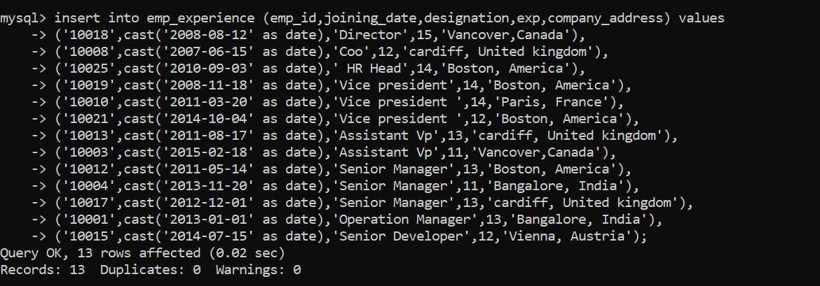

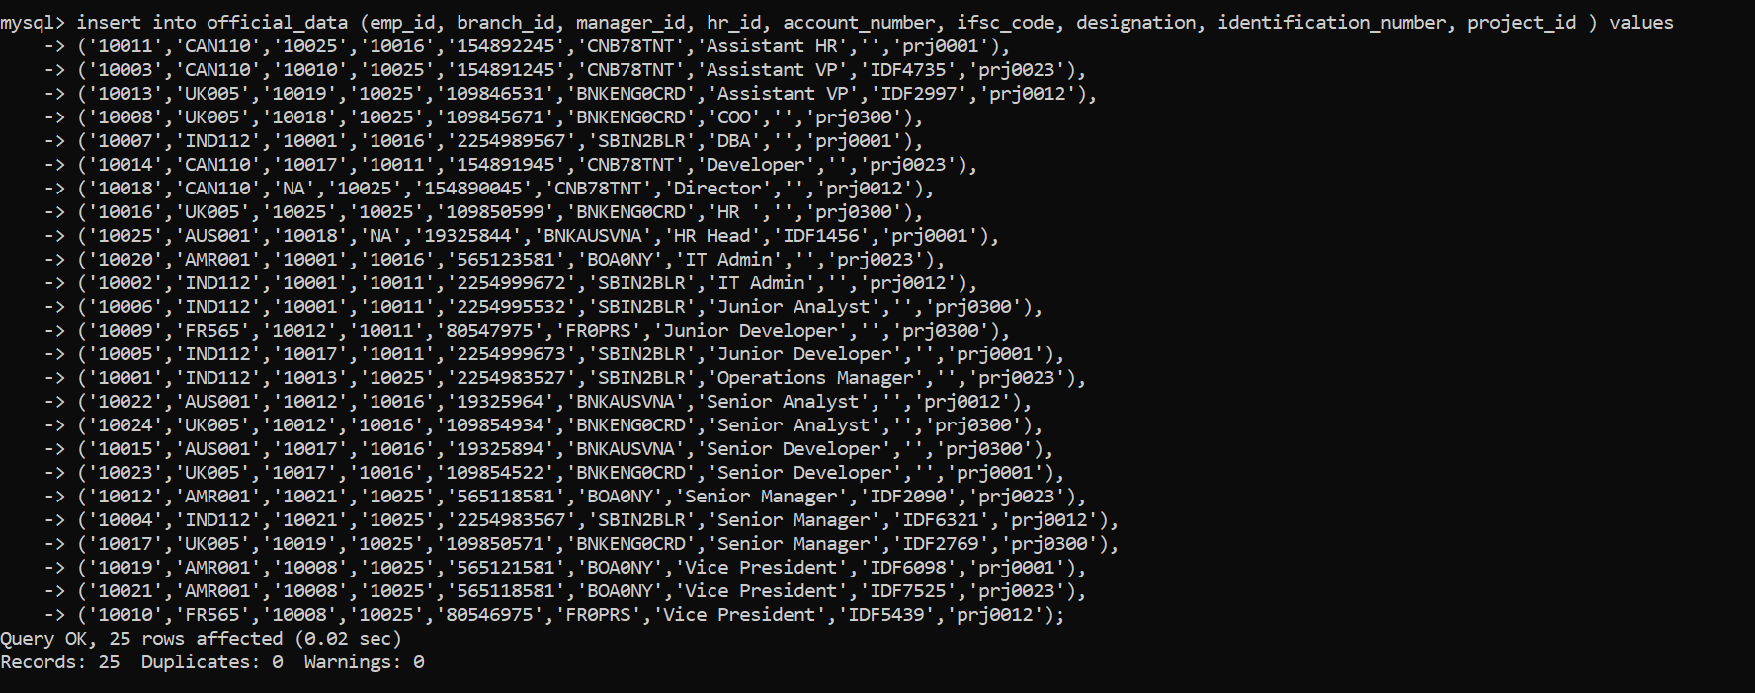

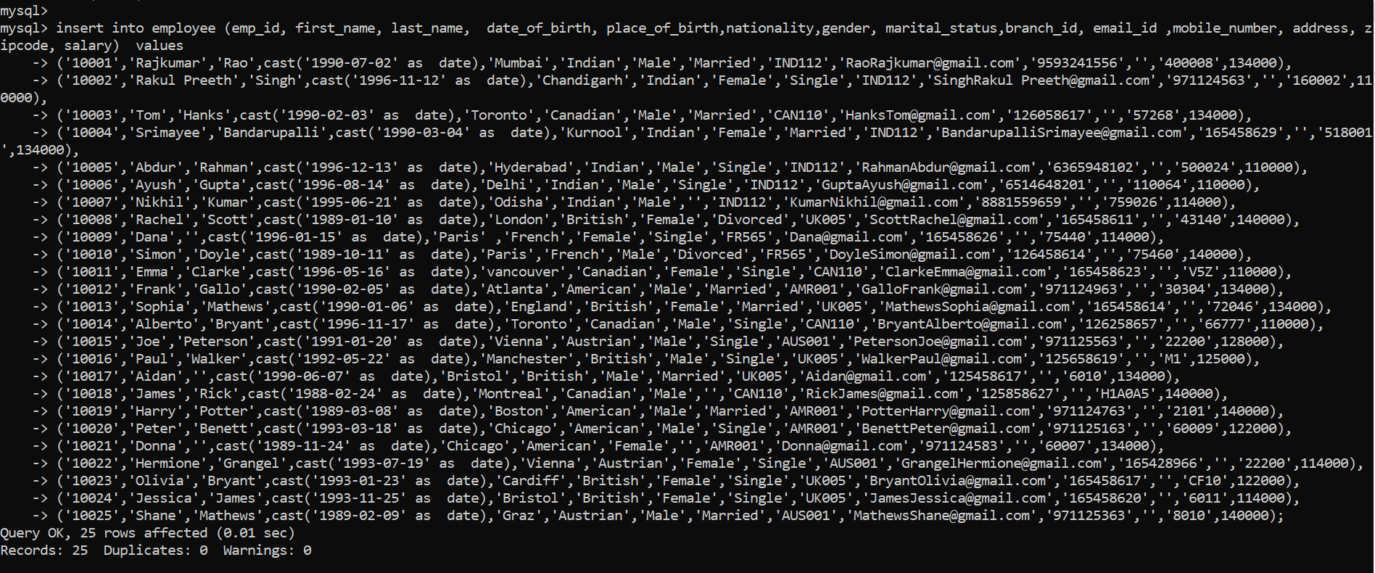

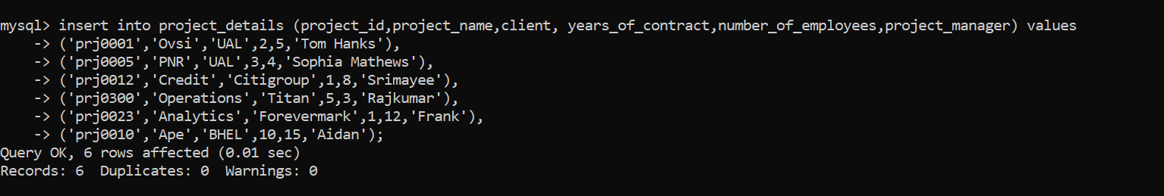

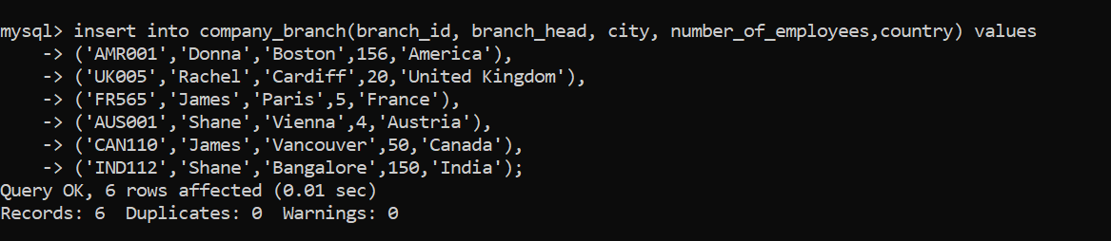

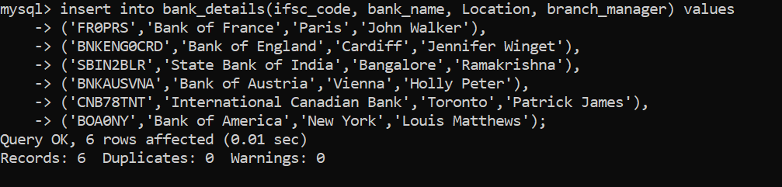

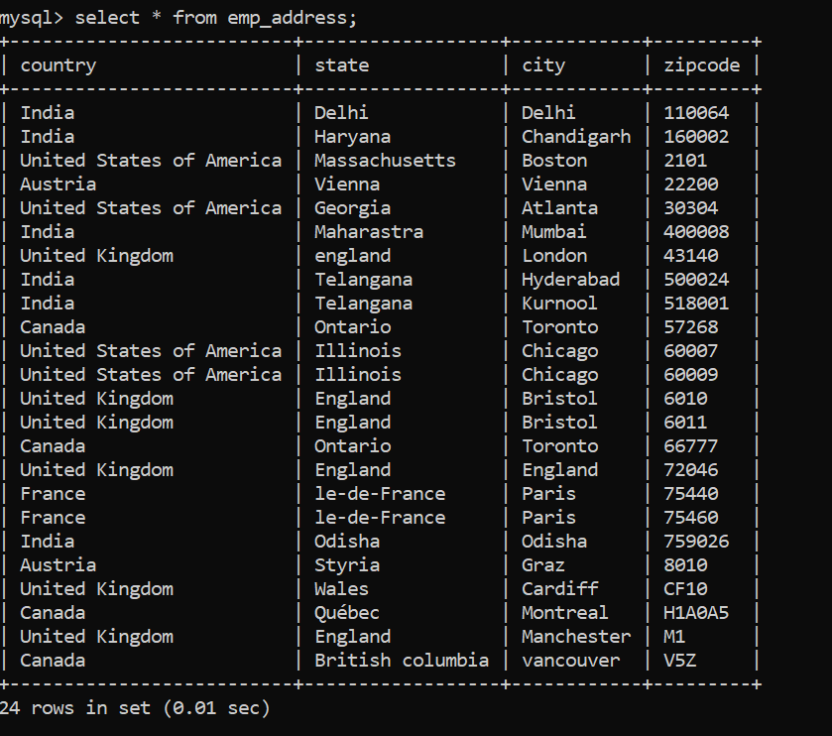

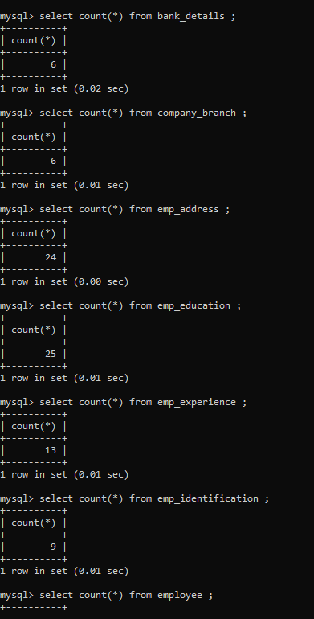

select count(*) from bank_details ;

select count(*) from company_branch ;

select count(*) from emp_address ;

select count(*) from emp_education ;

select count(*) from emp_experience ;

select count(*) from emp_identification ;

select count(*) from employee ;

select count(*) from official_data ;

select count(*) from project_details;