Dr Sarah Yeo
MBBS, FRACP
Respiratory & Sleep Specialist
4 Wantirna Road, Ringwood, 3134
1300 780 377
admin@respiratoryservice.com.au

{referringDoctorName}
{referringDoctorClinic}
{referringDoctorAddress}

{date}

RE: {patientName}
DOB: {patientDOB}
Contact Number: {patientContact}
Address: {patientAddress}

Dear {salutation},

PMHx
- {#pmhx}{item}{/pmhx}
Medications
- {#medications}{item}{/medications}
Allergies
- {#allergies}{item}{/allergies}
Social History
- {#socialHistory}{item}{/socialHistory}

{body}

Plan
- {#plan}{item}{/plan}

Thank you for your ongoing care.

Kind Regards,
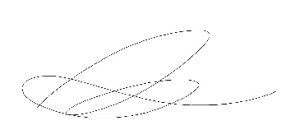
Electronically Approved by:
Dr Sarah Yeo
Respiratory & Sleep Physician

