378 Grimshaw Street, Bundoora VIC 3083
Phone: 1300 780 377
All correspondence to:
admin@respiratoryservice.com.au

{date}

{referringDoctorName}
{referringDoctorClinic}
{referringDoctorAddress}

Dear {salutation},

RE: {patientName}

DOB: {patientDOB}

{patientAddress}

Ph: {patientContact}

{body}

Kind regards,

Dictated but not sighted by
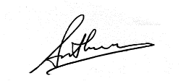

Dr Senthuran Shivakumar

MBBS BCh BAO, FRACP
Respiratory & Sleep Physician

