Login to AWS

Click services

In the compute select EC2

In the resources click Instances

Click Launch Instances in orange on upper right corner

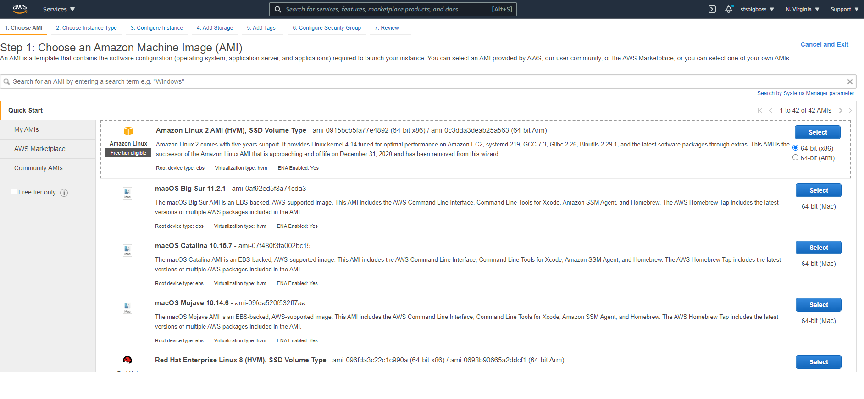

Select Amazon Linux 2 (Free tier eligible)

Select Instance type as t2 micro free tier eligible

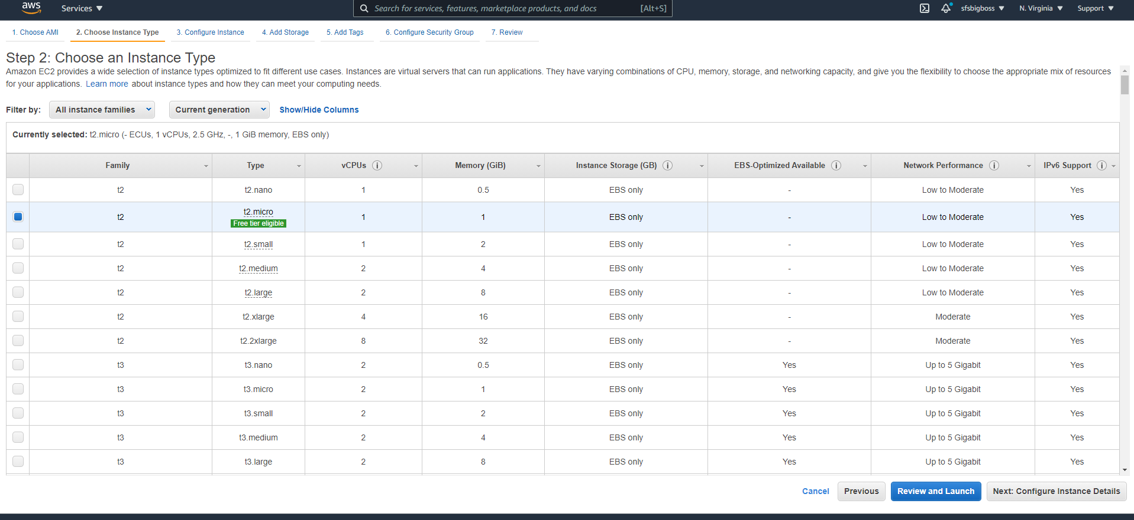

Click Next: Configure Instance Details at bottom right

Leave all default settings for Network, subnet, Auto-assign Public IP

Scroll down to bottom where it says advanced details.

In User data -As text put Script the creation of a web server, and a script to check the server is up.

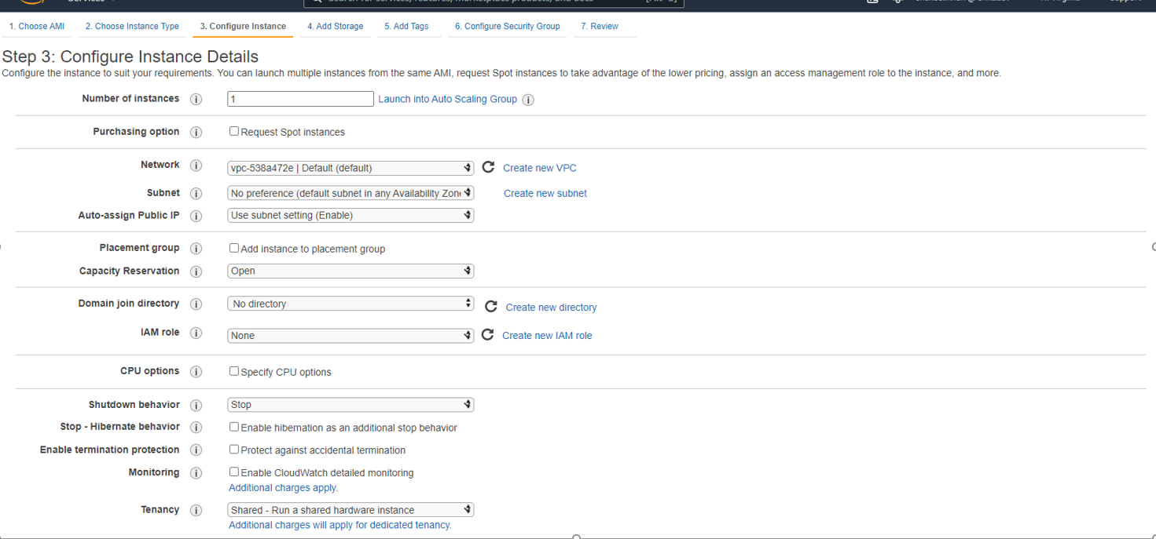

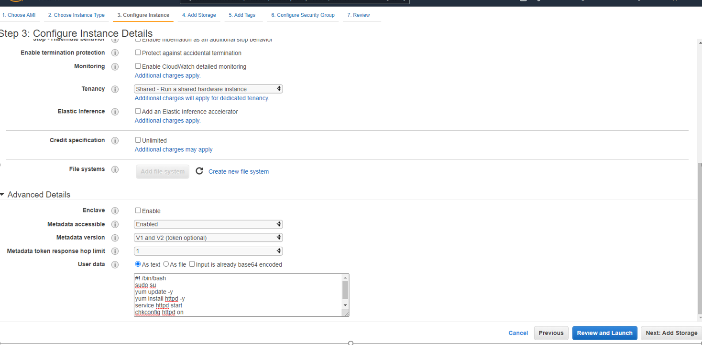

It will be like below

#! /bin/bash

sudo su

yum update -y

yum install httpd -y

service httpd start

chkconfig httpd on

Now Click Next: add storage at bottom right

Leave default

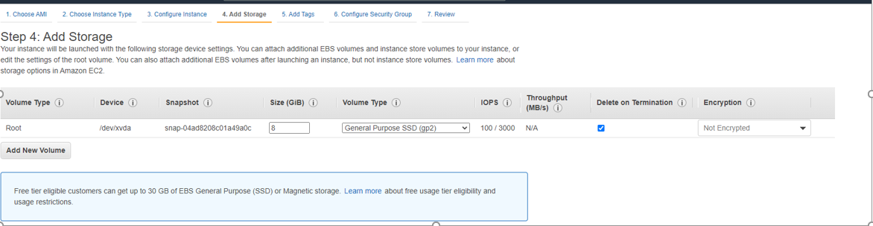

click Next: Add Tags at bottom right

Add Tag

Key-Name Value: ScriptedLinuxWebServer

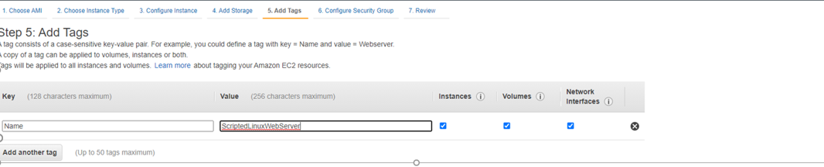

Click Next: Configure Security Group

Add Rule and open port 80

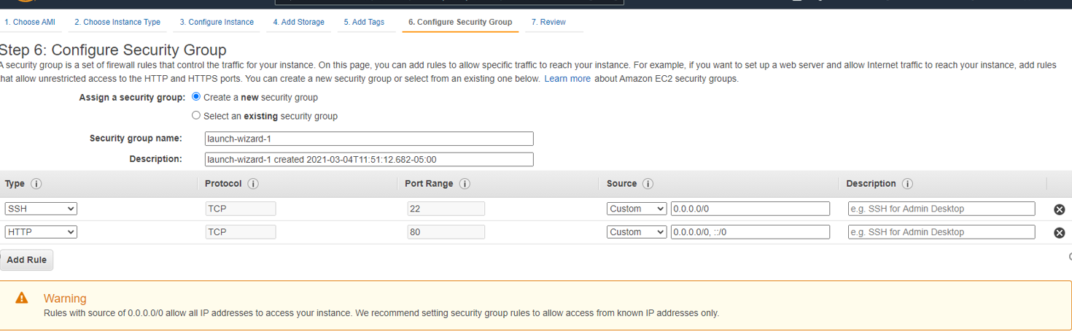

Click review and launch

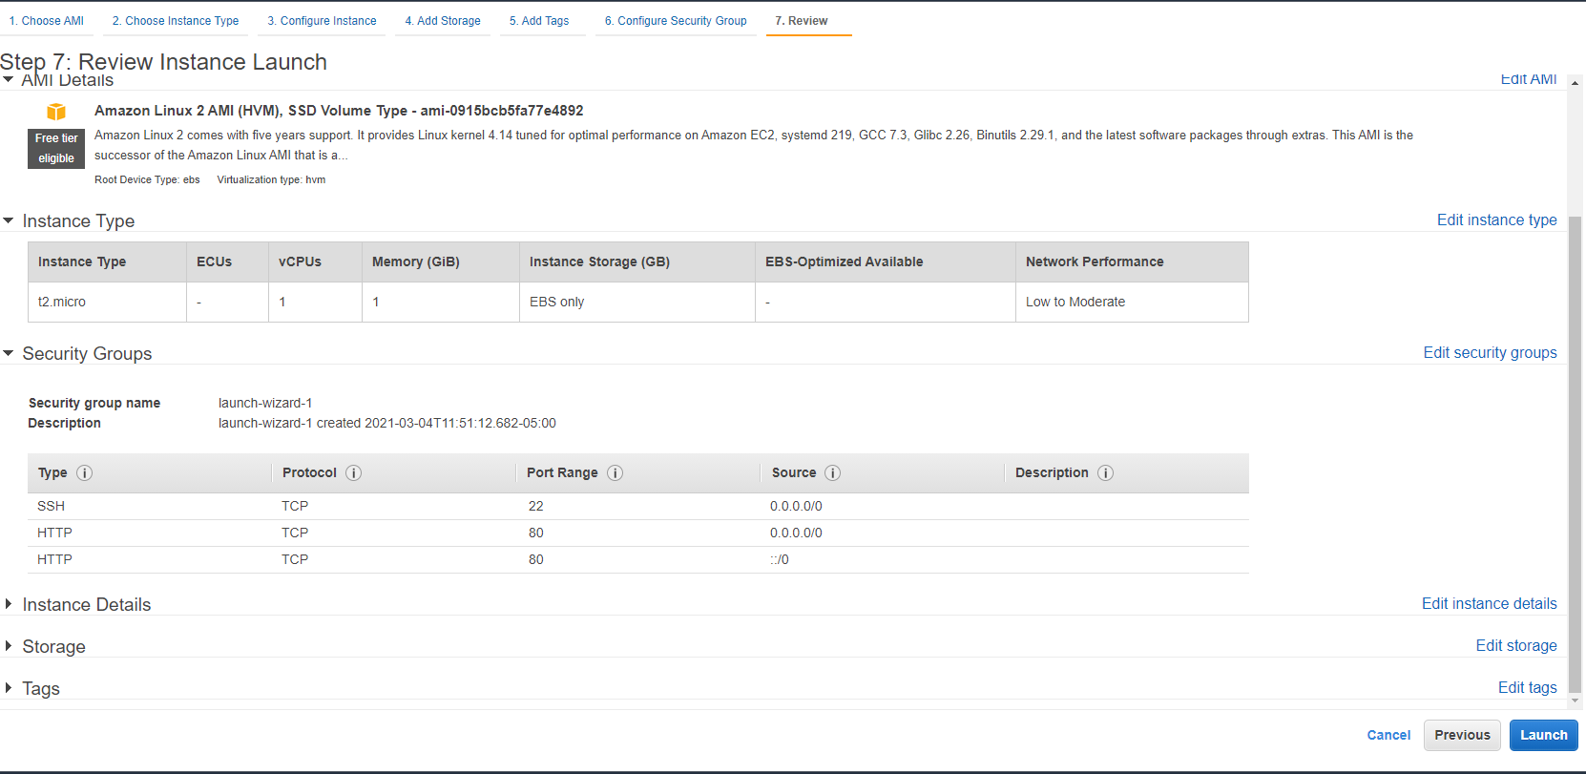

Click Launch

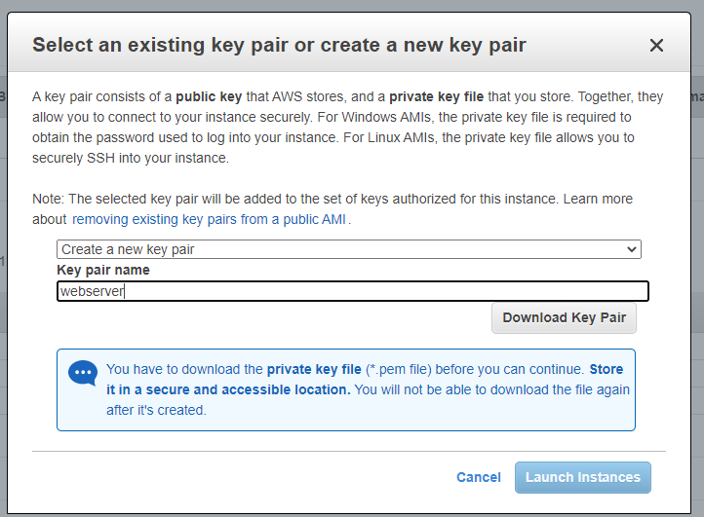

Create a new key pair. key pair name webserver- click Download

Once the instance is running click it in Instances

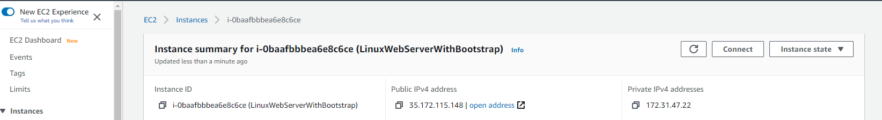

Click connect

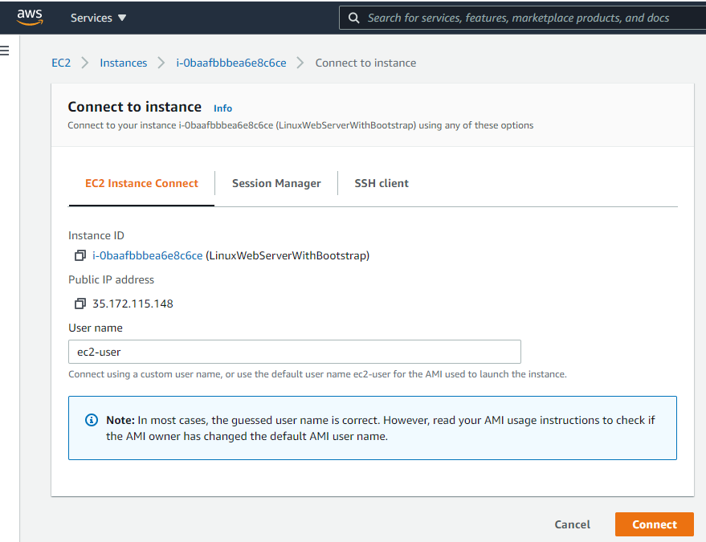

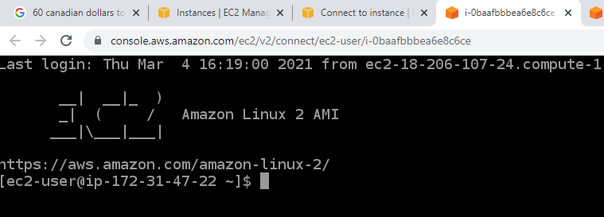

Run the command- service httpd status

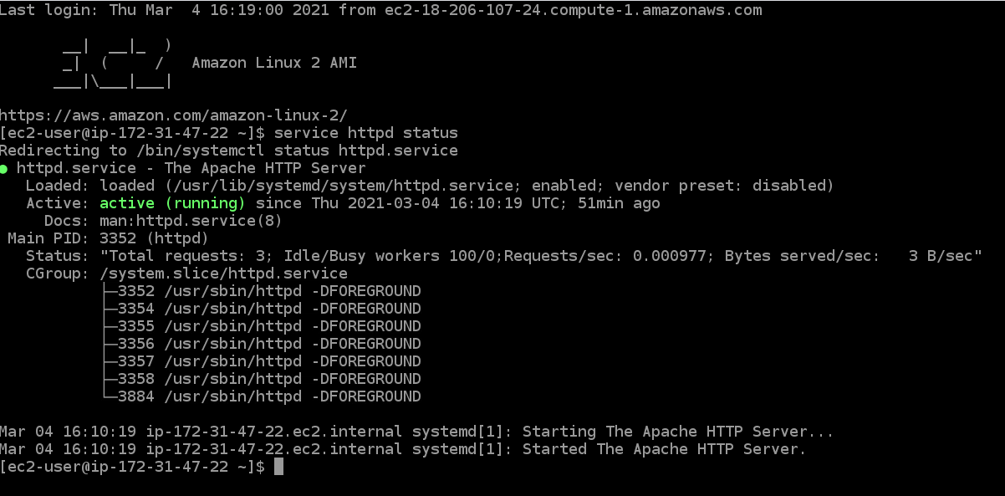

Put public address in address bar and it will open default website