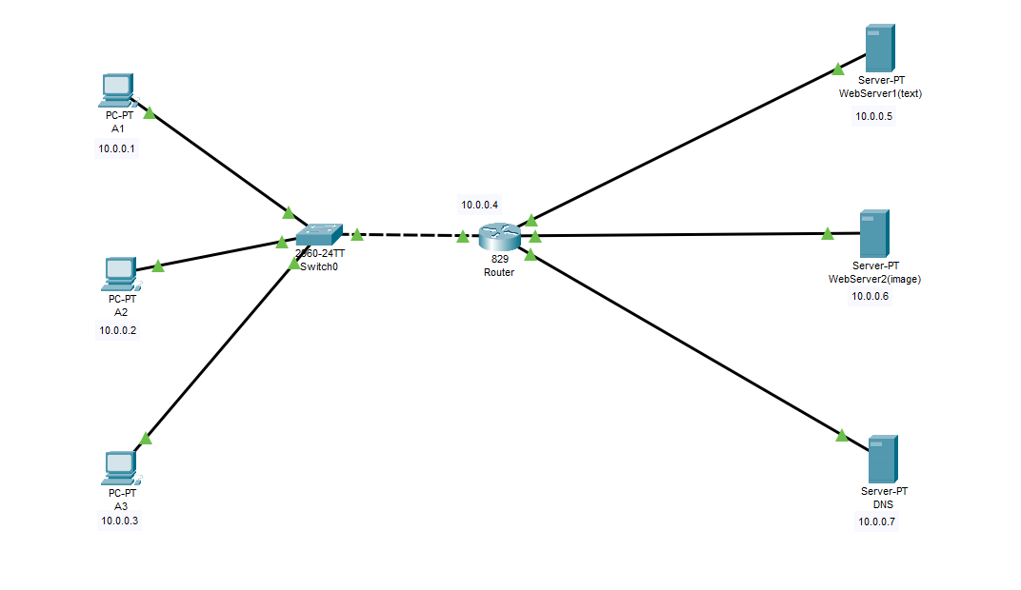**Creating Website On 1st server**

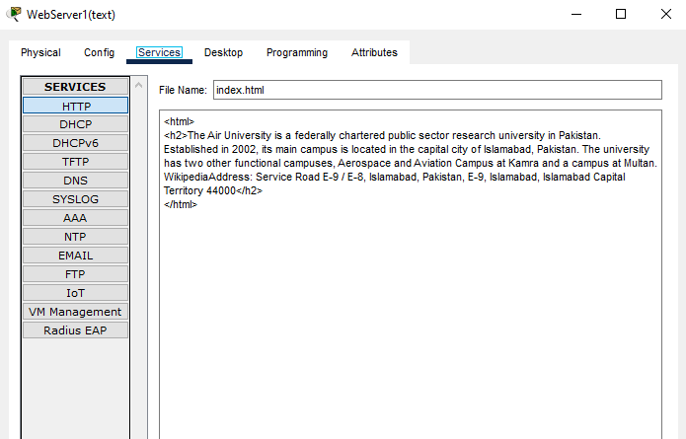

Creating Website On 2nd server

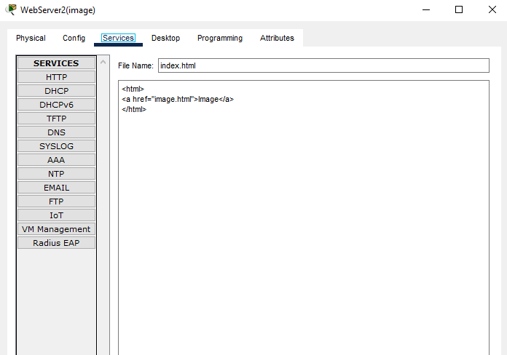

Configuration On DNS Server

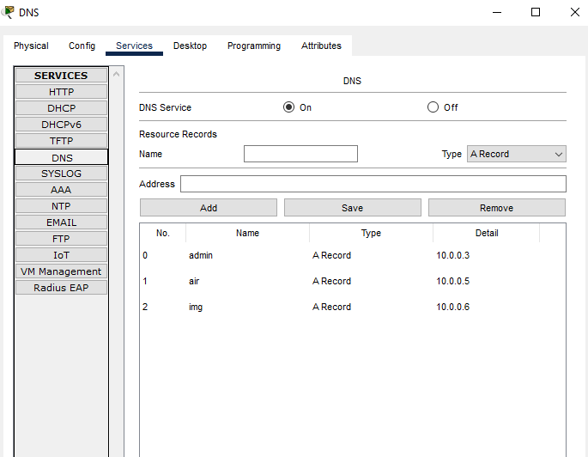

OUTPUT ON PC

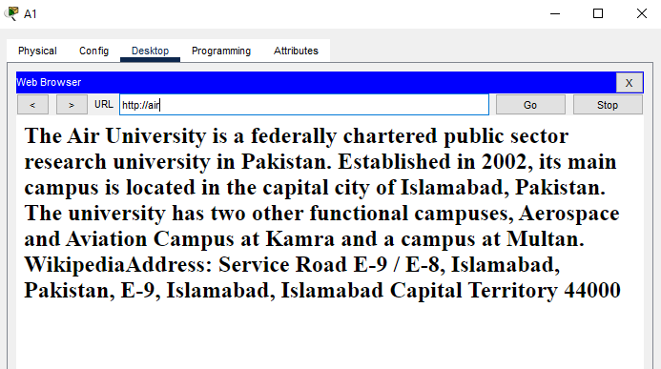

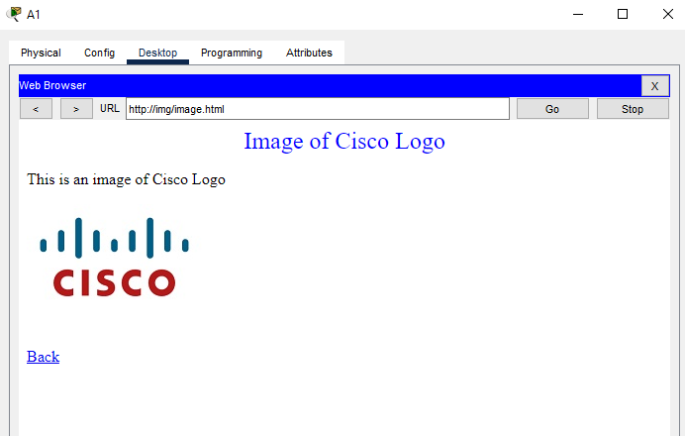

Main Points:

* At every end device in DNS server IP portion assign IP of DNS server
* At every end device in portion of local host assign ip of router