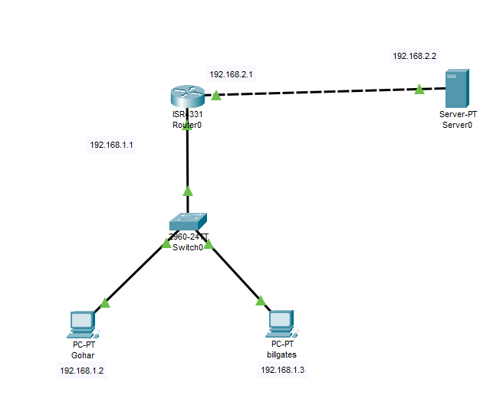

***Procedure:***

1. ***Email*** 
   1. Just like in above image configure ip of each device.
   2. Then make emails of systems in email portion of web server.
   3. After that go to each pc and make email in them.
   4. Then compose email from one pc to another.
2. ***Website*** 
   1. Then go to DNS portion in Server and assign name and IP address of server.
   2. Then give that ip in DNS address of each device
   3. Screen shots are given below

***E-Mail*** 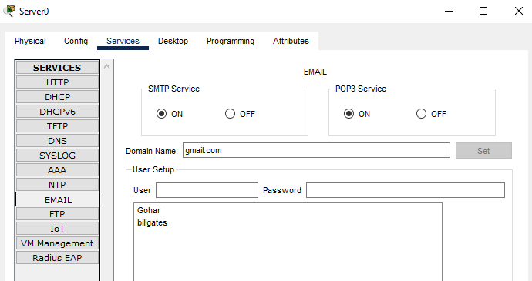

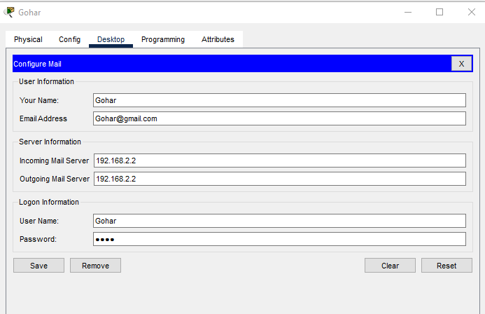

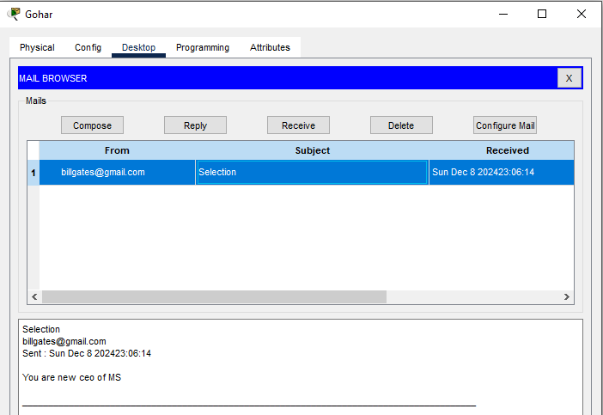

***Website***

