**SMALL CAMPUS NETWORK ON CISCO PACKET TRACER**

**TABLE OF CONTENT**

1. **INTRODUCTION**
2. **INTERFACE**
3. **ROUTING**
4. **E-Mail**
5. **DNS+WEB**
6. **IOT DEVICES CONNECTION**

***INTRODUCTION:***

This is a network design of University which consist of two campuses joined together by static routing each campus consist of IOT devices which can be used by their Sports Complex, Cafeteria and Faculties both campuses can send emails to each others also within the campus(inter-VLAN) each campus has its own DNS server for websites

***INTERFACE:***

**Overall Interface**

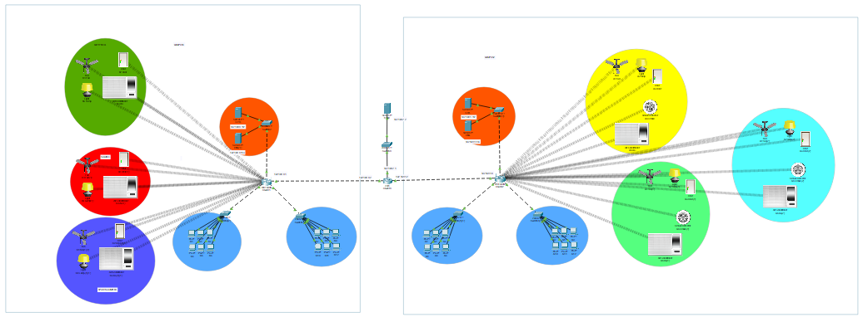

**CAMPUS 1**

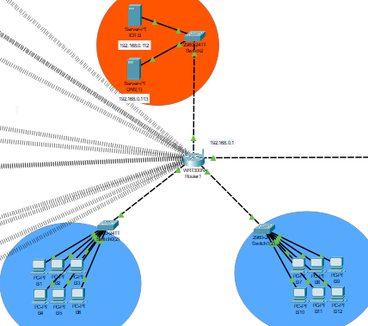

**CAMPUS 2**

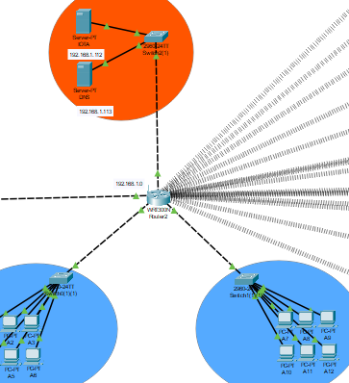

***E-MAILS:***

The SS show that User of Campus 1 can send Email to Campus 2 also

**EMAIL SERVER:**

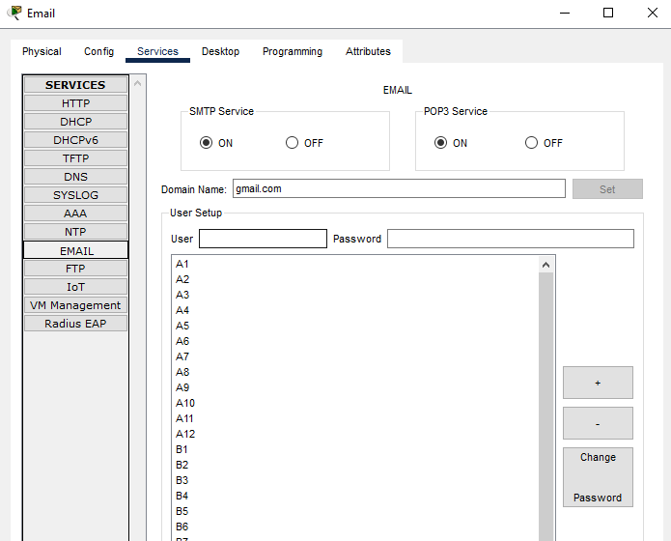

**SENDING:**

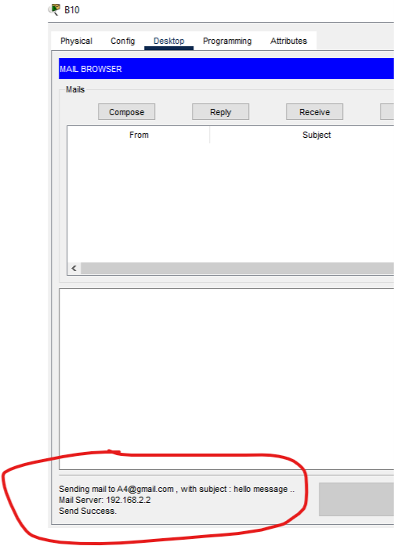

**RECEIVING:**

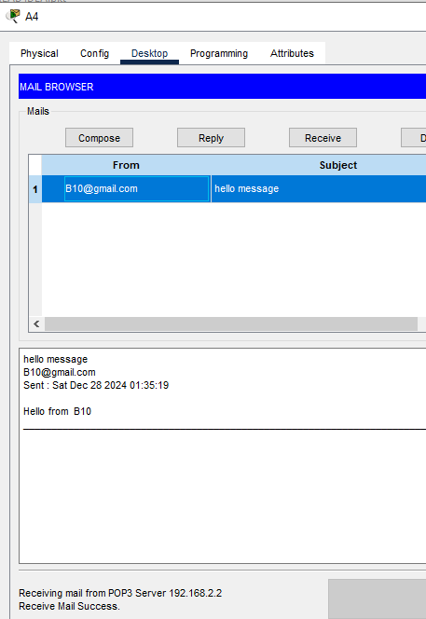

***DNS+WEB:***

These SS will you that we can open website using DNS server from any computer in Campus  
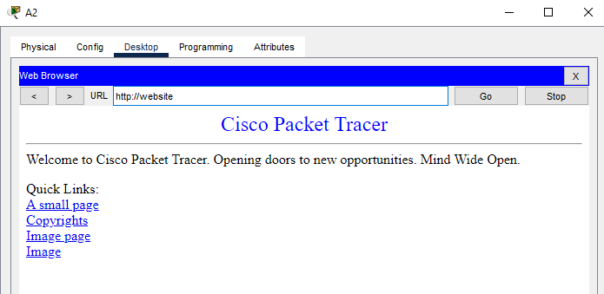

***ROUTING:***

These SS will show that PCs of Campus 1 can send packets to PCs of Campus 2

**Routers Involved:**

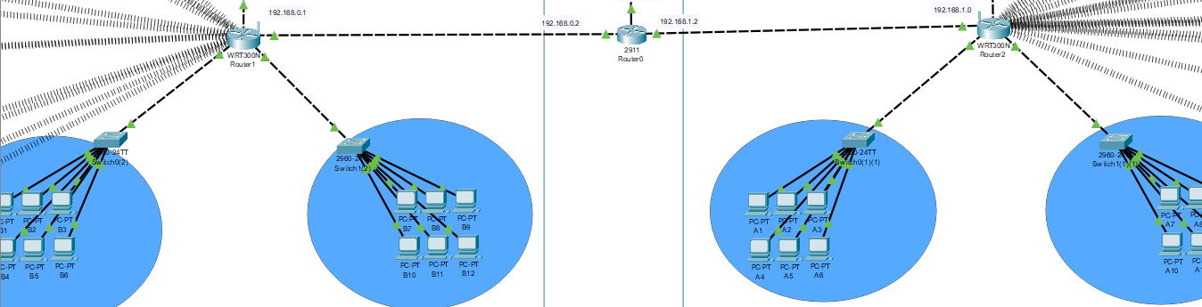

**SIMULATION RESULT SS:**

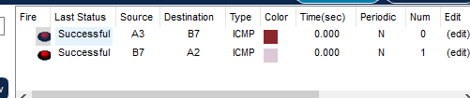

*A3->Campus1 => B7(Campus2)*

**PING RESULT SS:**

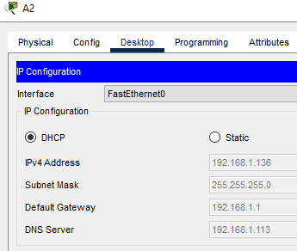

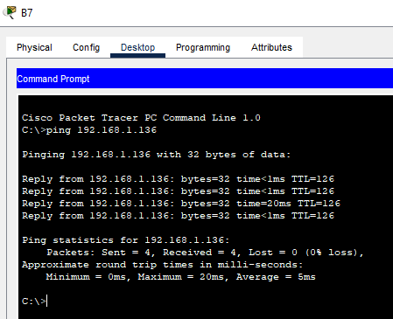

***IOT DEVICES CONNECTION:***

These SS will show result of Iot devices Configuration

**IOT Areas**

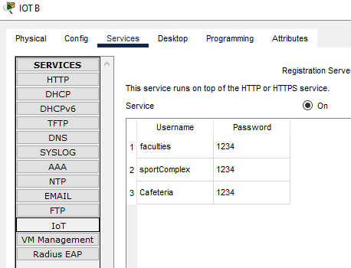

**IOT SERVER CONFIG:**

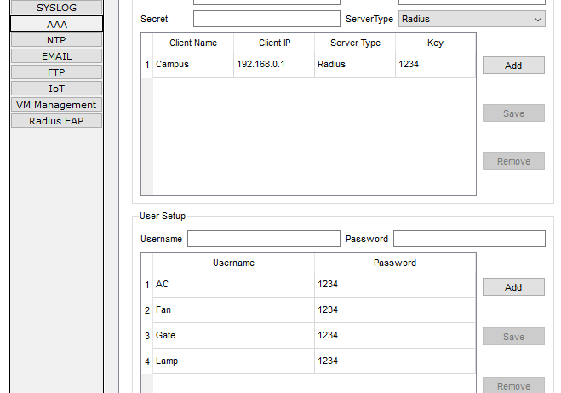

**LOGIN FROM PC:**

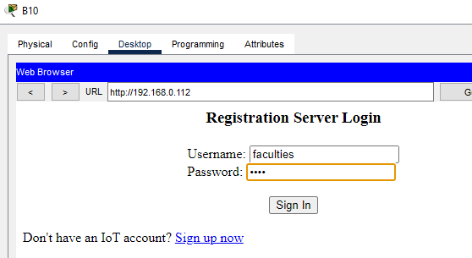

**IOT CONNECTION RESULT:**

