[ C Y B E R S E C U R I T Y · F I N A L P R O J E C T ]

POST-QUANTUM
BLOCKCHAIN FOG MICROGRID
Securing a Smart Energy Grid Against
Future Quantum Computers

FINAL PROJECT REPORT
Course: Introduction to Cyber Security
A working simulation that signs every energy transaction with
the quantum-proof ML-DSA-44 algorithm, verifies it with a fog
layer, and seals it into a tamper-evident blockchain.
Prepared by: Muhammad Usman
Date: 18 May 2026

ML-DSA-44 · NIST FIPS 204 · QUANTUM-SAFE BY DESIGN
REPORT CONTENTS
This report explains the project in plain language, then shows it actually running — first in the terminal, then in a web console — and finally explains every result and graph it produced.
01 Introduction — What This Project Is
The smart-grid idea and the quantum-computer threat.
02 How the System Works
The building blocks and the journey of one transaction.
03 Setting Up and Running the Project
Installing the requirements and the two ways to run it.
04 Demonstration 1 — Running in the Terminal
The attacker and defender nodes running as text.
05 Demonstration 2 — The Web Defense Console
Controlling the same simulation from the browser.
06 Results — What the Numbers Mean
Every results panel explained in simple terms.
07 The Performance Graphs Explained
What each of the seven charts shows and means.
08 Security Analysis and Conclusion
The verdict, why it worked, limits and final thoughts.

01 INTRODUCTION — WHAT THIS PROJECT IS

1.1 The Big Idea
Imagine a small neighbourhood that makes and shares its own electricity. Houses have solar panels on the roof, batteries in the garage, and chargers for their electric cars. When one home has spare power, it sends some to a neighbour who needs it. This kind of small, self-contained electricity network is called a microgrid.
Every time power moves between two devices, they exchange a short message that says something like "Solar Panel sent 12 kWh to the Battery." This message is called a transaction. The whole microgrid only works if everyone can trust these messages. If a hacker secretly changes one, the wrong person is billed for electricity — and in a real grid, fake messages could even make the power supply unstable.
This project is a computer simulation. It builds a tiny microgrid inside one computer and shows how to keep every transaction safe — not just from today’s hackers, but from a powerful future machine called a quantum computer.

1.2 What Is the Quantum Threat?
Today, messages on the internet are protected by digital signatures. A digital signature works like a wax seal on an old letter: it proves who sent the message, and it proves that nobody changed the message on the way. The digital signatures used everywhere today are built with mathematics called RSA and ECDSA.
Here is the problem. Scientists around the world are building quantum computers — a completely new kind of machine that can solve certain maths problems incredibly fast. Back in 1994, a scientist named Peter Shor discovered a method (now called Shor’s algorithm) that lets a quantum computer break RSA and ECDSA. When large quantum computers finally exist, today’s digital signatures could be forged, and a hacker could fake any message.
The solution is post-quantum cryptography (PQC): a new family of digital signatures built on mathematics that even a quantum computer cannot solve quickly. This project uses one of these new, official signatures, called ML-DSA-44.
KEY POINT This project proves, with a working simulation, that a smart energy grid can stay safe against future quantum computers by signing every transaction with a quantum-proof signature called ML-DSA-44.

1.3 The Project at a Glance
Item | Detail
Project type | Cyber security simulation (final semester project)
Main goal | Protect a smart-grid microgrid from message tampering, even against future quantum computers
Signature used | ML-DSA-44 — NIST standard FIPS 204 (also known as CRYSTALS-Dilithium)
Main parts | 5 smart devices, 3 fog nodes, a blockchain, an attacker, a database and analytics
Built with | Python — the ML-DSA-44 signature is written from scratch for learning
Two ways to run | A) two terminal windows B) a browser-based Defense Console

02 HOW THE SYSTEM WORKS
The project is made of a few simple parts that work together like a team. The diagram below shows all of them and the path a single transaction takes from start to finish.
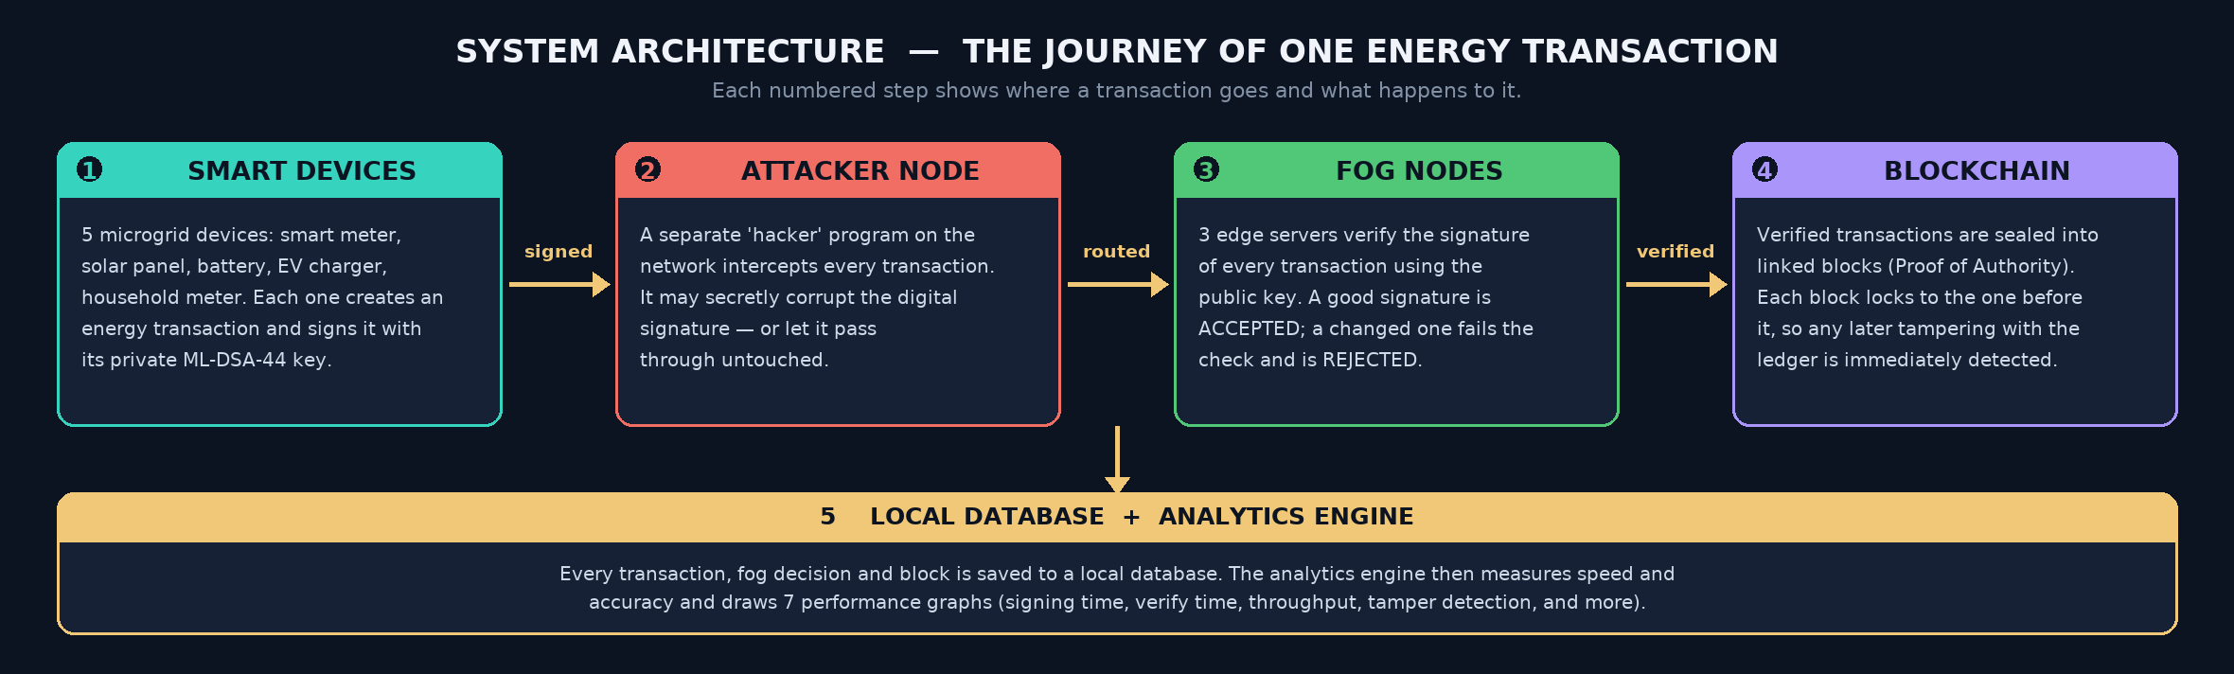
Figure 1. The system architecture. A transaction is signed by a device, routed past the attacker, verified by the fog nodes, and sealed into the blockchain.

2.1 The Main Building Blocks
- Smart devices — Five pretend smart-grid machines: a smart meter, a solar panel, a battery, an electric-vehicle (EV) charger, and a household meter. Each device creates energy transactions and signs them.
- ML-DSA-44 — The quantum-proof digital signature. It is an official world standard published by NIST (the United States standards body) as FIPS 204. In this project it is built from scratch in Python so you can see exactly how it works.
- Fog nodes — Three helper computers placed close to the devices, "at the edge" of the network. "Fog computing" simply means using nearby computers instead of a faraway cloud server. Their job here is to check the signature of every transaction and reject any message that was changed.
- Blockchain — A digital notebook. Each approved transaction is written into a block, and every block is locked to the block before it. If anyone alters an old block, the locks no longer match and the tampering is caught. This project uses Proof of Authority, which means trusted fog computers write the blocks — so there is no slow, power-hungry "mining" puzzle like Bitcoin uses.
- Attacker — A separate program that plays the role of a hacker sitting on the network. It quietly tries to corrupt transactions as they pass by.
- Database and analytics — The system saves every transaction, decision and block into a local file, then measures its own speed and accuracy and draws seven performance graphs.

2.2 The Journey of One Transaction
Following one transaction from birth to storage is the easiest way to understand the system. Here are the six steps (they match the numbers in Figure 1):
- Create and sign. A smart device builds a transaction — for example, "EV Charger sent 9 kWh to the Smart Meter" — and signs it with its own private ML-DSA-44 key. The signature is now locked to that exact message.
- Travel past the attacker. The transaction is sent across the network. The attacker intercepts it and decides whether to secretly corrupt the signature or let it pass.
- Fog verification. A fog node receives the transaction and checks the signature using the device’s public key. If the signature still matches the message, the transaction is valid. If even one bit was changed, the check fails and the transaction is rejected.
- Add to the blockchain. Every valid transaction is sealed into a block on the blockchain.
- Integrity check. The whole chain is re-checked to make sure no earlier block was secretly altered.
- Report. The system prints a summary and saves seven performance graphs.

2.3 Why Two Separate Programs?
The simulation is split into two programs that run at the same time, each in its own window:
- The Defender (defender/main.py) — runs all the "good guys": the five devices, the three fog nodes, the blockchain, the database and the analytics.
- The Attacker (attacker/main.py) — runs the "bad guy" on its own. It waits on network address 127.0.0.1, port 9999, for the defender to send traffic.
Keeping them separate makes the attack realistic: the attacker is genuinely a different program reaching the transactions over a real network connection, exactly like a real hacker would. If the attacker is switched off, the defender simply notices it is missing and safely carries on.

03 SETTING UP AND RUNNING THE PROJECT

3.1 What You Need
The project is light. It needs Python 3 (it was built with Python 3.12) and just one extra library — matplotlib — which is used to draw the graphs. Everything else uses tools that already come with Python.

3.2 Step 1 — Install the Requirements
Open a terminal in the project folder and run a single command. It reads the requirements.txt file and installs matplotlib.
pip install -r requirements.txt

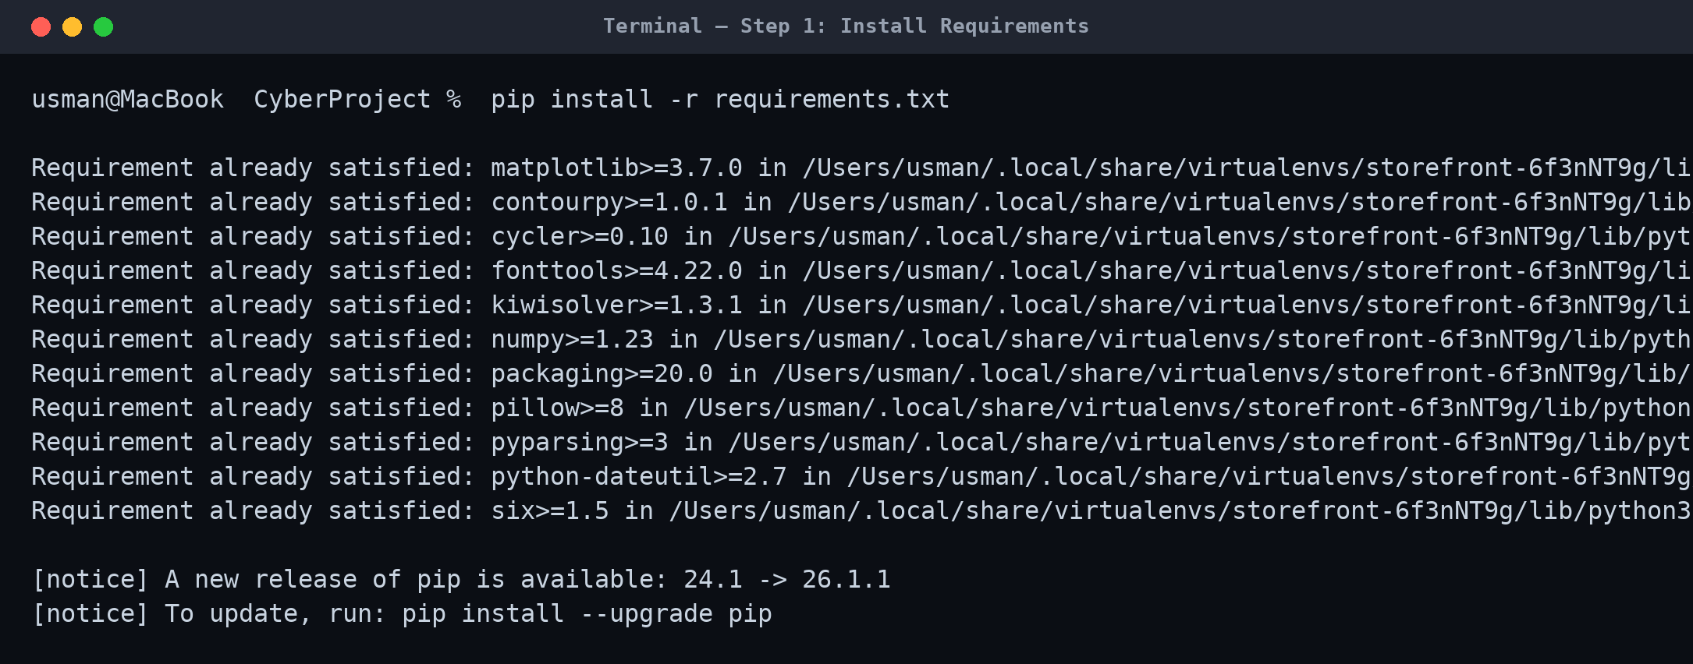
Figure 2. Installing the project’s one requirement. "Requirement already satisfied" simply means the library is in place.
If a library were missing, pip would download and install it. Here every piece was already present, so pip confirms each one is ready and the project can run.

3.3 Step 2 — Choose How to Run It
There are two ways to run the simulation. Both do the same work; they just look different.
- Way A — Two terminals. Start the attacker in one terminal window and the defender in another. You watch the raw output as text. This is shown in Section 4.
- Way B — The web Defense Console. Start one small web server and control the whole simulation from a good-looking page in your browser. This is shown in Section 5.
To run it in two terminals, use these commands. Start the attacker first so it is ready and listening before the defender begins:
# Terminal 1 — the attacker (the "bad guy")
python attacker/main.py

# Terminal 2 — the defender (all the "good guys")
python defender/main.py

To run the web console instead, start the server with one command; a browser tab then opens automatically:
python web/server.py
# then open http://localhost:8000 in your browser

04 DEMONSTRATION 1 — RUNNING IN THE TERMINAL
In this first demonstration the project runs in two terminal windows side by side. The attacker is started first so that it is already listening when the defender begins. Each program asks one or two simple setup questions and then runs automatically.
NOTE Every run creates random transactions, so the exact numbers change a little each time. The run shown here used 20 transactions with the attacker corrupting about half of the traffic it saw.

4.1 The Attacker Terminal
The attacker was started and set to listen for 30 seconds and tamper with 50% of the traffic it sees. It then binds to the network address 127.0.0.1:9999 and waits for the defender to connect.
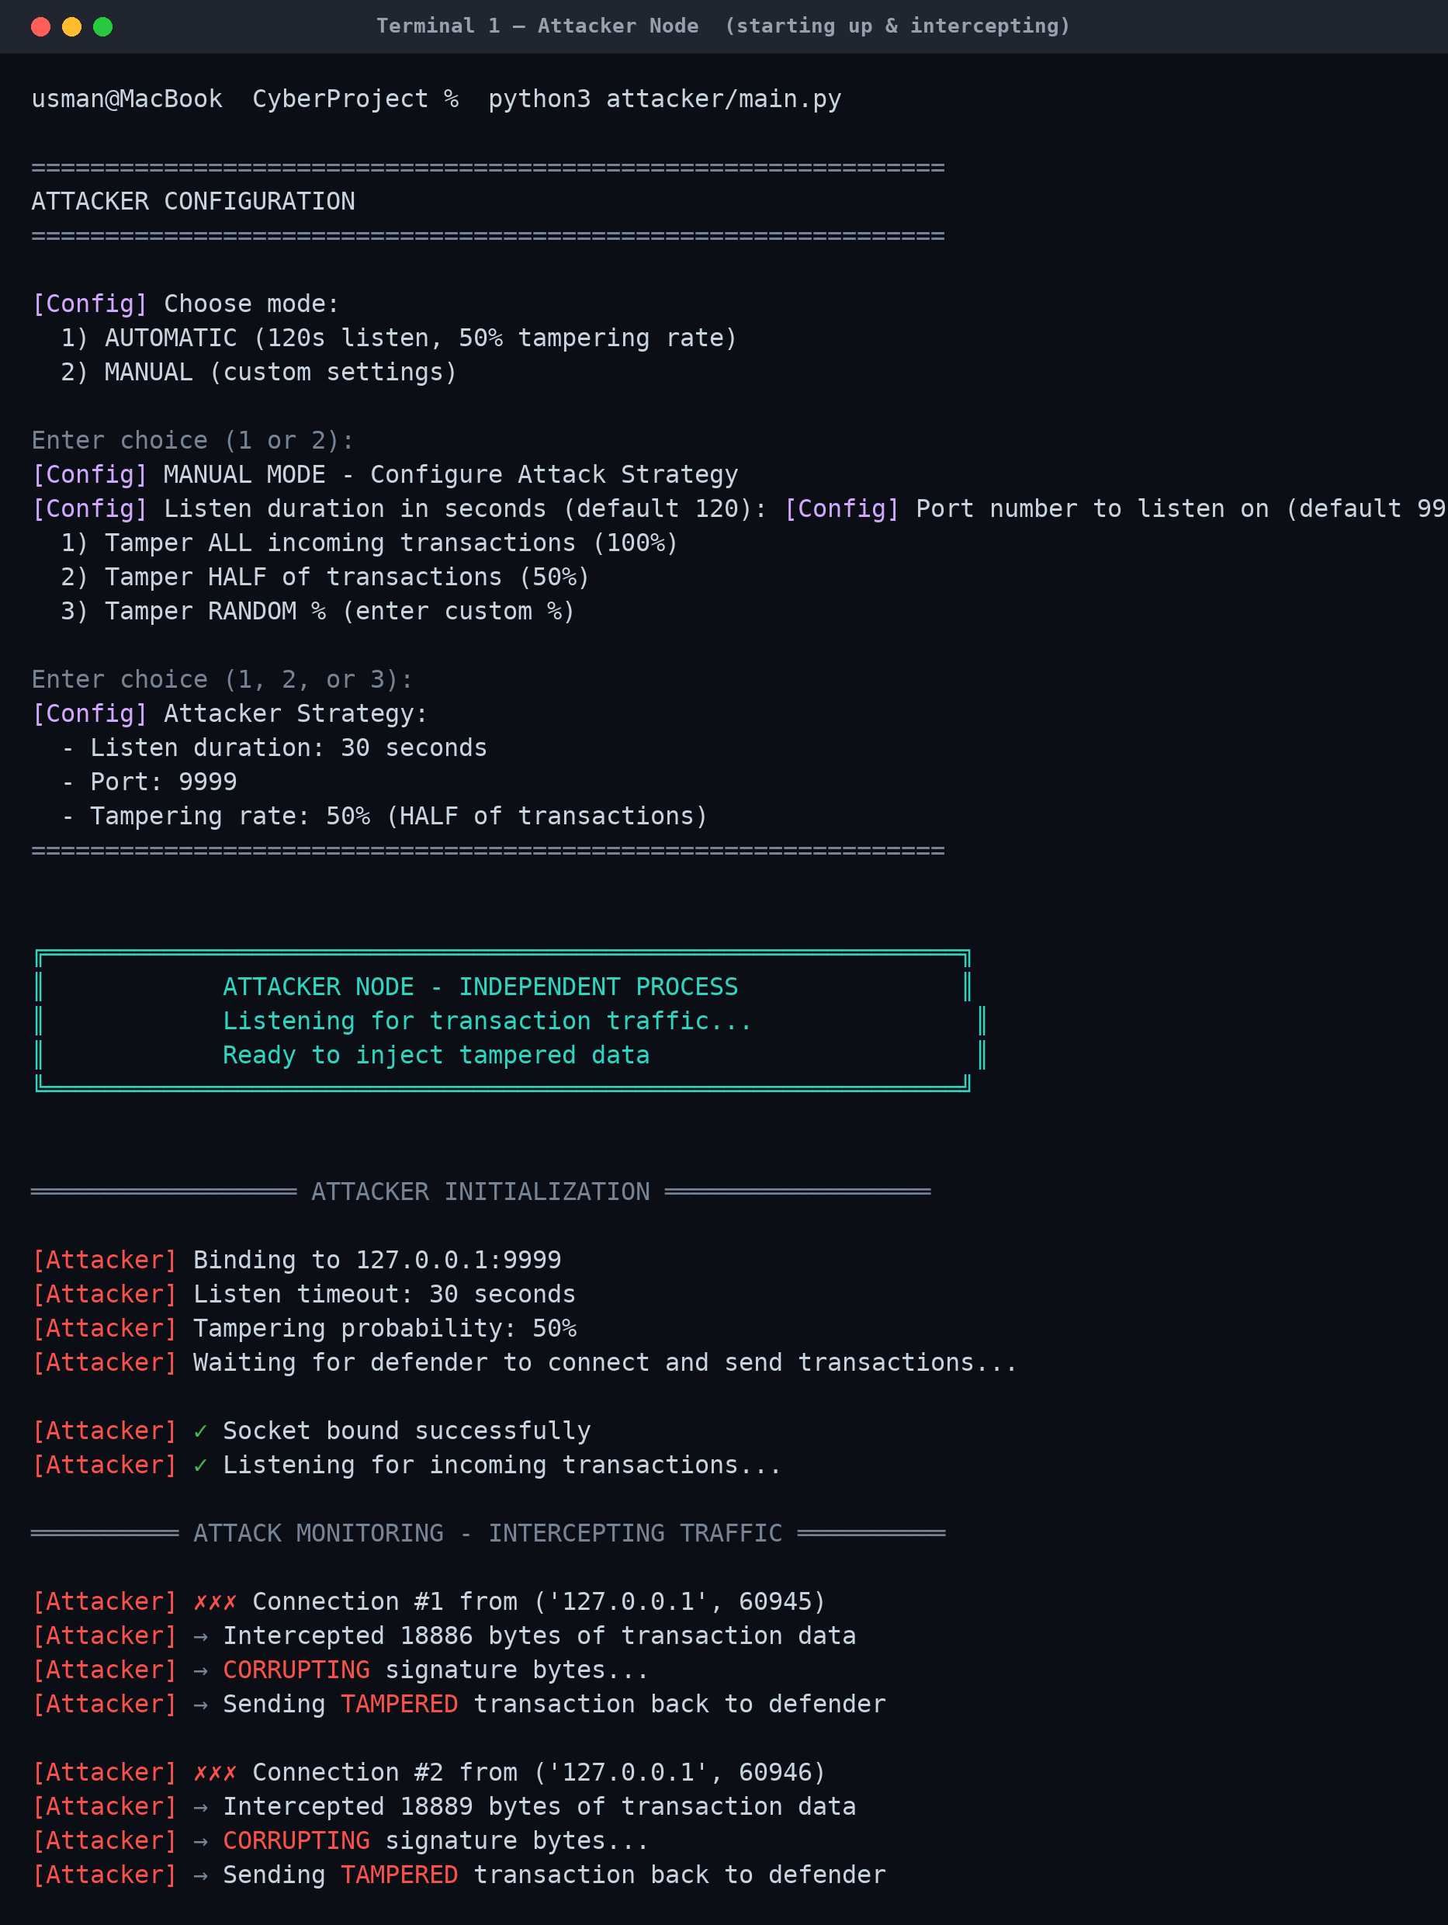
Figure 3. The attacker node starting up and intercepting traffic. For each connection it shows how many bytes it captured and what it decided to do.
Each time the defender sends a transaction, the attacker reports a new "Connection". It then makes a random choice: "CORRUPTING signature bytes" means it changed the signature to damage that message, while "Letting transaction pass" means it left that one alone.
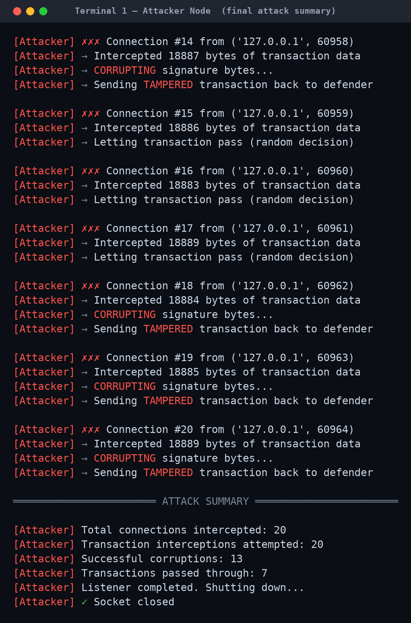
Figure 4. The attacker’s final report. Out of 20 transactions it intercepted, it corrupted 13 and let 7 pass untouched.The summary confirms the attack: 20 connections intercepted, 13 signatures corrupted, 7 passed through. Every corrupted transaction is now a damaged message travelling back to the defender — and the fog nodes will have to catch them all.

4.2 The Defender Terminal
The defender runs the whole defence in nine clear phases. The screenshots below follow it from start to finish.
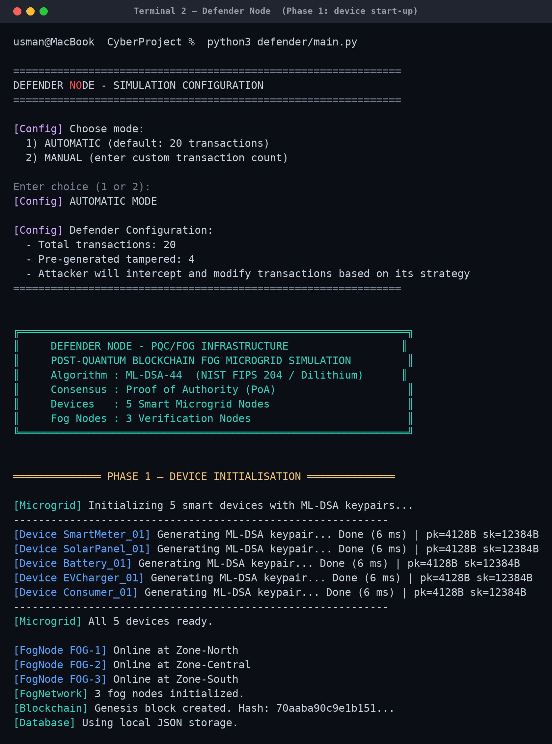
Figure 5. Phase 1 — start-up. The defender builds the five smart devices, gives each a fresh ML-DSA-44 key pair, and brings the fog nodes and blockchain online.
At start-up every device makes its own pair of keys: a private key for signing and a public key for checking. The line "pk=4128B sk=12384B" shows the size of those keys in bytes. The blockchain also creates its very first block, called the genesis block.
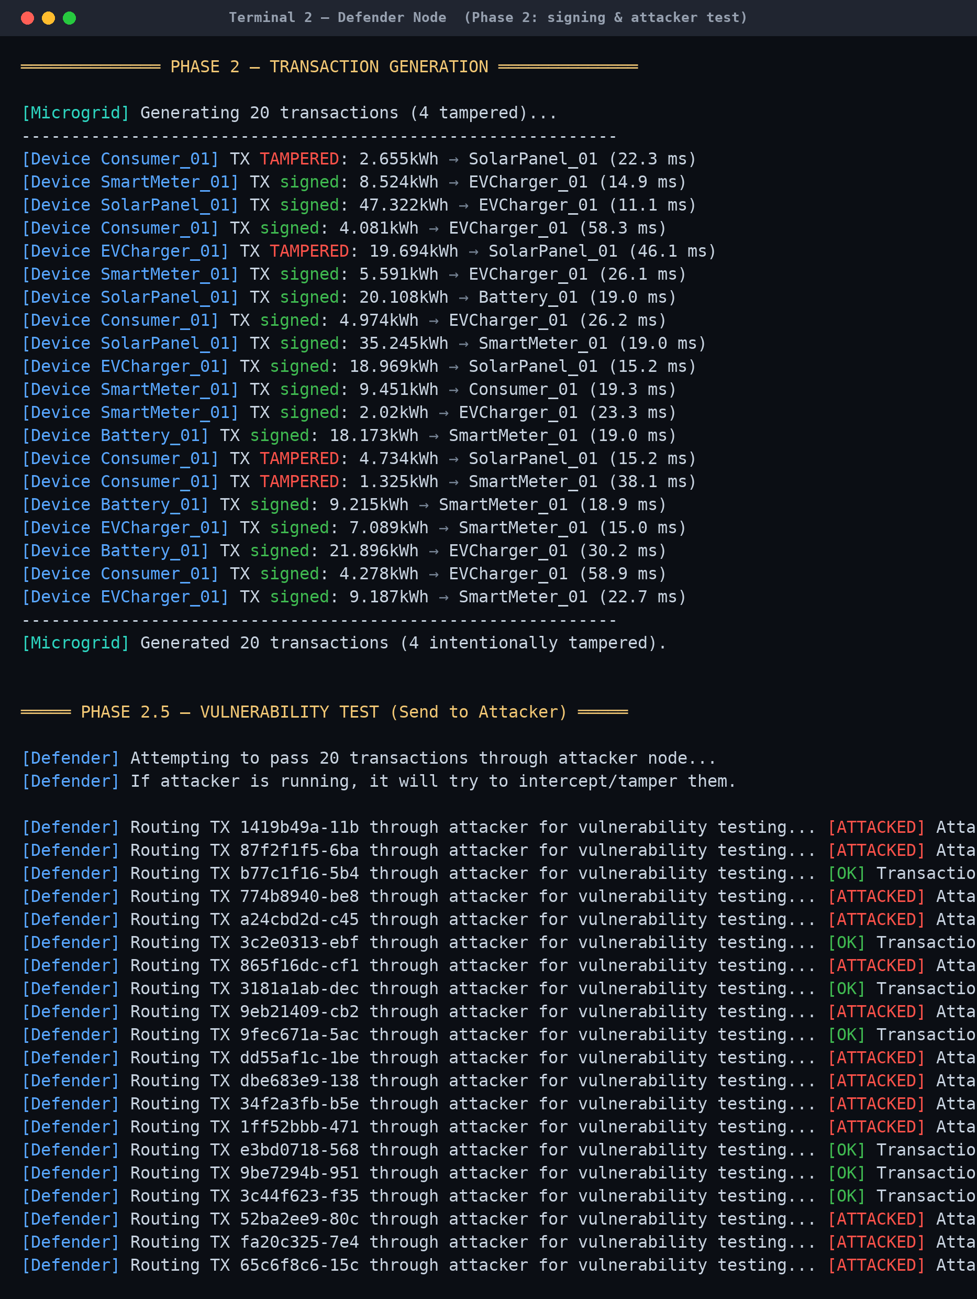
Figure 6. Phases 2 and 2.5 — the devices sign 20 transactions, then each one is routed through the attacker.
First the devices sign 20 transactions (four are deliberately damaged from the start, as an extra test). Then the defender sends every transaction to the attacker. "[ATTACKED] Attacker corrupted the signature!" means the attacker changed that message; "[OK] Transaction passed through" means it survived untouched.
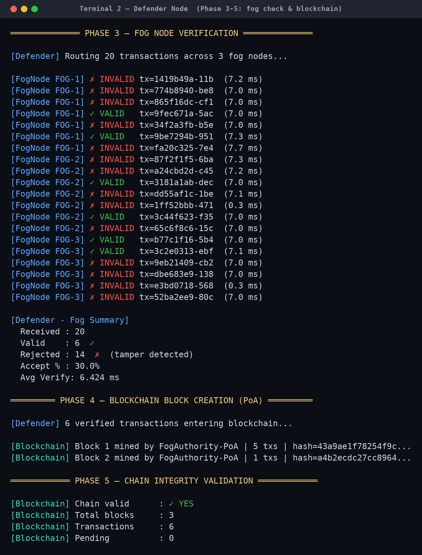
Figure 7. Phases 3 to 5 — the fog nodes verify every signature, then the blockchain seals the good transactions into blocks.
This is the most important screenshot. Each fog node checks every transaction: a green check mark and "VALID" means the signature is genuine, and a red cross and "INVALID" means the signature was changed, so the transaction is rejected. In this run the fog caught 14 bad transactions and accepted 6 good ones. The 6 good transactions are then sealed into blocks, and the chain reports "Chain valid: YES".
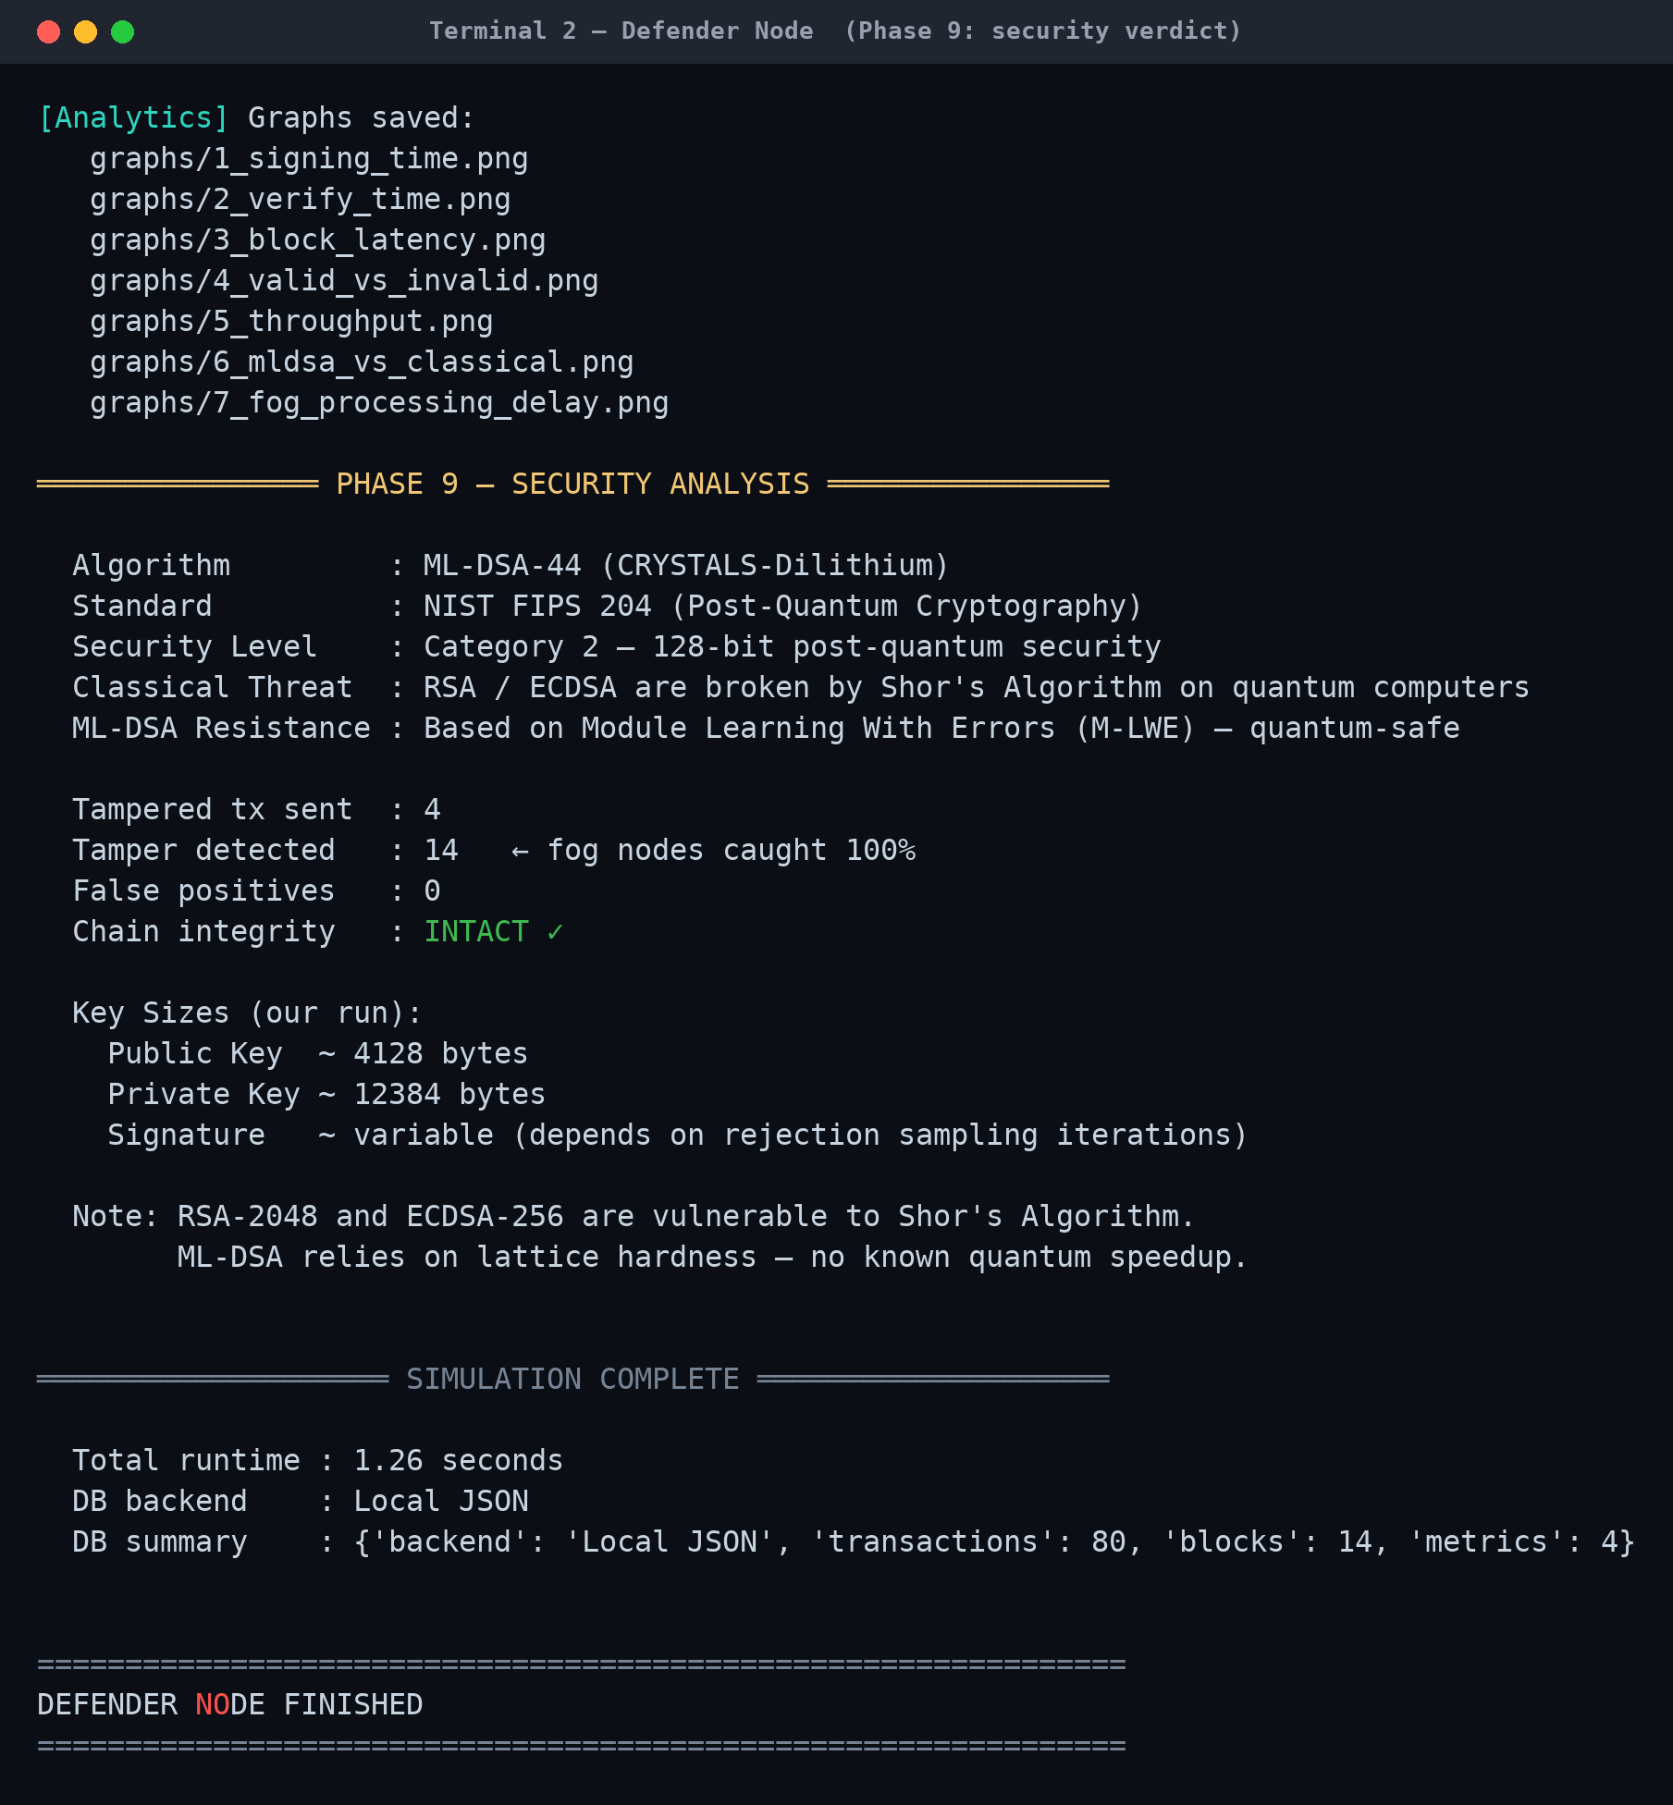
Figure 8. Phase 9 — the security verdict printed at the end of the run.
The final phase prints the security summary. The key result: every single tampered transaction was caught, no genuine transaction was wrongly rejected (zero false positives), and the blockchain’s integrity is intact. The defence worked.

05 DEMONSTRATION 2 — THE WEB DEFENSE CONSOLE
The same simulation can also be controlled from a web page called the Defense Console. It is started with the command python web/server.py, which opens it automatically in the browser. Behind the scenes the web page runs the very same attacker and defender programs — it simply shows everything in a clean, dark, "mission-control" style.

5.1 Setting Up the Run
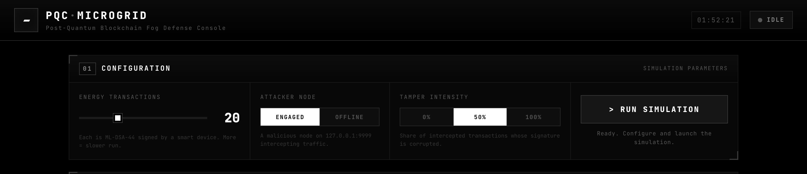
Figure 9. The Defense Console before a run. The Configuration panel has three simple settings.
The Configuration panel has three controls:
- Energy Transactions — how many transactions to create and sign (set to 20 here).
- Attacker Node — "ENGAGED" turns the hacker on; "OFFLINE" turns it off.
- Tamper Intensity — how aggressive the attacker is: 0%, 50% or 100% of intercepted transactions get corrupted (set to 50% here).
Pressing the "> RUN SIMULATION" button starts everything.

5.2 Watching It Run Live
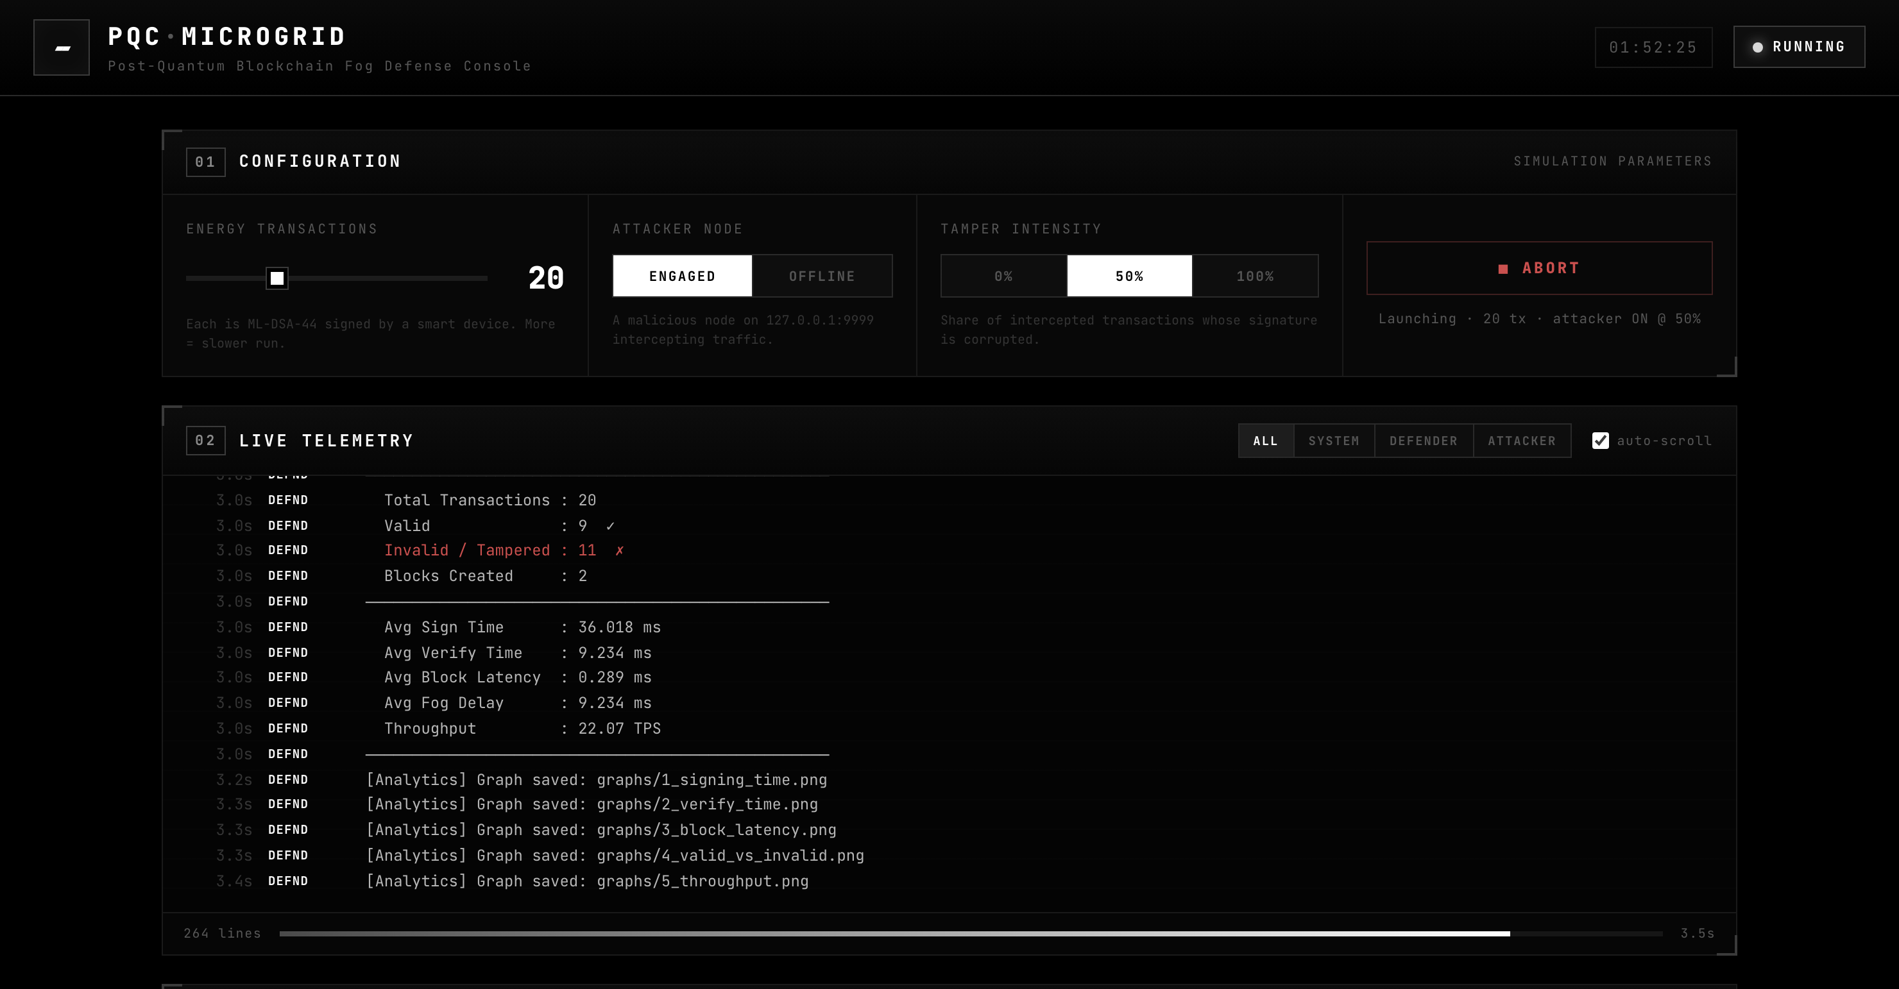
Figure 10. The simulation running. The Live Telemetry panel streams the real output of the defender and attacker as it happens.
While the simulation runs, the Live Telemetry panel shows the real messages from both programs in real time, and the status light at the top-right corner turns to "RUNNING". A whole run takes only a few seconds. When it finishes, the rest of the page fills in with the results, which are explained in the next section.

06 RESULTS — WHAT THE NUMBERS MEAN
When the run finishes, the Defense Console fills with panels of results. This section explains each one. All numbers below are from the web run: 20 transactions, with the attacker engaged at 50% tamper intensity.

6.1 Mission Metrics
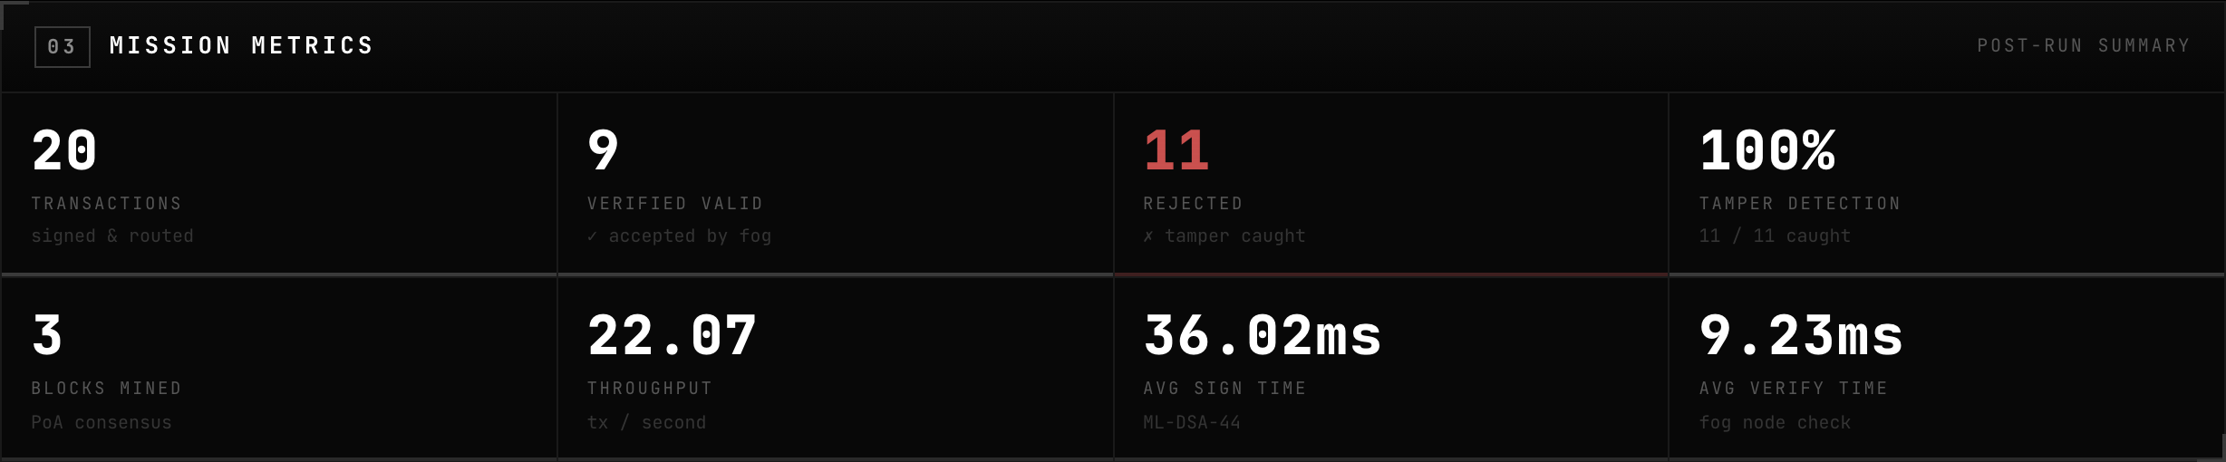
Figure 11. The headline numbers from the run.
The eight cards summarise the whole run:
- Transactions: 20 — the total number of transactions signed and routed.
- Verified Valid: 9 — genuine transactions the fog nodes accepted.
- Rejected: 11 — corrupted transactions the fog nodes caught and threw out.
- Tamper Detection: 100% — every tampered transaction was detected. None slipped through.
- Blocks Mined: 3 — blocks on the chain: the genesis block plus two blocks of real transactions.
- Throughput: 22.07 — transactions handled per second.
- Avg Sign Time: 36.02 ms — average time to create one signature (about three-hundredths of a second).
- Avg Verify Time: 9.23 ms — average time for a fog node to check one signature; checking is faster than signing.
The single most important number is Tamper Detection: 100%. It means the quantum-proof signatures, together with the fog check, caught every single attack.

6.2 Smart Devices
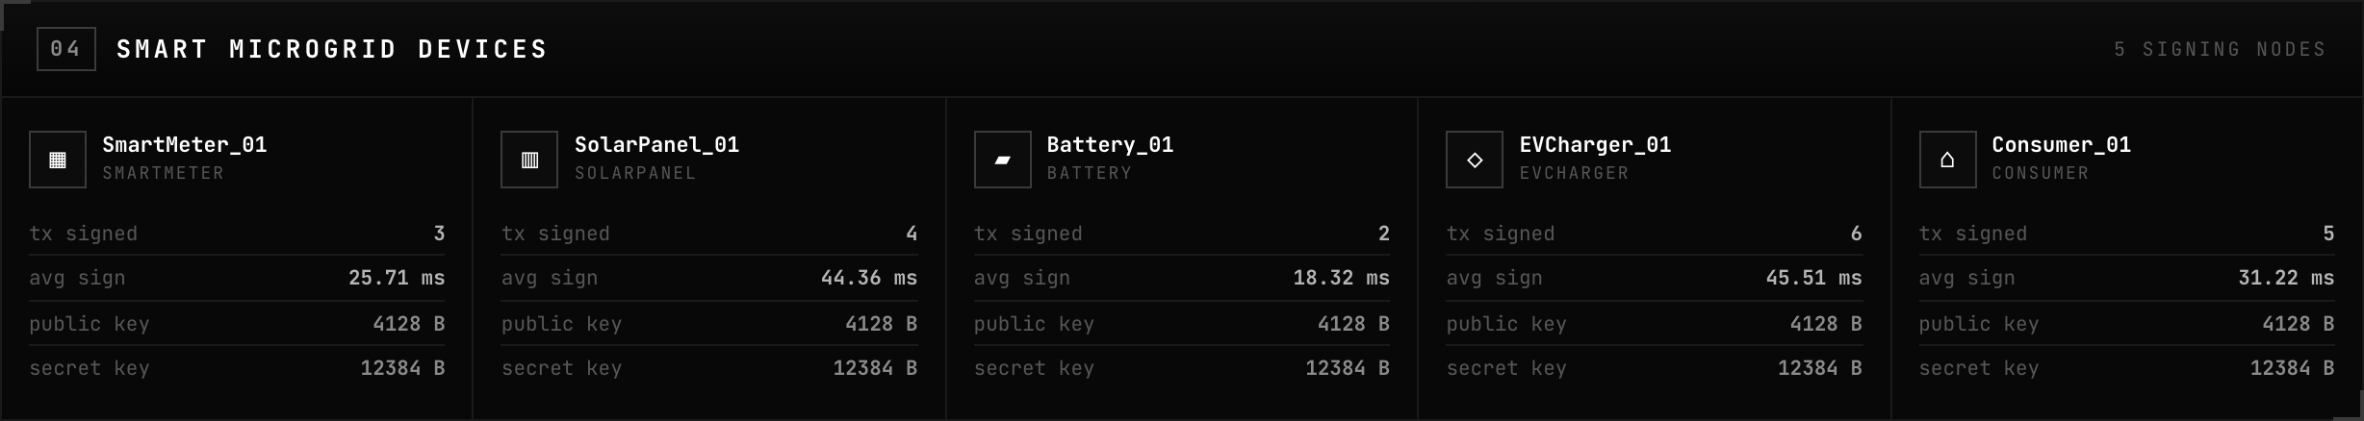
Figure 12. The five smart devices and their ML-DSA-44 keys.
Each card is one device. It shows how many transactions that device signed, its average signing time, and the size of its keys. Every device has a 4128-byte public key and a 12384-byte secret key. Post-quantum keys are larger than old-style keys — that extra size is part of what makes them quantum-safe.

6.3 Fog Verification Network
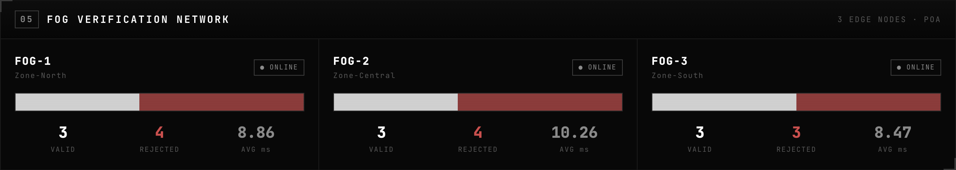
Figure 13. The three fog nodes share the verification work.
The 20 transactions are shared evenly across the three fog nodes (FOG-1, FOG-2 and FOG-3) so that no single node is overloaded. The coloured bar on each card shows its split of valid (light) versus rejected (red) transactions. Together the three nodes accepted 9 transactions and rejected 11.

6.4 Blockchain Ledger
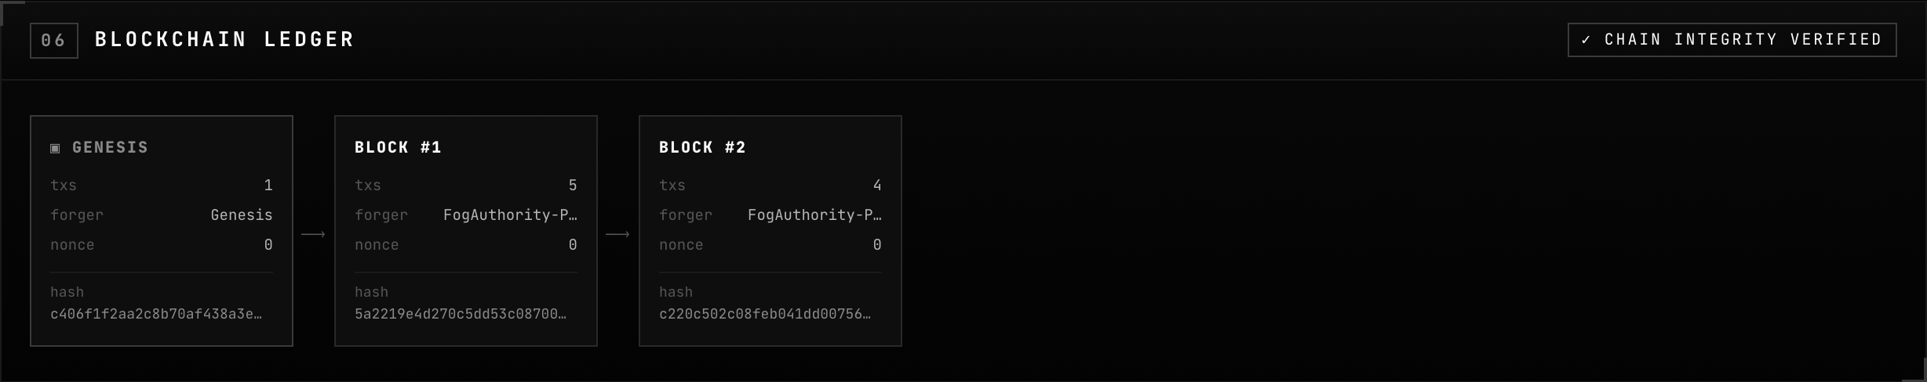
Figure 14. The blockchain after the run.
The chain has three blocks. GENESIS is the starting block. BLOCK #1 and BLOCK #2 hold the 9 verified transactions (5 + 4). Each block stores a hash — a unique fingerprint of its contents — and is locked to the block before it. The green badge "CHAIN INTEGRITY VERIFIED" confirms that no block was tampered with.

6.5 Transaction Ledger
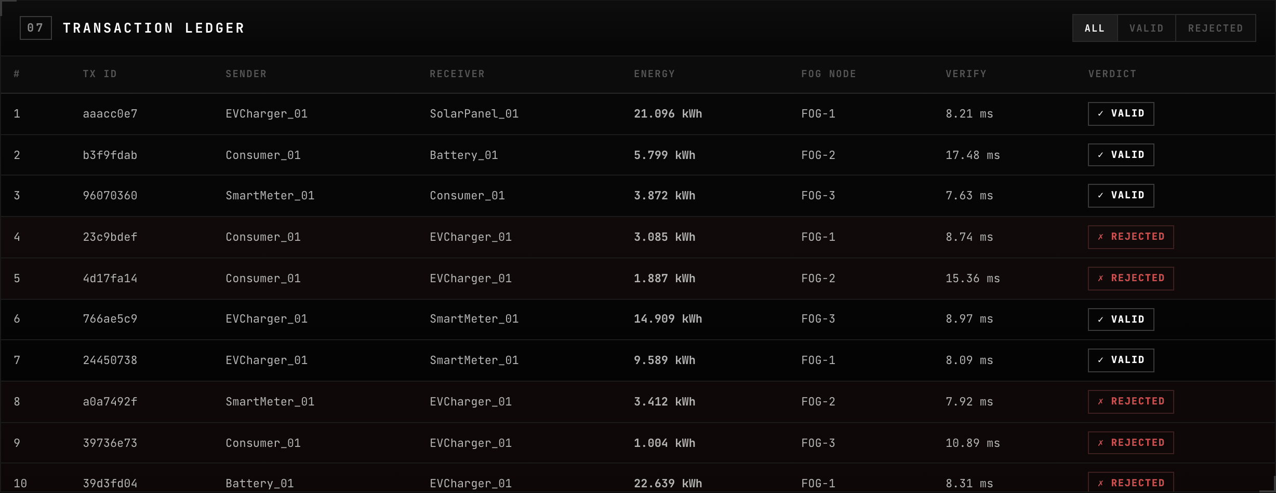
Figure 15. The full list of transactions and the fog’s verdict on each one.
This table lists every transaction: its short ID, the sender, the receiver, the energy amount, which fog node checked it, how long the check took, and the final verdict. Rows marked "VALID" passed the signature check; rows marked "REJECTED" were caught as tampered.

6.6 Results Summary
Measure | Result
Transactions processed | 20
Accepted as valid | 9
Rejected as tampered | 11
Tamper detection rate | 100% (11 of 11 caught)
False alarms (good ones wrongly rejected) | 0
Blocks on the chain | 3 (genesis + 2)
Blockchain integrity | Intact / verified
Average signing time | 36.02 ms
Average verification time | 9.23 ms

07 THE PERFORMANCE GRAPHS EXPLAINED
At the end of every run the project draws seven graphs and saves them in the graphs folder. They turn the raw numbers into pictures, so the system’s speed and accuracy are easy to see. Here is what each one shows and what it means.

Graph 1 — ML-DSA Signing Time
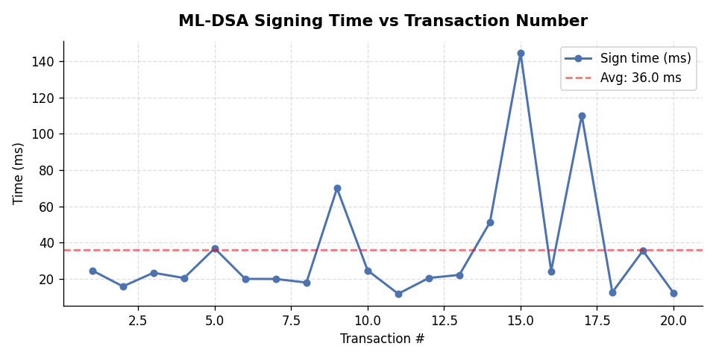
Figure 16. Time taken to sign each of the 20 transactions.
Each dot is one transaction; its height shows how many milliseconds it took to sign. The dashed line is the average. Most signatures take a similar short time, but a few spikes appear. The spikes happen because ML-DSA uses a step called rejection sampling — sometimes it must try a few times before it gets a valid signature, which takes a little longer.

Graph 2 — ML-DSA Verification Time
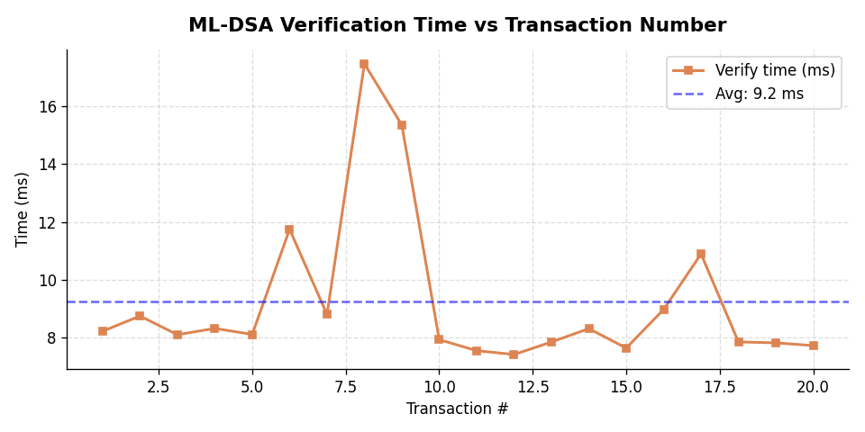
Figure 17. Time taken to verify each transaction’s signature.
This graph shows how long the fog nodes took to check each signature. Verification is steadier and generally faster than signing, because checking a signature is simpler work than creating one.

Graph 3 — Block Creation Latency
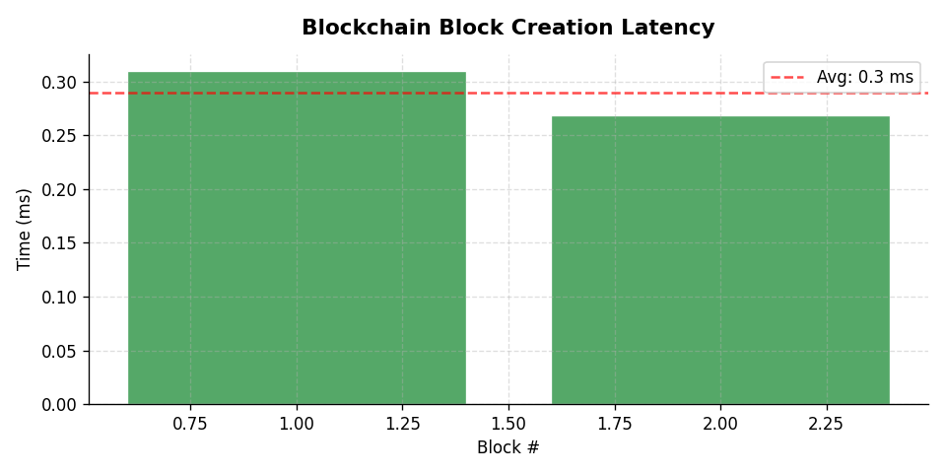
Figure 18. Time taken to build each blockchain block.
Each bar is one block. The times are tiny — well under one millisecond — because the blockchain uses Proof of Authority. Trusted nodes simply write the block; there is no slow "mining" puzzle to solve, unlike Bitcoin.

Graph 4 — Valid vs Invalid Transactions
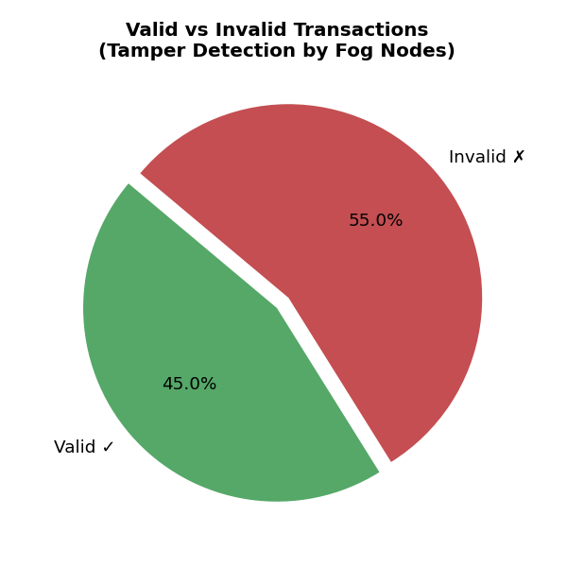
Figure 19. The share of accepted versus rejected transactions.
This pie chart shows the split for the run: the green slice is the genuine transactions the fog accepted, and the red slice is the tampered ones it rejected. It is a quick picture of how much of the traffic was under attack — here, just over half.

Graph 5 — System Throughput
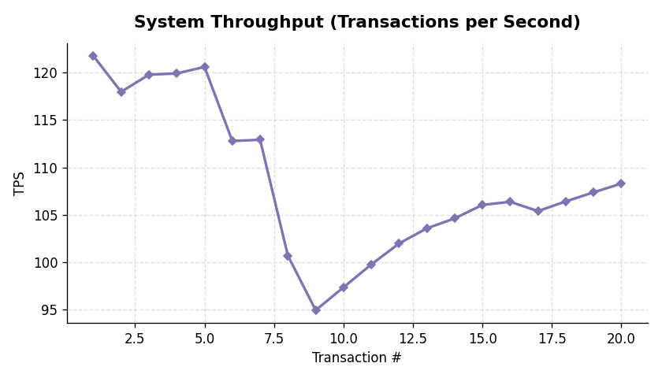
Figure 20. Transactions handled per second during the run.
Throughput means how many transactions the system can handle each second. The line settles at around 22 transactions per second — fast enough for a small microgrid, even with all the security checks switched on.

Graph 6 — ML-DSA-44 vs Classical Signatures
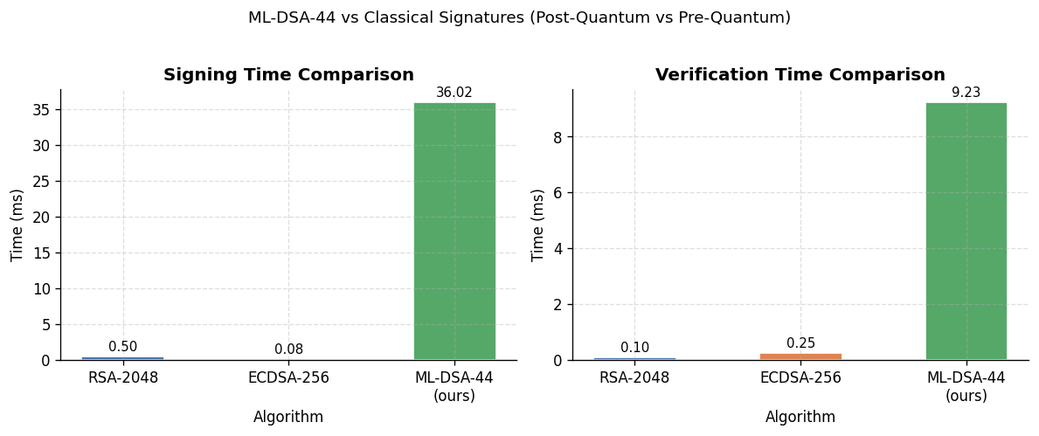
Figure 21. ML-DSA-44 compared with the older RSA and ECDSA signatures.
These bars compare the new quantum-proof signature with the older RSA-2048 and ECDSA-256 signatures. ML-DSA is a little slower than the old algorithms. That is the trade-off: a small amount of extra time in exchange for protection against quantum computers — and it is still quick enough for real use.

Graph 7 — Fog Node Verification Delay
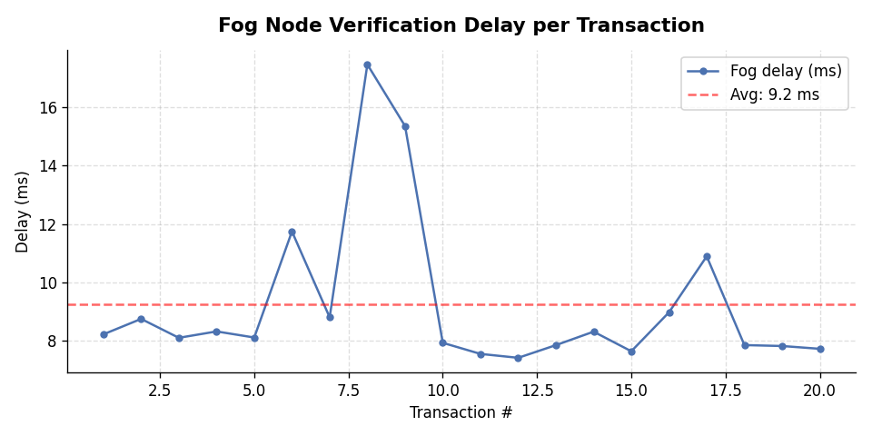
Figure 22. The delay each fog node added per transaction.
This shows the extra delay the fog layer adds while it checks each transaction. The delay is small and steady, which means the security check does not noticeably slow the microgrid down.

08 SECURITY ANALYSIS AND CONCLUSION

8.1 The Security Verdict
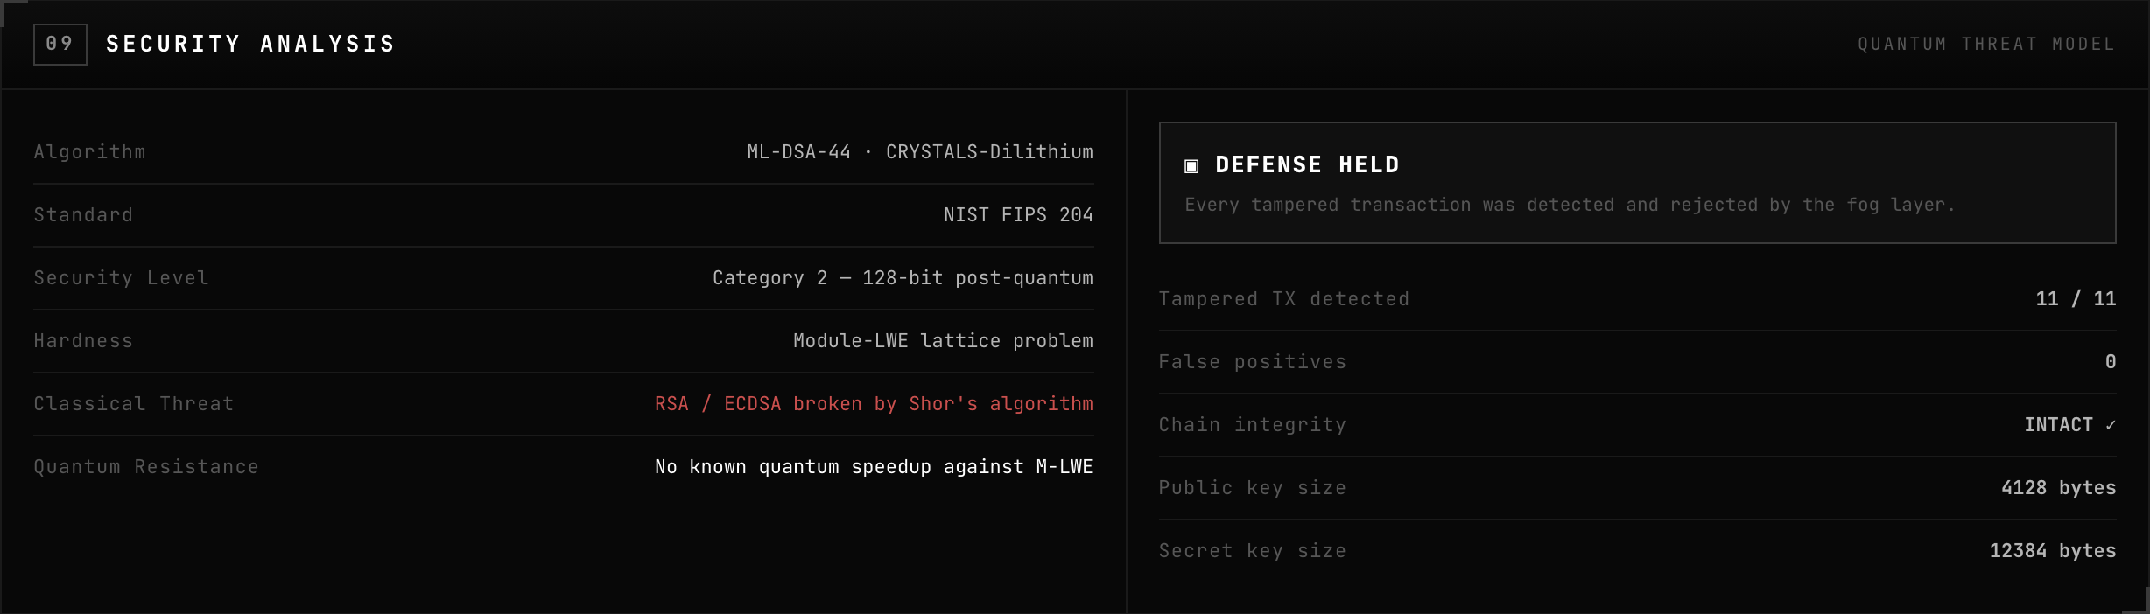
Figure 23. The Defense Console’s final verdict: DEFENSE HELD.
The Security Analysis panel gives the final verdict. Three results decide whether the defence held:
- Tampered transactions detected: 11 of 11 — every corrupted transaction was caught.
- False positives: 0 — no genuine transaction was ever wrongly rejected.
- Chain integrity: Intact — no blockchain block was secretly changed.
Because all three results are good, the console declares "DEFENSE HELD": every tampered transaction was detected and rejected by the fog layer.

8.2 Why It Worked
The defence works because of how a digital signature behaves. The signature is calculated from the exact contents of the message. If an attacker changes even one bit of the signature or the message, the mathematics no longer adds up, and the fog node’s check fails. The attacker also cannot create a fresh, correct signature, because that needs the device’s private key — and the private key never leaves the device.
The reason this is quantum-safe is the type of mathematics underneath. ML-DSA-44 is built on a hard problem called Module Learning With Errors (M-LWE), a "lattice" problem. Unlike RSA and ECDSA, there is no known way — not even with a quantum computer running Shor’s algorithm — to solve it quickly. That is why ML-DSA is an official NIST post-quantum standard, FIPS 204.

8.3 What This Project Shows
- A smart-grid microgrid can protect every transaction with a real, standardised post-quantum signature.
- A fog layer of edge computers can verify those signatures and catch 100% of tampering, with no false alarms.
- A Proof-of-Authority blockchain keeps a tamper-evident record of every approved transaction.
- The security cost is small: signing and verifying take only milliseconds, and throughput stays high.

8.4 Conclusion
Quantum computers will one day break the digital signatures the world depends on today. This project shows a clear, working answer for one important case — a smart energy grid. By signing every transaction with the quantum-proof ML-DSA-44 algorithm, verifying it with a fog layer, and recording it on a blockchain, the system caught every attack in the test runs while staying fast. It is a small but complete example of how to build systems that are safe not only today, but in the post-quantum future.
FINAL RESULT In every test run, 100% of tampered transactions were detected and rejected, with zero false alarms and the blockchain left fully intact. The quantum-safe defence held.

— END OF REPORT —

