Final Project Report

AI-Powered Personalized Learning System



Project Supervisor
Dr. Saima Munawar

Submitted By

S25PROJECT3B9CD

Syed Hamza Ali Shah Hamdani BC220207335
<<Group Member Name>> <<VU ID>>

Software Projects & Research Section,
Department of Computer Sciences,
Virtual University of Pakistan


CERTIFICATE

This is to certify that <<First Member Name>> (<<VU ID>>), <<Second Member Name>> (<<VU ID>>) have worked on and completed their Software Project at Software & Research Projects Section, Department of Computer Sciences, Virtual University of Pakistan in partial fulfillment of the requirement for the degree of BS in Computer Sciences under my guidance and supervision.

In our opinion, it is satisfactory and up to the mark and therefore fulfills the requirements of BS in Computer Sciences.

Supervisor / Internal Examiner

<<Project Supervisor Name>>
Supervisor,
Software Projects & Research Section,
Department of Computer Sciences
Virtual University of Pakistan

___________________
(Signature)

External Examiner/Subject Specialist
<<External Supervisor Name>>

___________________
(Signature)

Accepted By:

_____________
(For office use)

EXORDIUM

In the name of Allah, the Compassionate, the Merciful.

Praise be to Allah, Lord of Creation,
The Compassionate, the Merciful,
King of Judgment-day!

You alone we worship, and to You alone we pray for help,
Guide us to the straight path

The path of those who You have favored,

Not of those who have incurred Your wrath,
Nor of those who have gone astray.

DEDICATION

ACKNOWLEDGEMENT
PREFACE
TABLE OF CONTENTS

CHAPTER NO. 1
gathering & Analyzing info 9

1.1 Introduction 10

1.2 purpose 10

1.3 scope 10

1.4 definitions, acronyms and abbreviations 11
1.4.1 Admin Dashboard
1.4.2 Student Dashboard
1.4.2.1 AIRecommendation
1.4.3 Teacher Dashboard

1.5 Project requirements 11

1.5.1 Functional Requirements 11

1.5.2 Non-Functional Requirements 12

1.6 use cases and usage scenarios 13

1.6.1 Use Case Diagrams 13

1.6.2 Usage Scenarios 13

1.7 Development Methodology 22

1.7.1 Chosen Methodology 22

1.7.2 Reasons for Chosen Methodology 22
1.7.2 Work Plan (Gantt Chart) 23
1.7.2 Project Schedule (Submission Calendar) 23

CHAPTER NO. 2
designing the project 24

2.1 Introduction 25

2.2 purpose 25
2.3 scope 25

2.4 definitions, acronyms and abbreviations 26

2.5 Architectural Representation (Architecture Diagram) 27

2.6 Dynamic Model: Sequence Diagrams 28

2.7 Object Model/Logical Model: Class Diagram 37

2.8 Database Model (Database Diagram) 38

2.9 Graphical User Interfaces 39

Chapter no.3
DEvelopment 42
3.1 Development plan (Architecture Diagram) 43
<<Dear Students, you have to take special care of page numbers, which are written against each Chapter and sub headings. You have to mention your own page numbers and correct one against each document heading. Make proper table of contents. Remember that if there are any new headings or you have included more headings in your documents then you also have to write these in table of contents and modify table of contents according to your documents material>>

<<Dear Students, before starting each chapter the following would be the title page for each chapter on a separate page>>

CHAPTER 1
Gathering & Analyzing Info

  - Introduction
This project aims to develop an AI-driven personalized learning system that adapts to students' learning styles, strengths and weaknesses. The system will store student progress data, analyze their performance using AI and recommend customized learning materials, quizzes and study plans. It will use machine learning algorithms to predict areas where students need improvement and provide intelligent tutoring through chatbots and automated assessments.

  - purpose
The Purpose of this project is to assist the students for over come their learning weakness with the help of AI along the Teachers and also help teachers to analyze their Students Progress in effective way having AI based Insights, So they could assist or provide better Learning Materials for the students.

  - Scope
Personalized Learning System has an utmost Importance in the Pakistan. It makes Student to learn independent and Self-based Learner.

The AI-Powered Personalized Learning System focuses on enhancing education through AI-driven personalization. Its scope includes developing an adaptive platform that analyzes student performance, recommends tailored learning materials, and provides automated assessments. The system will feature an AI chat-bot for tutoring, progress tracking dashboards for teachers.
The project will leverage cloud-based AI tools (TensorFlow/PyTorch) and databases (PostgreSQL/MongoDB) for scalability. However, it excludes offline functionality or deep AI research, prioritizing practical implementation of existing models for educational optimization.

Thus, this system aims to bridge learning gaps by dynamically adjusting content difficulty and providing data-driven insights to educators. Its measurable outcomes include improved student engagement rates and reduced teacher workload through automation

  - definitions, acronyms and abbreviations
1.4.1 Admin Dashboard :- This Dashboard is used to track the total users like teacher and students and the class data etc
1.4.2 Student Dashboard:- This Dashboard is used to track the total number of assessments, learning materials, and consist of quick links to navigate rapidly between tabs
1.4.2.1 AIRecommendation:- This area is used as the recommendations hub for the student where he will get study plan, their subject or topic based weaknesses which will be tailored to the student weakness (The minimum 3 Learning Material should be there In the portal for the AI to work for this) and the content will be delivered to them according it plus the AI-Generated Quizzes Tailored to the student weaknesses.
1.4.3 Teacher Dashboard:- Teacher Dashboard is used to get the visualized data of the number of students, assessment delivered or pending status along with quick navigation links

  - Project requirements

1.5.1 Functional Requirements
User Authentication
The system must support user authentication for students, teachers and administrators.
Manage User Data and Progress Tracking
The system should manage a student database, including progress tracking, performance evaluation and learning history.
And Store & manage student profiles, learning history, and performance data.
AI-Powered Personalization
Analyze student performance using ML algorithms (e.g., clustering, recommendation systems).
Suggest adaptive learning paths based on strengths/weaknesses.
Automated Assessments & Quizz
The system must generate automated quizzes and assessments tailored to student weaknesses
Generate AI-based quizzes tailored to student needs.
AI Chatbot Tutor (NLP-Based)
The system should feature an AI-powered chatbot tutor to assist students with queries using NLP.
Teacher Dashboard & Analytics
The system should include a dashboard for teachers to monitor student progress and analyze performance metrics.

1.5.2 Non-Functional Requirements
Perfomance:-

Handle High volume of users with low latency

Security:-

End-to-end encryption for sensitive data.

Regular security audits & vulnerability testing.

Accuracy:-

The software will build up in accurate manner and will have good performance with respect to admin expectations.

Maintainability:-

This Application should be build in such a manner it should be easy to maintain and fix the potential bugs and errors.

Usability:-

Lucrative UI/UX design for students & teachers.

Multi-platform support (Web, Mobile-responsive).

Reliability:-

The ability of this application will execute and uphold it’s functions in the routine conditions and Data redundancy to prevent loss.

Accessibility:-

This could be accessible to all user of any niche on any device without any major difficulty.

1.6 use cases and usage scenarios

1.6.1 Use Case Diagrams
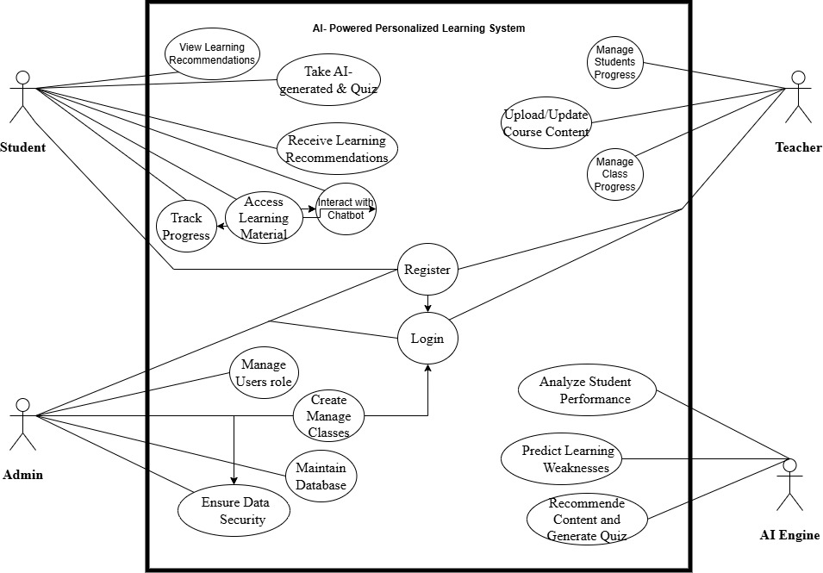

1.6.2 Usage Scenarios

Use Case Scenario #1
Use Case Title | Register
Use Case ID | UC-01
Actions | The All Actors Must have Access the Site  Fill the all Required Fields  Submit Form  Email Verification
Actor | Admin, Teacher, Student
Description | Admin, Teacher and Student Open the Website, Click upon the Registration button, A registration form will appear, By Adding basic Info Like Username, Number and Email Address Allows a new user to register and gain system access.
Alternative Paths | The Admin, Teacher, Student Can cancel the Registration process
Pre Conditions | No existing account, but Website is running Properly.
Post Conditions | Account created Successfully, All Verified members like Admin, Teacher, Student can log into the account
Author | BC220207335
Exceptions | Internet is not stable  Incorrect Email address or Phone Number  Email is Already in Use of other User

Use Case Scenario #2
Use Case Title | Log In /Log Out
Use Case ID | UC - 02
Actions | Student, Teacher, Admin can access the system by login into their Account and to logout from their account
Actor | Student, Teacher, Admin
Description | Allows students, teachers, and admins to securely access the system.
Alternative Paths | If Unable to log-in Request for Password Reset.
Pre Conditions | For Login into account The Student, Teacher and Admin has a registered account in the system.  To Logout The Student, Teacher and Admin is currently logged in.
Post Conditions | User is logged in and Browse their account
Author | BC220207335
Exception | Internet is not Working Properly  Wrong Information has been added  The Information added already exist  Excessive failed login attempts

Use Case Scenario #3
Use Case Title | View Personalized Dashboard
Use Case ID | UC - 03
Actions | The Student logs in and navigate to the dashboard, which displays the student progress data and recommendations
Actor | Student
Description | The Student view the information which will be relevant to the student such as assignments and course progress with learning suggestions and performance matrices
Alternative Paths | None
Pre Conditions | User is authentically logged in  Student has data associated to their account
Post Conditions | Personalized data is loaded  The student can access to their relevant academic information on dashboard
Author | BC220207335
Exception | Error in data retrival  Error in fetching data from server

Use Case Scenario # 4
Use Case Title | Take AI Generated & Quiz
Use Case ID | UC - 04
Actions | The Student will take and solve the quiz which is generated by the AI
Actor | Student
Description | The Student will log into the Account and take the Quizzes from the Generated AI quizzes and the following Quiz results will be delivered upon completion
Alternative Paths | The Student can leave the Quiz in between or change them
Pre Conditions | The Student has logged into the System
Post Conditions | The System Evaluates the Total marks Achieved in the Quizzes
Author | BC220207335
Exception | System failure during quiz compilation.  Error connecting to the question bank.

Use Case Scenario #5
Use Case Title | Interact with Chat-bot
Use Case ID | UC - 05
Actions | The Student will make chat with a Chat-bot regarding its educational queries by clicking at the chat-bot button in the interface, where the student will type the Questions about their relevant topics and get answers.
Actor | Student
Description | The student communicates with the system's integrated chatbot to get assistance, find information, ask questions about the platform, courses, or assignments, or seek guidance.
Alternative Paths | The can leave the chat-bot interaction
Pre Conditions | The Student must be logged into the Account
Post Conditions | The Student has completed the Conversation session with the chat-bot and received the desire answer
Author | BC220207335
Exception | Chat-bot service is offline or unresponsive.  System fails to load the chat-bot interface.  Chat-bot significantly misunderstands the student's query and provides irrelevant answers.

Use Case Scenario # 6
Use Case Title | Monitor Student Progress
Use Case ID | UC - 06
Actions | Teacher navigates to the section displaying class or student lists, Teacher selects a class, Teacher selects an individual student from the class list, System retrieves and displays the selected student's progress within the course/class
Actor | Teacher
Description | The Teacher reviews the Students progression and completion and excitement level of student’s in the courses or curriculum
Alternative Paths | None
Pre Conditions | The Teacher is logged in the system, the Teacher associated with the students who have already used this system.
Post Conditions | The teacher has reviewed the students current learning progress status, Teacher gain insight of student interest and pace
Author | BC220207335
Exception | Student does not exist in the selected class.  Progress data is corrupted or inconsistent.  System error retrieving or displaying progress information

Use Case Scenario # 7
Use Case Title | Generate Progressive Report
Use Case ID | UC - 07
Actions | Teacher navigates to the section displaying class or student lists, Teacher selects a class, Teacher selects an individual student from the class list, System retrieves and displays the selected student's progress within the course/class
Actor | Teacher
Description | The Teacher Generate the Students progression and completion and view a report that shows a student academic progress over the period.
Alternative Paths | if the Teacher searches for a student not in the system. It displays an error message of “student record not found”
Pre Conditions | The Teacher is logged in the system, Student academic data for the student and relevant time period must exist in the system.
Post Conditions | The progressive report for the selected student and time-frame has been successfully generated and is displayed to the Teacher.
Author | BC220207335
Exception | The Components which are required for the report generation are down or offline.  Progress data is corrupted or inconsistent.  System error retrieving or displaying progress information

Use Case Scenario # 8
Use Case Title | Monitor Class Progress
Use Case ID | UC - 08
Actions | Teacher logs into the system. Navigates to the "Class Progress" section. Selects the desired class from a list. Views the dashboard with high-level metrics
Actor | Teacher
Description | The Teacher checks General performance level of a class
Alternative Paths | Teacher might navigate back to the dashboard
Pre Conditions | The Teacher is logged in the system, At-least one class with progress data should exist.
Post Conditions | The teacher has reviewed the class students current learning progress overview, Teacher gain insight of class interest and pace
Author | BC220207335
Exception | Class data does not exist.  Progress data is corrupted or inconsistent.  System Fails to load the progress data.

Use Case Scenario # 9
Use Case Title | Manage User / Roles
Use Case ID | UC - 09
Actions | Admin views user list, Admin selects a user, Admin initiates role, System displays available roles, Admin selects role(s), Admin submits, System updates user's role and confirms success.
Actor | Admin
Description | It allows an admin to modify the access rights of a user by assinging them a different role.
Alternative Paths | None
Pre Conditions | Admin is logged in, Admin has permission to assign/change roles, The user exists, The roles to be assigned exist.
Post Conditions | The selected user's role(s) are updated in the database; The user's system permissions are now determined by the new role.
Author | BC220207335
Exception | User Not Found  Role not Found  Error in database  Attempts to assign invaild role.

Use Case Scenario # 10
Use Case Title | Analyze Performance
Use Case ID | UC - 10
Actions | AI Engine is triggered to perform performance analysis (e.g., by schedule, data arrival, external request). AI Engine connects to data sources (e.g., databases, APIs, data streams) and retrieves relevant performance metrics or log data.
Actor | AI Engine
Description | The AI Engine retrieves, processes, and analyzes performance data from target systems or components to identify trends and generate insights.
Alternative Paths | Teacher might navigate back to the dashboard
Pre Conditions | The AI Engine is operational and configured for performance analysis. The necessary data sources containing performance data are accessible to the AI Engine
Post Conditions | Performance analysis results for the target system are generated. Analysis results (including metrics, anomalies, insights) are stored or transmitted to the specified destination.
Author | BC220207335
Exception | Data Source Unavailable  Data is corrupted or inconsistent.  Analysis Model Failure to load the progress data.

Use Case Scenario # 11
Use Case Title | Generate Quizzes
Use Case ID | UC - 11
Actions | AI Engine receives a request with quiz parameters (e.g., topic, difficulty, numQuestions, questionTypes, AI Engine analyzes the provided parameters, AI Engine accesses its internal knowledge base and external data sources relevant to the specified topic and difficulty, AI Engine formulates questions and generating potential correct answers for Theory based questions and, for MCQ plausible incorrect options, AI Engine selects questions up to the requested number, AI Engine compiles the selected questions and their answers into a structured quiz data object.
Actor | AI Engine
Description | The AI Engine successfully receives valid quiz generation parameters, accesses necessary information, creates questions and answers, and outputs a complete quiz meeting the specified criteria.
Alternative Paths | The AI Engine successfully processes parameters but cannot find enough data meeting the exact difficulty/topic for the requested number of questions. It generates a valid quiz with fewer questions than requested
Pre Conditions | The AI Engine is operational and in a ready state. Relevant knowledge bases and data sources are accessible to the AI Engine. The AI Engine has received a valid request containing essential parameters (e.g., topic, number of questions, desired difficulty).
Post Conditions | A structured quiz data object containing questions and answers has been successfully generated. The generated quiz data is available for subsequent processing or delivery.
Author | BC220207335
Exception | Data Source Unavailable  Internet is Slow or unavailable

Use Case Scenario # 12
Use Case Title | Recommended Content
Use Case ID | UC - 12
Actions | The AI Engine is triggered by a request for recommendations, providing relevant context, The AI Engine retrieves relevant user data (history, preferences, profile). The AI Engine retrieves relevant content/item data. The AI Engine applies one or more recommendation algorithms based on the input context and retrieved data. The AI Engine generates a raw list of potential recommendations
Actor | AI Engine
Description | The AI Engine processes input (user ID, context, etc.) and internal data to generate and return a list of recommended content items.
Alternative Paths | If the chosen algorithm fails to generate enough recommendations, the AI Engine attempts a fallback algorithm or supplements the list with generic recommendations
Pre Conditions | The AI Engine is operational and in a ready state. Access to required data sources (user data store, content data store, historical interactions) is available, Recommendation algorithms are deployed and configured.
Post Conditions | A list of recommended content identifiers is returned to the requesting system.The recommendation event is logged (optional, but common).No internal AI Engine errors have occurred
Author | BC220207335
Exception | Failed to connect to or retrieve necessary user or content data.  Internet is Slow or unavailable  The received request for recommendations contains missing or malformed data.

1.7 Development Methodology

1.7.1 Chosen Methodology

VU Process Model

1.7.2 Reasons for Chosen Methodology
VU Process Model is the combination of waterfall and spiral models. It aims to leverage the structured approach of the waterfall model with the risk-oriented approach of the spiral model.
The VU process model typically involves five sequential phases: requirements gathering, planning, analysis and design, development, and final reporting.
VU Process Model Phases:-
Requirement Gathering:- In this Phase we document all functional and non-functional needs from stakeholders.
Planning:- It defines the timelines, resources, and risk management strategies.
Design:- This phase involves analyzing the requirements and designing the system architecture and components.
Development:- This Phase involve Code the software in a structured manner according to design
Final Reporting:- This phase involves documenting the project, including testing results, lessons learned, and recommendations for future projects.
Why I Choose this:-
I Choose this Model because The VU process model is a popular choice for software development projects due to its structured approach and ability to manage risks effectively. By combining elements of the waterfall and spiral models, it provides a more flexible and adaptable approach to software development. So the idea behind choosing this model is to get the benefits of both the models.
It’s each phase provide detailed deliverable Ideal for all kind of clients event for the Top-tier clients to understand it clearly and easily. This Provides facility to estimate the project cost, hence, give better understanding about the project.

1.7.2 Work Plan (Gantt Chart)
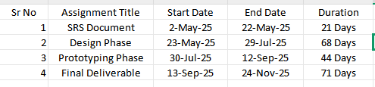

1.7.2 Project Schedule (Submission Calendar)
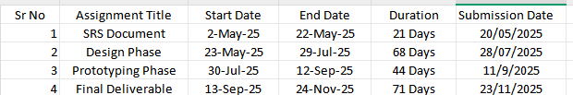

CHAPTER 2
Designing the Project

2.1 Introduction
The design phase in software engineering is a crucial stage in the Software Development Life Cycle (SDLC) where the blueprint for the software is created. It translates the requirements gathered during the planning and analysis phases into a detailed technical plan that guides the subsequent development and implementation.
In This document we have include the following with the details:-
Entity Relationship Diagram :An ERD is a visual representation of the entities (or objects/tables) in a system, the attributes (properties) of those entities, and the relationships between them. It is fundamental for database design. (ERD)

2.2 purpose
The primary purpose of the design phase in software engineering is to create a detailed blueprint for the software, translating user requirements into a structured plan that developers can use to build the system. This phase transforms abstract requirements into concrete specifications for the software's architecture, functionality, user interface, and data management. A well-executed design phase ensures that the final product meets user expectations, is of high quality, and is developed efficiently.

2.3 scope
Scope of Project:

Personalized Learning System has an utmost Importance in the Pakistan. It makes Student to learn independent and Self-based Learner.

The AI-Powered Personalized Learning System focuses on enhancing education through AI-driven personalization. Its scope includes developing an adaptive platform that analyzes student performance, recommends tailored learning materials, and provides automated assessments. The system will feature an AI chat-bot for tutoring, progress tracking dashboards for teachers, and secure integration with existing LMS platforms like Moodle.
The project will leverage cloud-based AI tools (TensorFlow/PyTorch) and databases (PostgreSQL/MongoDB) for scalability. However, it excludes offline functionality or deep AI research, prioritizing practical implementation of existing models for educational optimization.

Thus, this system aims to bridge learning gaps by dynamically adjusting content difficulty and providing data-driven insights to educators. Its measurable outcomes include improved student engagement rates and reduced teacher workload through automation.

2.4 definitions, acronyms and abbreviations
Sequence Diagrams: Sequence Diagrams are interaction diagrams that detail how operations are carried out. They capture the interaction between objects in the context of a collaboration. Sequence Diagrams are time focus and they show the order of the interaction visually by using the vertical axis of the diagram to represent time what messages are sent and when. Essentially, they show the order of events and the flow of communication within a system.
Architecture Design Diagram : An architecture diagram is a blueprint of a software system, showcasing its core components, their interconnections, and the communication channels that drive functionality. It defines the foundational framework of the application.
Class Diagram: A Class Diagram is a static structural diagram that describes the structure of a system by showing the system's classes, their attributes (data), operations (methods/behaviors), and the relationships between these classes. It is crucial for Object-Oriented Design (OOD).
Database Design: Database design is the process of structuring and organizing data in a database to efficiently store, retrieve, and manage information. It involves defining the structure, relationships, and constraints between data elements. A well-designed database ensures data integrity, reduces redundancy, and improves performance and scalability. While ERD provides the logical model, Database Design fleshes out the physical and implementation details.
Interface Design: Interface design focuses on crafting the visual and interactive elements of a digital product, like layouts, buttons, and typography, to create an intuitive and enjoyable user experience. It's essentially the "look and feel" of a website, app, or software. This also focuses on designing how users will interact with the system and potentially how different system components will interact (Application Programming Interfaces - API). It emphasizes usability, aesthetics, and user experience (UX).
Test Case : In this phase full, executable test suites are typical developed for the testing purpose, and the design phase involves identifying key test scenarios and outlining preliminary test cases. This is about incorporating "test-ability" into the design and ensuring that the requirements can be verified. They are crucial for identifying potential bugs and ensuring the software meets requirements before release.

2.5 Architectural Representation (Architecture Diagram)
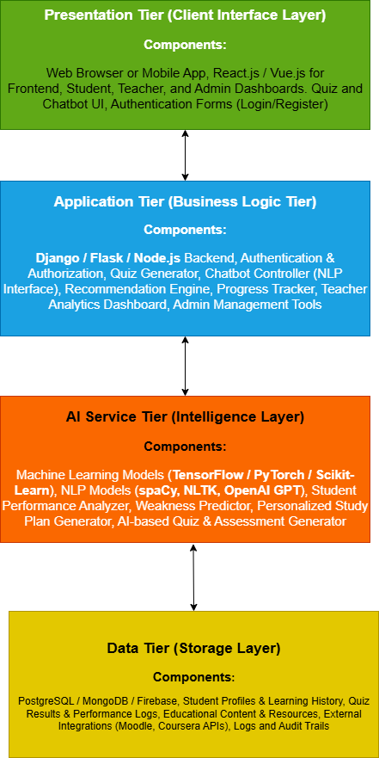

2.6 Dynamic Model: Sequence Diagrams

Registration/login:-
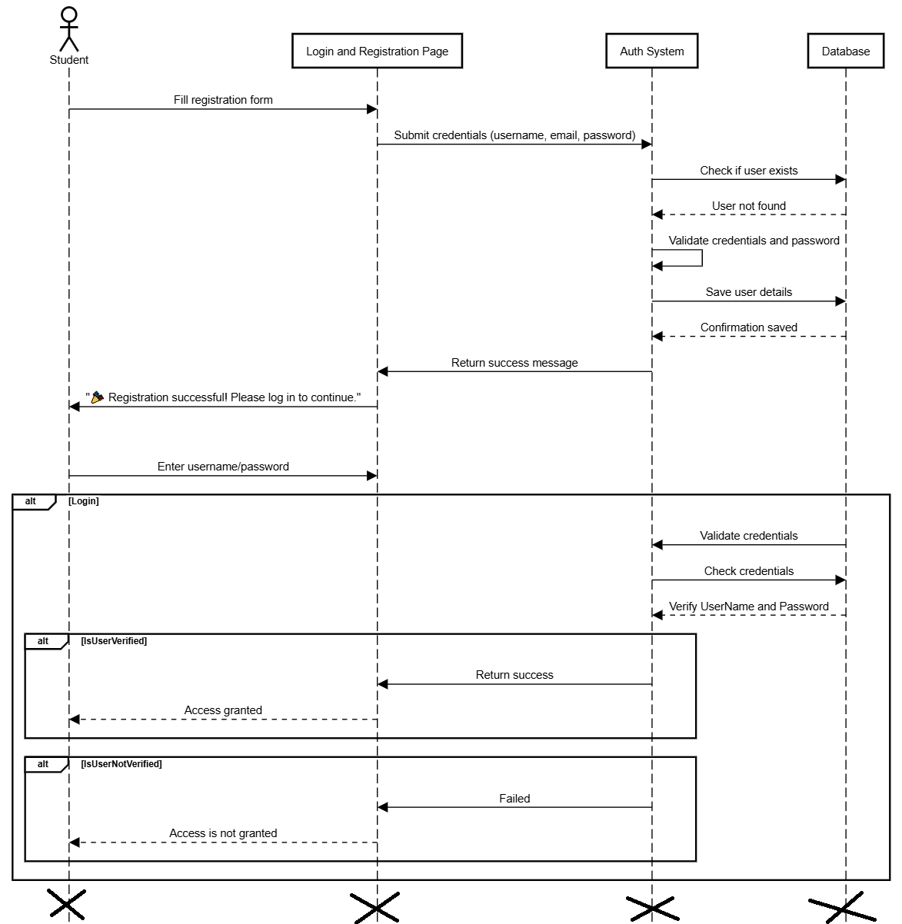
Student Personalized Dashboard:-
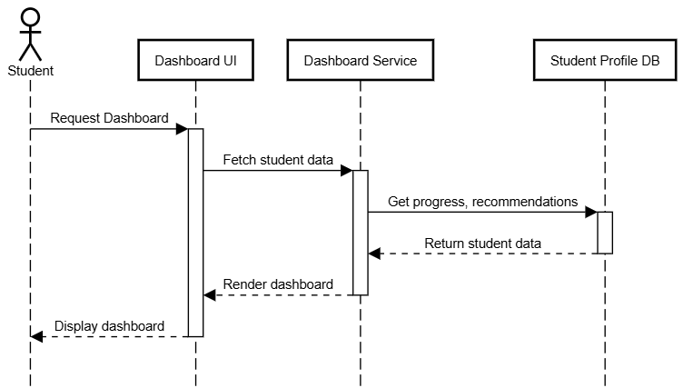

View/Receive Learning Recommendations:-
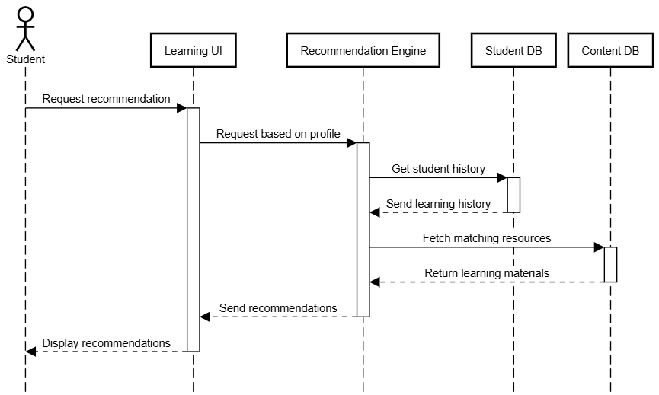
StudentGenerateQuiz:-
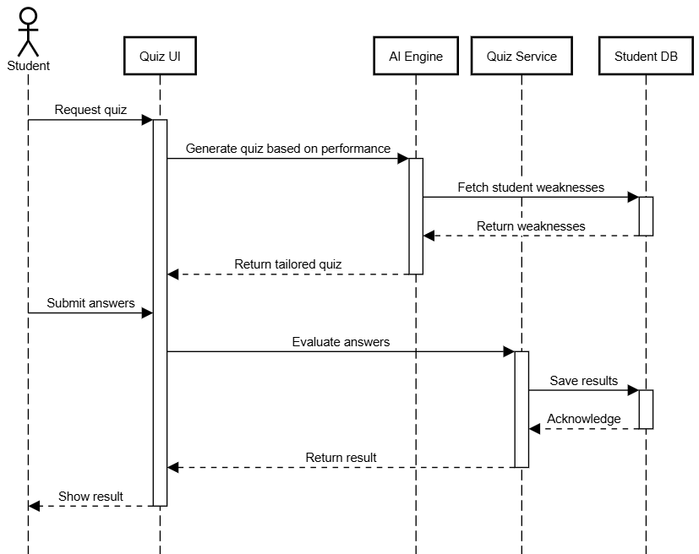
StudentAIEngineAskQueries:-
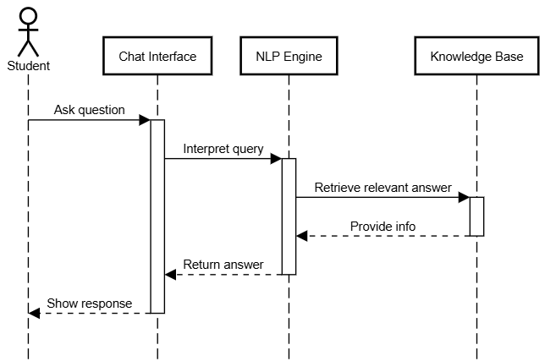
Student Progress and Performances:-
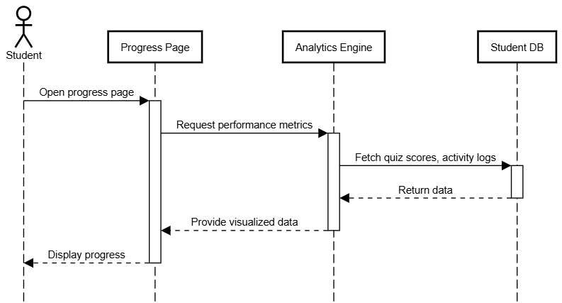
For Teacher Actor
Registration/login:-
Monitor Student Progress:-
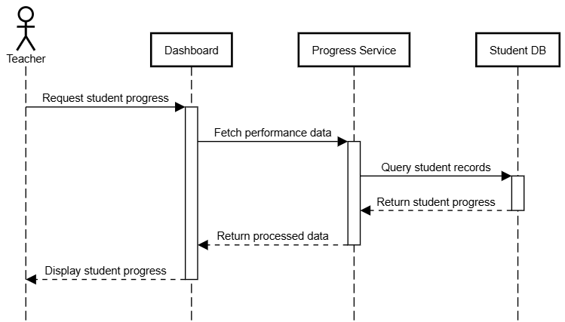
Analyze Performance Reports:-
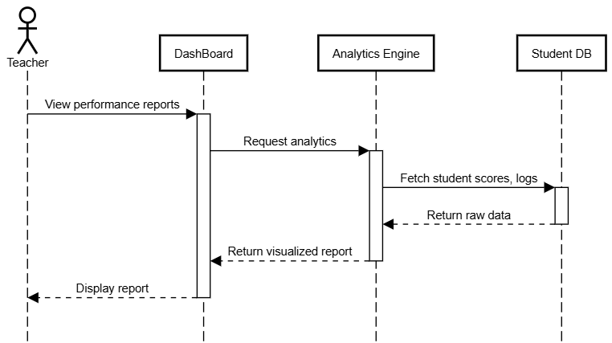
Upload/Update Course Content:-
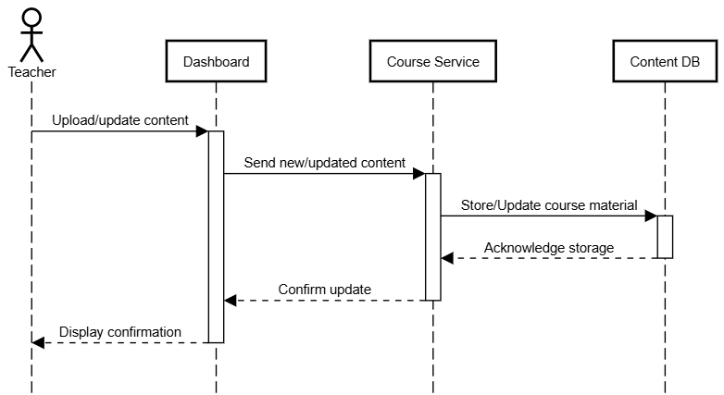

For Admin Actor
Login:-
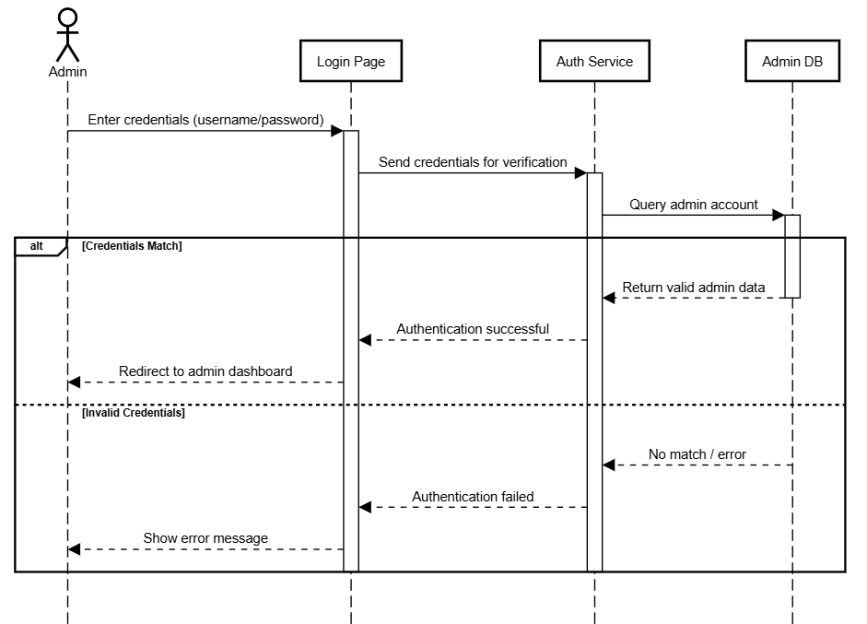
Manage Users:-
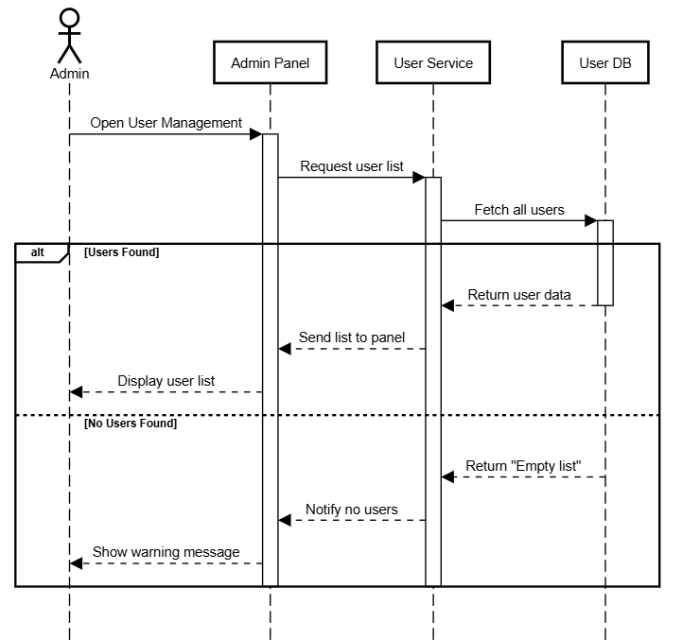
Configure System Setting:-
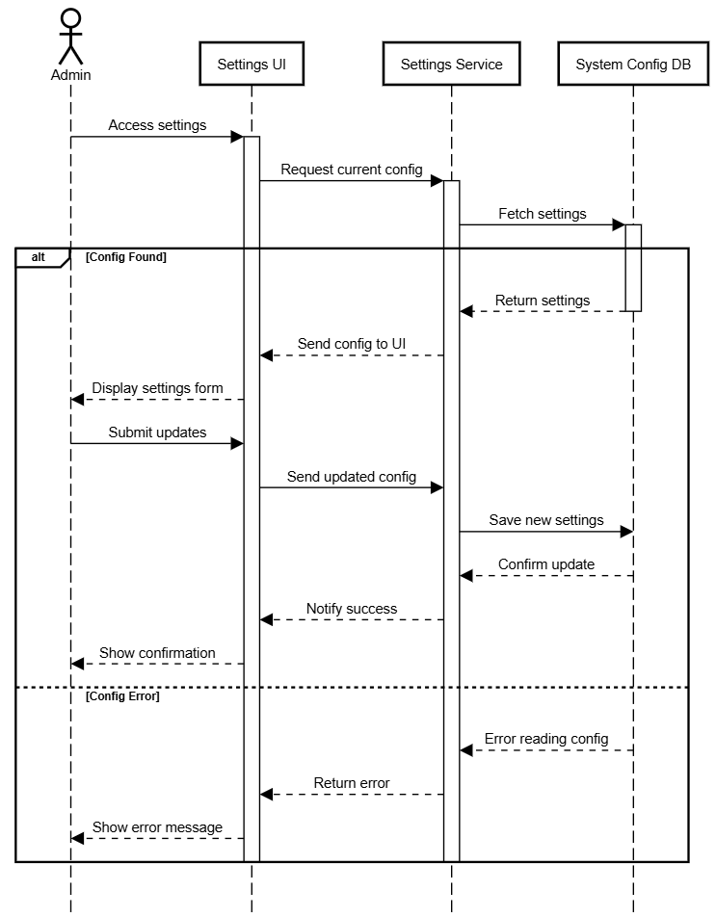
For AI System Actor
Analyze Student Performance:-
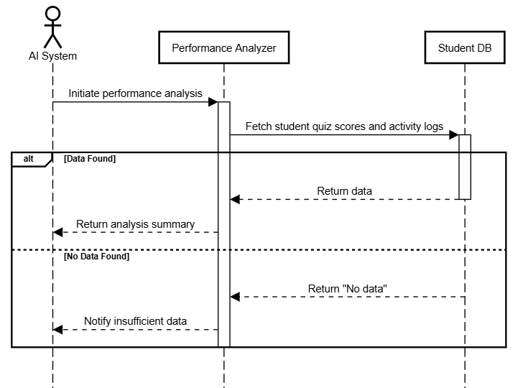
Generate Personalized Content:-
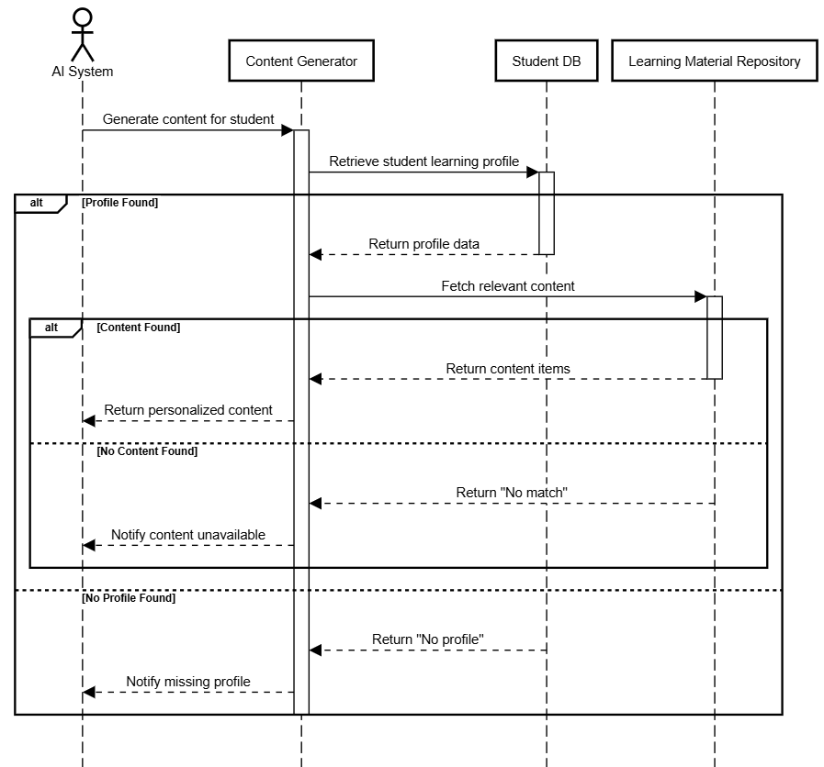
Predict Learning Weakness:-
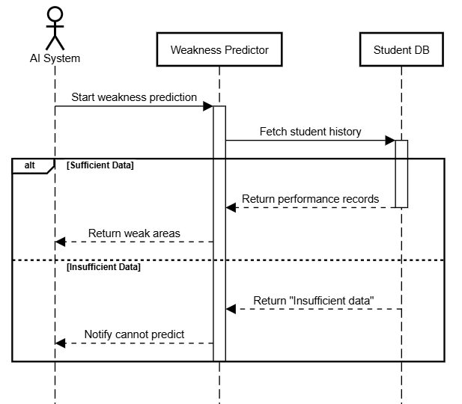
Power NLP Chatbot Responses:-
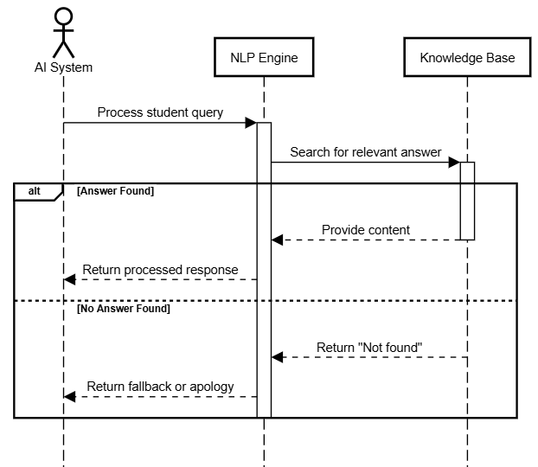

2.7 Object Model/Logical Model: Class Diagram

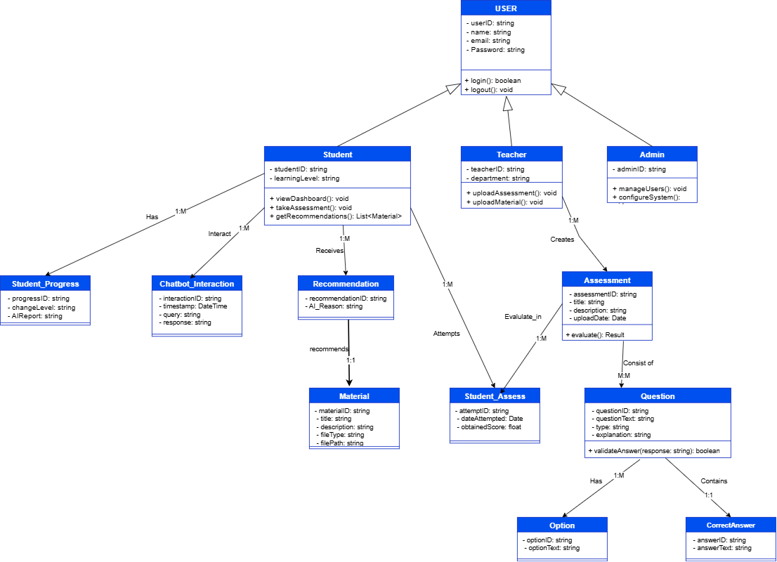

2.8 Database Model (Database Diagram)

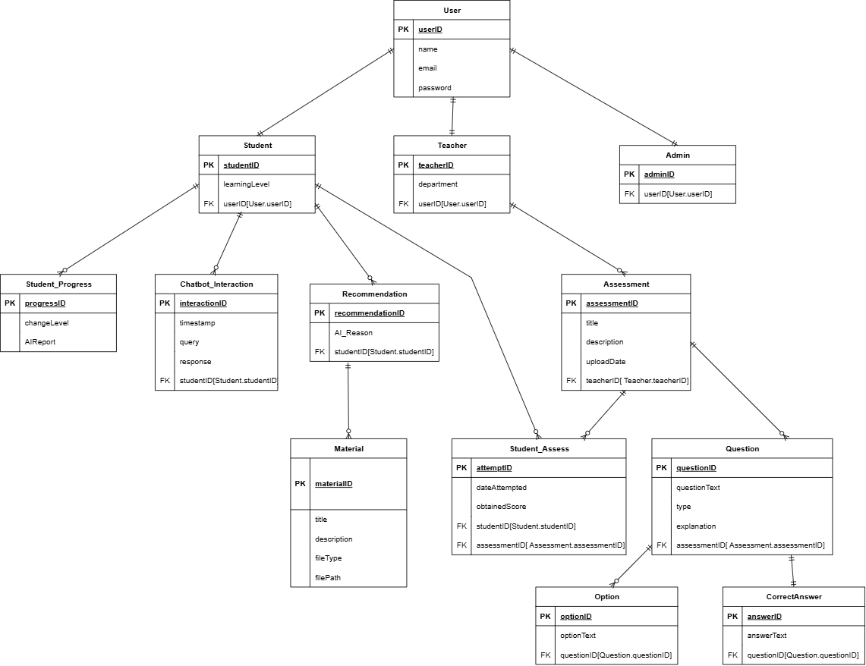

2.9 Graphical User Interfaces
Interface Design

Home Page Interface Design-

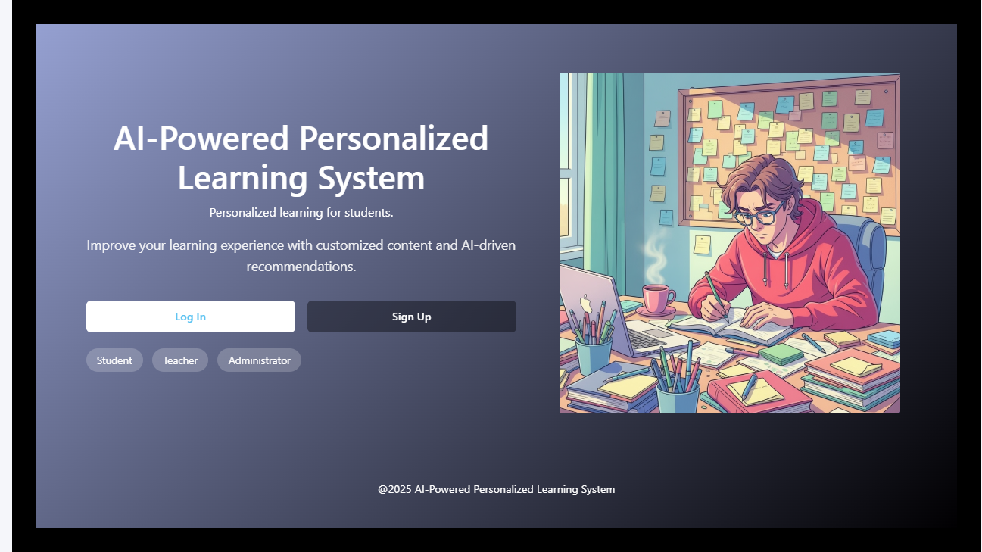

Login Page Interface Design

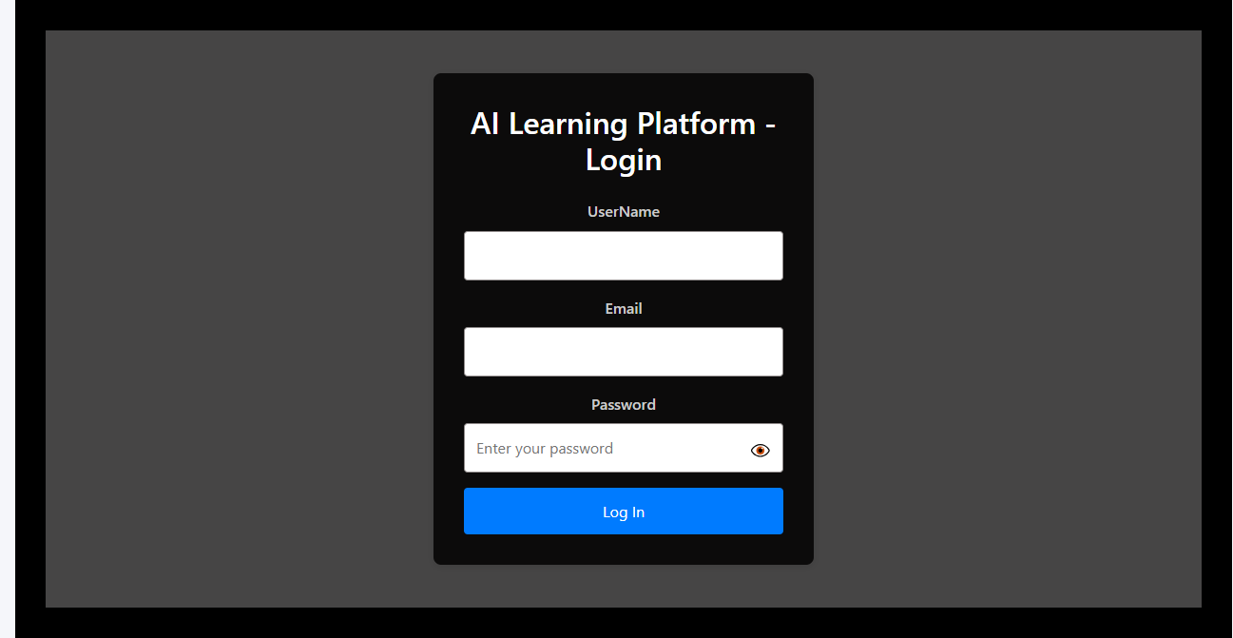

Register Page Interface Design:-

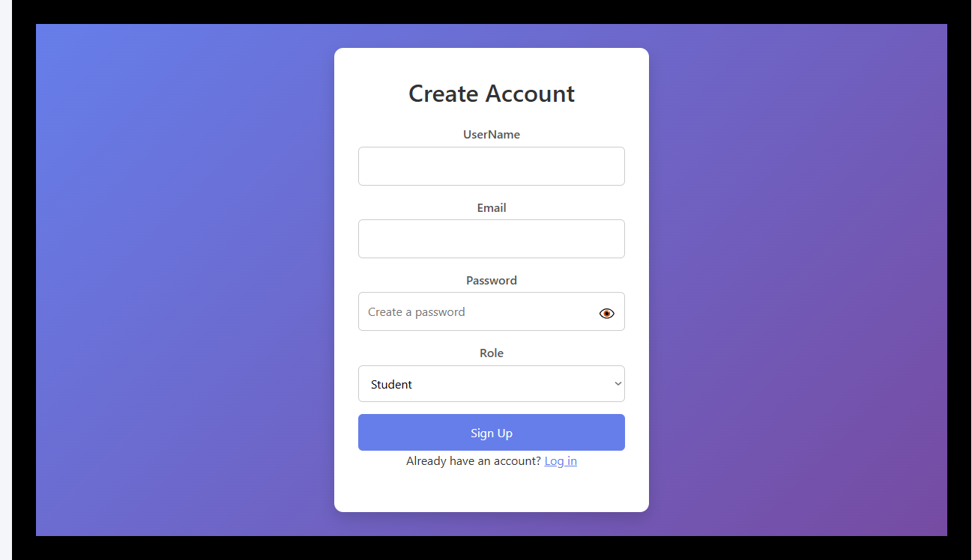

CHAPTER 3
Development

3.1 Development plan (Architecture Diagram)

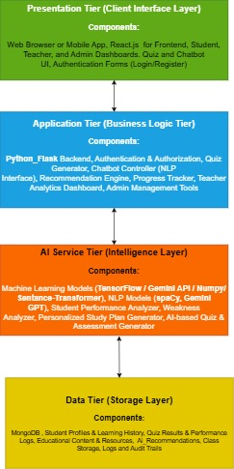
REFERENCES

APPENDIX

