29174
Hasan imam
Q2 Sandbox a command(moderate)

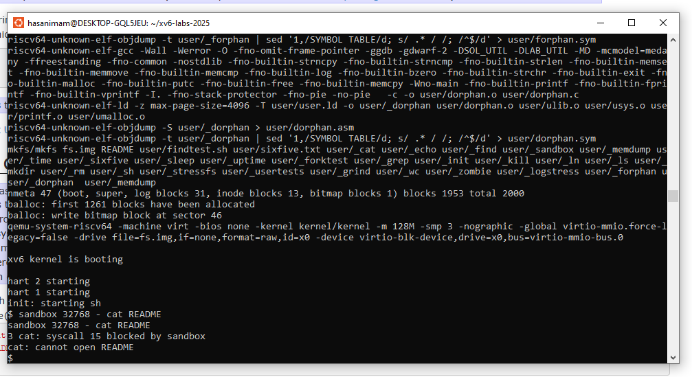

Q3 Sandbox with allowed pathnames(easy)
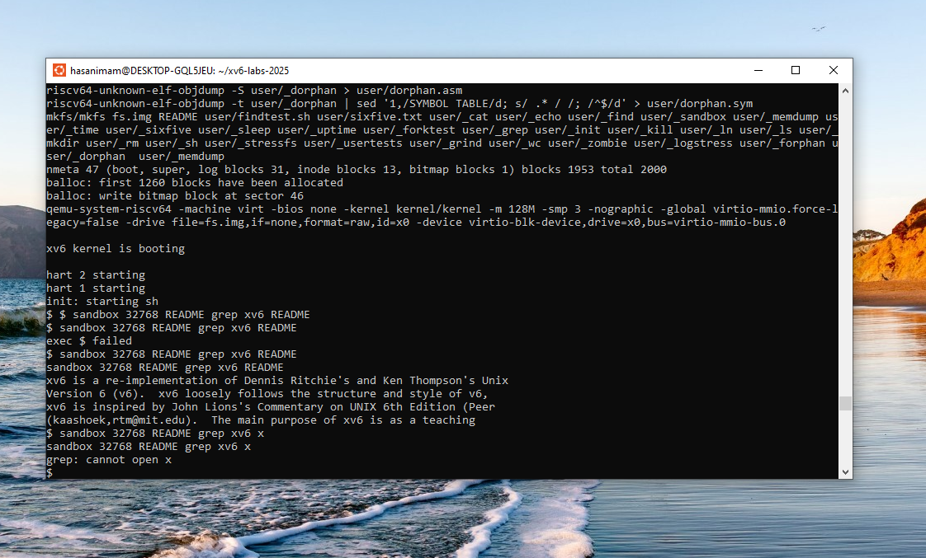
Q4
