Software Requirements Specification

for
InstaPulse – Social Media Content Optimization & Analytics System
Version 1.0 approved
Prepared by
Syed Hasan Nawaz (23i-0703) Muhammad Zain (23L-0712), Rabia (23F-0812), Mahad Bin Atif (22L-4951), Saim (21L-1897)
FAST NUCES
6 March 2026

Table of Contents
Table of Contents ii
Revision History ii
1. Introduction 1
1.1 Purpose 1
1.2 Document Conventions 1
1.3 Intended Audience and Reading Suggestions 1
1.4 Product Scope 1
1.5 References 1
2. Overall Description 2
2.1 Product Perspective 2
2.2 Product Functions 2
2.3 User Classes and Characteristics 2
2.4 Operating Environment 2
2.5 Design and Implementation Constraints 2
2.6 User Documentation 2
2.7 Assumptions and Dependencies 3
3. External Interface Requirements 3
3.1 User Interfaces 3
3.2 Hardware Interfaces 3
3.3 Software Interfaces 3
3.4 Communications Interfaces 3
4. System Features 4
4.1 System Feature 1 4
4.2 System Feature 2 (and so on) 4
5. Other Nonfunctional Requirements 4
5.1 Performance Requirements 4
5.2 Safety Requirements 5
5.3 Security Requirements 5
5.4 Software Quality Attributes 5
5.5 Business Rules 5
6. Other Requirements 5
Appendix A: Glossary 5
Appendix B: Analysis Models 5
Appendix C: To Be Determined List 6

Revision History
Name | Date | Reason For Changes | Version
Project Team | 5 March 2026 | Initial creation and baseline approval of the Software Requirements Specification document. | 1.0
Project Team | 9 March 2026 | Added UI mockups and UML/Analysis diagrams | 1.1

Introduction

Purpose

The purpose of this document is to define the software requirements for InstaPulse, a web-based social media content optimization and analytics system. The system acts as a Decision Support System (DSS) designed to help users evaluate and optimize content parameters prior to publishing.

Document Conventions
This document follows standard IEEE software requirement specification formatting. High-level feature priorities (e.g., High, Medium, Low) are assumed to be inherited by their detailed functional sub-requirements unless otherwise stated.

Intended Audience and Reading Suggestions
This document is intended for a diverse technical and strategic audience involved in the development, testing, and product management of the InstaPulse system. The primary readers include Software Engineers, Quality Assurance (QA) Testers, Product Managers, and Digital Marketing Strategists.

Product Scope
InstaPulse provides a structured software application that combines content drafting, evaluation, and optimization into a single workflow. The system includes a simplified social media application clone to simulate a controlled environment for testing post creation, feed display, and user engagement. The project scope strictly excludes mobile application development and real-time integration with external social media APIs.

References
- Press, G. (2016). Cleaning Big Data: Most Time-Consuming, Least Enjoyable Data Science Task. Forbes.
- Hootsuite Inc. (2023). Social Media Management Platform Overview.
- Buffer Inc. (2023). Social Media Scheduling and Analytics Tools.
- Schwaiger, M., et al. (2021). UR: SMART – A Tool for Analyzing Social Media Content. Information Systems and e-Business Management.

Overall Description

Product Perspective
Currently, most existing platforms, such as Hootsuite and Buffer, provide analytics only after a post is published, leading to trial-and-error strategies. InstaPulse is a new, self-contained web system that shifts the focus from post-publication execution to pre-publication planning and decision support. It will operate alongside a custom-built social media clone to practically demonstrate system integration and test optimization rules.

Product Functions
- Provide a user login and profile-based dashboard.
- Allow users to input post details, including captions, hashtags, posting time, and media type.
- Process input data to generate predicted engagement estimates.
- Provide rule-based optimization suggestions for content parameters.
- Store previous sessions to allow for historical comparison and reporting.
- Simulate core social media features (user registration, feed display, and like/engagement simulation) via an integrated clone.

Use Case Diagram
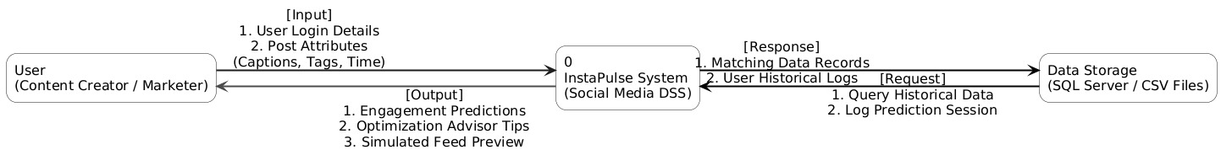

Context Diagram

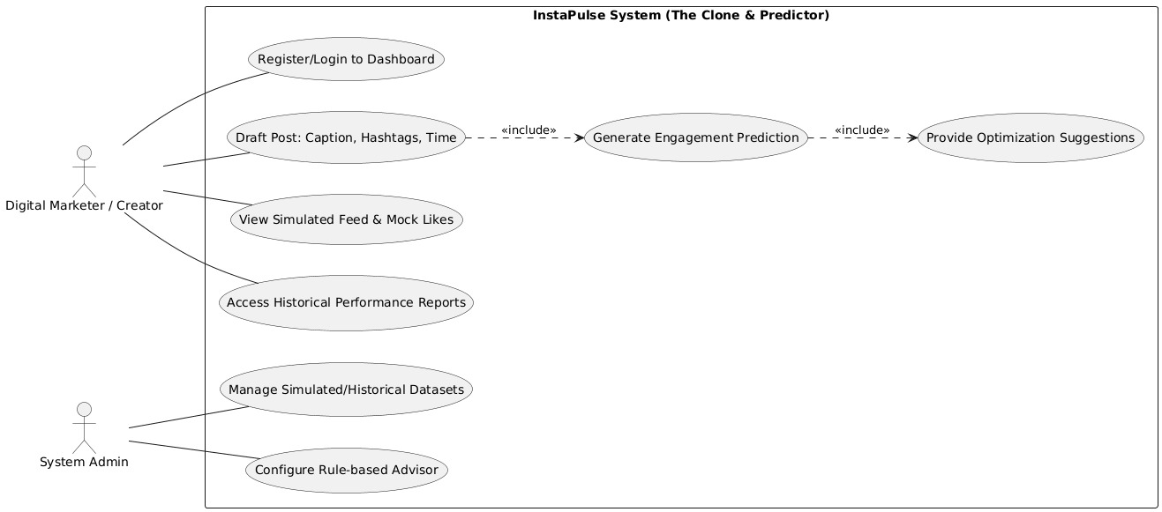

User Classes and Characteristics
The primary user classes for this software are content creators and digital marketers. They require a guided, step-by-step workflow during content planning to eliminate inefficient scheduling practices.

Operating Environment
The software will operate as a web-only system. It will utilize a console-based or minimal Graphical User Interface (GUI).

Design and Implementation Constraints
- Language: Development must be done in Python and/or C++.
- Database: Data storage is constrained to Microsoft SQL Server or CSV files.
- Architecture: The system must utilize a modular design that enforces a strict separation between input, processing, and data storage components.
- External APIs: The system will not integrate with live social media APIs; it must use simulated or historical datasets.

User Documentation
Given the system's focus on a user-centered workflow, user documentation will include a standard digital README file and a brief user manual. This documentation will guide users step-by-step on how to input their post details (captions, hashtags, etc.) and interpret the generated optimization suggestions.

Assumptions and Dependencies
- Users will input valid and realistic data for content evaluation.
- The system requires an active internet connection to function.
- The system's engagement predictions depend entirely on the provided simulated or historical datasets.

External Interface Requirements

User Interfaces
- The system will utilize a console-based or minimal Graphical User Interface (GUI).
- The interface must include a secure user login screen that leads to a profile-based dashboard.

Secure User Login Interface

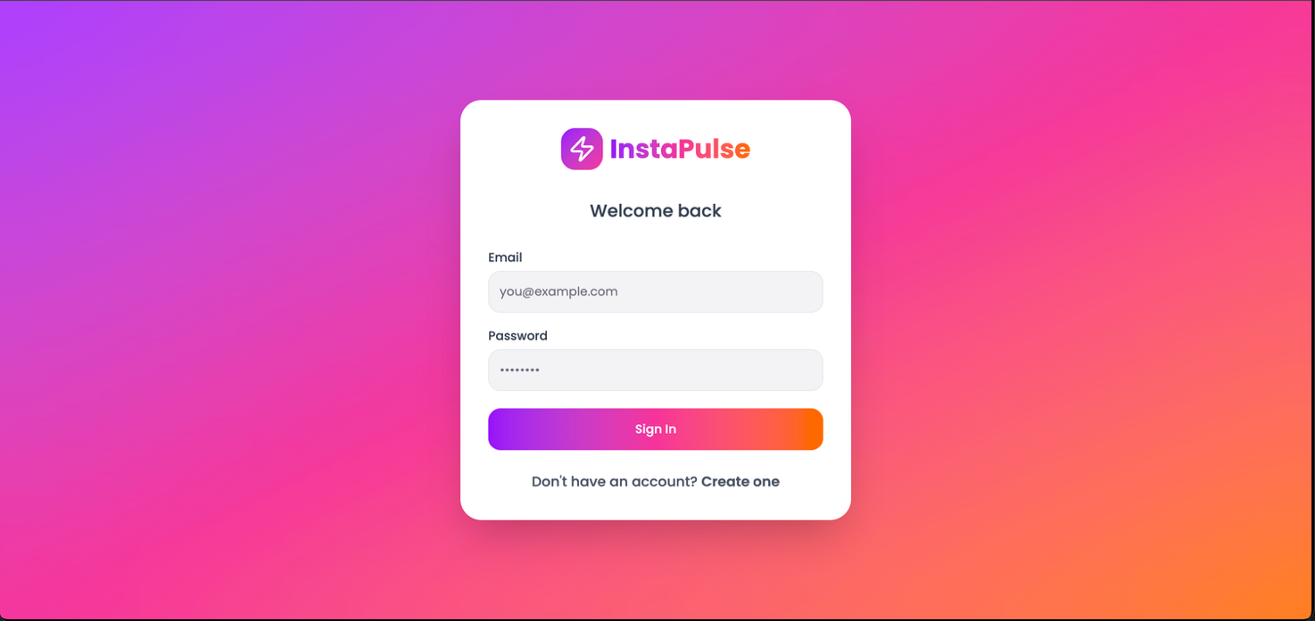

Main User Dashboard

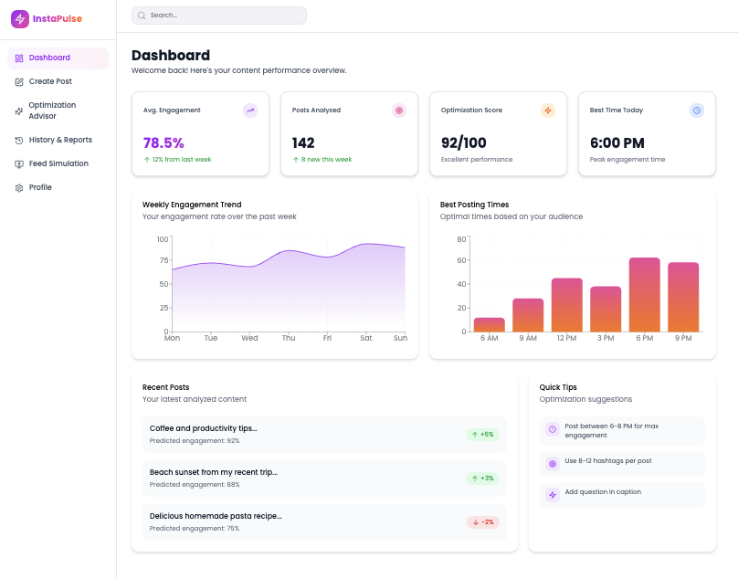
Profile Management Settings

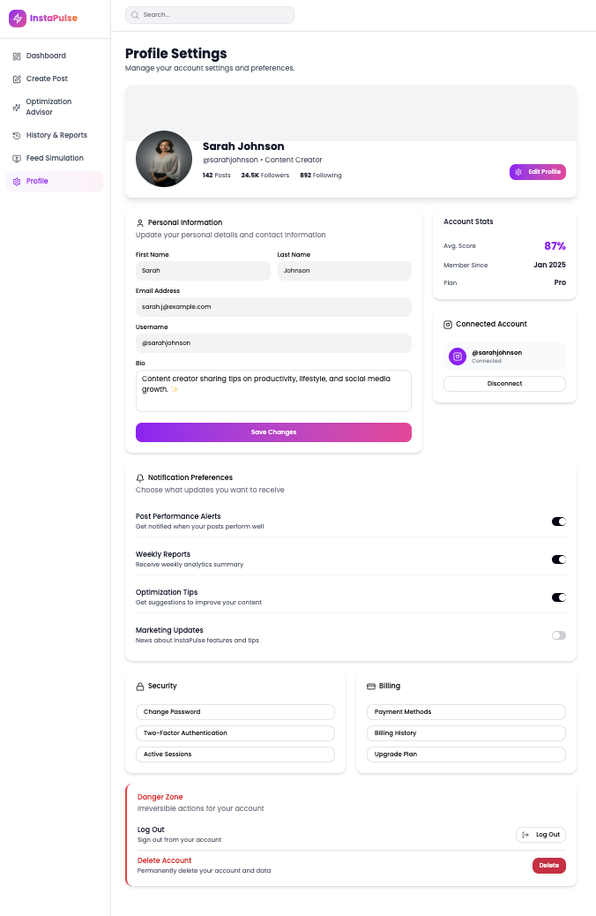

Dashboard Historical Reporting

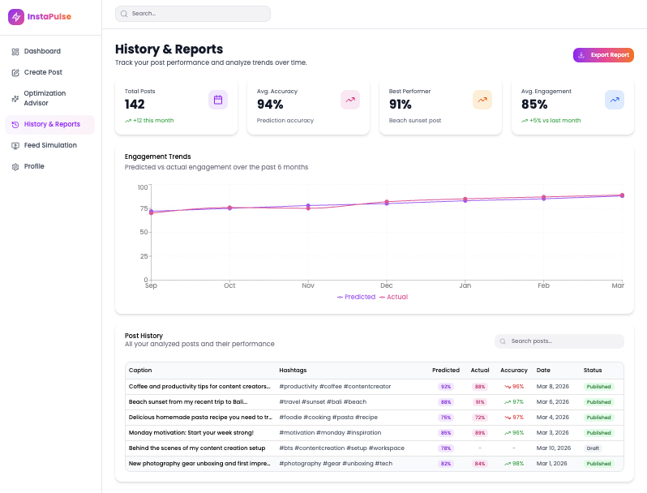

- A dedicated content input interface is required to allow users to easily input post details such as captions, hashtags, posting time, and media type.

Content Drafting and Input Interface

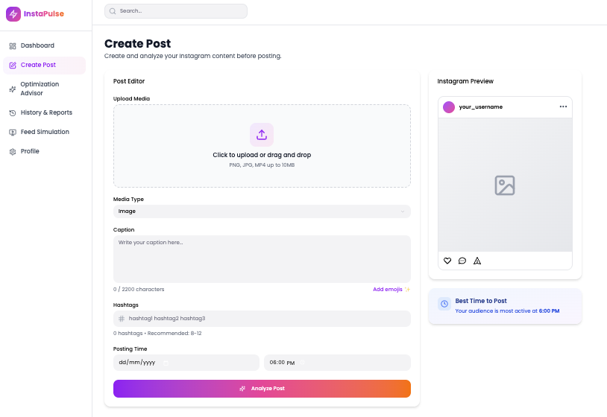

Rule-Based Optimization Suggestions

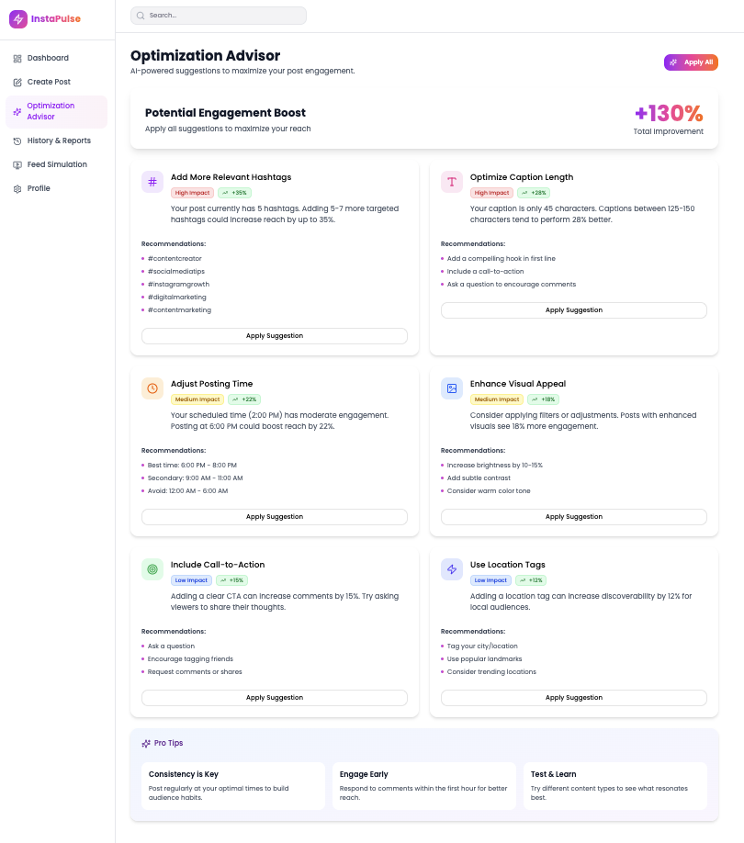

Post-Optimization Metrics

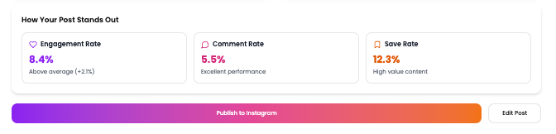

- The interface will feature a simulated feed display to test the social media clone functionality and view simulated engagement.

Simulated Social Media Clone Feed
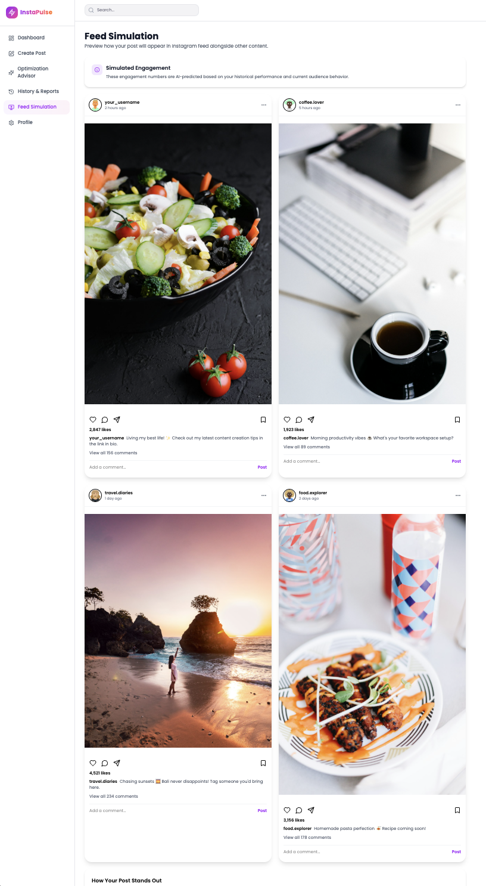

Hardware Interfaces
As a web-only application, InstaPulse does not require direct integration with any specialized hardware components. It will operate on standard computing hardware (PCs, laptops) capable of running a modern web browser and maintaining internet connectivity.

Software Interfaces
- Programming Languages: The system's core processing and backend logic will interface with Python and/or C++.
- Database/Storage: The system will interface with Microsoft SQL Server or utilize CSV files for data storage. This modular design separates data storage from input and processing.
- External APIs: The system strictly excludes real-time integration with Instagram or other live social media APIs. Instead, the software will interface with stored simulated or historical datasets to generate predictions.

Communications Interfaces
- The system requires standard internet connectivity to function properly.
- Standard web communication protocols (such as HTTP/HTTPS) will be utilized for secure interactions between the user interface frontend and the backend processing modules.

System Features
The functional requirements for the InstaPulse system are organized by major system features. This approach logically aligns with the system's modular architecture, dividing the functional capabilities into distinct components: User Management, Content Input, Processing & Analysis, the Optimization Advisor, History & Reporting, and the integrated Social Media App Clone.

4.1 User Management Module
- Handles user registration, login, and access to a profile-based dashboard.
4.2 Content Input Interface
- Allows users to draft posts by entering captions, selecting media types, applying hashtags, and choosing a posting time.
4.3 Processing & Analysis Module
- The backend logic that analyzes the drafted post before publishing and generates an engagement prediction.
4.4 Optimization Advisor
- Acts as a software-based consultant that provides rule-based suggestions to improve the user's content strategy.
4.5 History & Reporting Module
- Stores simulated engagement results and previous user sessions to allow for historical comparison.
4.6 Social Media App Clone Simulation
- A simulated environment that displays a feed and mimics likes and engagements to test the InstaPulse system.

Other Nonfunctional Requirements

Performance Requirements
- Processing Speed: The Processing & Analysis Module must evaluate input parameters and generate engagement predictions within 5 seconds of the user submitting a post draft.
- Database Optimization: Queries made to the Microsoft SQL Server or CSV datasets must be optimized to ensure that historical reports and dashboard data load without noticeable lag.

Safety Requirements
- Because InstaPulse is a software-based Decision Support System, physical safety hazards are not applicable.
- Software safety will focus entirely on data integrity, ensuring that user sessions, inputs, and historical comparisons are not lost or corrupted during backend processing.

Security Requirements
- Authentication: A secure user login mechanism is required to access the dashboard and Optimization Advisor.
- Data Isolation: User sessions must be strictly isolated so that one user cannot view the historical reports or drafted content of another user.
- Input Validation: All user inputs (captions, hashtags) must be sanitized to prevent common web vulnerabilities, such as SQL injection (since SQL Server is utilized) or Cross-Site Scripting (XSS).

Software Quality Attributes
- Maintainability & Modularity: The system architecture must enforce a strict separation of concerns (Input, Processing, Data Storage). This ensures that the optimization rules or datasets can be updated in the future without breaking the frontend interface.
- Usability: The system must act as a software-based consultant. The workflow must be highly intuitive, guiding non-technical digital marketers step-by-step through the pre-publication evaluation.
- Reliability: The underlying algorithm must be deterministic; identical post inputs (same caption, time, hashtags, media) processed against the same historical dataset must consistently yield the exact same predicted engagement results.

Business Rules
- Only registered and authenticated users are permitted to utilize the Optimization Advisor and historical reporting modules.
- System predictions and optimization suggestions must strictly rely on the provided historical or simulated datasets, adhering to the project constraint that prohibits the use of live social media platform APIs.

Other Requirements
Database Requirements:
- The system must support data persistence using either Microsoft SQL Server or standard CSV files.
- The database architecture must be decoupled from the application logic to allow for modular updates to the simulated social media datasets without requiring codebase refactoring.

Appendix A: Glossary
- CSV (Comma-Separated Values): A simple file format used to store tabular data, such as spreadsheets or databases.
- DSS (Decision Support System): An information system that supports business or organizational decision-making activities. In InstaPulse, it refers to the workflow that helps users plan content before posting.
- GUI (Graphical User Interface): A visual way of interacting with a computer using items such as windows, icons, and menus.
- Optimization Advisor: The specific module within InstaPulse that acts as a software-based consultant, providing rule-based suggestions for content improvement.
- Social Media Clone: A simplified, simulated social media environment built to test InstaPulse's predictions and display mock feeds and engagement.
Appendix B: Analysis Models

Class Diagram
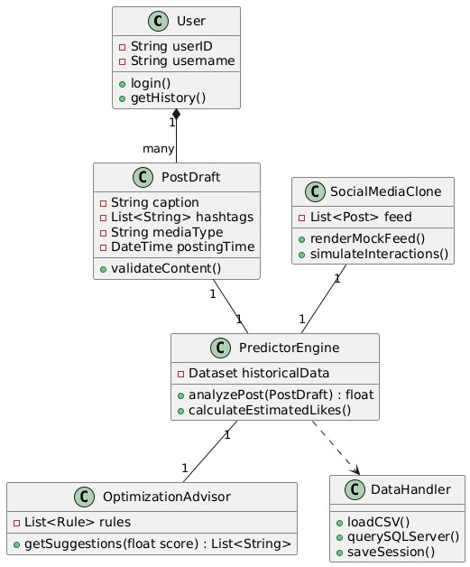

Level 1 Data Flow Diagram
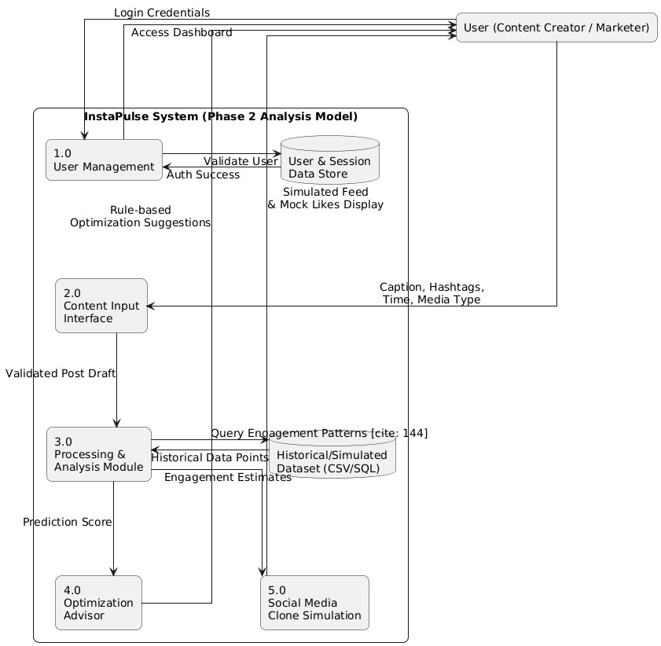

Appendix C: To Be Determined List
- The specific formulas and mathematical weights used by the rule-based Optimization Advisor to calculate predicted engagement.
- The exact UI layout and visual aesthetic of the simulated Social Media App Clone feed.
- The final decision between using Microsoft SQL Server versus CSV files for the primary data storage solution.

