|  |  |
| --- | --- |
| **Ex No: 1**  **Date: 16th August 2024** | **Implementing a Multi-Class Classification Model using Gradient Descent** |

**Objective:** To build a softmax regression classifier to recognize different types of flowers using gradient descent implementation.

**Descriptions:**  
 Multi-class classification involves assigning elements of a given set into more than two distinct groups. Softmax regression, also called multinomial logistic regression, extends logistic regression for use when there are multiple classes. In this context, the task is to classify images of flowers into one of several categories.

Given an input image x, the output y is a label that identifies the type of flower. Each class represents a specific flower category, and the model aims to predict the probability that the image belongs to each of these categories.

In a softmax regression model, there is no hidden layer. The output is computed by applying the softmax function to a linear combination of the input features. The model's parameters are optimized using the gradient descent algorithm.

**Model:**

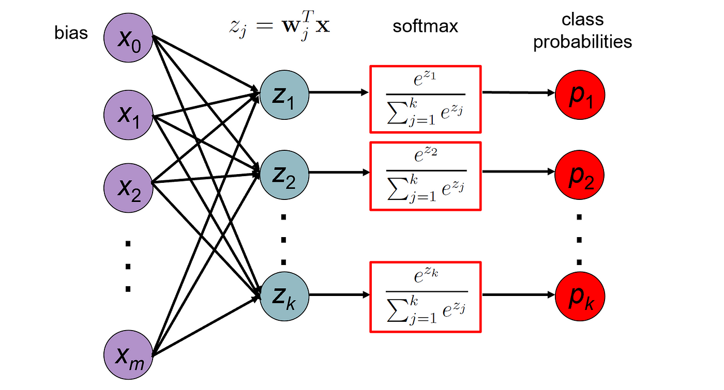

Image Source : [Click here](https://towardsdatascience.com/deep-dive-into-softmax-regression-62deea103cb8)

**Building the parts of the algorithm**

The main steps for building the Softmax Regression Model are:

1. Define the model structure (such as number of input features and classes).

There are 128 input features and 5 classes present in the given files

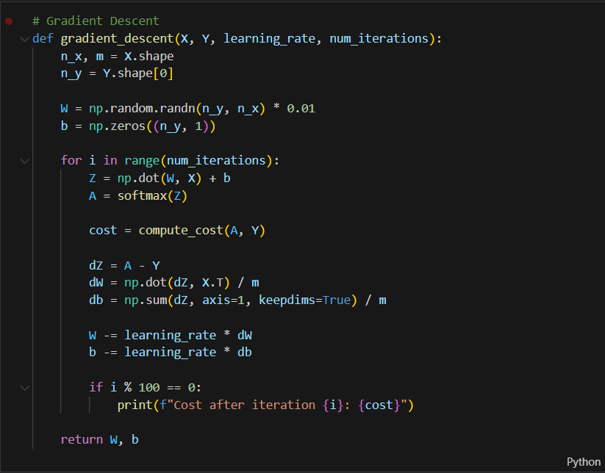

1. Initialize the model's parameters.



1. Loop:

* Calculate current loss (forward propagation using the softmax activation function).

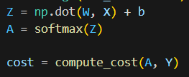

* Calculate current gradient (backward propagation).

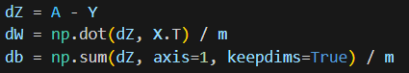

* Update parameters (gradient descent).



**GitHub Link:** [**https://github.com/SyedHashirA/deeplearning**](https://github.com/SyedHashirA/deeplearning)