|  |  |
| --- | --- |
| **Ex No: 10**  **Date: 23th October 2024** | **Deploy on AWS- source code link** |

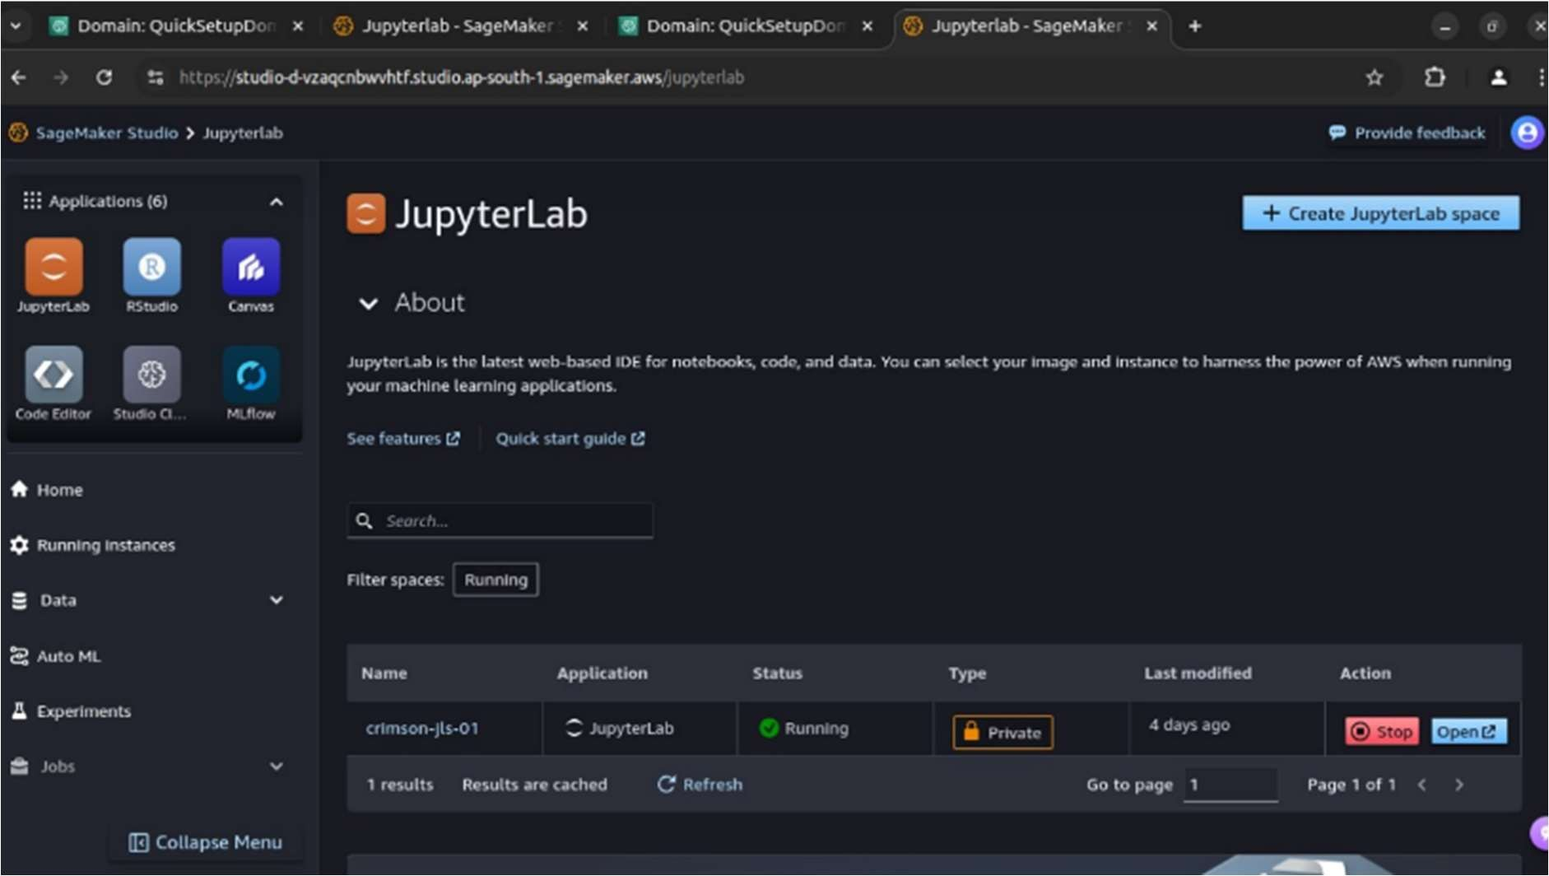

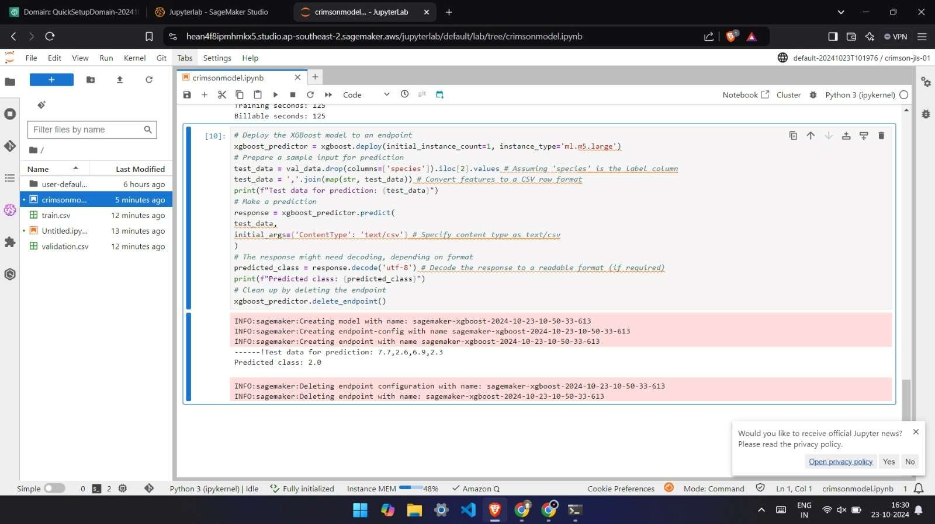

**GitHub Link**[**: https://github.com/SyedHashirA/deeplearning**](https://github.com/SyedHashirA/deeplearning)