Syed Hussain

Project_1

Empl# 23466869

Software design

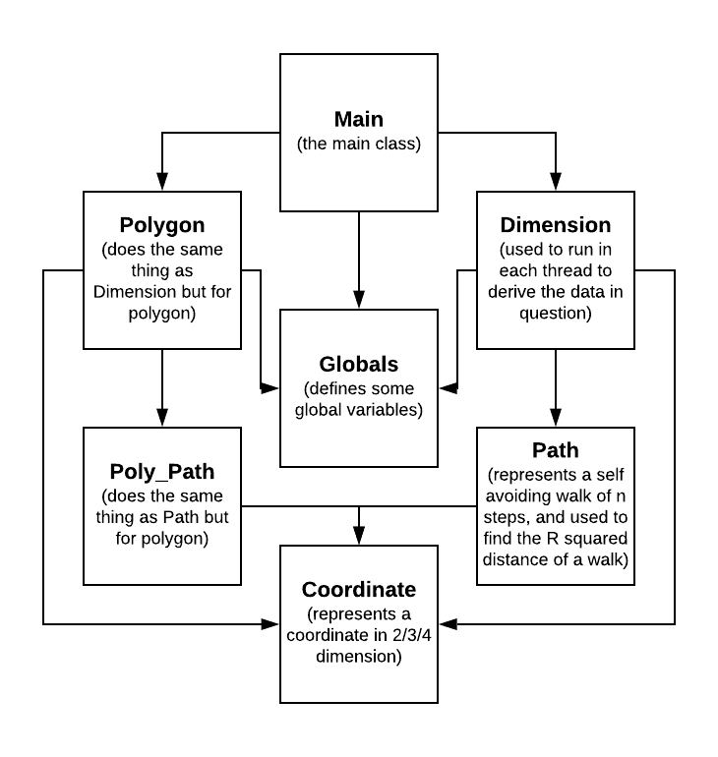

Optimizations

Implementation of efficient algorithms and data structures are key to write a fast and good program. Each thread is writing some values to CopyOnWriteArrayList<Double> that is initialized in Main class. After waiting for all the threads, the R squared average is calculated by looping over the CopyOnWriteArrayList<Double>. This substantially slows down the program. Instead of using a list to do that, Atomic double can be used to store the values. This removes the need for using a loop; this also saves a lot of memory allocation. However, there is no native implementation of atomic double, which means a separate implementation of atomic double is required.

The program can also make use of Java’s ThreadPool feature. Instead of manually creating and waiting for threads, a threadpool can be used to manage all the threads, which would reduce the complexity of the program, as well as enhancing the performance of the program.

Graph & Analysis

---------------------------------------------- 2D ------------------------------------------------------

|  |  |  |
| --- | --- | --- |
| n | R^2 | F_SAW |
| 10 | 26.22758 | 0.042023 |
| 11 | 30.02684 | 0.028734 |
| 12 | 34.18718 | 0.019425 |
| 13 | 38.30438 | 0.013125 |
| 14 | 42.84414 | 0.008779 |
| 15 | 47.32667 | 0.005966 |
| 16 | 51.92739 | 0.004019 |
| 17 | 56.54285 | 0.0027 |
| 18 | 61.55607 | 0.001812 |
| 19 | 66.60454 | 0.001215 |
| 20 | 71.30868 | 8.11E-04 |
| 21 | 77.02625 | 5.64E-04 |
| 22 | 82.46183 | 3.64E-04 |
| 23 | 88.63636 | 2.43E-04 |
| 24 | 92.90742 | 1.63E-04 |
| 25 | 98.17329 | 1.11E-04 |
| 26 | 109.2121 | 7.26E-05 |
| 27 | 113.345 | 4.87E-05 |
| 28 | 112.3882 | 3.40E-05 |
| 29 | 128.5 | 2.08E-05 |
| 30 | 129.7121 | 1.32E-05 |
| 31 | 142.0204 | 9.80E-06 |
| 32 | 149.4688 | 6.40E-06 |
| 33 | 160.0769 | 3.90E-06 |
| 34 | 172.9714 | 3.50E-06 |
| 35 | 167.7273 | 2.20E-06 |
| 36 | 168.7059 | 1.70E-06 |
| 37 | 237 | 1.20E-06 |
| 38 | 112.5 | 4.00E-07 |
| 39 | 101.5714 | 7.00E-07 |
| 40 | 149.5 | 4.00E-07 |

α = 0.0584

β = 0.394

---------------------------------------------- 3D ------------------------------------------------------

|  |  |  |
| --- | --- | --- |
| n | R^2 | F_SAW |
| 10 | 16.82764 | 0.145674 |
| 11 | 18.84868 | 0.115503 |
| 12 | 20.94898 | 0.091591 |
| 13 | 23.01846 | 0.072261 |
| 14 | 25.24213 | 0.057077 |
| 15 | 27.40467 | 0.045039 |
| 16 | 29.63386 | 0.035458 |
| 17 | 31.81298 | 0.027966 |
| 18 | 34.13592 | 0.021969 |
| 19 | 36.43763 | 0.017291 |
| 20 | 38.75622 | 0.013641 |
| 21 | 40.97303 | 0.010775 |
| 22 | 43.31118 | 0.008416 |
| 23 | 45.806 | 0.006636 |
| 24 | 47.97634 | 0.00519 |
| 25 | 50.82054 | 0.004096 |
| 26 | 52.9715 | 0.003218 |
| 27 | 55.28694 | 0.002519 |
| 28 | 58.0006 | 0.002007 |
| 29 | 60.96319 | 0.001549 |
| 30 | 62.79853 | 0.001226 |
| 31 | 64.87597 | 9.71E-04 |
| 32 | 68.49873 | 7.47E-04 |
| 33 | 72.36769 | 5.92E-04 |
| 34 | 72.98041 | 4.59E-04 |
| 35 | 75.37333 | 3.60E-04 |
| 36 | 77.4835 | 2.79E-04 |
| 37 | 81.18611 | 2.16E-04 |
| 38 | 86.32583 | 1.87E-04 |
| 39 | 90.13305 | 1.40E-04 |
| 40 | 89.26905 | 1.09E-04 |

α = 0.0529

β = 0.241

---------------------------------------------- 4D ------------------------------------------------------

|  |  |  |
| --- | --- | --- |
| n | R^2 | F_SAW |
| 10 | 14.01874 | 0.257835 |
| 11 | 15.57763 | 0.219559 |
| 12 | 17.15903 | 0.186882 |
| 13 | 18.71581 | 0.159265 |
| 14 | 20.32162 | 0.135164 |
| 15 | 21.93785 | 0.115004 |
| 16 | 23.52346 | 0.097728 |
| 17 | 25.12618 | 0.083064 |
| 18 | 26.77229 | 0.070637 |
| 19 | 28.42739 | 0.059987 |
| 20 | 30.07547 | 0.050844 |
| 21 | 31.69847 | 0.043176 |
| 22 | 33.32011 | 0.036745 |
| 23 | 35.04837 | 0.031128 |
| 24 | 36.66497 | 0.026564 |
| 25 | 38.23924 | 0.022469 |
| 26 | 40.01076 | 0.019055 |
| 27 | 41.71163 | 0.016102 |
| 28 | 43.50243 | 0.013696 |
| 29 | 44.97009 | 0.011576 |
| 30 | 46.84151 | 0.009814 |
| 31 | 48.49247 | 0.008348 |
| 32 | 50.09822 | 0.00709 |
| 33 | 51.68154 | 0.006042 |
| 34 | 53.54413 | 0.005139 |
| 35 | 55.25056 | 0.004301 |
| 36 | 56.97188 | 0.003655 |
| 37 | 58.78385 | 0.003115 |
| 38 | 60.28856 | 0.002625 |
| 39 | 61.98776 | 0.002247 |
| 40 | 63.61058 | 0.001886 |

α = 0.0477

β = 0.164

------------------------------------ 2D Polygon -----------------------------------------------------

|  |  |
| --- | --- |
| n | F_SAP |
| 2 | 0.24986 |
| 4 | 0.07827 |
| 6 | 0.013609 |
| 8 | 0.002543 |
| 10 | 7.52E-04 |
| 12 | 2.41E-04 |
| 14 | 8.73E-05 |
| 16 | 3.28E-05 |
| 18 | 1.15E-05 |
| 20 | 4.50E-06 |
| 22 | 1.50E-06 |
| 24 | 2.00E-07 |
| 26 | 2.00E-07 |
| 28 | 1.00E-07 |
| 30 | 0 |
| 32 | 0 |
| 34 | 0 |
| 36 | 0 |
| 38 | 0 |
| 40 | 0 |

ϒ = 0.573

------------------------------------ 3D Polygon -----------------------------------------------------

|  |  |
| --- | --- |
| n | F_SAP |
| 2 | 0.166524 |
| 4 | 0.041605 |
| 6 | 0.009775 |
| 8 | 0.003275 |
| 10 | 0.001259 |
| 12 | 5.29E-04 |
| 14 | 2.48E-04 |
| 16 | 1.16E-04 |
| 18 | 5.89E-05 |
| 20 | 2.64E-05 |
| 22 | 1.67E-05 |
| 24 | 7.50E-06 |
| 26 | 2.70E-06 |
| 28 | 2.00E-06 |
| 30 | 8.00E-07 |
| 32 | 7.00E-07 |
| 34 | 3.00E-07 |
| 36 | 2.00E-07 |
| 38 | 1.00E-07 |
| 40 | 1.00E-07 |

ϒ = 0.367

------------------------------------ 4D Polygon -----------------------------------------------------

|  |  |
| --- | --- |
| n | F_SAP |
| 2 | 0.156268 |
| 4 | 0.04157 |
| 6 | 0.012779 |
| 8 | 0.005568 |
| 10 | 0.002765 |
| 12 | 0.001469 |
| 14 | 8.24E-04 |
| 16 | 4.81E-04 |
| 18 | 2.89E-04 |
| 20 | 1.76E-04 |
| 22 | 1.04E-04 |
| 24 | 6.75E-05 |
| 26 | 4.31E-05 |
| 28 | 2.70E-05 |
| 30 | 1.66E-05 |
| 32 | 1.07E-05 |
| 34 | 6.10E-06 |
| 36 | 4.60E-06 |
| 38 | 3.70E-06 |
| 40 | 2.10E-06 |

ϒ = 0.271