SMARTUPIFRAUDDETECT: AN INTELLIGENT ML-BASED SYSTEM FOR IDENTIFYING ANOMALIES IN UPI PAYMENT NETWORKS
TABLE OF CONTENT
SL.NO | TITLE | PAGE.NO
01 | ABSTRACT
02 | EXISTING SYSTEM  2.1 DRAWBACKS
03 | INTRODUCTION  3.1 DATA SCIENCE  3.2 ARTIFICIAL INTELLIGENCE
04 | MACHINE LEARNING
05 | PREPARING DATASET
06 | PROPOSED SYSTEM  6.1 ADVANTAGES
07 | LITERATURE SURVEY
08 | SYSTEM STUDY  8.1 OBJECTIVES  8.2 PROJECT GOAL  8.3 SCOPE OF THE PROJECT
09 | FEASIBILITY STUDY
10 | LIST OF MODULES
11 | PROJECT REQUIREMENTS  11.1 FUNCTIONAL REQUIREMENTS  11.2 NON-FUNCTIONAL REQUIREMENTS
12 | ENVIRONMENT REQUIREMENT
13 | SOFTWARE DESCRIPTION  13.1 ANACONDA NAVIGATOR  13.2 JUPYTER NOTEBOOK
14 | PYTHON
15 | SYSTEM ARCHITECTURE
16 | WORKFLOW DIAGRAM
17 | USECASE DIAGRAM
18 | CLASS DIAGRAM
19 | ACTIVITY DIAGRAM
20 | SEQUENCE DIAGRAM
21 | ER – DIAGRAM
22 | MODULE DESCRIPTION  22.1 MODULE DIAGRAM  22.2 MODULE GIVEN INPUT EXPECTED OUTPUT
23 | DEPLOYMENT
24 | HTML
25 | CSS
26 | CODING
27 | CONCLUSION
28 | FUTURE WORK

LIST OF FIGURES
SL.NO | TITLE | PAGE.NO
01 | SYSTEM ARCHITECTURE
02 | WORKFLOW DIAGRAM
03 | USECASE DIAGRAM
04 | CLASS DIAGRAM
05 | ACTIVITY DIAGRAM
06 | SEQUENCE DIAGRAM
07 | ER – DIAGRAM
08 | MODULE DIAGRAM

LIST OF SYMBOLS
S.NO | NOTATION  NAME | NOTATION | DESCRIPTION
1. | Class | Class Name  -attribute  -attribute  +operation  +operation  +operation  + public  -private  # protected | Represents a collection of similar entities grouped together.
2. | Association | nAME  Class B  Class A  Class B  Class A | Associations represents static relationships between classes. Roles representsthe way the two classes see each other.
3. | Actor | Class A  Class A  Class B  Class B | It aggregates several classes into a single classes.
4. | Aggregation | Class A  Class A  Class B  Class B | Interaction between the system and external environment

5. | Relation  (uses) | uses | Used for additional process communication.
6. | Relation  (extends) | EXTENDS | Extends relationship is used when one use case is similar to another use case but does a bit more.
7. | Communication |  | Communication between various use cases.
8. | State | State | State of the processs.
9. | Initial State |  | Initial state of the object
10. | Final state |  | Final state of the object
11. | Control flow |  | Represents various control flow between the states.
12. | Decision box |  | Represents decision making process from a constraint
13. | Usecase | Usescase | Interact ion between the system and external environment.
14. | Component |  | Represents physical modules which is a collection of components.
15. | Node |  | Represents physical modules which are a collection of components.
16. | Data Process/State |  | A circle in DFD represents a state or process which has been triggered due to some event or acion.
17. | External entity |  | Represents external entities such as keyboard,sensors,etc.
18. | Transition |  | Represents communication that occurs between processes.
19. | Object Lifeline |  | Represents the vertical dimensions that the object communications.
20. | Message | Message | Represents the message exchanged.

ABSTRACT:
With the rapid growth of digital payments, the Unified Payments Interface (UPI) has become a popular and convenient method for financial transactions in India. However, this widespread adoption has also led to a significant rise in fraudulent activities within the payment ecosystem. This project introduces SMARTUPIFRAUDDETECT, a machine learning-powered system designed to detect suspicious patterns and flag potentially fraudulent UPI transactions. The system analyzes key transaction features such as amount, frequency, transaction type, and user behavior to identify anomalies that deviate from normal financial activities. A user-friendly web application built using the Django framework enables seamless interaction, allowing stakeholders to upload transaction data, view flagged cases, and understand risk patterns through intuitive visualizations. By enhancing the transparency and security of UPI payments, this system serves as a valuable tool in safeguarding digital financial infrastructure.
EXISTING SYSTEM:
Credit card fraud is a severe issue that causes significant losses for both cardholders and issuing banks. Existing methods utilize machine learning-based classifiers to identify fraudulent transactions from labeled transaction records. However, labeled data are often scarce compared to the billions of real transactions due to the high cost of annotation, which means that previous methods do not fully utilize the rich features of unlabeled data. What’s more, contemporary methods succumb to a fallacy of unawareness of the local risk structure and the inability to capture certain risk patterns. Therefore, we propose the Risk-aware Gated Temporal Attention Network (RGTAN) for fraud detection in this work. Specifically, we first build a temporal transaction graph based on the transaction records, which consists of temporal transactions (nodes) and their interactions (edges). Then we leverage a Gated Temporal Graph Attention (GTGA) Mechanism to propagate messages among the nodes and learn adaptive representations of transactions. We also model the fraud patterns through risk propagation, taking advantage of the relations among transactions. More importantly, we devise a neighbor risk-aware representation learning layer to enhance our method’s perception of multi-hop risk structures. We conduct extensive experiments on a real-world credit card transaction dataset and two public fraud detection datasets. The results show that our proposed method, RGTAN, outperforms other state-of-the-art methods on three fraud detection datasets. The risk-aware semi-supervised experiments also demonstrate the excellent performance of our model with only a small fraction of manually labeled data. Moreover, RGTAN has been deployed in a world-leading credit card issuer for credit card fraud detection, and the case study results show the effectiveness of our method in uncovering real-world fraud patterns.
DISADVANTAGES:
- Requires complex graph-based modeling, increasing system implementation and maintenance effort.
- Depends on temporal graph construction, which may not scale efficiently with massive transaction volumes.
- Still needs some labeled data, limiting performance in completely unlabeled or new domains.
- Gated Temporal Attention mechanisms add computational overhead during training and inference.
- Local risk structure modeling may lead to false positives in highly dynamic or diverse transaction environments.

3. INTRODUCTION:
In the realm of financial transactions, UPI (Unified Payments Interface) fraud prediction has become a critical area of research, driven by the increasing sophistication of fraud schemes. This project focuses on leveraging advanced machine learning techniques to detect UPI transaction fraud effectively. The process begins with data preprocessing, which involves cleaning the data, handling missing values, encoding categorical variables, and normalizing features to prepare the dataset for model training. Next, data visualization plays a vital role in exploring the patterns, correlations, and trends within the data, helping to identify key features that distinguish fraudulent transactions from legitimate ones. Various machine learning algorithms such as decision trees, random forests, support vector machines, and neural networks are employed to build predictive models. The models are evaluated based on their performance metrics, and the one with the highest accuracy is selected for deployment, ensuring robust fraud detection in UPI transactions.

3.1 Data Science:
Data science is an interdisciplinary field that uses scientific methods, processes, algorithms and systems to extract knowledge and insights from structured and unstructured data, and apply knowledge and actionable insights from data across a broad range of application domains.
The term "data science" has been traced back to 1974, when Peter Naur proposed it as an alternative name for computer science. In 1996, the International Federation of Classification Societies became the first conference to specifically feature data science as a topic. However, the definition was still in flux.
The term “data science” was first coined in 2008 by D.J. Patil, and Jeff Hammerbacher, the pioneer leads of data and analytics efforts at LinkedIn and Facebook. In less than a decade, it has become one of the hottest and most trending professions in the market.
Data science is the field of study that combines domain expertise, programming skills, and knowledge of mathematics and statistics to extract meaningful insights from data.
Data science can be defined as a blend of mathematics, business acumen, tools, algorithms and machine learning techniques, all of which help us in finding out the hidden insights or patterns from raw data which can be of major use in the formation of big business decisions.

Data Scientist:
Data scientists examine which questions need answering and where to find the related data. They have business acumen and analytical skills as well as the ability to mine, clean, and present data. Businesses use data scientists to source, manage, and analyze large amounts of unstructured data.
Required Skills for a Data Scientist:
- Programming: Python, SQL, Scala, Java, R, MATLAB.
- Machine Learning: Natural Language Processing, Classification, Clustering.
- Data Visualization: Tableau, SAS, D3.js, Python, Java, R libraries.
- Big data platforms: MongoDB, Oracle, Microsoft Azure, Cloudera.

3.2 Artificial Intelligence:
Artificial intelligence (AI) refers to the simulation of human intelligence in machines that are programmed to think like humans and mimic their actions. The term may also be applied to any machine that exhibits traits associated with a human mind such as learning and problem-solving.
Artificial intelligence (AI) is intelligence demonstrated by machines, as opposed to the natural intelligence displayed by humans or animals. Leading AI textbooks define the field as the study of "intelligent agents" any system that perceives its environment and takes actions that maximize its chance of achieving its goals. Some popular accounts use the term "artificial intelligence" to describe machines that mimic "cognitive" functions that humans associate with the human mind, such as "learning" and "problem-solving", however, this definition is rejected by major AI researchers.
Artificial intelligence is the simulation of human intelligence processes by machines, especially computer systems. Specific applications of AI include expert systems, natural language processing, speech recognition and machine vision.
AI applications include advanced web search engines, recommendation systems (used by Youtube, Amazon and Netflix), Understanding human speech (such as Siri or Alexa), self-driving cars (e.g. Tesla), and competing at the highest level in strategic game systems (such as chess and Go), As machines become increasingly capable, tasks considered to require "intelligence" are often removed from the definition of AI, a phenomenon known as the AI effect. For instance, optical character recognition is frequently excluded from things considered to be AI, having become a routine technology.
Artificial intelligence was founded as an academic discipline in 1956, and in the years since has experienced several waves of optimism, followed by disappointment and the loss of funding (known as an "AI winter"), followed by new approaches, success and renewed funding. AI research has tried and discarded many different approaches during its lifetime, including simulating the brain, modeling human problem-solving, formal logic, large databases of knowledge, and imitating animal behavior. In the first decades of the 21st century, highly mathematical statistical machine learning has dominated the field, and this technique has proved highly successful, helping to solve many challenging problems throughout industry and academia.
The various sub-fields of AI research are centered on particular goals and the use of particular tools. The traditional goals of AI research include reasoning, knowledge representation, planning, learning, natural language processing, perception and the ability to move and manipulate objects. General intelligence (the ability to solve an arbitrary problem) is among the field's long-term goals. To solve these problems, AI researchers use versions of search and mathematical optimization, formal logic, artificial neural networks, and methods based on statistics, probability, and economics. AI also draws upon computer science, psychology, linguistics, philosophy, and many other fields.
The field was founded on the assumption that human intelligence "can be so precisely described that a machine can be made to simulate it". This raises philosophical arguments about the mind and the ethics of creating artificial beings endowed with human-like intelligence. These issues have been explored by myth, fiction and philosophy since antiquity. Science fiction and futurology have also suggested that, with its enormous potential and power, AI may become an existential risk to humanity.
As the hype around AI has accelerated, vendors have been scrambling to promote how their products and services use AI. Often what they refer to as AI is simply one component of AI, such as machine learning. AI requires a foundation of specialized hardware and software for writing and training machine learning algorithms. No one programming language is synonymous with AI, but a few, including Python, R and Java, are popular.
In general, AI systems work by ingesting large amounts of labeled training data, analyzing the data for correlations and patterns, and using these patterns to make predictions about future states. In this way, a chatbot that is fed examples of text chats can learn to produce life like exchanges with people, or an image recognition tool can learn to identify and describe objects in images by reviewing millions of examples.
AI programming focuses on three cognitive skills: learning, reasoning and self-correction.
Learning processes. This aspect of AI programming focuses on acquiring data and creating rules for how to turn the data into actionable information. The rules, which are called algorithms, provide computing devices with step-by-step instructions for how to complete a specific task.
Reasoning processes. This aspect of AI programming focuses on choosing the right algorithm to reach a desired outcome.
Self-correction processes. This aspect of AI programming is designed to continually fine-tune algorithms and ensure they provide the most accurate results possible.
AI is important because it can give enterprises insights into their operations that they may not have been aware of previously and because, in some cases, AI can perform tasks better than humans. Particularly when it comes to repetitive, detail-oriented tasks like analyzing large numbers of legal documents to ensure relevant fields are filled in properly, AI tools often complete jobs quickly and with relatively few errors.
Artificial neural networks and deep learning artificial intelligence technologies are quickly evolving, primarily because AI processes large amounts of data much faster and makes predictions more accurately than humanly possible.

4. MACHINE LEARNING

Machine learning is to predict the future from past data. Machine learning (ML) is a type of artificial intelligence (AI) that provides computers with the ability to learn without being explicitly programmed. Machine learning focuses on the development of Computer Programs that can change when exposed to new data and the basics of Machine Learning, implementation of a simple machine learning algorithm using python. Process of training and prediction involves use of specialized algorithms. It feed the training data to an algorithm, and the algorithm uses this training data to give predictions on a new test data. Machine learning can be roughly separated in to three categories. There are supervised learning, unsupervised learning and reinforcement learning. Supervised learning program is both given the input data and the corresponding labelling to learn data has to be labelled by a human being beforehand. Unsupervised learning is no labels. It provided to the learning algorithm. This algorithm has to figure out the clustering of the input data. Finally, Reinforcement learning dynamically interacts with its environment and it receives positive or negative feedback to improve its performance.
Data scientists use many different kinds of machine learning algorithms to discover patterns in python that lead to actionable insights. At a high level, these different algorithms can be classified into two groups based on the way they “learn” about data to make predictions: supervised and unsupervised learning. Classification is the process of predicting the class of given data points. Classes are sometimes called as targets/ labels or categories. Classification predictive modeling is the task of approximating a mapping function from input variables(X) to discrete output variables(y). In machine learning and statistics, classification is a supervised learning approach in which the computer program learns from the data input given to it and then uses this learning to classify new observation. This data set may simply be bi-class (like identifying whether the person is male or female or that the mail is spam or non-spam) or it may be multi-class too. Some examples of classification problems are: speech recognition, handwriting recognition, bio metric identification, document classification etc.

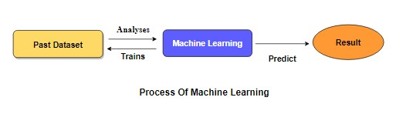
Supervised Machine Learning is the majority of practical machine learning uses supervised learning. Supervised learning is where have input variables (X) and an output variable (y) and use an algorithm to learn the mapping function from the input to the output is y = f(X). The goal is to approximate the mapping function so well that when you have new input data (X) that you can predict the output variables (y) for that data. Techniques of Supervised Machine Learning algorithms include logistic regression, multi-class classification, Decision Trees and support vector machines etc. Supervised learning requires that the data used to train the algorithm is already labelled with correct answers. Supervised learning problems can be further grouped into Classification problems. This problem has as its goal the construction of a succinct model that can predict the value of the dependent attribute from the attribute variables. The difference between the two tasks is the fact that the dependent attribute is numerical for categorical classification. A classification model attempts to draw some conclusions from observed values. Given one or more inputs a classification model will try to predict the value of one or more outcomes. A classification problem is when the output variable is a category, such as “red” or “blue”.

5. Preparing the Dataset:
This dataset contains number of records of features extracted from UPI, which were then used to find the fraud prediction.

PROPOSED SYSTEM:
The proposed system, SMARTUPIFRAUDDETECT, aims to enhance the security of UPI payment networks by identifying anomalous and potentially fraudulent transactions using machine learning techniques. The system processes transaction data to uncover suspicious patterns based on behavioral and contextual features such as transaction amount, frequency, recipient diversity, and time of transaction. A core component of the system is a trained machine learning model capable of distinguishing normal transactions from outliers. The model is integrated into a Django-based web application, allowing users to upload transaction datasets, analyze results, and visualize detected anomalies through interactive dashboards. The system continuously learns from new data to improve its anomaly detection capabilities. By providing a robust and intelligent analysis platform, SMARTUPIFRAUDDETECT supports early fraud detection and strengthens trust in digital financial systems.

ADVANTAGES:
- Enhances detection of suspicious UPI transactions using intelligent pattern analysis.
- Continuously improves performance through machine learning-based learning from new data.
- Provides a user-friendly Django web interface for seamless interaction and result visualization.
- Supports better decision-making for stakeholders through clear insights into transaction behavior.

Dataset
Test dataset
Data Processing

Training dataset
Classification ML Algorithm
UPI
Prediction

Architecture of Proposed Model

7. LITERATURE SURVEY:
General
A literature review is a body of text that aims to review the critical points of current knowledge on and/or methodological approaches to a particular topic. It is secondary sources and discuss published information in a particular subject area and sometimes information in a particular subject area within a certain time period. Its ultimate goal is to bring the reader up to date with current literature on a topic and forms the basis for another goal, such as future research that may be needed in the area and precedes a research proposal and may be just a simple summary of sources. Usually, it has an organizational pattern and combines both summary and synthesis.
A summary is a recap of important information about the source, but a synthesis is a re-organization or reshuffling of information. It might give a new interpretation of old material or combine new with old interpretations or it might trace the intellectual progression of the field, including major debates. Depending on the situation, the literature review may evaluate the sources and advise the reader on the most pertinent or relevant of them.

Review of Literature Survey

Title : Fraud Detection using Machine Learning
Author: Aditya Oza
Year : 2021
Recent research has shown that machine learning techniques have been applied very effectively to the problem of payments related fraud detection. Such ML based techniques have the potential to evolve and detect previously unseen patterns of fraud. In this paper, we apply multiple ML techniques based on Logistic regression and Support Vector Machine to the problem of payments fraud detection using a labeled dataset containing payment transactions. We show that our proposed approaches are able to detect fraud transactions with high accuracy and reasonably low number of false positives.
Title : Deep Learning for Credit Card Fraud Detection: A Review of Algorithms, Challenges, and Solutions
Author: IBOMOIYE DOMOR MIENYE
Year : 2024
Deep learning (DL), a branch of machine learning (ML), is the core technology in today’s technological advancements and innovations. Deep learning-based approaches are the state-of-the-art methods used to analyse and detect complex patterns in large datasets, such as credit card transactions. However, most credit card fraud models in the literature are based on traditional ML algorithms, and recently, there has been a rise in applications based on deep learning techniques. This study reviews the recent DL-based literature and presents a concise description and performance comparison of the widely used DL techniques, including convolutional neural network (CNN), simple recurrent neural network (RNN), long short-term memory (LSTM), and gated recurrent unit (GRU). Additionally, an attempt is made to discuss suitable performance metrics, common challenges encountered when training credit card fraud models using DL architectures and potential solutions, which are lacking in previous studies and would benefit deep learning researchers and practitioners. Meanwhile, the experimental results and analysis using a real-world dataset indicate the robustness of the deep learning architectures in credit card fraud detection.

Title : Review Paper on UPI Fraud Detection Using Machine Learning
Author: Miss. Sayalee S.
Year : 2023
With the rapid growth of digital transactions, the Unified Payments Interface (UPI) has emerged as a popular and convenient method for financial transactions in the modern era. However, the increasing reliance on digital platforms has also led to a rise in fraudulent activities. This paper proposes a robust UPI fraud detection system employing advanced machine learning techniques to enhance the security of digital transactions. The proposed system leverages a diverse set of features, including transactional patterns, user behaviour, and device information, to create a comprehensive model for fraud detection. Machine learning algorithms, such as supervised learning classifiers and anomaly detection techniques, are employed to analyse historical transaction data and identify patterns indicative of fraudulent activities. The model is trained on a labelled dataset that includes both genuine and fraudulent transactions, ensuring its ability to distinguish between normal and suspicious behaviour
Title : Online Payment Fraud Detection using Machine Learning Techniques.
Author: Taranjyot Singh Chawla
Year : 2022
When it comes to the simplicity of making a payment while sitting anywhere in the world, online payments have been a source of attractiveness. Over the past few decades, there has been an increase in online payments. E-payments enable businesses earn a lot of money in addition to consumers. However, because electronic payments are so simple, there is also a risk of fraud associated with them. A consumer must ensure that the payment he is paying is going exclusively to the appropriate service provider. Online fraud exposes users to the possibility of their data being compromised, as well as the inconvenience of having to report the fraud, block their payment method, and other things. When businesses are involved, it causes some issues; occasionally, they must issue refunds in order to keep customers. Therefore, it is crucial that both consumers and businesses are aware of these internet scams. A model to determine if an online payment is fraudulent or not is put forth in this study. To determine if a certain Online payment is fraudulent or not, some features like the type of payment, the recipient’s identity, etc. would be taken into account.

Title : Implementation Paper on UPI Fraud Detection using Machine Learning
Author: Miss. Sayalee S. Bodade,
Year : 2024
The UPI fraud detection system are to enhance the security and reliability of digital payment transactions, ultimately safeguarding users from fraudulent activities. Firstly, the paper aims to employ advanced machine learning algorithms and data analytics to analyze transaction patterns and detect anomalies that may indicate potential fraud. Secondly, it seeks to develop a robust system that can identify and mitigate various types of UPI fraud, including phishing, identity theft, and unauthorized transactions. The paper also aims to create a real-time monitoring mechanism to promptly identify suspicious activities and trigger alerts for immediate intervention. The scope of developing a UPI fraud detection system is vast and holds significant potential in addressing the emerging challenges in the digital payment landscape. Firstly, the paper encompasses the implementation of cutting-edge technologies such as machine learning, artificial intelligence, and data analytics to create a sophisticated fraud detection model. This model will have the capability to analyze massive datasets of UPI transactions in real-time, identifying patterns, anomalies, and trends associated with fraudulent activities.

8. SYSTEM STUDY:

8.1. Aim:
The aim of the UPI transaction fraud prediction project is to develop a robust machine learning model capable of identifying fraudulent transactions based on various transaction features. The data preprocessing involves handling missing values, encoding categorical variables, and scaling numerical data to ensure optimal model performance. Data visualization techniques like histograms, box plots, and correlation matrices will be employed to uncover patterns and relationships in the data. Various algorithms, will be compared to select the best model based on accuracy metrics.
Objectives:
1. To develop a machine learning model that predicts UPI transaction fraud with high accuracy by analyzing transaction data patterns.
2. To identify key transaction features that contribute to fraud, enhancing the model's interpretability and performance.
3. To build a scalable system that can provide real-time fraud detection and alerts for UPI transactions.

8.3 Project Goals:

- Exploration Data Analysis of Variable identification
- Loading the Dataset
- Import Required Library Packages
- Analyse the General Properties
- Find Duplicate and missing Values

- Univariate Data Analysis
- Rename, add data and drop the data
- To specify a data type

- Exploration data analysis of bi-variate and multivariate
- Plot diagram of pairplot, heatmap, histogram, scatterplot and boxplot

- Method of outlier detection with feature engineering
- Pre-processing the given dataset
- Splitting the test and training dataset

8.5 Scope of the Project:

The scope of the project "UPI Transaction Fraud Predictions with Advanced Machine Learning" focuses on leveraging machine learning techniques to detect and predict fraudulent activities in UPI (Unified Payments Interface) transactions. This project aims to analyze transaction data in real-time, identifying patterns and anomalies that indicate potential fraud. By utilizing advanced machine learning algorithms such as decision trees, random forests, support vector machines (SVM), or deep learning models, the system will classify transactions as legitimate or suspicious. The project will involve data preprocessing, feature engineering, and the development of an efficient fraud detection model capable of handling large-scale transaction datasets with high accuracy. Additionally, the system will incorporate various factors such as transaction amount, time, location, user behavior, and device information to build robust predictive models. The goal is to enhance the security and reliability of UPI transactions by minimizing the risks associated with fraudulent activities, providing a alert system for both users and financial institutions.

9. Feasibility Study:

Data Wrangling

In this section of the report will load in the data, check for cleanliness, and then trim and clean given dataset for analysis. Make sure that the document steps carefully and justify for cleaning decisions.

Data collection
The data set collected for predicting given data is split into Training set and Test set. Generally, 7:3 ratios are applied to split the Training set and Test set. The Data Model which was created using Machine Learning Regression Techniques are applied on the Training set and based on the test result accuracy, Test set prediction is done.

Preprocessing
The data which was collected might contain missing values that may lead to inconsistency. To gain better results data need to be preprocessed so as to improve the efficiency of the algorithm. The outliers have to be removed and also variable conversion need to be done.

Building the classification model
The prediction of Amazon Stock Price, A high accuracy prediction model is effective because of the following reasons: It provides better results in Regression problem.
- It is strong in preprocessing outliers, irrelevant variables, and a mix of continuous, categorical and the continuous variables.
- It produces out-of-bag estimate problems which has proven to be unbiased in many tests and it is relatively easy to tune with.

Construction of a Predictive Model

Machine learning needs data gathering have lot of past data’s. Data gathering have sufficient historical data and raw data. Before data pre-processing, raw data can’t be used directly. It’s used to pre-process then, what kind of algorithm with model. Training and testing this model working and predicting correctly with minimum errors. Tuned model involved by tuned time to time with improving the accuracy.

Collecting the Data
Pre-Process the Collected Data

Choose the model
Train model
Test model
Tune model
Prediction

Process of dataflow diagram

10. List of Modules:

- Data Pre-Processing
- Data Analysis of Visualization
- Linear Regression Algorithm
- Naïve Bayes Algorithm
- Decisoin Tree Algorithm
- RFC Algorithm
- Deployment ( User Interface )

11. Project Requirements
General:
Requirements are the basic constrains that are required to develop a system. Requirements are collected while designing the system. The following are the requirements that are to be discussed.
1. Functional requirements
2. Non-Functional requirements
3. Environment requirements
A. Hardware requirements
B. software requirements

11.1 Functional requirements:
The software requirements specification is a technical specification of requirements for the software product. It is the first step in the requirements analysis process. It lists requirements of a particular software system. The following details to follow the special libraries like sk-learn, pandas, numpy, matplotlib and seaborn.
11.2 Non-Functional Requirements:
Process of functional steps,
- Problem define
- Preparing data
- Implement the Algorithm
- Prediction the result

12. Environmental Requirements:
1. Software Requirements:
Operating System : Windows
Tool : Anaconda with Jupyter Notebook
2. Hardware requirements:
Processor : Pentium IV/III
Hard disk : minimum 80 GB
RAM : minimum 2 GB

13. SOFTWARE DESCRIPTION
The UPI (Unified Payments Interface) Transaction Fraud Prediction System leverages advanced machine learning techniques to detect and prevent fraudulent activities in during financial transactions. By analyzing transaction data, the system identifies patterns that are indicative of potential fraud. The machine learning model is trained on historical data to recognize legitimate and suspicious transaction behaviors, using algorithms like Random Forest, Support Vector Machines, or Neural Networks for accurate prediction. The system offers proactive fraud detection, providing alerts to users and financial institutions, thereby enhancing the security of digital payments and ensuring the integrity of UPI transactions. This software is designed to minimize false positives, maximize detection rates, and adapt to evolving fraud tactics, making it a critical tool in safeguarding online financial ecosystems.

13.1 ANACONDA NAVIGATOR
Anaconda Navigator is a desktop graphical user interface (GUI) included in Anaconda® distribution that allows you to launch applications and easily manage conda packages, environments, and channels without using command-line commands. Navigator can search for packages on Anaconda.org or in a local Anaconda Repository.
Anaconda. Now, if you are primarily doing data science work, Anaconda is also a great option. Anaconda is created by Continuum Analytics, and it is a Python distribution that comes preinstalled with lots of useful python libraries for data science.
Anaconda is a distribution of the Python and R programming languages for scientific computing (data science, machine learning applications, large-scale data processing, predictive analytics, etc.), that aims to simplify package management and deployment.
In order to run, many scientific packages depend on specific versions of other packages. Data scientists often use multiple versions of many packages and use multiple environments to separate these different versions.
The command-line program conda is both a package manager and an environment manager. This helps data scientists ensure that each version of each package has all the dependencies it requires and works correctly.
Navigator is an easy, point-and-click way to work with packages and environments without needing to type conda commands in a terminal window. You can use it to find the packages you want, install them in an environment, run the packages, and update them – all inside Navigator.

The following applications are available by default in Navigator:
- JupyterLab
- Jupyter Notebook
- Spyder
- PyCharm
- VSCode
- Glueviz
- Orange 3 App
- RStudio
- Anaconda Prompt (Windows only)
- Anaconda PowerShell (Windows only)

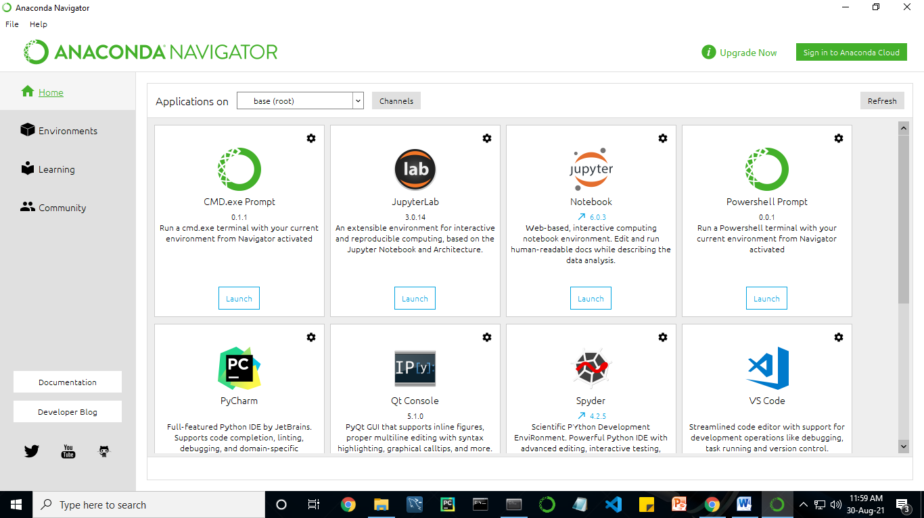

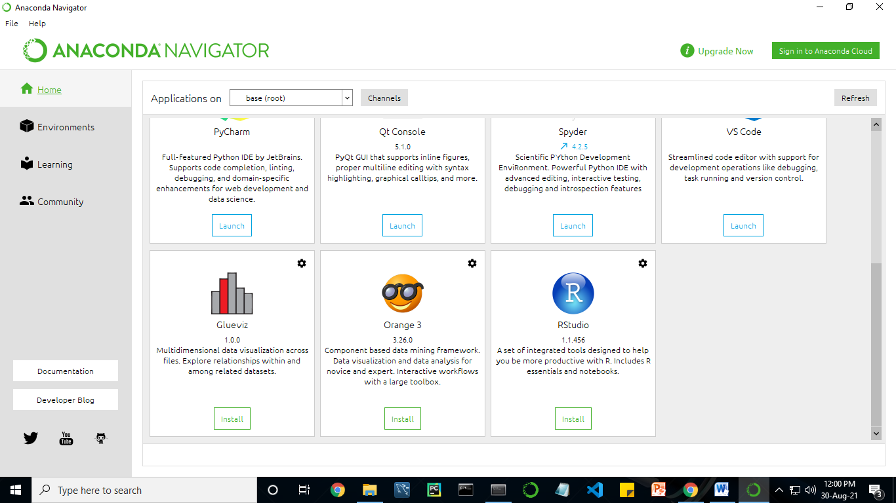

Anaconda Navigator is a desktop graphical user interface (GUI) included in Anaconda distribution.
Navigator allows you to launch common Python programs and easily manage conda packages, environments, and channels without using command-line commands. Navigator can search for packages on Anaconda Cloud or in a local Anaconda Repository.
Anaconda comes with many built-in packages that you can easily find with conda list on your anaconda prompt. As it has lots of packages (many of which are rarely used), it requires lots of space and time as well. If you have enough space, time and do not want to burden yourself to install small utilities like JSON, YAML, you better go for Anaconda.
Conda :
Conda is an open source, cross-platform, language-agnostic package manager and environment management system that installs, runs, and updates packages and their dependencies. It was created for Python programs, but it can package and distribute software for any language (e.g., R), including multi-language projects. The conda package and environment manager is included in all versions of Anaconda, Miniconda, and Anaconda Repository.
Anaconda is freely available, open source distribution of python and R programming languages which is used for scientific computations. If you are doing any machine learning or deep learning project then this is the best place for you. It consists of many softwares which will help you to build your machine learning project and deep learning project. these softwares have great graphical user interface and these will make your work easy to do. you can also use it to run your python script. These are the software carried by anaconda navigator.

13.2 JUPYTER NOTEBOOK
This website acts as “meta” documentation for the Jupyter ecosystem. It has a collection of resources to navigate the tools and communities in this ecosystem, and to help you get started.
Project Jupyter is a project and community whose goal is to "develop open-source software, open-standards, and services for interactive computing across dozens of programming languages". It was spun off from IPython in 2014 by Fernando Perez.
Notebook documents are documents produced by the Jupyter Notebook App, which contain both computer code (e.g. python) and rich text elements (paragraph, equations, figures, links, etc…). Notebook documents are both human-readable documents containing the analysis description and the results (figures, tables, etc.) as well as executable documents which can be run to perform data analysis.

Installation: The easiest way to install the Jupyter Notebook App is installing a scientific python distribution which also includes scientific python packages. The most common distribution is called Anaconda

Running the Jupyter Notebook

Launching Jupyter Notebook App: The Jupyter Notebook App can be launched by clicking on the Jupyter Notebook icon installed by Anaconda in the start menu (Windows) or by typing in a terminal (cmd on Windows): “jupyter notebook”

This will launch a new browser window (or a new tab) showing the Notebook Dashboard, a sort of control panel that allows (among other things) to select which notebook to open.

When started, the Jupyter Notebook App can access only files within its start-up folder (including any sub-folder). No configuration is necessary if you place your notebooks in your home folder or subfolders. Otherwise, you need to choose a Jupyter Notebook App start-up folder which will contain all the notebooks.

Save notebooks: Modifications to the notebooks are automatically saved every few minutes. To avoid modifying the original notebook, make a copy of the notebook document (menu file -> make a copy…) and save the modifications on the copy.

Executing a notebook: Download the notebook you want to execute and put it in your notebook folder (or a sub-folder of it).
- Launch the jupyter notebook app
- In the Notebook Dashboard navigate to find the notebook: clicking on its name will open it in a new browser tab.
- Click on the menu Help -> User Interface Tour for an overview of the Jupyter Notebook App user interface.
- You can run the notebook document step-by-step (one cell a time) by pressing shift + enter.
- You can run the whole notebook in a single step by clicking on the menu Cell -> Run All.
- To restart the kernel (i.e. the computational engine), click on the menu Kernel -> Restart. This can be useful to start over a computation from scratch (e.g. variables are deleted, open files are closed, etc…).

Purpose: To support interactive data science and scientific computing across all programming languages.

File Extension: An IPYNB file is a notebook document created by Jupyter Notebook, an interactive computational environment that helps scientists manipulate and analyze data using Python.
JUPYTER Notebook App:
The Jupyter Notebook App is a server-client application that allows editing and running notebook documents via a web browser.
The Jupyter Notebook App can be executed on a local desktop requiring no internet access (as described in this document) or can be installed on a remote server and accessed through the internet.
In addition to displaying/editing/running notebook documents, the Jupyter Notebook App has a “Dashboard” (Notebook Dashboard), a “control panel” showing local files and allowing to open notebook documents or shutting down their kernels.

kernel: A notebook kernel is a “computational engine” that executes the code contained in a Notebook document. The ipython kernel, referenced in this guide, executes python code. Kernels for many other languages exist (official kernels).
When you open a Notebook document, the associated kernel is automatically launched. When the notebook is executed (either cell-by-cell or with menu Cell -> Run All), the kernel performs the computation and produces the results.
Depending on the type of computations, the kernel may consume significant CPU and RAM. Note that the RAM is not released until the kernel is shut-down

Notebook Dashboard: The Notebook Dashboard is the component which is shown first when you launch Jupyter Notebook App. The Notebook Dashboard is mainly used to open notebook documents, and to manage the running kernels (visualize and shutdown).

The Notebook Dashboard has other features similar to a file manager, namely navigating folders and renaming/deleting files

Working Process:
- Download and install anaconda and get the most useful package for machine learning in Python.
- Load a dataset and understand its structure using statistical summaries and data visualization.
- Machine learning models, pick the best and build confidence that the accuracy is reliable.
Python is a popular and powerful interpreted language. Unlike R, Python is a complete language and platform that you can use for both research and development and developing production systems. There are also a lot of modules and libraries to choose from, providing multiple ways to do each task. It can feel overwhelming.

The best way to get started using Python for machine learning is to complete a project.
- It will force you to install and start the Python interpreter (at the very least).
- It will give you a bird’s eye view of how to step through a small project.
- It will give you confidence, maybe to go on to your own small projects.

When you are applying machine learning to your own datasets, you are working on a project. A machine learning project may not be linear, but it has a number of well-known steps:
- Define Problem.
- Prepare Data.
- Evaluate Algorithms.
- Improve Results.
- Present Results.

The best way to really come to terms with a new platform or tool is to work through a machine learning project end-to-end and cover the key steps. Namely, from loading data, summarizing data, evaluating algorithms and making some predictions.
Here is an overview of what we are going to cover:
- Installing the Python anaconda platform.
- Loading the dataset.
- Summarizing the dataset.
- Visualizing the dataset.
- Evaluating some algorithms.
- Making some predictions.

14. PYTHON
Introduction:
Python is an interpreted high-level general-purpose programming language. Its design philosophy emphasizes code readability with its use of significant indentation. Its language constructs as well as its object-oriented approach aim to help programmers write clear, logical code for small and large-scale projects.
Python is dynamically-typed and garbage-collected. It supports multiple programming paradigms, including structured (particularly, procedural), object-oriented and functional programming. It is often described as a "batteries included" language due to its comprehensive standard library.
Guido van Rossum began working on Python in the late 1980s, as a successor to the ABC programming language, and first released it in 1991 as Python 0.9.0. Python 2.0 was released in 2000 and introduced new features, such as list comprehensions and a garbage collection system using reference counting. Python 3.0 was released in 2008 and was a major revision of the language that is not completely backward-compatible. Python 2 was discontinued with version 2.7.18 in 2020.
Python consistently ranks as one of the most popular programming languages

History:
Python was conceived in the late 1980s by Guido van Rossum at Centrum Wiskunde & Informatica (CWI) in the Netherlands as a successor to ABC programming language, which was inspired by SETL, capable of exception handling and interfacing with the Amoeba operating system. Its implementation began in December 1989. Van Rossum shouldered sole responsibility for the project, as the lead developer, until 12 July 2018, when he announced his "permanent vacation" from his responsibilities as Python's Benevolent Dictator For Life, a title the Python community bestowed upon him to reflect his long-term commitment as the project's chief decision-maker. In January 2019, active Python core developers elected a 5-member "Steering Council" to lead the project. As of 2021, the current members of this council are Barry Warsaw, Brett Cannon, Carol Willing, Thomas Wouters, and Pablo Galindo Salgado.
Python 2.0 was released on 16 October 2000, with many major new features, including a cycle-detecting garbage collector and support for Unicode.
Python 3.0 was released on 3 December 2008. It was a major revision of the language that is not completely backward-compatible. Many of its major features were backported to Python 2.6.x and 2.7.x version series. Releases of Python 3 include the 2 to 3 utility, which automates (at least partially) the translation of Python 2 code to Python 3.
Python 2.7's end-of-life date was initially set at 2015 then postponed to 2020 out of concern that a large body of existing code could not easily be forward-ported to Python 3. No more security patches or other improvements will be released for it. With Python 2's end-of-life, only Python 3.6.x and later are supported.
Python 3.9.2 and 3.8.8 were expedited as all versions of Python (including 2.7) had security issues, leading to possible remote code execution and web cache poisoning.
Design Philosophy & Feature
Python is a multi-paradigm programming language. Object-oriented programming and structured programming are fully supported, and many of its features support functional programming and aspect-oriented programming (including by meta-programming and meta-objects (magic methods)). Many other paradigms are supported via extensions, including design by contract and logic programming.
Python uses dynamic typing and a combination of reference counting and a cycle-detecting garbage collector for memory management. It also features dynamic name resolution (late binding), which binds method and variable names during program execution.
Python's design offers some support for functional programming in the Lisp tradition. It has filter, map and reduce functions; list comprehensions, dictionaries, sets, and generator expressions. The standard library has two modules (itertools and functools) that implement functional tools borrowed from Haskell and Standard ML.

The language's core philosophy is summarized in the document The Zen of Python (PEP 20), which includes aphorisms such as:
- Beautiful is better than ugly.
- Explicit is better than implicit.
- Simple is better than complex.
- Complex is better than complicated.
- Readability counts.

Rather than having all of its functionality built into its core, Python was designed to be highly extensible (with modules). This compact modularity has made it particularly popular as a means of adding programmable interfaces to existing applications. Van Rossum's vision of a small core language with a large standard library and easily extensible interpreter stemmed from his frustrations with ABC, which espoused the opposite approach.
Python strives for a simpler, less-cluttered syntax and grammar while giving developers a choice in their coding methodology. In contrast to Perl's "there is more than one way to do it" motto, Python embraces a "there should be one— and preferably only one —obvious way to do it" design philosophy. Alex Martelli, a Fellow at the Python Software Foundation and Python book author, writes that "To describe something as 'clever' is not considered a compliment in the Python culture."
Python's developers strive to avoid premature optimization, and reject patches to non-critical parts of the C-Python reference implementation that would offer marginal increases in speed at the cost of clarity. When speed is important, a Python programmer can move time-critical functions to extension modules written in languages such as C, or use PyPy, a just-in-time compiler. Cython is also available, which translates a Python script into C and makes direct C-level API calls into the Python interpreter.
Python's developers aim to keep the language fun to use. This is reflected in its name a tribute to the British comedy group Monty Python and in occasionally playful approaches to tutorials and reference materials, such as examples that refer to spam and eggs (a reference to a Monty Python sketch) instead of the standard foo and bar.
A common neologism in the Python community is pythonic, which can have a wide range of meanings related to program style. To say that code is pythonic is to say that it uses Python idioms well, that it is natural or shows fluency in the language, that it conforms with Python's minimalist philosophy and emphasis on readability. In contrast, code that is difficult to understand or reads like a rough transcription from another programming language is called unpythonic.
Users and admirers of Python, especially those considered knowledgeable or experienced, are often referred to as Pythonistas

Syntax and Semantics :
Python is meant to be an easily readable language. Its formatting is visually uncluttered, and it often uses English keywords where other languages use punctuation. Unlike many other languages, it does not use curly brackets to delimit blocks, and semicolons after statements are allowed but are rarely, if ever, used. It has fewer syntactic exceptions and special cases than C or Pascal.

Indentation :

Main article: Python syntax and semantics & Indentation

Python uses whitespace indentation, rather than curly brackets or keywords, to delimit blocks. An increase in indentation comes after certain statements; a decrease in indentation signifies the end of the current block. Thus, the program's visual structure accurately represents the program's semantic structure. This feature is sometimes termed the off-side rule, which some other languages share, but in most languages indentation does not have any semantic meaning. The recommended indent size is four spaces.

Statements and control flow :
Python's statements include:
- The assignment statement, using a single equals sign =.
- The if statement, which conditionally executes a block of code, along with else and elif (a contraction of else-if).
- The for statement, which iterates over an iterable object, capturing each element to a local variable for use by the attached block.
- The while statement, which executes a block of code as long as its condition is true.
- The Try statement, which allows exceptions raised in its attached code block to be caught and handled by except clauses; it also ensures that clean-up code in a finally block will always be run regardless of how the block exits.
- The raise statement, used to raise a specified exception or re-raise a caught exception.
- The class statement, which executes a block of code and attaches its local namespace to a class, for use in object-oriented programming.
- The def statement, which defines a function or method.
- The with statement, which encloses a code block within a context manager (for example, acquiring a lock before the block of code is run and releasing the lock afterwards, or opening a file and then closing it), allowing resource-acquisition-is-initialization (RAII) - like behavior and replaces a common try/finally idiom.
- The break statement, exits from a loop.
- The continue statement, skips this iteration and continues with the next item.
- The del statement, removes a variable, which means the reference from the name to the value is deleted and trying to use that variable will cause an error. A deleted variable can be reassigned.
- The pass statement, which serves as a NOP. It is syntactically needed to create an empty code block.
- The assert statement, used during debugging to check for conditions that should apply.
- The yield statement, which returns a value from a generator function and yield is also an operator. This form is used to implement co-routines.
- The return statement, used to return a value from a function.
- The import statement, which is used to import modules whose functions or variables can be used in the current program.

The assignment statement (=) operates by binding a name as a reference to a separate, dynamically-allocated object. Variables may be subsequently rebound at any time to any object. In Python, a variable name is a generic reference holder and does not have a fixed data type associated with it. However, at a given time, a variable will refer to some object, which will have a type. This is referred to as dynamic typing and is contrasted with statically-typed programming languages, where each variable may only contain values of a certain type.
Python does not support tail call optimization or first-class continuations, and, according to Guido van Rossum, it never will.^{[80][81]} However, better support for co-routine-like functionality is provided, by extending Python's generators. Before 2.5, generators were lazy iterators; information was passed uni-directionally out of the generator. From Python 2.5, it is possible to pass information back into a generator function, and from Python 3.3, the information can be passed through multiple stack levels.

Expressions :
Some Python expressions are similar to those found in languages such as C and Java, while some are not:
- Addition, subtraction, and multiplication are the same, but the behavior of division differs. There are two types of divisions in Python. They are floor division (or integer division) // and floating-point/division. Python also uses the ** operator for exponentiation.
- From Python 3.5, the new @ infix operator was introduced. It is intended to be used by libraries such as NumPy for matrix multiplication.
- From Python 3.8, the syntax :=, called the 'walrus operator' was introduced. It assigns values to variables as part of a larger expression.
- In Python, == compares by value, versus Java, which compares numerics by value and objects by reference. (Value comparisons in Java on objects can be performed with the equals() method.) Python's is operator may be used to compare object identities (comparison by reference). In Python, comparisons may be chained, for example A<=B<=C.
- Python uses the words and, or, not for or its boolean operators rather than the symbolic &&, ||, ! used in Java and C.
- Python has a type of expression termed a list comprehension as well as a more general expression termed a generator expression.
- Anonymous functions are implemented using lambda expressions; however, these are limited in that the body can only be one expression.
- Conditional expressions in Python are written as x if c else y (different in order of operands from the c ? x : y operator common to many other languages).
- Python makes a distinction between lists and tuples. Lists are written as [1, 2, 3], are mutable, and cannot be used as the keys of dictionaries (dictionary keys must be immutable in Python). Tuples are written as (1, 2, 3), are immutable and thus can be used as the keys of dictionaries, provided all elements of the tuple are immutable. The + operator can be used to concatenate two tuples, which does not directly modify their contents, but rather produces a new tuple containing the elements of both provided tuples. Thus, given the variable t initially equal to (1, 2, 3), executing t = t + (4, 5) first evaluates t + (4, 5), which yields (1, 2, 3, 4, 5), which is then assigned back to t, thereby effectively "modifying the contents" of t, while conforming to the immutable nature of tuple objects. Parentheses are optional for tuples in unambiguous contexts.
- Python features sequence unpacking wherein multiple expressions, each evaluating to anything that can be assigned to (a variable, a writable property, etc.), are associated in an identical manner to that forming tuple literals and, as a whole, are put on the left-hand side of the equal sign in an assignment statement. The statement expects an iterable object on the right-hand side of the equal sign that produces the same number of values as the provided writable expressions when iterated through and will iterate through it, assigning each of the produced values to the corresponding expression on the left.
- Python has a "string format" operator %. This functions analogously ton printf format strings in C, e.g. “spam=%s eggs=%d” % (“blah”,2) evaluates to “spam=blah eggs=2”. In Python 3 and 2.6+, this was supplemented by the format() method of the str class, e.g. “spam={0} eggs={1}”.format(“blah”,2). Python 3.6 added "f-strings": blah = “blah”; eggs = 2; f‘spam={blah} eggs={eggs}’
- Strings in Python can be concatenated, by "adding" them (same operator as for adding integers and floats). E.g. “spam” + “eggs” returns “spameggs”. Even if your strings contain numbers, they are still added as strings rather than integers. E.g. “2” + “2” returns “2”.
- Python has various kinds of string literals:
  - Strings delimited by single or double quote marks. Unlike in Unix shells, Perl and Perl-influenced languages, single quote marks and double quote marks function identically. Both kinds of string use the backslash (\) as an escape character. String interpolation became available in Python 3.6 as "formatted string literals".
  - Triple-quoted strings, which begin and end with a series of three single or double quote marks. They may span multiple lines and function like here documents in shells, Perl and Ruby.
  - Raw string varieties, denoted by prefixing the string literal with an r. Escape sequences are not interpreted; hence raw strings are useful where literal backslashes are common, such as regular expressions and Windows-style paths. Compare "@-quoting" in C#.
- Python has array index and array slicing expressions on lists, denoted as a[Key], a[start:stop] or a[start:stop:step]. Indexes are zero-based, and negative indexes are relative to the end. Slices take elements from the start index up to, but not including, the stop index. The third slice parameter, called step or stride, allows elements to be skipped and reversed. Slice indexes may be omitted, for example a[:] returns a copy of the entire list. Each element of a slice is a shallow copy.

In Python, a distinction between expressions and statements is rigidly enforced, in contrast to languages such as Common Lisp, Scheme, or Ruby. This leads to duplicating some functionality. For example:

- List comprehensions vs. for-loops
- Conditional expressions vs. if blocks
- The eval() vs. exec() built-in functions (in Python 2, exec is a statement); the former is for expressions, the latter is for statements.

Statements cannot be a part of an expression, so list and other comprehensions or lambda expressions, all being expressions, cannot contain statements. A particular case of this is that an assignment statement such as a=1 cannot form part of the conditional expression of a conditional statement. This has the advantage of avoiding a classic C error of mistaking an assignment operator = for an equality operator == in conditions: if (c==1) {…} is syntactically valid (but probably unintended) C code but if c=1: … causes a syntax error in Python.

Methods :
Methods on objects are functions attached to the object's class; the syntax instance.method(argument) is, for normal methods and functions, syntactic sugar for Class.method(instance, argument). Python methods have an explicit self parameter access instance data, in contrast to the implicit self (or this) in some other object-oriented programming languages (e.g., C++, Java, Objective-C, or Ruby). Apart from this Python also provides methods, sometimes called d-under methods due to their names beginning and ending with double-underscores, to extend the functionality of custom class to support native functions such as print, length, comparison, support for arithmetic operations, type conversion, and many more.

Typing :
Python uses duck typing and has typed objects but untyped variable names. Type constraints are not checked at compile time; rather, operations on an object may fail, signifying that the given object is not of a suitable type. Despite being dynamically-typed, Python is strongly-typed, forbidding operations that are not well-defined (for example, adding a number to a string) rather than silently attempting to make sense of them.
Python allows programmers to define their own types using classes, which are most often used for object-oriented programming. New instances of classes are constructed by calling the class (for example, SpamClass() or EggsClass()), and the classes are instances of the metaclass type (itself an instance of itself), allowing meta-programming and reflection.
Before version 3.0, Python had two kinds of classes: old-style and new-style. The syntax of both styles is the same, the difference being whether the class object is inherited from, directly or indirectly (all new-style classes inherit from object and are instances of type). In versions of Python 2 from Python 2.2 onwards, both kinds of classes can be used. Old-style classes were eliminated in Python 3.0.
The long-term plan is to support gradual typing and from Python 3.5, the syntax of the language allows specifying static types but they are not checked in the default implementation, CPython. An experimental optional static type checker named mypy supports compile-time type checking.

15. System Architecture:
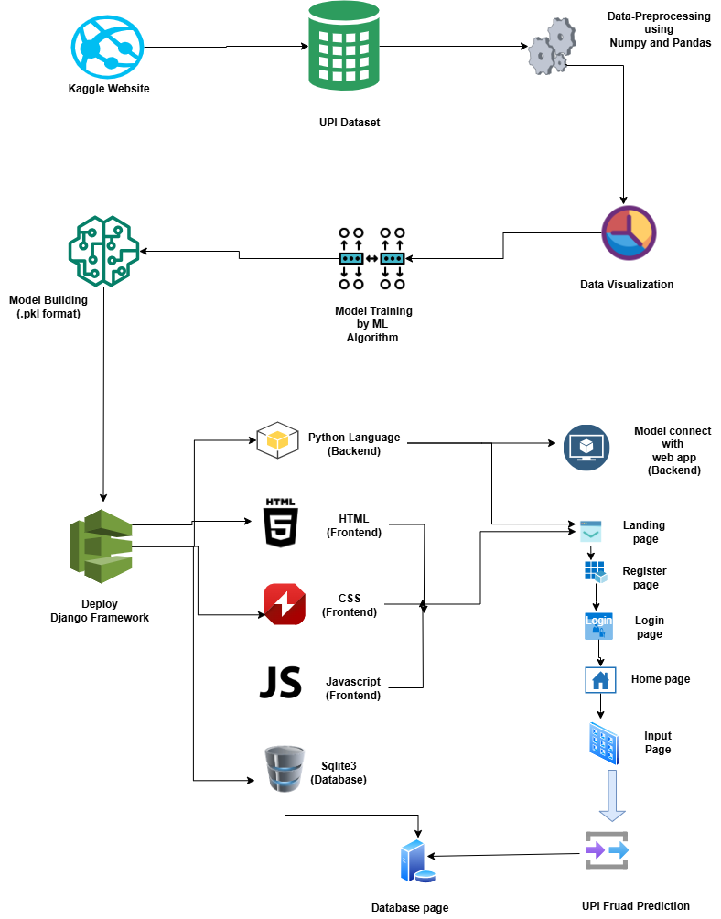

16. Work Flow Diagram:
Source Data

Data Processing and Cleaning

Testing Dataset
Training Dataset

Best Model by Accuracy
Regression ML Algorithms

UPI Prediction

17. Use Case Diagram:
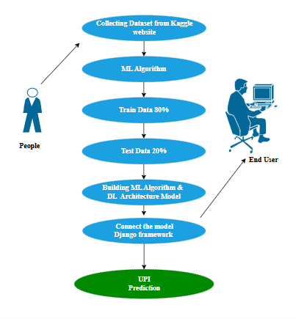

Use case diagrams are considered for high level requirement analysis of a system. So when the requirements of a system are analysed the functionalities are captured in use cases. So, it can say that uses cases are nothing but the system functionalities written in an organized manner.

18. Class Diagram:

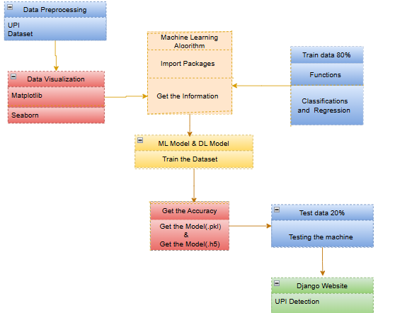

Class diagram is basically a graphical representation of the static view of the system and represents different aspects of the application. So a collection of class diagrams represent the whole system. The name of the class diagram should be meaningful to describe the aspect of the system. Each element and their relationships should be identified in advance Responsibility (attributes and methods) of each class should be clearly identified for each class minimum number of properties should be specified and because, unnecessary properties will make the diagram complicated. Use notes whenever required to describe some aspect of the diagram and at the end of the drawing it should be understandable to the developer/coder. Finally, before making the final version, the diagram should be drawn on plain paper and rework as many times as possible to make it correct.

19. Activity Diagram:
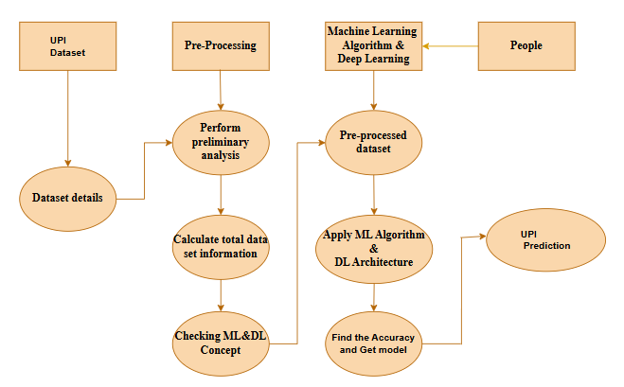

Activity is a particular operation of the system. Activity diagrams are not only used for visualizing dynamic nature of a system but they are also used to construct the executable system by using forward and reverse engineering techniques. The only missing thing in activity diagram is the message part. It does not show any message flow from one activity to another. Activity diagram is some time considered as the flow chart. Although the diagrams looks like a flow chart but it is not. It shows different flow like parallel, branched, concurrent and single.

20. Sequence Diagram:

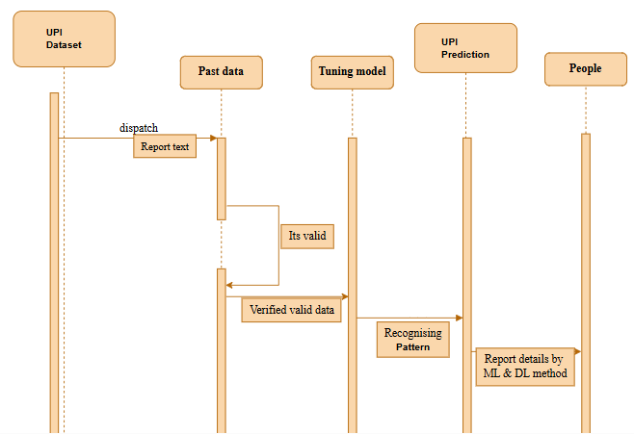

Sequence diagrams model the flow of logic within your system in a visual manner, enabling you both to document and validate your logic, and are commonly used for both analysis and design purposes. Sequence diagrams are the most popular UML artifact for dynamic modelling, which focuses on identifying the behaviour within your system. Other dynamic modelling techniques include activity diagramming, communication diagramming, timing diagramming, and interaction overview diagramming. Sequence diagrams, along with class diagrams and physical data models are in my opinion the most important design-level models for modern business application development.

21. Entity Relationship Diagram (ERD)
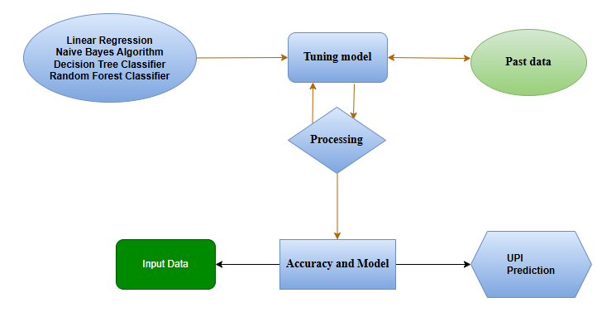

An entity relationship diagram (ERD), also known as an entity relationship model, is a graphical representation of an information system that depicts the relationships among people, objects, places, concepts or events within that system. An ERD is a data modeling technique that can help define business processes and be used as the foundation for a relational database. Entity relationship diagrams provide a visual starting point for database design that can also be used to help determine information system requirements throughout an organization. After a relational database is rolled out, an ERD can still serve as a referral point, should any debugging or business process re-engineering be needed later.
22. Module Description:
Data Pre-Processing:
Validation techniques in machine learning are used to get the error rate of the Machine Learning (ML) model, which can be considered as close to the true error rate of the dataset. If the data volume is large enough to be representative of the population, you may not need the validation techniques. However, in real-world scenarios, to work with samples of data that may not be a true representative of the population of given dataset. To finding the missing value, duplicate value and description of data type whether it is float variable or integer. The sample of data used to provide an unbiased evaluation of a model fit on the training dataset while tuning model hyper parameters.
The evaluation becomes more biased as skill on the validation dataset is incorporated into the model configuration. The validation set is used to evaluate a given model, but this is for frequent evaluation. It as machine learning engineers use this data to fine-tune the model hyper parameters. Data collection, data analysis, and the process of addressing data content, quality, and structure can add up to a time-consuming to-do list. During the process of data identification, it helps to understand your data and its properties; this knowledge will help you choose which algorithm to use to build your model.
A number of different data cleaning tasks using Python’s Pandas library and specifically, it focus on probably the biggest data cleaning task, missing values and it able to more quickly clean data. It wants to spend less time cleaning data, and more time exploring and modeling.
Some of these sources are just simple random mistakes. Other times, there can be a deeper reason why data is missing. It’s important to understand these different types of missing data from a statistics point of view. The type of missing data will influence how to deal with filling in the missing values and to detect missing values, and do some basic imputation and detailed statistical approach for dealing with missing data. Before, joint into code, it’s important to understand the sources of missing data. Here are some typical reasons why data is missing:
- User forgot to fill in a field.
- Data was lost while transferring manually from a legacy database.
- There was a programming error.
- Users chose not to fill out a field tied to their beliefs about how the results would be used or interpreted.

Variable identification with Uni-variate, Bi-variate and Multi-variate analysis:
- import libraries for access and functional purpose and read the given dataset
- General Properties of Analyzing the given dataset
- Display the given dataset in the form of data frame
- show columns
- shape of the data frame
- To describe the data frame
- Checking data type and information about dataset
- Checking for duplicate data
- Checking Missing values of data frame
- Checking unique values of data frame
- Checking count values of data frame
- Rename and drop the given data frame
- To specify the type of values
- To create extra columns

Data Validation/ Cleaning/Preparing Process
Importing the library packages with loading given dataset. To analyzing the variable identification by data shape, data type and evaluating the missing values, duplicate values. A validation dataset is a sample of data held back from training your model that is used to give an estimate of model skill while tuning models and procedures that you can use to make the best use of validation and test datasets when evaluating your models. Data cleaning / preparing by rename the given dataset and drop the column etc. to analyze the uni-variate, bi-variate and multi-variate process. The steps and techniques for data cleaning will vary from dataset to dataset. The primary goal of data cleaning is to detect and remove errors and anomalies to increase the value of data in analytics and decision making.

MODULE DIAGRAM
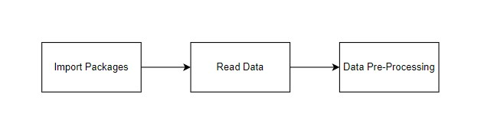
GIVEN INPUT EXPECTED OUTPUT
Input: data
Output: removing noisy dat

MODULE – 2:
Exploration Data Analysis of Visualization
Data visualization is an important skill in applied statistics and machine learning. Statistics does indeed focus on quantitative descriptions and estimations of data. Data visualization provides an important suite of tools for gaining a qualitative understanding. This can be helpful when exploring and getting to know a dataset and can help with identifying patterns, corrupt data, outliers, and much more. With a little domain knowledge, data visualizations can be used to express and demonstrate key relationships in plots and charts that are more visceral and stakeholders than measures of association or significance. Data visualization and exploratory data analysis are whole fields themselves and it will recommend a deeper dive into some the books mentioned at the end.

Sometimes data does not make sense until it can look at in a visual form, such as with charts and plots. Being able to quickly visualize of data samples and others is an important skill both in applied statistics and in applied machine learning. It will discover the many types of plots that you will need to know when visualizing data in Python and how to use them to better understand your own data.
- How to chart time series data with line plots and categorical quantities with bar charts.
- How to summarize data distributions with histograms and box plots.

MODULE DIAGRAM:
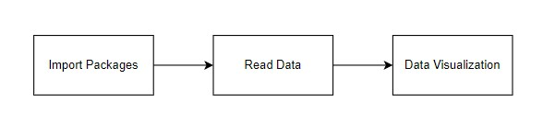

GIVEN INPUT EXPECTED OUTPUT
Input: data
Output: visualized data

Pre-processing refers to the transformations applied to our data before feeding it to the algorithm. Data Pre-processing is a technique that is used to convert the raw data into a clean data set. In other words, whenever the data is gathered from different sources it is collected in raw format which is not feasible for the analysis. To achieving better results from the applied model in Machine Learning method of the data has to be in a proper manner. Some specified Machine Learning model needs information in a specified format, for example, Random Forest algorithm does not support null values. Therefore, to execute random forest algorithm null values have to be managed from the original raw data set. And another aspect is that data set should be formatted in such a way that more than one Machine Learning and Deep Learning algorithms are executed in given dataset.

Comparing Algorithm with prediction in the form of best accuracy result
It is important to compare the performance of multiple different machine learning algorithms consistently and it will discover to create a test harness to compare multiple different machine learning algorithms in Python with scikit-learn. It can use this test harness as a template on your own machine learning problems and add more and different algorithms to compare. Each model will have different performance characteristics. Using resampling methods like cross validation, you can get an estimate for how accurate each model may be on unseen data. It needs to be able to use these estimates to choose one or two best models from the suite of models that you have created. When have a new dataset, it is a good idea to visualize the data using different techniques in order to look at the data from different perspectives. The same idea applies to model selection. You should use a number of different ways of looking at the estimated accuracy of your machine learning algorithms in order to choose the one or two to finalize. A way to do this is to use different visualization methods to show the average accuracy, variance and other properties of the distribution of model accuracies.
In the next section you will discover exactly how you can do that in Python with scikit-learn. The key to a fair comparison of machine learning algorithms is ensuring that each algorithm is evaluated in the same way on the same data and it can achieve this by forcing each algorithm to be evaluated on a consistent test harness.
In the example below 3 different algorithms are compared:
- LR
- NB
- DTC
- RFC

The K-fold cross validation procedure is used to evaluate each algorithm, importantly configured with the same random seed to ensure that the same splits to the training data are performed and that each algorithm is evaluated in precisely the same way. Before that comparing algorithm, Building a Machine Learning Model using install Scikit-Learn libraries. In this library package have to done preprocessing, linear model with logistic regression method, cross validating by KFold method, ensemble with random forest method and tree with decision tree classifier. Additionally, splitting the train set and test set. To predicting the result by comparing accuracy.

Regression:
Regression is a statistical method used in finance, investing, and other disciplines that attempts to determine the strength and character of the relationship between one dependent variable (usually denoted by Y) and a series of other variables (known as independent variables).
Regression helps investment and financial managers to value assets and understand the relationships between variables, such as commodity prices and the stocks of businesses dealing in those commodities.
The two basic types of regression are simple linear regression and multiple linear regression, although there are non-linear regression methods for more complicated data and analysis. Simple linear regression uses one independent variable to explain or predict the outcome of the dependent variable Y, while multiple linear regression uses two or more independent variables to predict the outcome.
Regression can help finance and investment professionals as well as professionals in other businesses. Regression can also help predict sales for a company based on weather, previous sales, GDP growth, or other types of conditions. The capital asset pricing model (CAPM) is an often-used regression model in finance for pricing assets and discovering costs of capital.
The general form of each type of regression is:
- Simple linear regression: Y = a + bX + u
- Multiple linear regression: Y = a + b₁X₁ ⁺ b₂X₂ + b₃X₃ + ... + b_{t}X_{t} + u
Where:
- Y = the variable that you are trying to predict (dependent variable).
- X = the variable that you are using to predict Y (independent variable).
- a = the intercept.
- b = the slope.
- u = the regression residual.
Regression is often used to determine how many specific factors such as the price of a commodity, interest rates, particular industries, or sectors influence the price movement of an asset. The aforementioned CAPM is based on regression, and it is utilized to project the expected returns for stocks and to generate costs of capital. A stock's returns are regressed against the returns of a broader index, such as the S&P 500, to generate a beta for the particular stock.
Beta is the stock's risk in relation to the market or index and is reflected as the slope in the CAPM model. The return for the stock in question would be the dependent variable Y, while the independent variable X would be the market risk premium.
Additional variables such as the market capitalization of a stock, valuation ratios, and recent returns can be added to the CAPM model to get better estimates for returns. These additional factors are known as the Fama-French factors, named after the professors who developed the multiple linear regression model to better explain asset returns.
Multiple linear regression (MLR), also known simply as multiple regression, is a statistical technique that uses several explanatory variables to predict the outcome of a response variable. The goal of multiple linear regression is to model the linear relationship between the explanatory (independent) variables and response (dependent) variables. In essence, multiple regression is the extension of ordinary least-squares (OLS) regression because it involves more than one explanatory variable.
Simple linear regression is a function that allows an analyst or statistician to make predictions about one variable based on the information that is known about another variable. Linear regression can only be used when one has two continuous variables—an independent variable and a dependent variable. The independent variable is the parameter that is used to calculate the dependent variable or outcome. A multiple regression model extends to several explanatory variables.

The multiple regression model is based on the following assumptions:
- There is a linear relationship between the dependent variables and the independent variables
- The independent variables are not too highly correlated with each other
- y_{i} observations are selected independently and randomly from the population
- Residuals should be normally distributed with a mean of 0 and variance σ
The coefficient of determination (R-squared) is a statistical metric that is used to measure how much of the variation in outcome can be explained by the variation in the independent variables. R² always increases as more predictors are added to the MLR model, even though the predictors may not be related to the outcome variable.
R² by itself can't thus be used to identify which predictors should be included in a model and which should be excluded. R² can only be between 0 and 1, where 0 indicates that the outcome cannot be predicted by any of the independent variables and 1 indicates that the outcome can be predicted without error from the independent variables.
When interpreting the results of multiple regression, beta coefficients are valid while holding all other variables constant ("all else equal"). The output from a multiple regression can be displayed horizontally as an equation, or vertically in table form.
The least-squares method is a form of mathematical regression analysis used to determine the line of best fit for a set of data, providing a visual demonstration of the relationship between the data points. Each point of data represents the relationship between a known independent variable and an unknown dependent variable.

Least Squares Method:
This method of regression analysis begins with a set of data points to be plotted on an x- and y-axis graph. An analyst using the least-squares method will generate a line of best fit that explains the potential relationship between independent and dependent variables.
The least-squares method provides the overall rationale for the placement of the line of best fit among the data points being studied. The most common application of this method, which is sometimes referred to as "linear" or "ordinary," aims to create a straight line that minimizes the sum of the squares of the errors that are generated by the results of the associated equations, such as the squared residuals resulting from differences in the observed value, and the value anticipated, based on that model.

The Line of Best Fit Equation:
The line of best fit determined from the least squares method has an equation that tells the story of the relationship between the data points. Line of best-fit equations may be determined by computer software models, which include a summary of outputs for analysis, where the coefficients and summary outputs explain the dependence of the variables being tested.

Least Squares Regression Line:
If the data shows a leaner relationship between two variables, the line that best fits this linear relationship is known as a least-squares regression line, which minimizes the vertical distance from the data points to the regression line. The term “least squares” is used because it is the smallest sum of squares of errors, which is also called the "variance."
In regression analysis, dependent variables are illustrated on the vertical y-axis, while independent variables are illustrated on the horizontal x-axis. These designations will form the equation for the line of best fit, which is determined from the least-squares method.
In contrast to a linear problem, a non-linear least-squares problem has no closed solution and is generally solved by iteration. The discovery of the least-squares method is attributed to Carl Friedrich Gauss, who discovered the method in 1795.
An example of the least-squares method is an analyst who wishes to test the relationship between a company’s stock returns, and the returns of the index for which the stock is a component. In this example, the analyst seeks to test the dependence of the stock returns on the index returns.
To achieve this, all of the returns are plotted on a chart. The index returns are then designated as the independent variable, and the stock returns are the dependent variable. The line of best fit provides the analyst with coefficients explaining the level of dependence.
The least-squares method is a mathematical technique that allows the analyst to determine the best way of fitting a curve on top of a chart of data points. It is widely used to make scatter plots easier to interpret and is associated with regression analysis. These days, the least-squares method can be used as part of most statistical software programs.
The least-squares method is used in a wide variety of fields, including finance and investing. For financial analysts, the method can help to quantify the relationship between two or more variables such as a stock’s share price and its earnings per share (EPS). By performing this type of analysis, investors may attempt to forecast the future behavior of stock prices or other factors.
To illustrate, consider the case of an investment considering whether to invest in a gold mining company. The investor might wish to know how sensitive the company’s stock price is to changes in the market price of gold. To study this, the investor could use the least-squares method to trace the relationship between those two variables over time onto a scatter plot. This analysis could help the investor predict the degree to which the stock’s price would likely rise or fall for any given increase or decrease in the price of gold.

The Difference Between Linear and Multiple Regression:
Ordinary linear squares (OLS) regression compares the response of a dependent variable given a change in some explanatory variables. However, a dependent variable is rarely explained by only one variable. In this case, an analyst uses multiple regression, which attempts to explain a dependent variable using more than one independent variable. Multiple regressions can be linear and nonlinear.
Multiple regressions are based on the assumption that there is a linear relationship between both the dependent and independent variables. It also assumes no major correlation between the independent variables.
A multiple regression considers the effect of more than one explanatory variable on some outcome of interest. It evaluates the relative effect of these explanatory, or independent, variables on the dependent variable when holding all the other variables in the model constant.
A dependent variable is rarely explained by only one variable. In such cases, an analyst uses multiple regression, which attempts to explain a dependent variable using more than one independent variable. The model, however, assumes that there are no major correlations between the independent variables.
In multiple linear regression, the model calculates the line of best fit that minimizes the variances of each of the variables included as it relates to the dependent variable. Because it fits a line, it is a linear model. There are also non-linear regression models involving multiple variables, such as logistic regression, quadratic regression, and probit models.
Any econometric model that looks at more than one variable may be a multiple. Factor models compare two or more factors to analyze relationships between variables and the resulting performance. The Fama and French Three-Factor Mod is such a model that expands on the capital asset pricing model (CAPM) by adding size risk and value risk factors to the market risk factor in CAPM (which is itself a regression model). By including these two additional factors, the model adjusts for this outperforming tendency, which is thought to make it a better tool for evaluating manager performance.

Nonlinear Regression:
Nonlinear regression is a form of regression analysis in which data is fit to a model and then expressed as a mathematical function. Simple linear regression relates two variables (X and Y) with a straight line (y = mx + b), while nonlinear regression relates the two variables in a nonlinear (curved) relationship.
The goal of the model is to make the sum of the squares as small as possible. The sum of squares is a measure that tracks how far the Y observations vary from the nonlinear (curved) function that is used to predict Y.
It is computed by first finding the difference between the fitted nonlinear function and every Y point of data in the set. Then, each of those differences is squared. Lastly, all of the squared figures are added together.
The smaller the sum of these squared figures, the better the function fits the data points in the set. Nonlinear regression uses logarithmic functions, trigonometric functions, exponential functions, power functions, Lorenz curves, Gaussian functions, and other fitting methods.
Nonlinear regression modeling is similar to linear regression modeling in that both seek to track a particular response from a set of variables graphically. Nonlinear models are more complicated than linear models to develop because the function is created through a series of approximations (iterations) that may stem from trial-and-error. Mathematicians use several established methods, such as the Gauss-Newton method and the Levenberg-Marquardt method.
Often, regression models that appear nonlinear upon first glance are actually linear. The curve estimation procedure can be used to identify the nature of the functional relationships at play in your data, so you can choose the correct regression model, whether linear or nonlinear.
Linear regression models, while they typically form a straight line, can also form curves, depending on the form of the linear regression equation. Likewise, it’s possible to use algebra to transform a nonlinear equation so that mimics a linear equation—such a nonlinear equation is referred to as “intrinsically linear.”
One example of how nonlinear regression can be used is to predict population growth over time. A scatterplot of changing population data over time shows that there seems to be a relationship between time and population growth, but that it is a nonlinear relationship, requiring the use of a nonlinear regression model. A logistic population growth model can provide estimates of the population for periods that were not measured, and predictions of future population growth.
Independent and dependent variables used in nonlinear regression should be quantitative. Categorical variables, like region of residence or religion, should be coded as binary variables or other types of quantitative variables.
In order to obtain accurate results from the nonlinear regression model, you should make sure the function you specify describes the relationship between the independent and dependent variables accurately. Good starting values are also necessary. Poor starting values may result in a model that fails to converge, or a solution that is only optimal locally, rather than globally, even if you’ve specified the right functional form for the model.

Residual Sum of Squares (RSS):

The residual sum of squares (RSS) is a statistical technique used to measure the amount of variance in a data set that is not explained by a regression model itself. Instead, it estimates the variance in the residuals, or error term.
Linear regression is a measurement that helps determine the strength of the relationship between a dependent variable and one or more other factors, known as independent or explanatory variables.
In general terms, the sum of squares is a statistical technique used in regression analysis to determine the dispersion of data points. In a regression analysis, the goal is to determine how well a data series can be fitted to a function that might help to explain how the data series was generated. The sum of squares is used as a mathematical way to find the function that best fits (varies least) from the data.
The RSS measures the amount of error remaining between the regression function and the data set after the model has been run. A smaller RSS figure represents a regression function.

Calculate the Residual Sum of Squares (RSS):
RSS = ∑^{n}_{i=1} (y^{i} - f(x_{i}))²
where:
- y_{i} = the i^{th} value of the variable to be predicted
- f(x_{i}) = predicted value of y_{i}
- n = upper limit of summation

Residual Sum of Squares (RSS) & Residual Standard Error (RSE)
The residual standard error (RSE) is another statistical term used to describe the difference in standard deviations of observed values versus predicted values as shown by points in a regression analysis.
It is a goodness-of-fit measure that can be used to analyze how well a set of data points fit with the actual model.
RSE is computed by dividing the RSS by the number of observations in the sample less 2, and then taking the square root: RSE = [RSS/(n-2)]^{1/2}
Financial markets have increasingly become more quantitatively driven; as such, in search of an edge, many investors are using advanced statistical techniques to aid in their decisions.
Big data, machine learning, and artificial intelligence applications further necessitate the use of statistical properties to guide contemporary investment strategies.
The residual sum of squares or RSS statistics is one of many statistical properties enjoying a renaissance.
Statistical models are used by investors and portfolio managers to track an investment's price and use that data to predict future movements.
The study called regression analysis–might involve analyzing the relationship in price movements between a commodity and the stocks of companies engaged in producing the commodity.
Any model might have variances between the predicted values and actual results. Although the variances might be explained by the regression analysis, the RSS represents the variances or errors that are not explained.
Since a sufficiently complex regression function can be made to closely fit virtually any data set, further study is necessary to determine whether the regression function is, in fact, useful in explaining the variance of the dataset.
Typically, however, a smaller or lower value for the RSS is ideal in any model since it means there's less variation in the data set.
In other words, the lower the sum of squared residuals, the better the regression model is at explaining the data.
The residual sum of squares (RSS) is the absolute amount of explained variation, whereas R-squared is the absolute amount of variation as a proportion of total variation.
The residual sum of squares (RSS) is also known as the sum of squared estimate of errors (SSE).
The total sum of squares (TSS) measures how much variation there is in the observed data, while the residual sum of squares measures the variation in the error between the observed data and modelled values.
In statistics, the values for the residual sum of squares and the total sum of squares (TSS) are oftentimes compared to each other.
The residual sum of squares can be zero. The smaller the residual sum of squares, the better your model fits your data; the greater the residual sum of squares, the poorer your model fits your data.
A value of zero means your model is a perfect fit.

Metrices:
Regression refers to predictive modeling problems that involve predicting a numeric value.
It is different from classification that involves predicting a class label. Unlike classification, you cannot use classification accuracy to evaluate the predictions made by a regression model.
Instead, you must use error metrics specifically designed for evaluating predictions made on regression problems.
- Regression predictive modeling are those problems that involve predicting a numeric value.
- Metrics for regression involve calculating an error score to summarize the predictive skill of a model.
- How to calculate and report mean squared error, root mean squared error, and mean absolute error.

Metrics for regression involve calculation an error score to summarize the predictive skill of a model. There are three error metrics that are commonly used for evaluating and reporting the performance of a regression model.
The sklearn.metrics module implements several loss, score, and utility functions to measure regression performance. Some of those have been enhanced to handle the multioutput case: mean_squared_error, mean_absolute_error, explained_variance_score and r2_score.
These functions have an multioutput keyword argument which specifies the way the scores or losses for each individual target should be averaged. The default is 'uniform_average', which specifies a uniformly weighted mean over outputs. If an ndarray of shape (n_outputs,) is passed, then its entries are interpreted as weights and an according weighted average is returned. If multioutput is 'raw_values' is specified, then all unaltered individual scores or losses will be returned in an array of shape (n_outputs,).
The r2_score and explained_variance_score accept an additional value 'variance_weighted' for the multioutput parameter. This option leads to a weighting of each individual score by the variance of the corresponding target variable. This setting quantifies the globally captured unscaled variance. If the target variables are of different scale, then this score puts more importance on well explaining the higher variance variables. multioutput='variance_weighted' is the default value for r2_score for backward compatibility. This will be changed to uniform_average in the future.

Popular metrics for regression models:
1. Mean Square Error
2. Root Mean Squared Error (R² Error)
3. Mean Absolute Error
4. Score Function (Explained Variance)
5. Median Absolute Error

Mean Square Error:
Mean Squared Error, or MSE for short, is a popular error metric for regression problems.
It is also an important loss function for algorithms fit or optimized using the least squares framing of a regression problem. Here “least squares” refers to minimizing the mean squared error between predictions and expected values.
The MSE is calculated as the mean or average of the squared differences between predicted and expected target values in a dataset.
MSE = 1 / N * sum for i to N (y_i – yhat_i)^2
Where y_i is the i’th expected value in the dataset and yhat_i is the i’th predicted value. The difference between these two values is squared, which has the effect of removing the sign, resulting in a positive error value.
The squaring also has the effect of inflating or magnifying large errors. That is, the larger the difference between the predicted and expected values, the larger the resulting squared positive error.
This has the effect of “punishing” models more for larger errors when MSE is used as a loss function. It also has the effect of “punishing” models by inflating the average error score when used as a metric.
We can create a plot to get a feeling for how the change in prediction error impacts the squared error.
The example below gives a small contrived dataset of all 1.0 values and predictions that range from perfect (1.0) to wrong (0.0) by 0.1 increments. The squared error between each prediction and expected value is calculated and plotted to show the quadratic increase in squared error.
The individual error terms are averaged so that we can report the performance of a model with regard to how much error the model makes generally when making predictions, rather than specifically for a given example.
The units of the MSE are squared units.
For example, if your target value represents “dollars,” then the MSE will be “squared dollars.” This can be confusing for stakeholders; therefore, when reporting results, often the root mean squared error is used instead (discussed in the next section).
The mean squared error between your expected and predicted values can be calculated using the mean_squared_error() function from the scikit-learn library.
The function takes a one-dimensional array or list of expected values and predicted values and returns the mean squared error value.
A perfect mean squared error value is 0.0, which means that all predictions matched the expected values exactly.
This is almost never the case, and if it happens, it suggests your predictive modeling problem is trivial.
A good MSE is relative to your specific dataset.
It is a good idea to first establish a baseline MSE for your dataset using a naive predictive model, such as predicting the mean target value from the training dataset. A model that achieves an MSE better than the MSE for the naive model has skill.

Root Mean Squared Error:
The Root Mean Squared Error, or RMSE, is an extension of the mean squared error.
Importantly, the square root of the error is calculated, which means that the units of the RMSE are the same as the original units of the target value that is being predicted.
For example, if your target variable has the units “dollars,” then the RMSE error score will also have the unit “dollars” and not “squared dollars” like the MSE.
As such, it may be common to use MSE loss to train a regression predictive model, and to use RMSE to evaluate and report its performance.
The RMSE can be calculated as follows:
- RMSE = sqrt(1 / N * sum for i to N (y_i – yhat_i)^2)
Where y_i is the i’th expected value in the dataset, yhat_i is the i’th predicted value, and sqrt() is the square root function.
We can restate the RMSE in terms of the MSE as:
- RMSE = sqrt(MSE)
Note that the RMSE cannot be calculated as the average of the square root of the mean squared error values. This is a common error made by beginners and is an example of Jensen’s inequality.
You may recall that the square root is the inverse of the square operation. MSE uses the square operation to remove the sign of each error value and to punish large errors. The square root reverses this operation, although it ensures that the result remains positive.
The root mean squared error between your expected and predicted values can be calculated using the mean_squared_error() function from the scikit-learn library.
By default, the function calculates the MSE, but we can configure it to calculate the square root of the MSE by setting the “squared” argument to False.
The function takes a one-dimensional array or list of expected values and predicted values and returns the mean squared error value.
A perfect RMSE value is 0.0, which means that all predictions matched the expected values exactly.
This is almost never the case, and if it happens, it suggests your predictive modeling problem is trivial.
A good RMSE is relative to your specific dataset.
It is a good idea to first establish a baseline RMSE for your dataset using a naive predictive model, such as predicting the mean target value from the training dataset. A model that achieves an RMSE better than the RMSE for the naive model has skill.

Mean Absolute Error:
Mean Absolute Error, or MAE, is a popular metric because, like RMSE, the units of the error score match the units of the target value that is being predicted.
Unlike the RMSE, the changes in MAE are linear and therefore intuitive.
That is, MSE and RMSE punish larger errors more than smaller errors, inflating or magnifying the mean error score. This is due to the square of the error value. The MAE does not give more or less weight to different types of errors and instead the scores increase linearly with increases in error.
As its name suggests, the MAE score is calculated as the average of the absolute error values. Absolute or abs() is a mathematical function that simply makes a number positive. Therefore, the difference between an expected and predicted value may be positive or negative and is forced to be positive when calculating the MAE.

The MAE can be calculated as follows:
- MAE = 1 / N * sum for i to N abs(y_i – yhat_i)
Where y_i is the i’th expected value in the dataset, yhat_i is the i’th predicted value and abs() is the absolute function.
We can create a plot to get a feeling for how the change in prediction error impacts the MAE.
The example below gives a small contrived dataset of all 1.0 values and predictions that range from perfect (1.0) to wrong (0.0) by 0.1 increments. The absolute error between each prediction and expected value is calculated and plotted to show the linear increase in error.
The mean absolute error between your expected and predicted values can be calculated using the mean_absolute_error() function from the scikit-learn library.
The function takes a one-dimensional array or list of expected values and predicted values and returns the mean absolute error value.
A perfect mean absolute error value is 0.0, which means that all predictions matched the expected values exactly.
This is almost never the case, and if it happens, it suggests your predictive modeling problem is trivial.
A good MAE is relative to your specific dataset.
It is a good idea to first establish a baseline MAE for your dataset using a naive predictive model, such as predicting the mean target value from the training dataset. A model that achieves a MAE better than the MAE for the naive model has skill.

Explained Variance:
r² = R² = η
In ANOVA, explained variance is calculated with the “eta-squared (η²)” ratio Sum of Squares(SS)_{between} to SS_{total}; It's the proportion of variances for between group differences. R² in regression has a similar interpretation: what proportion of variance in Y can be explained by X (Warner, 2013).
Variance describes how much a random variable differs from its expected value. The variance is defined as the average of the squares of the differences between the individual (observed) and the expected value. This means that it is always positive.
The explained variance is used to measure the proportion of the variability of the predictions of a machine learning model. Simply put, it is the difference between the expected value and the predicted value. It is a very important concept to understand how much information we can lose by reconciling the dataset.
In statistics, the score (or informant) is the gradient of the log-likelihood function with respect to the parameter vector. ... Since the score is a function of the observations that are subject to sampling error, it lends itself to a test statistic known as score test in which the parameter is held at a particular value
The explained variance score explains the dispersion of errors of a given dataset, and the formula is written as follows: Here, and Var(y) is the variance of prediction errors and actual values respectively. Scores close to 1.0 are highly desired, indicating better squares of standard deviations of errors.
The variance is the average of the squared differences from the mean. To figure out the variance, first calculate the difference between each point and the mean; then, square and average the results. For example, if a group of numbers ranges from 1 to 10, it will have a mean of 5.5.
High bias can cause an algorithm to miss the relevant relations between features and target outputs (underfitting). The variance is an error from sensitivity to small fluctuations in the training set. High variance may result from an algorithm modeling the random noise in the training data (overfitting).
When a data engineer modifies the ML algorithm to better fit a given data set, it will lead to low bias—but it will increase variance. This way, the model will fit with the data set while increasing the chances of inaccurate predictions. The same applies when creating a low variance model with a higher bias.
What is Proportion of Variance? “Proportion of variance” is a generic term to mean a part of variance as a whole. For example, the total variance in any system is 100%, but there might be many different causes for the total variance — each of which have their own proportion associated with them.
Distributions with a coefficient of variation to be less than 1 are considered to be low-variance, whereas those with a CV higher than 1 are considered to be high variance.
Variance is a measurement of the spread between numbers in a data set. Investors use variance to see how much risk an investment carries and whether it will be profitable. Variance is also used to compare the relative performance of each asset in a portfolio to achieve the best asset allocation.
If we want to reduce the amount of variance in a prediction, we must add bias. Consider the case of a simple statistical estimate of a population parameter, such as estimating the mean from a small random sample of data. A single estimate of the mean will have high variance and low bias.
Variance is neither good nor bad for investors in and of itself. However, high variance in a stock is associated with higher risk, along with a higher return. Low variance is associated with lower risk and a lower return. ... Investors of this kind usually want to have some high-variance stocks in their portfolios.
In terms of linear regression, variance is a measure of how far observed values differ from the average of predicted values, i.e., their difference from the predicted value mean. The goal is to have a value that is low.
High variance can cause an algorithm to model the random noise in the training data, rather than the intended outputs (overfitting).” Variance is the difference between many model's predictions. ... A high variance tends to occur when we use complicated models that can overfit our training sets.
Variance measures how far a set of data is spread out. A variance of zero indicates that all of the data values are identical. ... A high variance indicates that the data points are very spread out from the mean, and from one another. Variance is the average of the squared distances from each point to the mean.
High bias can cause an algorithm to miss the relevant relations between features and target outputs (underfitting). The variance is an error from sensitivity to small fluctuations in the training set. High variance may result from an algorithm modeling the random noise in the training data (overfitting).
Given a random variable, we often compute the expectation and variance, two important summary statistics. The expectation describes the average value and the variance describes the spread (amount of variability) around the expectation.
Variance is a measurement of the spread between numbers in a data set. Investors use variance to see how much risk an investment carries and whether it will be profitable. Variance is also used to compare the relative performance of each asset in a portfolio to achieve the best asset allocation.
The formula for calculating the standard score is given below: As the formula shows, the standard score is simply the score, minus the mean score, divided by the standard deviation
Score generation involves supplying a model that has been configured for scoring with a set of input parameter values to obtain a prediction. Use the Scoring Parameters panel to define the input parameters.
score(X_train,Y_train) is measuring the accuracy of the model against the training data. (How well the model explains the data it was trained with). <-- But note that this has nothing to do with test data. C. logreg.score(X_test, Y_test) is equivalent to your print(classification_report(Y_test, Y_pred)).

Median Absolute Error:
Median absolute error regression loss.
Median absolute error output is non-negative floating point. The best value is 0.0.
The median_absolute_error is particularly interesting because it is robust to outliers. The loss is calculated by taking the median of all absolute differences between the target and the prediction.
If y^i is the predicted value of the i-th sample and yi is the corresponding true value, then the median absolute error (MedAE) estimated over nsamples is defined as
MedAE(y,y^)=median(∣y1−y^1∣,…,∣yn−y^n∣)

The median_absolute_error does not support multioutput.

Finding median absolute error:
Here's how to do that in a few steps:
- Sort the dataset and find the median.
- Subtract the median from each data point.
- Find the Absolute value of Each Number.
- Sort the Numbers.
- Find the median of the new dataset.
It is the difference between the measured value and “true” value. For example, if a scale states 90 pounds but you know your true weight is 89 pounds, then the scale has an absolute error of 90 lbs – 89 lbs = 1 lbs.

ALGORITHM AND TECHNIQUES
  - LR ALGORITHM
  - NB ALGORITHM
  - DTC ALGORITHM
  - RFC ALGORITHM

Algorithm Explanation
In machine learning and statistics, classification is a supervised learning approach in which the computer program learns from the data input given to it and then uses this learning to classify new observation. This data set may simply be bi-class (like identifying whether the person is male or female or that the mail is spam or non-spam) or it may be multi-class too. Some examples of classification problems are: speech recognition, handwriting recognition, bio metric identification, document classification etc. In Supervised Learning, algorithms learn from labeled data. After understanding the data, the algorithm determines which label should be given to new data based on pattern and associating the patterns to the unlabeled new data.

Used Python Packages:
sklearn:
  - In python, sklearn is a machine learning package which include a lot of ML algorithms.
  - Here, we are using some of its modules like train_test_split, DecisionTreeClassifier or Logistic Regression and accuracy_score.
NumPy:
  - It is a numeric python module which provides fast maths functions for calculations.
  - It is used to read data in numpy arrays and for manipulation purpose.
Pandas:
  - Used to read and write different files.
  - Data manipulation can be done easily with data frames.

Matplotlib:
  - Data visualization is a useful way to help with identify the patterns from given dataset.
  - Data manipulation can be done easily with data frames.

MODULE – 3:
LINEAR REGRESSION:

Linear Regression is a fundamental machine learning algorithm used for predicting a continuous dependent variable based on one or more independent variables. It assumes a linear relationship between the input variables (features) and the output variable (target). The model fits a linear equation to the data, which can be represented as \( y = \beta_0 + \beta_1x_1 + \beta_2x_2 + \dots + \beta_nx_n \), where \( y \) is the predicted value, \( \beta_0 \) is the intercept, and \( \beta_1, \beta_2, \dots, \beta_n \) are the coefficients for each feature \( x_1, x_2, \dots, x_n \).

The algorithm is typically trained by finding the optimal values for the coefficients through a method called "Ordinary Least Squares" (OLS), which minimizes the sum of the squared differences between the predicted and actual values in the training data. This approach helps in fitting the best possible line (or hyperplane in higher dimensions) that represents the relationship between the variables. In a simple linear regression scenario, there is just one feature, making the model a straight line, while in multiple linear regression, more than one feature is considered, creating a multidimensional plane.

Linear regression is widely used due to its simplicity and efficiency, particularly in cases where the relationship between variables is expected to be linear. However, its performance can degrade when the assumptions of linearity, homoscedasticity (constant variance of errors), and no multicollinearity between features are violated. Despite these limitations, it serves as a baseline model for many regression problems and can be extended to more complex techniques like polynomial regression or regularized models such as Ridge and Lasso regression.
MODULE DIAGRAM
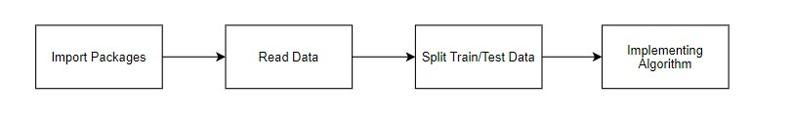
GIVEN INPUT EXPECTED OUTPUT
Input: Data
Output: Getting Accuracy

MODULE – 4 NAÏVE BAYES CLASSIFIER ALGORITHM:

The Naive Bayes Classifier is a probabilistic machine learning algorithm based on Bayes' Theorem, which is used for classification tasks. It assumes that the features used for classification are conditionally independent of each other, given the class label, which is why it is called "naive." Despite this simplifying assumption, it often performs surprisingly well in various real-world applications, especially when dealing with large datasets.

The algorithm works by calculating the conditional probability of each class given the input features. For each class, it multiplies the probability of the features occurring in that class and assigns the class with the highest probability as the predicted label. This process is based on Bayes' Theorem, which states that the probability of a class given the data is proportional to the probability of the data given the class multiplied by the prior probability of the class.

Naive Bayes is particularly effective for text classification tasks such as spam detection and sentiment analysis, where the features (words) are often conditionally independent. It is computationally efficient, simple to implement, and performs well even with noisy data. However, its performance can degrade when the independence assumption does not hold true, making it less effective in domains where features are strongly correlated.

MODULE DIAGRAM:

GIVEN INPUT EXPECTED OUTPUT
Input : Data
Output : Getting Accuracy

MODULE -5: DECISION TREE CLASSIFIER

The Decision Tree Classifier is a supervised machine learning algorithm used for both classification and regression tasks. It works by recursively partitioning the feature space into distinct regions and making predictions based on majority class labels for classification tasks or the average value for regression. The model splits the data at each node using a feature that best separates the data, often by selecting the feature that maximizes information gain or minimizes impurity (e.g., Gini index or entropy in classification). These splits continue until a stopping criterion is met, such as a node reaching a predefined depth or the data being homogeneous within a node.

The main strength of Decision Trees lies in their simplicity and interpretability. The model can be visualized as a tree structure, with each internal node representing a feature, each branch representing a decision rule, and each leaf node representing the predicted outcome. This makes it easy for users to understand how decisions are made and why certain predictions are reached. Additionally, Decision Trees handle both numerical and categorical data well and do not require extensive data preprocessing like feature scaling.

However, Decision Trees are prone to overfitting, especially when the tree becomes too deep and captures noise in the data. To combat this, techniques such as pruning, ensemble methods like Random Forests, or limiting tree depth are often applied to improve generalization. Despite this limitation, Decision Trees are still widely used due to their flexibility, ease of use, and the foundation they provide for more complex models in machine learning.

MODULE DIAGRAM:

GIVEN INPUT EXPECTED OUTPUT
Input : Data
Output : Getting Accuracy

MODULE – 6:

RANDOM FOREST CLASSIFIER ALGORITHM:

Random Forest is an ensemble learning algorithm that can be used for both classification and regression tasks. It builds multiple decision trees and merges them together to get a more accurate and stable prediction.
Here's a step-by-step explanation of how Random Forest works:
Bootstrapping:
Random Forest starts by creating multiple subsets of the original dataset through a process called bootstrapping. This involves randomly sampling the data with replacement, creating new datasets of the same size as the original.
Building Decision Trees:
For each subset, a decision tree is constructed. Decision trees are built by selecting the best feature from a random subset of features at each node, considering various criteria such as Gini impurity for classification or mean squared error for regression.
Voting (Classification) or Averaging (Regression):
Once all the trees are built, they "vote" for the class (in classification) or provide a prediction (in regression) for a new data point. For classification, the class that receives the most votes becomes the predicted class. For regression, the predictions are averaged.
Reducing Overfitting:
One of the key advantages of Random Forest is that it reduces overfitting. Each tree in the forest is trained on a different subset of the data, and by averaging or voting, the model becomes more robust and less prone to the noise present in individual trees.
Feature Importance:
Random Forest provides a measure of feature importance. Features that are more frequently used for splitting in the trees are considered more important. This information can be valuable for understanding the underlying patterns in the data.
Tuning Parameters:
Random Forest has several hyperparameters that can be tuned to optimize its performance, including the number of trees in the forest, the maximum depth of each tree, and the number of features considered at each split.
Advantages of Random Forest:
Reduces overfitting.
Handles missing values well.
Provides feature importance.
Can handle large datasets with high dimensionality.
Disadvantages:
Can be computationally expensive.
The model may become less interpretable with a large number of trees.
Random Forest is a versatile and powerful algorithm that is widely used in practice, especially in situations where interpretability is not the primary concern and high predictive accuracy is desired.
Top of Form

MODULE DIAGRAM:

GIVEN INPUT EXPECTED OUTPUT
Input : Data
Output : Getting Accuracy

23. Django (Web FrameWork) :
Django is an extremely popular and fully featured server-side web framework, written in Python. This module shows you why Django is one of the most popular web server frameworks, how to set up a development environment, and how to start using it to create your own web applications. In this first Django article we answer the question "What is Django?" and give you an overview of what makes this web framework special. We'll outline the main features, including some advanced functionality that we won't have time to cover in detail in this module. We'll also show you some of the main building blocks of a Django application, to give you an idea of what it can do before you set it up and start playing. Now that you know what Django is for, we'll show you how to set up and test a Django development environment on Windows, Linux (Ubuntu), and macOS — whatever common operating system you are using, this article should give you what you need to be able to start developing Django apps. Django is a high-level Python web framework that enables rapid development of secure and maintainable websites. Built by experienced developers, Django takes care of much of the hassle of web development, so you can focus on writing your app without needing to reinvent the wheel.
Complete
Django follows the "Batteries included" philosophy and provides almost everything developers might want to do "out of the box". Because everything you need is part of the one "product", it all works seamlessly together, follows consistent design principles, and has extensive and up-to-date documentation.

Versatile
Django can be (and has been) used to build almost any type of website — from content management systems and wikis, through to social networks and news sites. It can work with any client-side framework, and can deliver content in almost any format (including HTML, RSS feeds, JSON, XML, etc). The site you are currently reading is built with Django!

Internally, while it provides choices for almost any functionality you might want (e.g. several popular databases, templating engines, etc.), it can also be extended to use other components if needed.

Secure
• Django helps developers avoid many common security mistakes by providing a framework that has been engineered to "do the right things" to protect the website automatically. For example, Django provides a secure way to manage user accounts and passwords, avoiding common mistakes like putting session information in cookies where it is vulnerable (instead cookies just contain a key, and the actual data is stored in the database) or directly storing passwords rather than a password hash.

A password hash is a fixed-length value created by sending the password through a cryptographic hash function. Django can check if an entered password is correct by running it through the hash function and comparing the output to the stored hash value. However due to the "one-way" nature of the function, even if a stored hash value is compromised it is hard for an attacker to work out the original password.

Django enables protection against many vulnerabilities by default, including SQL injection, cross-site scripting, cross-site request forgery and clickjacking (see Website security for more details of such attacks).

Scalable
Django uses a component-based “shared-nothing” architecture (each part of the architecture is independent of the others, and can hence be replaced or changed if needed). Having a clear separation between the different parts means that it can scale for increased traffic by adding hardware at any level: caching servers, database servers, or application servers. Some of the busiest sites have successfully scaled Django to meet their demands (e.g. Instagram and Disqus, to name just two).

Maintainable
Django code is written using design principles and patterns that encourage the creation of maintainable and reusable code. In particular, it makes use of the Don't Repeat Yourself (DRY) principle so there is no unnecessary duplication, reducing the amount of code. Django also promotes the grouping of related functionality into reusable "applications" and, at a lower level, groups related code into modules (along the lines of the Model View Controller (MVC) pattern).

Portable
Django is written in Python, which runs on many platforms. That means that you are not tied to any particular server platform, and can run your applications on many flavours of Linux, Windows, and Mac OS X. Furthermore, Django is well-supported by many web hosting providers, who often provide specific infrastructure and documentation for hosting Django sites.

Start Using an API
- Most APIs require an API key. ...
- The easiest way to start using an API is by finding an HTTP client online, like REST-Client, Postman, or Paw.
- The next best way to pull data from an API is by building a URL from existing API documentation.

The flask object implements a WSGI application and acts as the central object. It is passed the name of the module or package of the application. Once it is created it will act as a central registry for the view functions, the URL rules, template configuration and much more.
The name of the package is used to resolve resources from inside the package or the folder the module is contained in depending on if the package parameter resolves to an actual python package (a folder with an __init__.py file inside) or a standard module (just a .py file).
For more information about resource loading, see open resource().
Usually you create a Flask instance in your main module or in the __init__.py file of your package.

Parameters
- rule (str) – The URL rule string.
- endpoint (Optional[str]) – The endpoint name to associate with the rule and view function. Used when routing and building URLs. Defaults to view_func.__name__.
- view_func (Optional[Callable]) – The view function to associate with the endpoint name.
- provide_automatic_options (Optional[bool]) – Add the OPTIONS method and respond to OPTIONS requests automatically.
- options (Any) – Extra options passed to the Rule object.
Return type -- None

After_Request(f)
Register a function to run after each request to this object.
The function is called with the response object, and must return a response object. This allows the functions to modify or replace the response before it is sent.
If a function raises an exception, any remaining after request functions will not be called. Therefore, this should not be used for actions that must execute, such as to close resources. Use teardown_request() for that.

Parameters:
f (Callable[[Response], Response])
Return type
Callable[[Response], Response]
after_request_funcs: t.Dict[AppOrBlueprintKey,
t.List[AfterRequestCallable]]
A data structure of functions to call at the end of each request, in the format {scope: [functions]}. The scope key is the name of a blueprint the functions are active for, or None for all requests.
To register a function, use the after_request() decorator.
This data structure is internal. It should not be modified directly and its format may change at any time.
app_context()
Create an AppContext. Use as a with block to push the context, which will make current_app point at this application.
An application context is automatically pushed by RequestContext.push() when handling a request, and when running a CLI command. Use this to manually create a context outside of these situations.
With app.app_context():
Init_db()

I

CODE:
from django.shortcuts import render, redirect
from django.urls import reverse_lazy
from django.contrib.auth.views import LoginView, PasswordResetView, PasswordChangeView
from django.contrib import messages
from django.contrib.messages.views import SuccessMessageMixin
from django.views import View
from django.contrib.auth.decorators import login_required
from django.contrib.auth import logout as auth_logout
import numpy as np
import joblib
from .forms import RegisterForm, LoginForm, UpdateUserForm, UpdateProfileForm
from . models import UserPredictModel
from .forms import UserPredictDataForm

def home(request):
return render(request, 'users/home.html')

@login_required(login_url='users-register')

def index(request):
return render(request, 'app/index.html')

class RegisterView(View):
form_class = RegisterForm
initial = {'key': 'value'}
template_name = 'users/register.html'

def dispatch(self, request, *args, **kwargs):
# will redirect to the home page if a user tries to access the register page while logged in
if request.user.is_authenticated:
return redirect(to='/')

# else process dispatch as it otherwise normally would
return super(RegisterView, self).dispatch(request, *args, **kwargs)

def get(self, request, *args, **kwargs):
form = self.form_class(initial=self.initial)
return render(request, self.template_name, {'form': form})

def post(self, request, *args, **kwargs):
form = self.form_class(request.POST)

if form.is_valid():
form.save()

username = form.cleaned_data.get('username')
messages.success(request, f'Account created for {username}')

return redirect(to='login')

return render(request, self.template_name, {'form': form})

# Class based view that extends from the built in login view to add a remember me functionality

class CustomLoginView(LoginView):
form_class = LoginForm

def form_valid(self, form):
remember_me = form.cleaned_data.get('remember_me')

if not remember_me:
# set session expiry to 0 seconds. So it will automatically close the session after the browser is closed.
self.request.session.set_expiry(0)

# Set session as modified to force data updates/cookie to be saved.
self.request.session.modified = True

# else browser session will be as long as the session cookie time "SESSION_COOKIE_AGE" defined in settings.py
return super(CustomLoginView, self).form_valid(form)

class ResetPasswordView(SuccessMessageMixin, PasswordResetView):
template_name = 'users/password_reset.html'
email_template_name = 'users/password_reset_email.html'
subject_template_name = 'users/password_reset_subject'
success_message = "We've emailed you instructions for setting your password, " \
"if an account exists with the email you entered. You should receive them shortly." \
" If you don't receive an email, " \
"please make sure you've entered the address you registered with, and check your spam folder."
success_url = reverse_lazy('users-home')

class ChangePasswordView(SuccessMessageMixin, PasswordChangeView):
template_name = 'users/change_password.html'
success_message = "Successfully Changed Your Password"
success_url = reverse_lazy('users-home')

@login_required
def profile(request):
if request.method == 'POST':
user_form = UpdateUserForm(request.POST, instance=request.user)
profile_form = UpdateProfileForm(request.POST, request.FILES, instance=request.user.profile)

if user_form.is_valid() and profile_form.is_valid():
user_form.save()
profile_form.save()
messages.success(request, 'Your profile is updated successfully')
return redirect(to='users-profile')
else:
user_form = UpdateUserForm(instance=request.user)
profile_form = UpdateProfileForm(instance=request.user.profile)

return render(request, 'users/profile.html', {'user_form': user_form, 'profile_form': profile_form})

Model = joblib.load('users/UPI1.pkl')
def model(request):
if request.method == 'POST':
fields = ['AverageAmountTransactionDay', 'TransactionAmount', 'Is_declined',
'TotalNumberOfDeclinesDay', 'isForeignTransaction', 'isHighRiskCountry',
'DailyChargebackAvgAmt', 'Six_MonthAvgChbkAmt', 'Six_MonthChbkFreq']

form = UserPredictDataForm(request.POST)
features = []
for i in fields:
info = int(request.POST[i])
features.append(info)

Final_features = [np.array(features, dtype=int)]

prediction = Model.predict(Final_features)
actual_output = prediction[0]
print(actual_output)

if actual_output == 0:
actual_output = 'NO'

elif actual_output == 1:
actual_output = 'YES'

print(features)
print(actual_output)
if form.is_valid():
print('Saving data in Form')
form_instance = form.save() # Save form data but don't commit to DB yet
form_instance.save()
data = UserPredictModel.objects.latest('id')
data.isFradulent = actual_output
data.save()
return render(request, 'app/result.html', {'form':form, 'prediction_text':actual_output})
else:
print('Else working')
form = UserPredictDataForm(request.POST)
return render(request, 'app/model.html', {'form':form})

import numpy as np
import matplotlib.pyplot as plt
import seaborn as sns
import base64
from io import BytesIO
from django.shortcuts import render

def Basic_report(request):
return render(request,'app/Basic_report.html')

def Metrics_report(request):
return render(request,'app/Metrics_report.html')

def model_db(request):
data = UserPredictModel.objects.all()
return render(request, 'app/model_db.html', {'data': data})

from .models import Profile
def profile_list(request):
# Fetch all profile objects from the database
profiles = Profile.objects.all()

# Pass the profiles data to the template
return render(request, 'app/profile_list.html', {'profiles': profiles})

def logout_view(request):
auth_logout(request)
return redirect('/')
OUTPUT:
LANDING PAGE:


REGISTER:
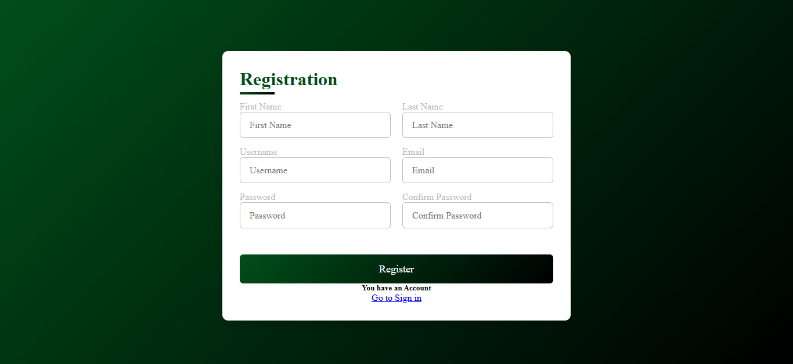

LOGIN:
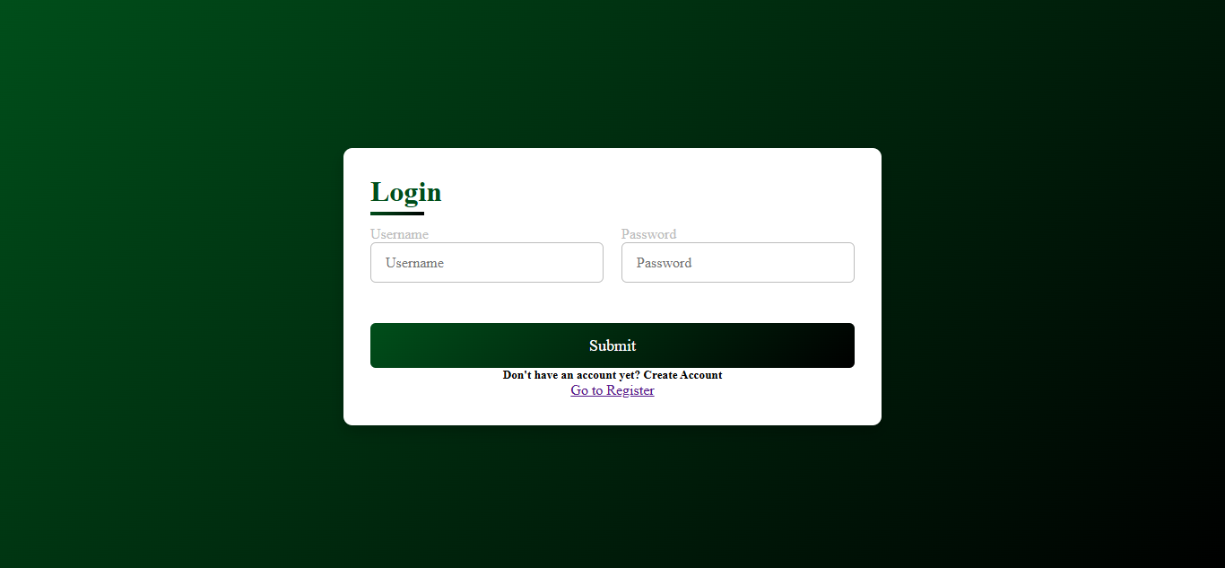

HOME:


DATABASE:
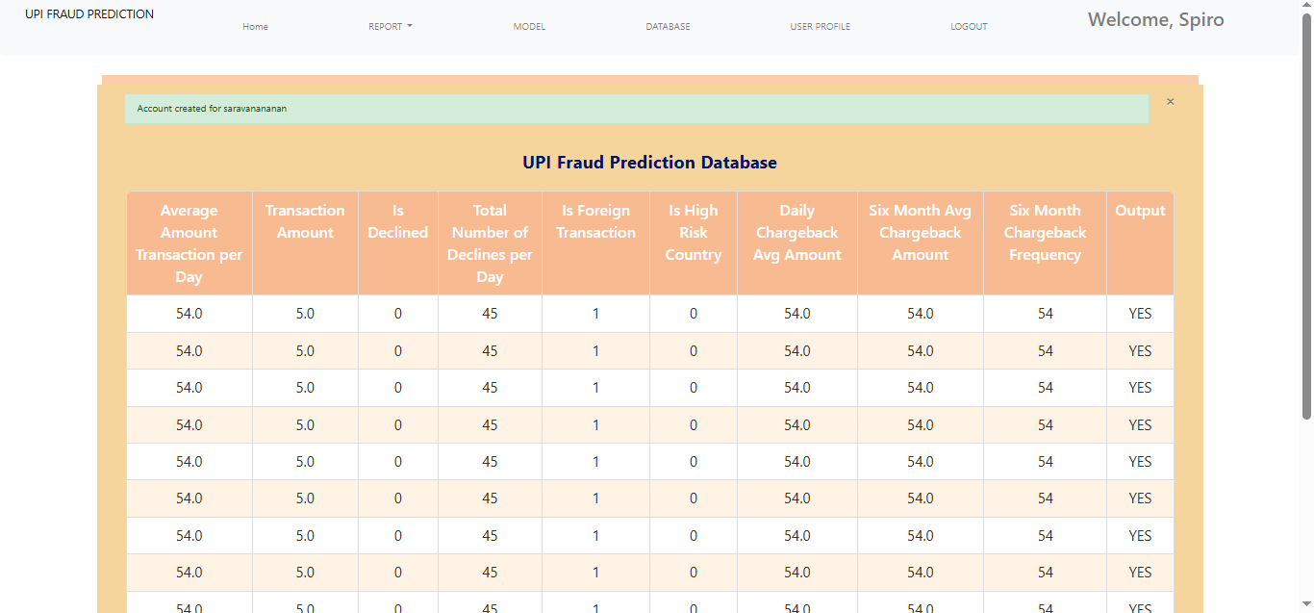

PROFILE:
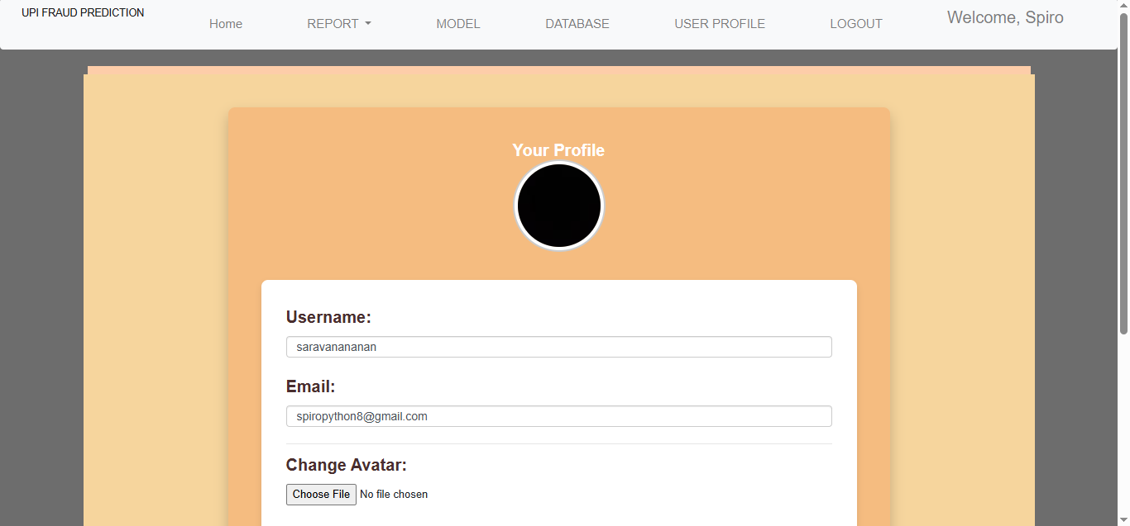

PREDICTION:
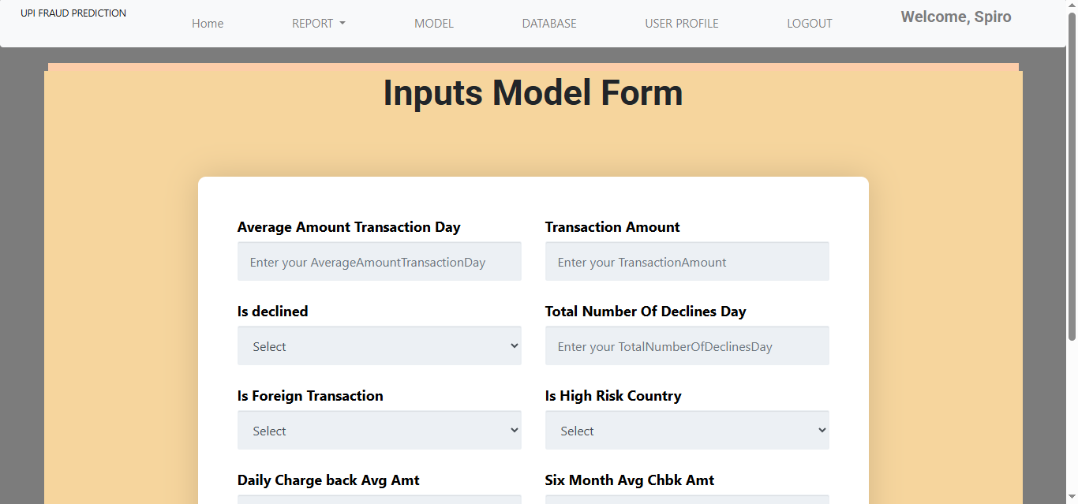

REPORT:
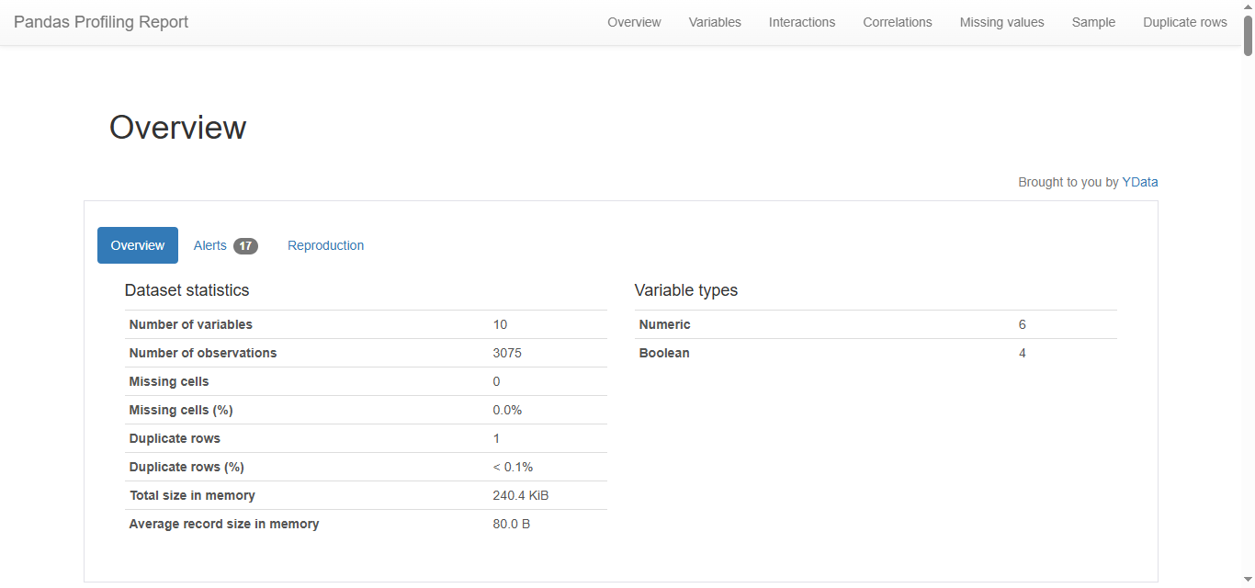

27. Conclusion:

Predictive analytics for Hepatitis C represents a significant advancement in enhancing patient care through data science techniques. By leveraging sophisticated machine learning algorithms and statistical models, healthcare professionals can gain invaluable insights into patient outcomes, treatment responses, and disease progression. These insights enable more accurate risk assessments, personalized treatment plans, and proactive management strategies. As a result, predictive analytics facilitates timely interventions, potentially improving overall treatment efficacy and patient quality of life. The integration of these data-driven approaches not only streamlines clinical workflows but also empowers healthcare providers with the tools needed to make informed decisions, ultimately contributing to more effective and individualized patient care.
28. Future Work:
- Prediction methods to connect with cloud model.
- To optimize the work to implement in IOT System.

ent in Artificial Intelligence Environment.
