## Data point are of different nature / scale…? What will happen to my model?

Data Drift

1. Blindly re-training
2. Data monitoring
   1. Identify which features is causing the drift
   2. Nudge the problematic feature
   3. If required, then re-train

<https://docs.microsoft.com/en-us/azure/machine-learning/how-to-monitor-datasets?tabs=python>

<https://www.analyticsvidhya.com/blog/2021/10/mlops-and-the-importance-of-data-drift-detection/>

## Loss function

<https://keras.io/api/losses/>

## Dense Layer

<https://keras.io/api/layers/core_layers/dense/>

Sampling (design of experiments)

1. Sample (train or test) should reflect the population
2. Sampling techniques
   1. Stratified
   2. Clustered
   3. Random
3. Cross validation

<https://en.wikipedia.org/wiki/Confusion_matrix>

y = 2x

y = x^2

## Overfitting

Bias and Variance trade-off:

|  |  |  |
| --- | --- | --- |
| input | 28X28 |  |
| Flatten | 784 |  |
| hidden | 128 | 1024 |
| 0utput | 10 |  |

comparing models:

|  |  |  |  |  |
| --- | --- | --- | --- | --- |
|  | model_0 | model_1 | model_2 | model_3 |
|  | 128 | 1024 | 2 h layers | w/o normalization |
| training acc | 0.8917 | 0.8950 | 0.8971 | 0.7876 |
| test acc | 0.8738 | 0.8726 | 0.885699987 | 0.7876 |

Normalization:

|  |  |
| --- | --- |
| 245 | 0.960784314 |
| 255 | 1 |
| 128 | 0.501960784 |

Issues with DNN:

1. Blank spaces are of no use
2. Feature map perception

## Convolution layer

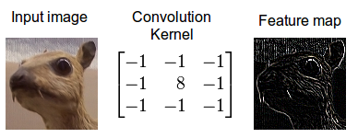

## Pooling layer

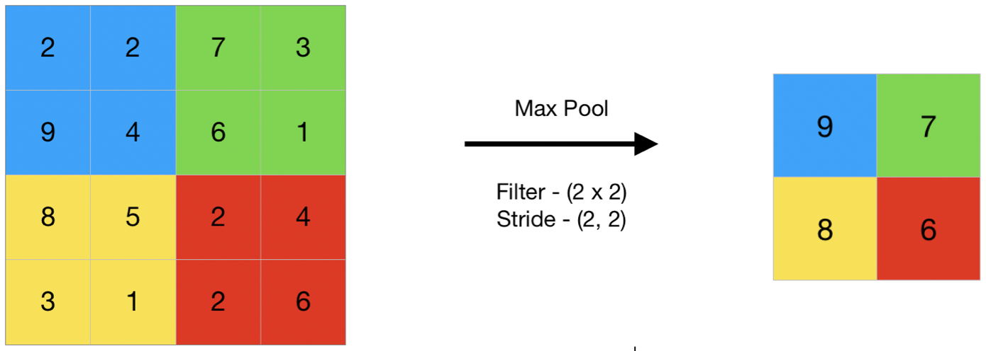

H.W

1. Replicate the notebook
2. Tinker with convolution layer parameters and observe the accuracy