AI is all about making intelligent machines.

Example: Google Assistance, Tesla Car , Siri etc.

Machine Learning is all about the data.

* I want a system to detect the images of Cat or Dog(task)
* ML approaches we will feed numerous images of cat and dog.
* We will tell the algorithm that these images are of cat or dog
* Now the algorithm without our input, it finds the pattern between the images and when we give a new image it can predict correctly whether the image is of cat or dog.
* In Machine learning we give lot of data to the algorithm to learn from.
* It is similar to the child seeing and learning.

**Types of Machine Learning:**

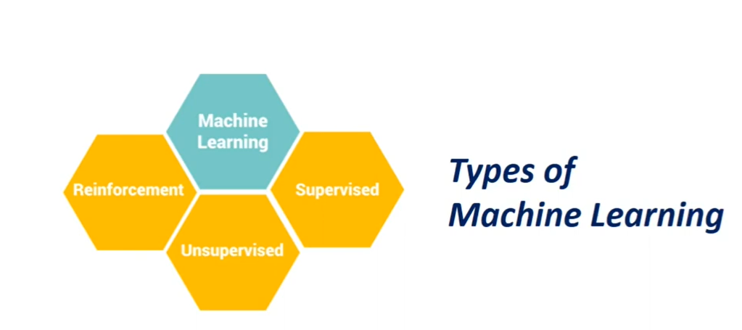

Our goal is to build intelligent machine.

* Machine learns from the data.

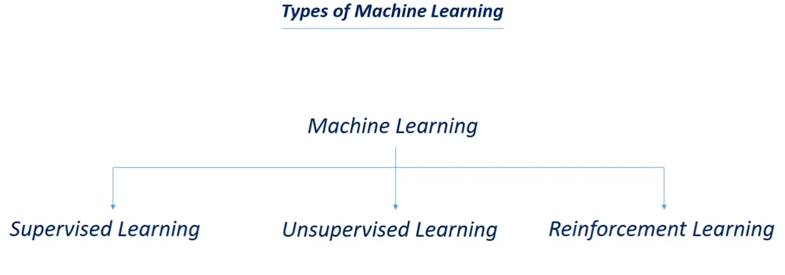

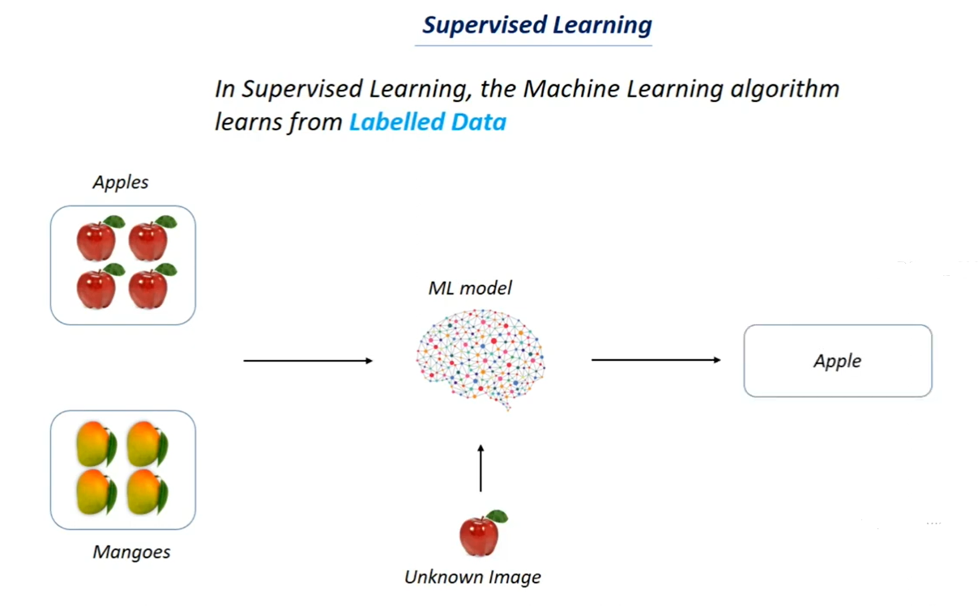

Here we are giving supervision in terms of labels.

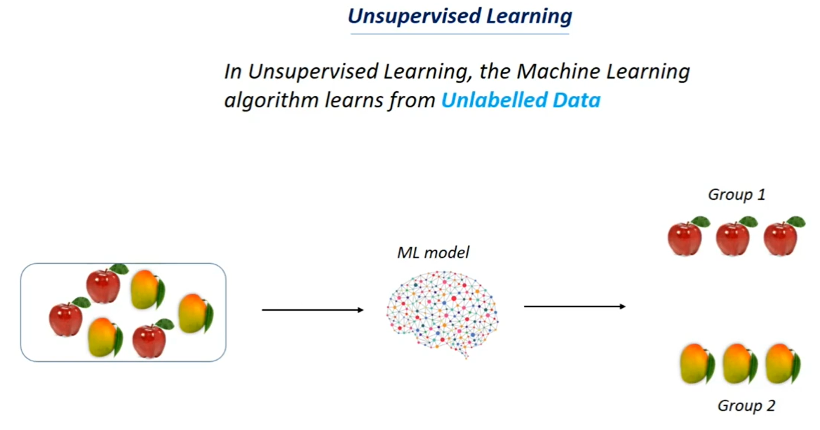

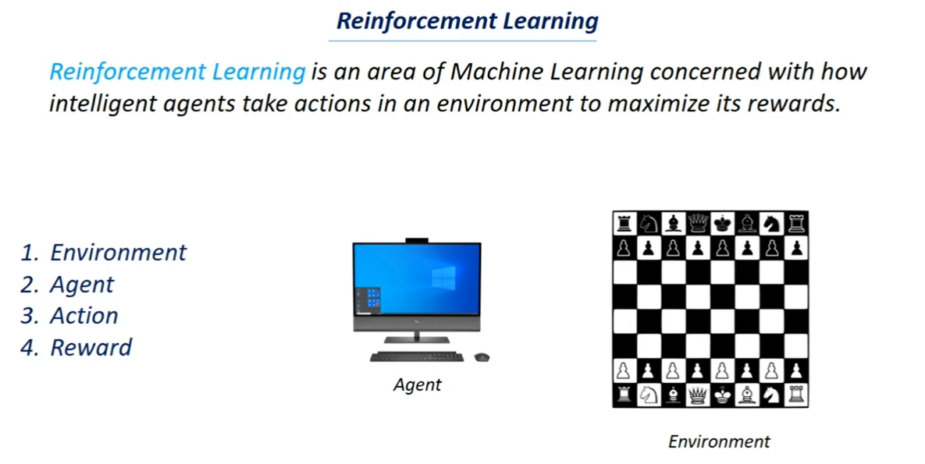

Positive rewards

Negative rewards

* Move is the action
* If it is moving towards winning it will be reward as positive
* Similarly with negative rewards.
* Main goal is to increase the chance of winning.

