Wiki

ICP 7

Team: 1

Members: Ahmad, Cameron, Marajan, Syed Jawad

Objective:

The objective of this lab is to get familiar with Raspberry Pi 3 and its applications in Node Red. Initially, the class started with Raspberry Pi intro and after the lecture the after that students started to connect their laptops with Raspberry Pi.

Task 1:

The students started to connect their laptops with Raspberry Pi and started working on unfinished sensor assignment. In doing such exercise the readings for Temperature, pressure, Ambient, and Humidity were captured and visualized on visualization platform. The screen shots of this task are below:

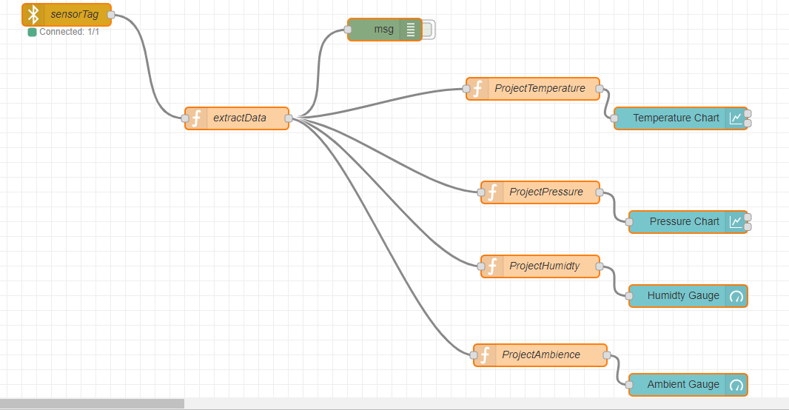

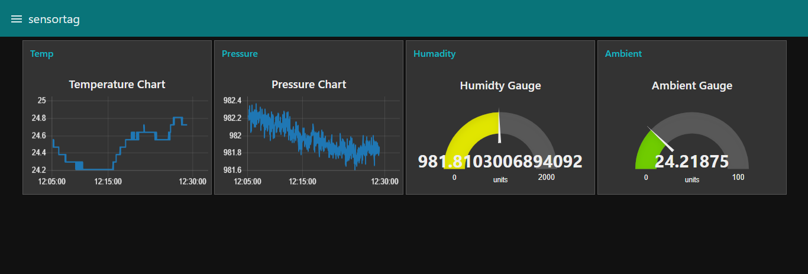

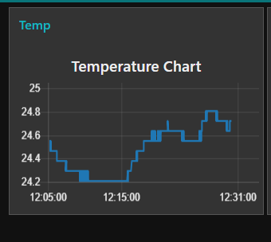

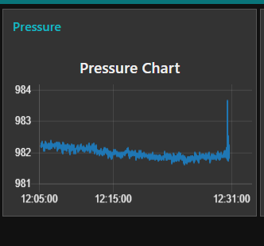

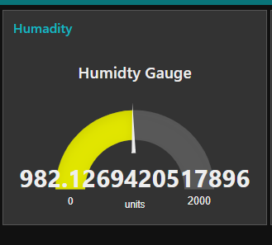

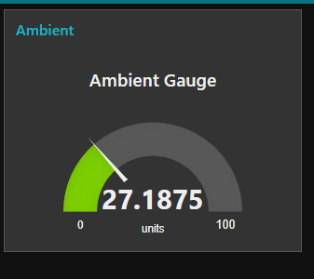

Task 2: