# 

**ACKNOWLEDGEMENT**

We are pleased to present **“Online Shopping System”** projectand takethis opportunity to express our profound gratitude to all those people who helped us in completion of this project.

We express our deepest gratitude towards our project guide for …….valuable and timely advice during the various phases in our project. We would also like to thank her for providing us with all proper facilities and support as the project co-coordinator. We would like to thank her for support, patience and faith in our capabilities and for giving us flexibility in terms of working and reporting schedules.

We would like to thank all our friends for their smiles and friendship making the college life enjoyable and memorable and family members who

always stood beside us and provided the utmost important moral support. Finally, we would like to thank everyone who has helped us directly or indirectly in our project.

We thank our college for providing us with excellent facilities that helped us to complete and present this project. We would also like to thank the staff members and lab assistants for permitting us to use computers in the lab as and when required.

**INTRODUCTION OF PROJECT ONLINE SHOPPING SYSTEM**

The “Online Shopping System” has been developed to override the problems prevailing in the practicing manual system. This software is supported to eliminated and, in some cases, reduce the hardships faced by this existing system. Moreover, this system is designed for the particular need of the company to carry out operations ina smooth and effective manner.

The application is reduce as much as possible to avoid while entering the data .It also provide all error message while entering invalid data..No formal knowledge is needed for the user to use the this system.Thus by this all its proves it is user-friendly.Online shopping System ,as described above ,can lead to to error free ,secure,reliable and fastr management system.It can assist the user to concentrate on their other activities rather to concentrate on the record keeping ,Thus it will help organization in utilizationof resources .

Every organization ,weather big or small ,has challenges to overcome and managing the information of customers,product,order,Type ,payment ,every Online Shopping System has different product needs ,therefore we design exclusive employe management systems that are adapted to your managerial requirements.This is designed to assist in strategic planning,and will help you ensure that your organization is equipped with the right level of information and details for your goals.Also ,for those buys executive who are always on the go Systems come with remote access features,which will allow you to manage your workforce anytime,all times.These systems will ultimately allow you to better mange resources.

**ABSTRACT OF PROJECT ONLINE SHOPPING SYSTEM**

The purpose of online shopping System is to automate the existing manual system by the help of computerized equipments and full-fledged computer software, full-filling their requirements, so that their valuable data/information can be stored for a longer period with easy accessing and manipulation of the same. The required software and hardware are easily available and easy to work with.

Online Shopping System, as described above, can lead to error free, secure,

reliable and fast management system. It can assist the user to concentrate on them

other activities rather to concentrate on the record keeping. Thus, it will help organization

in better utilization of resources. The organization can maintain computerized records

without redundant entries. That means that one need not be distracted by information

that is not relevant, while being able to reach the information.

The aim is to automate its existing manual system by the help of computerized

equipments and full-fledged computer software, fulfilling their requirements, so that them

valuable data/information can be stored for a longer period with easy accessing and

manipulation of the same. Basically, the project describes how to manage for good

performance and better services for the clients.

**Objective OF PROJECT ONLINE SHOPPING SYSTEM**

The main objective of the Project on Online Shopping System is to manage the

details of Product, Customer, Stock, Order, Payment. It manages all the information

about Product, Type, Payment Product. The project is totally built at administrative end

and thus, only the administrator is guaranteed the access. The purpose of the project is

to build an application program to reduce the manual work for managing the Product,

Customer, Type, Stock. It tracks all the details about the Stock, Order, Payment

**Functionalities provided by Online Shopping System are as follows:**

• Provides the searching facilities based on various factors. Such as Product, Stock,

Order, Payment

• Online Shopping System also manage the Type details online for Order details,

Payment details, Product

• It tracks all the information of Customer, Type, Order etc

• Manage the information of Customer

• Shows the information and description of the Product, Stock

• To increase efficiency of managing the Product, Customer

• It deals with monitoring the information and transactions of Order.

• Manage the information of Product

• Editing, adding and updating of Records is improved which results in proper

resource management of Product data.

• Manage the information of Order

• Integration of all records of Payment.

**Scope of the project Online Shopping System**

It may help collecting perfect management in details. In a very short time, the

collection will be obvious, simple and sensible. It will help a person to know the

management of passed year perfectly and vividly. It also helps in current all works

relative to Online Shopping System. It will be also reduced the cost of collecting the management & collection procedure will go on smoothly.

Our project aims at Business process automation, i.e., we have tried to

computerize various processes of Online Shopping System.

• In computer system the person has to fill the various forms & number of copies of the forms can be easily generated at a time.

• In computer system, it is not necessary to create the manifest but we can directly

print it, which saves our time.

• To assist the staff in capturing the effort spent on their respective working areas.

To utilize resources in an efficient manner by increasing their productivity through

automation

• The system generates types of information that can be used for various

purposes.

• It satisfies the user requirement

• Be easy to understand by the user and operator

• Be easy to operate

• Have a good user interface

• Be expandable

**Reports of Online Shopping System:**

• It generates the report on Product, Customer, Type

• Provide filter reports on Stock, Order, Payment

• You can easily export PDF for the Product Type, Order

• Application also provides excel export for Customer, Stock, Payment

• You can also export the report into csv format for Product, Customer, Payment

Modules of Online Shopping System:

• Product Management Module: Used for managing the Product details.

• Payment Module: Used for managing the details of Payment

• Type Module: Used for managing the details of Type

Customer Management Module: Used for managing the information and details

of the Customer.

• Stock Module: Used for managing the Stock details

• Order Module: Used for managing the Order information

• Login Module: Used for managing the login details

• Users Module: Used for managing the users of the system

**Input Data and Validation of Project on Online Shopping System**

• All the fields such as Product, Stock, Payment is validated and does not take

invalid values

• Each form for product, Customer, Type can not accept blank value fields

• Avoiding errors in data

• Controlling amount of input

• Integration of all the modules/forms in the system.

• Preparation of the test cases.

• Preparation of the possible test data with all the validation checks.

• Actual testing done manually.

• Recording of all the reproduced errors.

• Modifications done for the errors found during testing.

• Prepared the test result scripts after rectification of the errors.

• Functionality of the entire module/forms.

• Validations for user input.

• Checking of the Coding standards to be maintained during coding.

• Testing the module with all the possible test data.

• Testing of the functionality involving all type of calculations etc.

• Commenting standard in the source files.

The software quality plan we will use the following SQA Strategy:

• In the first step, we will select the test factors and rank them. The selected test

factors such as reliability, maintainability, portability or etc, will be placed in the

matrix according to their ranks.

**The software quality plan we will use the following SQA Strategy:**

In the first step, we will select the test factors and rank them. The selected test

factors such as reliability, maintainability, portability or etc, will be placed in the

matrix according to their ranks.

• The second step is for identifying the phases of the development process. The

phase should be recorded in the matrix.

• The third step is that identifying the business risks of the software deliverables.

The risks will be ranked into three ranks such as high, medium and low.

Project Design

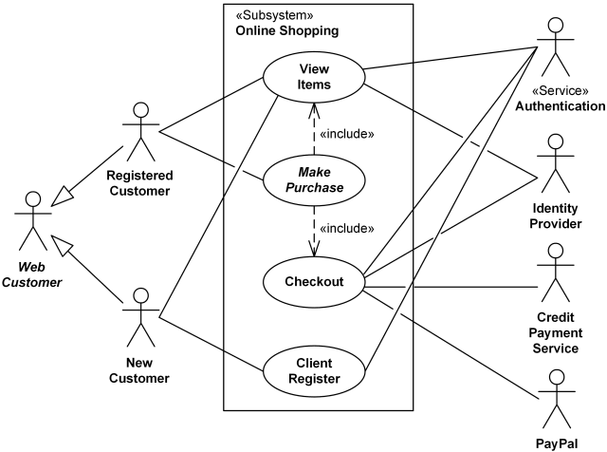**Use-Case Diagram**

**Sequence Diagram**

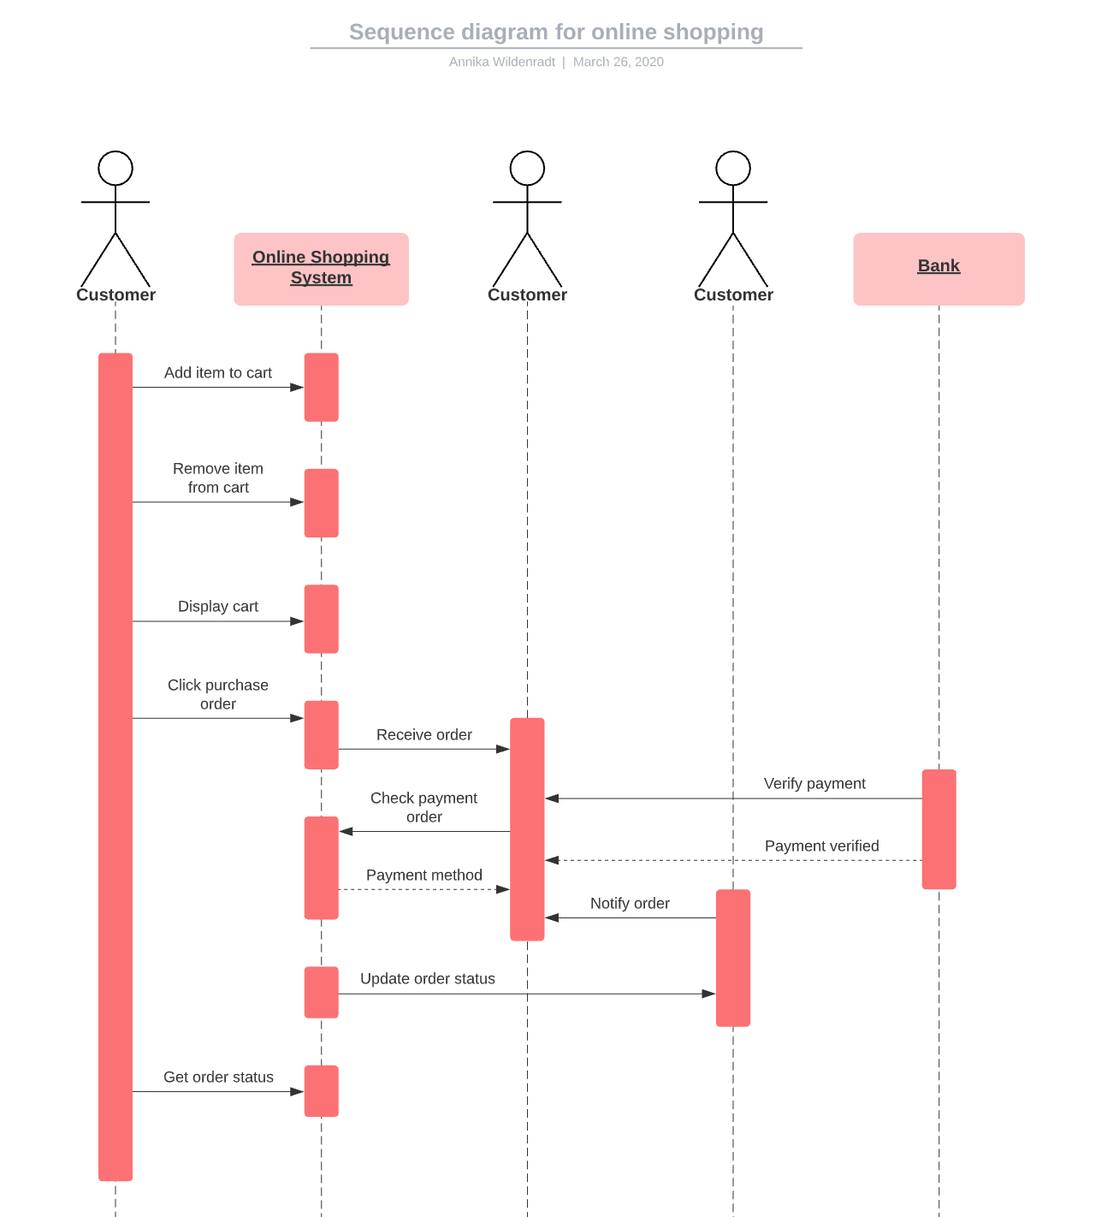

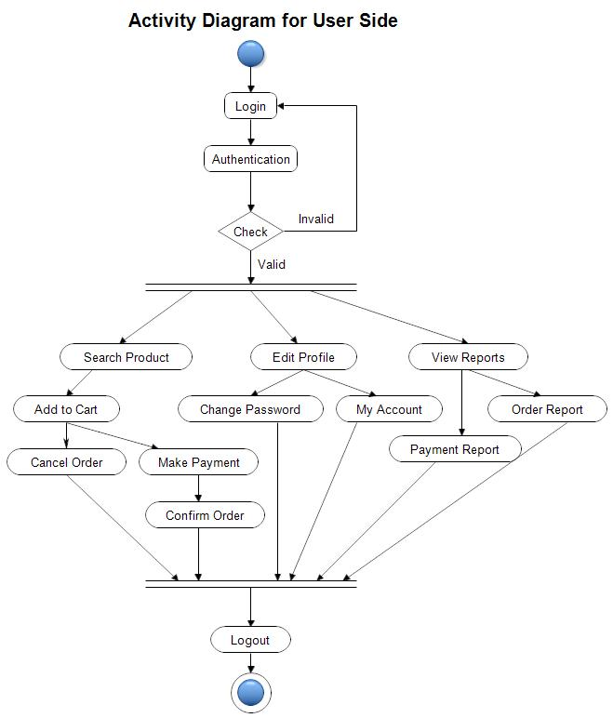**Activity Diagram**

**Class Diagram**

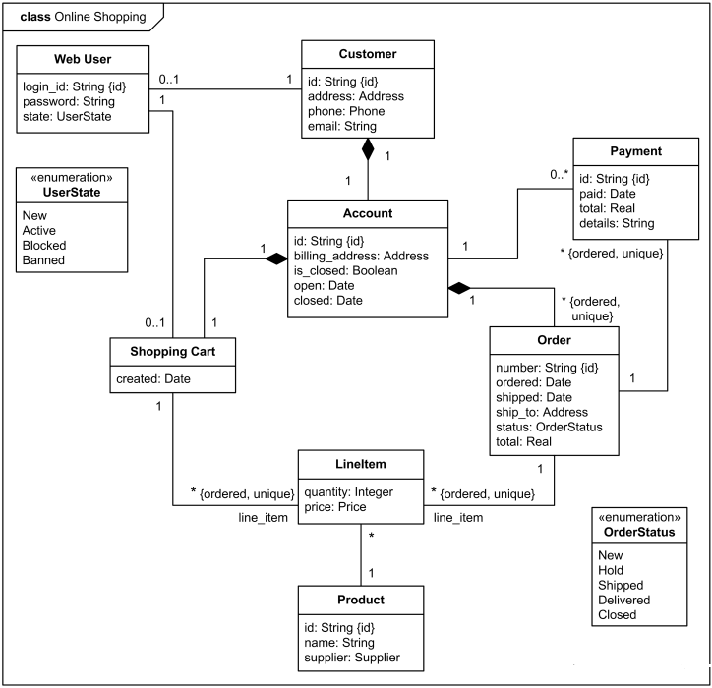

**Features of the project Online Shopping System:**

**Product and Component based**

• Creating & Changing Issues at ease

Query Issue List to any depth

• Reporting & Charting in more comprehensive way

• User Accounts to control the access and maintain security

• Simple Status & Resolutions

• Multi-level Priorities & Severities.

• Targets & Milestones for guiding the programmers

• Attachments & Additional Comments for more information

• Robust database back-end

• Various level of reports available with a lot of filter criteria's

• It contains better storage capacity.

• Accuracy in work

• Easy & fast retrieval of information.

. Well designed reports.

• Decrease the load of the person involve in existing manual system.

• Access of any information individually.

• Work becomes very speedy.

• Easy to update information

**Feasibility Study:**

After doing the project Online Shopping System, study and analyzing all the

existing or required functionalities of the system, the next task is to do the feasibility

study for the project. All projects are feasible - given unlimited resources and infinite

time

Feasibility study includes consideration of all the possible ways to provide a solution to

the given problem. The proposed solution should satisfy all the user requirements and

should be flexible enough so that future changes can be easily done based on the

future upcoming requirements.

**A. Economical Feasibility**

This is a very important aspect to be considered while developing a project. We

decided the technology based on minimum possible cost factor.

• All hardware and software cost has to be borne by the organization.

• Overall, we have estimated that the benefits the organization is going to receive

from the proposed system will surely overcome the initial costs and the later on

running cost for system

**B. Technical Feasibility**

This included the study of function, performance and constraints that may affect

the ability to achieve an acceptable system. For this feasibility study, we studied

complete functionality to be provided in the system, as described in the System

Requirement Specification (SRS), and checked if everything was possible using

different type of frontend and backend plaformst.

**C. Operational Feasibility**

No doubt the proposed system is fully GUI based that is very user friendly and all

inputs to be taken all self-explanatory even to a layman. Besides, a proper training has

been conducted to let know the essence of the system to the users so that they feel

comfortable with new system. As far our study is concerned the clients are comfortable

and happy as the system has cut down their loads and doing.

**System Design of Online Shopping System**

In this phase, a logical system is built which fulfils the given requirements. Design

phase of software development deals with transforming the clients's requirements into a

logically working system. Normally, design is performed in the following in the following

two steps:

**1. Primary Design Phase:**

In this phase, the system is designed at block level. The blocks are created on

the basis of analysis done in the problem identification phase. Different blocks

are created for different functions emphasis is put on minimising the information

flow between blocks. Thus, all activities which require more interaction are kept

in one block

**2. Secondary Design Phase:**

In the secondary phase the detailed design of every block is performed.

The general tasks involved in the design process are the following:

1. Design various blocks for overall system processes.

2. Design smaller, compact and workable modules in each block.

3. Design various database structures.

4. Specify details of programs to achieve desired functionality.

5. Design the form of inputs, and outputs of the system.

6. Perform documentation of the design.

7. System reviews

**User Interface Design**

User Interface Design is concerned with the dialogue between a user and the

computer. It is concerned with everything from starting the system or logging into the

system to the eventually presentation of desired inputs and outputs. The overall flow of

screens and messages are called a dialogue.

**The following steps are various guidelines for User Interface Design:**

1. The system user should always be aware of what to do next.

2. The screen should be formatted so that various types of information, instructions

and messages always appear in the same general display area.

3. Message, instructions or information should be displayed long enough to allow

the system user to read them.

4. Use display attributes sparingly.

5. Default values for fields and answers to be entered by the user should be

specified

6. A user should not be allowed to proceed without correcting an error.

7. The system user should never get an operating system message or fatal error.

**PROJECT PLANNING**

Software project plan can be viewed as the following:

1) Within the organization: How the project is to be implemented? What are

various constraints (time, cost, staff)? What is market strategy?

2) With respect to the customer: Weekly or timely meetings with the customer

with presentation on status reports. Customers feedback is also taken and further

modification and developments are done. Project milestones and deliverables

are also presented to the customer.

For a successful software project, the following steps can be followed:

Select a project

o Identifying project's aims and objectives

o Understanding requirements and specification

o Methods of analysis, design and implementation

o Testing techniques

o Documentation

Project milestones and deliverables

Budget allocation

o Exceeding limits within control

* Project Estimates

o Cost

0 Time

o Size of code

o Duration

• Resource Allocation

o Hardware

o Software

o Previous relevant project information

o Digital Library

Risk Management

O Risk avoidance

Risk detection

**Project Scheduling:**

**An elementary Gantt chart or Timeline chart for the development plan is given below.**

**The plan explains the tasks versus the time (in weeks) they will take to complete.**

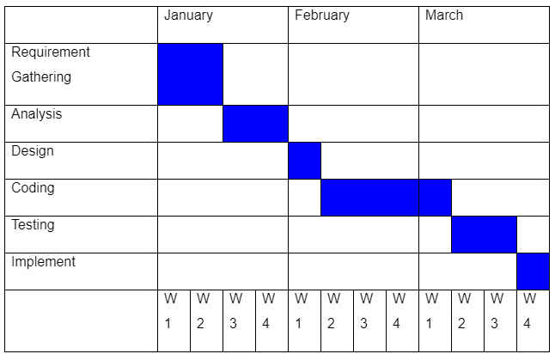

**Tools/Platform, Hardware and Software Requirement specifications:**

|  |  |
| --- | --- |
| **Name of component** | **Specification** |
| **Operating System** | **Windows 10** |
| **Language** | **Java 2 Runtime Environment** |
| **Database** | **MySQL Server** |
| **Browser** | **Any of Mozilla, Opera, Chrome etc** |
| **Web Server** | **Tomcat 9** |
| **Software Development Kit** | **Java JDK 1.7 or Above** |
| **Scripting Language Enable** | **JSP (Java Server Pages)**  **servlet** |
| **Database JDBC Driver** | **MySQL Jconnector** |

|  |  |
| --- | --- |
| **Name of component** | **Specification** |
| **Processor** | **Pentium III 630MHz** |
| **RAM** | **128 MB** |
| **Hard disk** | **20 GB** |
| **Monitor** | **15" color monitor** |
| **Keyboard** | 122keys |

**Hardware**

**Security Testing of the Project**

Testing is vital for the success of any software. no system design is ever perfect. Testing is also

carried in two phases. first phase is during the software engineering that is during the module

creation second phase is after the completion of software. this is system testing which verifies

that the whole set of programs hanged together.

**White Box Testing:**

In this technique, the close examination of the logical parts through the software are tested by

cases that exercise species sets of conditions or loops. all logical parts of the software checked

once errors that can be corrected using this technique are typographical errors. logical

expressions which should be executed once may be getting executed more than once and error

resulting by using wrong controls and loops. When the box testing tests all the independent part

within a module a logical decision on their true and the false side are exercised, all loops and

bounds within their operational bounds were exercised and internal data structure to ensure

their validity was exercised once.

**Black Box Testing:**

This method enables the software engineer to device sets of input techniques that fully exercise

all functional requirements for a program. black box testing tests the input, the output and the

external data. it checks whether the input data is correct and whether we are getting the desired

output

**Alpha Testing**

Acceptance testing is also sometimes called alpha testing. Be spoke systems are developed for

a single customer. The alpha testing proceeds until the system developer and the customer

agree that the provided system is an acceptable implementation of the system requirements.

**Beta Testing:**

On the other hand, when a system isto be marked as a software product, another process

called beta testing is often conducted. During beta testing, a system is delivered among anumber of potential users who agree to use it. The customers then report problems to the

developers. This provides the product for real use and detects errors which may not have beenanticipated by the system developers.

**Unit Testing:**

Each module is considered independently. it focuses on each unit of software as implemented in

the source codes. it is white box testing.

**Integration Testing:**

Integration testing aims at constructing the program structure while at the same constructing

tests to uncover errors associated with interfacing the modules. modules are integrated by using

the top-down approach.

**Validation Testing:**

Validation testing was performed to ensure that all the functional and performance requirements

are met.

**System Testing:**

It is executing programs to check logical changes made in it with intention of finding errors. a

system is tested for online response, volume of transaction, recovery from failure etc. System

testing is done to ensure that the system satisfies all the user requirements.

Class Diagram**:**

Ecommerce project

* **Src**
* **Com.ecommerce.dao**
* productDao.java
* BrandDao.java
* BrandDaoImp.java
* cartDao.java
* cartDaoImp.java
* clothDao.java
* ClothDaoImp.java
* Helper.java
* orderDao.java
* orderDaoImp.java
* ProductDao.java
* ProductDaoImp.java
* userDao.java
* userDaoImp.java
* **com.ecommerce.dbutility**
* DButility.java
* **Com.ecommerce.pojo**
* Brand.java
* Cart.java
* Category.java
* Cloth.java
* Order.java
* Product.java
* User.java
* **Com.ecommerce.servlet**
* Cartservlet.java
* Loginservlet.java
* Orderservlet.java
* Productoperatioserv.java
* Registerservlet.java
* **WebContent**
* **Components**
* Common_cs_js.jsp
* Message.jsp
* Navbar.jsp
* **Css**
* Style.css
* Userprofilepic
* Img
* Admin.jsp
* Index.jsp
* Login.jsp
* Product.jsp
* Register.jsp

**Screenshots of the Project Online Shopping System**



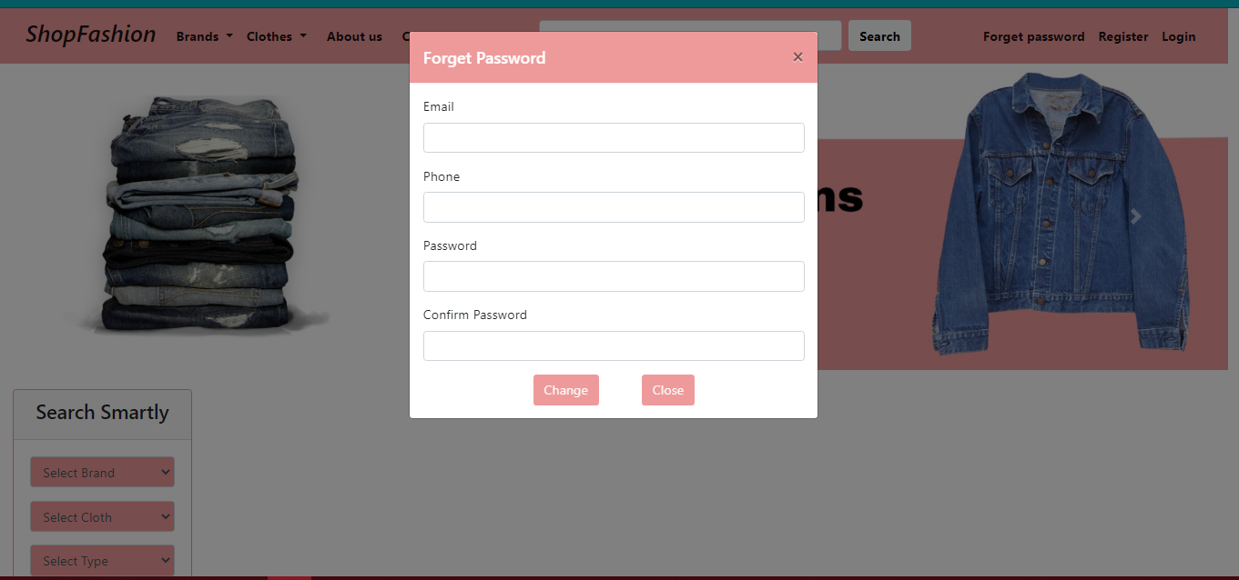

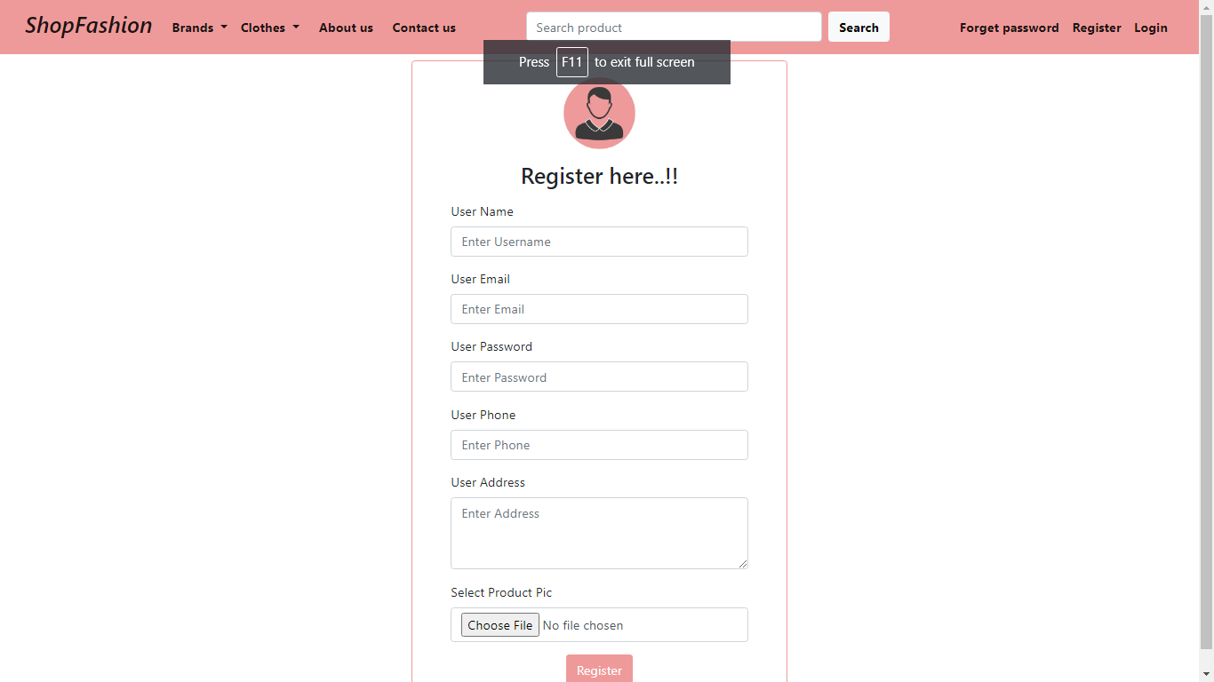

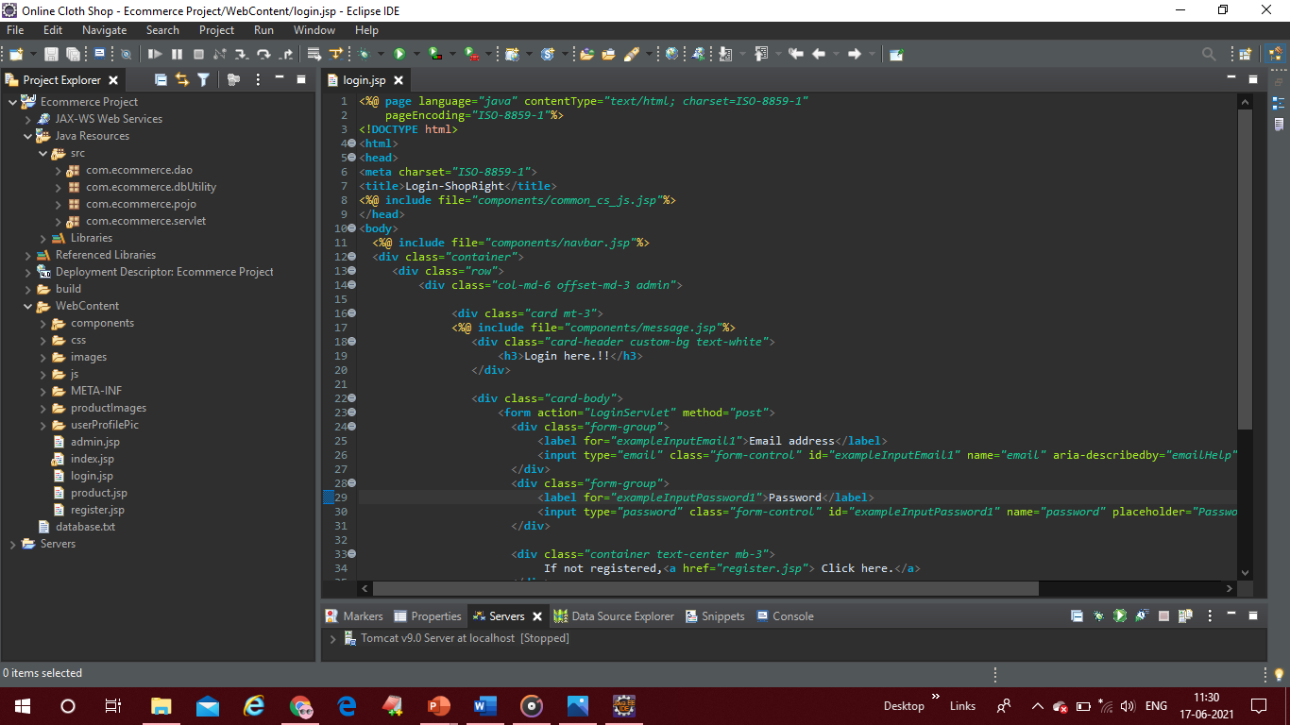

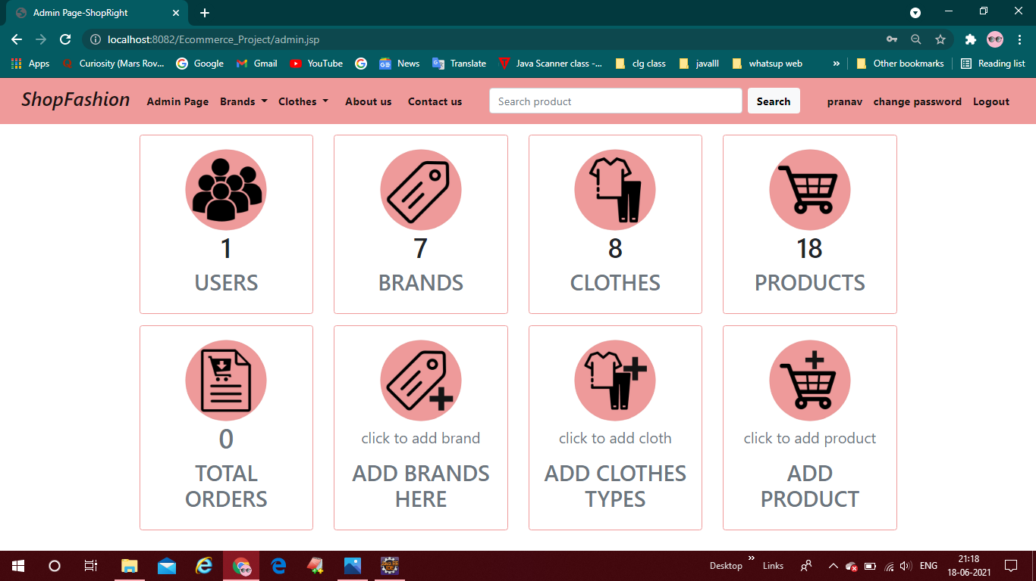

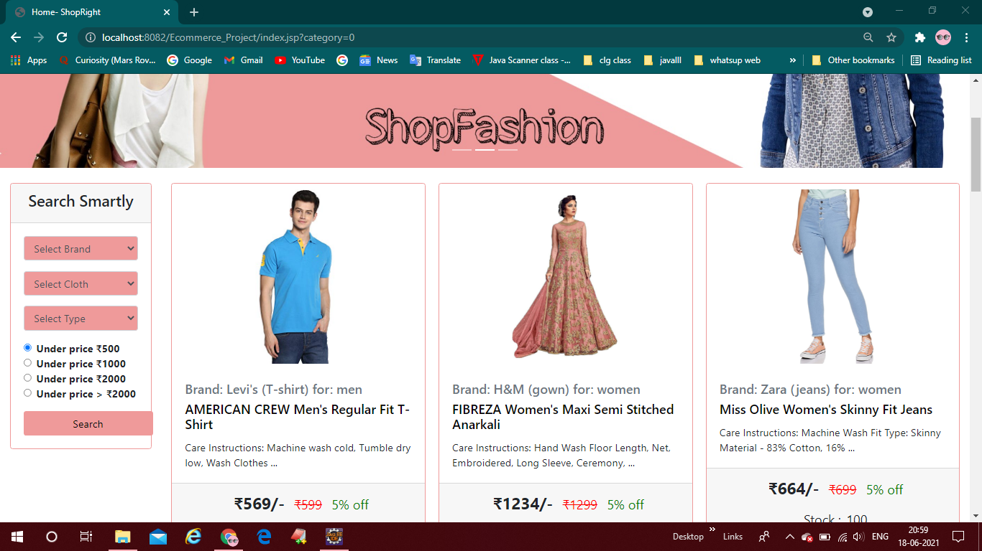

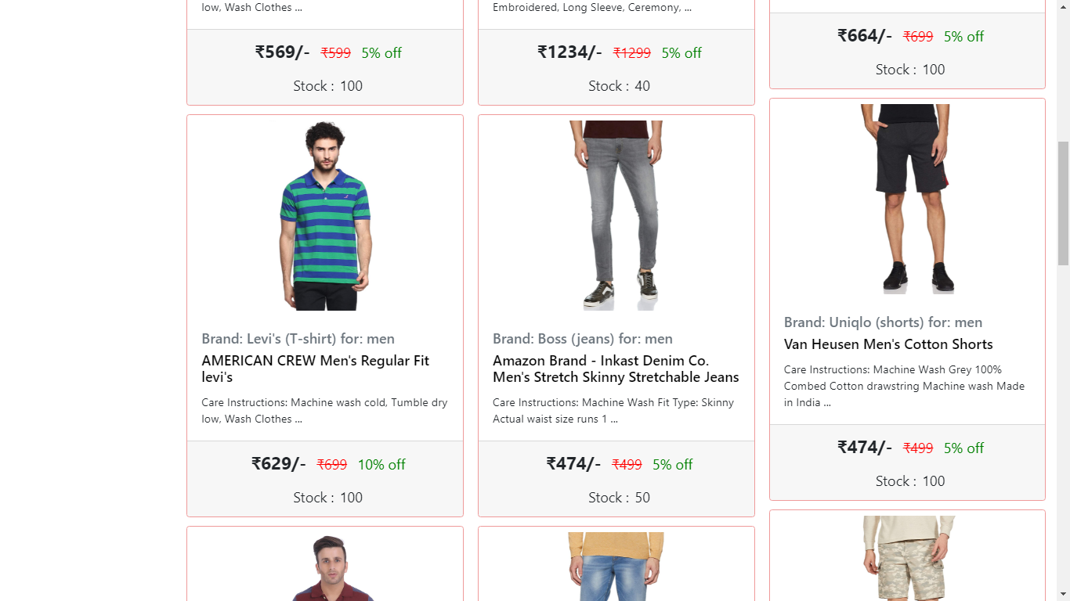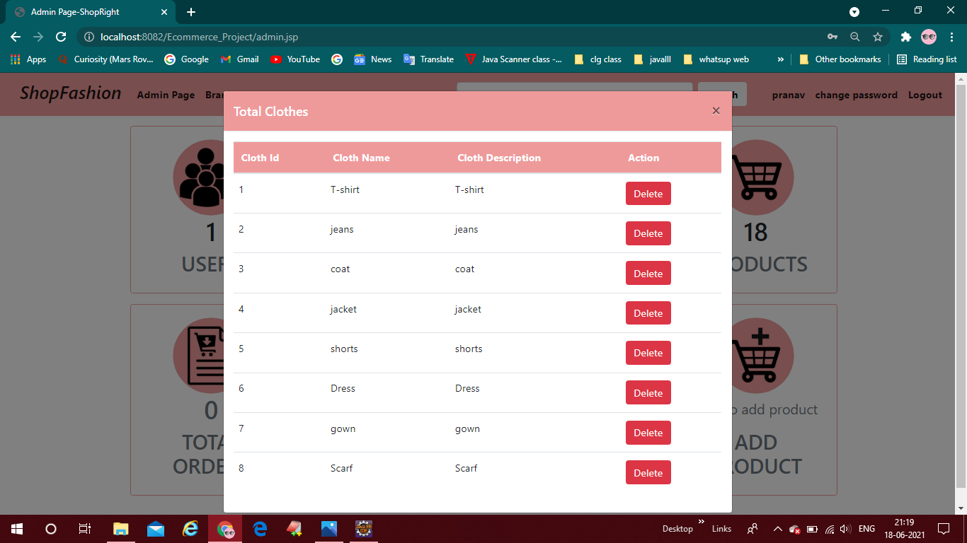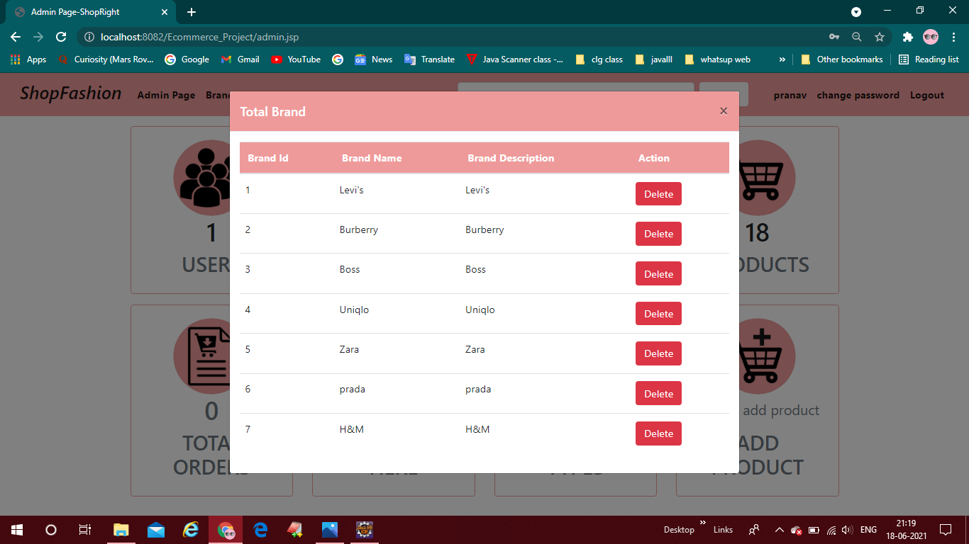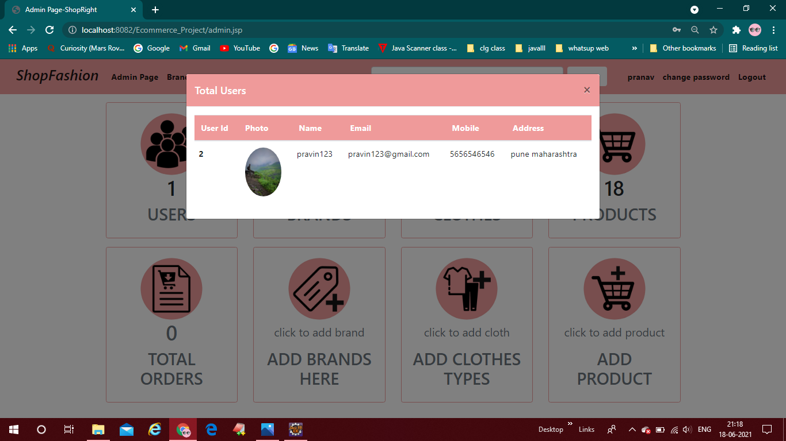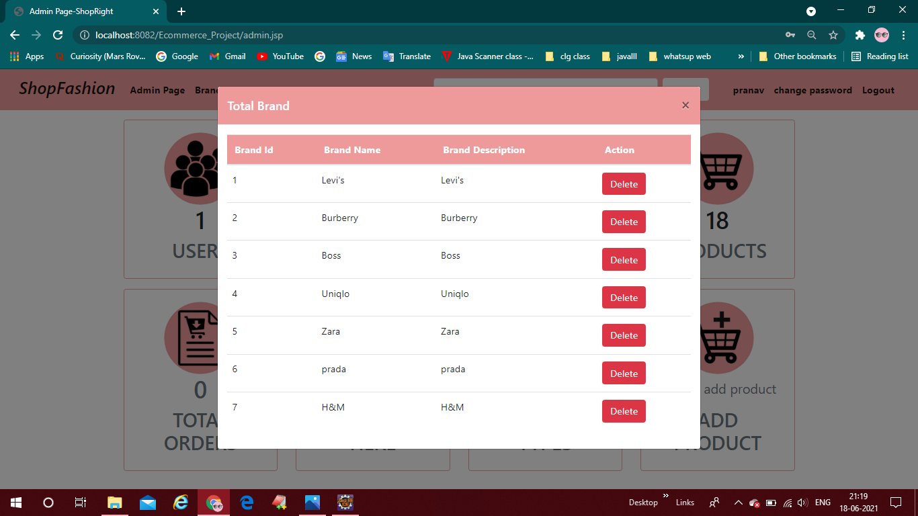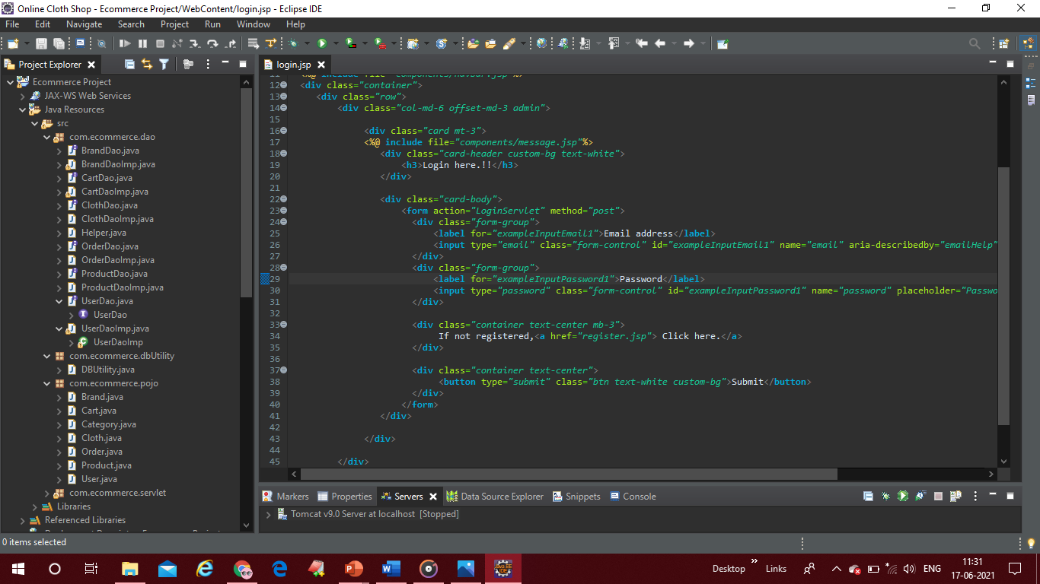

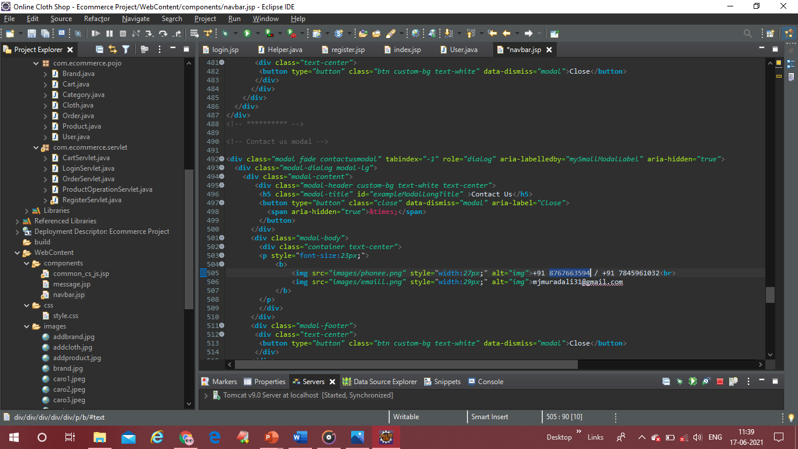

**Database screenshots**

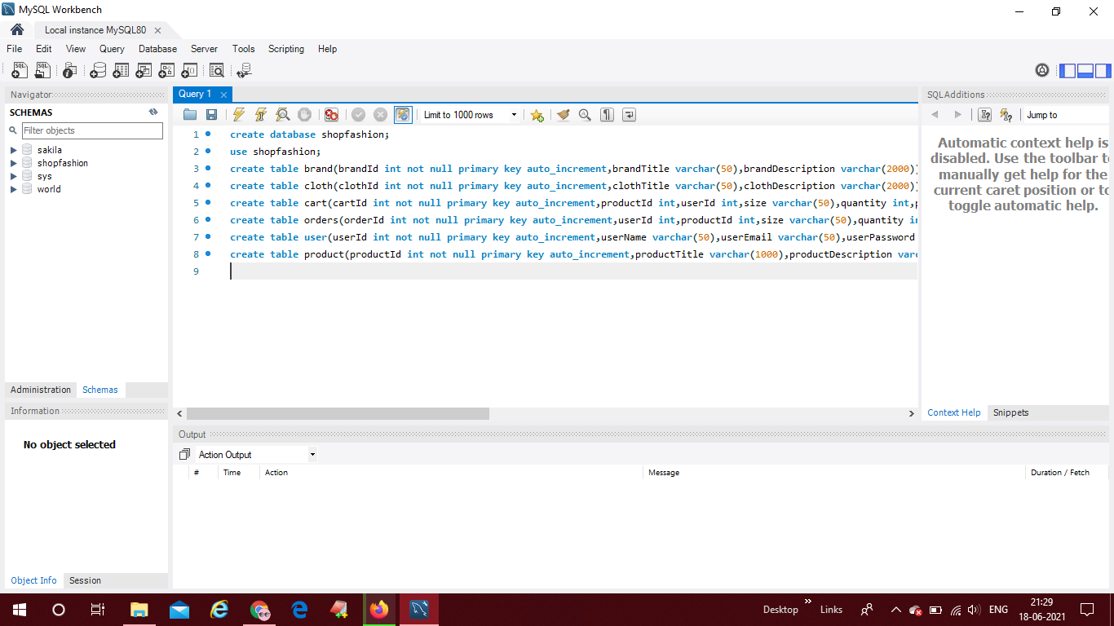

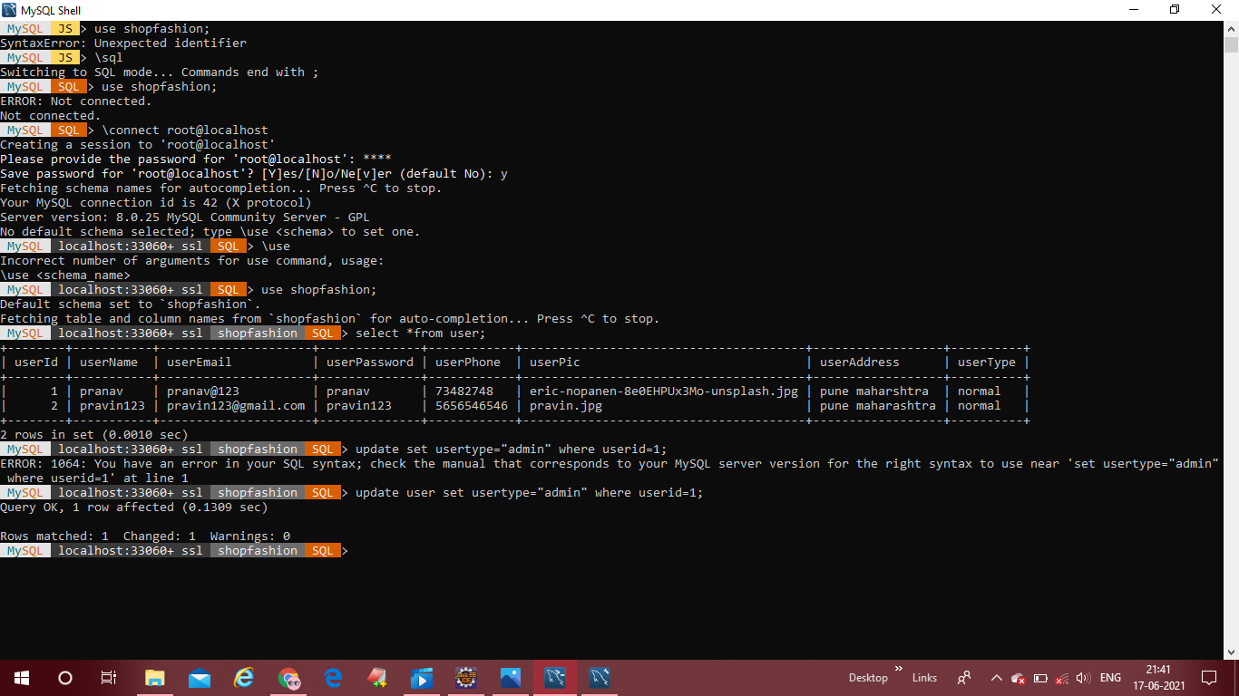

**Conclusion of the Project Online Shopping System:**

Our project is only a humble venture to satisfy the needs to manage their project

work. Several user-friendly coding has also adopted. This package shall prove to be a

powerful package in satisfying all the requirements of the school. The objective of

software planning is to provide a frame work that enables the manger to make

reasonable estimates made within a limited time frame at the beginning of the software

project and should be updated regularly as the project progress.

**At the end it is concluded that we have made effort on following points...**

A description of the background and context of the project and its relation to work

already done in the area.

Made statement of the aims and objectives of the project.

The description of Purpose. Scope, and applicability

• We define the problem on which we are working in the project.

. We describe the requirement Specifications of the system and the actions that

can be done on these things.

• We understand the problem domain and produce a model of the system, which

describes operations that can be performed on the system.

• We included features and operations in detail, including screen layouts.

• We designed user interface and security issues related to system.

• Finally, the system is implemented and tested according to test cases.

**Future Scope of the Project:**

In a nutshell, it can be summarized that the future scope of the project circles

around maintaining information regarding:

* . We can add printer in future.
* We can give more advance software for Online Shopping System including more facilities
* We will host the platform on online servers to make it accessible worldwide
* Integrate multiple load balancers to distribute the loads of the system
* Create the master and slave database structure to reduce the overload of the database queries.
* Implement the backup mechanism for taking backup of codebase and database on regular basis on different servers.

The above-mentioned points are the enhancements which can be done to increase

the applicability and usage of this project. Here we can maintain the records of Product

and Customer. Also, as it can be seen that now-a-days the players are versatile, i.e., so

there is a scope for introducing a method to maintain the Online Shopping System.

Enhancements can be done to maintain all the product, Customer, Stock, Order,

Payment.

We have left all the options open so that if there is any other future requirement

in the system by the user for the enhancement of the system then it is possible to

implement them. In the last we would like to thanks all the persons involved in the

development of the system directly or indirectly. We hope that the project will serve its

purpose for which it is develop there by underlining success of process.

**Limitation of Project on Online Shopping System**

Although I have put my best efforts to make the software flexible, easy to operate

but limitations cannot be ruled out even by me. Though the software presents a broad

range of options to its users some intricate options could not be covered into it, partly

because of logistic and partly due to lack of sophistication. Paucity of time was also

major constraint, thus it was not possible to make the software foolproof and dynamic.

Lack of time also compelled me to ignore some part such as storing old result of the

candidate etc.

Considerable efforts have made the software easy to operate even for the people

not related to the field of computers but it is acknowledged that a layman may find it a

bit problematic at the first instance. The user is provided help at each step for his

convenience in working with the software.

**List of limitations which is available in the Online Shopping System:**

• Excel export has not been developed for product; Customer due to some criticality.

• The transactions are executed in off-line mode, hence on-line data for Stock, Order

capture and modification is not possible.

• Off-line reports of Product, Payment, Stock cannot be generated due to batch mode

execution