MarketLink Platform
  - Comprehensive Technical Architecture, Frontend, Backend & System Flowchart Report
Review date: 27 September 2026 | Framework: Next.js 16 App Router & React 19 | Data layer: MySQL with process-local demo fallback

Contents
Contents 2
List of Figures 2
List of Tables 2
Subject Index 2
1. Executive Summary & Platform Overview 4
2. System Architecture & Visual Flowcharts 4
3. Frontend Architecture & Page Breakdown 6
1. CartDrawer (src/components/CartDrawer.tsx) 8
2. AuthModal (src/components/AuthModal.tsx) 8
3. ChatbotWidget ('Marco AI') (src/components/ChatbotWidget.tsx) 8
4. DbStatusBadge (src/components/DbStatusBadge.tsx) 8
3.3 Website Screenshots and Visual Review 8
4. Backend Architecture & REST API Infrastructure 10
5. MySQL Database Schema & Data Models 11
6. Marco AI Engine & Roman Urdu Synonym Intelligence 12
7. Security, Governance & Performance Audit 12
7.3 Priority Findings and Remediation 13

List of Figures
Figure 1: High-Level System Architecture & Dual Database Resilience Flow 5
Figure 2: User Authentication & Role-Based Control Flow 5
Figure 3: Multi-Stage Order Lifecycle Pipeline 6
Figure 4: Marco AI NLP Parser, Synonym Resolver & Recommendation Generator 6
Figure 5: Homepage and discovery journey 8
Figure 6: Product catalog and filters 8
Figure 7: Farmer storefront 9
Figure 8: Regional market map 8
Figure 9: Customer order history 9
Figure 10: Contact and support 9
Figure 11: Farmer portal entry 9
Figure 12: Admin portal entry 9
Figure 13: Dashboard route runtime result 9

List of Tables
Table 1: Core platform mission and value proposition 4
Table 2: Technology and component pillars 4
Table 3: Database availability and fallback behavior 5
Table 4: Route directory and frontend feature summary 6
Table 5: Backend API endpoint inventory 10
Table 6: Database entities and relationships 11
Table 7: Marco produce synonym examples 12
Table 8: Verification claims compared with observed checks 12
Table 9: Priority security, reliability and UX findings 13

Subject Index
Alphabetical index by report section. Use the contents field for page navigation.
Admin portal | §3.1, §3.2, §7.1
Authentication and sessions | §2.2, §7.1
API routes | §4.1
Cart and checkout | §2.3, §3.2, §7.1
Contact support | §3.1, Figure 10
Database fallback | §2.1, §5.1
Farmer portal | §3.1, Figure 11
Inventory and reservations | §5.1
Marco chatbot | §2.4, §6
Market hubs | §3.1, Figure 8
Orders and COD | §2.3, §3.1, §4.1
Product catalog | §3.1, Figure 6
Security findings | §7.1
Shopper profile | §3.1
Testing and runtime checks | §7.2
Verification and reviews | §7.1, §7.2

1. Executive Summary & Platform Overview
MarketLink is a Pakistan-focused, direct-to-consumer agricultural marketplace and farm-to-table platform. It uses Next.js 16 App Router, React 19, TypeScript, Tailwind CSS, Next.js API route handlers and a MySQL data layer with a process-local memory fallback. The product concept connects growers and makers with consumers; the active implementation remains a prototype and does not yet provide production-grade identity, authorization or durable commerce guarantees.
Table 1: Core platform mission and value proposition
💡 Core Platform Mission & Value Proposition
MarketLink is intended to reduce reliance on agricultural intermediaries and connect farmers more directly with consumers. The claimed commission savings have not been independently verified in this code review. By providing direct commerce, product pricing, farmer profiles, catalog stock indicators, and a rule-based assistant that recognizes English and Roman Urdu produce synonyms ('Marco'), MarketLink ensures high profitability for growers and fresh, organic produce for urban households.

1.1 Key Technical Highlights
Table 2: Technology and component pillars
Component Pillar | Implementation Detail & Specifications
Full-Stack Framework | Next.js 16.3.6 (App Router) + React 19.2.8 + TypeScript 5.9
Styling & UI Components | Tailwind CSS v4, Glassmorphism design, Framer Motion, Radix UI Primitives, Lucide Icons
Dual Database Engine | MySQL 8 database pool (mysql2) with automatic in-memory standby engine fallback (memoryDb)
AI Assistant ('Marco') | Rule-based catalog assistant with English and Roman Urdu produce-synonym matching and product-card add-to-cart actions

2. System Architecture & Visual Flowcharts
The MarketLink system is architected around a multi-tier client-server paradigm with modular Next.js API route handlers and a dual persistence strategy. Below are the core flowcharts illustrating system components and data pipelines.
2.1 System Architecture & Dual Persistence Engine
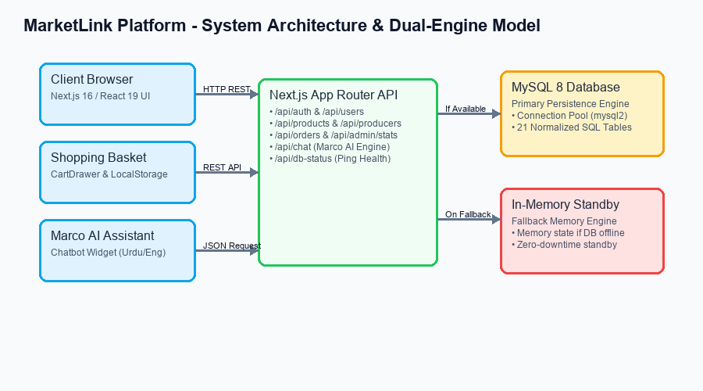
Figure 1: High-Level System Architecture & Dual Database Resilience Flow
Table 3: Database availability and fallback behavior
💡 Dual Persistence Resilience Architecture
The backend implements an automatic DB health verification layer (checkDbStatus). When MySQL is online, all queries execute against the relational database tables via pooled connections. If the MySQL server is unreachable, the system automatically redirects read/write calls to an in-memory standby database state (memoryDb), providing a development/demo fallback. This in-memory state is process-local and is not durable across restarts or synchronized across instances.

2.2 Authentication & Role-Based Access Control (RBAC)
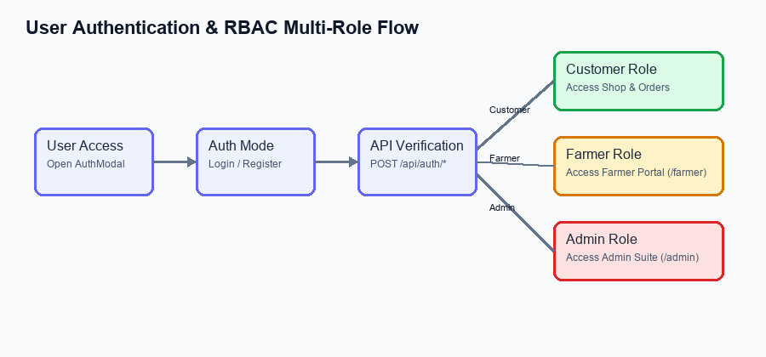
Figure 2: User Authentication & Role-Based Control Flow
2.3 Direct-to-Consumer Order Lifecycle
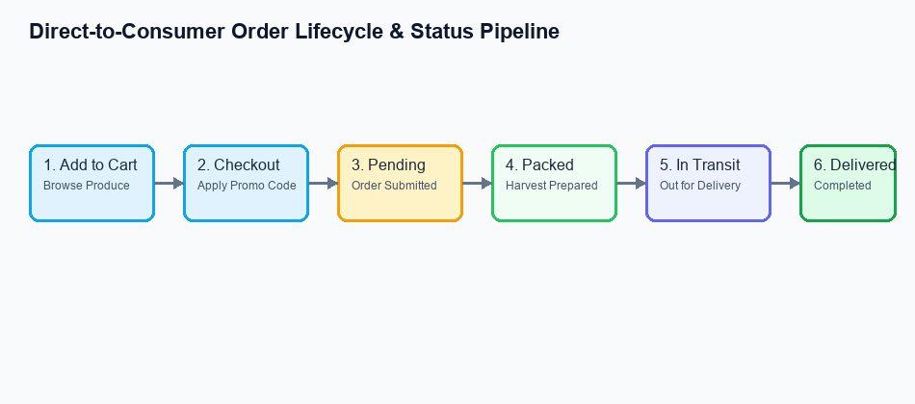
Figure 3: Multi-Stage Order Lifecycle Pipeline
2.4 Marco AI Chatbot Processing & Synonym Engine
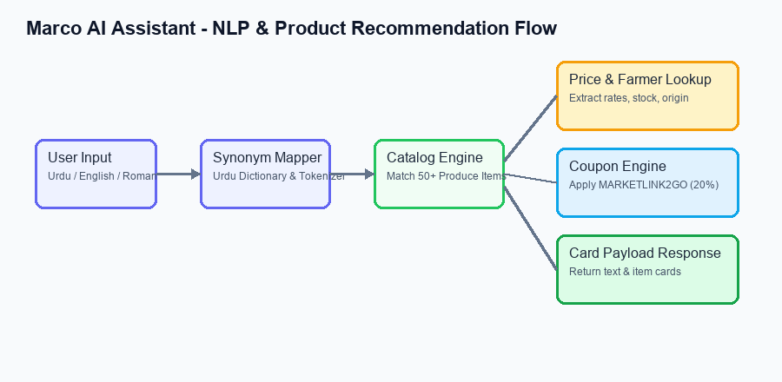
Figure 4: Marco AI NLP Parser, Synonym Resolver & Recommendation Generator

3. Frontend Architecture & Page Breakdown
MarketLink's user interface is crafted with modern micro-animations, vibrant responsive layouts, glassmorphism card styling, and seamless state management. The layout hierarchy utilizes Next.js App Router conventions with interactive client components.
3.1 Complete Page Directory & Feature Specifications
Table 4: Route directory and frontend feature summary
Route / Path | Primary Purpose | Key Interactive Components & Features
/ (Home) | Main D2C Landing Page | HeroVideoCarousel, RoutineResetBundleSection, ShopCollectionsSection, WhatBringsYouHereSection, AboutUsSection, FAQ, Testimonials
/shop | Marketplace Produce Catalog | Search, category/seller/price/location/rating/perk filters, sorting, grid/list modes, pagination, farmer preview and localStorage-backed cart. Static discovery products are merged with API products.
/producers | Verified Farmer Directory | Producer cards with story, location, specialty and product links. Producer data is loaded through /api/producers.
/producers/[slug] | Producer Detail Profile | Farm story, origin location, verification status and the producer's static product listings. The storefront page does not render a map.
/orders | Customer Order History | Order status labels, item summaries, delivery address and date, and COD information. User filtering is client-side; the API returns a broad order list.
/dashboard | Role dispatcher / admin alias | Intended to route customer/farmer/admin by role; live review showed HTTP 200 with only the global chatbot and no dashboard content.
/farmer | Farmer Management Portal | Product and order screens plus profile editing. Login and selected-producer association are not securely enforced server-side; calendar, review and payout areas include local demo state.
/admin | Enterprise Admin Suite | Overview, product/producer/order/user management and statistics screens. The inspected API handlers do not enforce admin authorization.
/about | Brand Story & Mission Page | Interactive scrolling timeline component, Direct-to-Consumer impact metrics, Eco-sustainability highlights
/contact | Support & Location Map | Contact form and support FAQs alongside a globe/map visual. The API returns a ticket ID and logs the submission; durable support routing was not found.
/profile | Customer profile | Displays locally stored identity, role and address, with order and role-portal links. No profile-edit API was found.
/help | Help and policies | Static FAQ, privacy and terms tabs. Policy claims should be aligned with actual operations.
404 / global error | Not-found and recovery states | Custom not-found page and global error recovery action; unknown route returned HTTP 404 in the local crawl.

3.2 Key Core Interactive Components

1. CartDrawer (src/components/CartDrawer.tsx)
A slide-out drawer providing full cart management. Includes real-time quantity adjustments, subtotal computation, promo code redemption engine (e.g. 'MARKETLINK2GO' providing 20% discount), free delivery threshold calculator, and a streamlined checkout submission form.

2. AuthModal (src/components/AuthModal.tsx)
Unified authentication modal offering Sign In and Register tabs with dynamic role assignment (Customer, Farmer, Admin). Integrates with local storage and backend API authentication routes.

3. ChatbotWidget ('Marco AI') (src/components/ChatbotWidget.tsx)
Floating conversational UI component powered by the Marco AI API. Supports quick prompt buttons, Roman Urdu understanding, and renders interactive product cards with instant 'Add to Cart' buttons directly inside chat messages.

4. DbStatusBadge (src/components/DbStatusBadge.tsx)
Real-time health badge positioned in the header/footer displaying the operational mode of the persistence layer (Green badge for live MySQL 8 pool connection; Amber badge for In-Memory Standby Engine).

3.3 Website Screenshots and Visual Review
The following figures are direct desktop captures of the local website, reviewed at a 1440 × 1000 browser viewport on 27 September 2026. They document the rendered experience; explanations distinguish visible interface from backend behavior inferred from source and API checks.
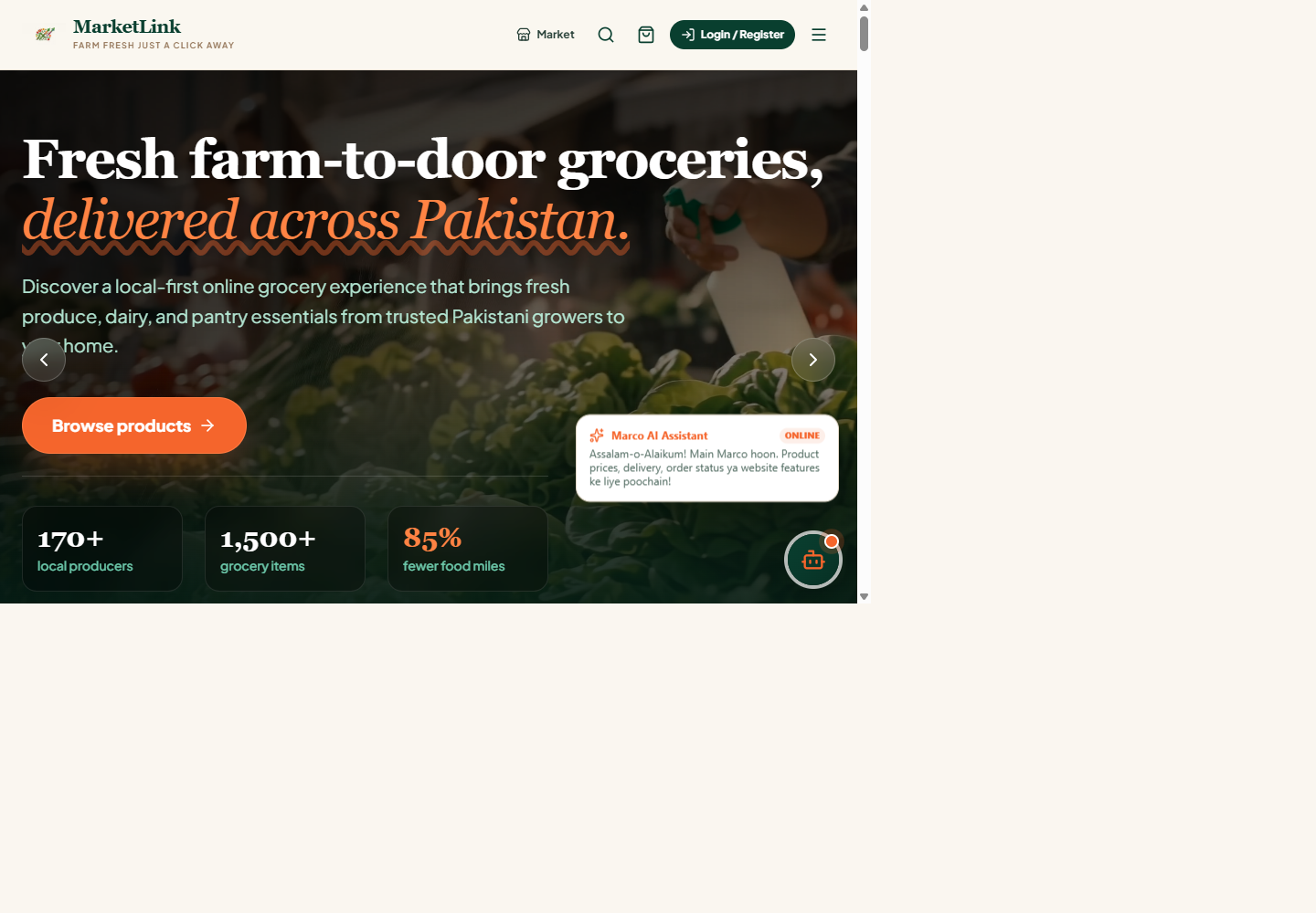  Figure 5: Homepage and discovery journey  The homepage brings together the video-led value proposition, category collections, seasonal product picks, farmer stories and the regional market map. It is the primary discovery and navigation entry point. | 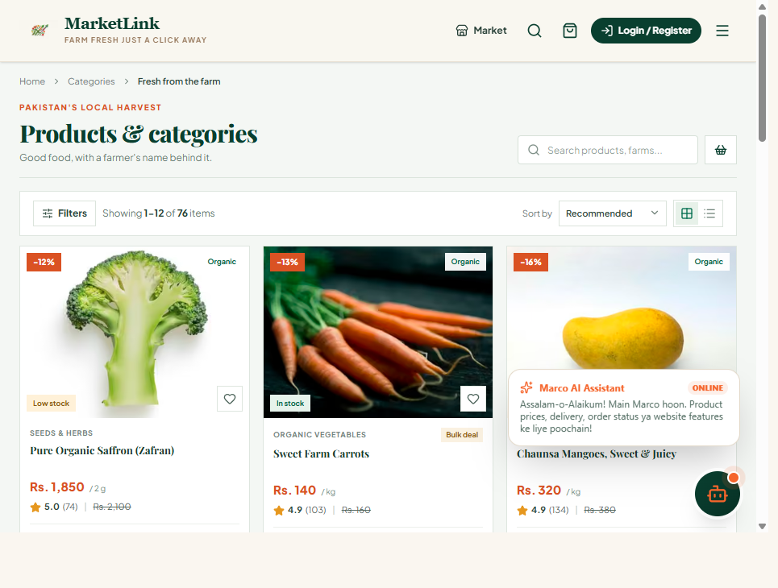  Figure 6: Product catalog and filters  The catalog supports search, price and location filters, seller/category facets, rating and perk filters, sorting, grid/list presentation and pagination. Product and farmer information appear together on each card.
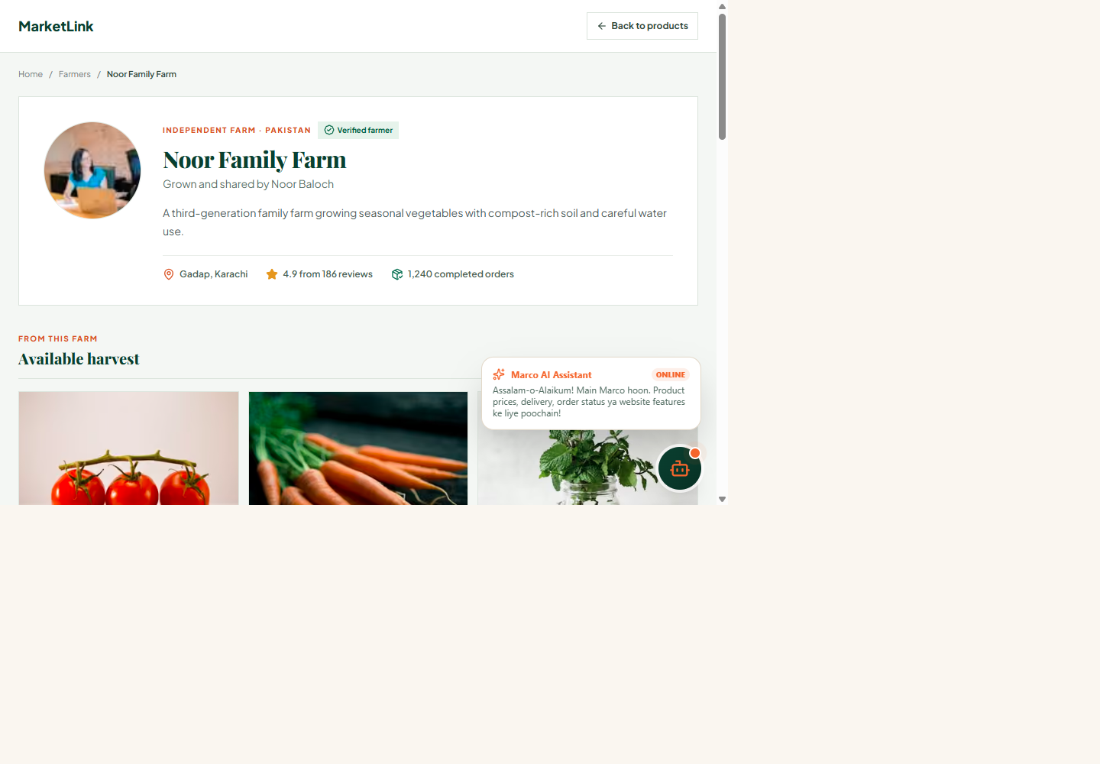  Figure 7: Farmer storefront  A producer profile presents the farm story, verification status, location, ratings and available harvest. Product links return the shopper to the catalog. | 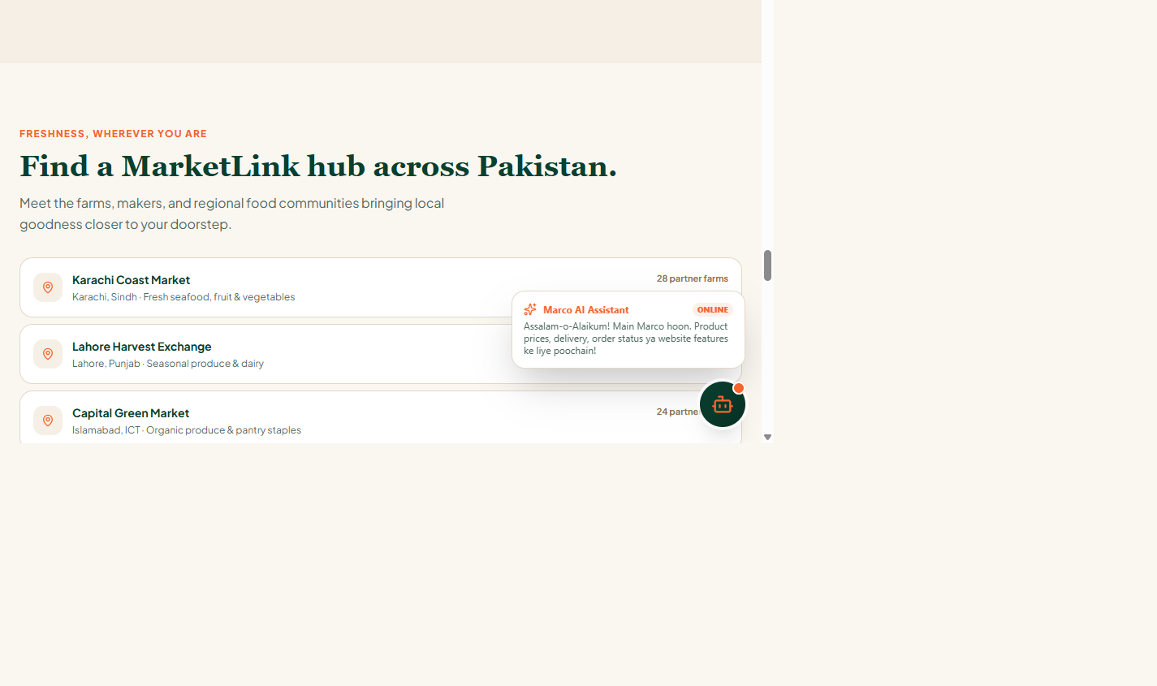  Figure 8: Regional market map  The homepage map pairs a city/hub list with a Leaflet/OpenStreetMap view. Selecting a hub updates the highlighted location and summary.
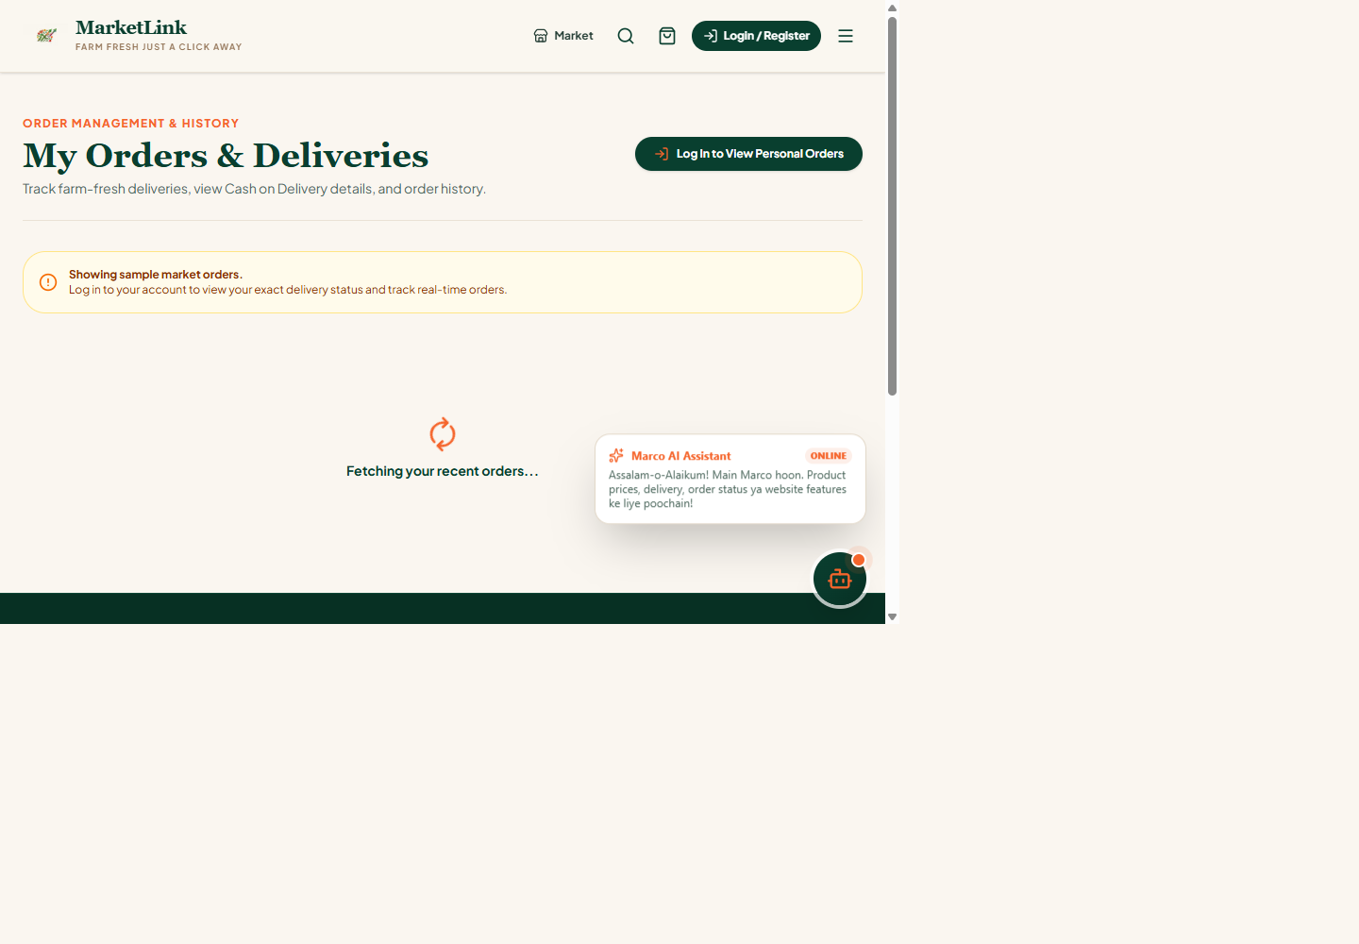  Figure 9: Customer order history  The order screen presents status, items, address, COD and delivery date. In the inspected implementation, order data is fetched broadly and filtered on the client, so this view is not an authorization boundary. | 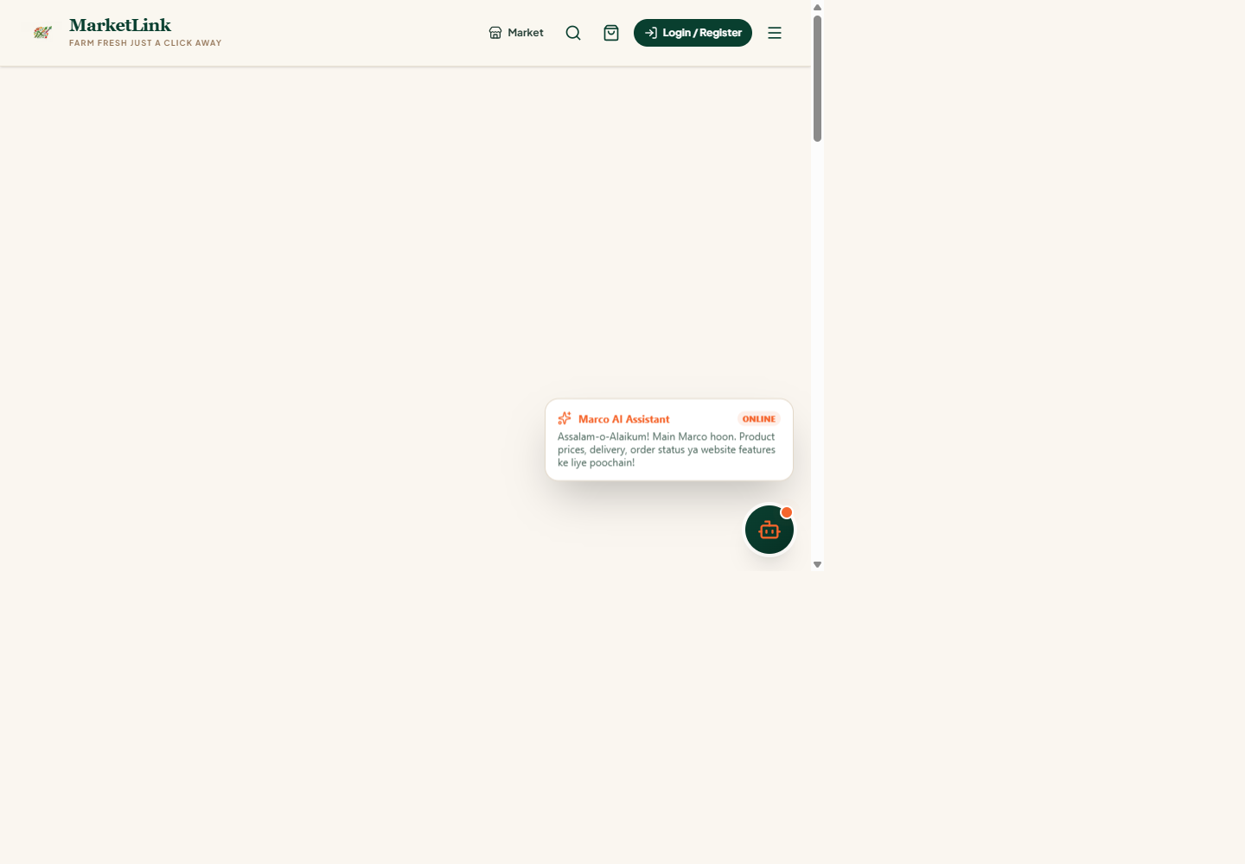  Figure 10: Contact and support  The support page combines a contact form, location-focused visual and FAQs. The current contact API generates a ticket identifier and logs the request; durable ticketing or email delivery was not found.
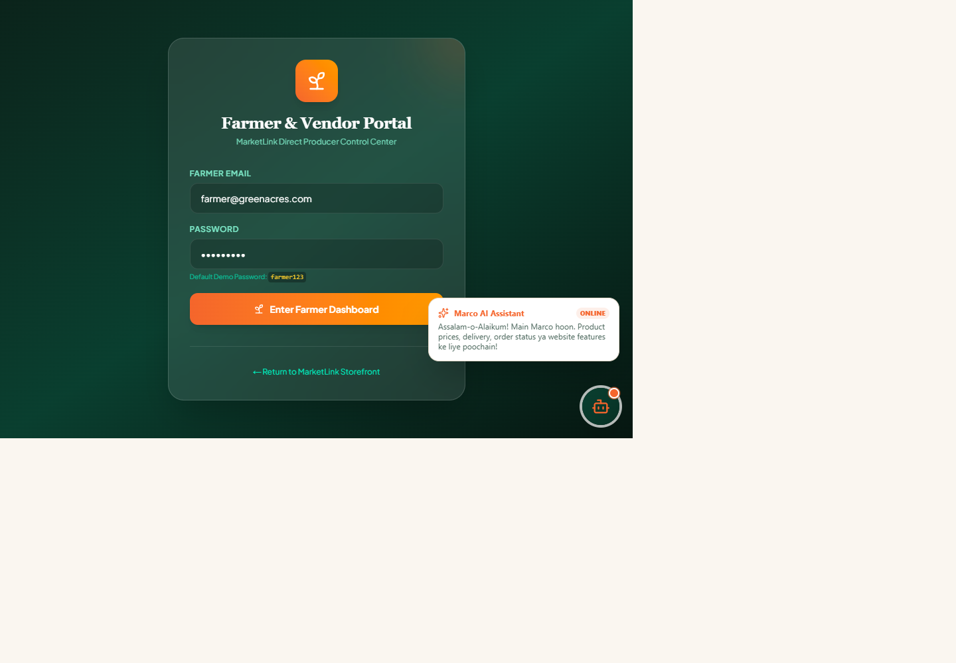  Figure 11: Farmer portal entry  The farmer portal entry leads to a workspace for products, orders, crop schedule, profile, reviews and payouts. Some of these areas are demo-only client state, and portal login is not securely bound to a farmer identity. | 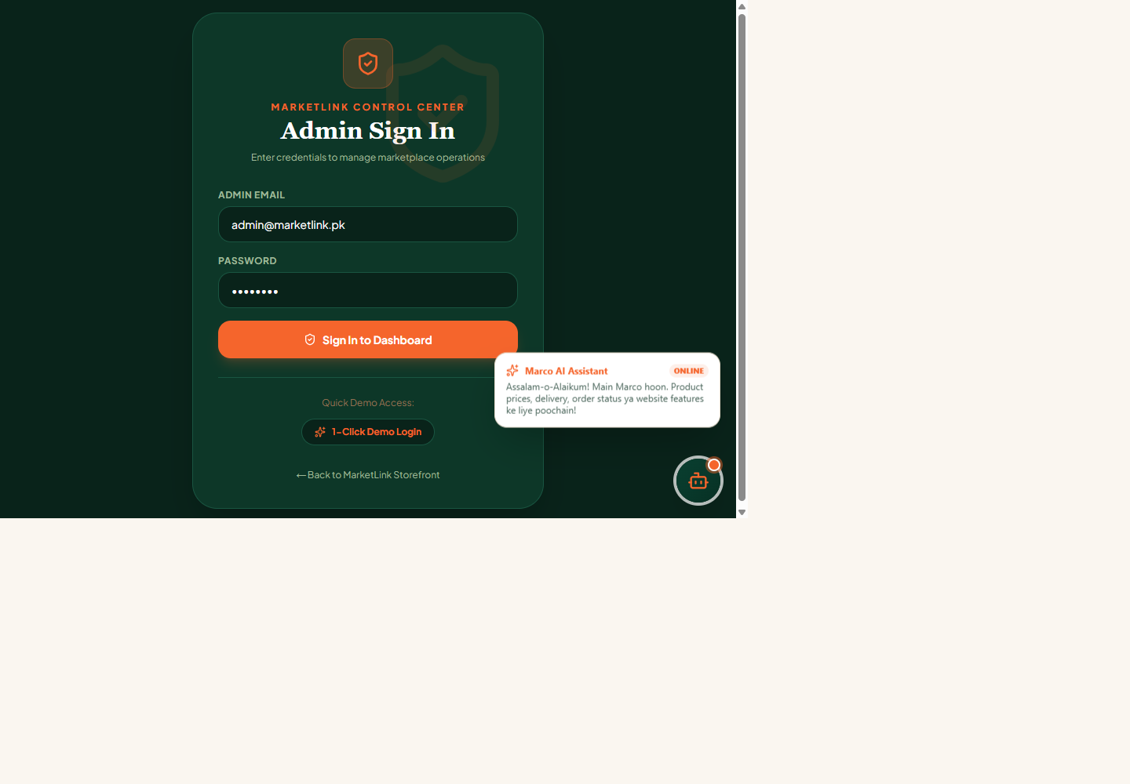  Figure 12: Admin portal entry  The admin entry exposes a demo login path. The console code includes overview and CRUD screens, but API authorization must be enforced server-side before this can be treated as a protected admin area.

Figure 13: Dashboard route runtime result
During the local review, /dashboard returned HTTP 200 but only the global chatbot was visible; no dashboard content rendered. This is a reproducible defect to investigate, not an intended dashboard state.

4. Backend Architecture & REST API Infrastructure
MarketLink's backend leverage Next.js 16 Route Handlers written in TypeScript. API endpoints process incoming requests, perform input validation, interact with the dual database engine (`src/lib/db.ts`), and return formatted JSON payloads.
4.1 Complete REST API Endpoints Specification
Table 5: Backend API endpoint inventory
Method | Endpoint Path | Description & Purpose | Payload / Parameters
POST | /api/auth/register | Registers a customer or farmer account; the inspected implementation stores the password without hashing. | { email, password, full_name, role, zipcode }
POST | /api/auth/login | Looks up email and compares the supplied password directly; returns a fixed sample token rather than a verified session. | { email, password }
POST | /api/admin/auth | Admin check contains permissive aliases/default-password logic; its cookie is not used to authorize the other APIs. | { password }
GET | /api/admin/stats | Aggregates store KPIs; no server-side admin authorization was found in the handler. | None (Admin Cookie / Header)
GET / POST / PUT / DELETE | /api/products | Fetches filtered produce catalog OR creates new product listing | GET: ?category=&tag=&search= | POST: Product Object
GET / POST / PATCH / DELETE | /api/producers | Fetches growers directory OR adds/updates farm profile | GET: All producers | POST: Producer Object
GET / POST / PUT / DELETE | /api/orders | GET returns a broad list; POST performs shallow checks and trusts client totals/items; PUT updates status; DELETE removes by ID. | GET: all orders | POST: items, client total, user_id, date, shipping_address | PUT: id/status | DELETE: id
GET | /api/categories | Retrieves produce category taxonomy and product counts | None
POST | /api/quiz | Submits grocery preference survey response | { zipcode, dietary_prefs, household_size }
GET | /api/db-status | Performs TCP ping health check on MySQL connection pool | None
POST | /api/chat | Processes NLP queries via Marco AI Engine and returns product cards | { message, history }
GET / POST / DELETE | /api/users | Lists, creates or deletes users. The fallback response currently exposes password-named fields; restrict the response shape and protect the route. | POST: email, full_name, password, address, role | DELETE: id
POST | /api/contact | Validates required contact fields, generates a random ticket identifier and logs the request. No durable ticket store or email delivery was found. | name, email, message; optional contact details

5. MySQL Database Schema & Data Models
MarketLink includes a broad relational schema defined in `schema.sql`; the active application code uses only part of this model, so production readiness has not been established. The schema spans 21 core tables covering multi-vendor operations, inventory reservations, physical farmers market stalls, and transactional outbox events.
5.1 Core Database Tables Overview
Table 6: Database entities and relationships
Table Name | Key Columns & Data Types | Domain Purpose & Relationships
producers | id, name, slug, location, city, district, rating, verified, completed_orders | Stores farmer/grower profiles. Foreign key target for products & stalls.
products | id, name, slug, producer_id, category_id, price, unit, stock, organic, listing_status | Product catalog items. FK to producers(id) and categories(id).
users | id, email, password_hash, full_name, zipcode, address, account_status | User accounts across all roles (customer, farmer, admin).
user_roles | user_id, role ('customer','farmer','admin'), granted_at | Role-based access mapping. FK to users(id) ON DELETE CASCADE.
orders | id, user_id, total_amount, status, delivery_date, items_json, idempotency_key | Legacy order header and JSON item snapshot. The current insert helper also writes shipping_address, but that column is absent from the inspected schema.
vendor_orders | id, order_id, stall_id, vendor_status, subtotal, acceptance_deadline_at | Vendor-specific split order tracking for multi-producer orders.
carts & cart_items | cart_id, customer_id, product_id, quantity, active_customer_id | Customer shopping cart sessions with active status constraints.
markets & stalls | market_id, stall_id, producer_id, lat/long, market_status, stall_status | Physical market hub and producer stall location mapping.
inventory_reservations | id, order_item_id, product_id, quantity, reservation_status, expires_at | Real-time stock reservation lock preventing double selling.
audit_logs & outbox | id, actor_user_id, action, resource_type, event_type, payload | Security audit tracking and Transactional Outbox pattern for events.

6. Marco AI Engine & Roman Urdu Synonym Intelligence
The Marco AI engine (`src/app/api/chat/route.ts`) provides intelligent assistance tailored for Pakistani local produce buyers. It features a built-in synonym lookup map (`PRODUCE_SYNONYM_MAP`) bridging English produce terms with Urdu and Roman Urdu vernacular.
Table 7: Marco produce synonym examples
💡 Bilingual & Vernacular Natural Language Understanding
Example Synonym Mappings:
• 'vine-ripened-tomatoes' ➔ ['tamatar', 'red tomato', 'tomato', 'fresh tomato']
• 'sargodha-kinnow' ➔ ['kinnow', 'kino', 'orange', 'citrus']
• 'pure-golden-desi-ghee' ➔ ['ghee', 'desi ghee', 'pure ghee', 'makhan ghee']
• 'super-kernel-basmati' ➔ ['rice', 'chawal', 'basmati', 'super kernel']
• 'fresh-organic-ginger' ➔ ['adrak', 'ginger', 'fresh adrak']
• Promo Code: Entering 'MARKETLINK2GO' or asking for discounts returns the active 20% cart discount coupon.

7. Security, Governance & Performance Audit
7.1 Security & Data Protection Measures
1. Parameterized SQL Queries: Most query parameters are bound, which reduces SQL injection risk; this does not replace input validation, authorization, or a complete security review.
2. RBAC Route Protection: The UI has role-specific screens, but API routes inspected in this review do not enforce server-side role and resource-ownership checks.
3. Session Integrity: The schema defines an auth_sessions table, but the inspected login flow returns a fixed sample token and stores user identity/role flags in localStorage; the session table is not used by that flow.
4. System Audit Trail: The schema defines an audit_logs table, but no audited management-action service path was found in the inspected API implementation.
7.2 Verification & Build Audit Results
A local `npm run lint` check during this review failed with 47 errors and 87 warnings. A production build was not run as part of this review; prior build claims in this source document were not independently verified.
Table 8: Verification claims compared with observed checks
Observed Verification Results
Local route crawl: 12 core pages returned HTTP 200; unknown route returned 404.
Database: mock_fallback; MySQL was not connected.
API smoke: 76 products, 5 sample orders and 6 sample users.
Lint: npm run lint failed with 47 errors and 87 warnings.
Production build: not run in this review. Earlier build claims were not independently verified.

7.3 Priority Findings and Remediation
Table 9: Priority security, reliability and UX findings
Severity / issue | Evidence and user impact | Recommended action
CRITICAL | Admin login bypass | The admin auth route accepts matching admin aliases OR a default password. The two credentials are not consistently verified as a pair. | Require verified credentials, rate limits and a secure server-issued session.
CRITICAL | Missing API authorization | Product, producer, order and user mutation routes, broad reads and admin stats do not enforce server-side roles or resource ownership. | Add centralized session validation and per-resource authorization to every protected handler.
CRITICAL | Credential exposure | The memory fallback user API response includes password/password_hash-named fields. | Never return credential fields; hash passwords and remove seeded secrets from runtime data.
HIGH | Order price and items trusted from client | Order POST accepts client-supplied totals/items and does not recompute current prices or validate stock before saving. | Recalculate totals from canonical product IDs, validate quantities/stock and persist atomically.
HIGH | Order schema mismatch | saveOrder inserts shipping_address, but the inspected orders table/migrations do not define that column; DB write failure can fall back to memory and still appear successful. | Align schema and repository; surface write failure instead of returning a durable-success impression.
HIGH | Authentication is not production-grade | Registration stores raw password text; login compares raw values and returns a fixed sample token. The schema auth_sessions table is not used by the flow. | Use password hashing and secure HttpOnly/SameSite sessions with expiry, revocation and account checks.
HIGH | Farmer identity/ownership is UI-only | The portal uses a shared demo password/localStorage flag and selectable producer IDs not bound to the authenticated user. | Bind approved farmer accounts to producer profiles and enforce tenant scope on each server request.
HIGH | In-memory fallback is volatile | Fallback records are process-local and SQL errors can be swallowed, so writes may disappear on restart or differ across instances. | Restrict fallback to explicit demo mode; fail closed on production writes and expose degraded health.
MEDIUM | Dashboard route does not render | Live /dashboard returned HTTP 200 with only the global chatbot and no dashboard content. | Reproduce and fix client redirect/render behavior; add an E2E route assertion.
MEDIUM | Demo features and promo claims | Quiz, chatbot tracking, contact ticketing, payouts/reviews and delivery/discount claims exceed persisted workflows found in code. | Connect these journeys to durable services or label them as demos and align user-facing policy copy.

