
Interface Specification Document (ISD)
Document 01 of 09 · B2B Data Engineering Platform

05/10/2026
DataRopes.ai
Data Engineering Internship · B2B Data Engineering Platform
Defines how each source system hands data to the platform: objects, formats, frequency, extraction and load behaviour, controls and error handling.
Document ID | B2B-DEP-01
Version | 1.3
Status | Final
Date | 05/10/2026
Prepared by | Syed Kazim Raza
Reviewed by | [Team Lead]

Document Control

Revision History
Version | Date | Author | Description of Change
0.1 | - | Syed Kazim Raza | Template created
1.0 | 29/09/2026 | Syed Kazim Raza | Content populated from pipeline code, source profiling and pipeline_run_log
1.1 | 30/09/2026 | Syed Kazim Raza | Updated to the rebuilt data; CSV TRUNCATE + load in one transaction; staging emptied after each run; quarantine
1.2 | 04/10/2026 | Syed Kazim Raza | Interface diagram redrawn (light theme, editable draw.io source in docs/diagrams)
1.3 | 05/10/2026 | Syed Kazim Raza | Formatting to documentation standard: table column widths, numbered figure and table captions with lists, figure descriptions, complete acronym list

Approvals
Role | Name | Signature | Date
Prepared by | Syed Kazim Raza
Reviewed by | [Team Lead]
Approved by | [Manager]

Related Documents
Ref | Document | Location
R1 | Business Requirements Document (BRD) | Provided by DataRopes
R2 | Project Document (technical reference) | docs/deliverables/project_document.md
R3 | Project Plan | docs/deliverables/project_plan.md
R4 | README / Deployment Guide | README.md

Contents
Document Control 2
Contents 3
List of Figures 4
List of Tables 5
1. Introduction 6
1.1 Purpose 6
1.2 Scope 6
1.3 Intended Audience 6
1.4 Definitions & Acronyms 7
2. Interface Overview 8
3. Source System Details 9
4. Interface IF-01: SQL Server → staging (8 tables) 9
4.1 General Information 9
4.2 Objects Transferred 10
4.3 Extraction & Load Logic 10
4.4 Error Handling & Re-run 10
5. Interface IF-02: marketing_leads.csv → staging.marketing_leads 11
5.1 General Information 11
5.2 File Specification 11
5.3 Record Layout 11
5.4 Extraction & Load Logic 12
5.5 Error Handling & Re-run 12
6. Interface IF-03: web_logs.csv → staging.web_logs 14
6.1 General Information 14
6.2 File Specification 14
6.3 Record Layout 14
6.4 Extraction & Load Logic 15
6.5 Error Handling & Re-run 15
7. Scheduling & Orchestration 17
8. Control & Audit Tables 18
9. Interface Data Quality Checks 19
10. Error Handling & Recovery 20
11. Security 20
12. Assumptions, Constraints & Open Issues 21

List of Figures
Figure 1: Interface diagram — sources, interfaces and staging targets 8
Figure 2: Sample rows of marketing_leads.csv 13
Figure 3: Sample rows of web_logs.csv 16
Figure 4: Staging tables are empty after a successful run 17
Figure 5: metadata.pipeline_run_log — one row per pipeline stage and run 18
Figure 6: metadata.pipeline_watermarks — one watermark per SQL Server table 19

List of Tables
Table 1: Intended Audience 6
Table 2: Definitions & Acronyms 7
Table 3: Interface inventory 9
Table 4: Source System Details 9
Table 5: IF-01 general information 9
Table 6: IF-01 objects transferred 10
Table 7: IF-02 general information 11
Table 8: IF-02 file specification 11
Table 9: IF-02 record layout 11
Table 10: IF-03 general information 14
Table 11: IF-03 file specification 14
Table 12: IF-03 record layout 14
Table 13: Scheduling & Orchestration 17
Table 14: Control & Audit Tables 18
Table 15: Interface Data Quality Checks 19
Table 16: Error Handling & Recovery 20
Table 17: Assumptions, Constraints & Open Issues 21

1. Introduction

1.1 Purpose
This document specifies every data interface between the source systems and the PostgreSQL staging layer of the B2B Data Engineering Platform.

1.2 Scope
In scope:
- Interfaces from SQL Server (b2b_source_db) and the two CSV feeds into PostgreSQL staging
- Scheduling, control tables, error handling and security of those interfaces
Out of scope:
- Transformations after staging (see SMX/SMD)
- Data generation logic (see Development Document)

1.3 Intended Audience
Table 1: Intended Audience
Audience | How they use this document
Data Engineers | Build and maintain the ingestion pipelines
Team Lead / Reviewer | Confirm interface behaviour matches the BRD
QA / Testers | Derive interface test cases

1.4 Definitions & Acronyms
Table 2: Definitions & Acronyms
Term | Definition
B2B | Business-to-Business: companies selling to other companies.
BRD | Business Requirements Document: here the Project Requirements Document provided by DataRopes.
CDC | Change Data Capture: extracting only records that are new or changed since the last run.
CI/CD | Continuous Integration / Continuous Delivery: automated build, test and deployment (out of scope for this project).
CSV | Comma-Separated Values: the text-file format of the marketing leads and web logs feeds.
DEP | Data Engineering Platform: prefix of the document IDs (B2B-DEP-01 …).
DQ | Data Quality: DQ-x numbers the data-quality findings of the source analysis.
HTTP | Hypertext Transfer Protocol: the web protocol recorded in the web logs (GET, POST …).
ID | Identifier.
Interface (IF) | A defined data flow from one source system to its staging target(s), with its own pipeline script.
ISD | Interface Specification Document (deliverable 01).
MB | Megabyte.
ODBC | Open Database Connectivity: the driver standard Python uses to connect to SQL Server.
PII | Personally Identifiable Information: data that identifies a person (names, e-mails, phone numbers).
PK | Primary Key: the column(s) that uniquely identify a row.
Run log | metadata.pipeline_run_log: one row per pipeline execution with status, rows and watermark.
SLA | Service Level Agreement: an agreed target for availability or delivery time.
SMD | Source Mapping Document (deliverable 05, Word).
SMX | Source-to-Target Mapping workbook (deliverable 05, Excel).
Snapshot load | Full re-load of a source (TRUNCATE + append) instead of an incremental extract.
SQL | Structured Query Language.
Staging | PostgreSQL landing schema: raw copy of the latest batch, no keys, plus _loaded_at; emptied after each successful run.
URL | Uniform Resource Locator: a web address.
UTF-8 | Unicode character encoding used by the CSV files.
UTM | Urchin Tracking Module: campaign parameters (utm_source, utm_medium, utm_campaign).
Watermark | Highest updated_at successfully extracted per table; stored in metadata.pipeline_watermarks.

2. Interface Overview
Figure 1 gives an overview of the three interfaces: each source, the Python pipeline that moves it and the staging table it lands in.
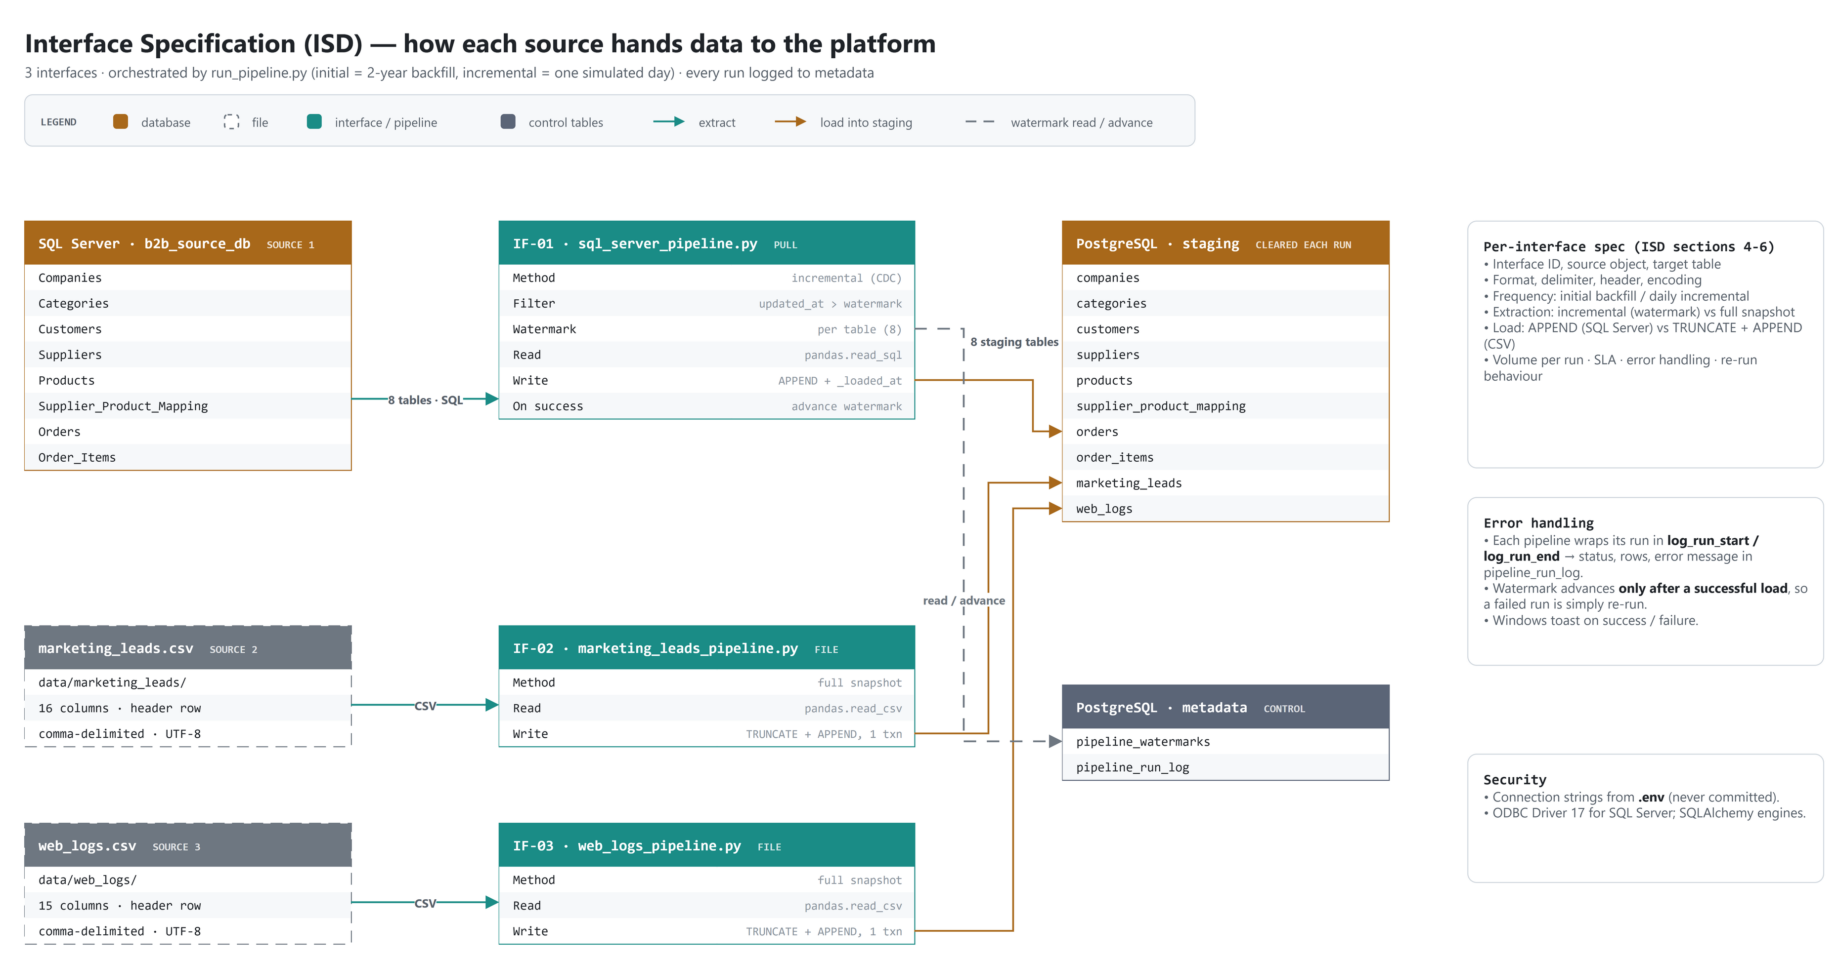
Figure 1: Interface diagram — sources, interfaces and staging targets
Table 3: Interface inventory
Interface ID | Source System | Source Object(s) | Format | Target (staging) | Extraction | Load Method | Frequency
IF-01 | SQL Server b2b_​source_​db | 8 tables in schema source (Companies ... Order_​Items) | Relational (ODBC) | staging.<table> (8 tables) | Incremental (watermark on updated_at); full on first run | APPEND | Every pipeline run
IF-02 | Marketing (CSV feed) | marketing_​leads.​csv | CSV, comma, header | staging.​marketing_​leads | Full snapshot | TRUNCATE + APPEND | Every pipeline run
IF-03 | Web server (CSV feed) | web_​logs.​csv | CSV, comma, header | staging.​web_​logs | Full snapshot | TRUNCATE + APPEND | Every pipeline run

3. Source System Details
Table 4: Source System Details
Source | Technology | Location / Connection | Access Method | Credentials Handling | Owner
S1 SQL Server | Microsoft SQL Server 16.0.1000.6 (2022 Express) | Local instance, database b2b_​source_​db, schema source. SQLAlchemy URL mssql+pyodbc with the ODBC driver named in .env | Read-only SELECT via pandas.read_sql | Windows authentication; server, driver, database and auth option read from .env (SQL_SERVER_*) | Source system (simulated by python/generators)
S2 Marketing CSV | CSV file on local disk | data/​marketing_​leads/​marketing_​leads.​csv (path in config/​config.​py) | pandas.read_csv | File-system permissions only | Marketing (simulated)
S3 Web logs CSV | CSV file on local disk | data/​web_​logs/​web_​logs.​csv (path in config/​config.​py) | pandas.read_csv | File-system permissions only | Web platform (simulated)

4. Interface IF-01: SQL Server → staging (8 tables)

4.1 General Information
Table 5: IF-01 general information
Interface ID | IF-01
Interface name | SQL Server → staging (8 tables)
Source | SQL Server b2b_source_db, schema source (8 tables)
Target | PostgreSQL b2b_warehouse_db, schema staging (8 tables of the same name, lower case)
Pipeline script | python/pipelines/sql_server_pipeline.py (queries in python/utils/constants.py SOURCE1_QUERIES)
Trigger / orchestration | python -m python.pipelines.run_pipeline initial | incremental (started manually from the command line)
Frequency | Initial backfill once; then one incremental run per simulated business day
Extraction type | Incremental per table (watermark); full extract when no watermark exists yet
Change indicator / watermark | updated_at; key sql_server_<table> in metadata.pipeline_watermarks
Load type | APPEND (DataFrame.to_sql, chunksize 2,500)
Expected volume per run | Initial: 722,463 rows. Incremental: about 850-900 new/changed rows (run log: min 851 rows extracted)
SLA / completion window | Measured: average 21.2 s, maximum 78.8 s per run (4 completed runs; the maximum is the initial load)

4.2 Objects Transferred
Table 6: IF-01 objects transferred
# | Source Table | Target Table | Watermark Column | Initial Rows | Rows / Day | Load Order
1 | source.Companies | staging.​companies | updated_at | 2,500 | 1-3 updated | Level 0
2 | source.Categories | staging.​categories | updated_at | 10 | 0 | Level 0
3 | source.Customers | staging.​customers | updated_at | 94,755 | 3-5 updated | Level 1
4 | source.Suppliers | staging.​suppliers | updated_at | 400 | 0 | Level 1
5 | source.Products | staging.​products | updated_at | 96 | 0-2 deactivated | Level 1
6 | source.Supplier_Product_Mapping | staging.​supplier_​product_​mapping | updated_at | 347 | 0 | Level 2
7 | source.Orders | staging.​orders | updated_at | 156,678 | 180-230 new + 5-10 status updates | Level 3
8 | source.Order_Items | staging.​order_​items | updated_at | 470,263 | ~550-700 new (lines of new orders) | Level 4

4.3 Extraction & Load Logic
One execution of sql_server_pipeline.run() performs these steps:
1. Log start: insert a row in metadata.pipeline_run_log with status 'running' and a new run_id.
2. Extract: read the table's watermark; if it exists, SELECT ... FROM source.<Table> WHERE updated_at > :watermark; otherwise the full table. The watermark is passed as a bind parameter, not concatenated into the SQL.
3. Load: append each non-empty DataFrame to staging.<table> with to_sql(if_exists='append', chunksize=2500). PostgreSQL fills _loaded_at with now().
4. Advance watermarks: only after all loads succeeded, store MAX(updated_at) of each table whose watermark moved.
5. Log end: update the run-log row with status 'completed', rows_extracted, rows_loaded and the highest watermark.

4.4 Error Handling & Re-run
- Any exception is caught in run(): the run-log row is closed with status 'failed' and the error message, and the exception is re-raised so run_pipeline stops and shows a Windows failure notification.
- Watermarks are only advanced after a successful load, so a failed run changes no watermark. The next run re-extracts the same rows.
- If a failure happens after some tables were already appended, those rows are appended again on the re-run. This is safe: the intermediate step keeps only the latest version per key, so duplicates are removed.
- Re-run: simply execute the same command again; no manual clean-up is required.

5. Interface IF-02: marketing_leads.csv → staging.marketing_leads

5.1 General Information
Table 7: IF-02 general information
Interface ID | IF-02
Interface name | marketing_leads.csv → staging.marketing_leads
Source | CSV file data/marketing_leads/marketing_leads.csv
Target | PostgreSQL staging.marketing_leads
Pipeline script | python/pipelines/marketing_leads_pipeline.py
Trigger / orchestration | python -m python.pipelines.run_pipeline initial | incremental (manual command line)
Frequency | Every pipeline run
Extraction type | Full snapshot (whole file is read every run)
Change indicator / watermark | None - the file has updated_at, but the file is rewritten in place when leads change, so it is reloaded completely
Load type | TRUNCATE staging table + APPEND (to_sql)
Expected volume per run | Whole file: currently 150,616 rows (31.7 MB), growing by 180-230 leads per day
SLA / completion window | Measured: average 17.7 s, max 20.7 s per run

5.2 File Specification
Table 8: IF-02 file specification
File name / path | data/marketing_leads/marketing_leads.csv
Naming convention | Fixed name marketing_leads.csv (single cumulative file, no date suffix)
Format | CSV
Delimiter | Comma (,)
Quote character | Double quote (") - pandas default, only when a value contains a comma
Header row | Yes - first row holds the column names
Encoding | UTF-8
Date / timestamp format | YYYY-MM-DD HH:MM:SS, optionally with microseconds (.ffffff)
Record count / file size | 150,616 records, 31.7 MB (profiled 30/09/2026); no trailer/control record

5.3 Record Layout
Table 9: IF-02 record layout
# | Field | Data Type | Length | Nullable | Description | Sample Value
1 | lead_id | Text (hex id) | 32 | N | Identifier of the marketing lead that generated the record (NULL if none). | 3ecb55e9...
2 | source | Text | 100 | N | Marketing channel the lead came from (e.g. Website, Referral). | Cold Call
3 | campaign_name | Text | 150 | N | Marketing campaign name. | Summer Sale
4 | utm_source | Text | 100 | N | UTM source parameter (e.g. google, linkedin). | linkedin
5 | utm_medium | Text | 100 | N | UTM medium parameter (e.g. cpc, email). | social
6 | utm_campaign | Text | 150 | N | UTM campaign parameter. | summer_sale
7 | company_name | Text | 200 | N | Legal/trading name of the company. | Beck-Walsh
8 | company_size | Text | 30 | N | Employee-size band of the lead's company. | 1-10
9 | industry | Text | 100 | N | Industry of the lead's company. | Technology
10 | country | Text | 100 | N | Country name. | United States
11 | city | Text | 100 | N | City name. | Seattle
12 | lead_score | Integer | - | N | Lead quality score, 1-100. | 7
13 | estimated_order_value | Decimal | 12,2 | N | Estimated value of the potential order. | 5747.47
14 | funnel_stage | Text | 30 | N | Current sales-funnel stage of the lead. | New
15 | created_at | Timestamp | - | N | Timestamp when the record was created in the source system. | 2025-08-08 05:02:55
16 | updated_at | Timestamp | - | N | Timestamp of the last change in the source system; drives incremental extraction and upserts. | 2026-03-21 06:15:54

5.4 Extraction & Load Logic
1. Log start in metadata.pipeline_run_log (status 'running').
2. Read the whole file with pd.read_csv(..., parse_dates=[created_at, updated_at]); other types are inferred by pandas.
3. Profile the DataFrame (shape, dtypes, null counts) to the log.
4. Load: TRUNCATE staging.marketing_leads and to_sql(if_exists='append', chunksize=2500) in one transaction. _loaded_at is filled by PostgreSQL.
5. Log end with status 'completed' and the row count. No watermark is stored for this interface.
How the file grows: the daily generator appends new leads to the file and rewrites existing rows when a lead's funnel_stage / lead_score changes, so the file always holds the current state of every lead.

5.5 Error Handling & Re-run
- A missing or unreadable file, or a parse error, fails the run before the TRUNCATE, so staging keeps the previous snapshot.
- If the append fails, the TRUNCATE is rolled back too, so staging keeps the previous snapshot. The pipeline stops and the transform does not run.
- Failures are logged with status 'failed' and the error message, and run_pipeline shows a failure notification.
- Re-run is always safe: the interface is a full snapshot, so running it again produces exactly the same staging content.
Figure 2 shows the first rows of the marketing leads file as delivered, with its header row and comma-separated layout.
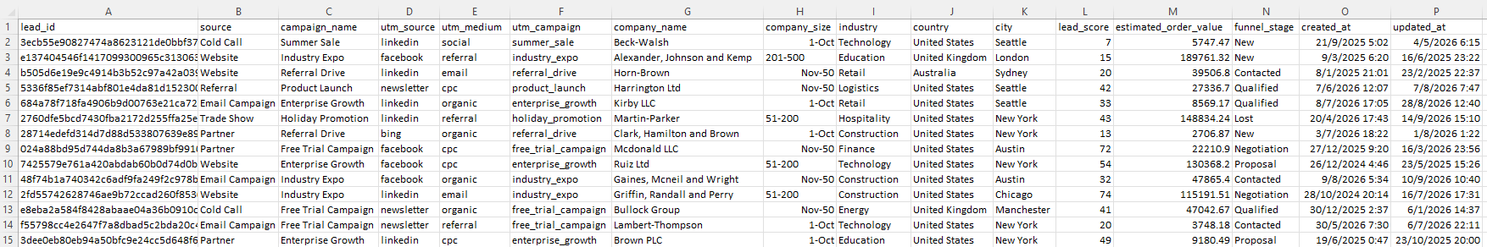
Figure 2: Sample rows of marketing_leads.csv

6. Interface IF-03: web_logs.csv → staging.web_logs

6.1 General Information
Table 10: IF-03 general information
Interface ID | IF-03
Interface name | web_logs.csv → staging.web_logs
Source | CSV file data/web_logs/web_logs.csv
Target | PostgreSQL staging.web_logs
Pipeline script | python/pipelines/web_logs_pipeline.py
Trigger / orchestration | python -m python.pipelines.run_pipeline initial | incremental (manual command line)
Frequency | Every pipeline run
Extraction type | Full snapshot (whole file is read every run)
Change indicator / watermark | None - log lines are immutable and the file has no change column
Load type | TRUNCATE staging table + APPEND (to_sql)
Expected volume per run | Whole file: currently 301,220 rows (59.9 MB), growing by 370-450 log lines per day
SLA / completion window | Measured: average 30.0 s, max 41.0 s per run

6.2 File Specification
Table 11: IF-03 file specification
File name / path | data/web_logs/web_logs.csv
Naming convention | Fixed name web_logs.csv (single cumulative file, no date suffix)
Format | CSV
Delimiter | Comma (,)
Quote character | Double quote (") - pandas default, only when a value contains a comma
Header row | Yes - first row holds the column names
Encoding | UTF-8
Date / timestamp format | YYYY-MM-DD HH:MM:SS, optionally with microseconds (.ffffff)
Record count / file size | 301,220 records, 59.9 MB (profiled 30/09/2026); no trailer/control record

6.3 Record Layout
Table 12: IF-03 record layout
# | Field | Data Type | Length | Nullable | Description | Sample Value
1 | log_id | Text (hex id) | 32 | N | Identifier of the web request log entry. | c4896ec9...
2 | country | Text | 100 | N | Country name. | United Kingdom
3 | city | Text | 100 | N | City name. | Manchester
4 | log_timestamp | Timestamp | - | N | Timestamp of the web request. | 2026-01-13 13:18:50
5 | client_ip | Text | 45 | N | IP address of the client. | 10.19.246.214
6 | auth_user | Text | 150 | Y (15,014 empty) | Authenticated user name (NULL for anonymous requests). | martyn70
7 | session_id | Text (hex id) | 32 | N | Web session identifier. | f831053e...
8 | http_method | Text | 10 | N | HTTP method of the request (GET, POST, PUT, DELETE). | DELETE
9 | request_path | Text | 255 | N | Requested URL path. | /api/orders
10 | status_code | Integer | - | N | HTTP response status code (100-599). | 200
11 | bytes_sent | Integer | - | N | Response size in bytes. | 356429
12 | referer | Text | 255 | N | Referring URL. | https://twitter.com
13 | device_type | Text | 30 | N | Client device type: Desktop, Mobile or Tablet. | Desktop
14 | browser | Text | 50 | N | Client browser. | Firefox
15 | is_bot | Boolean (True/False) | - | N | TRUE if the request came from a bot / crawler. | False

6.4 Extraction & Load Logic
1. Log start in metadata.pipeline_run_log (status 'running').
2. Read the whole file with pd.read_csv(..., parse_dates=[log_timestamp]); other types are inferred by pandas.
3. Profile the DataFrame (shape, dtypes, null counts) to the log.
4. Load: TRUNCATE staging.web_logs and to_sql(if_exists='append', chunksize=2500) in one transaction. _loaded_at is filled by PostgreSQL.
5. Log end with status 'completed' and the row count. No watermark is stored for this interface.
How the file grows: the daily generator appends new request lines (append-only); existing lines never change.

6.5 Error Handling & Re-run
- A missing or unreadable file, or a parse error, fails the run before the TRUNCATE, so staging keeps the previous snapshot.
- If the append fails, the TRUNCATE is rolled back too, so staging keeps the previous snapshot. The pipeline stops and the transform does not run.
- Failures are logged with status 'failed' and the error message, and run_pipeline shows a failure notification.
- Re-run is always safe: the interface is a full snapshot, so running it again produces exactly the same staging content.
Figure 3 shows the first rows of the web logs file as delivered.
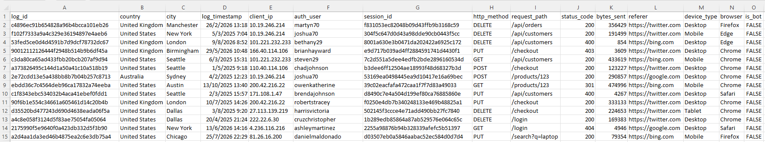
Figure 3: Sample rows of web_logs.csv

7. Scheduling & Orchestration
Table 13: Scheduling & Orchestration
Run Mode | Command | Interfaces Executed | Order | Trigger
initial | python -m python.pipelines.run_pipeline initial | Generators (master + transactions), IF-01, IF-02, IF-03, transform, warehouse load | Generate -> IF-01 -> IF-02 -> IF-03 -> intermediate -> clear staging -> warehouse | Manual, once per environment
incremental | python -m python.pipelines.run_pipeline incremental | CDC generator (one simulated day), IF-01, IF-02, IF-03, transform, warehouse load | Generate day -> IF-01 -> IF-02 -> IF-03 -> intermediate -> clear staging -> warehouse | Manual, once per simulated day (BRD: no CI/CD, local orchestration)

Figure 4 is the evidence that staging is emptied after a successful run: every staging table returns 0 rows.
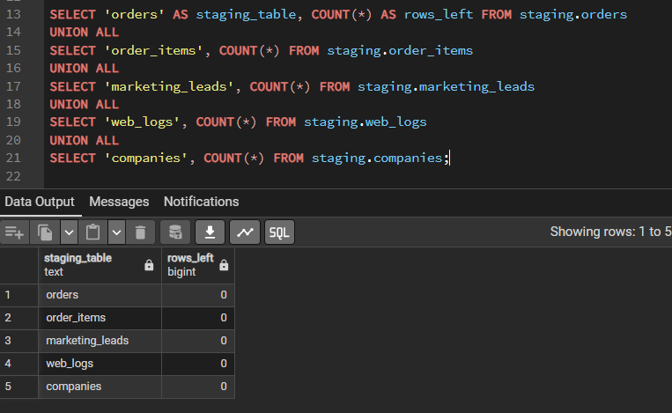
Figure 4: Staging tables are empty after a successful run

8. Control & Audit Tables
Table 14: Control & Audit Tables
Control Table | Column | Purpose
metadata.pipeline_watermarks | pipeline_name (PK) | Watermark key: sql_server_<table> (8 rows)
metadata.pipeline_watermarks | last_extracted_at | Highest updated_at loaded successfully; lower bound of the next extract
metadata.pipeline_run_log | run_id, pipeline_name | One row per execution of a pipeline or stage (interfaces, intermediate_transform, warehouse_load)
metadata.pipeline_run_log | run_started_at, run_ended_at, status | Duration and outcome: running / completed / failed
metadata.pipeline_run_log | rows_extracted, rows_loaded, watermark_used | Volumes and watermark of the run, for reconciliation
metadata.pipeline_run_log | error_message | Exception text of a failed run
staging.<every table> | _loaded_at | Ingestion timestamp of each row; used to pick the latest version downstream

Figure 5 shows the run log: one row per pipeline stage and run, with start and end time, rows loaded and status.
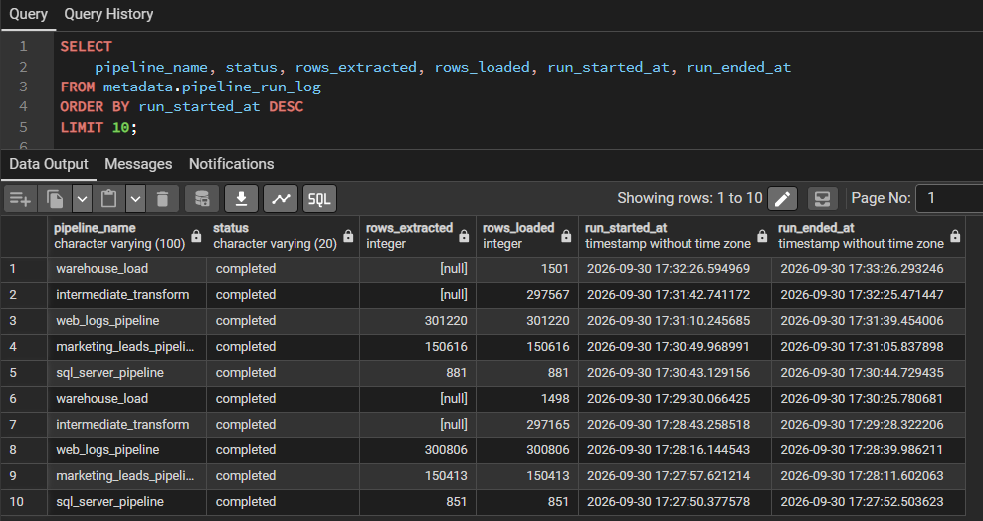
Figure 5: metadata.pipeline_run_log — one row per pipeline stage and run
Figure 6 shows the stored watermarks, one per SQL Server table; the next incremental run extracts only rows changed after them.
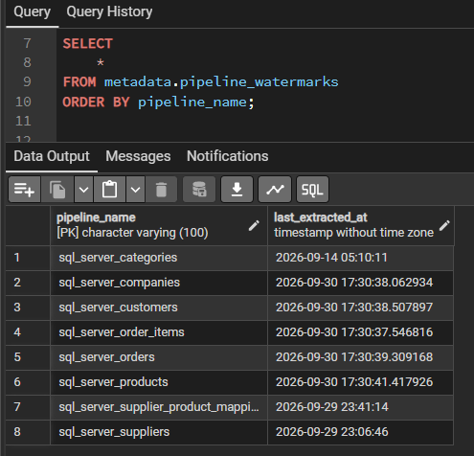
Figure 6: metadata.pipeline_watermarks — one watermark per SQL Server table

9. Interface Data Quality Checks
Table 15: Interface Data Quality Checks
Check ID | Interface | Check | Action on Failure
DQ-01 | All | Row count, dtypes and null counts profiled for every extracted DataFrame | Logged for review; load continues
DQ-02 | All | rows_extracted = rows_loaded recorded in pipeline_run_log | Mismatch investigated manually
DQ-03 | IF-01 | Extract filtered by updated_at > watermark; watermark only advanced on success | Failed run leaves watermark unchanged
DQ-04 | IF-02, IF-03 | File must exist and parse (header, timestamp columns) | Run fails before TRUNCATE; previous snapshot kept
DQ-05 | All | Field-level rules (mandatory, domain, range, referential) applied in the intermediate layer - see SMD section 7 | Row not promoted; CSV rows saved in intermediate.rejected_records

10. Error Handling & Recovery
Table 16: Error Handling & Recovery
Scenario | Detection | Handling | Recovery / Re-run
SQL Server unreachable / login fails | Exception in read_sql; run log 'failed'; failure notification | Run stops; no watermark moves | Fix connection (.env / service) and re-run
PostgreSQL unreachable | Exception on connect; run stops | Nothing written | Fix and re-run
Failure after partial append (IF-01) | Run log 'failed' | Watermarks unchanged; some tables already appended | Re-run; duplicates removed by intermediate dedup
CSV missing / corrupt | read_csv exception; run log 'failed' | TRUNCATE not executed | Restore/regenerate the file and re-run
Transform or warehouse stage fails | Stage run log 'failed' (e.g. one intermediate_transform failure in the log) | Stage transaction rolled back | Fix cause and re-run the pipeline; all stages are idempotent

11. Security
- Credentials are never in code: all connection settings (SQL_SERVER_*, POSTGRES_*) are read from a local .env file with python-dotenv. .env is excluded from Git; the pipeline fails at start-up if any variable is missing.
- SQL Server uses Windows authentication (trusted connection) through the ODBC driver, so no SQL Server password is stored.
- PostgreSQL uses the user/password from .env.
- Access: the pipeline only reads from SQL Server and the CSV files; it writes only to PostgreSQL schemas staging, intermediate, warehouse and metadata.
- SQL injection: the watermark is passed as a bound parameter to text(); table names come from a fixed mapping, not from user input.
- Personal data (PII): customers (name, e-mail, phone, date of birth), supplier contacts, web-log client_ip and auth_user. All data is synthetic (Faker), but in production these columns would require masking or restricted access in the marts.

12. Assumptions, Constraints & Open Issues
Table 17: Assumptions, Constraints & Open Issues
ID | Type | Description | Owner | Status
A1 | Assumption | Source updated_at is maintained on every insert and update (required for IF-01 CDC). | Data Engineering | Accepted
A2 | Assumption | CSV files always contain the complete current data set (snapshot semantics). | Data Engineering | Accepted
C1 | Constraint | Runs are started manually through run_pipeline.py, as specified in the requirements (no CI/CD). | Data Engineering | Accepted

