
Source System Analysis & ERD
Document 02 of 09 · B2B Data Engineering Platform

05/10/2026
DataRopes.ai
Data Engineering Internship · B2B Data Engineering Platform
Documents the analysis of the source systems: entities, relationships, business rules, data profiling and data-quality findings.
Document ID | B2B-DEP-02
Version | 1.3
Status | Final
Date | 05/10/2026
Prepared by | Syed Kazim Raza
Reviewed by | [Team Lead]

Document Control

Revision History
Version | Date | Author | Description of Change
0.1 | - | Syed Kazim Raza | Template created
1.0 | 28/09/2026 | Syed Kazim Raza | Content populated from source DDL and read-only profiling of SQL Server and CSV files
1.1 | 30/09/2026 | Syed Kazim Raza | Profiling re-run on the rebuilt data; dirty CSV rows (DQ-04)
1.2 | 04/10/2026 | Syed Kazim Raza | Source ERD redrawn (light theme, editable draw.io source in docs/diagrams)
1.3 | 05/10/2026 | Syed Kazim Raza | Formatting to documentation standard: table column widths, numbered figure and table captions with lists, figure descriptions, complete acronym list

Approvals
Role | Name | Signature | Date
Prepared by | Syed Kazim Raza
Reviewed by | [Team Lead]
Approved by | [Manager]

Related Documents
Ref | Document | Location
R1 | Business Requirements Document (BRD) | Provided by DataRopes
R2 | Project Document (technical reference) | docs/deliverables/project_document.md
R3 | Project Plan | docs/deliverables/project_plan.md
R4 | README / Deployment Guide | README.md

Contents
Document Control 2
Contents 3
List of Figures 4
List of Tables 5
1. Introduction 6
1.1 Purpose 6
1.2 Scope 6
1.3 Intended Audience 6
1.4 Definitions & Acronyms 6
2. Source Systems Overview 7
3. Source Entity–Relationship Diagram 8
4. Entity Catalogue 9
5. Relationships & Cardinality 9
6. Business Rules Observed in the Source 10
7. Data Profiling Results 11
8. Data Quality Findings 15
9. Change Data Capture Analysis 15
10. Assumptions & Open Questions 16

List of Figures
Figure 1: Source system ERD — b2b_source_db and CSV feeds 8
Figure 2: Row counts of the source tables in SQL Server 13
Figure 3: Sample rows of marketing_leads.csv 14
Figure 4: Sample rows of web_logs.csv 14

List of Tables
Table 1: Intended Audience 6
Table 2: Definitions & Acronyms 6
Table 3: Source Systems Overview 7
Table 4: Entity Catalogue 9
Table 5: Relationships & Cardinality 9
Table 6: Business Rules Observed in the Source 10
Table 7: Data Profiling Results 11
Table 8: Data Quality Findings 15
Table 9: Change Data Capture Analysis 15
Table 10: Assumptions & Open Questions 16

1. Introduction

1.1 Purpose
This document records what was learned about the source systems before modelling and building the pipelines.

1.2 Scope
In scope:
- SQL Server b2b_source_db (8 tables) and the marketing-leads and web-logs CSV feeds
- Entity relationships, source business rules, profiling and data quality
Out of scope:
- Target data models (see LDM / PDM)
- Interface mechanics (see ISD)

1.3 Intended Audience
Table 1: Intended Audience
Audience | How they use this document
Data Engineers / Modellers | Understand the sources before modelling
Team Lead | Validate that the analysis is complete

1.4 Definitions & Acronyms
Table 2: Definitions & Acronyms
Term | Definition
B2B | Business-to-Business: companies selling to other companies.
BR | Business Rule: a rule the data must follow, numbered BR-1 … in the Source System Analysis.
BRD | Business Requirements Document: here the Project Requirements Document provided by DataRopes.
Business key | Source identifier of an entity: 32-character hex UUID generated in Python (no IDENTITY columns).
CDC | Change Data Capture: how new and changed records can be identified in a source.
CSV | Comma-Separated Values: the text-file format of the marketing leads and web logs feeds.
DDL | Data Definition Language: SQL that creates schemas, tables, indexes and views.
DEP | Data Engineering Platform: prefix of the document IDs (B2B-DEP-01 …).
DQ | Data Quality: DQ-x numbers the data-quality findings of the source analysis.
Entity | A business object stored as one source table or file (e.g. Orders).
ERD | Entity-Relationship Diagram: a diagram of tables (entities) and their relationships.
FK | Foreign Key: a column that references the primary key of another table.
HTTP | Hypertext Transfer Protocol: the web protocol recorded in the web logs (GET, POST …).
ID | Identifier.
ISD | Interface Specification Document (deliverable 01).
KPI | Key Performance Indicator: a business measure shown on the dashboard (KPI-01 … KPI-15).
LDM | Logical Data Model (deliverable 03).
Load level | Dependency level 0-4: an entity can only be loaded after the entities it references.
OLTP | Online Transaction Processing: an operational database such as the SQL Server source.
PDM | Physical Data Model (deliverable 04).
Profiling | Measuring row counts, nulls, distinct values and ranges to understand data content and quality.
SCD | Slowly Changing Dimension: SCD1 overwrites changes, SCD2 keeps every version with validity dates.
SQL | Structured Query Language.
UQ | Unique constraint: no two rows may have the same value.
UTF-8 | Unicode character encoding used by the CSV files.
UTM | Urchin Tracking Module: campaign parameters (utm_source, utm_medium, utm_campaign).

2. Source Systems Overview
Table 3: Source Systems Overview
Source ID | Name | Type | Technology | Business Domain | Entities | Update Pattern
S1 | b2b_source_db | Operational database (OLTP) | Microsoft SQL Server 16.0.1000.6 Express, schema source | Companies, customers, suppliers, catalogue, orders | 8 tables | Inserts and updates, updated_at maintained, no deletes
S2 | marketing_leads.csv | Flat file (CSV) | Local file, comma separated, UTF-8 | Marketing / lead funnel | 1 file | Cumulative file; new leads appended, changed leads rewritten in place
S3 | web_logs.csv | Flat file (CSV) | Local file, comma separated, UTF-8 | Web platform traffic | 1 file | Append-only log

3. Source Entity–Relationship Diagram
Figure 1 shows the source data model: the eight SQL Server tables with their keys and relationships, plus the two CSV feeds.
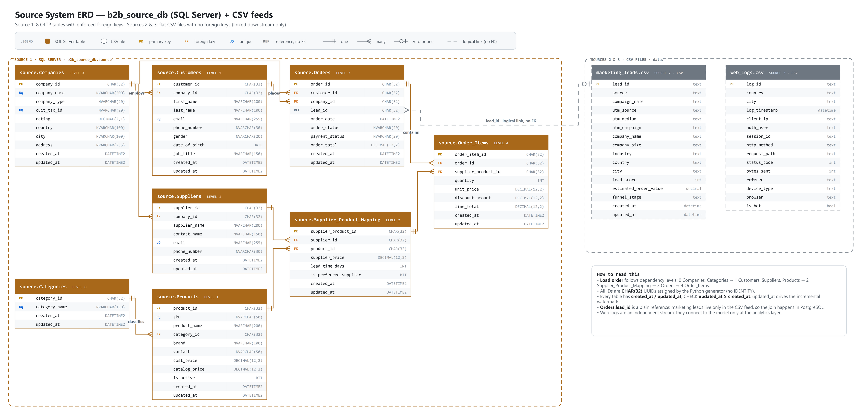
Figure 1: Source system ERD — b2b_source_db and CSV feeds

4. Entity Catalogue
Table 4: Entity Catalogue
Entity | Source | Description | Business Key | Load Level | Row Count
Companies | S1 | Buyer and supplier organisations on the platform | company_id | Level 0 | 2,500
Categories | S1 | Product category catalogue | category_id | Level 0 | 10
Customers | S1 | Buyer contact persons who place orders | customer_id | Level 1 | 94,755
Suppliers | S1 | Supplier accounts (one per supplier company) | supplier_id | Level 1 | 400
Products | S1 | Products with cost and catalog price | product_id (UQ sku) | Level 1 | 96
Supplier_​Product_​Mapping | S1 | Which supplier sells which product, price and lead time | supplier_product_id (UQ supplier_id + product_id) | Level 2 | 347
Orders | S1 | Order header: customer, company, status, payment, total | order_id | Level 3 | 156,678
Order_​Items | S1 | Order lines: supplier-product, quantity, price, discount | order_item_id (UQ order_id + supplier_product_id) | Level 4 | 470,263
marketing_​leads | S2 | Marketing leads with campaign, UTM and funnel stage | lead_id | Level 0 (independent) | 150,616
web_​logs | S3 | HTTP requests on the B2B portal | log_id | Level 0 (independent) | 301,220

5. Relationships & Cardinality
Table 5: Relationships & Cardinality
Parent | Child | Join Column(s) | Cardinality | FK Enforced? | Notes
Companies | Customers | company_id | 1 : 10-80 (buyer companies only; 2,100 have customers) | Yes (FK) | BR-1: customers belong only to Buyer companies
Companies | Suppliers | company_id | 1 : 1 (400 supplier companies, 400 suppliers) | Yes (FK) | BR-2: suppliers belong only to Supplier companies
Categories | Products | category_id | 1 : many (10 categories, 96 products) | Yes (FK) | BR-3: product belongs to one category
Suppliers | Supplier_​Product_​Mapping | supplier_id | 1 : 0..many (234 of 400 suppliers have offers) | Yes (FK) | Resolves the many-to-many Supplier-Product
Products | Supplier_​Product_​Mapping | product_id | 1 : 2-5 | Yes (FK) | BR-4: product has several suppliers; UNIQUE(supplier_id, product_id)
Customers | Orders | customer_id | 1 : 0..many (57,396 customers have ordered) | Yes (FK) | BR-5
Companies | Orders | company_id | 1 : 0..many | Yes (FK) | Must equal the customer's company (0 violations)
Orders | Order_​Items | order_id | 1 : 1..many (avg 3.0 lines) | Yes (FK) | BR-6; UNIQUE(order_id, supplier_product_id)
Supplier_​Product_​Mapping | Order_​Items | supplier_product_id | 1 : 0..many | Yes (FK) | An order line buys a specific supplier offer
marketing_​leads (S2) | Orders | lead_id | 1 : 0..1 (6,044 orders from leads) | No (cross-source) | BR-8; validated in the intermediate layer

6. Business Rules Observed in the Source
Table 6: Business Rules Observed in the Source
Rule ID | Rule | Entities | Enforced By
BR-1 | Customers belong only to Buyer companies (10-80 customers each) | Companies, Customers | Generator; checked by profiling (0 violations)
BR-2 | Suppliers belong only to Supplier companies | Companies, Suppliers | Generator; checked by profiling (0 violations)
BR-3 | A product belongs to exactly one category | Products | FK + NOT NULL
BR-4 | A product has 2-5 suppliers; one offer per supplier-product pair | Supplier_Product_Mapping | Generator; UNIQUE constraint
BR-5 | An order belongs to one customer and cannot predate the customer | Orders, Customers | FK; generator (0 violations)
BR-6 | An order has one or more order items | Orders, Order_Items | Generator (0 orders without items)
BR-7 | order_total = SUM(line_total); line_total = quantity x unit_price - discount | Orders, Order_Items | Generator (0 mismatches)
BR-8 | Every Won lead produces exactly one order; conversion derived from Orders.lead_id | marketing_leads, Orders | Generator; conversion derived from orders
BR-9 | updated_at >= created_at | All tables | CHECK constraints
BR-10 | Cancelled orders stay in the data but are excluded from revenue | Orders | Downstream KPI logic (7,613 cancelled orders)
BR-D1 | Domains: company_type, gender, order_status, payment_status; rating 1.0-5.0; prices, amounts >= 0; catalog_price >= cost_price | Several | CHECK constraints
BR-D2 | Unique company_name, cuit_tax_id, category_name, sku, customer and supplier e-mail | Several | UNIQUE constraints

7. Data Profiling Results
Profiling was run read-only against the SQL Server source and the two CSV files on 30/09/2026 (row counts, nulls, distinct values, ranges and cross-table checks), extending the queries in sql_server/exploration/dataset_validations.sql. The pipeline also prints shape, dtypes and null counts of every extracted batch. Key columns:
Table 7: Data Profiling Results
Table | Column | Rows | Null % | Distinct | Min | Max | Issues
Companies | company_​id | 2,500 | 0.​0% | 2,500 | - | - | Unique
Companies | Rating | 2,500 | 0.​0% | 26 | 2.​5 | 5.​0 | Range 2.​5-5.​0 within 1.​0-5.​0
Customers | company_​id | 94,755 | 0.​0% | 2,100 | - | - | 2,100 buyer companies
Customers | phone_​number | 94,755 | 0.​0% | 91,307 | len 12 | len 17 | Digits only
Products | catalog_​price | 96 | 0.​0% | 96 | 3.​60 | 20547.​27 | 17 products inactive
Supplier_​Product_​Mapping | lead_​time_​days | 347 | 0.​0% | 19 | 3 | 21 | 3-21 days
Orders | order_​date | 156,678 | 0.​0% | 156,298 | 2024-09-30 10:07:45 | 2026-09-30 17:27:15 | ~2 years of history
Orders | lead_​id | 156,678 | 96.​1% | 6,044 | - | - | Null = not from a lead (expected)
Orders | order_​total | 156,678 | 0.​0% | 154,123 | 2.​40 | 303352.​99 | 0 mismatches with lines
Order_​Items | Quantity | 470,263 | 0.​0% | 10 | 1 | 10 | 1-10 units
Order_​Items | discount_​amount | 470,263 | 0.​0% | 192,789 | 0.​00 | 27899.​36 | 0 line_​total mismatches
marketing_​leads.​csv | lead_​score | 150,616 | 0.​0% | 102 | 0 | 150 | 0 duplicate lead_​id; 723 outside 1-100 (DQ-04)
marketing_​leads.​csv | estimated_​order_​value | 150,616 | 0.​0% | 148,515 | -1000.​00 | 1999961.​38 | 741 negative (DQ-04)
web_​logs.​csv | auth_​user | 301,220 | 5.​0% | 158,330 | 3 | 22 | Anonymous requests
web_​logs.​csv | session_​id | 301,220 | 0.​0% | 301,220 | 32 | 32 | One id per request
web_​logs.​csv | status_​code | 301,220 | 0.​0% | 9 | 200 | 999 | 8 valid codes + 999 (DQ-04)
Figure 2 shows the row count of every source table in SQL Server at the time of profiling.
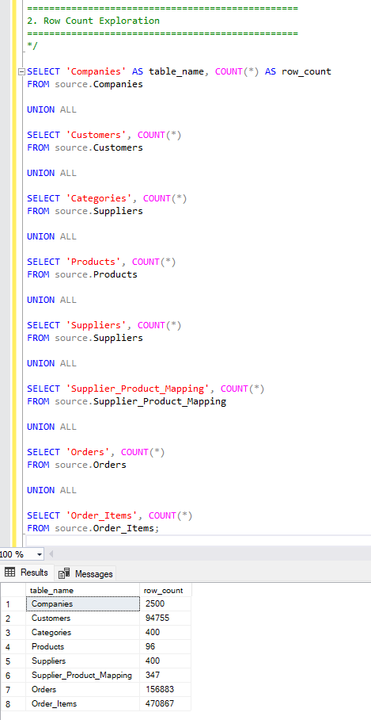
Figure 2: Row counts of the source tables in SQL Server
Figure 3 shows the first rows of the marketing leads file as delivered, with its header row and comma-separated layout.
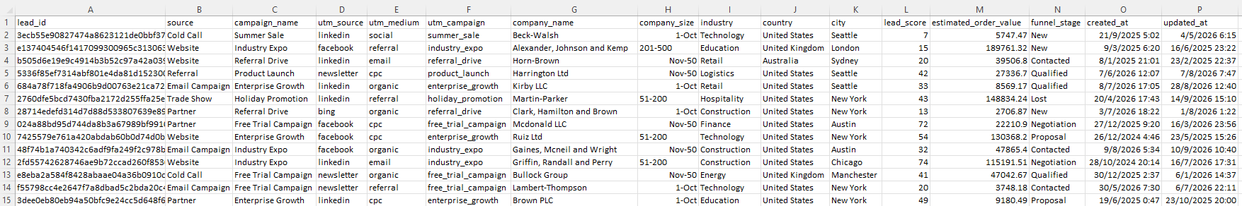
Figure 3: Sample rows of marketing_leads.csv
Figure 4 shows the first rows of the web logs file as delivered.
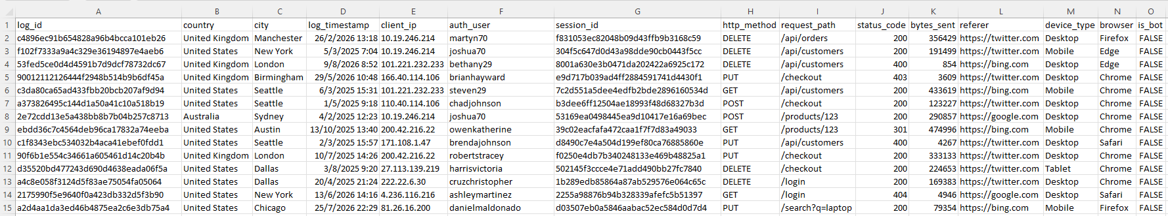
Figure 4: Sample rows of web_logs.csv

8. Data Quality Findings
Table 8: Data Quality Findings
Finding ID | Table / Column | Issue | Impact | Resolution in Pipeline
DQ-01 | All SQL Server tables | No quality violations found: 0 orphans, 0 role mismatches, 0 total/line mismatches, 0 orders before customer creation | Low - source constraints and generator enforce the rules | Rules re-validated in intermediate anyway (defence in depth)
DQ-02 | Orders.created_at | created_at of all orders is the insert time (from 2026-09-30), while order_date covers 2024-09 to 2026-09 | Medium - created_at is not the business date | Warehouse uses order_date for date_key and partitioning, never created_at
DQ-03 | web_logs.auth_user | 15,014 rows (5.0%) empty | Low - anonymous traffic is expected | Kept as NULL (column optional)
DQ-04 | marketing_leads.csv, web_logs.csv | About 1.5% of CSV rows are broken on purpose: 2,258 leads (score 0/150, negative value, empty industry) and 4,517 web logs (status 999, negative bytes, PATCH, empty browser) | Medium - invalid rows must not reach the warehouse | Caught in the intermediate layer and saved in intermediate.rejected_records (Quarantine table) with a reason

9. Change Data Capture Analysis
Table 9: Change Data Capture Analysis
Table | Change Indicator | Deletes Handled? | Extraction Strategy
Companies | updated_at (1-3 updated per day) | No | Watermark on updated_at; SCD2 in warehouse
Categories | updated_at (static) | No | Watermark on updated_at
Customers | updated_at (3-5 updated per day) | No | Watermark on updated_at
Suppliers | updated_at (static) | No | Watermark on updated_at
Products | updated_at (0-2 deactivated per day; soft delete via is_active) | Soft delete only | Watermark on updated_at
Supplier_Product_Mapping | updated_at (static) | No | Watermark on updated_at
Orders | updated_at (180-230 new + 5-10 status changes per day) | No | Watermark on updated_at
Order_Items | updated_at (insert only) | No | Watermark on updated_at
marketing_leads.csv | updated_at exists, but file rewritten in place | No | Full snapshot reload (TRUNCATE + APPEND)
web_logs.csv | None (append-only log) | No | Full snapshot reload (TRUNCATE + APPEND)

10. Assumptions & Open Questions
Table 10: Assumptions & Open Questions
ID | Type | Description | Owner | Status
A1 | Assumption | No physical deletes occur in the source; products are soft-deleted with is_active = 0. | Data Engineering | Accepted
A2 | Assumption | updated_at is set on every change (all generator UPDATE statements set it). | Data Engineering | Accepted
A3 | Assumption | Data is synthetic (Python Faker generators), as specified in the requirements. | Data Engineering | Accepted

