
Logical Data Model (LDM)
Document 03 of 09 · B2B Data Engineering Platform

05/10/2026
DataRopes.ai
Data Engineering Internship · B2B Data Engineering Platform
Describes the business entities, attributes, relationships and history rules of the analytical model, independent of any database technology.
Document ID | B2B-DEP-03
Version | 1.3
Status | Final
Date | 05/10/2026
Prepared by | Syed Kazim Raza
Reviewed by | [Team Lead]

Document Control

Revision History
Version | Date | Author | Description of Change
0.1 | - | Syed Kazim Raza | Template created
1.0 | 29/09/2026 | Syed Kazim Raza | Content populated: entities, attributes, relationships, history rules, logical-to-physical mapping
1.1 | 30/09/2026 | Syed Kazim Raza | Related document paths updated (no model change)
1.2 | 04/10/2026 | Syed Kazim Raza | LDM diagram redrawn (light theme, draw.io); note on business-rule IDs added in section 9
1.3 | 05/10/2026 | Syed Kazim Raza | Formatting to documentation standard: table column widths, numbered figure and table captions with lists, figure descriptions, complete acronym list

Approvals
Role | Name | Signature | Date
Prepared by | Syed Kazim Raza
Reviewed by | [Team Lead]
Approved by | [Manager]

Related Documents
Ref | Document | Location
R1 | Business Requirements Document (BRD) | Provided by DataRopes
R2 | Project Document (technical reference) | docs/deliverables/project_document.md
R3 | Project Plan | docs/deliverables/project_plan.md
R4 | README / Deployment Guide | README.md

Contents
Document Control 2
Contents 3
List of Figures 4
List of Tables 5
1. Introduction 6
1.1 Purpose 6
1.2 Scope 6
1.3 Intended Audience 6
1.4 Definitions & Acronyms 6
2. Modelling Approach 7
3. Subject Areas 7
4. Logical Data Model Diagram 8
5. Entity Definitions 10
6. Attribute Definitions 10
7. Relationships 13
8. History & Change Handling 14
9. Business Rules 17
10. Logical-to-Physical Mapping 18
11. Assumptions, Constraints & Open Issues 18

List of Figures
Figure 1: Logical data model — entities and relationships 9
Figure 2: SCD Type 2 — companies with more than one version 15
Figure 3: Rows that broke a business rule, kept in rejected_records 17

List of Tables
Table 1: Intended Audience 6
Table 2: Definitions & Acronyms 6
Table 3: Subject Areas 7
Table 4: Entity Definitions 10
Table 5: Attribute Definitions 10
Table 6: Relationships 13
Table 7: History & Change Handling 14
Table 8: Business Rules 17
Table 9: Logical-to-Physical Mapping 18
Table 10: Assumptions, Constraints & Open Issues 18

1. Introduction

1.1 Purpose
This document defines the logical data model that the warehouse implements.

1.2 Scope
In scope:
- Business entities, attributes, keys, relationships and cardinality
- History (SCD) and business rules at the logical level
Out of scope:
- Data types, indexes, partitions (see PDM)

1.3 Intended Audience
Table 1: Intended Audience
Audience | How they use this document
Data Modellers / Engineers | Build the physical model from it
Analysts / Business | Confirm entities and definitions

1.4 Definitions & Acronyms
Table 2: Definitions & Acronyms
Term | Definition
AK | Alternate Key: a second unique identifier of an entity besides its primary key.
Attribute | A fact that describes an entity (e.g. order status).
B2B | Business-to-Business: companies selling to other companies.
BI | Business Intelligence: reporting and dashboards, here Power BI.
BR | Business Rule: a rule the data must follow, numbered BR-1 … in the Source System Analysis.
BRD | Business Requirements Document: here the Project Requirements Document provided by DataRopes.
Conformed dimension | A dimension shared with the same meaning by several facts (e.g. Date).
DEP | Data Engineering Platform: prefix of the document IDs (B2B-DEP-01 …).
Entity | A business object the organisation wants to keep information about (e.g. Order).
ERD | Entity-Relationship Diagram: a diagram of tables (entities) and their relationships.
Fact / Dimension | Kimball terms: facts hold measurable events, dimensions hold the descriptive context.
FK | Foreign Key: a column that references the primary key of another table.
Grain | What exactly one row (instance) represents.
HTTP | Hypertext Transfer Protocol: the web protocol recorded in the web logs (GET, POST …).
ID | Identifier.
Identifier (PK) | Attribute(s) that uniquely identify one instance of an entity. Logical identifiers are business keys.
KPI | Key Performance Indicator: a business measure shown on the dashboard (KPI-01 … KPI-15).
LDM | Logical Data Model (deliverable 03).
OLTP | Online Transaction Processing: an operational database such as the SQL Server source.
PDM | Physical Data Model (deliverable 04).
SCD | Slowly Changing Dimension: SCD1 overwrites changes, SCD2 keeps every version with validity dates.
UUID | Universally Unique Identifier: the 32-character IDs used as business keys.
YYYYMMDD | Date written as year, month, day (e.g. 20260930); the format of date_key.

2. Modelling Approach
The warehouse follows the Kimball dimensional approach: business processes are modelled as facts at the lowest useful grain, surrounded by descriptive dimensions. This keeps queries simple for Power BI (star joins) and makes KPIs additive.
Because the platform covers four business processes (ordering, order lines, lead generation and web traffic), the model is a galaxy schema (fact constellation): four fact entities share conformed dimensions instead of four isolated stars.
- Date is conformed across all four facts, so revenue, leads and traffic can be compared on the same calendar.
- Customer, Company, Product and Supplier are shared by Order and Order Line, so header-level and line-level KPIs slice identically.
- Category is modelled as its own logical entity but flattened into Product physically (it has one attribute and 10 instances).
- Supplier Offer resolves the many-to-many relationship between Supplier and Product and carries the offer's price and lead time.
Why this design: the source is a normalised OLTP model (source ERD) that is efficient for writing but needs many joins for analysis. The dimensional model trades some redundancy for fewer joins, stable keys and history tracking where the business needs it (Company, SCD Type 2).
Order and Marketing Lead are linked through the business key lead_id rather than a dimension, because a lead is itself an event (fact) with its own grain.

3. Subject Areas
Table 3: Subject Areas
Subject Area | Entities | Business Questions Answered
Sales | Order, Order Line, Date | Monthly revenue trend; revenue by company and product; gross margin (KPI 1-4)
Customer & Company | Customer, Company | Customer lifetime value; customer activity; sales by geography (KPI 5-7)
Product & Supply | Product, Category, Supplier, Supplier Offer | Supplier revenue; supplier-product performance, preferred suppliers (KPI 13-14)
Marketing | Marketing Lead, Order, Date | Lead conversion funnel; lead quality vs order value (KPI 11-12)
Web Activity | Web Request, Date | Traffic by device; geographic web traffic; error / bot share (KPI 8-10)

4. Logical Data Model Diagram
Figure 1 shows the logical model: business entities, their identifiers and the cardinality of each relationship, without technical data types.
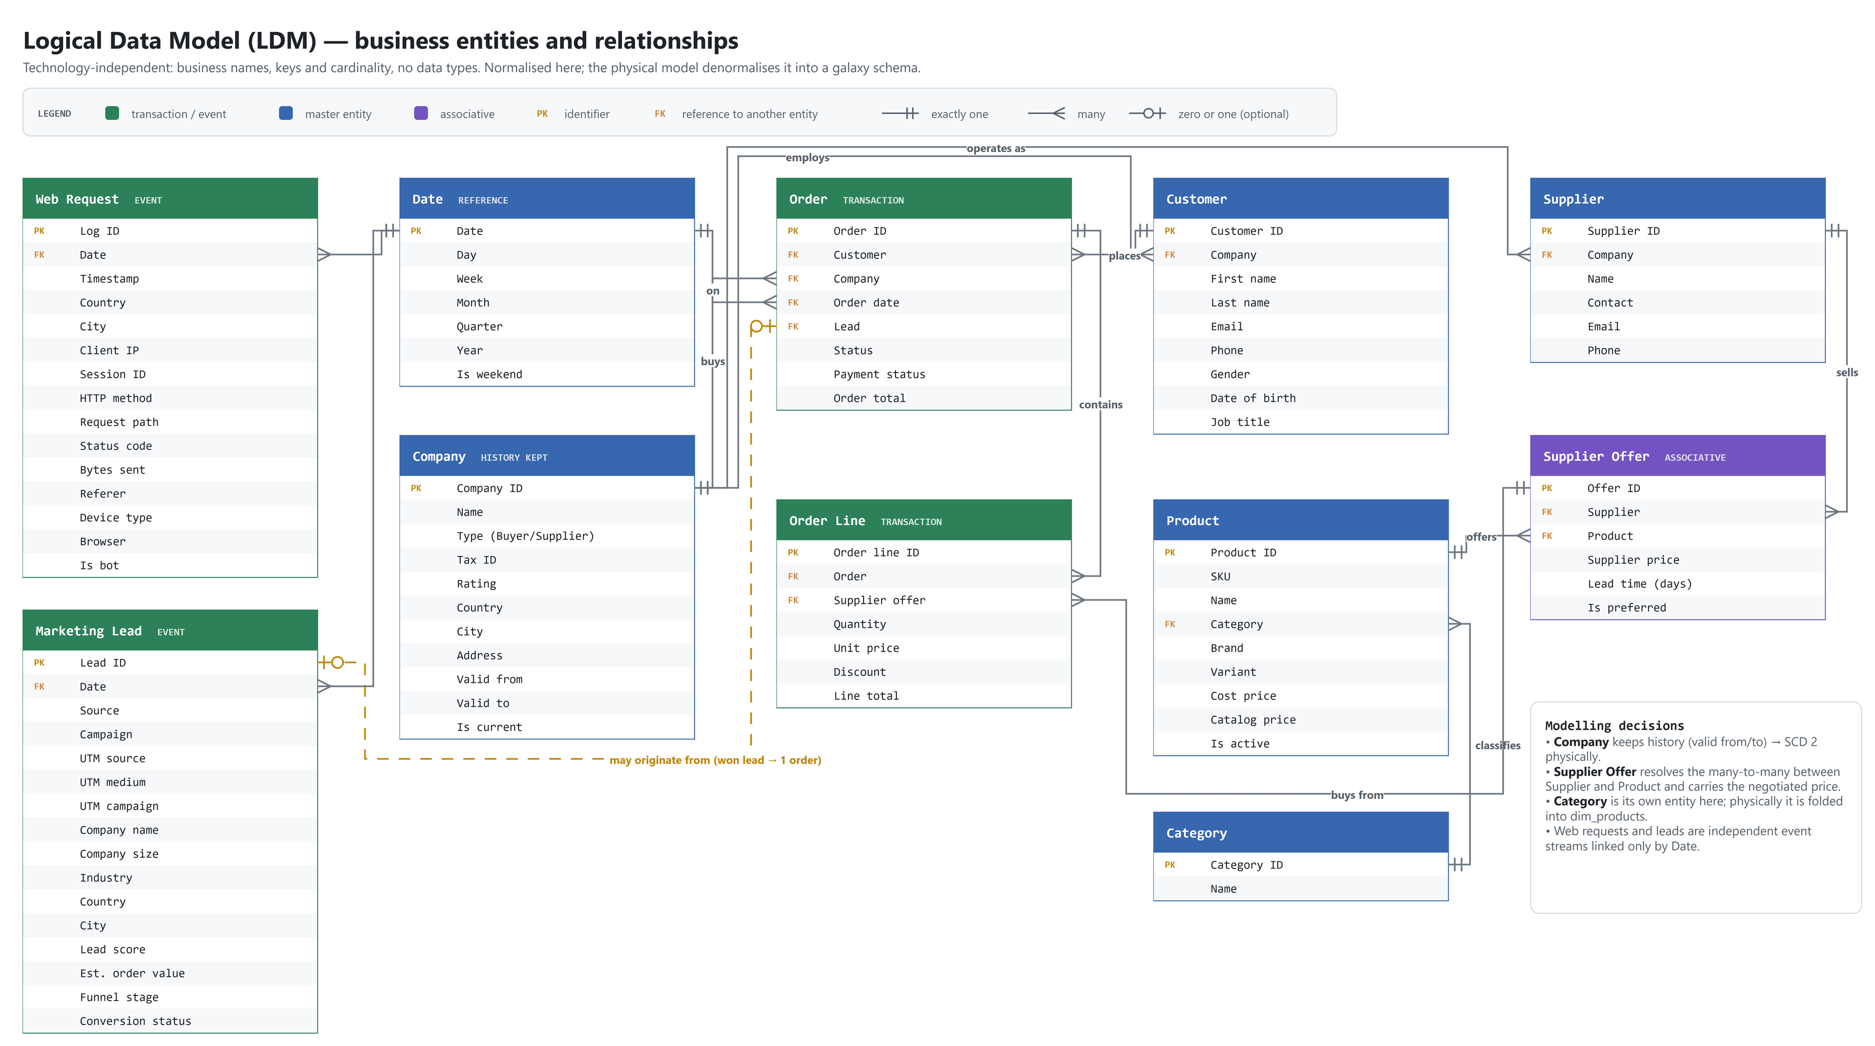
Figure 1: Logical data model — entities and relationships

5. Entity Definitions
Table 4: Entity Definitions
Entity | Type | Definition | Primary Identifier | Grain
Date | Dimension (reference) | A calendar day used to analyse all events. | Date key (YYYYMMDD) | One per calendar day
Company | Dimension (SCD2) | An organisation registered on the platform, acting as Buyer or Supplier. | company_id (+ validity period) | One per company version
Customer | Dimension | A person at a buyer company who places orders. | customer_id | One per customer
Supplier | Dimension | The selling account of a supplier company. | supplier_id | One per supplier
Category | Dimension (flattened) | A grouping of products. | category_id | One per category
Product | Dimension | An item that can be bought on the platform. | product_id (alt: sku) | One per product
Supplier Offer | Dimension / bridge | A product as offered by one supplier, with its price and lead time. | supplier_product_id (alt: supplier + product) | One per supplier-product pair
Order | Fact (transaction) | A purchase placed by a customer on behalf of a buyer company. | order_id | One per order
Order Line | Fact (transaction) | One supplier offer bought within an order, with quantity, price and discount. | order_item_id | One per order line
Marketing Lead | Fact (accumulating) | A prospect captured by a marketing campaign, tracked through the sales funnel. | lead_id | One per lead
Web Request | Fact (event) | One HTTP request made to the B2B web portal. | log_id | One per request

6. Attribute Definitions
The key attributes of each entity (49 of 100) in business language: identifiers, references and the attributes used by the KPIs. The complete list with data types is in 04b_Data_Dictionary.xlsx. Key: PK = identifier, FK = reference to another entity, AK = alternate (unique) key.
Table 5: Attribute Definitions
Entity | Attribute | Definition | Key | Domain / Allowed Values | Mandatory
Date | date key | Date surrogate key in YYYYMMDD format (FK to dim_date); also the partition key on facts. | PK |  | Yes
Company | company id | Business identifier of the company (32-char hex UUID assigned by the Python generator). | PK |  | Yes
Company | company name | Legal/trading name of the company. | AK |  | Yes
Company | company type | Role of the company in the marketplace: Buyer or Supplier. |  | Buyer, Supplier | Yes
Company | cuit tax id | Company tax identification number (unique per company). | AK |  | Yes
Company | rating | Company rating on a 1.0-5.0 scale. |  | 1.0 - 5.0 | Yes
Company | effective start date | Start of validity of this company version. |  |  | Yes
Company | effective end date | End of validity (empty = current). |  |  | No
Company | is current | Marks the current version. |  |  | Yes
Customer | customer id | Business identifier of the customer (a buyer contact person). | PK |  | Yes
Customer | company id | Company the record belongs to. | FK Company |  | Yes
Customer | email | E-mail address (lower-cased from intermediate onwards). | AK |  | Yes
Supplier | supplier id | Business identifier of the supplier. | PK |  | Yes
Supplier | company id | Company the record belongs to. | FK Company |  | Yes
Supplier | email | E-mail address (lower-cased from intermediate onwards). | AK |  | Yes
Category | category id | Business identifier of the product category. | PK |  | Yes
Category | category name | Name of the product category. | AK |  | Yes
Product | product id | Business identifier of the product. | PK |  | Yes
Product | sku | Stock-keeping unit code of the product. | AK |  | Yes
Product | category id | Business identifier of the product category. | FK Category |  | Yes
Product | cost price | Unit cost price of the product. |  | >= 0 | Yes
Product | catalog price | Unit list (catalog) price of the product; >= cost price. |  | >= cost price | Yes
Supplier Offer | supplier product id | Business identifier of a supplier-product offer (which supplier sells which product). | PK |  | Yes
Supplier Offer | supplier id | Business identifier of the supplier. | FK Supplier |  | Yes
Supplier Offer | product id | Business identifier of the product. | FK Product |  | Yes
Supplier Offer | supplier price | Price at which the supplier offers the product. |  | >= 0 | Yes
Order | order id | Business identifier of the order. | PK |  | Yes
Order | customer id | Business identifier of the customer (a buyer contact person). | FK Customer |  | Yes
Order | company id | Company the record belongs to. | FK Company |  | Yes
Order | lead id | Identifier of the marketing lead that generated the record (NULL if none). | FK Marketing Lead |  | No
Order | order date | Date and time the order was placed. | FK Date |  | Yes
Order | order status | Fulfilment status of the order. |  | Pending, Confirmed, Processing, Shipped, Delivered, Cancelled | Yes
Order | payment status | Payment status of the order. |  | pending, paid, failed, refunded | Yes
Order | order total | Total order amount (sum of line totals). |  | >= 0 | Yes
Order Line | order item id | Business identifier of the order line. | PK |  | Yes
Order Line | order id | Business identifier of the order. | FK Order |  | Yes
Order Line | supplier product id | Business identifier of a supplier-product offer (which supplier sells which product). | FK Supplier Offer |  | Yes
Order Line | quantity | Quantity ordered on the line (> 0). |  | > 0 | Yes
Order Line | unit price | Unit selling price on the line. |  | >= 0 | Yes
Order Line | line total | Line amount = quantity x unit_price - discount_amount. |  | >= 0 | Yes
Marketing Lead | lead id | Identifier of the marketing lead that generated the record (NULL if none). | PK |  | Yes
Marketing Lead | lead score | Lead quality score, 1-100. |  | 1 - 100 | Yes
Marketing Lead | funnel stage | Current sales-funnel stage of the lead. |  | New, Contacted, Qualified, Proposal, Negotiation, Won, Lost | Yes
Marketing Lead | created at | Date and time the lead was captured (lead date). | FK Date |  | Yes
Marketing Lead | conversion status | Converted if at least one order references the lead, otherwise Not Converted. |  | Converted, Not Converted | Yes
Web Request | log id | Identifier of the web request log entry. | PK |  | Yes
Web Request | log timestamp | Timestamp of the web request. | FK Date |  | Yes
Web Request | status code | HTTP response status code (100-599). |  | 100 - 599 | Yes
Web Request | device type | Client device type: Desktop, Mobile or Tablet. |  | Desktop, Mobile, Tablet | Yes

7. Relationships
Table 6: Relationships
Parent Entity | Child Entity | Relationship | Cardinality | Optionality
Company | Customer | employs | 1 : N | A company has 0..N customers (only buyers); a customer has exactly 1 company
Company | Supplier | sells as | 1 : 1 | Only supplier companies; each has exactly 1 supplier account
Category | Product | classifies | 1 : N | Every product has exactly 1 category
Supplier | Supplier Offer | offers | 1 : N | A supplier has 0..N offers
Product | Supplier Offer | is offered as | 1 : N | A product has 2..5 offers
Customer | Order | places | 1 : N | A customer has 0..N orders; an order has exactly 1 customer
Company | Order | is billed for | 1 : N | Mandatory; equals the customer's company
Order | Order Line | contains | 1 : N | An order has 1..N lines
Supplier Offer | Order Line | is bought in | 1 : N | A line buys exactly 1 offer (implies Product and Supplier)
Marketing Lead | Order | converts into | 1 : 0..1 | Optional on both sides; most orders have no lead
Date | Order | is order date of | 1 : N | Mandatory
Date | Marketing Lead | is lead date of | 1 : N | Mandatory
Date | Web Request | is request date of | 1 : N | Mandatory

8. History & Change Handling
Table 7: History & Change Handling
Entity | Change Type | Approach (SCD) | Reason
Company | Attribute changes (name, type, tax id, rating, location) | SCD Type 2 - new version with validity dates | Orders must be reported with the company attributes valid at order time (BR-12)
Customer | Contact data changes (e-mail, phone, job title) | SCD Type 1 - overwrite | Only the current contact data is relevant for reporting
Supplier / Supplier Offer | Rare changes (price, lead time) | SCD Type 1 - overwrite | No historical supplier analysis required
Product / Category | Deactivation, price changes | SCD Type 1 - overwrite | Order lines keep their own unit price, so product price history is not needed
Order | Status and payment status progress | Overwrite latest state on the fact | KPIs use the current status; status history not required
Marketing Lead | Funnel stage, score, conversion | Overwrite latest state (accumulating fact) | Funnel reporting uses the current stage
Web Request / Order Line / Date | No changes | Insert only | Immutable events / static calendar

Figure 2 shows how history is kept for companies: a changed company has an expired version and a current version.
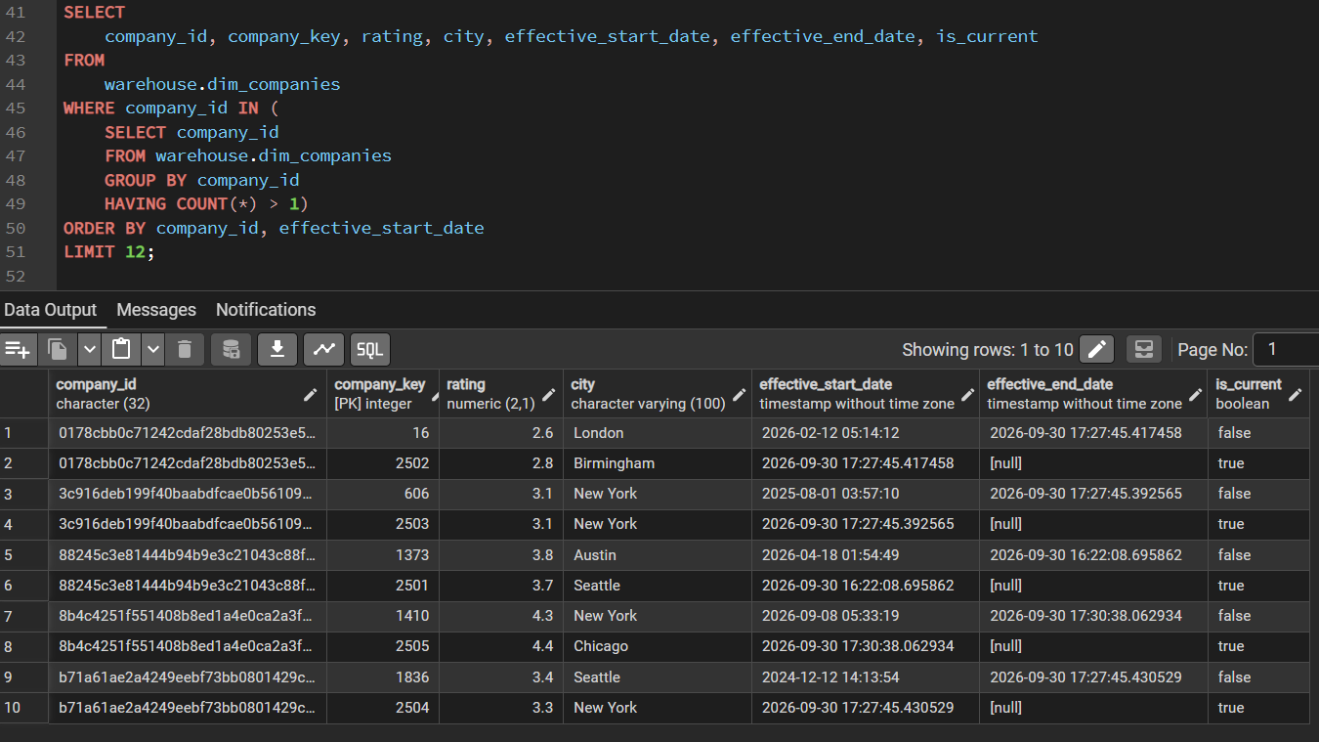
Figure 2: SCD Type 2 — companies with more than one version

9. Business Rules
Table 8: Business Rules
Rule ID | Rule | Entities Affected
BR-1 / BR-2 | Customers belong only to Buyer companies; suppliers only to Supplier companies | Company, Customer, Supplier
BR-4 | A product is offered by 2-5 suppliers; one offer per supplier-product pair | Product, Supplier, Supplier Offer
BR-5 | An order belongs to one customer and its company, and cannot predate the customer | Order, Customer, Company
BR-6 / BR-7 | An order has at least one line; order total = sum of line totals; line total = quantity x unit price - discount | Order, Order Line
BR-8 | A lead converts into at most one order; conversion status derives from the existence of that order | Marketing Lead, Order
BR-10 | Cancelled orders are kept but excluded from revenue | Order, Order Line
BR-12 | Company history is preserved (SCD2); facts link to the version valid at event time | Company, Order, Order Line
Rule IDs BR-1 to BR-10 are the business rules observed in the source (02 Source System Analysis, section 6); only the rules that shape the logical model are repeated here. BR-12 is a modelling rule defined in this document.

Figure 3 shows the rows that broke a business rule; they are kept in rejected_records with a reason instead of being dropped.
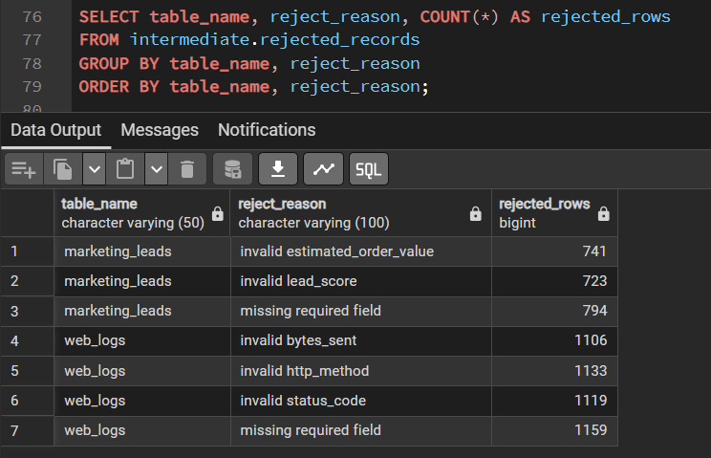
Figure 3: Rows that broke a business rule, kept in rejected_records

10. Logical-to-Physical Mapping
Table 9: Logical-to-Physical Mapping
Logical Entity | Physical Table(s) | Physical Treatment
Date | warehouse.dim_date | Generated calendar; integer key YYYYMMDD
Company | warehouse.dim_companies | SCD2: surrogate company_key, effective dates, is_current, partial unique index on current row
Customer | warehouse.dim_customers | SCD1; surrogate customer_key
Supplier | warehouse.dim_suppliers | SCD1; surrogate supplier_key
Category | warehouse.dim_products (category_id, category_name) | Flattened into Product (no separate table)
Product | warehouse.dim_products | SCD1; surrogate product_key
Supplier Offer | warehouse.dim_supplier_product | SCD1; holds supplier_key and product_key
Order | warehouse.fact_orders | Monthly range partitions on date_key; item_count derived
Order Line | warehouse.fact_order_items | Offer resolved to product_key + supplier_key; order attributes denormalised; partitioned
Marketing Lead | warehouse.fact_leads | order_id attached; partitioned on lead date
Web Request | warehouse.fact_web_logs | Insert-only; partitioned

11. Assumptions, Constraints & Open Issues
Table 10: Assumptions, Constraints & Open Issues
ID | Type | Description | Owner | Status
A1 | Assumption | Current-state reporting is sufficient for all entities except Company (SCD Type 2 as required). | Data Engineering | Accepted
C1 | Constraint | Marketing Lead and Web Request are not linked to Company / Customer: the sources share no common key. | Data Engineering | Accepted

