
Physical Data Model (PDM)
Document 04 of 09 · B2B Data Engineering Platform

05/10/2026
DataRopes.ai
Data Engineering Internship · B2B Data Engineering Platform
Specifies how the model is implemented in PostgreSQL: schemas, tables, data types, keys, constraints, indexes and partitions.
Document ID | B2B-DEP-04
Version | 1.3
Status | Final
Date | 05/10/2026
Prepared by | Syed Kazim Raza
Reviewed by | [Team Lead]

Document Control

Revision History
Version | Date | Author | Description of Change
0.1 | - | Syed Kazim Raza | Template created
1.0 | 28/09/2026 | Syed Kazim Raza | Content populated from DDL scripts and the PostgreSQL catalog (constraints, indexes, partitions)
1.1 | 30/09/2026 | Syed Kazim Raza | Row counts of the rebuilt data; staging emptied after each run; rejected_records; DEFAULT partition; pk_fact_leads
1.2 | 04/10/2026 | Syed Kazim Raza | PDM diagram redrawn (light theme, draw.io); design notes show dimension CLUSTER and DEFAULT partition
1.3 | 05/10/2026 | Syed Kazim Raza | Formatting to documentation standard: table column widths, numbered figure and table captions with lists, figure descriptions, complete acronym list

Approvals
Role | Name | Signature | Date
Prepared by | Syed Kazim Raza
Reviewed by | [Team Lead]
Approved by | [Manager]

Related Documents
Ref | Document | Location
R1 | Business Requirements Document (BRD) | Provided by DataRopes
R2 | Project Document (technical reference) | docs/deliverables/project_document.md
R3 | Project Plan | docs/deliverables/project_plan.md
R4 | README / Deployment Guide | README.md

Contents
Document Control 2
Contents 3
List of Figures 4
List of Tables 5
1. Introduction 6
1.1 Purpose 6
1.2 Scope 6
1.3 Intended Audience 6
1.4 Definitions & Acronyms 6
2. Platform & Environment 7
3. Layered Schema Design 7
4. Physical Data Model Diagram 8
5. Table Inventory 9
6. Column Specifications 9
7. Keys & Constraints 11
8. Indexing Strategy 12
9. Partitioning Strategy 13
10. Surrogate Keys & SCD Implementation 14
11. Naming Conventions 17
12. DDL Deployment Order 17
13. Assumptions, Constraints & Open Issues 17

List of Figures
Figure 1: Physical data model — warehouse schema 8
Figure 2: Monthly partitions of fact_orders, plus the DEFAULT partition 14
Figure 3: dim_companies — SCD Type 2 versions of the same company 16

List of Tables
Table 1: Intended Audience 6
Table 2: Definitions & Acronyms 6
Table 3: Platform & Environment 7
Table 4: Layered Schema Design 7
Table 5: Table Inventory 9
Table 6: Column Specifications 9
Table 7: Keys & Constraints 11
Table 8: Indexing Strategy 12
Table 9: Partitioning Strategy 13
Table 10: Naming Conventions 17
Table 11: DDL Deployment Order 17
Table 12: Assumptions, Constraints & Open Issues 17

1. Introduction

1.1 Purpose
This document describes the physical implementation of the data model across all PostgreSQL layers.

1.2 Scope
In scope:
- Staging, intermediate, warehouse, marts and metadata schemas
- Tables, columns, data types, keys, constraints, indexes, partitions, naming
Out of scope:
- Business definitions (see LDM)
- Source-to-target transformation rules (see SMX)

1.3 Intended Audience
Table 1: Intended Audience
Audience | How they use this document
Data Engineers / DBAs | Create, maintain and tune the database
Reviewers | Check design against standards

1.4 Definitions & Acronyms
Table 2: Definitions & Acronyms
Term | Definition
B2B | Business-to-Business: companies selling to other companies.
BI | Business Intelligence: reporting and dashboards, here Power BI.
BRD | Business Requirements Document: here the Project Requirements Document provided by DataRopes.
CSV | Comma-Separated Values: the text-file format of the marketing leads and web logs feeds.
DDL | Data Definition Language: SQL that creates schemas, tables, indexes and views.
Degenerate dimension | A business key kept on a fact without its own dimension table (order_id, lead_id).
DEP | Data Engineering Platform: prefix of the document IDs (B2B-DEP-01 …).
FK | Foreign Key: a column that references the primary key of another table.
HTTP | Hypertext Transfer Protocol: the web protocol recorded in the web logs (GET, POST …).
ID | Identifier.
KPI | Key Performance Indicator: a business measure shown on the dashboard (KPI-01 … KPI-15).
LDM | Logical Data Model (deliverable 03).
MERGE | PostgreSQL 15+ statement that inserts or updates in one pass; used by all loads.
Partial index | An index that covers only rows matching a WHERE condition (e.g. is_current = TRUE).
PDM | Physical data model: tables, columns, data types, keys, indexes and partitions as implemented in PostgreSQL.
PK | Primary Key: the column(s) that uniquely identify a row.
Range partitioning | Splitting a table into child tables by value ranges of a column (here: one partition per month of date_key).
SCD | Slowly Changing Dimension: SCD1 overwrites changes, SCD2 keeps every version with validity dates.
SERIAL | PostgreSQL auto-incrementing integer column, used for surrogate keys.
SMX | Source-to-Target Mapping workbook (deliverable 05, Excel).
SQL | Structured Query Language.
UTF-8 | Unicode character encoding used by the CSV files.
UUID | Universally Unique Identifier: the 32-character IDs used as business keys.
YYYYMMDD | Date written as year, month, day (e.g. 20260930); the format of date_key.

2. Platform & Environment
Table 3: Platform & Environment
DBMS | PostgreSQL
Version | 18.4 (MERGE requires 15+)
Database | b2b_warehouse_db (name from .env POSTGRESQL_DATABASE)
Schemas | staging, intermediate, warehouse, marts, metadata
Encoding | UTF8
Tooling | pgAdmin 4 / psql; Python SQLAlchemy + psycopg2 for loads; Power BI Desktop for reporting

3. Layered Schema Design
Table 4: Layered Schema Design
Schema | Purpose | Constraints | Load Pattern | Retention
staging | Raw landing copy of the sources | None (no PK/FK, all nullable); _loaded_at NOT NULL DEFAULT now() | Append (SQL Server) / TRUNCATE + append (CSV); emptied after each run | Latest batch only (48 kB after a run)
intermediate | Clean, validated, latest version per key | PK, FK, UNIQUE and CHECK constraints | MERGE upsert (idempotent) | Current state only
warehouse | Dimensional model for reporting | PK, FK, UNIQUE, CHECK; partial unique index for SCD2 | MERGE (SCD1 / SCD2 / facts) | Full history; partitions 2 years back to 6 months ahead
marts | 15 KPI views for Power BI (+2 pipeline views) | Views only (no storage) | CREATE OR REPLACE VIEW | n/a
metadata | Watermarks and run log | PK on pipeline_name / run_id | Insert / update by pipelines | Unlimited

4. Physical Data Model Diagram
Figure 1 shows the physical warehouse schema with data types, primary and foreign keys and indexed columns.
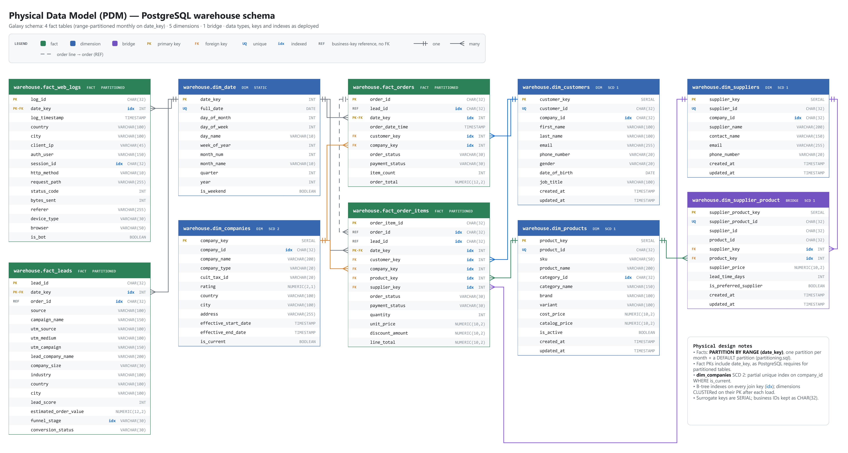
Figure 1: Physical data model — warehouse schema

5. Table Inventory
Table 5: Table Inventory
Schema | Table | Type | Grain | Primary Key | Partitioning | Est. Rows | DDL
warehouse | dim_​date | Dimension (generated) | One row per calendar day | date_​key | - | 912 | §12/6
warehouse | dim_​companies | Dimension - SCD2 | One row per company version | company_​key | - | 2,505 | §12/6
warehouse | dim_​customers | Dimension - SCD1 | One row per customer | customer_​key | - | 94,755 | §12/6
warehouse | dim_​suppliers | Dimension - SCD1 | One row per supplier | supplier_​key | - | 400 | §12/6
warehouse | dim_​products | Dimension - SCD1 | One row per product | product_​key | - | 96 | §12/6
warehouse | dim_​supplier_​product | Dimension / bridge - SCD1 | One row per supplier-product offer | supplier_​product_​key | - | 347 | §12/6
warehouse | fact_​orders | Fact - transaction | One row per order | order_​id, date_​key | Monthly x31 + default | 156,678 | §12/6
warehouse | fact_​order_​items | Fact - transaction | One row per order line | order_​item_​id, date_​key | Monthly x31 + default | 470,263 | §12/6
warehouse | fact_​web_​logs | Fact - event | One row per HTTP request | log_​id, date_​key | Monthly x31 + default | 296,703 | §12/6
warehouse | fact_​leads | Fact - accumulating | One row per lead | lead_​id, date_​key | Monthly x31 + default | 148,358 | §12/6
metadata | pipeline_​watermarks / pipeline_​run_​log | Control / audit | One row per watermark key / per run | pipeline_​name / run_​id | - | 8 / 20 | §12/3
staging | 10 tables (companies ... web_​logs) | Landing | Latest batch (emptied after each run) | None | - | 0 after a run | §12/4
intermediate | 10 tables (same names) + rejected_​records | Clean | One row per business key | Business key | - | 1,170,110 (+ 6,775 rejected) | §12/5

6. Column Specifications
The full column-level specification of all 43 tables (458 columns: type, nullability, default, keys, description, example, SMX mapping ID) is maintained in 04b_Data_Dictionary.xlsx. The two most important tables are summarised below: the SCD2 company dimension and the order fact.
Table 6: Column Specifications
Table | Column | Data Type | Null | Default | Key | Description
dim_companies | company_key | SERIAL | N |  | PK | Surrogate key of the company version (SCD2).
dim_companies | company_id | CHAR(32) | N |  |  | Business identifier of the company (32-char hex UUID assigned by the Python generator).
dim_companies | company_name | VARCHAR(200) | N |  |  | Legal/trading name of the company.
dim_companies | company_type | VARCHAR(20) | N |  |  | Role of the company in the marketplace: Buyer or Supplier.
dim_companies | cuit_tax_id | VARCHAR(20) | N |  |  | Company tax identification number (unique per company).
dim_companies | Rating | NUMERIC(2,1) | N |  |  | Company rating on a 1.0-5.0 scale.
dim_companies | Country | VARCHAR(100) | N |  |  | Country name.
dim_companies | City | VARCHAR(100) | N |  |  | City name.
dim_companies | Address | VARCHAR(255) | N |  |  | Street address of the company.
dim_companies | effective_start_date | TIMESTAMP | N |  |  | Start of the validity period of this company version.
dim_companies | effective_end_date | TIMESTAMP | Y |  |  | End of the validity period (NULL = current version).
dim_companies | is_current | BOOLEAN | N | TRUE |  | TRUE for the current company version.
fact_orders | order_id | CHAR(32) | N |  | PK | Business identifier of the order.
fact_orders | lead_id | CHAR(32) | Y |  |  | Identifier of the marketing lead that generated the record (NULL if none).
fact_orders | date_key | INT | N |  | PK/FK | Date surrogate key in YYYYMMDD format (FK to dim_date); also the partition key on facts.
fact_orders | order_date_time | TIMESTAMP | N |  |  | Date and time the order was placed (renamed from order_date).
fact_orders | customer_key | INT | N |  | FK | Surrogate key of the customer.
fact_orders | company_key | INT | N |  | FK | Surrogate key of the company version (SCD2).
fact_orders | order_status | VARCHAR(30) | N |  |  | Fulfilment status of the order.
fact_orders | payment_status | VARCHAR(30) | N |  |  | Payment status of the order.
fact_orders | item_count | INT | N |  |  | Number of order lines in the order.
fact_orders | order_total | NUMERIC(12,2) | N |  |  | Total order amount (sum of line totals).

7. Keys & Constraints
Table 7: Keys & Constraints
Constraint | Table | Type | Definition
<table>_pkey | All dimensions | PRIMARY KEY | Surrogate key (company_key, customer_key, ...); dim_date on date_key
pk_fact_orders / pk_fact_order_items / pk_fact_web_logs / pk_fact_leads | Facts | PRIMARY KEY | (business key, date_key) - partition key must be part of the PK
<table>_<business_key>_key | dim_customers, dim_suppliers, dim_products, dim_supplier_product, dim_date | UNIQUE | Business key unique (customer_id, supplier_id, product_id, supplier_product_id, full_date)
uq_dim_companies_current | dim_companies | UNIQUE partial index | UNIQUE (company_id) WHERE is_current = TRUE - one current version per company
uq_foi_order_supplier_product | fact_order_items | UNIQUE | (order_id, supplier_key, product_key, date_key) - no duplicate product per order
fk_fo_* / fk_foi_* / fk_fwl_date / fk_fl_date | Facts | FOREIGN KEY | date_key -> dim_date; customer_key, company_key, product_key, supplier_key -> dimensions (14 FKs)
fk_dsp_supplier / fk_dsp_product | dim_supplier_product | FOREIGN KEY | supplier_key -> dim_suppliers, product_key -> dim_products
CHECK constraints | Dimensions and facts | CHECK | Domains (company_type, gender, order/payment status, conversion_status), ranges (rating, lead_score, status_code, calendar parts), non-negative amounts, catalog_price >= cost_price, SCD2 end > start

8. Indexing Strategy
Table 8: Indexing Strategy
Index | Table | Column(s) | Type | Purpose
uq_​dim_​companies_​current | dim_companies | company_id WHERE is_current | Unique partial B-tree | Enforce one current version; fast current lookup
idx_​dim_​companies_​id | dim_companies | company_id | B-tree | Point-in-time lookup of company versions in fact loads
idx_​dim_​customers_​company | dim_customers | company_id | B-tree | Customer-to-company joins
idx_​dim_​suppliers_​company | dim_suppliers | company_id | B-tree | Supplier-to-company joins
idx_​dim_​products_​category | dim_products | category_id | B-tree | Filter / group by category
<table>_pkey (CLUSTER) | All 6 dimensions | Surrogate key | B-tree + CLUSTER | Rows stored in key order after each load (run_pipeline.py), as the requirements ask
idx_​dsp_​supplier, idx_​dsp_​product | dim_supplier_product | supplier_key; product_key | B-tree | FK joins
idx_​fo_​date / customer / company / lead | fact_orders | date_key; customer_key; company_key; lead_id | B-tree (per partition) | Date filters, FK joins, lead-to-order link
idx_​foi_​date / customer / company / product / supplier / lead / order | fact_order_items | date_key; customer_key; company_key; product_key; supplier_key; lead_id; order_id | B-tree (per partition) | Date filters, FK joins, order roll-up
idx_​fwl_​date, idx_​fwl_​session | fact_web_logs | date_key; session_id | B-tree (per partition) | Date filters; session lookups
idx_​fl_​date / order / funnel | fact_leads | date_key; order_id; funnel_stage | B-tree (per partition) | Date filters, conversion join, funnel grouping

9. Partitioning Strategy
Table 9: Partitioning Strategy
Table | Partition Key | Scheme | Granularity | Maintenance
fact_orders | date_key (INT YYYYMMDD) | RANGE, FROM (YYYYMM01) TO (next month) | Monthly - 31 partitions (2024_09 ... 2027_03) + 1 DEFAULT | partitioning.sql runs on every warehouse load: CREATE TABLE IF NOT EXISTS for 2 years back to 6 months ahead; no automatic drop
fact_order_items | date_key (INT YYYYMMDD) | RANGE, FROM (YYYYMM01) TO (next month) | Monthly - 31 partitions (2024_09 ... 2027_03) + 1 DEFAULT | partitioning.sql runs on every warehouse load: CREATE TABLE IF NOT EXISTS for 2 years back to 6 months ahead; no automatic drop
fact_web_logs | date_key (INT YYYYMMDD) | RANGE, FROM (YYYYMM01) TO (next month) | Monthly - 31 partitions (2024_09 ... 2027_03) + 1 DEFAULT | partitioning.sql runs on every warehouse load: CREATE TABLE IF NOT EXISTS for 2 years back to 6 months ahead; no automatic drop
fact_leads | date_key (INT YYYYMMDD) | RANGE, FROM (YYYYMM01) TO (next month) | Monthly - 31 partitions (2024_09 ... 2027_03) + 1 DEFAULT | partitioning.sql runs on every warehouse load: CREATE TABLE IF NOT EXISTS for 2 years back to 6 months ahead; no automatic drop

Figure 2 lists the monthly partitions of fact_orders and the DEFAULT partition that catches unexpected dates.
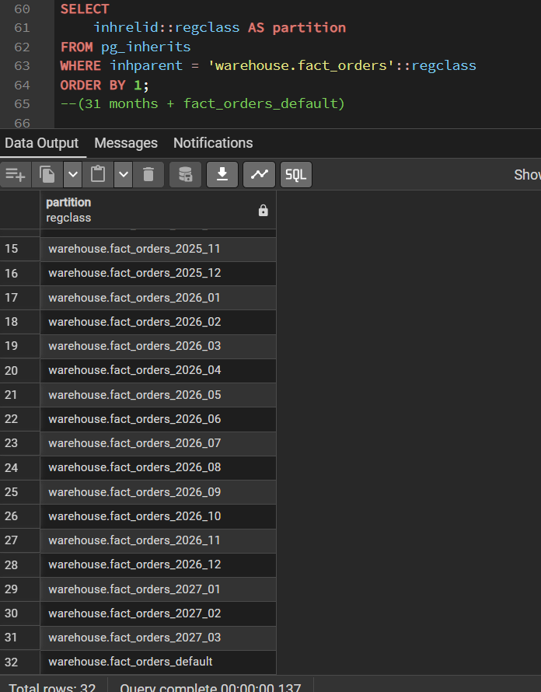
Figure 2: Monthly partitions of fact_orders, plus the DEFAULT partition

10. Surrogate Keys & SCD Implementation
- Surrogate keys: every dimension except dim_date has a SERIAL integer key (company_key, customer_key, supplier_key, product_key, supplier_product_key). Facts store only these integer keys, which keeps fact rows narrow and joins fast. The business key (32-char id) is kept in the dimension with a UNIQUE constraint (SCD1 dimensions).
- dim_date uses a smart integer key YYYYMMDD, which doubles as the fact partition key and makes partition ranges readable.
- SCD Type 1 (dim_customers, dim_suppliers, dim_products, dim_supplier_product): MERGE ... WHEN MATCHED AND (a IS DISTINCT FROM b OR ...) THEN UPDATE - the row is overwritten only when an attribute actually changed; IS DISTINCT FROM makes the comparison NULL-safe.
- SCD Type 2 (dim_companies, 2,505 rows for 2,500 companies): step 1 MERGE expires the current row (effective_end_date = source.updated_at, is_current = FALSE) when one of 7 tracked attributes changed; step 2 inserts a new current row for every company without a current row. The first version starts at created_at, later versions at updated_at.
- Integrity of SCD2 is enforced physically by the partial unique index uq_dim_companies_current (one current row per company_id) and the CHECK effective_end_date IS NULL OR effective_end_date > effective_start_date.
- As-of join in fact loads: fact_orders and fact_order_items pick the company version valid at order time:
JOIN warehouse.dim_companies com
ON com.company_id = o.company_id
AND o.order_date >= com.effective_start_date
AND (com.effective_end_date IS NULL OR o.order_date < com.effective_end_date)
Figure 3 shows the SCD Type 2 columns of dim_companies for one company: the old version is closed and the new one is current.
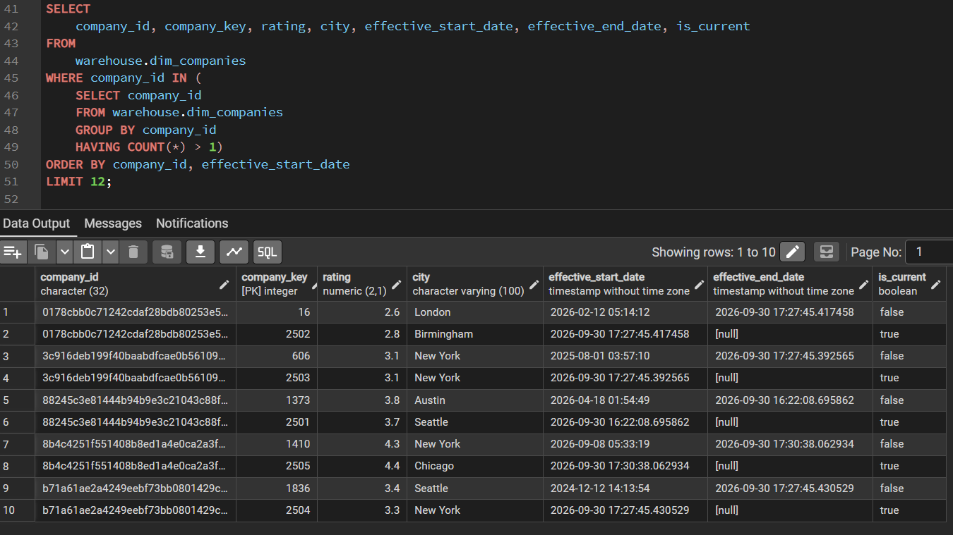
Figure 3: dim_companies — SCD Type 2 versions of the same company

11. Naming Conventions
Table 10: Naming Conventions
Object | Convention | Example
Schema | Lower-case layer name | staging, intermediate, warehouse, marts, metadata
Staging / intermediate table | Lower-case plural source entity name | orders, order_items, supplier_product_mapping
Dimension / fact table | dim_<entity plural> / fact_<process> | dim_companies, fact_order_items
Surrogate / business key | <entity>_key (INT) / <entity>_id (CHAR(32)) | company_key / company_id
Date key | date_key INT YYYYMMDD | 20260928
Partition | <fact>_YYYY_MM | fact_orders_2026_09
Constraint / index | pk_<table>, fk_<abbr>_<ref>, uq_<...>, idx_<abbr>_<column> | pk_fact_orders, fk_foi_product, idx_fo_date
Mart view | marts.vw_<subject> | marts.vw_monthly_revenue_trend
Audit column | _loaded_at (leading underscore = technical) | staging.orders._loaded_at

12. DDL Deployment Order
Table 11: DDL Deployment Order
Order | Script | Creates
1 | sql_server/source1/ddl-source1.sql | b2b_source_db and 8 source tables (drops and recreates the database)
2 | sql_server/metadata/ddl-metadata.sql | metadata.Generation_Seeds (SQL Server)
3 | postgresql/metadata/metadata_ddl.sql | pipeline_watermarks, pipeline_run_log
4 | postgresql/staging/staging_ddl.sql | 10 staging tables
5 | postgresql/intermediate/DDL/intermediate_ddl.sql | 10 intermediate tables + rejected_records, with constraints
6 | postgresql/warehouse/DDL/warehouse_ddl.sql | 6 dimensions, 4 partitioned facts, 23 indexes
7 | postgresql/warehouse/PARTITIONS_SETUP/partitioning.sql | Monthly fact partitions + DEFAULT (re-run on every load)
8 | postgresql/marts/marts_ddl.sql | 15 KPI views (17 views in marts)

13. Assumptions, Constraints & Open Issues
Table 12: Assumptions, Constraints & Open Issues
ID | Type | Description | Owner | Status
A1 | Assumption | Facts fall inside the partition window (2 years back to 6 months ahead); any other date goes to the DEFAULT partition, which stays empty. | Data Engineering | Accepted
A2 | Assumption | Staging is emptied after each successful run; the sources keep all data if a reload is needed. | Data Engineering | Accepted

