
Architecture Document
Document 06 of 09 · B2B Data Engineering Platform

05/10/2026
DataRopes.ai
Data Engineering Internship · B2B Data Engineering Platform
Describes the solution architecture: goals, constraints, context, building blocks, runtime behaviour, deployment, key decisions and quality requirements.
Document ID | B2B-DEP-06
Version | 1.4
Status | Final
Date | 05/10/2026
Prepared by | Syed Kazim Raza
Reviewed by | [Team Lead]

Document Control

Revision History
Version | Date | Author | Description of Change
0.1 | - | Syed Kazim Raza | Template created
1.0 | 29/09/2026 | Syed Kazim Raza | Architecture of the completed platform
1.1 | 30/09/2026 | Syed Kazim Raza | Updated to the rebuilt data; staging emptied after each run; quarantine table; test results
1.2 | 04/10/2026 | Syed Kazim Raza | Architecture, data-flow and end-to-end diagrams redrawn; Power BI shown in Import mode; metadata and quarantine shown
1.3 | 05/10/2026 | Syed Kazim Raza | Architecture and end-to-end diagrams redrawn in container style (technology logos, numbered run order, results per stage)
1.4 | 05/10/2026 | Syed Kazim Raza | Formatting to documentation standard: table column widths, numbered figure and table captions with lists, figure descriptions, complete acronym list

Approvals
Role | Name | Signature | Date
Prepared by | Syed Kazim Raza
Reviewed by | [Team Lead]
Approved by | [Manager]

Related Documents
Ref | Document | Location
R1 | Business Requirements Document (BRD) | Provided by DataRopes
R2 | Project Document (technical reference) | docs/deliverables/project_document.md
R3 | Project Plan | docs/deliverables/project_plan.md
R4 | README / Deployment Guide | README.md

Contents
Document Control 2
Contents 3
List of Figures 4
List of Tables 5
1. Introduction 6
1.1 Purpose 6
1.2 Scope 6
1.3 Intended Audience 6
1.4 Definitions & Acronyms 6
2. Goals & Quality Objectives 7
2.1 Requirements Overview 7
2.2 Quality Goals 7
2.3 Stakeholders 7
3. Constraints 8
4. System Context & Scope 9
5. Solution Strategy 10
6. Building Block View 11
7. Runtime View 13
7.1 Scenario: Initial Load (2-year backfill) 15
7.2 Scenario: Daily Incremental Run 15
7.3 Scenario: Failure and Re-run 15
8. Deployment View 16
9. Cross-cutting Concepts 16
9.1 Change Data Capture & Watermarks 16
9.2 Idempotency & Transactions 17
9.3 Slowly Changing Dimensions 17
9.4 Data Quality 17
9.5 Logging, Monitoring & Alerting 17
9.6 Security & Configuration 18
10. Architecture Decisions 18
11. Quality Requirements (Non-Functional) 18
12. Risks & Technical Debt 19
13. Glossary 19

List of Figures
Figure 1: End-to-end flow — from seeded data to dashboard 9
Figure 2: System architecture 11
Figure 3: Table-level data flow 14
Figure 4: Staging tables are empty after a successful run 16
Figure 5: Rejected rows by table and reason 17

List of Tables
Table 1: Intended Audience 6
Table 2: Definitions & Acronyms 6
Table 3: Quality Goals 7
Table 4: Stakeholders 7
Table 5: Constraints 8
Table 6: System Context & Scope 10
Table 7: Solution Strategy 10
Table 8: Building Block View 12
Table 9: Deployment View 16
Table 10: Architecture Decisions 18
Table 11: Quality Requirements (Non-Functional) 18
Table 12: Risks & Technical Debt 19
Table 13: Glossary 19

1. Introduction

1.1 Purpose
This document describes the architecture of the B2B Data Engineering Platform (structure based on arc42).

1.2 Scope
In scope:
- End-to-end architecture from data generation to Power BI
- Components, data flow, deployment, cross-cutting concepts, decisions
Out of scope:
- Column-level mappings (SMX)
- Detailed code (Development Document)

1.3 Intended Audience
Table 1: Intended Audience
Audience | How they use this document
Team Lead / Architects | Review design and decisions
Data Engineers | Understand how components fit
New joiners | Onboard quickly

1.4 Definitions & Acronyms
Table 2: Definitions & Acronyms
Term | Definition
ADR | Architecture Decision Record: a recorded design decision with alternatives and rationale (ADR-01 …).
B2B | Business-to-Business: companies selling to other companies.
BI | Business Intelligence: reporting and dashboards, here Power BI.
BRD | Business Requirements Document: here the Project Requirements Document provided by DataRopes.
CDC | Change Data Capture: only new or changed rows are extracted on each run.
CI/CD | Continuous Integration / Continuous Delivery: automated build, test and deployment (out of scope for this project).
CSV | Comma-Separated Values: the text-file format of the marketing leads and web logs feeds.
DDL | Data Definition Language: SQL that creates schemas, tables, indexes and views.
DEP | Data Engineering Platform: prefix of the document IDs (B2B-DEP-01 …).
ELT | Extract-Load-Transform: raw data is loaded first, then transformed inside the database with SQL.
ETL | Extract, Transform, Load: data is transformed before it is loaded (the alternative to ELT).
FK | Foreign Key: a column that references the primary key of another table.
HTTP | Hypertext Transfer Protocol: the web protocol recorded in the web logs (GET, POST …).
ID | Identifier.
Idempotent | Running the same load twice gives the same result (no duplicates).
IF | Interface: IF-01 … IF-03 number the interfaces in the Interface Specification.
KPI | Key Performance Indicator: a business measure shown on the dashboard (KPI-01 … KPI-15).
MB | Megabyte.
NFR | Non-Functional Requirement: a quality requirement such as performance or reliability.
ODBC | Open Database Connectivity: the driver standard Python uses to connect to SQL Server.
PK | Primary Key: the column(s) that uniquely identify a row.
SCD Type 2 | Keeps a new dimension row for every change so history is preserved.
SMX | Source-to-Target Mapping workbook (deliverable 05, Excel).
SQL | Structured Query Language.
Watermark | The last extracted updated_at per table, used as the starting point of the next extract.

2. Goals & Quality Objectives

2.1 Requirements Overview
The Project Requirements Document asks for a local B2B data platform on PostgreSQL that:
- ingests 3 sources: an SQL Server operational database, web server logs and marketing leads;
- stages raw data in PostgreSQL with CDC (only changed rows, tracked by updated_at watermarks);
- builds a star constellation-schema warehouse with an SCD Type 2 company dimension and date-partitioned facts;
- answers 15 KPIs through SQL views, shown in Power BI;
- runs end-to-end through local orchestration with monitoring and notifications, idempotent loads and no CI/CD.
The data is synthetic: Python generators create 2 years of history and then one new day of activity per incremental run.

2.2 Quality Goals
Table 3: Quality Goals
Priority | Quality Goal | Scenario / Measure
1 | Correctness & idempotency | Re-running any stage gives identical results; all warehouse loads use MERGE.
2 | Traceability | Every rejected row is kept with a reason (rejected_records) and every run is logged in metadata.pipeline_run_log.
3 | Efficiency | Only changed rows are extracted (CDC); facts are partitioned by month. An incremental run takes about 3 minutes.
4 | Simplicity | One SQL script per table and step; runs on a single laptop with free tools.

2.3 Stakeholders
Table 4: Stakeholders
Role | Name | Expectations
Team Lead (DataRopes) | Reviewer | A working, documented pipeline that meets the requirements
Data Engineering Intern | Syed Kazim Raza | Design, build and document the platform
Business users | Dashboard consumers | Reliable KPIs in Power BI, refreshed after each run

3. Constraints
Table 5: Constraints
Constraint | Type | Explanation
Local platform | Technical | Everything runs on one Windows machine: SQL Server Express, PostgreSQL, Python, Power BI Desktop.
PostgreSQL 15+ | Technical | Required for the MERGE statement used by all loads (installed: 18.4).
Synthetic data | Organisational | No production data is available; Python generators create realistic data.
No CI/CD | Organisational | Scripts are executed manually through the orchestrator (requirements document).
No automated test framework | Organisational | Validation is done with SQL test queries after end-to-end runs (requirements document).

4. System Context & Scope
Figure 1 shows the end-to-end flow of one pipeline run, from the data generators to the dashboard, with the results of the final run.
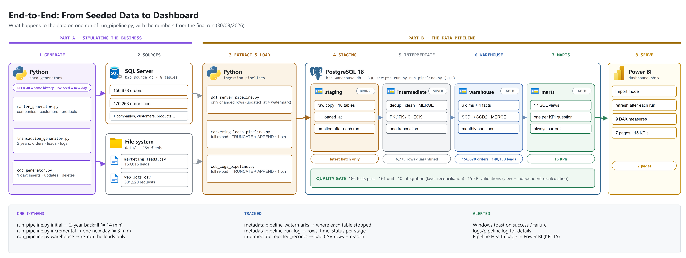
Figure 1: End-to-end flow — from seeded data to dashboard
Table 6: System Context & Scope
External System / Actor | Interface | Data Exchanged
SQL Server b2b_source_db | IF-01: SQL query (pyodbc), incremental | Companies, customers, suppliers, products, orders, order items
marketing_leads.csv | IF-02: file read, full snapshot | Marketing leads, campaigns, funnel stage
web_logs.csv | IF-03: file read, full snapshot | HTTP requests: device, browser, status, bytes
Power BI Desktop | PostgreSQL connector on schema marts | 15 KPI views

5. Solution Strategy
Table 7: Solution Strategy
Decision Area | Approach | Rationale
Integration style | ELT: load raw data into PostgreSQL first, transform with SQL | Raw data lands before it is cleaned; SQL is the best tool for set-based transforms
Layering | staging -> intermediate -> warehouse -> marts | Each layer has one job: land, clean, model, serve
Modelling | Kimball galaxy schema: 4 facts sharing conformed dimensions | Simple star joins for Power BI; several business processes in one model
Incremental loads | Watermark CDC on updated_at + idempotent MERGE | Required by the requirements document; safe to re-run
Orchestration | Python run_pipeline.py (initial / incremental) with run log and Windows notifications | Local, no CI/CD; one command runs everything
Serving | SQL views in schema marts, consumed by Power BI | Business logic stays in SQL and is reusable

6. Building Block View
Figure 2 shows the building blocks: each technology with the components it runs, and the numbered order of a pipeline run.
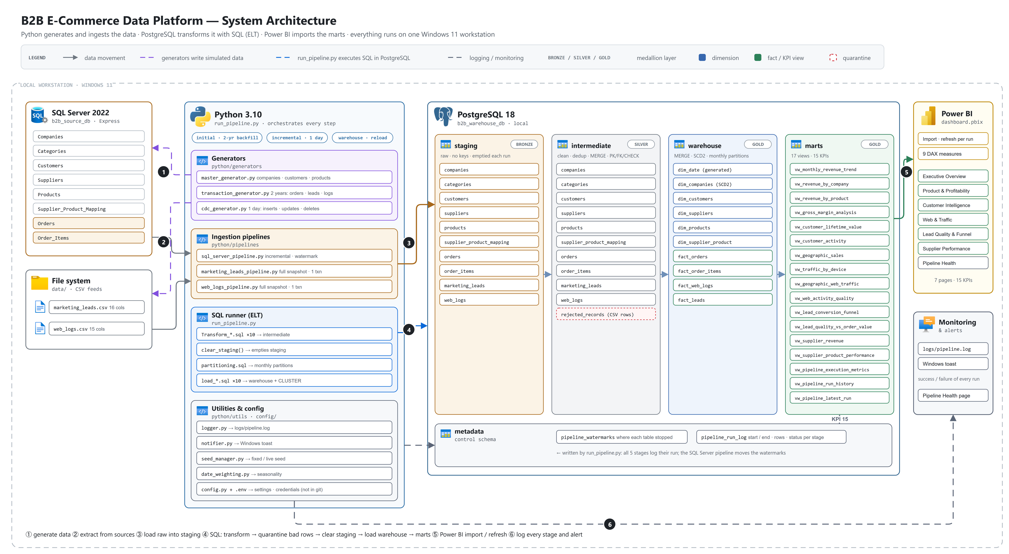
Figure 2: System architecture
Table 8: Building Block View
Component / Layer | Responsibility | Technology | Artifacts
Data generators | Create 2 years of history, then one new day per run (new rows + updates) | Python, Faker | python/generators/
Source layer | Operational database and two CSV feeds | SQL Server 2022 Express, CSV files | sql_server/, data/
Ingestion pipelines | Extract changed rows / files and append to staging | Python, pandas, SQLAlchemy | python/pipelines/*_pipeline.py
Staging | Raw copy of the latest batch + _loaded_at; emptied after each run | PostgreSQL | postgresql/staging/
Intermediate | Deduplicate, clean, validate; latest version per key; bad CSV rows to rejected_records | PostgreSQL SQL (MERGE) | postgresql/intermediate/transform/
Warehouse | 6 dimensions (SCD1/SCD2) and 4 partitioned facts | PostgreSQL SQL (MERGE) | postgresql/warehouse/
Marts & reporting | 15 KPI views and the Power BI dashboard | PostgreSQL views, Power BI | postgresql/marts/, dashboard.pbix
Orchestration & monitoring | Run all stages in order, log runs, notify | Python | run_pipeline.py, python/utils/, metadata schema

7. Runtime View
Figure 3 traces every table from staging through intermediate and warehouse to the mart views.
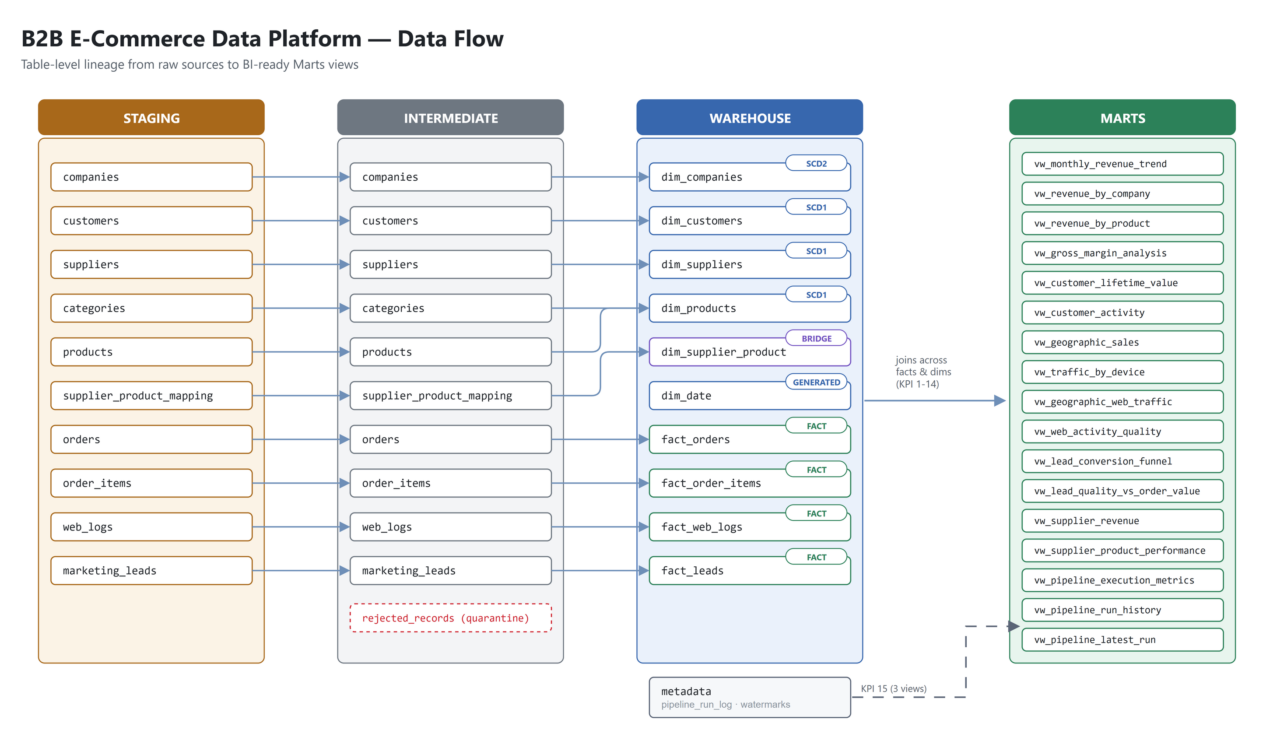
Figure 3: Table-level data flow

7.1 Scenario: Initial Load (2-year backfill)
1. Run python -m python.pipelines.run_pipeline initial.
2. Generators create master data (companies, customers, products ...) and 2 years of orders, leads and web logs; SQL Server is loaded and the two CSV files are written.
3. The three ingestion pipelines load everything into staging (no watermark yet = full extract) and store the first watermarks.
4. The 10 intermediate scripts clean and validate the data in one transaction; invalid CSV rows go to intermediate.rejected_records.
5. Staging is checked and emptied; the warehouse load fills dim_date, the dimensions, creates the monthly partitions and loads the four facts.
6. A Windows notification reports success; Power BI can be refreshed.

7.2 Scenario: Daily Incremental Run
1. Run python -m python.pipelines.run_pipeline incremental.
2. The CDC generator simulates one day: 180-230 new orders, 180-230 leads, 370-450 web logs (dated today) and updates to companies, customers, orders, leads and products.
3. The SQL Server pipeline extracts only rows with updated_at after the watermark; the CSV pipelines reload their files.
4. Intermediate MERGE inserts new keys and updates changed ones; staging is emptied; the warehouse applies SCD1/SCD2 and merges the facts.
5. Run log and notification are written. Typical duration: about 3 minutes.

7.3 Scenario: Failure and Re-run
If any stage fails, the orchestrator stops, the run is logged in metadata.pipeline_run_log with status 'failed' and the error message, and a failure notification appears. Watermarks are only moved after a successful load, and the intermediate stage runs in one transaction that is rolled back on error; staging is only emptied after it succeeded. Running the same command again therefore picks up the same data and, because every load is a MERGE, produces the correct result without duplicates.
Figure 4 is the evidence that staging is emptied after a successful run: every staging table returns 0 rows.
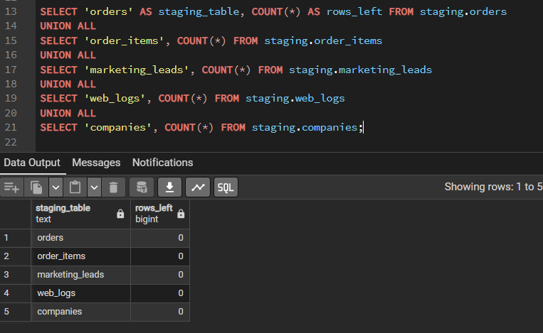
Figure 4: Staging tables are empty after a successful run

8. Deployment View
Table 9: Deployment View
Node / Environment | Software | Purpose
Developer laptop (Windows 11) | SQL Server 2022 Express + ODBC Driver 17 | Source database b2b_source_db
Developer laptop (Windows 11) | PostgreSQL 18.4 | b2b_warehouse_db: staging, intermediate, warehouse, marts, metadata
Developer laptop (Windows 11) | Python 3.10 + requirements.txt | Generators, pipelines, orchestrator
Developer laptop (Windows 11) | Power BI Desktop | Dashboard (dashboard.pbix) on schema marts

9. Cross-cutting Concepts

9.1 Change Data Capture & Watermarks
For SQL Server, each table has a watermark (last loaded updated_at) in metadata.pipeline_watermarks. The extract reads only rows with updated_at later than the watermark, and the watermark moves forward only after a successful load. The CSV files have no reliable change column, so they are reloaded completely on each run. Implemented in sql_server_pipeline.py and pipeline_utils.py.

9.2 Idempotency & Transactions
Every intermediate and warehouse load is a MERGE on the business key: new rows are inserted, changed rows updated, unchanged rows left alone. The intermediate stage runs all 10 scripts in one transaction. Re-running a stage on the same data therefore never creates duplicates.

9.3 Slowly Changing Dimensions
dim_companies is SCD Type 2 (as required): a change to name, type, tax id, rating or location closes the current row and adds a new one, so orders are always reported with the company data valid at order time (2,505 versions for 2,500 companies). The other dimensions are SCD Type 1 (overwrite).

9.4 Data Quality
Staging accepts everything. The intermediate layer keeps only the latest version of each record, trims text, and checks mandatory fields, allowed values, ranges and parent records. Invalid CSV rows are saved in intermediate.rejected_records with a reason (1.5% are broken on purpose to test this). Database constraints in intermediate and warehouse (PK, FK, CHECK) act as a second safety net, and 161 unit tests, 10 integration tests and 15 KPI checks validate each layer.
Figure 5 shows the rejected rows per table and reason, as stored in intermediate.rejected_records.
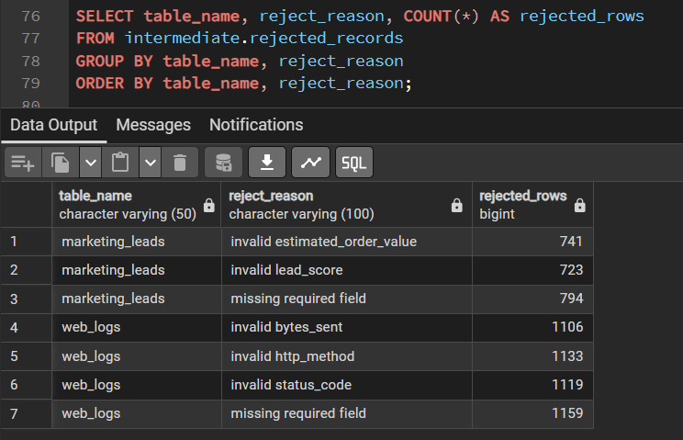
Figure 5: Rejected rows by table and reason

9.5 Logging, Monitoring & Alerting
Every stage writes to logs/pipeline.log and to the console, and records start, end, status, row counts and watermark in metadata.pipeline_run_log. The pipeline-health KPI views (vw_pipeline_execution_metrics, vw_pipeline_run_history, vw_pipeline_latest_run) show load times, failures and data freshness in Power BI. A Windows toast notification reports success or failure of each run.

9.6 Security & Configuration
Connection details are stored in a local .env file (excluded from Git) and validated at start-up. SQL Server uses Windows authentication. Business parameters (volumes, date window, seed, chunk size, paths) are central in config/config.py.

10. Architecture Decisions
Table 10: Architecture Decisions
ADR | Decision | Alternatives Considered | Rationale | Consequences
ADR-01 | ELT inside PostgreSQL | ETL in Python (pandas) | Set-based SQL is faster and easier to test; raw data stays available | All transformation logic lives in SQL scripts
ADR-02 | Watermark CDC on updated_at | SQL Server built-in CDC; full reloads | Required by the requirements; simple and works on Express edition | Physical deletes are not detected (the source only soft-deletes)
ADR-03 | MERGE for every load | TRUNCATE + reload; INSERT only | Idempotent and incremental | Needs PostgreSQL 15+
ADR-04 | Galaxy schema with conformed dimensions | One wide table per KPI; single star | Several business processes share Date, Customer, Company, Product | 4 fact tables to maintain
ADR-05 | SCD2 only for companies | SCD2 everywhere | Only company attributes need history (requirement) | Other dimensions show current values
ADR-06 | Monthly range partitions on date_key | No partitioning; yearly partitions | Required by the requirements; fast date filters | Partitions created by partitioning.sql before each load
ADR-07 | Empty staging after each successful run | Keep every version in staging | No data lake here; a growing raw copy only costs space and slows the transforms | Staging holds 48 kB after a run instead of growing (230 MB before)
ADR-08 | Quarantine table for invalid CSV rows | Drop invalid rows silently | Bad rows must be visible and countable | 2,258 leads and 4,517 web logs saved with a reason

11. Quality Requirements (Non-Functional)
Table 11: Quality Requirements (Non-Functional)
NFR ID | Category | Requirement | How It Is Met
NFR-01 | Reliability | A failed run can be repeated without manual clean-up | Watermarks only move on success; MERGE loads; transactions
NFR-02 | Performance | Incremental run finishes in minutes | CDC extract, partition pruning, indexes on join keys (about 3 minutes measured)
NFR-03 | Auditability | Every run and every loaded row is traceable | pipeline_run_log, _loaded_at, rejected_records with a reason
NFR-04 | Data quality | Only valid, deduplicated data reaches the warehouse | Intermediate validation, quarantine table, constraints, 186 SQL tests
NFR-05 | Security | No credentials in code | .env file excluded from Git; Windows authentication for SQL Server
NFR-06 | Maintainability | Easy to change one table's logic | One SQL script per table and step; central config

12. Risks & Technical Debt
Table 12: Risks & Technical Debt
Risk / Debt | Impact | Mitigation / Plan
Single local machine | No high availability | Acceptable for the project; all DDL and code are in Git, so the platform can be rebuilt from scratch
Synthetic data | Results do not reflect a real business | Generators follow the business rules and seasonal patterns from the requirements
Manual execution | Runs depend on someone starting them | One command runs everything; can be scheduled with Windows Task Scheduler if needed
No raw archive | Staging is emptied after each run | Sources keep all data (reload by resetting watermarks); a data lake would keep raw files

13. Glossary
Table 13: Glossary
Term | Definition
Galaxy schema | Several fact tables sharing dimensions (fact constellation).
Conformed dimension | A dimension used with the same meaning by several facts.
Surrogate key | Integer key generated in the warehouse, used by facts to join dimensions.
Partition | A physical piece of a large table, here one per month.
MERGE | SQL statement that inserts new rows and updates existing rows in one step.

