
Development Document
Document 07 of 09 · B2B Data Engineering Platform

05/10/2026
DataRopes.ai
Data Engineering Internship · B2B Data Engineering Platform
Technical design and implementation guide: environment, repository, configuration, component specifications, scripts, orchestration and runbook.
Document ID | B2B-DEP-07
Version | 1.2
Status | Final
Date | 05/10/2026
Prepared by | Syed Kazim Raza
Reviewed by | [Team Lead]

Document Control

Revision History
Version | Date | Author | Description of Change
0.1 | - | Syed Kazim Raza | Template created
1.0 | 28/09/2026 | Syed Kazim Raza | Development documentation of the completed platform
1.1 | 30/09/2026 | Syed Kazim Raza | New settings and functions (dirty data, clear_staging); load_to_staging; milestone 30/09/2026
1.2 | 05/10/2026 | Syed Kazim Raza | Formatting to documentation standard: table column widths, numbered figure and table captions with lists, figure descriptions, complete acronym list

Approvals
Role | Name | Signature | Date
Prepared by | Syed Kazim Raza
Reviewed by | [Team Lead]
Approved by | [Manager]

Related Documents
Ref | Document | Location
R1 | Business Requirements Document (BRD) | Provided by DataRopes
R2 | Project Document (technical reference) | docs/deliverables/project_document.md
R3 | Project Plan | docs/deliverables/project_plan.md
R4 | README / Deployment Guide | README.md

Contents
Document Control 2
Contents 3
List of Figures 4
List of Tables 5
1. Introduction 6
1.1 Purpose 6
1.2 Scope 6
1.3 Intended Audience 6
1.4 Definitions & Acronyms 6
2. Development Environment 7
3. Repository Structure 7
4. Configuration 9
5. Coding Standards & Naming Conventions 9
6. Component Specifications 10
6.1 Data Generators (master, transaction, CDC) 10
6.2 SQL Server Pipeline 10
6.3 Marketing Leads Pipeline 10
6.4 Web Logs Pipeline 10
6.5 Orchestrator (run_pipeline.py) 11
6.6 Utilities (logging, notifier, pipeline utils) 11
7. SQL Transformation Scripts (Staging → Intermediate) 11
8. Warehouse Load Scripts (Intermediate → Warehouse) 12
9. Marts / KPI Views 13
10. Orchestration & Execution Flow 13
11. Logging, Monitoring & Notifications 14
12. Build & Deployment Runbook 16
13. Version Control & Milestones 16
14. Known Limitations & Future Work 17

List of Figures
Figure 1: Repository structure (top-level folders) 8
Figure 2: Terminal after an incremental run — staging checked and cleared, warehouse loaded 15
Figure 3: metadata.pipeline_run_log — latest runs of every stage 16

List of Tables
Table 1: Intended Audience 6
Table 2: Definitions & Acronyms 6
Table 3: Development Environment 7
Table 4: Repository Structure 7
Table 5: Configuration 9
Table 6: Coding Standards & Naming Conventions 9
Table 7: Component specification — Data Generators (master, transaction, CDC) 10
Table 8: Component specification — SQL Server Pipeline 10
Table 9: Component specification — Marketing Leads Pipeline 10
Table 10: Component specification — Web Logs Pipeline 10
Table 11: Component specification — Orchestrator (run_pipeline.py) 11
Table 12: Component specification — Utilities (logging, notifier, pipeline utils) 11
Table 13: SQL Transformation Scripts (Staging → Intermediate) 11
Table 14: Warehouse Load Scripts (Intermediate → Warehouse) 12
Table 15: Marts / KPI Views 13
Table 16: Orchestration & Execution Flow 13
Table 17: Build & Deployment Runbook 16
Table 18: Version Control & Milestones 16
Table 19: Known Limitations & Future Work 17

1. Introduction

1.1 Purpose
This document explains how the platform is implemented so that another engineer can build, run and extend it.

1.2 Scope
In scope:
- Python generators and pipelines, SQL transformation and load scripts, orchestration, logging, deployment
Out of scope:
- Architecture rationale (Architecture Document)
- Test cases (Test Document)

1.3 Intended Audience
Table 1: Intended Audience
Audience | How they use this document
Data Engineers | Build, run and extend the code
Reviewers | Review implementation quality

1.4 Definitions & Acronyms
Table 2: Definitions & Acronyms
Term | Definition
B2B | Business-to-Business: companies selling to other companies.
BI | Business Intelligence: reporting and dashboards, here Power BI.
BRD | Business Requirements Document: here the Project Requirements Document provided by DataRopes.
CDC | Change Data Capture: extracting only the rows that changed since the last run (here: watermark on updated_at).
CSV | Comma-Separated Values: the text-file format of the marketing leads and web logs feeds.
CTE | Common Table Expression: a named sub-query (WITH …) inside a SQL statement.
DDL | Data Definition Language: SQL that creates schemas, tables, indexes and views.
DEP | Data Engineering Platform: prefix of the document IDs (B2B-DEP-01 …).
ELT | Extract, Load, Transform: raw data is loaded first and transformed inside the database with SQL.
Generator | Python module that creates synthetic source data (Faker + business rules).
GeoIP | IP geolocation: looking up the country and city of an IP address.
ID | Identifier.
KPI | Key Performance Indicator: a business measure shown on the dashboard (KPI-01 … KPI-15).
ODBC | Open Database Connectivity: the driver standard Python uses to connect to SQL Server.
Orchestrator | run_pipeline.py: runs all generators, pipelines and SQL stages in order.
Pipeline | Python module that moves one source into the staging schema.
Run log | metadata.pipeline_run_log: one row per stage execution.
SCD | Slowly Changing Dimension: SCD1 overwrites changes, SCD2 keeps every version with validity dates.
SQL | Structured Query Language.
Watermark | Last loaded updated_at per SQL Server table (metadata.pipeline_watermarks).

2. Development Environment
Table 3: Development Environment
Component | Version | Purpose
Python | 3.10.0 | Generators, pipelines, orchestrator
SQL Server | 2022 Express (16.0) | Source database b2b_source_db
PostgreSQL | 18.4 (15+ required for MERGE) | Staging, intermediate, warehouse, marts, metadata
ODBC Driver | ODBC Driver 17 for SQL Server | pyodbc connection to SQL Server
Power BI Desktop | Current release | Dashboard on schema marts
Git | Current release | Version control
Python packages | pandas 2.2.3, SQLAlchemy 2.0.49, psycopg2-binary 2.9.12, pyodbc 5.3.0, Faker 40.36.0, python-dotenv 1.2.2, win10toast 0.9 | Pinned in requirements.txt

3. Repository Structure
Table 4: Repository Structure
Folder | Contents
config/ | config.py (volumes, dates, seed, paths, logging) and database.py (SQL Server and PostgreSQL engines from .env)
data/ | Generated CSV files: marketing_leads/marketing_leads.csv, web_logs/web_logs.csv
python/generators/ | master_generator.py, transaction_generator.py, cdc_generator.py, load_to_sqlserver.py
python/pipelines/ | sql_server_pipeline.py, marketing_leads_pipeline.py, web_logs_pipeline.py, run_pipeline.py
python/utils/ | constants.py, date_weighting.py, logger.py, notifier.py, pipeline_utils.py, seed_manager.py
sql_server/ | source1/ddl-source1.sql (source schema), metadata/ddl-metadata.sql, exploration/dataset_validations.sql
postgresql/ | metadata/, staging/, intermediate/ (DDL, transform, tests), warehouse/ (DDL, Load, PARTITIONS_SETUP, tests), marts/ (KPI1-15, marts_ddl.sql), tests/ (integration, KPI checks)
docs/, logs/ | Documentation, images, dashboard; pipeline.log

Figure 1 shows the top-level folders of the repository.
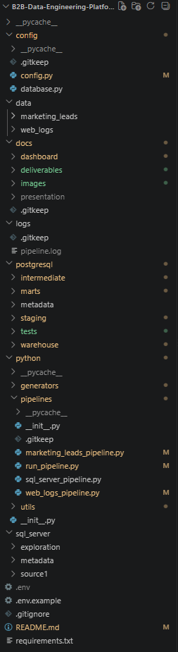
Figure 1: Repository structure (top-level folders)

4. Configuration
Table 5: Configuration
Parameter | File | Default | Description
NUM_COMPANIES / NUM_SUPPLIERS / NUM_CATEGORIES | config/config.py | 2,500 / 400 / 10 | Master data volumes
MIN/MAX_CUSTOMERS_PER_COMPANY | config/config.py | 10 / 80 | Customers per buyer company
MIN/MAX_SUPPLIERS_PER_PRODUCT | config/config.py | 2 / 5 | Suppliers offering each product
NUM_ORDERS / NUM_ORDER_ITEMS | config/config.py | 150,000 / 450,000 | Backfill transaction volumes
NUM_MARKETING_LEADS / NUM_WEB_LOGS | config/config.py | 150,000 / 300,000 | Backfill CSV volumes
START_DATE / END_DATE | config/config.py | today - 2 years / today | History window of the backfill
RANDOM_SEED | config/config.py | 40 | Deterministic seeding (with metadata.Generation_Seeds)
CHUNK_SIZE | config/config.py | 2,500 | Rows per batch in DataFrame.to_sql
DAILY_ORDERS_RANGE / DAILY_LEADS_RANGE / DAILY_WEB_LOGS_RANGE | config/config.py | (180, 230) / (180, 230) / (370, 450) | Volumes of one simulated day
CUSTOMER_ONBOARDING_MAX_DAYS / SALES_CYCLE_MAX_DAYS | config/config.py | 90 / 90 | Customers join within 90 days of their company; Won leads order within 90 days
DIRTY_DATA_PERCENT | config/config.py | 1.5 | % of CSV rows broken on purpose to test validation
SQL_SERVER_* / POSTGRES_* / POSTGRESQL_DATABASE | .env | - | Connection settings (not in Git)

5. Coding Standards & Naming Conventions
Table 6: Coding Standards & Naming Conventions
Area | Standard
Python | One module per responsibility; module docstring with execution flow; get_logger(__name__) for logging; try/except with logging and re-raise
SQL | One script per target table; CTE steps (latest -> cleaned -> validated) followed by MERGE; header comment explaining purpose and flow
Tables / columns | snake_case; dim_ / fact_ prefixes; <entity>_id business keys, <entity>_key surrogate keys; _loaded_at for technical columns
Scripts / files | Transform_<table>.sql, load_dim_<x>.sql / load_fact_<x>.sql, Test_<table>.sql / <table>_tests.sql, KPI<n>.sql
Commits | Short descriptive message per milestone

6. Component Specifications

6.1 Data Generators (master, transaction, CDC)
Table 7: Component specification — Data Generators (master, transaction, CDC)
Module / file | python/generators/master_generator.py, transaction_generator.py, cdc_generator.py, load_to_sqlserver.py
Purpose | Create realistic synthetic data: master data, 2 years of transactions, then one simulated day of new rows and updates per incremental run
Inputs | config.py volumes and dates, constants.py (countries, categories, bot user agents ...), existing SQL Server data for daily runs
Outputs | SQL Server source tables; marketing_leads.csv and web_logs.csv
Key functions | generate_master_datasets, generating_orders_and_orderitems_datasets, generate_web_logs, generate_marketing_leads, generate_daily_datasets, generate_daily_updates, add_dirty_leads, add_dirty_web_logs
Parameters | NUM_* volumes, START_DATE / END_DATE, RANDOM_SEED; weighted_datetime_between() adds seasonal and weekday patterns
Error handling | Exceptions are logged and re-raised so the orchestrator stops
Logging | pipeline.log (module logger)

6.2 SQL Server Pipeline
Table 8: Component specification — SQL Server Pipeline
Module / file | python/pipelines/sql_server_pipeline.py
Purpose | Incrementally copy the 8 SQL Server tables into staging
Inputs | source.* tables; watermarks from metadata.pipeline_watermarks
Outputs | staging.<table> (append); updated watermarks; run-log row
Key functions | extracting_incremental_data, profile_dataframe, load_to_staging, run
Parameters | TABLE_MAPPING, SOURCE1_QUERIES, CHUNK_SIZE
Error handling | Run logged as 'failed' with the error; watermarks not moved; exception re-raised
Logging | pipeline.log + metadata.pipeline_run_log (rows extracted/loaded, watermark)

6.3 Marketing Leads Pipeline
Table 9: Component specification — Marketing Leads Pipeline
Module / file | python/pipelines/marketing_leads_pipeline.py
Purpose | Reload data/marketing_leads/marketing_leads.csv into staging.marketing_leads (full snapshot)
Inputs | data/marketing_leads/marketing_leads.csv
Outputs | staging.marketing_leads; run-log row
Key functions | extract (pd.read_csv), profile, load_to_staging (TRUNCATE + to_sql append, one transaction), run
Parameters | Output path from config.py, CHUNK_SIZE
Error handling | Run logged as 'failed'; exception re-raised
Logging | pipeline.log + metadata.pipeline_run_log

6.4 Web Logs Pipeline
Table 10: Component specification — Web Logs Pipeline
Module / file | python/pipelines/web_logs_pipeline.py
Purpose | Reload data/web_logs/web_logs.csv into staging.web_logs (full snapshot)
Inputs | data/web_logs/web_logs.csv
Outputs | staging.web_logs; run-log row
Key functions | extract (pd.read_csv), profile, load_to_staging (TRUNCATE + to_sql append, one transaction), run
Parameters | Output path from config.py, CHUNK_SIZE
Error handling | Run logged as 'failed'; exception re-raised
Logging | pipeline.log + metadata.pipeline_run_log

6.5 Orchestrator (run_pipeline.py)
Table 11: Component specification — Orchestrator (run_pipeline.py)
Module / file | python/pipelines/run_pipeline.py
Purpose | Single entry point that runs the complete platform in the right order
Inputs | Command-line argument: initial or incremental
Outputs | Loaded intermediate and warehouse (staging emptied after use); run log; notification
Key functions | run_initial, run_incremental, run_module, run_transform, clear_staging, run_warehouse_load, main
Parameters | Ordered lists of transform and load scripts
Error handling | Any failure stops the run, logs it and shows a failure notification (exit code 1); intermediate stage in one transaction
Logging | pipeline.log, pipeline_run_log (intermediate_transform, warehouse_load), Windows toast

6.6 Utilities (logging, notifier, pipeline utils)
Table 12: Component specification — Utilities (logging, notifier, pipeline utils)
Module / file | python/utils/logger.py, notifier.py, pipeline_utils.py, seed_manager.py, date_weighting.py, constants.py
Purpose | Shared helpers for logging, notifications, watermarks and run log, seeding and realistic dates
Inputs | config.py settings
Outputs | Log lines, toast notifications, metadata rows
Key functions | get_logger, notify, get_last_watermark, update_watermark, log_run_start, log_run_end, get_live_seed, weighted_datetime_between
Parameters | LOG_LEVEL, LOG_FORMAT, PIPELINE_LOGS_PATH
Error handling | notify() never breaks a run (errors are caught and logged)
Logging | File + console handlers on logs/pipeline.log

7. SQL Transformation Scripts (Staging → Intermediate)
Table 13: SQL Transformation Scripts (Staging → Intermediate)
Order | Script | Source | Target | Logic Summary | Depends On
1 | Transform_​companies.​sql | staging.​companies | intermediate.​companies | Latest version per key, trim/clean, validate, MERGE | -
2 | Transform_​categories.​sql | staging.​categories | intermediate.​categories | Latest version per key, trim/clean, validate, MERGE | -
3 | Transform_​customers.​sql | staging.​customers | intermediate.​customers | Latest version per key, trim/clean, validate, MERGE | companies
4 | Transform_​suppliers.​sql | staging.​suppliers | intermediate.​suppliers | Latest version per key, trim/clean, validate, MERGE | companies
5 | Transform_​products.​sql | staging.​products | intermediate.​products | Latest version per key, trim/clean, validate, MERGE | categories
6 | Transform_​supplier_​product_​mapping.​sql | staging.​supplier_​product_​mapping | intermediate.​supplier_​product_​mapping | Latest version per key, trim/clean, validate, MERGE | suppliers, products
7 | Transform_​marketing_​leads.​sql | staging.​marketing_​leads | intermediate.​marketing_​leads | Save invalid rows in rejected_records, then latest version per key, trim/clean, validate, MERGE | -
8 | Transform_​orders.​sql | staging.​orders | intermediate.​orders | Latest version per key, trim/clean, validate, MERGE; sets lead conversion_status | customers, companies, marketing_leads
9 | Transform_​order_​items.​sql | staging.​order_​items | intermediate.​order_​items | Latest version per key, trim/clean, validate, MERGE | orders, supplier_product_mapping
10 | Transform_​web_​logs.​sql | staging.​web_​logs | intermediate.​web_​logs | Save invalid rows in rejected_records, then latest version per key, trim/clean, validate, MERGE | -

8. Warehouse Load Scripts (Intermediate → Warehouse)
Table 14: Warehouse Load Scripts (Intermediate → Warehouse)
Order | Script | Target | Load Type | Logic Summary | Depends On
1 | load_​dim_​date.​sql | dim_date | Insert new dates | Calendar 2 years back to 6 months ahead | -
2 | load_​dim_​companies.​sql | dim_companies | SCD Type 2 | Expire changed version, insert new current version | intermediate.companies
3 | load_​dim_​customers.​sql | dim_customers | SCD Type 1 MERGE | Overwrite changed attributes | intermediate.customers
4 | load_​dim_​suppliers.​sql | dim_suppliers | SCD Type 1 MERGE | Overwrite changed attributes | intermediate.suppliers
5 | load_​dim_​products.​sql | dim_products | SCD Type 1 MERGE | Adds category_name from categories | intermediate.products, categories
6 | load_​dim_​supplier_​product.​sql | dim_supplier_product | SCD Type 1 MERGE | Adds supplier_key and product_key | dim_suppliers, dim_products
7 | load_​fact_​orders.​sql | fact_orders | MERGE | Keys looked up; company version valid at order date; item_count | dimensions, partitioning.sql
8 | load_​fact_​order_​items.​sql | fact_order_items | MERGE | Keys looked up; order status copied from order | dimensions, partitioning.sql
9 | load_​fact_​web_​logs.​sql | fact_web_logs | Insert new only | date_key from log timestamp | dim_date
10 | load_​fact_​leads.​sql | fact_leads | MERGE | date_key from lead date; order_id of converted leads | dim_date, intermediate.orders

9. Marts / KPI Views
Table 15: Marts / KPI Views
View | Source File | Reads From
marts.vw_monthly_revenue_trend | marts/KPI1.sql | fact_order_items, dim_date
marts.vw_revenue_by_company | marts/KPI2.sql | fact_order_items, dim_companies
marts.vw_revenue_by_product | marts/KPI3.sql | fact_order_items, dim_products
marts.vw_gross_margin_analysis | marts/KPI4.sql | fact_order_items, dim_products, dim_suppliers, dim_supplier_product
marts.vw_customer_lifetime_value | marts/KPI5.sql | fact_orders, fact_order_items, dim_companies
marts.vw_customer_activity | marts/KPI6.sql | fact_orders
marts.vw_geographic_sales | marts/KPI7.sql | fact_order_items, dim_companies
marts.vw_traffic_by_device | marts/KPI8.sql | fact_web_logs
marts.vw_geographic_web_traffic | marts/KPI9.sql | fact_web_logs
marts.vw_web_activity_quality | marts/KPI10.sql | fact_web_logs
marts.vw_lead_conversion_funnel | marts/KPI11.sql | fact_leads
marts.vw_lead_quality_vs_order_value | marts/KPI12.sql | fact_leads, fact_orders
marts.vw_supplier_revenue | marts/KPI13.sql | fact_order_items, dim_suppliers
marts.vw_supplier_product_performance | marts/KPI14.sql | fact_order_items, dim_products, dim_suppliers
vw_pipeline_execution_metrics, vw_pipeline_run_history, vw_pipeline_latest_run | marts/KPI15.sql | metadata.pipeline_run_log, pipeline_watermarks

10. Orchestration & Execution Flow
Table 16: Orchestration & Execution Flow
Step | Stage | Function / Command | Depends On | Logged As
1 | Generate data | python.​generators.* (initial: master + transactions; incremental: cdc_​generator) | - | pipeline.log
2 | SQL Server -> staging | python.​pipelines.​sql_​server_​pipeline | Step 1 | sql_server_pipeline
3 | Marketing leads -> staging | python.​pipelines.​marketing_​leads_​pipeline | Step 1 | marketing_leads_pipeline
4 | Web logs -> staging | python.​pipelines.​web_​logs_​pipeline | Step 1 | web_logs_pipeline
5 | Staging -> intermediate | run_​transform() - 10 scripts, one transaction | Steps 2-4 | intermediate_transform
6 | Clear staging | clear_​staging() - check every row is in intermediate or rejected_​records, then TRUNCATE | Step 5 | pipeline.log
7 | Intermediate -> warehouse | run_​warehouse_​load() - dimensions, partitioning.​sql, facts | Step 6 | warehouse_load
8 | Notify | notify() - Windows toast success / failure | Step 7 | pipeline.log

11. Logging, Monitoring & Notifications
- logs/pipeline.log: every module logs through get_logger() to the file and the console, format time | level | module | line | message.
- metadata.pipeline_run_log: each stage writes a row when it starts ('running') and updates it at the end ('completed' or 'failed') with rows extracted/loaded, watermark and error message.
- metadata.pipeline_watermarks: last loaded updated_at for each of the 8 SQL Server tables.
- Pipeline health in Power BI: KPI 15 views show load times, error rates, data freshness and watermark lag.
- Notifications: a Windows toast (win10toast) reports success or failure at the end of every run.
Figure 2 shows the terminal output of an incremental run: every stage completes, staging is checked and cleared and the warehouse is loaded.
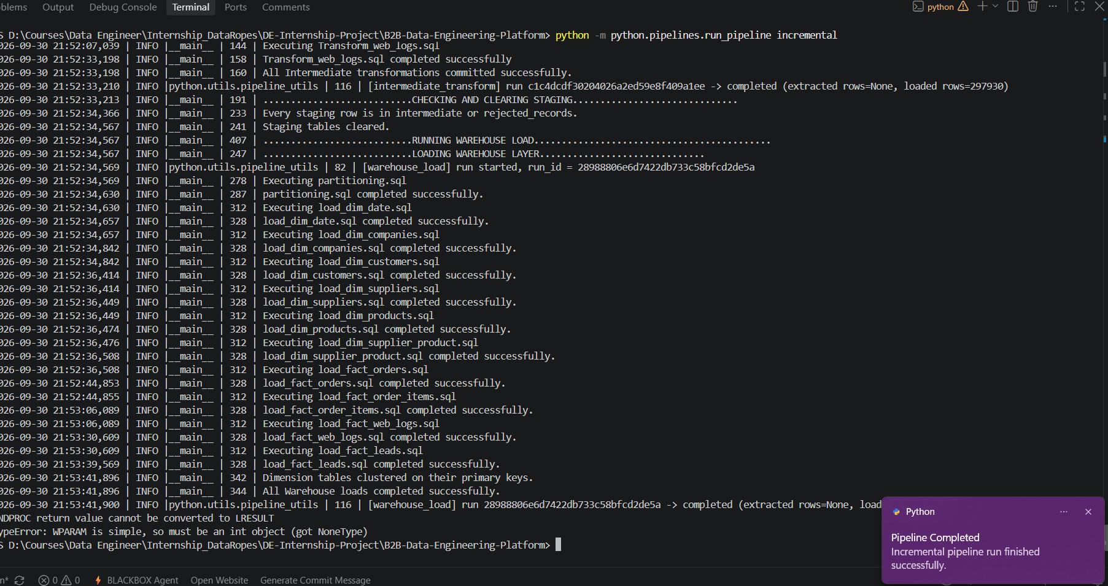
Figure 2: Terminal after an incremental run — staging checked and cleared, warehouse loaded
Figure 3 shows the latest run of every stage in metadata.pipeline_run_log.
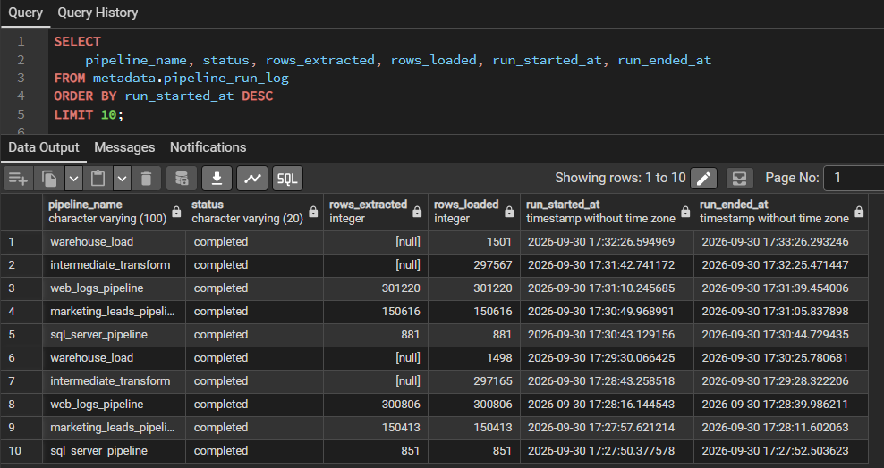
Figure 3: metadata.pipeline_run_log — latest runs of every stage

12. Build & Deployment Runbook
Table 17: Build & Deployment Runbook
Step | Action | Command / Script
1 | Install prerequisites | Python 3.10+, SQL Server Express + ODBC Driver 17, PostgreSQL 15+, Power BI Desktop
2 | Install Python packages | pip install -r requirements.txt
3 | Configure connections | Copy .env.example to .env and fill in SQL Server / PostgreSQL settings
4 | Create PostgreSQL database | Empty database named as POSTGRESQL_DATABASE (b2b_warehouse_db)
5 | Run SQL Server DDL | sql_server/source1/ddl-source1.sql, then sql_server/metadata/ddl-metadata.sql
6 | Run PostgreSQL DDL | metadata, staging, intermediate, warehouse, partitioning.sql, marts_ddl.sql (in this order)
7 | Initial load (2-year backfill) | python -m python.pipelines.run_pipeline initial
8 | Daily incremental run | python -m python.pipelines.run_pipeline incremental
9 | Validate and report | Run the SQL tests (0 rows expected); open docs/dashboard/dashboard.pbix or connect Power BI to schema marts

13. Version Control & Milestones
Table 18: Version Control & Milestones
Date | Commit / Tag | Milestone
2026-07-30 | Initialize project structure | Project set-up, architecture and configuration
2026-08-05 | transaction generator + SQL Server master data load | Source data generation
2026-08-06 | CDC generator + 2 years backfill + continuous ingestion | Source layer complete
2026-08-07 | ELT pipelines, staging schema populated | Staging layer complete
2026-08-11 | Intermediate schema validated & populated | Intermediate layer complete
2026-08-15 | Warehouse schema validated & populated | Warehouse layer complete, pipeline end-to-end
2026-08-17 | Production data volumes, Power BI dashboard | Marts and dashboard complete
2026-09-30 | Review fixes | Realistic data, quarantine table, temporary staging, KPI fixes

14. Known Limitations & Future Work
Table 19: Known Limitations & Future Work
Item | Description | Planned Action
Scheduling | Runs are started manually, as specified in the requirements. | Windows Task Scheduler or Apache Airflow
IP geolocation | Locations are generated with the synthetic data. | GeoIP lookup (e.g. MaxMind GeoLite2) for real client IPs
Raw data archive | Staging is emptied after each run; raw files are not archived. | Keep raw files in a data lake / cheap storage
Cloud deployment | Platform runs on one local machine. | Containerise and move to a managed PostgreSQL / cloud warehouse

