
Test Document (Unit & Integration)
Document 08 of 09 · B2B Data Engineering Platform

05/10/2026
DataRopes.ai
Data Engineering Internship · B2B Data Engineering Platform
Test strategy, environment, criteria and results for unit, integration and KPI validation testing. Detailed cases are in the Test Case Register.
Document ID | B2B-DEP-08
Version | 1.2
Status | Final
Date | 05/10/2026
Prepared by | Syed Kazim Raza
Reviewed by | [Team Lead]

Document Control

Revision History
Version | Date | Author | Description of Change
0.1 | - | Syed Kazim Raza | Template created
1.0 | 29/09/2026 | Syed Kazim Raza | Test results of the final run (29/09/2026)
1.1 | 30/09/2026 | Syed Kazim Raza | Re-tested on the rebuilt data: 186 tests passed; quarantine tests; defect log
1.2 | 05/10/2026 | Syed Kazim Raza | Formatting to documentation standard: table column widths, numbered figure and table captions with lists, figure descriptions, complete acronym list

Approvals
Role | Name | Signature | Date
Prepared by | Syed Kazim Raza
Reviewed by | [Team Lead]
Approved by | [Manager]

Related Documents
Ref | Document | Location
R1 | Business Requirements Document (BRD) | Provided by DataRopes
R2 | Project Document (technical reference) | docs/deliverables/project_document.md
R3 | Project Plan | docs/deliverables/project_plan.md
R4 | README / Deployment Guide | README.md

Contents
Document Control 2
Contents 3
List of Figures 4
List of Tables 5
1. Introduction 6
1.1 Purpose 6
1.2 Scope 6
1.3 Intended Audience 6
1.4 Definitions & Acronyms 6
2. Test Strategy 7
3. Test Environment 7
4. Test Data 7
5. Entry & Exit Criteria 8
6. Unit Test Summary 8
7. Integration Test Summary 9
8. KPI Validation 10
9. Defect Log 11
10. Test Results Summary 12
11. Test Evidence 12
12. Sign-off 21

List of Figures
Figure 1: Pipeline run log — all stages completed 12
Figure 2: Unit test query returning zero rows — intermediate 13
Figure 3: Unit test query returning zero rows — warehouse 14
Figure 4: SCD Type 2 — companies with more than one version 15
Figure 5: Idempotency re-run — row counts unchanged 16
Figure 6: Layer reconciliation — every CSV row is loaded or rejected 17
Figure 7: Rejected rows by table and reason 18
Figure 8: Integration test summary — failed_rows is 0 for every test 19
Figure 9: Terminal after an incremental run — staging checked and cleared 20

List of Tables
Table 1: Intended Audience 6
Table 2: Definitions & Acronyms 6
Table 3: Test Strategy 7
Table 4: Test Environment 7
Table 5: Entry & Exit Criteria 8
Table 6: Unit Test Summary 8
Table 7: Integration Test Summary 9
Table 8: KPI Validation 10
Table 9: Defect Log 11
Table 10: Test Results Summary 12
Table 11: Sign-off 21

1. Introduction

1.1 Purpose
This document defines how the platform is tested and records the results.

1.2 Scope
In scope:
- Unit tests per table/object, integration tests across layers, end-to-end pipeline runs, KPI validation
Out of scope:
- Performance and load testing at production scale
- Security penetration testing

1.3 Intended Audience
Table 1: Intended Audience
Audience | How they use this document
QA / Data Engineers | Execute tests and record results
Team Lead | Review coverage and sign off

1.4 Definitions & Acronyms
Table 2: Definitions & Acronyms
Term | Definition
B2B | Business-to-Business: companies selling to other companies.
BI | Business Intelligence: reporting and dashboards, here Power BI.
BRD | Business Requirements Document: here the Project Requirements Document provided by DataRopes.
CDC | Change Data Capture: extracting only the rows that changed since the last run (here: watermark on updated_at).
CI/CD | Continuous Integration / Continuous Delivery: automated build, test and deployment (out of scope for this project).
CSV | Comma-Separated Values: the text-file format of the marketing leads and web logs feeds.
DEP | Data Engineering Platform: prefix of the document IDs (B2B-DEP-01 …).
ID | Identifier.
Integration test | A check across layers or tables (e.g. source rows = intermediate + rejected = warehouse).
IT | Integration Test: IT-01 … IT-10 in the Test Document.
KPI validation | Comparing a KPI view's result with an independent calculation from the warehouse tables.
MoM | Month-over-Month: change compared with the previous month.
Read-only run | Tests are executed in a READ ONLY transaction, so testing never changes data.
SCD | Slowly Changing Dimension: SCD1 overwrites changes, SCD2 keeps every version with validity dates.
SQL | Structured Query Language.
Test register | 08b_Test_Case_Register.xlsx: one row per test case with expected and actual result.
UAT | User Acceptance Testing: business users confirm the solution meets their needs.
Unit test | A SQL query that checks one rule on one table (e.g. no duplicate order_id). It passes when it returns 0 rows.

2. Test Strategy
Table 3: Test Strategy
Test Level | Objective | What Is Tested | Technique | Owner
Unit | Each table meets its data rules | Uniqueness, completeness, allowed values, ranges, referential integrity, SCD2 rules | SQL test queries per table (0 rows = pass) | Data Engineer
Integration | Data flows correctly between layers | Row reconciliation source -> intermediate (+ rejected) -> warehouse, watermarks, SCD2 history, lead-order link | Read-only reconciliation queries | Data Engineer
System / End-to-End | The whole pipeline runs end to end | initial and incremental runs of run_pipeline.py | Execute the pipeline, check run log and notifications | Data Engineer
KPI Validation | KPIs are correct | All 15 mart views | Compare view totals with independent SQL on the facts | Data Engineer
User Acceptance (UAT) | Business users accept the dashboard | Power BI dashboard, 7 pages | Demonstration and review | Team Lead

3. Test Environment
Table 4: Test Environment
Databases | SQL Server 2022 Express (b2b_source_db); PostgreSQL 18.4 (b2b_warehouse_db)
Data volume | 470,263 order lines, 156,678 orders, 148,358 leads, 296,703 web requests (+ 6,775 rejected CSV rows)
Tools | pgAdmin 4 / psql for SQL tests; Python (SQLAlchemy) to execute all test files in one run; Power BI Desktop
Test data source | Synthetic data from the project generators: 2-year backfill plus daily incremental runs
Execution method | Manual end-to-end runs followed by the SQL test files (requirements: no pytest, no CI/CD)

4. Test Data
All tests use the synthetic data created by the project's generators, so no production data is needed:
- Deterministic seeding: RANDOM_SEED = 40 and metadata.Generation_Seeds make the reference data repeatable.
- History: a 2-year backfill (2,500 companies, 94,755 customers, 156,678 orders) with seasonal and weekday patterns.
- Change cases (CDC): each incremental run updates companies (SCD2 test cases), customers, order statuses and lead stages, and deactivates products (soft deletes).
- Edge cases: cancelled orders (7,613, 4.9 %), bot traffic, anonymous web requests, orders from leads and without a lead, and 1.5% broken CSV rows.

5. Entry & Exit Criteria
Table 5: Entry & Exit Criteria
Criteria | Entry | Exit
Unit | Pipeline run completed; intermediate and warehouse loaded | All unit tests return 0 rows (or matching counts)
Integration | Unit tests passed | All layers reconcile; watermarks and SCD2 history correct
KPI validation | Warehouse loaded and marts views created | Every KPI total equals its independent calculation

6. Unit Test Summary
Table 6: Unit Test Summary
Test File | Object Under Test | # Cases | Checks Covered | Result
Test_categories.sql | intermediate.​categories | 5 | Completeness, Uniqueness | 5 / 5 passed
Test_customers.sql | intermediate.​customers | 6 | Business rule, Completeness, Consistency, Domain / allowed values | 6 / 6 passed
Test_order_items.sql | intermediate.​order_​items | 9 | Business rule, Completeness, Consistency, Reconciliation | 9 / 9 passed
Test_orders.sql | intermediate.​orders | 11 | Business rule, Completeness, Consistency, Domain / allowed values | 11 / 11 passed
Test_products.sql | intermediate.​products | 7 | Business rule, Completeness, Consistency, Referential integrity | 7 / 7 passed
Test_suppliers.sql | intermediate.​suppliers | 7 | Completeness, Consistency, Referential integrity, Uniqueness | 7 / 7 passed
Test_web_logs.sql | intermediate.​web_​logs | 5 | Business rule, Completeness, Domain / allowed values, Uniqueness | 5 / 5 passed
Tests_companies.sql | intermediate.​companies | 12 | Business rule, Completeness, Domain / allowed values, Range | 12 / 12 passed
Tests_supplier_product_mapping.sql | intermediate.​supplier_​product_​mapping | 8 | Business rule, Completeness, Consistency, Uniqueness | 8 / 8 passed
Test_rejected_records.sql | intermediate.​rejected_​records | 4 | Completeness, Uniqueness, Domain / allowed values, Range | 4 / 4 passed
dim_companies_tests.sql | warehouse.​dim_​companies | 11 | Business rule, Completeness, Consistency, Domain / allowed values | 11 / 11 passed
dim_customers_tests.sql | warehouse.​dim_​customers | 5 | Business rule, Reconciliation, Referential integrity, Uniqueness | 5 / 5 passed
dim_products_tests.sql | warehouse.​dim_​products | 4 | Reconciliation, Referential integrity, Uniqueness | 4 / 4 passed
dim_supplier_product_tests.sql | warehouse.​dim_​supplier_​product | 9 | Business rule, Key integrity, Range, Reconciliation | 9 / 9 passed
dim_suppliers_tests.sql | warehouse.​dim_​suppliers | 5 | Business rule, Reconciliation, Referential integrity, Uniqueness | 5 / 5 passed
fact_leads_tests.sql | warehouse.​fact_​leads | 8 | Business rule, Consistency, Range, Reconciliation | 8 / 8 passed
fact_order_items_tests.sql | warehouse.​fact_​order_​items | 15 | Business rule, Consistency, Range, Reconciliation | 15 / 15 passed
fact_orders_tests.sql | warehouse.​fact_​orders | 13 | Business rule, Consistency, Domain / allowed values, Key integrity | 13 / 13 passed
fact_warehouse_tests.sql | warehouse (all tables) | 10 | Business rule, Consistency, Reconciliation, Referential integrity | 10 / 10 passed
fact_web_logs_tests.sql | warehouse.​fact_​web_​logs | 7 | Business rule, Consistency, Domain / allowed values, Range | 7 / 7 passed

7. Integration Test Summary
Table 7: Integration Test Summary
Test ID | Scenario | Layers | Expected Result | Result
IT-01 | Source -> intermediate completeness | Source, Intermediate | Every source record (8 tables + 2 files) is in intermediate or in rejected_records | Pass - 0 differences (2,258 + 4,517 rejected CSV rows)
IT-02 | Staging cleared after a successful run | Staging, Intermediate | Every staging row is in intermediate or rejected_records; then all 10 staging tables are empty | Pass - 0 staging rows left
IT-03 | Intermediate -> warehouse completeness | Intermediate, Warehouse | Row counts equal for 5 dimensions (current rows) and 4 facts | Pass - 0 differences
IT-04 | CDC watermark correctness | Metadata, Source | Each of the 8 watermarks = MAX(updated_at) of its source table | Pass - 8 of 8 watermarks correct
IT-05 | SCD Type 2 history after CDC updates | Source, Intermediate, Warehouse | Changed companies have a closed old version whose end = start of the new version; one current version each | Pass - 5 companies with history, 0 gaps/overlaps
IT-06 | Point-in-time company lookup | Warehouse | Every order points to the company version valid at order time | Pass - 0 orders outside their version's validity
IT-07 | Order header vs order lines | Warehouse | fact_orders.order_total = SUM(line_total) and item_count = number of lines | Pass - 0 mismatching orders
IT-08 | Lead to order link (cross-source) | Intermediate, Warehouse | Converted leads carry their order_id; every order's lead_id exists in fact_leads | Pass - 0 inconsistent leads, 0 orders with unknown lead
IT-09 | End-to-end incremental run | All | Latest run of all 5 stages has status 'completed' | Pass - 5 of 5 stages completed
IT-10 | Idempotent re-run of warehouse loads | Warehouse | Re-running the four load_fact_*.sql scripts leaves all fact row counts unchanged | Pass - 0 rows changed by each MERGE; counts and value totals identical (orders 156,678, lines 470,263, web logs 296,703, leads 148,358)

8. KPI Validation
Table 8: KPI Validation
KPI ID | KPI | Validation Method | Expected | Actual | Result
KPI-01 | Monthly Revenue Trend | Sum of monthly net revenue = non-cancelled line revenue of the same 23 complete months | 4,400,274,489.23 | 4,400,274,489.23 | Pass
KPI-02 | Revenue by Company | Sum of company gross revenue = SUM(quantity x unit_price) of buyer, non-cancelled lines | 5,133,378,828.46 | 5,133,378,828.46 | Pass
KPI-03 | Revenue by Product | Sum of product net revenue = total net revenue; one row per product | 4,621,200,118.84 | 4,621,200,118.84 | Pass
KPI-04 | Gross Margin Analysis | Sum of gross profit = SUM(line_total - quantity x supplier_price) | 954,597,910.13 | 954,597,910.13 | Pass
KPI-05 | Customer Lifetime Value | Sum of company total spend = net revenue of buyer companies | 4,621,200,118.84 | 4,621,200,118.84 | Pass
KPI-06 | Customer Activity | Repeat purchase rate recomputed from fact_orders | 60.31 | 60.31 | Pass
KPI-07 | Geographic Sales | Sum of revenue by location = total net revenue | 4,621,200,118.84 | 4,621,200,118.84 | Pass
KPI-08 | Traffic by Device | Sum of sessions = distinct (session, device) of non-bot requests | 281,911 | 281,911 | Pass
KPI-09 | Geographic Web Traffic | Countries in the view = countries in non-bot web logs | 3 | 3 | Pass
KPI-10 | Web Activity Quality | Sum of requests by endpoint = all web-log rows; errors = status 400-599 | 296703 / 59348 | 296703 / 59348 | Pass
KPI-11 | Lead Conversion Funnel | Sum of converted leads = leads with conversion_status 'Converted' | 6,044 | 6,044 | Pass
KPI-12 | Lead Quality vs Order Value | Converted-lead count = independent join count; correlation within -1..1 | 5748 | r=0.0071 | 5748 | r=0.0071 | Pass
KPI-13 | Supplier Revenue | Sum of supplier revenue = total net revenue; shares add up to 100 % | 4621200118.84 | 100% | 4621200118.84 | 100% | Pass
KPI-14 | Supplier Product Performance | Sum of supplier-product revenue = total net revenue | 4,621,200,118.84 | 4,621,200,118.84 | Pass
KPI-15 | Pipeline Execution Metrics | One row per pipeline in the run log; data freshness / watermark lag populated | 5 rows, 5 with freshness | 5 rows, 5 with freshness | Pass

9. Defect Log
Table 9: Defect Log
Defect ID | Found In | Description | Severity | Status | Fix / Commit
D-01 | Test_​web_​logs.​sql | A leftover query at the top returned every web log | Low | Fixed | Query removed (30/09/2026)
D-02 | Tests_​companies.​sql | A stray semicolon split one test in two | Low | Fixed | Semicolon removed
D-03 | Test_​categories.​sql | Missing semicolon; TEST 5 checked companies instead of categories | Low | Fixed | Semicolon added; table corrected
D-04 | dim_​companies_​tests.​sql (TEST 11) | Checked the current SCD2 version instead of the first one (failed after a company change) | Medium | Fixed | Checks MIN(effective_start_date) per company
D-05 | KPI 6 (vw_​customer_​activity) | Extra is_current filter gave 449 customers without a country | Medium | Fixed | Join on company_key only
D-06 | KPI 1 (vw_​monthly_​revenue_​trend) | Future and partial months included; 'Latest Net MoM %' card showed '--' | Medium | Fixed | Complete months only; month_num / month_start added
D-07 | Data generators | Daily data was back-dated; volume ramp hid seasonality; no failed/refunded payments | High | Fixed | Date first, then customer; daily data dated today; payment by order status

10. Test Results Summary
Table 10: Test Results Summary
Test Level | Planned | Executed | Passed | Failed | Pass %
Unit | 161 | 161 | 161 | 0 | 100 %
Integration | 10 | 10 | 10 | 0 | 100 %
KPI Validation | 15 | 15 | 15 | 0 | 100 %
Total | 186 | 186 | 186 | 0 | 100 %

11. Test Evidence
Figure 1 shows that every pipeline stage of the final run completed.
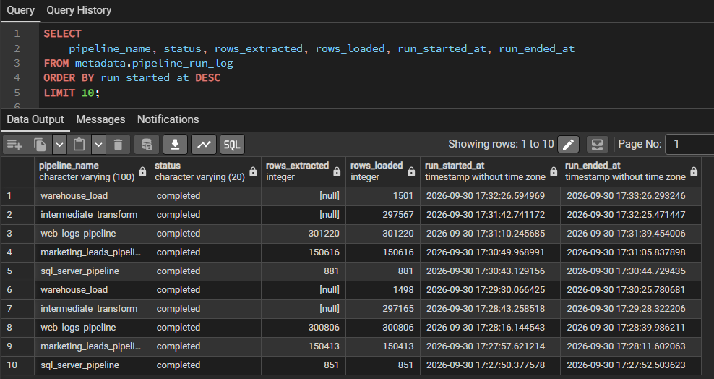
Figure 1: Pipeline run log — all stages completed
Figure 2 shows an intermediate-layer unit test: the query returns zero rows, which means the test passed.
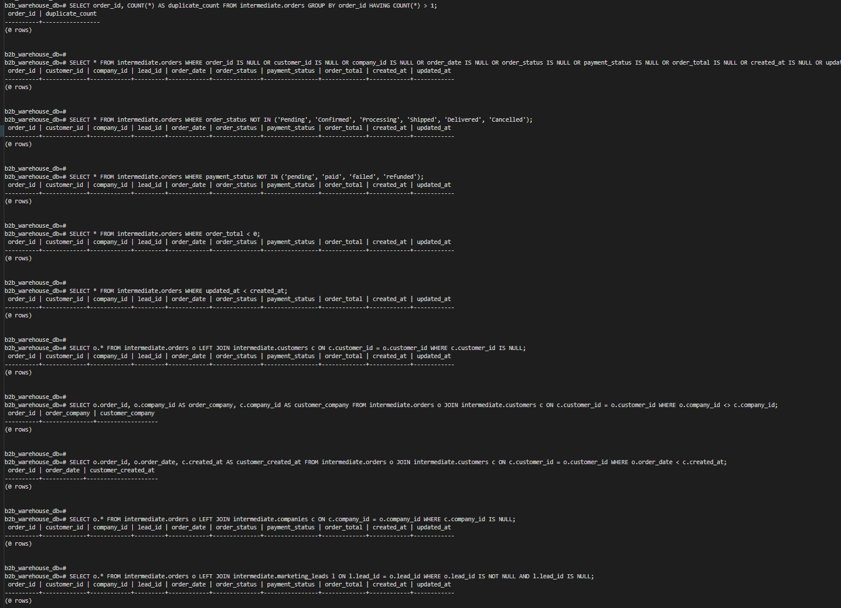
Figure 2: Unit test query returning zero rows — intermediate
Figure 3 shows a warehouse unit test returning zero rows (passed).
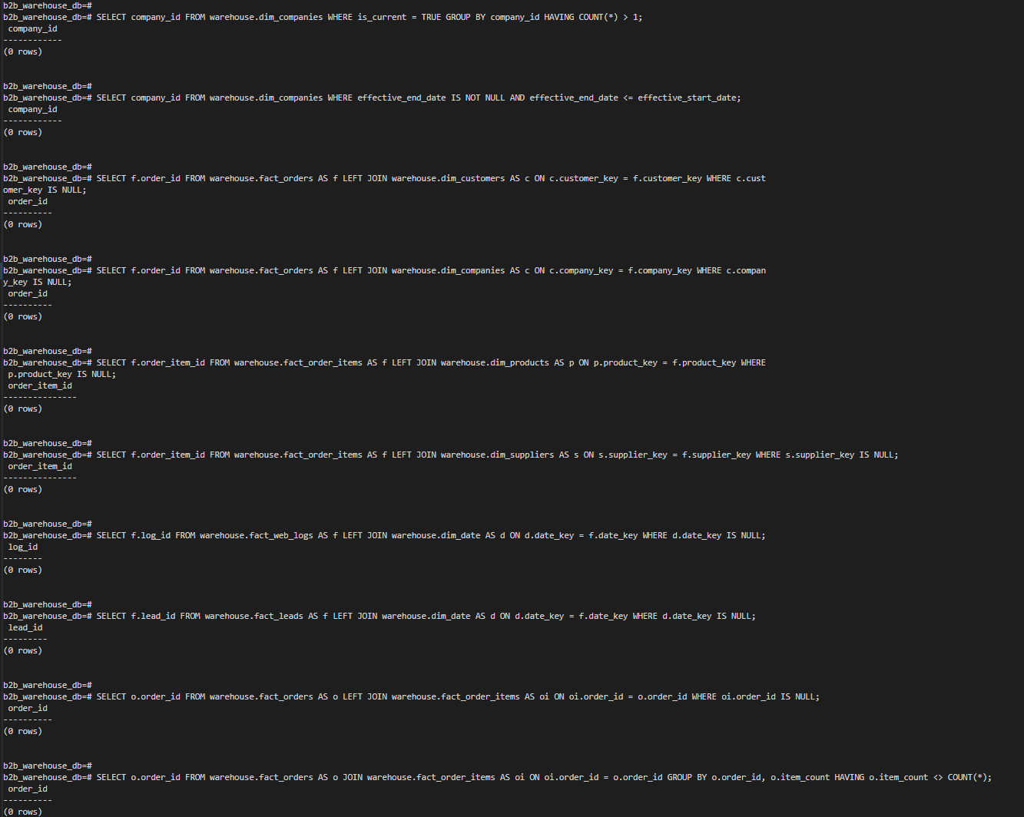
Figure 3: Unit test query returning zero rows — warehouse
Figure 4 shows how history is kept for companies: a changed company has an expired version and a current version.
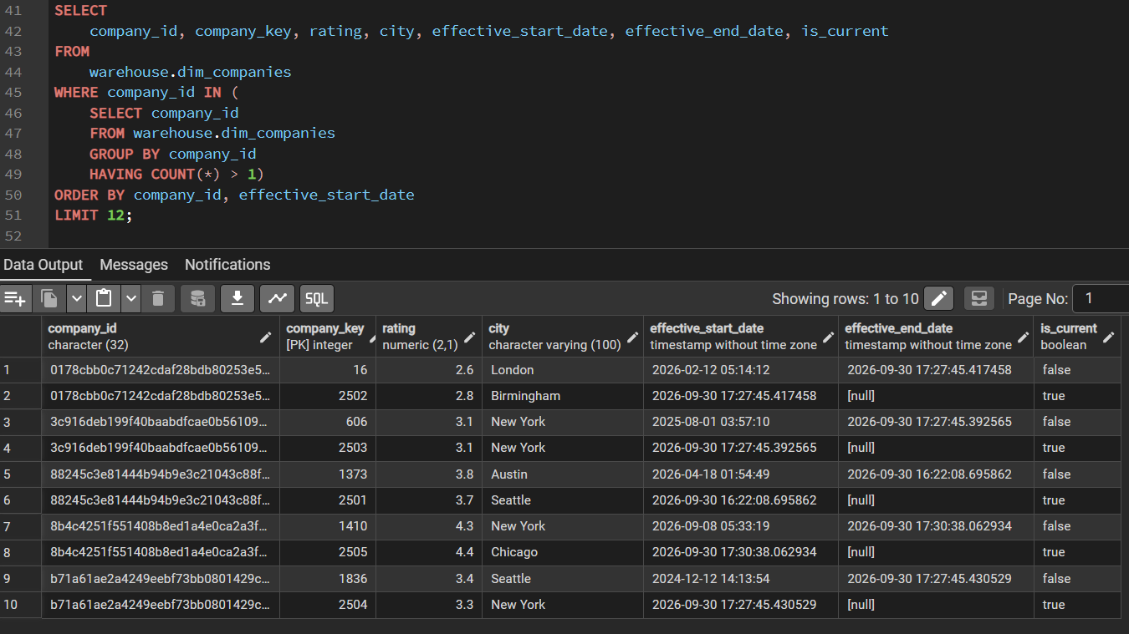
Figure 4: SCD Type 2 — companies with more than one version
Figure 5 shows the idempotency test: re-running the warehouse loads leaves every row count unchanged.
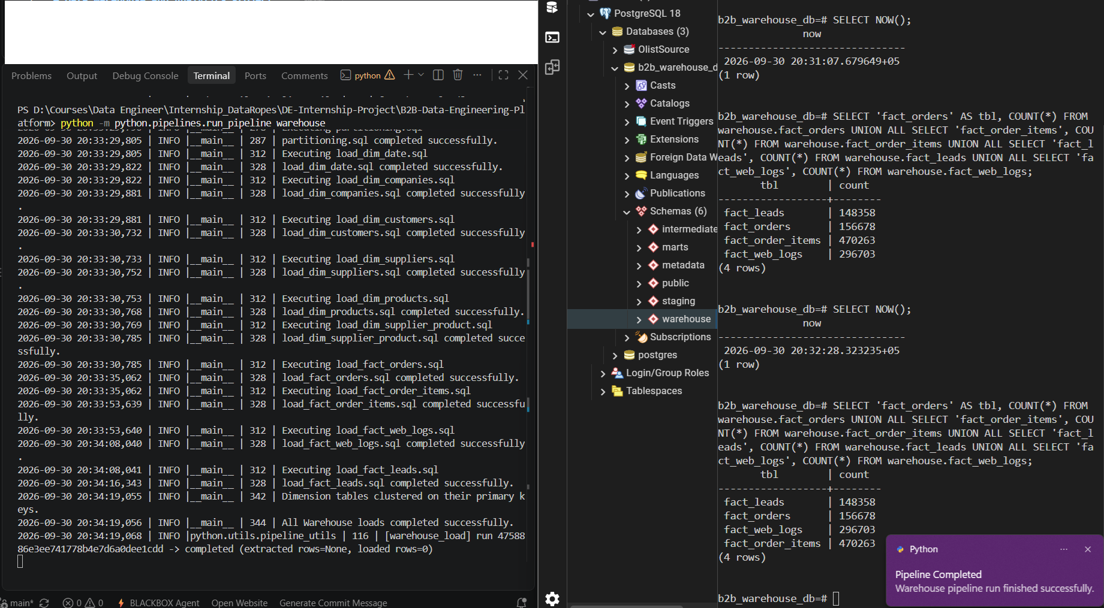
Figure 5: Idempotency re-run — row counts unchanged
Figure 6 shows the layer reconciliation: every CSV row is either loaded or rejected, none is lost.
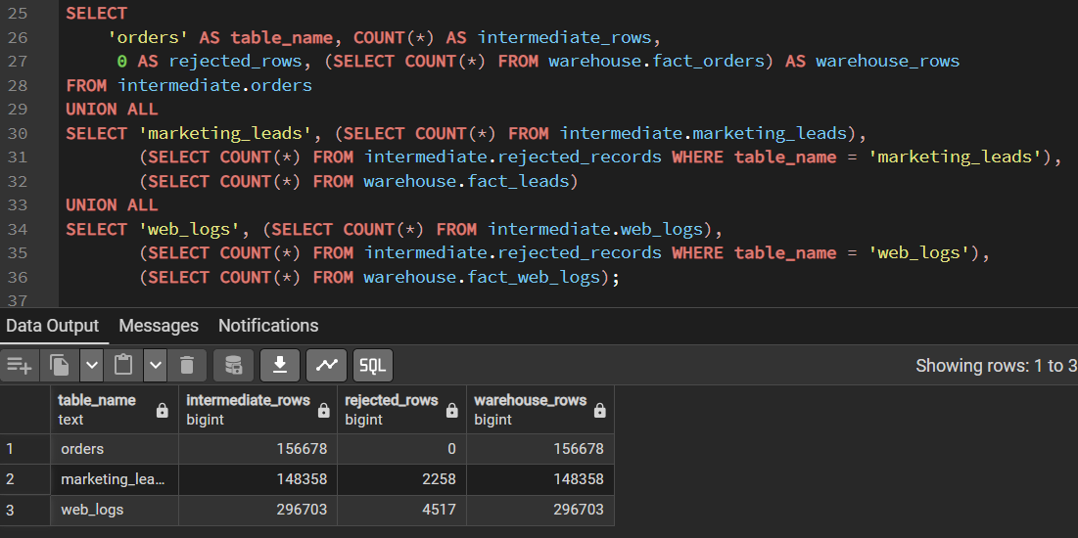
Figure 6: Layer reconciliation — every CSV row is loaded or rejected
Figure 7 shows the rejected rows per table and reason, as stored in intermediate.rejected_records.
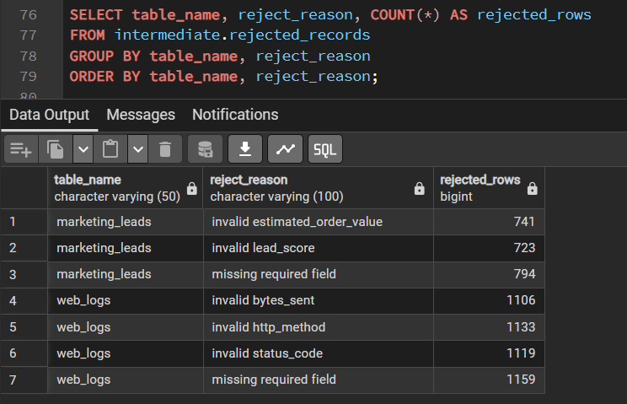
Figure 7: Rejected rows by table and reason
Figure 8 shows the integration test summary: failed_rows is 0 for every test.
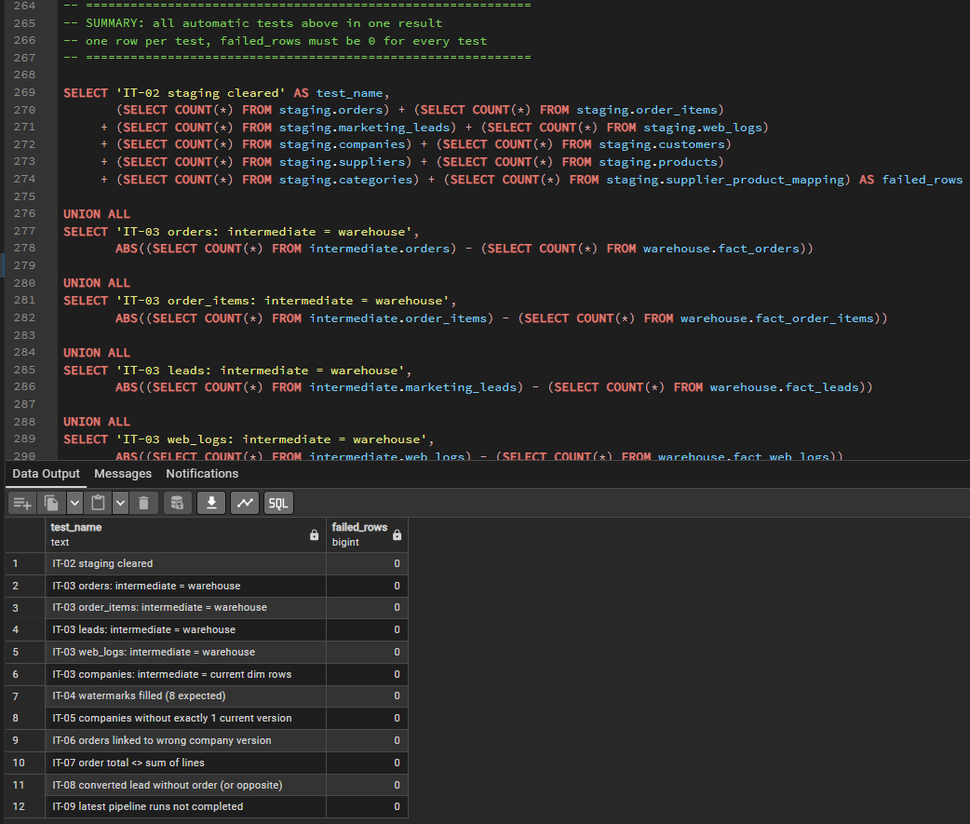
Figure 8: Integration test summary — failed_rows is 0 for every test
Figure 9 shows the terminal output of an incremental run: every stage completes, staging is checked and cleared and the warehouse is loaded.
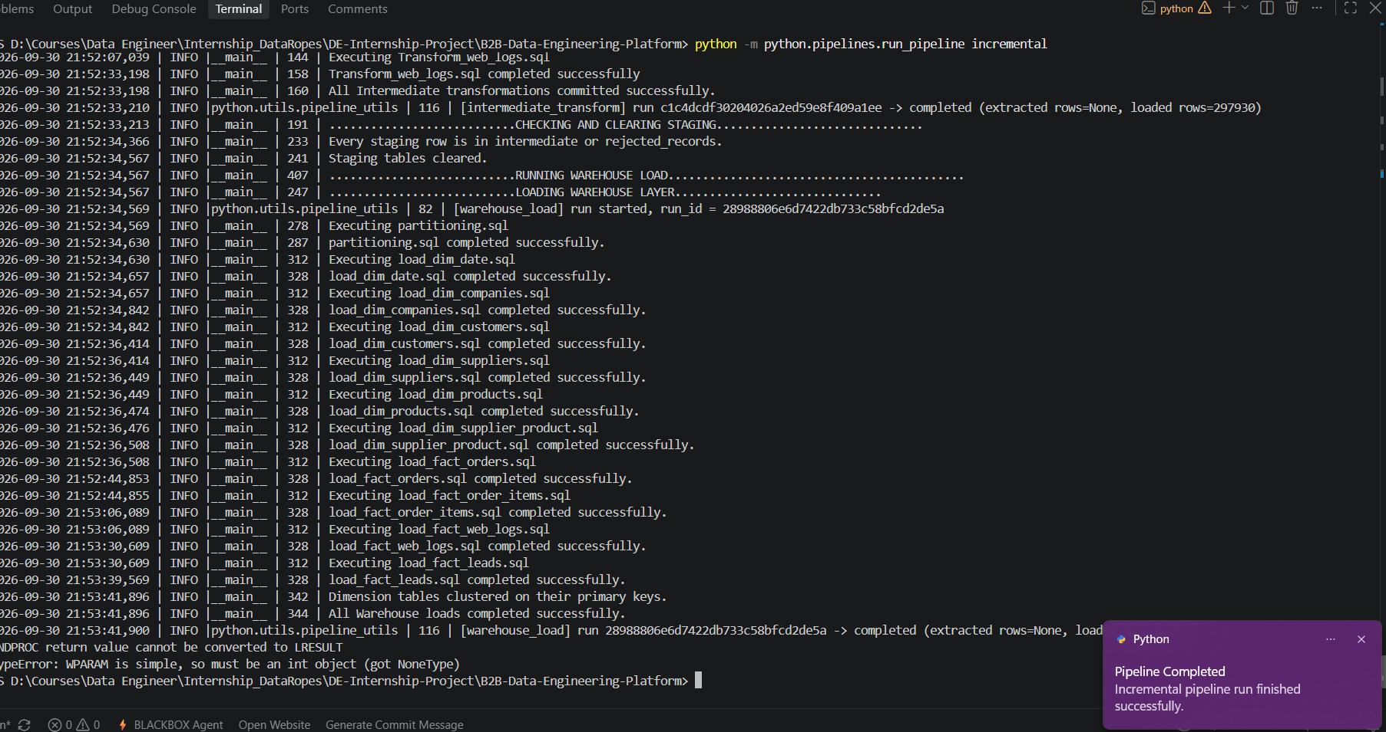
Figure 9: Terminal after an incremental run — staging checked and cleared

12. Sign-off
Table 11: Sign-off
Role | Name | Decision | Signature | Date
Tester | Syed Kazim Raza | All tests passed - accepted |  | 30/09/2026
Team Lead

