
KPI Definition Document
Document 09 of 09 · B2B Data Engineering Platform

05/10/2026
DataRopes.ai
Data Engineering Internship · B2B Data Engineering Platform
Defines every KPI delivered by the platform: business meaning, formula, grain, filters, sources, refresh and validation.
Document ID | B2B-DEP-09
Version | 1.3
Status | Final
Date | 05/10/2026
Prepared by | Syed Kazim Raza
Reviewed by | [Team Lead]

Document Control

Revision History
Version | Date | Author | Description of Change
0.1 | - | Syed Kazim Raza | Template created
1.0 | 29/09/2026 | Syed Kazim Raza | Definitions, formulas and validation of the 15 KPIs
1.1 | 30/09/2026 | Syed Kazim Raza | Validated on the rebuilt data; KPI-01 complete months only; KPI-02 grouped by company
1.2 | 04/10/2026 | Syed Kazim Raza | Dashboard images labelled with KPI IDs
1.3 | 05/10/2026 | Syed Kazim Raza | Formatting to documentation standard: table column widths, numbered figure and table captions with lists, figure descriptions, complete acronym list

Approvals
Role | Name | Signature | Date
Prepared by | Syed Kazim Raza
Reviewed by | [Team Lead]
Approved by | [Manager]

Related Documents
Ref | Document | Location
R1 | Business Requirements Document (BRD) | Provided by DataRopes
R2 | Project Document (technical reference) | docs/deliverables/project_document.md
R3 | Project Plan | docs/deliverables/project_plan.md
R4 | README / Deployment Guide | README.md

Contents
Document Control 2
Contents 3
List of Figures 4
List of Tables 5
1. Introduction 6
1.1 Purpose 6
1.2 Scope 6
1.3 Intended Audience 6
1.4 Definitions & Acronyms 6
2. KPI Catalogue 6
3. KPI Definition Cards 8
3.1 KPI-01 Monthly Revenue Trend 8
3.2 KPI-02 Revenue by Company 8
3.3 KPI-03 Revenue by Product 8
3.4 KPI-04 Gross Margin Analysis 9
3.5 KPI-05 Customer Lifetime Value 9
3.6 KPI-06 Customer Activity 9
3.7 KPI-07 Geographic Sales 10
3.8 KPI-08 Traffic by Device 10
3.9 KPI-09 Geographic Web Traffic 11
3.10 KPI-10 Web Activity Quality 11
3.11 KPI-11 Lead Conversion Funnel 11
3.12 KPI-12 Lead Quality vs Order Value 12
3.13 KPI-13 Supplier Revenue 12
3.14 KPI-14 Supplier Product Performance 12
3.15 KPI-15 Pipeline Execution Metrics 13
4. Semantic Model & Measures 13
5. Dashboard Pages 14
6. KPI Validation Summary 22
7. Glossary 24

List of Figures
Figure 1: 5. Dashboard Pages 15
Figure 2: Dashboard page — Executive Overview (KPI-01, KPI-02) 16
Figure 3: Dashboard page — Product & Profitability (KPI-03, KPI-04) 17
Figure 4: Dashboard page — Customer Intelligence (KPI-05, KPI-06, KPI-07) 18
Figure 5: Dashboard page — Web & Traffic Analytics (KPI-08, KPI-09, KPI-10) 19
Figure 6: Dashboard page — Lead Quality & Sales Funnel (KPI-11, KPI-12) 20
Figure 7: Dashboard page — Supplier Performance (KPI-13, KPI-14) 21
Figure 8: Dashboard page — Pipeline Health (KPI-15) 23

List of Tables
Table 1: Intended Audience 6
Table 2: Definitions & Acronyms 6
Table 3: KPI Catalogue 6
Table 4: KPI-01 Monthly Revenue Trend — definition card 8
Table 5: KPI-02 Revenue by Company — definition card 8
Table 6: KPI-03 Revenue by Product — definition card 8
Table 7: KPI-04 Gross Margin Analysis — definition card 9
Table 8: KPI-05 Customer Lifetime Value — definition card 9
Table 9: KPI-06 Customer Activity — definition card 9
Table 10: KPI-07 Geographic Sales — definition card 10
Table 11: KPI-08 Traffic by Device — definition card 10
Table 12: KPI-09 Geographic Web Traffic — definition card 11
Table 13: KPI-10 Web Activity Quality — definition card 11
Table 14: KPI-11 Lead Conversion Funnel — definition card 11
Table 15: KPI-12 Lead Quality vs Order Value — definition card 12
Table 16: KPI-13 Supplier Revenue — definition card 12
Table 17: KPI-14 Supplier Product Performance — definition card 12
Table 18: KPI-15 Pipeline Execution Metrics — definition card 13
Table 19: Semantic Model & Measures 13
Table 20: Dashboard Pages 14
Table 21: Glossary 24

1. Introduction

1.1 Purpose
This document is the single reference for what each KPI means and how it is calculated.

1.2 Scope
In scope:
- The 15 KPI views in the marts schema and the Power BI dashboard pages that use them
Out of scope:
- Pipeline internals (Development Document)

1.3 Intended Audience
Table 1: Intended Audience
Audience | How they use this document
Business users / Analysts | Understand and trust the numbers
Data Engineers | Maintain KPI logic
QA | Validate KPI results

1.4 Definitions & Acronyms
Table 2: Definitions & Acronyms
Term | Definition
AOV | Average order value = revenue / number of orders.
B2B | Business-to-Business: companies selling to other companies.
BI | Business Intelligence: reporting and dashboards, here Power BI.
BRD | Business Requirements Document: here the Project Requirements Document provided by DataRopes.
CDC | Change Data Capture: extracting only the rows that changed since the last run (here: watermark on updated_at).
DAX | Data Analysis Expressions: the formula language of Power BI measures.
DEP | Data Engineering Platform: prefix of the document IDs (B2B-DEP-01 …).
Gross revenue | SUM(quantity x unit_price) before discounts.
ID | Identifier.
KPI | Key Performance Indicator: a measurable value that answers a business question.
Mart view | SQL view in schema marts that Power BI reads.
MoM | Month-over-Month: change compared with the previous month.
Net revenue | SUM(line_total) = after discounts; cancelled orders excluded.
SQL | Structured Query Language.
UTM | Urchin Tracking Module: campaign parameters (utm_source, utm_medium, utm_campaign).

2. KPI Catalogue
Table 3: KPI Catalogue
KPI ID | KPI Name | Business Question | Audience | Mart View | Dashboard Page
KPI-01 | Monthly Revenue Trend | How is revenue developing month by month? | Management | marts.​vw_​monthly_​revenue_​trend | Executive Overview
KPI-02 | Revenue by Company | Which buyer companies bring most revenue (Pareto)? | Sales / Management | marts.​vw_​revenue_​by_​company | Executive Overview
KPI-03 | Revenue by Product | Which products are bestsellers or slow movers? | Product / Category managers | marts.​vw_​revenue_​by_​product | Product & Profitability
KPI-04 | Gross Margin Analysis | What margin do we make per product and supplier? | Finance / Purchasing | marts.​vw_​gross_​margin_​analysis | Product & Profitability
KPI-05 | Customer Lifetime Value | How much has each buyer company spent, by acquisition cohort? | Sales / Account management | marts.​vw_​customer_​lifetime_​value | Customer Intelligence
KPI-06 | Customer Activity | How often do customers buy and how much per order? | Sales / Marketing | marts.​vw_​customer_​activity | Customer Intelligence
KPI-07 | Geographic Sales | Where do our sales come from and which regions grow? | Management / Sales | marts.​vw_​geographic_​sales | Customer Intelligence
KPI-08 | Traffic by Device | Which devices do visitors use and how often do they reach checkout? | Marketing / Web team | marts.​vw_​traffic_​by_​device | Web & Traffic Analytics
KPI-09 | Geographic Web Traffic | Where does web traffic come from and what are the top referrers? | Marketing / Web team | marts.​vw_​geographic_​web_​traffic | Web & Traffic Analytics
KPI-10 | Web Activity Quality | Which pages produce errors? | Web team / IT | marts.​vw_​web_​activity_​quality | Web & Traffic Analytics
KPI-11 | Lead Conversion Funnel | Which sources and campaigns turn leads into orders? | Marketing | marts.​vw_​lead_​conversion_​funnel | Lead Quality & Sales Funnel
KPI-12 | Lead Quality vs Order Value | Do higher-scored leads place bigger orders? | Marketing / Sales | marts.​vw_​lead_​quality_​vs_​order_​value | Lead Quality & Sales Funnel
KPI-13 | Supplier Revenue | Which suppliers generate most revenue and how concentrated is it? | Purchasing / Management | marts.​vw_​supplier_​revenue | Supplier Performance
KPI-14 | Supplier Product Performance | Which supplier-product combinations perform best? | Purchasing | marts.​vw_​supplier_​product_​performance | Supplier Performance
KPI-15 | Pipeline Execution Metrics | Is the data pipeline healthy and the data fresh? | Data Engineering | marts.​vw_​pipeline_​execution_​metrics | Pipeline Health

3. KPI Definition Cards

3.1 KPI-01 Monthly Revenue Trend
Table 4: KPI-01 Monthly Revenue Trend — definition card
Business question | How is revenue developing month by month?
Definition | Gross and net revenue per calendar month with month-over-month growth.
Formula | Gross = SUM(quantity x unit_price); Net = SUM(line_total); MoM % = (this month - previous month) / previous month x 100
Unit | Currency; %
Grain | Calendar month (complete months only: the current month and the partial first month are left out)
Dimensions / slicers | Year, month
Filters & exclusions | Cancelled orders excluded (order_status <> 'Cancelled')
Source tables | fact_order_items, dim_date
Mart view / SQL file | marts.vw_monthly_revenue_trend - postgresql/marts/KPI1.sql (deployed by marts_ddl.sql)
Refresh | After every pipeline run (views read the warehouse directly); Power BI refresh
Owner / audience | Management
Target / threshold | Monitoring KPI - no fixed target
Visualisation | Executive Overview page: Line and column combo chart; cards Total Net Revenue, Latest Net MoM %
Validation | Sum of monthly net revenue = non-cancelled line revenue of the same 23 complete months. Expected 4,400,274,489.23, actual 4,400,274,489.23 - Pass

3.2 KPI-02 Revenue by Company
Table 5: KPI-02 Revenue by Company — definition card
Business question | Which buyer companies bring most revenue (Pareto)?
Definition | Gross revenue per buyer company, ranked, with cumulative share and Top-20 % flag.
Formula | Gross revenue per company (grouped by company_id, current name shown); rank / total companies <= 0.20 = 'Top 20%'
Unit | Currency; %
Grain | Buyer company
Dimensions / slicers | Company, performance group
Filters & exclusions | Cancelled orders excluded (order_status <> 'Cancelled'); buyers only
Source tables | fact_order_items, dim_companies
Mart view / SQL file | marts.vw_revenue_by_company - postgresql/marts/KPI2.sql (deployed by marts_ddl.sql)
Refresh | After every pipeline run (views read the warehouse directly); Power BI refresh
Owner / audience | Sales / Management
Target / threshold | Monitoring KPI - no fixed target
Visualisation | Executive Overview page: Clustered bar chart
Validation | Sum of company gross revenue = SUM(quantity x unit_price) of buyer, non-cancelled lines. Expected 5,133,378,828.46, actual 5,133,378,828.46 - Pass

3.3 KPI-03 Revenue by Product
Table 6: KPI-03 Revenue by Product — definition card
Business question | Which products are bestsellers or slow movers?
Definition | Net revenue per product and category, ranked into Best Sellers (top 30 %), Average and Slow Movers (bottom 30 %).
Formula | Net revenue = SUM(line_total) of non-cancelled order lines per product
Unit | Currency
Grain | Product
Dimensions / slicers | Product, category, performance group
Filters & exclusions | Cancelled orders excluded (order_status <> 'Cancelled')
Source tables | fact_order_items, dim_products
Mart view / SQL file | marts.vw_revenue_by_product - postgresql/marts/KPI3.sql (deployed by marts_ddl.sql)
Refresh | After every pipeline run (views read the warehouse directly); Power BI refresh
Owner / audience | Product / Category managers
Target / threshold | Monitoring KPI - no fixed target
Visualisation | Product & Profitability page: Clustered bar chart
Validation | Sum of product net revenue = total net revenue; one row per product. Expected 4,621,200,118.84, actual 4,621,200,118.84 - Pass

3.4 KPI-04 Gross Margin Analysis
Table 7: KPI-04 Gross Margin Analysis — definition card
Business question | What margin do we make per product and supplier?
Definition | Actual selling price vs catalog price and supplier price, with gross profit and margin %.
Formula | Gross profit = SUM(line_total) - SUM(quantity x supplier_price); Margin % = gross profit / SUM(line_total) x 100
Unit | Currency; %
Grain | Product x supplier
Dimensions / slicers | Product, supplier
Filters & exclusions | Cancelled orders excluded (order_status <> 'Cancelled')
Source tables | fact_order_items, dim_products, dim_suppliers, dim_supplier_product
Mart view / SQL file | marts.vw_gross_margin_analysis - postgresql/marts/KPI4.sql (deployed by marts_ddl.sql)
Refresh | After every pipeline run (views read the warehouse directly); Power BI refresh
Owner / audience | Finance / Purchasing
Target / threshold | Monitoring KPI - no fixed target
Visualisation | Product & Profitability page: Table and cards
Validation | Sum of gross profit = SUM(line_total - quantity x supplier_price). Expected 954,597,910.13, actual 954,597,910.13 - Pass

3.5 KPI-05 Customer Lifetime Value
Table 8: KPI-05 Customer Lifetime Value — definition card
Business question | How much has each buyer company spent, by acquisition cohort?
Definition | Total spend and orders per buyer company; cohort = month of the first order.
Formula | Total spend = SUM(line_total); orders = COUNT(DISTINCT order_id); cohort = TO_CHAR(MIN(order_date), 'YYYY-MM')
Unit | Currency; count
Grain | Buyer company
Dimensions / slicers | Company, country, cohort
Filters & exclusions | Cancelled orders excluded (order_status <> 'Cancelled')
Source tables | fact_order_items, fact_orders, dim_companies
Mart view / SQL file | marts.vw_customer_lifetime_value - postgresql/marts/KPI5.sql (deployed by marts_ddl.sql)
Refresh | After every pipeline run (views read the warehouse directly); Power BI refresh
Owner / audience | Sales / Account management
Target / threshold | Monitoring KPI - no fixed target
Visualisation | Customer Intelligence page: Bar chart, matrix, cohort slicer
Validation | Sum of company total spend = net revenue of buyer companies. Expected 4,621,200,118.84, actual 4,621,200,118.84 - Pass

3.6 KPI-06 Customer Activity
Table 9: KPI-06 Customer Activity — definition card
Business question | How often do customers buy and how much per order?
Definition | Orders per customer, average order value (AOV) and repeat purchase rate.
Formula | AOV = SUM(order_total) / COUNT(orders); Repeat rate = customers with > 1 order / active customers x 100
Unit | Count; currency; %
Grain | Customer
Dimensions / slicers | Customer status (repeat / one-time)
Filters & exclusions | Cancelled orders excluded (order_status <> 'Cancelled')
Source tables | fact_orders
Mart view / SQL file | marts.vw_customer_activity - postgresql/marts/KPI6.sql (deployed by marts_ddl.sql)
Refresh | After every pipeline run (views read the warehouse directly); Power BI refresh
Owner / audience | Sales / Marketing
Target / threshold | Monitoring KPI - no fixed target
Visualisation | Customer Intelligence page: Clustered column chart; cards Repeat Rate, Average Customer AOV
Validation | Repeat purchase rate recomputed from fact_orders. Expected 60.31, actual 60.31 - Pass

3.7 KPI-07 Geographic Sales
Table 10: KPI-07 Geographic Sales — definition card
Business question | Where do our sales come from and which regions grow?
Definition | Revenue and order count by country and city; the top city per country is flagged 'Growth Region'.
Formula | Net revenue = SUM(line_total) of non-cancelled order lines per country and city
Unit | Currency; count
Grain | Country x city
Dimensions / slicers | Country, city
Filters & exclusions | Cancelled orders excluded (order_status <> 'Cancelled')
Source tables | fact_order_items, dim_companies
Mart view / SQL file | marts.vw_geographic_sales - postgresql/marts/KPI7.sql (deployed by marts_ddl.sql)
Refresh | After every pipeline run (views read the warehouse directly); Power BI refresh
Owner / audience | Management / Sales
Target / threshold | Monitoring KPI - no fixed target
Visualisation | Customer Intelligence page: Map and table
Validation | Sum of revenue by location = total net revenue. Expected 4,621,200,118.84, actual 4,621,200,118.84 - Pass

3.8 KPI-08 Traffic by Device
Table 11: KPI-08 Traffic by Device — definition card
Business question | Which devices do visitors use and how often do they reach checkout?
Definition | Sessions per device type and the share of sessions that reached /checkout.
Formula | Conversion % = sessions with a /checkout request / sessions x 100
Unit | Count; %
Grain | Device type
Dimensions / slicers | Device type
Filters & exclusions | Bot traffic excluded (is_bot = FALSE)
Source tables | fact_web_logs
Mart view / SQL file | marts.vw_traffic_by_device - postgresql/marts/KPI8.sql (deployed by marts_ddl.sql)
Refresh | After every pipeline run (views read the warehouse directly); Power BI refresh
Owner / audience | Marketing / Web team
Target / threshold | Monitoring KPI - no fixed target
Visualisation | Web & Traffic Analytics page: Donut chart
Validation | Sum of sessions = distinct (session, device) of non-bot requests. Expected 281,911, actual 281,911 - Pass

3.9 KPI-09 Geographic Web Traffic
Table 12: KPI-09 Geographic Web Traffic — definition card
Business question | Where does web traffic come from and what are the top referrers?
Definition | Sessions by country, city and referrer; the top referrer per location is flagged.
Formula | Sessions = COUNT(DISTINCT session_id)
Unit | Count
Grain | Country x city x referrer
Dimensions / slicers | Country, city, referrer
Filters & exclusions | Bot traffic excluded
Source tables | fact_web_logs
Mart view / SQL file | marts.vw_geographic_web_traffic - postgresql/marts/KPI9.sql (deployed by marts_ddl.sql)
Refresh | After every pipeline run (views read the warehouse directly); Power BI refresh
Owner / audience | Marketing / Web team
Target / threshold | Monitoring KPI - no fixed target
Visualisation | Web & Traffic Analytics page: Map
Validation | Countries in the view = countries in non-bot web logs. Expected 3, actual 3 - Pass

3.10 KPI-10 Web Activity Quality
Table 13: KPI-10 Web Activity Quality — definition card
Business question | Which pages produce errors?
Definition | Requests and 4xx / 5xx errors per endpoint with error rate.
Formula | Error rate % = (4xx + 5xx requests) / all requests x 100
Unit | Count; %
Grain | Request path
Dimensions / slicers | Endpoint
Filters & exclusions | All traffic (bots included)
Source tables | fact_web_logs
Mart view / SQL file | marts.vw_web_activity_quality - postgresql/marts/KPI10.sql (deployed by marts_ddl.sql)
Refresh | After every pipeline run (views read the warehouse directly); Power BI refresh
Owner / audience | Web team / IT
Target / threshold | Monitoring KPI - no fixed target
Visualisation | Web & Traffic Analytics page: Bar chart and cards
Validation | Sum of requests by endpoint = all web-log rows; errors = status 400-599. Expected 296703 / 59348, actual 296703 / 59348 - Pass

3.11 KPI-11 Lead Conversion Funnel
Table 14: KPI-11 Lead Conversion Funnel — definition card
Business question | Which sources and campaigns turn leads into orders?
Definition | Leads, qualified leads, converted leads and orders per source, campaign and UTM channel.
Formula | Conversion % = converted leads / total leads x 100
Unit | Count; %
Grain | Source x campaign x UTM
Dimensions / slicers | Source, campaign, utm_source, utm_medium
Filters & exclusions | None
Source tables | fact_leads
Mart view / SQL file | marts.vw_lead_conversion_funnel - postgresql/marts/KPI11.sql (deployed by marts_ddl.sql)
Refresh | After every pipeline run (views read the warehouse directly); Power BI refresh
Owner / audience | Marketing
Target / threshold | Monitoring KPI - no fixed target
Visualisation | Lead Quality & Sales Funnel page: Funnel, cards (Lead Conversion Rate), slicers
Validation | Sum of converted leads = leads with conversion_status 'Converted'. Expected 6,044, actual 6,044 - Pass

3.12 KPI-12 Lead Quality vs Order Value
Table 15: KPI-12 Lead Quality vs Order Value — definition card
Business question | Do higher-scored leads place bigger orders?
Definition | Correlation between lead score and the value of the order the lead produced.
Formula | CORR(lead_score, order_total) over converted leads
Unit | Coefficient (-1 to 1)
Grain | All converted leads
Dimensions / slicers | -
Filters & exclusions | Converted leads with a non-cancelled order
Source tables | fact_leads, fact_orders
Mart view / SQL file | marts.vw_lead_quality_vs_order_value - postgresql/marts/KPI12.sql (deployed by marts_ddl.sql)
Refresh | After every pipeline run (views read the warehouse directly); Power BI refresh
Owner / audience | Marketing / Sales
Target / threshold | Monitoring KPI - no fixed target
Visualisation | Lead Quality & Sales Funnel page: Cards
Validation | Converted-lead count = independent join count; correlation within -1..1. Expected 5748 | r=0.0071, actual 5748 | r=0.0071 - Pass

3.13 KPI-13 Supplier Revenue
Table 16: KPI-13 Supplier Revenue — definition card
Business question | Which suppliers generate most revenue and how concentrated is it?
Definition | Orders and revenue per supplier with share of total and rank.
Formula | Share % = supplier revenue / total revenue x 100
Unit | Currency; %
Grain | Supplier
Dimensions / slicers | Supplier
Filters & exclusions | Cancelled orders excluded (order_status <> 'Cancelled')
Source tables | fact_order_items, dim_suppliers
Mart view / SQL file | marts.vw_supplier_revenue - postgresql/marts/KPI13.sql (deployed by marts_ddl.sql)
Refresh | After every pipeline run (views read the warehouse directly); Power BI refresh
Owner / audience | Purchasing / Management
Target / threshold | Monitoring KPI - no fixed target
Visualisation | Supplier Performance page: Cards
Validation | Sum of supplier revenue = total net revenue; shares add up to 100 %. Expected 4621200118.84 | 100%, actual 4621200118.84 | 100% - Pass

3.14 KPI-14 Supplier Product Performance
Table 17: KPI-14 Supplier Product Performance — definition card
Business question | Which supplier-product combinations perform best?
Definition | Orders, quantity and revenue per supplier and product.
Formula | Net revenue = SUM(line_total) of non-cancelled order lines per supplier-product pair
Unit | Currency; count
Grain | Supplier x product
Dimensions / slicers | Supplier, product
Filters & exclusions | Cancelled orders excluded (order_status <> 'Cancelled')
Source tables | fact_order_items, dim_suppliers, dim_products
Mart view / SQL file | marts.vw_supplier_product_performance - postgresql/marts/KPI14.sql (deployed by marts_ddl.sql)
Refresh | After every pipeline run (views read the warehouse directly); Power BI refresh
Owner / audience | Purchasing
Target / threshold | Monitoring KPI - no fixed target
Visualisation | Supplier Performance page: Bar and column charts, matrix
Validation | Sum of supplier-product revenue = total net revenue. Expected 4,621,200,118.84, actual 4,621,200,118.84 - Pass

3.15 KPI-15 Pipeline Execution Metrics
Table 18: KPI-15 Pipeline Execution Metrics — definition card
Business question | Is the data pipeline healthy and the data fresh?
Definition | Average load time, success and error rate per pipeline stage, data freshness and CDC watermark lag.
Formula | Error rate % = failed runs / runs x 100; freshness = now - last watermark
Unit | Duration; %
Grain | Pipeline stage
Dimensions / slicers | Pipeline, run date
Filters & exclusions | Finished runs only
Source tables | metadata.pipeline_run_log, metadata.pipeline_watermarks
Mart view / SQL file | marts.vw_pipeline_execution_metrics (+ vw_pipeline_run_history, vw_pipeline_latest_run) - postgresql/marts/KPI15.sql (deployed by marts_ddl.sql)
Refresh | After every pipeline run (views read the warehouse directly); Power BI refresh
Owner / audience | Data Engineering
Target / threshold | All stages 'completed'; freshness below one day
Visualisation | Pipeline Health page: Cards, area charts, tables; measures Last Run Status, Data Freshness, Watermark Lag
Validation | One row per pipeline in the run log; data freshness / watermark lag populated. Expected 5 rows, 5 with freshness, actual 5 rows, 5 with freshness - Pass

4. Semantic Model & Measures
Table 19: Semantic Model & Measures
Measure | Definition / DAX | Table | Used In
Total Gross Revenue | SUM(vw_​monthly_​revenue_​trend[gross_​revenue]) | vw_monthly_revenue_trend | Executive Overview
Total Net Revenue | SUM(vw_​monthly_​revenue_​trend[net_​revenue]) | vw_monthly_revenue_trend | Executive Overview
Latest Net MoM % | net_​mom_​pct of the latest year and month | vw_monthly_revenue_trend | Executive Overview
Repeat Rate | DIVIDE(customers with status 'Repeat Customer', all customers) x 100 | vw_customer_activity | Customer Intelligence
Average Customer AOV | AVERAGE(vw_​customer_​activity[average_​order_​value]) | vw_customer_activity | Customer Intelligence
Lead Conversion Rate | DIVIDE(SUM(converted_​leads), SUM(total_​leads)) | vw_lead_conversion_funnel | Lead Quality & Sales Funnel
Last Run Status | status of the latest run_​timestamp | vw_pipeline_run_history | Pipeline Health
Data Freshness / Watermark Lag (Formatted) | Seconds formatted as 'Xd Yh' / 'Xh Ym' | vw_pipeline_execution_metrics | Pipeline Health

5. Dashboard Pages
Table 20: Dashboard Pages
Page | KPIs Shown | Audience
Executive Overview | KPI-01, KPI-02 | Management
Product & Profitability | KPI-03, KPI-04 | Product, finance
Customer Intelligence | KPI-05, KPI-06, KPI-07 | Sales, account management
Web & Traffic Analytics | KPI-08, KPI-09, KPI-10 | Marketing, web team
Lead Quality & Sales Funnel | KPI-11, KPI-12 | Marketing, sales
Supplier Performance | KPI-13, KPI-14 | Purchasing
Pipeline Health | KPI-15 | Data engineering

Figure 1 shows 5. Dashboard Pages.
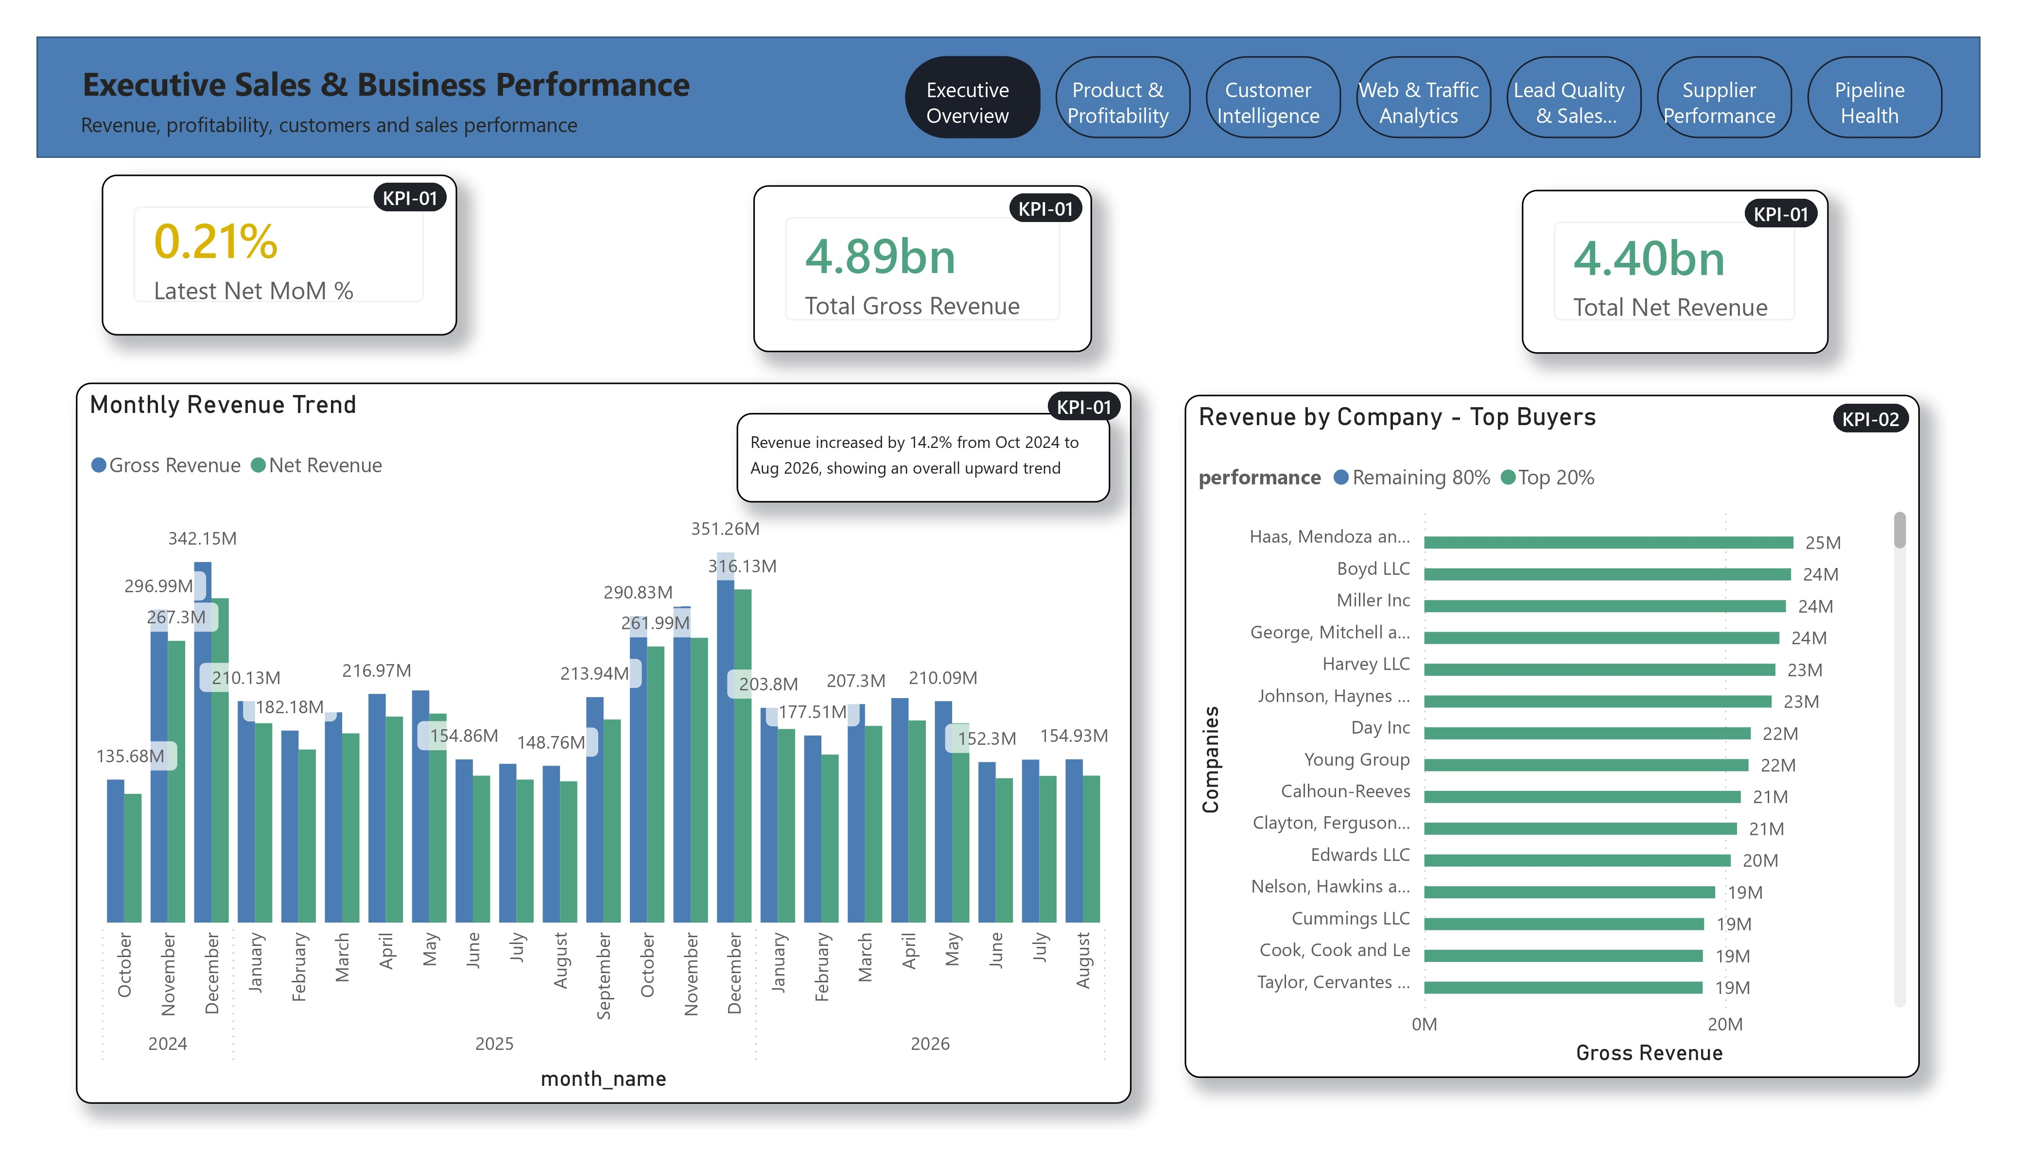
Figure 1: 5. Dashboard Pages
Figure 2 shows the Executive Overview page of the Power BI dashboard; every visual carries the number of the KPI it displays (KPI-01, KPI-02).
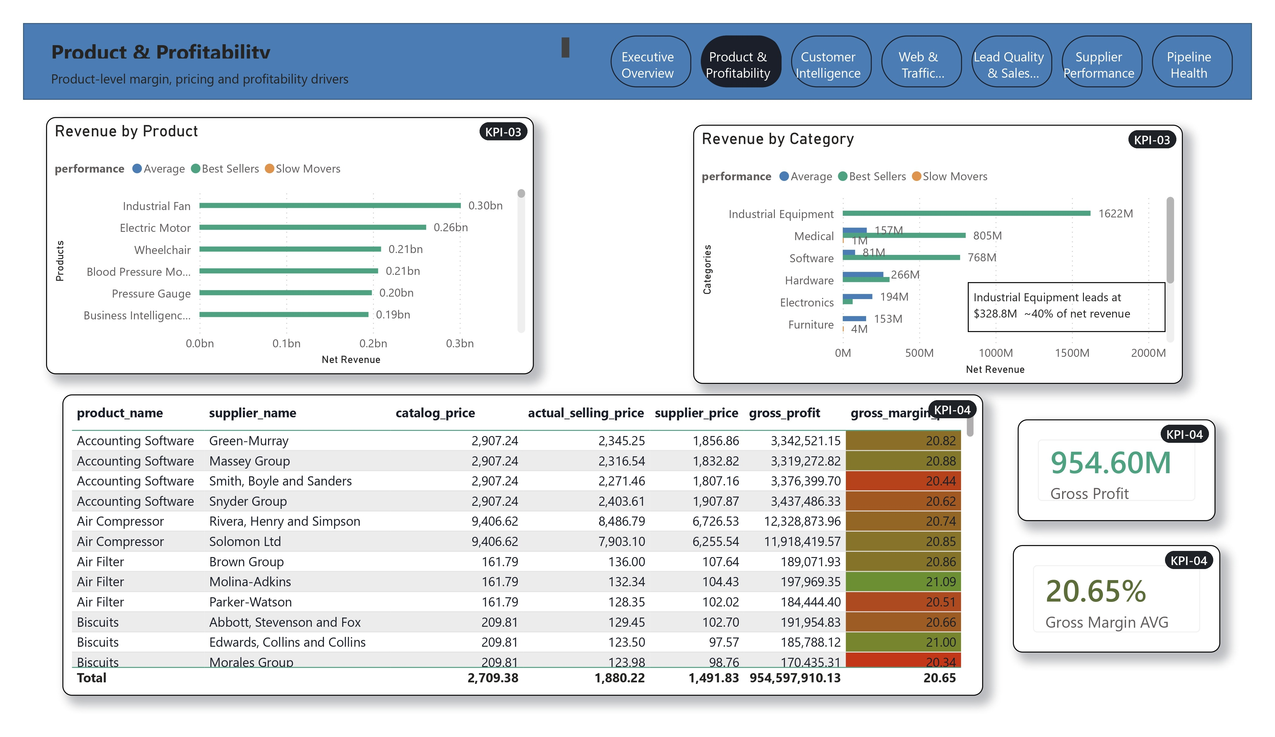
Figure 2: Dashboard page — Executive Overview (KPI-01, KPI-02)
Figure 3 shows the Product & Profitability page of the Power BI dashboard; every visual carries the number of the KPI it displays (KPI-03, KPI-04).
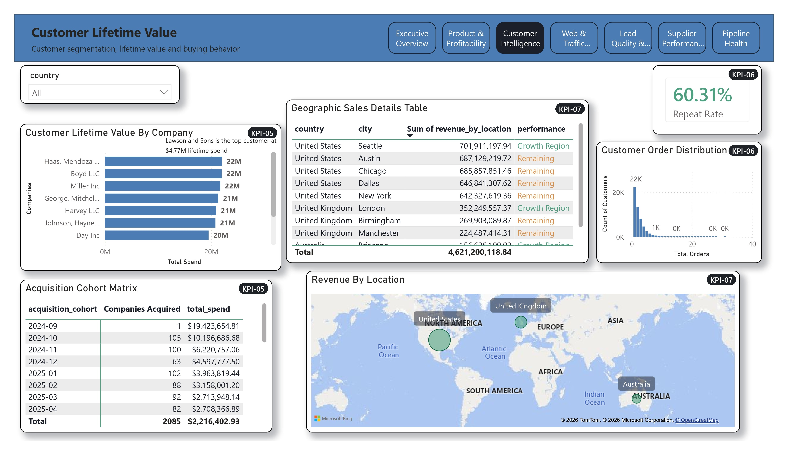
Figure 3: Dashboard page — Product & Profitability (KPI-03, KPI-04)
Figure 4 shows the Customer Intelligence page of the Power BI dashboard; every visual carries the number of the KPI it displays (KPI-05, KPI-06, KPI-07).
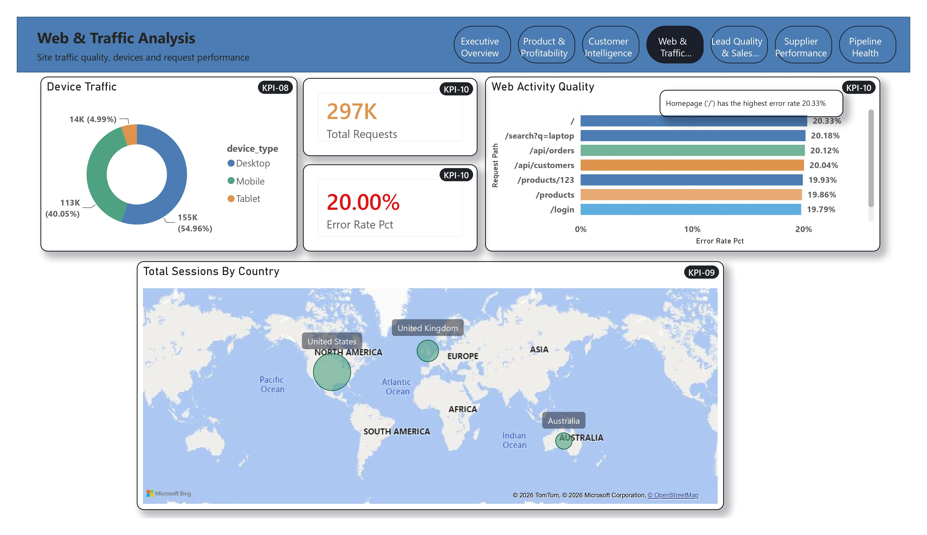
Figure 4: Dashboard page — Customer Intelligence (KPI-05, KPI-06, KPI-07)
Figure 5 shows the Web & Traffic Analytics page of the Power BI dashboard; every visual carries the number of the KPI it displays (KPI-08, KPI-09, KPI-10).
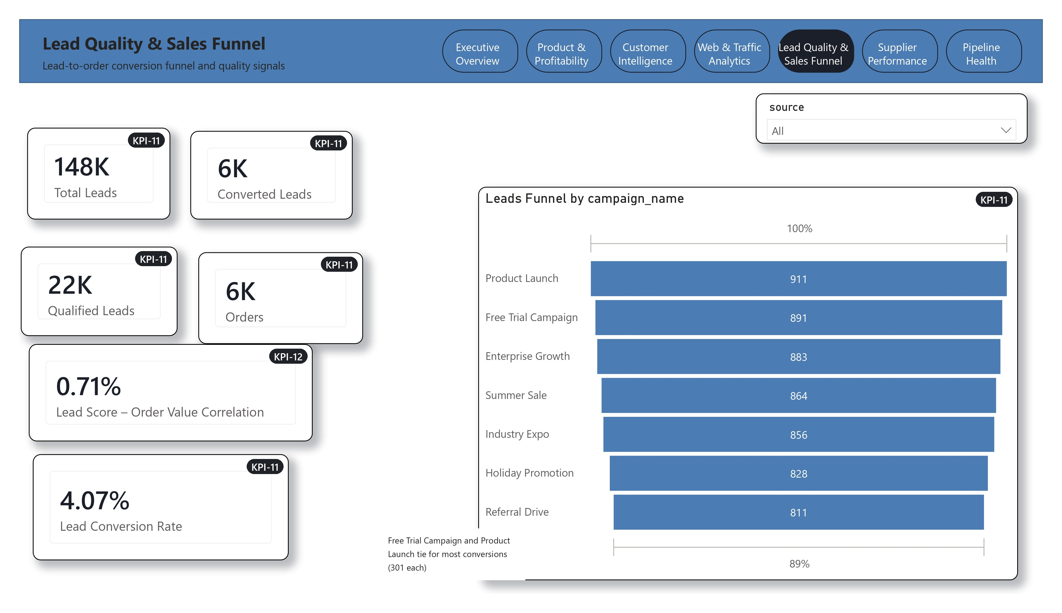
Figure 5: Dashboard page — Web & Traffic Analytics (KPI-08, KPI-09, KPI-10)
Figure 6 shows the Lead Quality & Sales Funnel page of the Power BI dashboard; every visual carries the number of the KPI it displays (KPI-11, KPI-12).
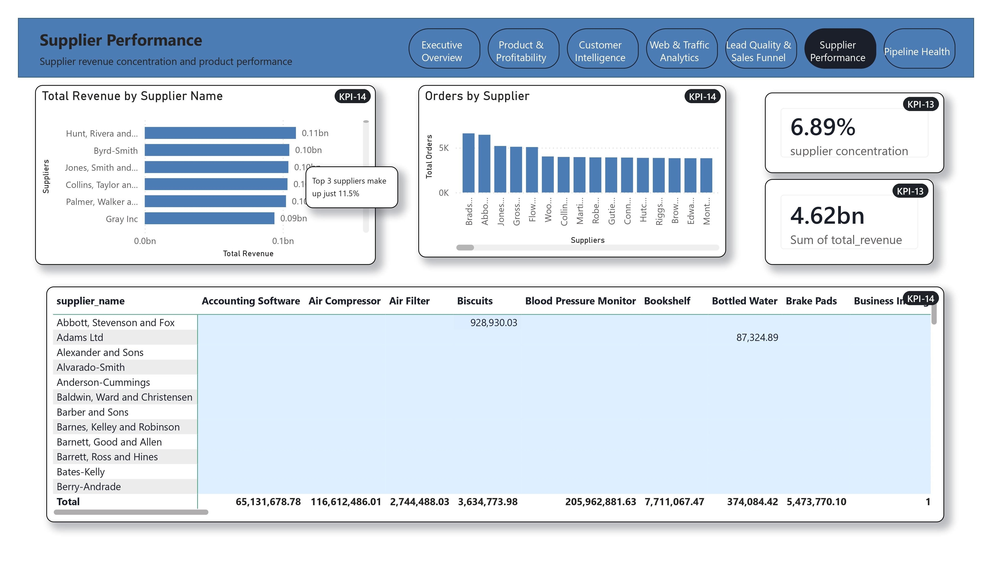
Figure 6: Dashboard page — Lead Quality & Sales Funnel (KPI-11, KPI-12)
Figure 7 shows the Supplier Performance page of the Power BI dashboard; every visual carries the number of the KPI it displays (KPI-13, KPI-14).
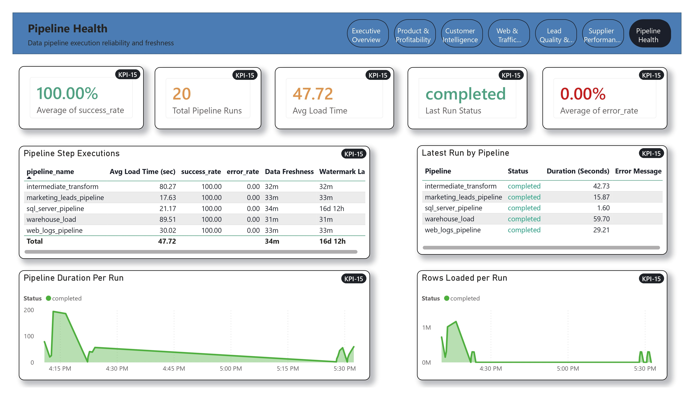
Figure 7: Dashboard page — Supplier Performance (KPI-13, KPI-14)

6. KPI Validation Summary
All 15 KPIs were validated on the final data set by comparing each view with an independent calculation on the warehouse tables (details in the Test Document, section 8, and 08b_Test_Case_Register.xlsx, sheet KPI_Validation). Result: 15 of 15 passed.
- Net revenue is identical in KPI-03, 05, 07, 13 and 14: 4,621,200,118.84 (KPI-01 shows the 23 complete months only), and equals the sum of non-cancelled order totals.
- Repeat purchase rate 60.31 %, 6,044 converted leads, 59348 error requests out of 296703.
- KPI-12 shows a correlation of 0.0071 between lead score and order value, i.e. practically no relationship in the generated data.
Figure 8 shows the Pipeline Health page of the Power BI dashboard; every visual carries the number of the KPI it displays (KPI-15).
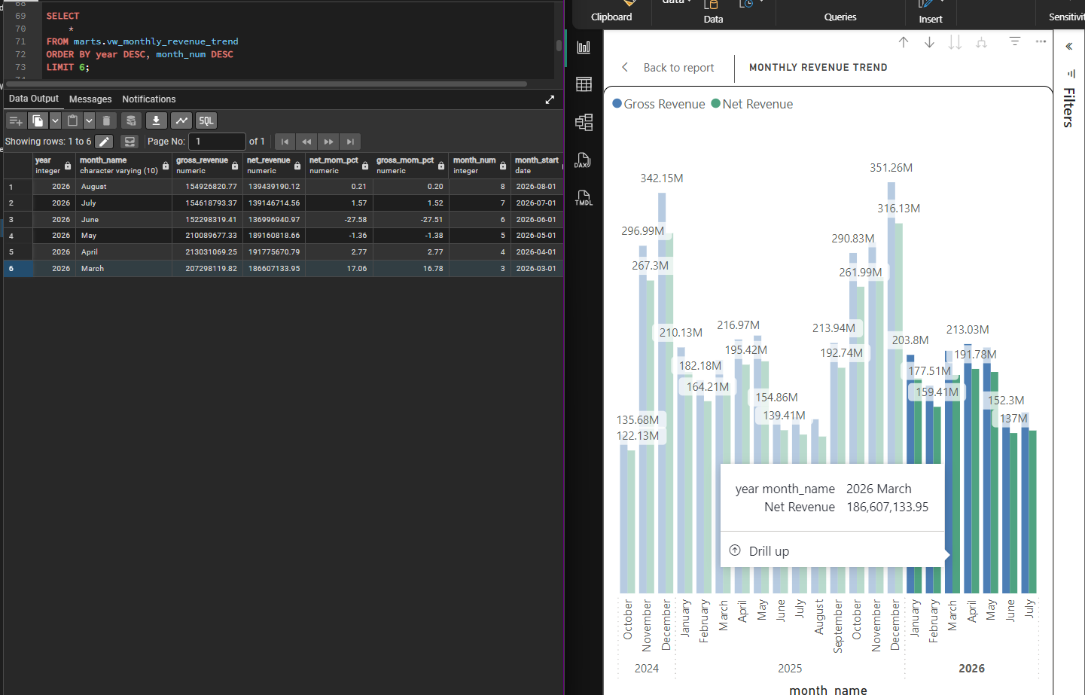
Figure 8: Dashboard page — Pipeline Health (KPI-15)

7. Glossary
Table 21: Glossary
Term | Definition
MoM | Month over month: change compared with the previous month.
Pareto (80/20) | Analysis showing that a small share of customers brings most revenue.
Cohort | Group of customers by the month of their first order.
Conversion rate | Share of leads (or sessions) that result in an order (or checkout).
Watermark lag | Time since the last extracted change; shows how fresh the data is.

