**COAL LAB 5**

**21k-4834**

**TASK 1**

include Irvine32.inc

.data

arr dword 20 dup(?)

.code

main proc

mov esi, offset arr

mov eax, 0

mov [esi], eax

call writedec

call crlf

add esi, 4

mov eax, 1

mov [esi], eax

call writedec

call crlf

mov ecx, 8

l1:

add esi, 4

mov eax, [esi-8]

add eax, [esi-4]

mov [esi], eax

call writedec

call crlf

loop l1

exit

main endp

end main

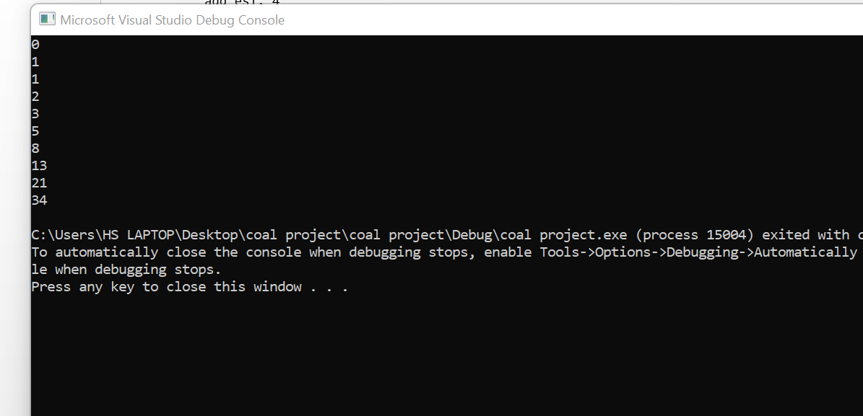

**TASK 2**

include Irvine32.inc

.data

arr Dword 8,5,1,2,6

.code

main proc

mov ecx, 4

mov ebx, 4

mov esi, 0

mov edi, 0

l1:

mov edx, ecx

mov ecx, ebx

mov edi, esi

add edi, 4

l2:

mov eax, arr[esi]

cmp eax, arr[edi]

jl target

XCHG eax, arr[edi]

xchg arr[esi],eax

target:

add edi, 4

loop l2

mov ecx, edx

dec ebx

add esi, 4

loop l1

mov ecx, 5

mov esi, 0

l3:

mov eax, arr[esi]

call writedec

call crlf

add esi, 4

loop l3

exit

main endp

end main

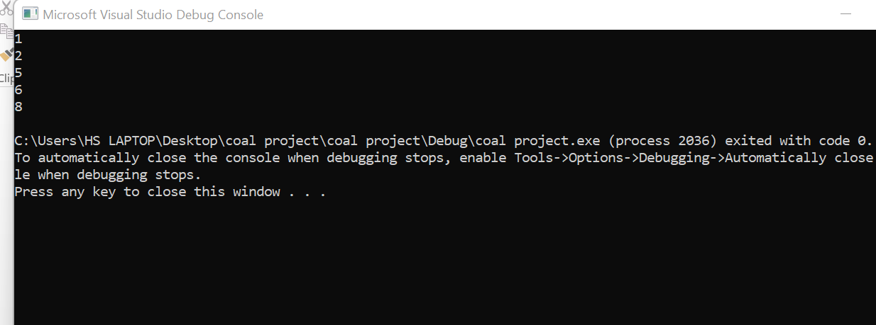

**TASK 3**

INCLUDE Irvine32.inc

.code

main PROC

mov eax, 1

mov ecx, 4

mov ebx, 1

l1:

mov edx, ecx

mov ecx,ebx

l2:

call writedec

loop l2

call crlf

inc ebx

mov ecx, edx

loop l1

call crlf

call crlf

mov ecx, 4

mov ebx, 4

l3:

mov edx, ecx

mov ecx,ebx

l4:

call writedec

loop l4

call crlf

dec ebx

mov ecx, edx

loop l3

call crlf

call crlf

mov ebx, 4

mov ecx, 4

l5:

mov eax, 4

mov edx, ecx

mov ecx, ebx

l6:

call writedec

dec eax

loop l6

call crlf

dec ebx

mov ecx, edx

loop l5

call crlf

call crlf

mov ebx, 4

mov ecx, 4

l7:

mov eax, 1

mov edx, ecx

mov ecx, ebx

l8:

call writedec

inc eax

loop l8

call crlf

dec ebx

mov ecx, edx

loop l7

exit

main ENDP

END main

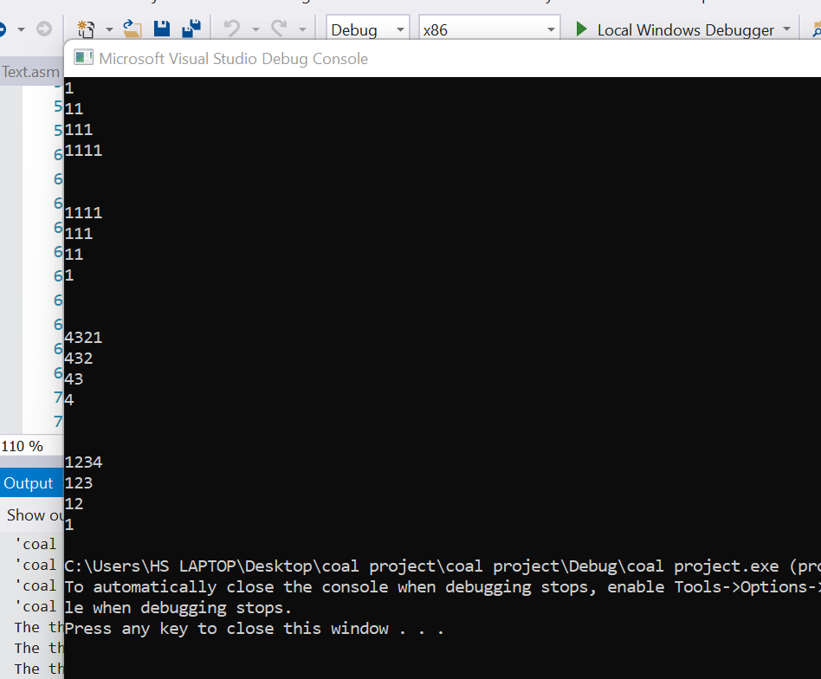

**TASK 4**

include Irvine32.inc

.data

id dword 5 dup(?)

name1 byte 5 dup(30 dup(?),0)

birthyear dword 5 dup(?)

annualsalary Dword 5 dup(?)

totalannualsalary dword ?

prompt1 byte "Enter Employee's id : ",0

prompt2 byte "Enter Employee's name : ",0

prompt3 byte "Enter Employee's Birth Year : ",0

prompt4 byte "Enter Employee's Annual Salary : ",0

prompt5 byte "Total annual salary : ",0

.code

main proc

mov ecx, 5

mov esi, 0

mov edi, 0

l1:

mov edx, offset prompt1

call writestring

call readint

mov id[esi], eax

mov edx, offset prompt2

call writestring

mov ebx, ecx

mov edx, offset name1

add edx, edi

mov ecx, 31

call readstring

add edi, 31

mov ecx, ebx

mov edx, offset prompt3

call writestring

call readint

mov birthyear[esi], eax

mov edx, offset prompt4

call writestring

call readint

mov annualsalary[esi],eax

add esi, 4

loop l1

mov ecx, 4

mov eax, annualsalary

mov esi, 4

l2:

add eax, annualsalary[esi]

add esi,4

loop l2

mov totalannualsalary, eax

mov edx, offset prompt5

call writestring

call writedec

exit

main endp

end main

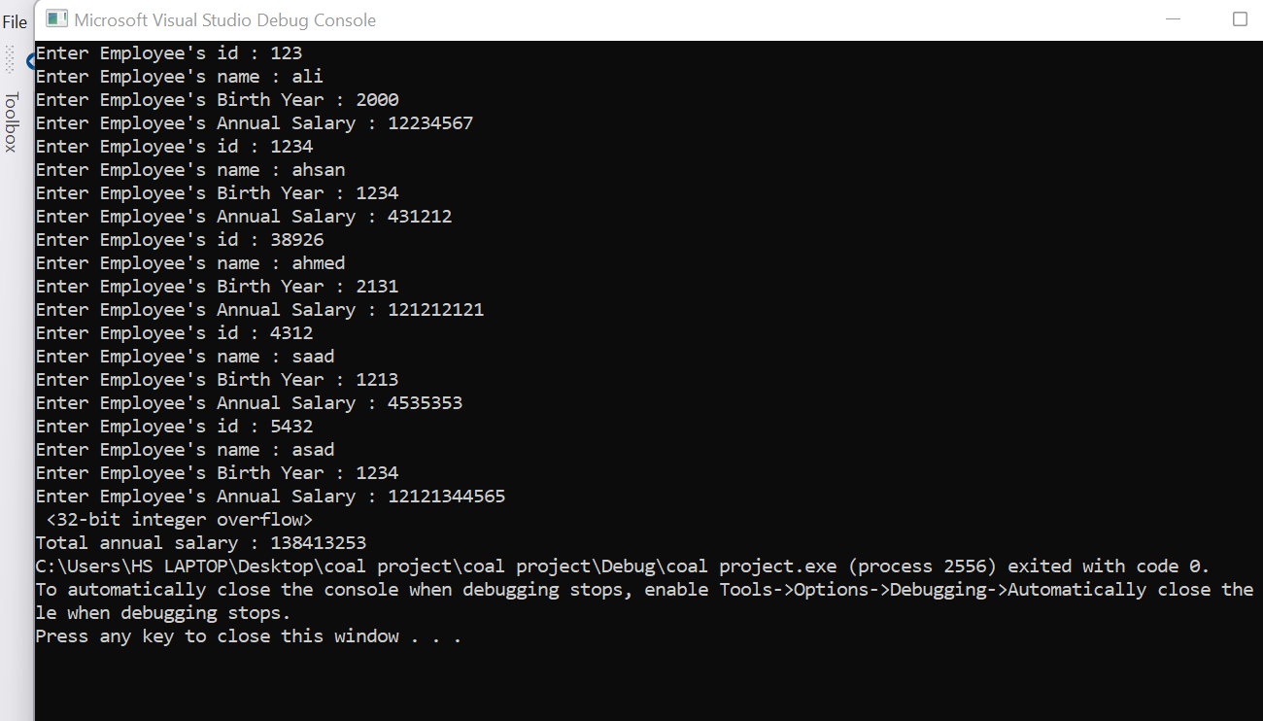

**TASK 5**

include Irvine32.inc

.data

source byte "Hello World",0

target byte 11 dup(?), 0

.code

main proc

mov ecx, 11

mov esi, 0

l1:

mov al, source[esi]

mov target[esi], al

add esi, 1

loop l1

mov edx, offset source

call writestring

call crlf

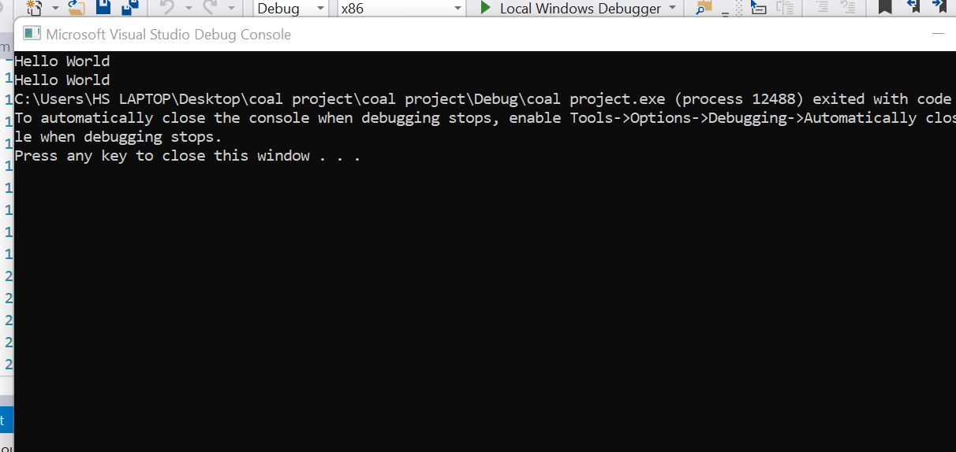

mov edx, offset target

call writestring

exit

main endp

end main

**TASK 6**

include Irvine32.inc

.data

arr DWORD 1,2,3,4,5

.code

main proc

mov esi, 0

mov ecx, lengthof arr / 2

mov ebx, type arr * lengthof arr

l1:

sub ebx, 4

mov eax, arr[esi]

XCHG eax, arr[ebx]

XCHG arr[esi], eax

add esi , type arr

loop l1

mov esi, offset arr

mov ecx, lengthof arr

l2:

mov eax, [esi]

add esi, type arr

call writedec

call crlf

loop l2

exit

main endp

end main

