**COAL LAB 9**

**21k-4834**

TASK 1

INCLUDE Irvine32.inc

.code

main PROC

mov eax, 2

mov ebx, eax

mov ecx, eax

shl eax, 4

shl ebx, 2

add eax, ebx

add eax, ecx

call writeint

exit

main ENDP

END main

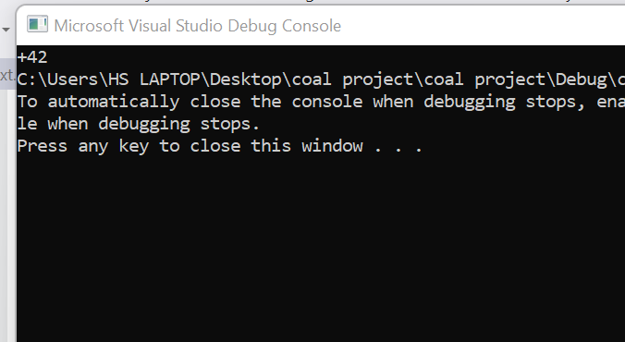

TASK 2

INCLUDE Irvine32.inc

.code

main PROC

mov ax, -128

shl eax, 16

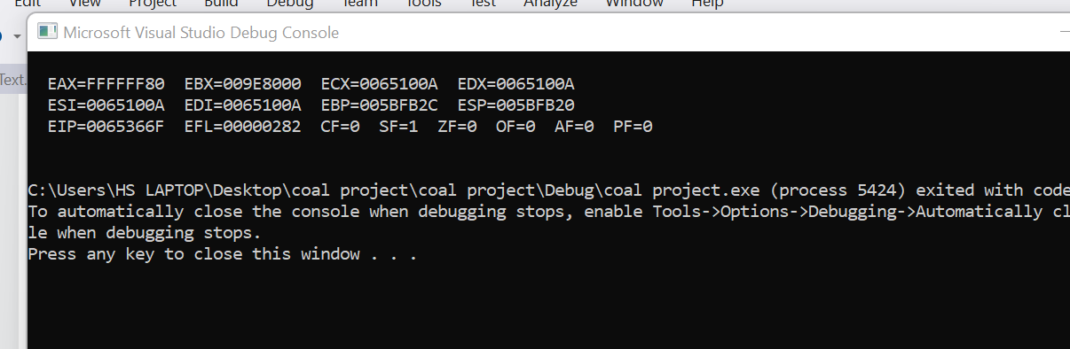

sar eax, 16

call dumpregs

exit

main ENDP

END main

TASK 3

INCLUDE Irvine32.inc

.data

timestamp word 0101011111100000b

bMinutes byte ?

.code

main PROC

movzx eax, timestamp

shl ax, 5

shr ax, 10

mov bMinutes, al

movzx eax, bMinutes

call writebin

exit

main ENDP

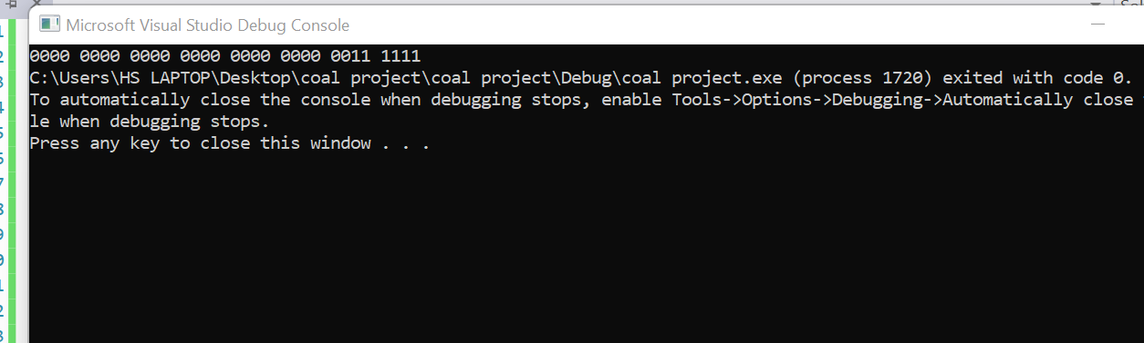

END main

TASK 4

INCLUDE Irvine32.inc

.code

main PROC

mov ax, 1d

mov bx, 0d

call dumpregs

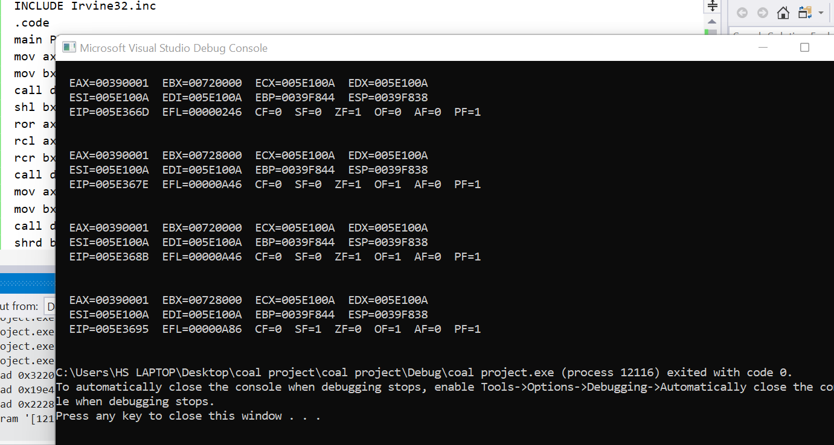

shl bx, 1

ror ax, 1

rcl ax, 1

rcr bx, 1

call dumpregs

mov ax, 1d

mov bx, 0d

call dumpregs

shrd bx, ax, 1

call dumpregs

exit

main ENDP

END main

TASK 5

INCLUDE Irvine32.inc

.data

v1 sdword 15

v2 sdword 10

v3 sdword 5

.code

main proc

mov edx, 0

mov eax, v2

mov ecx, v3

idiv ecx

mov ebx, eax

mov edx, 0

mov eax, v1

mov ecx, v2

idiv ecx

mov edx, 0

imul ebx

mov v1, eax

call dumpregs

exit

main ENDP

END main

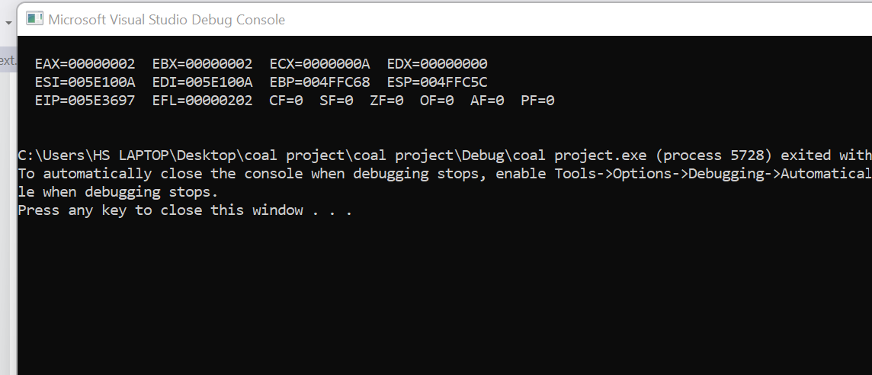

TASK 6

include irvine32.inc

.data

v1 qword 22422552233h

v2 qword 11111100111h

.code

main proc

call Extended_Add

call dumpregs ; edx:eax

exit

main endp

Extended_Add proc

mov eax, dword ptr v1

mov ebx, dword ptr v1+4

mov ecx, dword ptr v2

mov edx, dword ptr v2+4

add eax, ecx

adc edx, ebx

ret

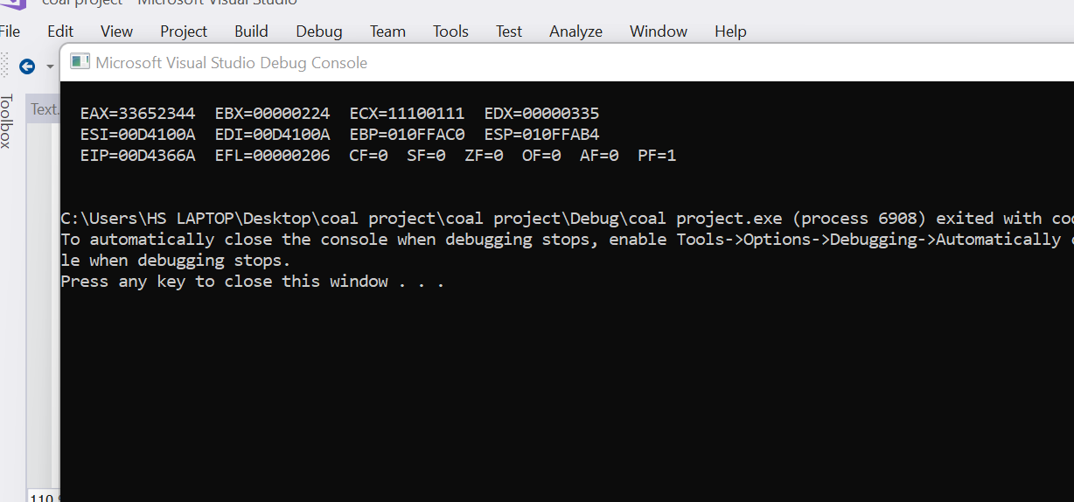

Extended_Add endp

end main