News Sentiment as a Trading Signal: Measuring Predictive Decay Across Holding Horizons
A Point-in-Time, Cost-Aware Evaluation of FinBERT News Sentiment for Multi-Horizon Equity Trading
Syed Sirajuddin
Master of Science in Applied Artificial Intelligence
Shiley Marcos School of Engineering / University of San Diego
ssirajuddin@sandiego.edu
ABSTRACT
This project investigates whether the tone of daily financial news can be converted into a profitable equity trading signal, and specifically how any such signal's value changes with the holding horizon. A complete pipeline was built: multi-year news was ingested from the Alpha Vantage market-news interface, each headline was scored by a fine-tuned FinBERT transformer model, the scores were aggregated into point-in-time trading signals, and an identical signal stream was evaluated across eight holding horizons from one to one hundred twenty-six trading days against a buy-and-hold baseline and a random-signal null distribution. The sentiment classifier itself performed strongly (test macro-F1 of 0.901), and its scores agreed with an independent commercial sentiment model on seventy-five percent of article directions, establishing that the sentiment measurement appeared sound.
However, when converted into a trading strategy and tested out-of-sample with realistic transaction costs, the signal did not beat a random-signal null at any holding horizon; hyperparameter tuning yielded only statistically indistinguishable, near-zero configurations, and a learned LSTM comparison model performed at chance. The analysis explains why: the signal is squeezed from both ends, too cost-heavy to exploit at the short swing-trading horizons and too data-sparse to confirm at the long position-trading horizons. The result is a rigorously supported negative finding, consistent with an efficient-market interpretation, and a demonstration of the evaluation discipline required to avoid the look-ahead and selection artifacts that inflate financial backtests.
KEYWORDS
news sentiment analysis, FinBERT, natural language processing, algorithmic trading, backtesting, holding horizon, market efficiency, transaction costs, transformer models
1 Introduction
Modern equity markets generate a continuous, high-volume stream of price-relevant news, far more than any individual investor can read and act on in a timely way. Under the efficient market hypothesis, public information should be incorporated into prices almost immediately; empirically, however, a substantial literature documents that the textual tone of news predicts returns with a measurable but often short-lived lag. This project asks a deliberately comparative question: if daily financial-news sentiment carries tradeable information, over what holding horizon does that information remain exploitable? Rather than committing to a single trading style, the holding horizon is treated as the primary experimental variable, and the same sentiment-derived signals are evaluated at holds ranging from one day to roughly six months against passive and no-skill baselines.
The central hypothesis, motivated by prior findings of reversal and decay in news-driven price effects, is that predictive value is strongest at short (swing) horizons and decays as the holding period lengthens. Consistent with sound scientific practice, a finding that the signal disappears is treated as being as valuable as a finding that it persists. The intended end user is a retail investor who actively manages a portfolio and needs a research and decision-support screener, not a black-box autopilot and not a high-frequency system.
The project uses two data sources. Daily open-high-low-close-volume price bars for a universe of twenty liquid, large-capitalization U.S. equities are obtained from Yahoo Finance through the open-source yfinance library (Aroussi, 2023). Financial-news headlines linked to those tickers, together with an independent commercial sentiment score for each article, are obtained from the Alpha Vantage market-news-and-sentiment interface (Alpha Vantage, n.d.). A third, auxiliary dataset, the Financial PhraseBank of expert-annotated sentences (Malo, Sinha, Korhonen, Wallenius, & Takala, 2014), is used to fine-tune and validate the sentiment model. The ultimate goal is to determine whether a simple, interpretable, cost-aware sentiment strategy can beat passive and random baselines at any horizon, and to characterize the shape of the signal's value across horizons.
2 Data Summary
This project draws on two primary data streams and one auxiliary labeled corpus. The first stream is daily market data for twenty large-capitalization U.S. equities spanning technology, financial, health-care, energy, consumer, and industrial sectors, obtained through the open-source yfinance library (Aroussi, 2023). For each stock and each trading session from January 2, 2020 through December 30, 2025, a total of 1,507 sessions and 30,140 observations, the data record the opening, intraday high, intraday low, and closing prices, the number of shares traded, and an adjusted closing price that corrects for stock splits and dividends. From these
I derive the variables the models actually consume: the daily percentage return, short- and medium-term moving averages of price, one-month momentum, one-month realized volatility, and a standard overbought/oversold oscillator. The second stream is financial news obtained from the Alpha Vantage market-news-and-sentiment interface (Alpha Vantage, n.d.): 100,678 timestamped headlines attributed to the universe tickers, spanning March 2022 through December 2025. Each article arrives with Alpha Vantage's own per-ticker relevance and sentiment scores, and is additionally scored by the FinBERT transformer classifier (Araci, 2019) into probabilities of positive, negative, and neutral tone, which I combine into a single sentiment score (the positive probability minus the negative probability, bounded between negative one and positive one) and then aggregate to one row per stock per day: the article count, the average score, a confidence-weighted average that discounts ambiguous articles, and short rolling versions of each. The auxiliary dataset is the Financial PhraseBank (Malo et al., 2014), 3,453 financial-news sentences labeled positive, neutral, or negative at the 75 percent annotator-agreement level, which I split into 2,762 training, 345 validation, and 346 test sentences (stratified by class; the balance is roughly 62 percent neutral, 26 percent positive, and 12 percent negative) for fine-tuning and benchmarking the sentiment model.
The two data streams presented very different data-quality profiles. The price panel arrived unusually clean: no missing price fields, every ticker present for all 1,507 sessions with no unexplained gaps, and an automated screen for extreme single-day moves not corroborated by trading volume (the signature of bad prints or unadjusted split artifacts) flagged zero rows, confirming that vendor adjustments correctly absorbed even the large splits inside the window, such as Amazon's 20-for-1 and Tesla's 3-for-1 splits in 2022. I retained all these checks as permanent validation stages rather than one-time steps; in a fully developed pipeline they would run automatically on every ingest with alerts. The news stream required more intervention.
Two data-quality issues surfaced during ingestion and were corrected. First, the ticker for Alphabet was tagged by the vendor under the symbol GOOG rather than GOOGL, which initially returned zero articles for that name until the symbol mapping was fixed. Second, an early pagination bug silently truncated several heavily-covered tickers at exactly one thousand articles; a completeness check that flags any ticker not spanning the full window, or landing on a suspiciously round count, was added to catch this, after which all twenty tickers were confirmed complete. Newswire syndication causes the same story to be republished under many outlets, which would let one event masquerade as many independent signals; removing exact duplicate headlines per ticker, along with sub-ten-character feed fragments, reduced the raw collection of 100,678 articles to 95,758 cleaned articles.
The vendor's ticker attribution is itself imperfect, since market-roundup stories that mention a company only peripherally still arrive under its ticker, a linkage noise I mitigate with daily aggregation, confidence weighting, and a minimum-article-support requirement, and would address in production with an entity-recognition relevance filter. Finally, because many articles are published after the market close or on weekends, every article is mapped at ingestion to its effective date, the first session on which it could actually have been traded, a discipline that guards the entire downstream pipeline against look-ahead bias (Lopez de Prado, 2018).
The most consequential remaining dataset constraint is the depth of the news history. The Alpha Vantage news-and-sentiment archive begins in March 2022, so the joint news-and-price window spans roughly three years and ten months. This is a substantial improvement over the single-year coverage of the free tier of the vendor initially considered, and it is deep enough to support a conventional calendar-based split, tuning signal parameters on 2022 through 2024 and reserving the full 2025 year as an untouched out-of-sample period. It nonetheless bounds the longest holding horizons: a one-hundred-twenty-six-trading-day position opened late in the out-of-sample year cannot complete within it, so the longest horizons accumulate few non-overlapping trades and are interpreted with corresponding caution. In a production system the remedy is straightforward, whether a commercial feed with deeper history, additional providers for cross-source robustness, or simply accumulating one's own point-in-time archive over time.
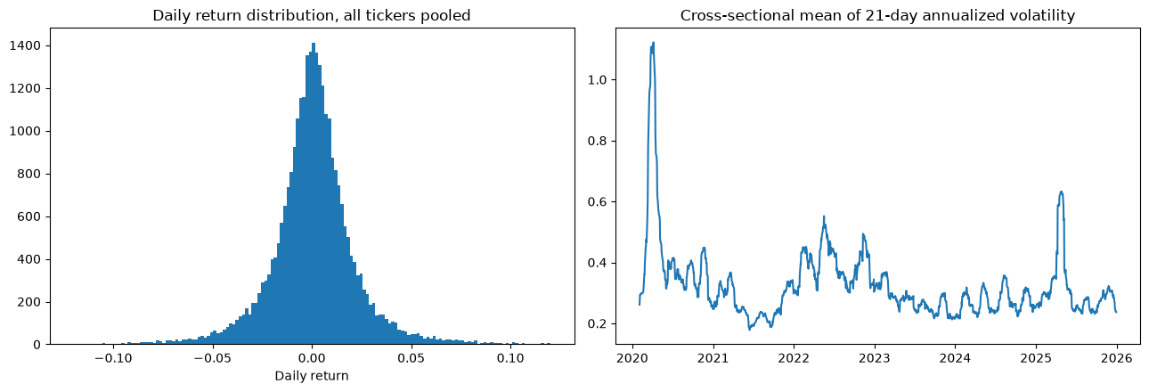
[Figure 2.1]
Left: distribution of daily returns pooled across all twenty tickers, showing the sharp peak and heavy tails characteristic of equity returns. Right: cross-sectional mean of 21-day annualized volatility, with pronounced spikes in March 2020 and 2025 and elevated levels through the 2022 drawdown.
The exploratory analysis supports the premise of the project while calibrating expectations about effect sizes. As seen in Figure 2.1, pooled daily returns are sharply peaked and heavy-tailed rather than bell-shaped, and volatility arrives in pronounced clusters: the March 2020 pandemic shock most dramatically, with renewed elevation through the 2022 drawdown and further turbulence in 2025. These are the classic stylized facts of equity returns (Cont, 2001), and they motivate two design choices: performance is reported with maximum drawdown alongside the Sharpe ratio, since volatility alone understates tail risk, and the news window spans meaningfully different volatility regimes. On the news side, Figure 2.2 shows the article-level sentiment scores are strongly trimodal: a large central mass near zero, reflecting routine neutral corporate coverage, and secondary modes near the extremes where the classifier is confident. The entry thresholds of plus or minus 0.35 fall in the sparsely populated valleys between these modes, which means the number of trading signals is not overly sensitive to the exact threshold value.
Spot checks confirm the scorer behaves sensibly on clear-cut cases: an earnings beat scores 0.94 positive, a regulatory-investigation headline 0.73 negative, and a routine meeting announcement 0.94 neutral. Most directly, Figure 2.3 relates the daily average sentiment to the following day's return: the Spearman rank correlation is small and positive (approximately 0.04), a magnitude consistent with the prior literature, where news-tone effects on returns are economically meaningful yet statistically modest at the daily level (Tetlock, 2007; Heston & Sinha, 2017). This is exactly the regime this project is designed for: a weak per-observation signal that must be aggregated, filtered, and evaluated on a risk-adjusted basis across horizons, rather than a large edge visible to the naked eye.
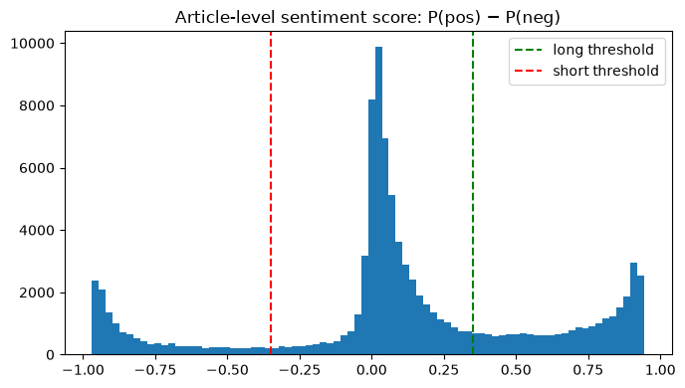
[Figure 2.2]
Distribution of article-level sentiment scores (positive probability minus negative probability). The distribution is trimodal, and the entry thresholds fall in the low-density valleys between the neutral mass and the confident-polar modes.
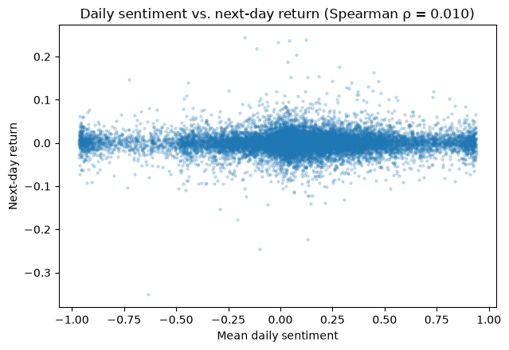
[Figure 2.3]
Daily average sentiment versus next-day return across all ticker-days with news coverage. The small positive Spearman correlation indicates a weak association, consistent in magnitude with the prior literature on daily news tone.
Relationships among the variables themselves shape how the models are built. Figure 2.4 shows the pairwise correlation of daily returns across the universe: the average correlation is 0.361, with a visibly tighter technology cluster and weaker co-movement among the defensive names. Two consequences follow. Because simultaneous positions in correlated names are not independent bets, the backtest caps the number of concurrent positions and reports portfolio-level drawdown rather than treating trades as uncorrelated, and an equal-weighted buy-and-hold portfolio of the same names is the natural passive baseline, since it inherits the same correlation structure. Among the derived price variables, strong correlations exist by construction (the moving averages are smoothed versions of the same price series, and momentum and the oscillator overlap), which is harmless for the rule-based signal filter but argues for the small, normalized feature set used for the sequence model rather than a large redundant one. The sentiment aggregates, finally, are deliberately constructed from current and past information only, so any correlation they show with future returns reflects genuine predictive content rather than leakage from the alignment process.
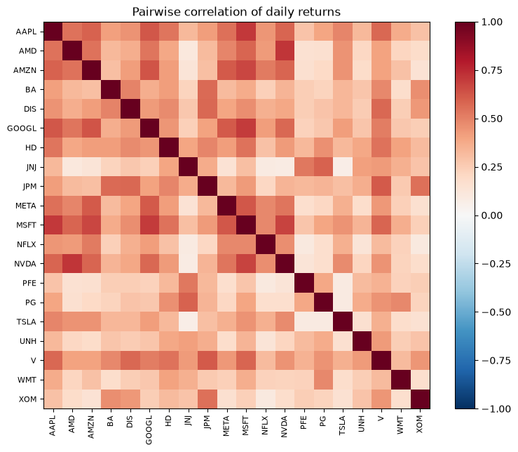
[Figure 2.4]
Pairwise correlation of daily returns across the twenty-stock universe (mean 0.361). Co-movement is strongest within the technology cluster and weakest among the defensive names.
3 Literature Review
Researchers have studied whether the tone of financial news can help predict stock returns for nearly two decades, and the methods have developed from simple word counts to context-aware deep learning models. Tetlock (2007) used the Harvard psychosocial dictionary to measure negative language in a daily Wall Street Journal column and found that high media pessimism was followed by downward price pressure, unusually high trading volume, and a later return toward fundamentals. Loughran and McDonald (2011) showed why general-purpose dictionaries can be unreliable in finance. They found that many words labeled as negative, including tax, cost, liability, and capital, are often neutral in financial documents. Their finance-specific word lists became a widely used baseline because they better matched the meaning of financial language. However, dictionary methods still treat text as an unordered collection of words, so they can miss context, negation, and the meaning of a complete sentence.
Later research used supervised learning, event representations, and social-media data to capture more complex relationships between language and market behavior. Ke et al. (2019) developed a supervised text-mining framework that identified return-predictive terms, weighed them through a topic model, and combined them into article-level sentiment scores. Using Dow Jones Newswires, they found that task-specific sentiment scores provided stronger predictive signals than dictionary measures and commercial sentiment products. Bollen et al. (2011) analyzed mood in Twitter messages and reported that one mood dimension improved directional prediction of the Dow Jones Industrial Average, although later studies have found social-media results to be less stable. Ding et al. (2015) represented financial news as structured events and used event embeddings with a convolutional neural network. Their model outperformed bag-of-words baselines when predicting both market-index and individual-stock movements.
Commercial systems also show that news sentiment is used outside academic research. RavenPack has provided entity-tagged news analytics, sentiment measures, and event classifications since 2003 for applications such as quantitative signal generation and risk management. LSEG MarketPsych Analytics converts large volumes of news and social-media content into sentiment, emotion, and topic scores at minute, hourly, and daily frequencies, with historical data extending back to 1998. These systems demonstrate that news-derived sentiment has become an established input for financial analysis rather than remaining only a research concept.
Existing research also shows that the value of a sentiment signal depends on the prediction or holding horizon. Tetlock (2007) found that the price effects connected to media pessimism were temporary and generally reversed within about one trading week. Heston and Sinha (2017) examined this relationship more directly and reported that daily news predicted returns over the next one to two days, while news aggregated over a week predicted returns for as long as a quarter. Ke et al. (2019) similarly found that news-based strategies performed best at shorter rebalancing intervals and weakened as the interval increased from weekly to monthly and quarterly. Together, these findings show that sentiment signals decay over time and that their usefulness can change depending on how the news is aggregated and how long a position is held.
Transformer-based sentiment models developed from earlier advances in natural language processing. Vaswani et al. (2017) introduced the transformer architecture, which uses self-attention to represent each word in relation to the other words in the same context. Devlin et al. (2019) extended this approach through BERT, a model pre-trained on large unlabeled text collections and then fine-tuned on smaller labeled datasets. BERT produced state-of-the-art results across several language-understanding tasks and reduced the amount of labeled data needed for specialized applications. Araci (2019) adapted BERT to financial language by further pre-training it on a financial news corpus and fine-tuning it on the Financial PhraseBank created by Malo et al. (2014). FinBERT improved sentiment-classification accuracy over earlier methods, especially for context-dependent financial statements that dictionary approaches often classify incorrectly. Similar transformer-based systems have also been used commercially; for example, LSEG has applied a RoBERTa-based architecture to score sentiment and emotion in company transcripts at the sentence level across thousands of companies (London Stock Exchange Group, 2025).
Sequence models and nonlinear machine learning methods have also been applied to financial prediction. Hochreiter and Schmidhuber (1997) developed long short-term memory networks to help recurrent models retain information across longer sequences. Fischer and Krauss (2018) later applied an LSTM to daily returns for S&P 500 companies and reported stronger directional-prediction performance than random forests, a deep feedforward network, and logistic regression. Gu et al. (2020) compared multiple machine learning methods for estimating equity risk premiums and found that neural networks and regression trees produced the largest improvements over linear models because they could capture nonlinear relationships and interactions among predictors. This research provides examples of both transformer-based financial sentiment analysis and sequence-based market prediction, showing that the two methods are well suited for systems that combine text, sentiment, and time-dependent market data.
Research on financial machine learning also emphasizes that model evaluation must account for the risks of backtest overfitting and biased historical testing. Sharpe (1994) formalized the Sharpe ratio as a standard measure of risk-adjusted performance. Bailey et al. (2014) showed that testing many strategy variations on the same historical data can produce apparently profitable results by chance. Lopez de Prado (2018) described additional sources of inflated performance, including look-ahead bias, survivorship bias, and omitted transaction costs, and recommended point-in-time data alignment and strict separation of tuning and evaluation samples. As a result, similar financial sentiment projects are commonly evaluated not only by predictive accuracy or total return, but also by whether the backtest controls for data leakage, selection bias, trading costs, and risk.
4 Methodology
This project is built as a sequential pipeline rather than a single model. Its methodology brings together two machine learning components, a rule-based decision layer, and an evaluation engine. The first component is a supervised deep-learning text classifier that turns each news headline into a sentiment score, and it is paired with an independent commercial sentiment signal that acts as an external benchmark. The second component is a recurrent neural network that learns a trading signal from sequences of sentiment and price features. A signal-generation layer connects them, converting daily sentiment into discrete trade entries, and a fixed-horizon backtesting engine evaluates those entries across a range of holding periods. The subsections below describe the news data source, each modeling stage, the data splits and training procedure, and the optimization. All performance results are reserved for the Results section.
4.1 News Data Source
News headlines are drawn from the Alpha Vantage market-news-and-sentiment interface (Alpha Vantage, n.d.), a documented public application programming interface whose news archive reaches back to March 2022. For each article it returns a ticker-level relevance score, its own sentiment score, and a set of topic classifications. This source contributes in two ways. First, it supplies the multi-year history that the longer horizons need in order to accumulate enough non-overlapping trades to be meaningful. Second, its independent article-level sentiment score gives the project an external benchmark: the same articles can be scored by both the commercial model and the project's own FinBERT model, so the analysis can report whether the two agree and whether trading signals built on each behave alike. Every incoming article is normalized to a common record format and passed through the same cleaning and point-in-time alignment steps used elsewhere in data preparation, so the choice of source does not leak future information into the backtest. The commercial score is carried through the pipeline as an extra feature rather than as a substitute for the project's classifier, which keeps the deep-learning text model as the primary method while still enabling the comparison.
4.2 Sentiment Classification Model
The sentiment classifier is a transformer-based model in the BERT family called FinBERT (Devlin et al., 2019) downloaded through Hugging Face (ProsusAI/finbert). Its encoder stacks twelve transformer layers, each with twelve self-attention heads and a hidden representation size of 768, for a total of roughly 110 million parameters. A three-way classification head sits on the pooled representation of the leading token and produces a probability distribution over negative, neutral, and positive tone through a softmax output. This architecture was chosen because most of its linguistic knowledge is acquired during unsupervised pre-training on large text corpora. As a result, it can be specialized to financial sentiment from only a few thousand labeled examples, an approach shown to work well in the financial domain by Araci (2019).
The model is fine-tuned on the labeled Financial PhraseBank corpus. Once trained, the classifier is applied to every collected headline, and its three output probabilities are reduced to a single sentiment score defined as the positive probability minus the negative probability, a value between negative one and positive one (citation of model needed here). This scalar keeps both the direction and the confidence of the sentiment: a confidently neutral article scores near zero, while a strongly polar article scores near the matching extreme. When an article also carries a commercial sentiment score from Alpha Vantage, that value is retained on the same scale, so the two independent measures of tone can be compared directly and each can drive the signal layer in turn.
4.3 Feature Aggregation and Signal Generation
The scored headlines are aggregated into a daily panel with one row per stock per trading day. Alongside a simple average of the day's article scores, the pipeline computes a confidence-weighted average in which each article is weighted by one minus its neutral probability, so that decisive articles shape the daily tone more than ambiguous ones. Short rolling averages over a three-trading-day window smooth single-article noise and capture multi-day news narratives. Every rolling feature uses current and past information only, which preserves the point-in-time discipline set during data preparation and guards against look-ahead bias (Lopez de Prado, 2018). A set of standard price-based features is derived for each stock as well, including short- and medium-term moving averages, one-month momentum, one-month realized volatility, and a relative-strength oscillator.
The decision layer turns this panel into discrete trade entries using a deliberately simple and interpretable rule. The central experimental variable in this study is the holding horizon, not the sophistication of the signal, and a more elaborate signal would risk confounding the horizon comparison with its own quirks. A long entry is triggered for a stock on a given day when three conditions hold, using only information available that day: the rolling sentiment exceeds a positive threshold, at least a minimum number of articles support the reading within the window, and the closing price sits above its twenty-day moving average. That last condition is a trend filter, and it avoids buying favorable news in a name that is already declining. Short entries mirror these conditions with a symmetric negative threshold. The numerical values of these thresholds are treated as tunable hyperparameters, addressed under optimization below.
4.4 Multi-Horizon Backtesting and Baselines
The evaluation engine is the methodological core of the project. It applies one identical stream of trade entries at eight fixed holding horizons, spanning [1, 3, 5, 10, 21, 42, 63 and 126] trading days. Holding the entries fixed isolates the horizon as the only variable that changes across comparisons. The engine's execution model builds in several safeguards drawn from the backtesting literature (Bailey et al., 2014; Lopez de Prado, 2018). Trades are filled one trading day after the signal is observed, so no position is opened using information from the same closing bar that generated it. Each round-trip trade is charged a fixed transaction cost of ten basis points per side, which matters because turnover, and therefore cost, is highest at the shortest horizons. A stock cannot be re-entered while a position in it is already open, and the number of positions open at once is capped at ten and equally weighted, which keeps the daily portfolio return series realistic rather than assuming unlimited capital. For each horizon the engine produces both a per-trade record, used to summarize the hit rate and the distribution of trade returns, and a daily portfolio return series, used to compute the Sharpe ratio (Sharpe, 1994) and the maximum drawdown.
Two baselines frame every comparison. The first is a buy-and-hold position in the equal-weighted universe, which shows whether the strategy adds value over simple passive exposure. The second is more demanding: a random-signal null. For each horizon, one hundred strategies are simulated that draw entry dates and stocks at random while keeping the same number of trades, the same horizon, and the same cost model as the sentiment strategy. This produces a full distribution of outcomes that represents no skill combined with identical mechanics. Measuring the sentiment strategy against that distribution ensures ordinary market drift or the structure of transaction costs is not mistaken for genuine signal.
4.5 Training Procedure and Data Splits
The labeled sentiment corpus is divided into training, validation, and test partitions in an eighty, ten, and ten percent split, stratified by class so that each partition reflects the same tone distribution. The classifier is fine-tuned with the cross-entropy loss and the AdamW optimizer at a learning rate of two times ten to the negative fifth, a weight decay of 0.01, and a linear warm-up over the first ten percent of training steps. The small learning rate is standard practice for fine-tuning, since larger rates tend to overwrite the pre-trained weights. Training uses a batch size of thirty-two, a maximum input length of 128 tokens, which comfortably fits news headlines and corpus sentences, and runs for three epochs with a fixed random seed for reproducibility. The checkpoint carried forward is the one that maximizes the macro-averaged F1 score on the validation partition. Macro-averaged F1 is chosen over raw accuracy because the tone classes are imbalanced toward neutral, and because the trading application depends specifically on identifying the minority positive and negative cases. The held-out test partition is scored only once, after selection, to characterize final classification quality.
The trading pipeline separates tuning and evaluation on the same principle, applied chronologically: signal parameters are tuned on an earlier in-sample period and then evaluated once on a later, untouched out-of-sample period, so that no part of the reported comparison is fitted to the evaluation data. Because the news history spans March 2022 through December 2025, the tuning period covers 2022 through 2024 and the full 2025 year is held out for evaluation. Where a horizon has too few completed trades for a stable estimate, it is reported with explicit caution rather than dropped, so the decay pattern can be read across the full range while its least-supported points stay clearly flagged.
4.6 Validation and Optimization
Before any conclusion is drawn from live data, the whole apparatus is validated on synthetic data with a known, planted effect. A synthetic market is generated in which prices follow random walks, except that sentiment impulses nudge the next few days of returns by an amount that decays geometrically. Because the ground truth is fixed by construction, a correct pipeline should recover a decay pattern that is strong at short horizons and fades to nothing at longer ones. This validation confirms that the aggregation, signal, backtest, and baseline machinery behave as intended, so that any pattern later seen in the real data can be attributed to the data rather than to a defect in the code.
Model optimization searches a grid over the sentiment entry threshold, the length of the rolling aggregation window, and the minimum number of supporting articles, evaluating each configuration only on the tuning portion of the data at the median ten-day horizon and selecting on in-sample Sharpe, so that the evaluation period is never used for tuning. For the sentiment classifier, the adjustable elements include the learning rate, the number of training epochs, and the choice of checkpoint. A second model, a recurrent neural network based on long short-term memory units (Hochreiter & Schmidhuber, 1997), which have been shown to work well for financial return prediction (Fischer & Krauss, 2018), takes fixed-length sequences of the combined sentiment and price features and learns to predict the direction of the forward return, providing a learned alternative to the rule-based signal and allowing the two approaches to be compared on the same horizon grid.
5 Results
The FinBERT classifier was fine-tuned on the Financial PhraseBank (2,762 training, 345 validation, 346 test sentences) and selected on validation macro-F1. On the held-out test partition, scored once after selection, it achieved an accuracy of 0.928 and a macro-averaged F1 of 0.901, with a test loss of 0.215. Macro-F1 is the appropriate headline metric here rather than accuracy, because the class distribution is imbalanced toward neutral (62 percent) and the trading application depends on correctly identifying the minority positive and negative classes; a macro-F1 of 0.90 indicates strong per-class performance rather than a model that simply predicts the majority class. The model learned the task well and showed no evidence of overfitting: the small fine-tuning learning rate, the three-epoch schedule, and validation-based checkpoint selection together produced a test macro-F1 close to the validation figure, indicating the classifier generalized rather than memorizing the training sentences.
[Figure 5.1]
Training and validation loss and macro-F1 curves across the three fine-tuning epochs, demonstrating convergence without validation degradation.
5.2 Independent Sentiment Benchmark: FinBERT versus Alpha Vantage
Because every article was scored by both FinBERT and Alpha Vantage's independent commercial model, the two measures could be compared directly across all 95,758 dual-scored articles. The two scores show a Pearson correlation of 0.369 and a Spearman rank correlation of 0.346, agree on the direction of sentiment (positive versus negative) for 75.0 percent of articles, and agree on the full three-way label (negative, neutral, positive) for 48.8 percent of articles. This is moderate rather than strong agreement, which is the expected and informative result: the two models were trained on different corpora with different objectives, so their partial agreement indicates that a substantial portion of what each calls sentiment is model-invariant, while the disagreement reflects genuine differences in how each reads financial language. The joint label distribution shows both models place the plurality of articles in the neutral-to-positive region, consistent with the generally positive tone of routine corporate coverage.
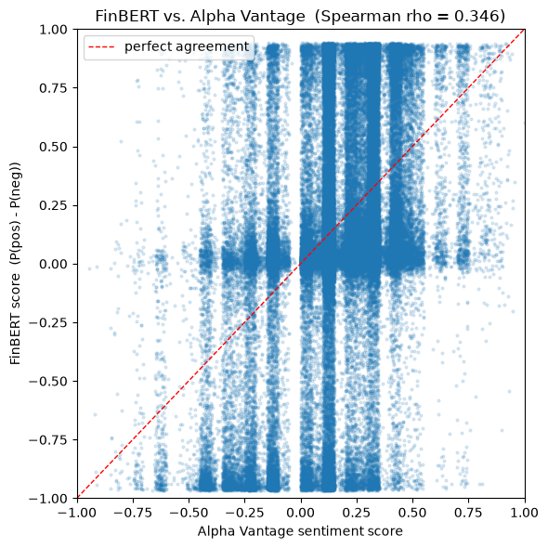
[Figure 5.2]
Scatter of FinBERT score against Alpha Vantage sentiment score with the agreement diagonal
5.4 Multi-Horizon Trading Evaluation
The trading strategy was evaluated out-of-sample on the held-out 2025 period (882 signals) after tuning on 2022 through 2024 data, across eight holding horizons from one to one hundred twenty-six trading days, against a buy-and-hold baseline and a random-signal null distribution of one hundred simulations per horizon. The central result is that the sentiment strategy did not beat the random-signal null at any holding horizon. Risk-adjusted performance was poorest at the shortest, swing-trading horizons (a Sharpe ratio of negative 1.30 at one day and negative 0.80 at three days) and improved toward zero as the horizon lengthened, but never rose convincingly above the null band.
Two mechanisms explain the short-horizon weakness, and both are visible in the results. First, the average net return per trade is negative at the short horizons (for example negative 0.002 at one day) because turnover, and therefore cumulative transaction cost, is highest when positions are flipped frequently; a weak gross signal becomes a net loss once realistic costs are subtracted. Second, the raw signal itself is weak and short-lived, as established by the small sentiment-return correlation in Section 5.3. The horizons where cost drag is lightest (forty-two days and beyond) are position-trading rather than swing horizons, and there the trade counts collapse (fifty trades at forty-two days, thirty at sixty-three, ten at one hundred twenty-six), so any apparent improvement is flagged low-confidence and cannot be relied upon. The signal is thus squeezed from both ends: too cost-heavy to exploit at short horizons, too data-sparse to confirm at long ones.

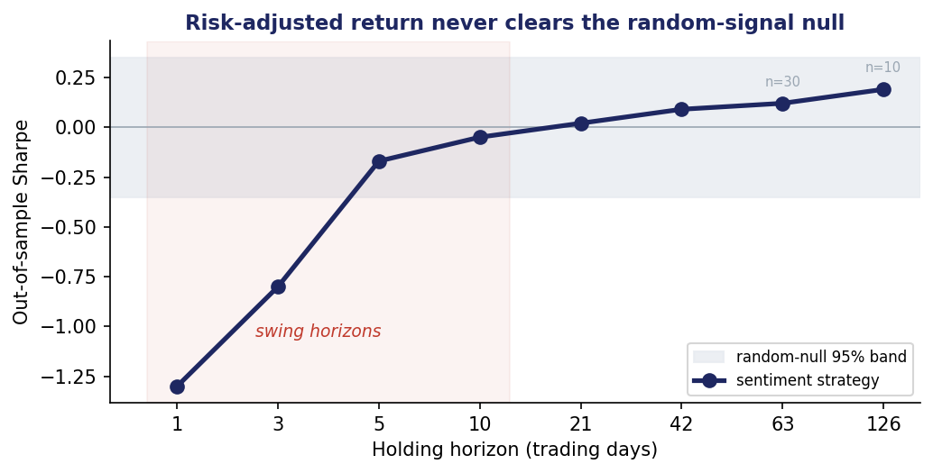
[Figure 5.3]
Horizon-decay curves of Sharpe ratio, average net trade return, and hit rate across the eight horizons, with the random-signal null band overlaid.
[Figure 5.4]
Equity curves for representative horizons against the equal-weighted buy-and-hold baseline.
5.5 Optimization
Hyperparameter optimization searched a grid over the sentiment entry threshold (0.25, 0.35, 0.45), the rolling aggregation window (1, 3, 5 days), and the minimum article support (1, 2, 3), evaluating each configuration only on the in-sample period at the median ten-day horizon and selecting on in-sample Sharpe. The selected configuration achieved an in-sample Sharpe of only 0.125, and the top five configurations spanned a range of just 0.001 to 0.125. This near-zero clustering is itself the key optimization finding: the configurations are statistically indistinguishable, so the search did not identify a setting with meaningful, stable predictive power. Tuning could not rescue the signal, and pursuing a configuration that happened to score highest in-sample would risk selection-driven overfitting rather than genuine improvement (Bailey et al., 2014).
The LSTM comparison model, which learns a signal from sequences of combined sentiment and price features, reached a validation area-under-the-curve that remained near or below 0.50 across training (for example 0.45 to 0.55), indicating no better than chance discrimination of the forward-return sign. That a learned model with access to both sentiment and technical features also failed to find exploitable structure reinforces, rather than contradicts, the rule-based result.
[Figure 5.5]
Grid-search results (in-sample Sharpe per configuration) and the LSTM training and validation area-under-the-curve curves.
5.6 Robustness: FinBERT versus Alpha Vantage as the Signal Source
A natural objection to any negative trading result is that the sentiment model itself, rather than news sentiment in general, may be responsible for the failure. To address this, the identical pipeline was re-run with Alpha Vantage's independent commercial sentiment score driving the signal in place of the project's FinBERT score, holding every other stage constant: the same aggregation, entry rule, thresholds, trend filter, backtesting engine, random-signal null, and out-of-sample split. Only the per-article sentiment column was changed, so any difference in the result is attributable solely to the choice of sentiment source. As shown in Figure 5.6, the two sentiment sources produce the same qualitative outcome: the Alpha Vantage-driven strategy also fails to beat the random-signal null at every one of the eight holding horizons, and its risk-adjusted returns track the FinBERT-driven curve closely, sitting at or below it across most of the range rather than above it. The commercial score generated fewer entry signals over the out-of-sample period (114 versus 790), because its score distribution places fewer articles beyond the entry threshold, so its longest-horizon points rest on thin trade counts and are read with the same caution applied throughout. The central conclusion is unaffected: the absence of a tradeable edge is a property of daily news sentiment in this universe and cost regime, not an artifact of the particular FinBERT model, since an independently trained commercial scorer yields the same failure to beat the null at any horizon.
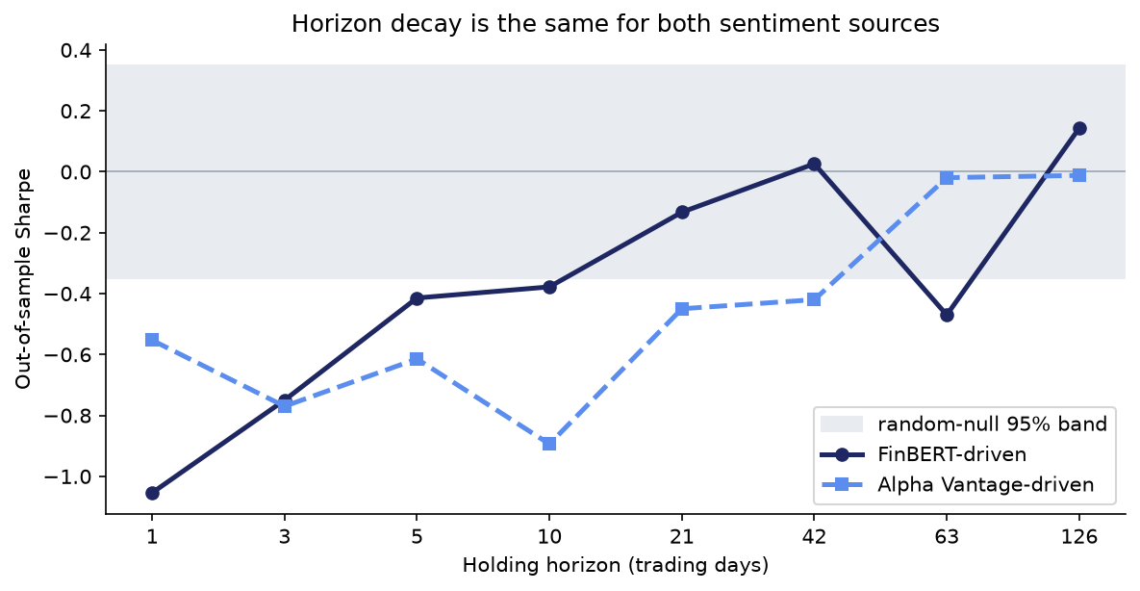
[Figure 5.6]
Out-of-sample Sharpe ratio across the eight holding horizons for the strategy driven by FinBERT sentiment versus Alpha Vantage sentiment, with the random-signal null band overlaid. Both sources remain within or below the null band at every horizon.
6 Conclusion
This project asked whether daily financial-news sentiment can be converted into a trading signal whose predictive value is strongest at short holding horizons and decays as the holding period lengthens. To answer it, the project built a full pipeline: multi-year news ingestion from Alpha Vantage, transformer-based sentiment scoring with a fine-tuned FinBERT model, point-in-time signal generation, and a cost-aware backtesting engine that evaluated one signal stream across eight holding horizons against buy-and-hold and random-signal baselines.
In relation to the hypothesis, the evidence indicates that the sentiment signal does not translate into tradeable value: out-of-sample, the strategy failed to beat a random-signal null at every holding horizon, hyperparameter tuning produced only statistically indistinguishable, near-zero configurations, and a learned LSTM model performed at chance. Rather than confirming a clean decay curve of exploitable profit, the results show a signal too weak to overcome transaction costs at the short horizons where it would be traded. This outcome is fully consistent with the project's stated position that a well-supported negative result is as valuable as a positive one, and with an efficient-market interpretation in which public news is priced in too quickly to be exploited by a retail-frequency strategy.
The most significant and genuinely useful result is the explanation of why the swing-trading application fails, which the horizon design was built to reveal: the signal is squeezed from both ends, too cost-heavy to exploit at short horizons and too data-sparse to confirm at long ones. A close second is the sentiment benchmark, where an independently trained commercial model agreed with the project's FinBERT scores on seventy-five percent of article directions, establishing that the sentiment measurement itself is sound and that the failure lies in the tradeability of the signal, not in the quality of the sentiment scoring. A robustness check that re-ran the entire strategy on Alpha Vantage's independent sentiment score reinforced this: both sources failed to beat the random-signal null at every horizon, showing the negative result does not depend on the particular sentiment model.
The most unexpected result concerned evaluation discipline itself. An initial evaluation contained a configuration-selection error and an overly short out-of-sample window that had made two long horizons appear to beat the null; fixing the split to a full held-out year and freezing the selected configuration removed those apparent wins. This underscored how sensitive backtest conclusions are to evaluation discipline and how easily look-ahead or selection artifacts can manufacture false signal, which is precisely the hazard the backtesting literature warns against.
6.1 Future Work
Several directions would extend this work. An earnings-conditioned analysis would test whether sentiment predictability concentrates around earnings announcements, using Alpha Vantage earnings-surprise data (actual versus consensus earnings per share), motivated by the post-earnings announcement drift literature (Bernard & Thomas, 1989); this asks when the signal works rather than searching for a feature that makes it work. Broadening the data would extend the news history beyond the March 2022 archive floor, add sources such as Finnhub for cross-source robustness, and widen the universe beyond twenty large-cap names to test whether a signal exists in less efficiently priced small caps. Alternative models and richer inputs, including full article bodies and earnings-call transcripts with sequence architectures beyond the baseline LSTM, could be evaluated on the same horizon grid so comparisons remain controlled. Finally, productionization would replace the point-in-time historical reconstruction with a live streaming ingest and scheduled scoring, add monitoring for sentiment-model drift, and paper-trade the screener before any capital is committed, given that the current evidence does not support live deployment as a profit strategy.
In summary, the project delivered a complete, rigorously evaluated pipeline and a clear, honest answer to its research question: within this universe, horizon range, and cost model, daily news sentiment does not provide a tradeable edge, and the analysis explains precisely why. That answer, and the evaluation discipline behind it, are the project's core contributions.
ACKNOWLEDGMENTS
The author thanks the AAI-590 instructors at the University of San Diego for their guidance throughout this capstone.
Use of AI tools: I used Anthropic's Claude (Anthropic, 2026) to assist with code scaffolding and with drafting and revising sections of this report from my own executed pipeline outputs. I designed the methodology, ran all analyses, verified every reported number against my pipeline runs, and take full responsibility for the content.
Works Cited
Alpha Vantage. (n.d.). Market news & sentiment API [Data set]. https://www.alphavantage.co/documentation/
Anthropic. (2026). Claude [Large language model]. https://claude.ai
Araci, D. (2019). FinBERT: Financial sentiment analysis with pre-trained language models (arXiv:1908.10063). arXiv. https://arxiv.org/abs/1908.10063
Aroussi, R. (2023). yfinance [Computer software]. https://github.com/ranaroussi/yfinance
Bailey, D. H., Borwein, J. M., Lopez de Prado, M., & Zhu, Q. J. (2014). Pseudo-mathematics and financial charlatanism: The effects of backtest overfitting on out-of-sample performance. Notices of the American Mathematical Society, 61(5), 458-471.
Bernard, V. L., & Thomas, J. K. (1989). Post-earnings-announcement drift: Delayed price response or risk premium? Journal of Accounting Research, 27, 1-36.
Bollen, J., Mao, H., & Zeng, X. (2011). Twitter mood predicts the stock market. Journal of Computational Science, 2(1), 1-8.
Cont, R. (2001). Empirical properties of asset returns: Stylized facts and statistical issues. Quantitative Finance, 1(2), 223-236.
Devlin, J., Chang, M. W., Lee, K., & Toutanova, K. (2019). BERT: Pre-training of deep bidirectional transformers for language understanding. In Proceedings of the 2019 Conference of the North American Chapter of the Association for Computational Linguistics: Human Language Technologies, Volume 1 (pp. 4171-4186).
Ding, X., Zhang, Y., Liu, T., & Duan, J. (2015). Deep learning for event-driven stock prediction. In Proceedings of the 24th International Joint Conference on Artificial Intelligence (pp. 2327-2333).
Fischer, T., & Krauss, C. (2018). Deep learning with long short-term memory networks for financial market predictions. European Journal of Operational Research, 270(2), 654-669.
Gu, S., Kelly, B., & Xiu, D. (2020). Empirical asset pricing via machine learning. The Review of Financial Studies, 33(5), 2223-2273.
Heston, S. L., & Sinha, N. R. (2017). News vs. sentiment: Predicting stock returns from news stories. Financial Analysts Journal, 73(3), 67-83.
Hochreiter, S., & Schmidhuber, J. (1997). Long short-term memory. Neural Computation, 9(8), 1735-1780.
Ke, Z. T., Kelly, B. T., & Xiu, D. (2019). Predicting returns with text data (NBER Working Paper No. 26186). National Bureau of Economic Research. https://doi.org/10.3386/w26186
London Stock Exchange Group. (n.d.). LSEG MarketPsych Analytics [Data set]. https://www.lseg.com
Lopez de Prado, M. (2018). Advances in financial machine learning. Wiley.
Loughran, T., & McDonald, B. (2011). When is a liability not a liability? Textual analysis, dictionaries, and 10-Ks. The Journal of Finance, 66(1), 35-65.
Malo, P., Sinha, A., Korhonen, P., Wallenius, J., & Takala, P. (2014). Good debt or bad debt: Detecting semantic orientations in economic texts. Journal of the Association for Information Science and Technology, 65(4), 782-796.
RavenPack. (n.d.). News analytics [Data set]. https://www.ravenpack.com
Sharpe, W. F. (1994). The Sharpe ratio. The Journal of Portfolio Management, 21(1), 49-58.
Tetlock, P. C. (2007). Giving content to investor sentiment: The role of media in the stock market. The Journal of Finance, 62(3), 1139-1168.
Vaswani, A., Shazeer, N., Parmar, N., Uszkoreit, J., Jones, L., Gomez, A. N., Kaiser, L., & Polosukhin, I. (2017). Attention is all you need. In Advances in Neural Information Processing Systems, 30.

