2. Data Summary

This project draws on two primary data streams and one auxiliary labeled corpus. The first stream is daily market data for twenty large-capitalization U.S. equities spanning technology, financial, health-care, energy, consumer, and industrial sectors, obtained through the open-source yfinance library (Aroussi, 2023). For each stock and each trading session from January 2, 2020 through December 30, 2025, a total of 1,507 sessions and 30,140 observations, the data record the opening, intraday high, intraday low, and closing prices, the number of shares traded, and an adjusted closing price that corrects for stock splits and dividends. From these I derive the variables the models actually consume: the daily percentage return, short- and medium-term moving averages of price, one-month momentum, one-month realized volatility, and a standard overbought/oversold oscillator. The second stream is financial news: 26,955 timestamped headlines attributed to the universe tickers, retrieved from the Finnhub company-news interface (Finnhub, n.d.). Each headline is scored by the FinBERT transformer classifier (Araci, 2019) into probabilities of positive, negative, and neutral tone, which I combine into a single sentiment score (the positive probability minus the negative probability, bounded between −1 and +1) and then aggregate to one row per stock per day: the article count, the average score, a confidence-weighted average that discounts ambiguous articles, and short rolling versions of each. The auxiliary dataset is the Financial PhraseBank (Malo, Sinha, Korhonen, Wallenius, & Takala, 2014), 3,453 financial-news sentences labeled positive, neutral, or negative at the 75% annotator-agreement level, which I split into 2,762 training, 345 validation, and 346 test sentences (stratified by class; the balance is roughly 62% neutral, 26% positive, and 12% negative) for fine-tuning and benchmarking the sentiment model.
The two data streams presented very different data-quality profiles. The price panel arrived unusually clean: no missing price fields, every ticker present for all 1,507 sessions with no unexplained gaps, and an automated screen for extreme single-day moves not corroborated by trading volume (the signature of bad prints or unadjusted split artifacts) flagged zero rows, confirming that vendor adjustments correctly absorbed even the large splits inside the window, such as Amazon's 20-for-1 and Tesla's 3-for-1 splits in 2022. I retained all these checks as permanent validation stages rather than one-time steps; in a fully developed pipeline they would run automatically on every ingest with alerts. The news stream required more intervention. Newswire syndication causes the same story to be republished under many outlets, which would let one event masquerade as many independent signals; removing exact duplicate headlines per ticker, along with sub-ten-character feed fragments, eliminated 939 articles (3.5%), leaving 26,016. The ticker attribution supplied by the vendor is itself imperfect: market-roundup stories that mention a company only peripherally still arrive under its ticker, a linkage noise I mitigate with daily aggregation, confidence weighting, and a minimum-article-support requirement, and would address in production with an entity-recognition relevance filter. Finally, because many articles are published after the market close or on weekends, every article is mapped at ingestion to its effective date, the first session on which it could actually have been traded, a discipline that guards the entire downstream pipeline against look-ahead bias (López de Prado, 2018).
The most consequential dataset issue is the depth of the news history. The vendor's free tier returns roughly one year of articles counting back from the request date, so the earliest article in my collection is dated July 21, 2025, and the joint news-and-price window covers only about five and a half months. This has two direct implications for the study design. First, the longest planned holding horizons cannot be evaluated inside this window (a 126-trading-day hold initiated in July 2025 extends past the end of the price data), so the top of the horizon grid will be truncated and results near it interpreted with caution. Second, the originally planned calendar-based out-of-sample split (tuning before January 2024, testing after) is not usable as planned, since every news observation postdates it; I will instead split the news window itself, tuning signal parameters on its earlier portion and reserving the later portion for evaluation. In a production system the remedy is straightforward: a commercial news feed with deep history, the open GDELT archive as a free alternative, or simply accumulating one's own point-in-time archive over time. I note the limitation prominently because it constrains the horizon comparison at the heart of the project, and one step I plan to attempt is upgrading to a paid monthly subscription for greater data access when it is time to actually train the model.
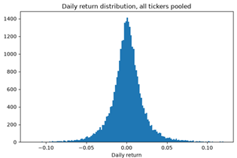
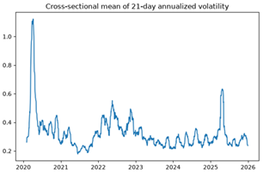
Figure 2.1
Top: distribution of daily returns pooled across all twenty tickers, showing the sharp peak and heavy tails characteristic of equity returns. Bottom: cross-sectional mean of 21-day annualized volatility, with pronounced spikes in March 2020 and 2025 and elevated levels through the 2022 drawdown.

The exploratory analysis supports the premise of the project while calibrating expectations about effect sizes. As seen in Figure 2.1, pooled daily returns are sharply peaked and heavy-tailed rather than bell-shaped, and volatility arrives in pronounced clusters: the March 2020 pandemic shock most dramatically, with renewed elevation through the 2022 drawdown and further turbulence in 2025. These are the classic stylized facts of equity returns (Cont, 2001), and they motivate two design choices: performance will be reported with maximum drawdown alongside the Sharpe ratio, since volatility alone understates tail risk, and the news window, despite its brevity, still spans meaningfully different volatility conditions. On the news side, Figure 2.2 shows the article-level sentiment scores are strongly trimodal: a large central mass near zero, reflecting routine neutral corporate coverage, and secondary modes near the extremes where the classifier is confident. My entry thresholds of ±0.35 fall in the sparsely populated valleys between these modes, which means the number of trading signals is not overly sensitive to the exact threshold value. Spot checks confirm the scorer behaves sensibly on clear-cut cases: an earnings beat scores 0.94 positive, a regulatory-investigation headline 0.73 negative, and a routine meeting announcement 0.94 neutral. Most directly, Figure 2.3 relates the daily average sentiment to the following day's return: the Spearman rank correlation is +0.041, a small but positive association whose magnitude is consistent with the prior literature, where news-tone effects on returns are economically meaningful yet statistically modest at the daily level (Tetlock, 2007; Heston & Sinha, 2017). This is exactly the regime this project is designed for: a weak per-observation signal that must be aggregated, filtered, and evaluated on a risk-adjusted basis across horizons, rather than a large edge visible to the naked eye.

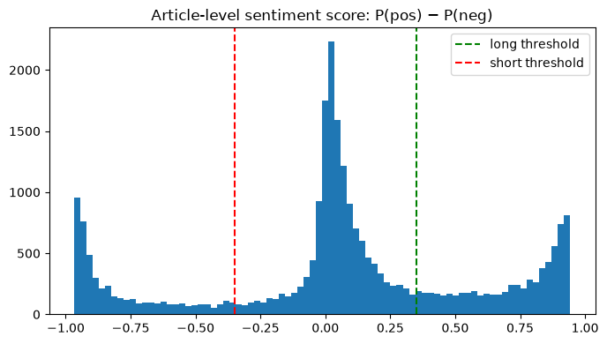

Figure 2.2
Distribution of article-level sentiment scores (positive probability minus negative probability). The distribution is trimodal, and the ±0.35 entry thresholds (dashed lines) fall in the low-density valleys between the neutral mass and the confident-polar modes.

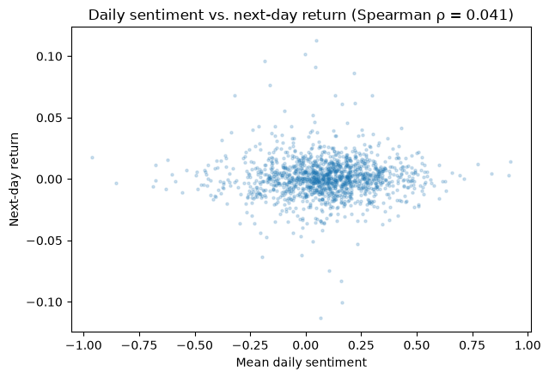

Figure 2.3
Daily average sentiment versus next-day return across all ticker-days with news coverage. The Spearman rank correlation of +0.041 indicates a small positive association, consistent in magnitude with the prior literature on daily news tone.

Relationships among the variables themselves shape how the models are built. Figure 2.4 shows the pairwise correlation of daily returns across the universe: the average correlation is 0.361, with a visibly tighter technology cluster and weaker co-movement among the defensive names. Two consequences follow. Because simultaneous positions in correlated names are not independent bets, the backtest caps the number of concurrent positions and reports portfolio-level drawdown rather than treating trades as uncorrelated, and an equal-weighted buy-and-hold portfolio of the same names is the natural passive baseline, since it inherits the same correlation structure. Among the derived price variables, strong correlations exist by construction (the moving averages are smoothed versions of the same price series, and momentum and the oscillator overlap), which is harmless for the rule-based signal filter but argues for the small, normalized feature set I use for the optional sequence model rather than a large redundant one. The sentiment aggregates, finally, are deliberately constructed from current and past information only, so any correlation they show with future returns reflects genuine predictive content rather than leakage from the alignment process.

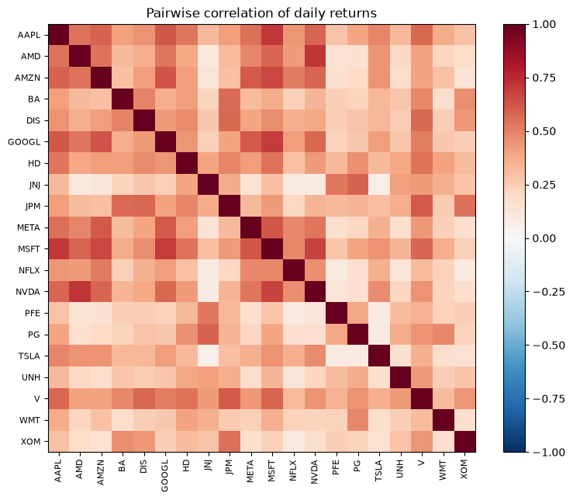

Figure 2.4
Pairwise correlation of daily returns across the twenty-stock universe (mean 0.361). Co-movement is strongest within the technology cluster and weakest among the defensive names

Use of AI tools: I used Anthropic's Claude (Anthropic, 2026) to assist with the analysis code and an initial draft of this section; I executed and verified all analyses and reported figures myself and take full responsibility for the content.
Works Cited (Section 2 additions)
Anthropic. (2026). Claude [Large language model]. https://claude.ai
Araci, D. (2019). FinBERT: Financial sentiment analysis with pre-trained language models (arXiv:1908.10063). arXiv. https://arxiv.org/abs/1908.10063
Aroussi, R. (2023). yfinance [Computer software]. https://github.com/ranaroussi/yfinance
Cont, R. (2001). Empirical properties of asset returns: Stylized facts and statistical issues. Quantitative Finance, 1(2), 223–236.
Finnhub. (n.d.). Company news API [Data set]. https://finnhub.io
Heston, S. L., & Sinha, N. R. (2017). News vs. sentiment: Predicting stock returns from news stories. Financial Analysts Journal, 73(3), 67–83.
López de Prado, M. (2018). Advances in financial machine learning. Wiley.
Malo, P., Sinha, A., Korhonen, P., Wallenius, J., & Takala, P. (2014). Good debt or bad debt: Detecting semantic orientations in economic texts. Journal of the Association for Information Science and Technology, 65(4), 782–796.
Tetlock, P. C. (2007). Giving content to investor sentiment: The role of media in the stock market. The Journal of Finance, 62(3), 1139–1168.

