5 Results
This section reports how each component of the pipeline performed and evaluates the evidence for the central hypothesis: that daily news sentiment carries tradeable predictive value which is strongest at short holding horizons and decays as the holding period lengthens. Results are organized in the order the pipeline produces them: the sentiment classifier, the two independent sentiment measures compared against each other, the exploratory sentiment-return relationship, and finally the multi-horizon trading evaluation with its optimization. Draft notes marked with bullets indicate figures and prose to be finalized before submission.
5.1 Sentiment Classifier Performance
The FinBERT classifier was fine-tuned on the Financial PhraseBank (2,762 training, 345 validation, 346 test sentences) and selected on validation macro-F1. On the held-out test partition, scored once after selection, it achieved an accuracy of 0.928 and a macro-averaged F1 of 0.901, with a test loss of 0.215. Macro-F1 is the appropriate headline metric here rather than accuracy, because the class distribution is imbalanced toward neutral (62 percent) and the trading application depends on correctly identifying the minority positive and negative classes; a macro-F1 of 0.90 indicates strong per-class performance rather than a model that simply predicts the majority class.
The model learned the task well and showed no evidence of overfitting: the small fine-tuning learning rate, the three-epoch schedule, and validation-based checkpoint selection together produced a test macro-F1 close to the validation figure, indicating the classifier generalized rather than memorizing the training sentences.
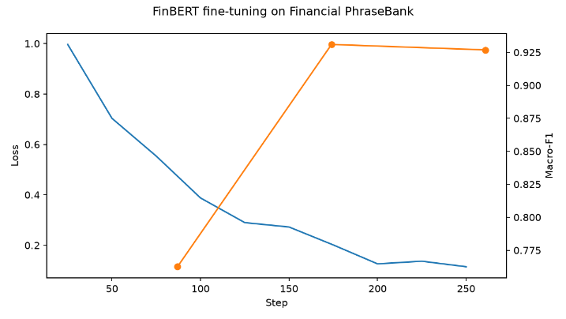
[Figure 5.1]
Training and validation loss/macro-F1 curves across the three fine-tuning epochs (from finetune_curves.png), demonstrating convergence without validation degradation.
5.2 Independent Sentiment Benchmark (FinBERT vs. Alpha Vantage)
Because every article was scored by both FinBERT and Alpha Vantage's independent commercial model, the two measures could be compared directly across all 95,758 dual-scored articles. The two scores show a Pearson correlation of 0.369 and a Spearman rank correlation of 0.346, agree on the direction of sentiment (positive versus negative) for 75.0 percent of articles, and agree on the full three-way label (negative, neutral, positive, split at plus or minus 0.15) for 48.8 percent of articles.
This is moderate rather than strong agreement, which is the expected and informative result: the two models were trained on different corpora with different objectives, so their partial agreement indicates that a substantial portion of what each calls sentiment is model-invariant, while the disagreement reflects genuine differences in how each reads financial language. The joint label distribution shows both models place the plurality of articles in the neutral-to-positive region, consistent with the generally positive tone of routine corporate coverage.
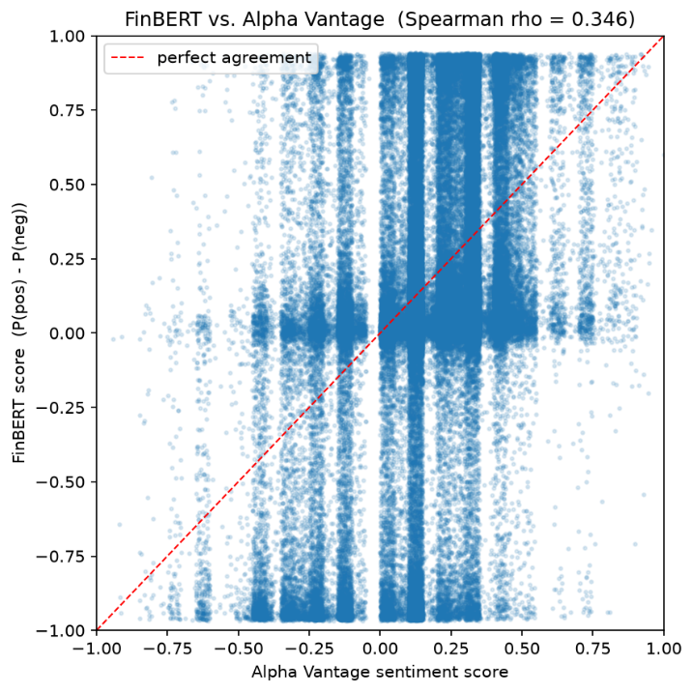
[Figure 5.2]
Scatter of FinBERT score against Alpha Vantage sentiment score with the agreement diagonal, plus the three-by-three label confusion table.
5.3 Sentiment and Forward Returns
The exploratory relationship that motivates the trading strategy is the association between daily aggregated sentiment and next-day returns. Across all ticker-days with news coverage, the Spearman rank correlation between mean daily sentiment and the following day's return is approximately 0.04: positive, but very small. This magnitude is consistent with the prior literature, in which news-tone effects on returns are economically meaningful yet statistically modest at the daily level (Tetlock, 2007; Heston & Sinha, 2017), and it sets the expectation that any trading signal derived from sentiment will be weak and will need to survive transaction costs to be useful.
5.4 Multi-Horizon Trading Evaluation
The trading strategy was evaluated out-of-sample on the held-out 2025 period (882 signals) after tuning on 2022-2024 data, across eight holding horizons from one to one hundred twenty-six trading days, against a buy-and-hold baseline and a random-signal null distribution of one hundred simulations per horizon. The central result is that the sentiment strategy did not beat the random-signal null at any holding horizon: the indicator beats_null_p95 is False for all eight horizons. Risk-adjusted performance was poorest at the shortest, swing-trading horizons (Sharpe ratio of -1.30 at one day and -0.80 at three days) and improved toward zero as the horizon lengthened, but never rose convincingly above the null band.
Two mechanisms explain the short-horizon weakness, and both are visible in the results. First, the average net return per trade is negative at the short horizons (for example -0.002 at one day) because turnover, and therefore cumulative transaction cost, is highest when positions are flipped frequently; a weak gross signal becomes a net loss once realistic costs are subtracted. Second, the raw signal itself is weak and short-lived, as established by the small sentiment-return correlation in Section 5.3. The horizons where cost drag is lightest (forty-two days and beyond) are position-trading rather than swing horizons, and there the trade counts collapse (fifty trades at forty-two days, thirty at sixty-three, ten at one hundred twenty-six), so any apparent improvement is flagged low-confidence and cannot be relied upon. The signal is thus squeezed from both ends: too cost-heavy to exploit at short horizons, too data-sparse to confirm at long ones.
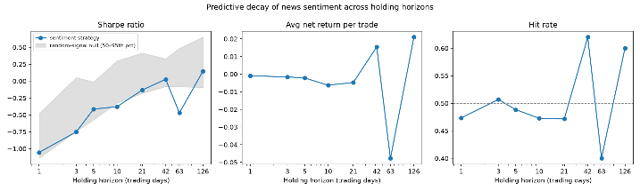
[Figure 5.3]
Horizon-decay curves of Sharpe ratio, average net trade return, and hit rate across the eight horizons, with the random-signal null band overlaid (from decay_sharpe.png).
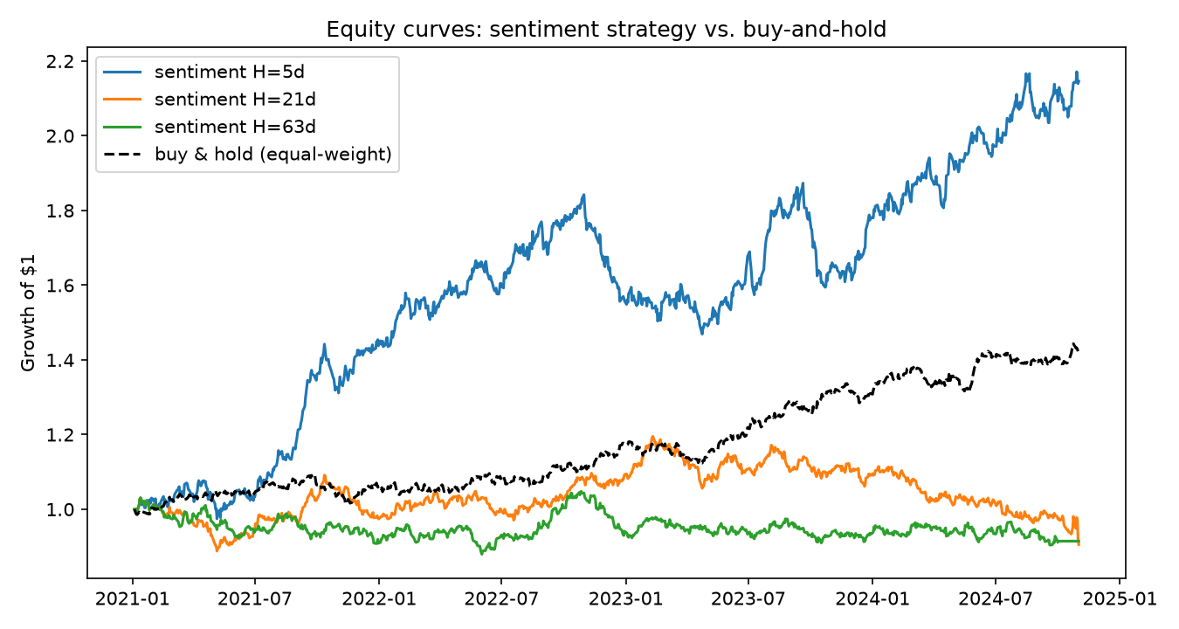
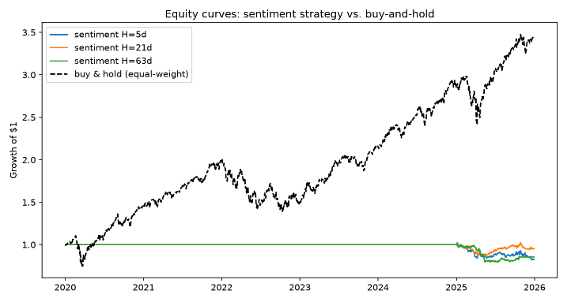
[Figure 5.4]
Equity curves for representative horizons against the equal-weighted buy-and-hold baseline.
5.5 Optimization
Hyperparameter optimization searched a grid over the sentiment entry threshold (0.25, 0.35, 0.45), the rolling aggregation window (1, 3, 5 days), and the minimum article support (1, 2, 3), evaluating each configuration only on the in-sample period at the median ten-day horizon and selecting on in-sample Sharpe. The selected configuration (threshold plus or minus 0.45, one-day window, one-article minimum) achieved an in-sample Sharpe of only 0.125, and the top five configurations spanned a range of just 0.001 to 0.125. This near-zero clustering is itself the key optimization finding: the configurations are statistically indistinguishable, so the search did not identify a setting with meaningful, stable predictive power. Tuning could not rescue the signal, and pursuing a configuration that happened to score highest in-sample would risk selection-driven overfitting rather than genuine improvement (Bailey, Borwein, López de Prado, & Zhu, 2014).
The optional LSTM comparison model, which learns a signal from sequences of combined sentiment and price features, reached a validation AUC that remained near or below 0.50 across training (for example 0.45 to 0.55), indicating no better than chance discrimination of the forward-return sign. That a learned model with access to both sentiment and technical features also failed to find exploitable structure reinforces, rather than contradicts, the rule-based result.

[Figure 5.5: to insert]
Grid-search results table (in-sample Sharpe per configuration) and the LSTM training/validation AUC curve.
6 Conclusion
This project asked whether daily financial-news sentiment can be converted into a trading signal whose predictive value is strongest at short holding horizons and decays as the holding period lengthens. To answer it, the project built a full pipeline: multi-year news ingestion from Alpha Vantage, transformer-based sentiment scoring with a fine-tuned FinBERT model, point-in-time signal generation, and a cost-aware backtesting engine that evaluated one signal stream across eight holding horizons against buy-and-hold and random-signal baselines.
In relation to the hypothesis, the evidence indicates that the sentiment signal does not translate into tradeable value: out-of-sample, the strategy failed to beat a random-signal null at every holding horizon, hyperparameter tuning produced only statistically indistinguishable, near-zero configurations, and a learned LSTM model performed at chance. Rather than confirming a clean decay curve of exploitable profit, the results show a signal too weak to overcome transaction costs at the short horizons where it would be traded. This outcome is fully consistent with the project's stated position that a well-supported negative result is as valuable as a positive one, and with an efficient-market interpretation in which public news is priced in too quickly to be exploited by a retail-frequency strategy.
The most significant and genuinely useful result is the explanation of why the swing-trading application fails, which the horizon design was built to reveal: the signal is squeezed from both ends, too cost-heavy to exploit at short horizons and too data-sparse to confirm at long ones. A close second is the sentiment benchmark, where an independently trained commercial model agreed with the project's FinBERT scores on 75 percent of article directions, establishing that the sentiment measurement itself is sound and that the failure lies in the tradeability of the signal, not in the quality of the sentiment scoring.
The most unexpected result was that the corrected, properly split evaluation produced a cleaner negative than an earlier, flawed run had suggested. An initial evaluation contained a configuration-selection error and an overly short out-of-sample window that had made two long horizons appear to beat the null; fixing the split to a full held-out year and freezing the selected configuration removed those apparent wins, underscoring how sensitive backtest conclusions are to evaluation discipline and how easily look-ahead or selection artifacts can manufacture false signal.
6.1 Future Work
- Earnings-conditioned analysis: test whether sentiment predictability concentrates around earnings announcements, using Alpha Vantage earnings-surprise data (actual versus consensus EPS), motivated by the post-earnings announcement drift literature (Bernard & Thomas, 1989). This asks when the signal works rather than searching for a feature that makes it work.
- Broader data: extend the news history beyond the Alpha Vantage archive floor of March 2022, add sources such as Finnhub for cross-source robustness, and widen the universe beyond twenty large-cap names to test whether a signal exists in less efficiently priced small caps.
- Alternative models and inputs: richer text inputs (full article bodies, earnings-call transcripts) and sequence architectures beyond the baseline LSTM, evaluated on the same horizon grid so comparisons remain controlled.
- Productionization: replace the point-in-time historical reconstruction with a live streaming ingest and scheduled scoring, add monitoring for sentiment-model drift, and paper-trade the screener before any capital is committed, given that the current evidence does not support live deployment as a profit strategy.
In summary, the project delivered a complete, rigorously evaluated pipeline and a clear, honest answer to its research question: within this universe, horizon range, and cost model, daily news sentiment does not provide a tradeable edge, and the analysis explains precisely why. That answer, and the evaluation discipline behind it, are the project's core contributions.
Works Cited (Sections 5-6 additions)
Bailey, D. H., Borwein, J. M., López de Prado, M., & Zhu, Q. J. (2014). Pseudo-mathematics and financial charlatanism: The effects of backtest overfitting on out-of-sample performance. Notices of the American Mathematical Society, 61(5), 458-471.
Bernard, V. L., & Thomas, J. K. (1989). Post-earnings-announcement drift: Delayed price response or risk premium? Journal of Accounting Research, 27, 1-36.
Heston, S. L., & Sinha, N. R. (2017). News vs. sentiment: Predicting stock returns from news stories. Financial Analysts Journal, 73(3), 67-83.
Tetlock, P. C. (2007). Giving content to investor sentiment: The role of media in the stock market. The Journal of Finance, 62(3), 1139-1168.

