# AWS(Amazon Web Services) Tutorial for Beginners: Learn in 2 Hours

### Training Summary

AWS (Amazon Web Service) is a cloud computing platform that enables users to access on demand computing services like database storage, virtual cloud server, etc. This online course will give an in-depth knowledge on EC2 instance as well as useful strategy on how to build and modify instance for your own applications.

### What should I know?

This guide is designed for complete beginners. Basic knowledge on cloud computing, networking, storage, security, will be an additional help.

## Syllabus

# What is AWS? Amazon Cloud Services Tutorial

## What is Cloud Computing?

Cloud computing is a term referred to storing and accessing data over the internet. It doesn't store any data on the hard disk of your personal computer. In cloud computing, you can access data from a remote server.

## What is AWS?

Amazon web service is a platform that offers flexible, reliable, scalable, easy-to-use and cost-effective cloud computing solutions.

AWS is a comprehensive, easy to use computing platform offered Amazon. The platform is developed with a combination of infrastructure as a service (IaaS), platform as a service (PaaS) and packaged software as a service (SaaS) offerings.

In this tutorial, you will learn,

* [What is Cloud Computing?](https://www.guru99.com/what-is-aws.html#1)
* [What is AWS?](https://www.guru99.com/what-is-aws.html#2)
* [History of AWS](https://www.guru99.com/what-is-aws.html#3)
* [Important AWS Services](https://www.guru99.com/what-is-aws.html#4)
* [Applications of AWS services](https://www.guru99.com/what-is-aws.html#5)
* [Companies using AWS](https://www.guru99.com/what-is-aws.html#6)
* [Advantages of AWS](https://www.guru99.com/what-is-aws.html#7)
* [Disadvantages of AWS](https://www.guru99.com/what-is-aws.html#8)
* [Best practices of AWS](https://www.guru99.com/what-is-aws.html#9)

## History of AWS

* 2002- AWS services launched
* 2006- Launched its cloud products
* 2012- Holds first customer event
* 2015- Reveals revenues achieved of $4.6 billion
* 2016- Surpassed $10 billon revenue target
* 2016- Release snowball and snowmobile
* 2019- Offers nearly 100 cloud services

## Important AWS Services

Amazon Web Services offers a wide range of different business purpose global cloud-based products. The products include storage, databases, analytics, networking, mobile, development tools, enterprise applications, with a pay-as-you-go pricing model.

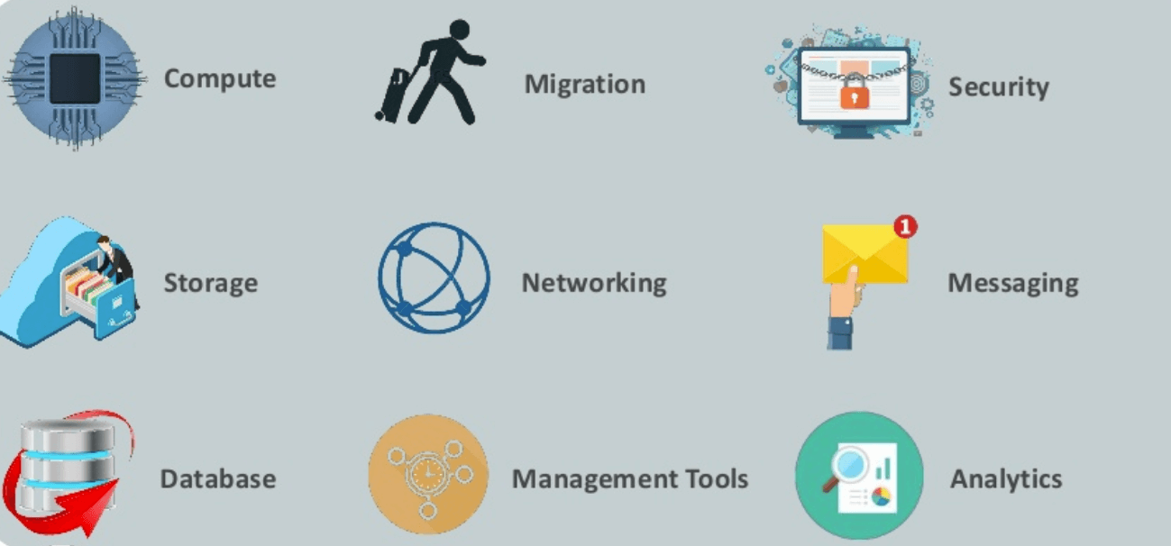Important AWS Services

**Here, are essential AWS services.**

### AWS Compute Services

Here, are Cloud Compute Services offered by Amazon:

1. **EC2(Elastic Compute Cloud)** - EC2 is a virtual machine in the cloud on which you have OS level control. You can run this cloud server whenever you want.
2. **LightSail**-This cloud computing tool automatically deploys and manages the computer, storage, and networking capabilities required to run your applications.
3. **Elastic Beanstalk —**The tool offers automated deployment and provisioning of resources like a highly scalable production website.
4. **EKS (Elastic Container Service for Kubernetes) —**The tool allows you toKubernetes on Amazon cloud environment without installation.
5. **AWS Lambda —**ThisAWS service allows you to run functions in the cloud. The tool is a big cost saver for you as you to pay only when your functions execute.

### Migration

Migration services used to transfer data physically between your datacenter and AWS.

1. **DMS (Database Migration Service)**-DMS service can be used to migrate on-site databases to AWS. It helps you to migrate from one type of database to another — for example, Oracle to MySQL.
2. **SMS (Server Migration Service)** - SMS migration services allows you to migrate on-site servers to AWS easily and quickly.
3. **Snowball** — Snowball is a small application which allows you to transfer terabytes of data inside and outside of AWS environment.

### Storage

1. **Amazon Glacier-** It is an extremely low-cost storage service. It offers secure and fast storage for data archiving and backup.
2. **Amazon Elastic Block Store (EBS)-** It provides block-level storage to use with Amazon EC2 instances. Amazon Elastic Block Store volumes are network-attached and remain independent from the life of an instance.
3. **AWS Storage Gateway-** This AWS service is connecting on-premises software applications with cloud-based storage. It offers secure integration between the company's on-premises and AWS's storage infrastructure.

### Security Services

1. **IAM (Identity and Access Management)** —  IAM is a secure cloud security service which helps you to manage users, assign policies, form groups to manage multiple users.
2. **Inspector** — It is an agent that you can install on your virtual machines, which reports any security vulnerabilities.
3. **Certificate Manager** — The service offers free SSL certificates for your domains that are managed by Route53.
4. **WAF (Web Application Firewall)** — WAF security service offers application-level protectionand allows you to block SQL injection and helps you to block cross-site scripting attacks.
5. **Cloud Directory**— This service allows you to create flexible, cloud-native directories for managinghierarchies of data along multiple dimensions.
6. **KMS (Key Management Service)** — It is a managed service. This security service helps you to create and control the encryption keyswhich allows you to encrypt your data.
7. **Organizations** — You can create groups ofAWS accounts using this service to manages security and automation settings.
8. **Shield** — Shield is managedDDoS (Distributed Denial of Service protection service). It offers safeguards against web applications running on AWS.
9. **Macie** — It offers a data visibility security service which helps classify and protect your sensitive critical content.
10. **GuardDuty** —It offers threat detectionto protect your AWS accounts and workloads.

### Database Services

1. **Amazon RDS-**ThisDatabase AWS service is easy to set up, operate, and scale a relational database in the cloud.
2. **Amazon DynamoDB-** It is a fast, fully managed NoSQL database service. It is a simple service which allow cost-effective storage and retrieval of data. It also allows you to serve any level of request traffic.
3. **Amazon ElastiCache-** It is a web service which makes it easy to deploy, operate, and scale an in-memory cache in the cloud.
4. **Neptune-**It is a fast, reliable and scalable **graph database** service.
5. **Amazon RedShift -**It is Amazon's data warehousing solution which you can use to perform complex OLAP queries.

### Analytics

1. **Athena** — This analytics service allows permSQL queries on your S3 bucket to find files.
2. **CloudSearch** — You should use this AWS service to create a fully managed search engine for your website.
3. **ElasticSearch** — It is similar to CloudSearch. However, it offers more features like application monitoring.
4. **Kinesis** — This AWS analytics service helps you to stream and analyzing real-time data at massive scale.
5. **QuickSight** —It is a business analytics tool. It helps you to create visualizations in a dashboard for data in Amazon Web Services. For example, S3, DynamoDB, etc.
6. **EMR (Elastic Map Reduce)**—This AWS analytics service mainly used for big data processing like Spark, Splunk, Hadoop, etc.
7. **Data Pipeline** — Allows you to move data from one place to another. For example from DynamoDB to S3.

### Management Services

1. **CloudWatch** — Cloud watch helps you to monitor AWS environments like EC2, RDS instances, and CPU utilization. It also triggers alarms depends on various metrics.
2. **CloudFormation** — It is a way of turning infrastructure into the cloud. You can use templates for providing a whole production environment in minutes.
3. **CloudTrail** — It offers an easy method of auditing AWS resources. It helps you to log all changes.
4. **OpsWorks** — The service allows you to automated Chef/Puppet deployments on AWS environment.
5. **Config** — This AWS service monitors your environment. The tool sends alerts about changes when you break certain defined configurations.
6. **Service Catalog**— This service helps large enterprises to authorize which services user will be used and which won't.
7. **AWS Auto Scaling** — The service allows you to automatically scale your resources up and down based on given CloudWatch metrics.
8. **Systems Manager**— This AWS service allows you to group your resources. It allows you to identify issues and act on them.
9. **Managed Services**—It offers management of your AWS infrastructure which allows you to focus on your applications.

### Internet of Things

1. **IoT Core**— It is a managed cloud AWS service. The service allows connected devices like cars, light bulbs, sensor grids, to securely interact with cloud applications and other devices.
2. **IoT Device Management**— It allows you to manage your IoT devices at any scale.
3. **IoT Analytics** — This AWS IOT service is helpful to perform analysis on data collected by your IoT devices.
4. **Amazon FreeRTOS** — This real-time operating system for microcontrollers helps you to connect IoT devices in the local server or into the cloud.

### Application Services

1. **Step Functions** — It is a way of visualizing what's going inside your application and what different microservices it is using.
2. **SWF (Simple Workflow Service)** — The service helps you to coordinate both automated tasks and human-led tasks.
3. **SNS (Simple Notification Service)** — You can use this service to send you notifications in the form of email and SMS based on given AWS services.
4. **SQS (Simple Queue Service)** — Use this AWS service to decouple your applications. It is a pull-based service.
5. **Elastic Transcoder** — This AWS service tool helps you to changes a video's format and resolution to support various devices like tablets, smartphones, and laptops of different resolutions.

### Deployment and Management

1. **AWS CloudTrail:**The services records AWS API calls and send backlog files to you.
2. **Amazon CloudWatch:** The tools monitor AWS resources like Amazon EC2 and Amazon RDS DB Instances. It also allows you to monitor custom metrics created by user's applications and services.
3. **AWS CloudHSM:**This AWS service helps you meet corporate, regulatory, and contractual, compliance requirements for maintaining data security by using the Hardware Security Module(HSM) appliances inside the AWS environment.

### Developer Tools

1. **CodeStar** — Codestar is a cloud-based service for creating, managing, and working with various software development projects on AWS.
2. **CodeCommit** —  It is AWS's version control servicewhich allows you tostore your code and other assets privately in the cloud.
3. **CodeBuild** — This Amazon developer service help you to automates the process of building and compilingyour code.
4. **CodeDeploy** — It is a way of deploying your code in EC2 instances automatically.
5. **CodePipeline** — It helps you create a deployment pipeline like testing, building, testing, authentication, deployment on development and production environments.
6. **Cloud9** —It is an Integrated Development Environment for writing, running, and debugging code in the cloud.

### Mobile Services

1. **Mobile Hub**— Allows you to add, configure and design features for mobile apps.
2. **Cognito** — Allows users to signup using his or her social identity.
3. **Device Farm** — Device farm helps you to improve the quality of apps by quickly testing hundreds of mobile devices.
4. **AWS AppSync** —It is a fully managed GraphQL service that offers real-time data synchronization and offline programming features.

### Business Productivity

1. **Alexa for Business** — It empowers your organization with voice, using Alexa. It will help you to Allows you to build custom voice skills for your organization.
2. **Chime** — Can be used for online meeting and video conferencing.
3. **WorkDocs** — Helps to store documents in the cloud
4. **WorkMail** — Allows you to send and receive business emails.

### Desktop & App Streaming

1. **WorkSpaces** — Workspace is a VDI(Virtual Desktop Infrastructure). It allows you to use remote desktops in the cloud.
2. **AppStream —** A way ofstreaming desktop applicationsto your users in the web browser. For example, using MS Word in Google Chrome.

### Artificial Intelligence

1. **Lex** — Lex tool helps you to build chatbots**quickly.**
2. **Polly** —  It is AWS's text-to-speech service allows you to create audio versions of your notes.
3. **Rekognition** — It is AWS's face recognition service. This AWS service helps you to recognize faces and object in images and videos.
4. **SageMaker** — Sagemaker allows you to build, train, and deploy machine learning models at any scale.
5. **Transcribe** —  It is AWS's speech-to-text service that offers high-quality and affordable transcriptions.
6. **Translate** — It is a very similar tool to Google Translate which allows you to translate text in one language to another.

### AR & VR (Augmented Reality & Virtual Reality)

1. **Sumerian** — Sumerian is a set of tool for offering high-quality virtual reality (VR) experiences on the web. The service allows you to create interactive 3D scenes and publish it as a website for users to access.

### Customer Engagement

1. **Amazon Connect** — Amazon Connect allows you to create your customer care centerin the cloud.
2. **Pinpoint** — Pinpoint helps you to understand your users and engage with them.
3. **SES (Simple Email Service)** — Helps you to send bulkemails to your customers at a relatively cost-effective price.

### Game Development

1. **GameLift**- It is a service which is managed by AWS. You can use this service to host dedicated game servers. It allows you to scale seamlessly without taking your game offline.

## Applications of AWS services

Amazon Web services are widely used for various computing purposes like:

* Web site hosting
* Application hosting/SaaS hosting
* Media Sharing (Image/ Video)
* Mobile and Social Applications
* Content delivery and Media Distribution
* Storage, backup, and disaster recovery
* Development and test environments
* Academic Computing
* Search Engines
* Social Networking

## Companies using AWS

* Instagram
* Zoopla
* Smugmug
* Pinterest
* Netflix
* Dropbox
* Etsy
* Talkbox
* Playfish
* Ftopia

## Advantages of AWS

Following are the pros of using AWS services:

* AWS allows organizations to use the already familiar programming models, operating systems, databases, and architectures.
* It is a cost-effective service that allows you to pay only for what you use, without any up-front or long-term commitments.
* You will not require to spend money on running and maintaining data centers.
* Offers fast deployments
* You can easily add or remove capacity.
* You are allowed cloud access quickly with limitless capacity.
* Total Cost of Ownership is very low compared to any private/dedicated servers.
* Offers Centralized Billing and management
* Offers Hybrid Capabilities
* Allows you to deploy your application in multiple regions around the world with just a few clicks

## Disadvantages of AWS

* If you need more immediate or intensive assistance, you'll have to opt for paid support packages.
* Amazon Web Services may have some common cloud computing issues when you move to a cloud. For example, downtime, limited control, and backup protection.
* AWS sets default limits on resources which differ from region to region. These resources consist of images, volumes, and snapshots.
* Hardware-level changes happen to your application which may not offer the best performance and usage of your applications.

## Best practices of AWS

* You need to design for failure, but nothing will fail.
* It's important to decouple all your components before using AWS services.
* You need to keep dynamic data closer to compute and static data closer to the user.
* It's important to know security and performance tradeoffs.
* Pay for computing capacity by the hourly payment method.
* Make a habit of a one-time payment for each instance you want to reserve and to receive a significant discount on the hourly charge.

# How to Create EC2 Instance in AWS: Step by Step Tutorial

## What is Amazon EC2 Instance?

An**EC2 instance** is nothing but a virtual server in Amazon[Web services](https://www.guru99.com/web-services-tutorial.html)terminology. It stands for**Elastic Compute Cloud.** It is a web service where an AWS subscriber can request and provision a compute server in AWS cloud.

An**on-demand** EC2 instance is an offering from AWS where the subscriber/user can rent the virtual server per hour and use it to deploy his/her own applications.

The instance will be charged per hour with different rates based on the type of the instance chosen. AWS provides multiple instance types for the respective business needs of the user.

Thus, you can rent an instance based on your own CPU and memory requirements and use it as long as you want. You can terminate the instance when it’s no more used and save on costs. This is the most striking advantage of an on-demand instance- you can drastically save on your CAPEX.

In this tutorial, you will learn-

* [Login and access to AWS services](https://www.guru99.com/creating-amazon-ec2-instance.html#1)
* [Choose AMI](https://www.guru99.com/creating-amazon-ec2-instance.html#2)
* [Choose EC2 Instance Types](https://www.guru99.com/creating-amazon-ec2-instance.html#3)
* [Configure Instance](https://www.guru99.com/creating-amazon-ec2-instance.html#4)
* [Add Storage](https://www.guru99.com/creating-amazon-ec2-instance.html#5)
* [Tag Instance](https://www.guru99.com/creating-amazon-ec2-instance.html#6)
* [Configure Security Groups](https://www.guru99.com/creating-amazon-ec2-instance.html#7)
* [Review Instances](https://www.guru99.com/creating-amazon-ec2-instance.html#8)
* [Create a EIP and connect to your instance](https://www.guru99.com/creating-amazon-ec2-instance.html#9)
* [What is Spot Instance?](https://www.guru99.com/creating-amazon-ec2-instance.html#10)
* [Create a Spot Request](https://www.guru99.com/creating-amazon-ec2-instance.html#12)
  + [Find Instance Types](https://www.guru99.com/creating-amazon-ec2-instance.html#13)
  + [Configure the Spot instance](https://www.guru99.com/creating-amazon-ec2-instance.html#14)
  + [Review your Spot instance](https://www.guru99.com/creating-amazon-ec2-instance.html#15)

Let us see in detail how to launch an on-demand EC2 instance in AWS Cloud.

## Login and access to AWS services

**Step 1)**In this step,

* Login to your AWS account and go to the AWS Services tab at the top left corner.
* Here, you will see all of the AWS Services categorized as per their area viz. Compute, Storage, Database, etc. For creating an EC2 instance, we have to choose Computeà EC2 as in the next step.

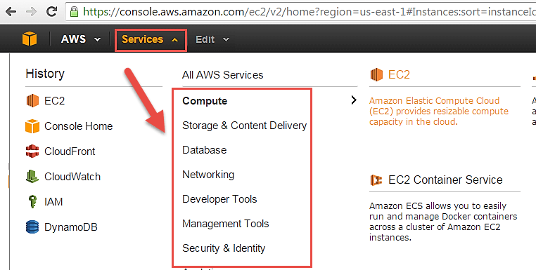

* Open all the services and click on EC2 under Compute services. This will launch the dashboard of EC2.

Here is the EC2 dashboard. Here you will get all the information in gist about the AWS EC2 resources running.

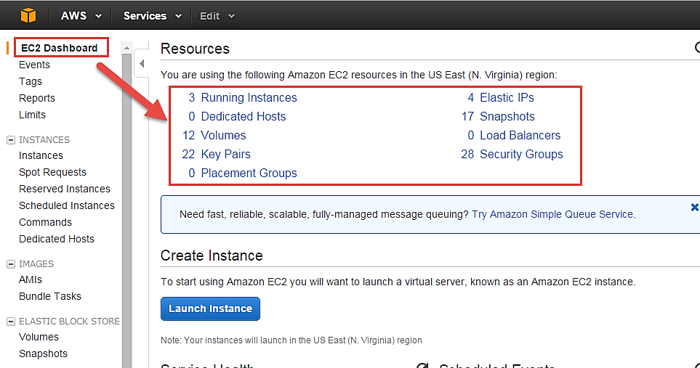

**Step 2)** On the top right corner of the EC2 dashboard, choose the AWS Region in which you want to provision the EC2 server.

Here we are selecting N. Virginia. AWS provides 10 Regions all over the globe.

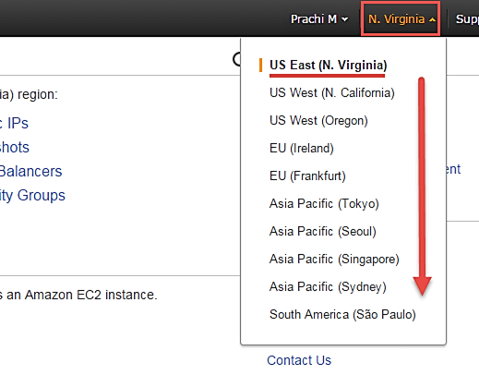

**Step 3)**In this step

* Once your desired Region is selected, come back to the EC2 Dashboard.
* Click on 'Launch Instance' button in the section of Create Instance (as shown below).

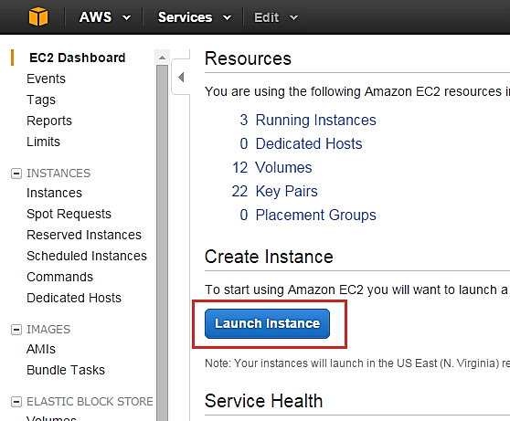

Instance creation wizard page will open as soon as you click 'Launch Instance'.

## Choose AMI

**Step 1)**In this step we will do,

1. You will be asked to choose an AMI of your choice. (An AMI is an Amazon Machine Image. It is a template basically of an Operating System platform which you can use as a base to create your instance). Once you launch an EC2 instance from your preferred AMI, the instance will automatically be booted with the desired OS. (We will see more about AMIs in the coming part of the tutorial).
2. Here we are choosing the default Amazon[Linux](https://www.guru99.com/unix-linux-tutorial.html)(64 bit) AMI.

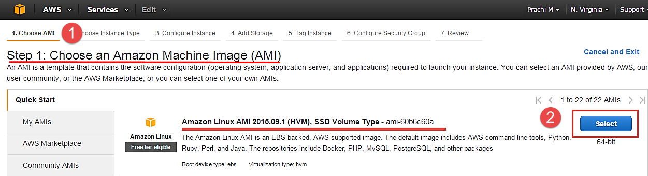

## Choose EC2 Instance Types

**Step 1)** In the next step, you have to choose the type of instance you require based on your business needs.

1. We will choose t2.micro instance type, which is a 1vCPU and 1GB memory server offered by AWS.
2. Click on "Configure Instance Details" for further configurations

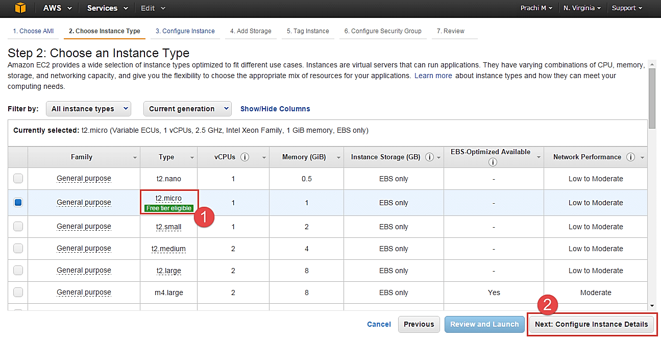

* In the next step of the wizard, enter details like no. of instances you want to launch at a time.
* Here we are launching one instance.

## Configure Instance

**Step 1)**No. of instances- you can provision up to 20 instances at a time. Here we are launching one instance.



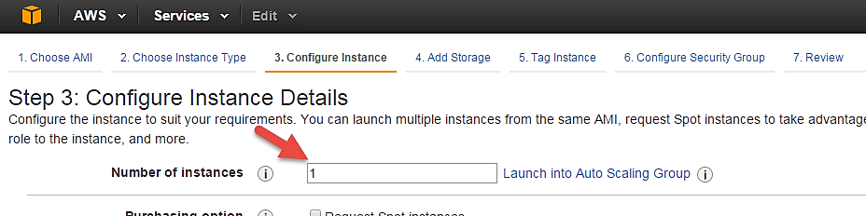

**Step 2)** Under Purchasing Options, keep the option of 'Request Spot Instances' unchecked as of now. (This is done when we wish to launch Spot instances instead of on-demand ones. We will come back to Spot instances in the later part of the tutorial).

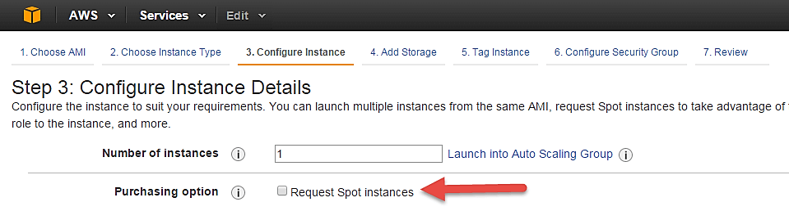

**Step 3)** Next, we have to configure some basic networking details for our EC2 server.

* You have to decide here, in which VPC (Virtual Private Cloud) you want to launch your instance and under which subnets inside your VPC. It is better to determine and plan this prior to launching the instance. Your AWS architecture set-up should include IP ranges for your subnets etc. pre-planned for better management. (We will see how to create a new VPC in Networking section of the tutorial.
* Subnetting should also be pre-planned. E.g.: If it's a web server you should place it in the public subnet and if it's a DB server, you should place it in a private subnet all inside your VPC.

Below,

1. Network section will give a list of VPCs available in our platform.
2. Select an already existing VPC
3. You can also create a new VPC

Here I have selected an already existing VPC where I want to launch my instance.

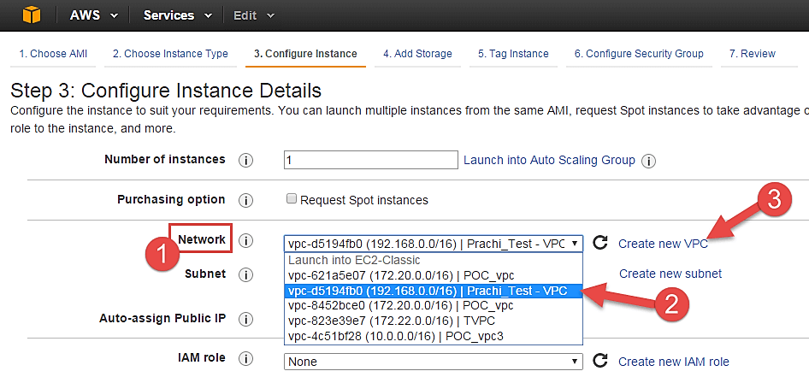

**Step 4)**In this step,

* A VPC consists of subnets, which are IP ranges that are separated for restricting access.
* Below,

1. Under Subnets, you can choose the subnet where you want to place your instance.
2. I have chosen an already existing public subnet.
3. You can also create a new subnet in this step.

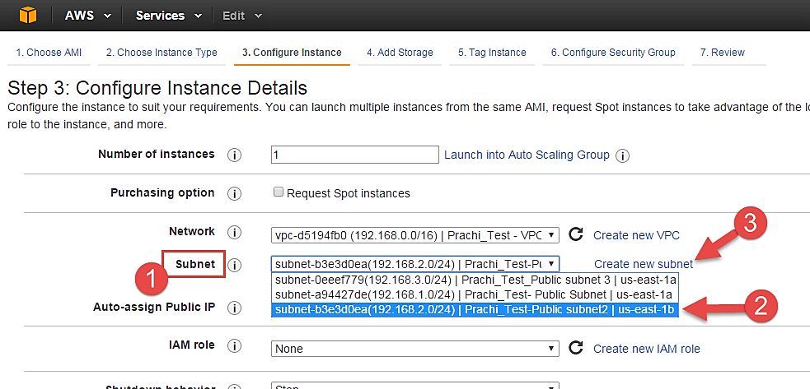

Once your instance is launched in a public subnet, AWS will assign a dynamic public IP to it from their pool of IPs.

**Step 5)**In this step,

* You can choose if you want AWS to assign it an IP automatically, or you want to do it manually later. You can enable/ disable 'Auto assign Public IP' feature here likewise.
* Here we are going to assign this instance a static IP called as EIP (Elastic IP) later. So we keep this feature disabled as of now.

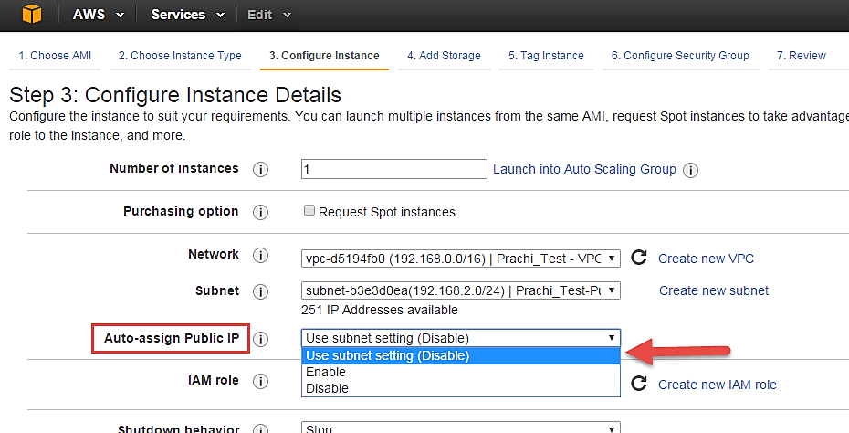

**Step 6)**In this step,

* In the following step, keep the option of IAM role 'None' as of now. We will visit the topic of IAM role in detail in IAM services.

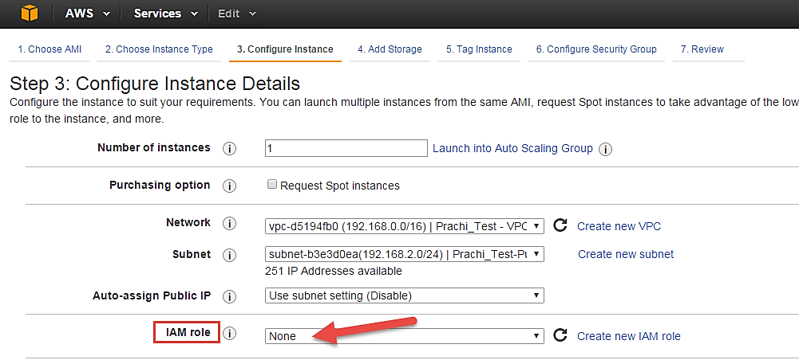

**Step 7)**In this step, you have to do following things

* Shutdown Behavior – when you accidently shut down your instance, you surely don't want it to be deleted but stopped.
* Here we are defining my shutdown behavior as Stop.

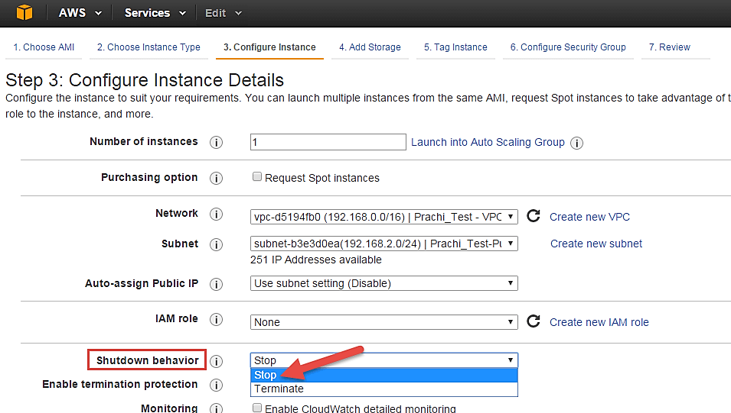

**Step 8)**In this step,

* In case, you have accidently terminated your instance, AWS has a layer of security mechanism. It will not delete your instance if you have enabled accidental termination protection.
* Here we are checking the option for further protecting our instance from accidental termination.

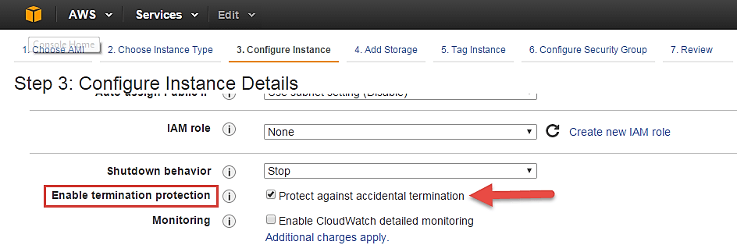

**Step 9)**In this step,

* Under Monitoring- you can enable Detailed Monitoring if your instance is a business critical instance. Here we have kept the option unchecked. AWS will always provide Basic monitoring on your instance free of cost. We will visit the topic of monitoring in AWS Cloud Watch part of the tutorial.
* Under Tenancy- select the option if shared tenancy. If your application is a highly secure application, then you should go for dedicated capacity. AWS provides both options.

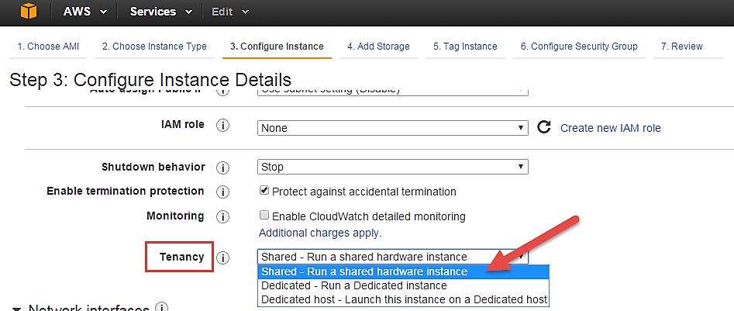

**Step 10)**In this step,

* Click on 'Add Storage' to add data volumes to your instance in next step.

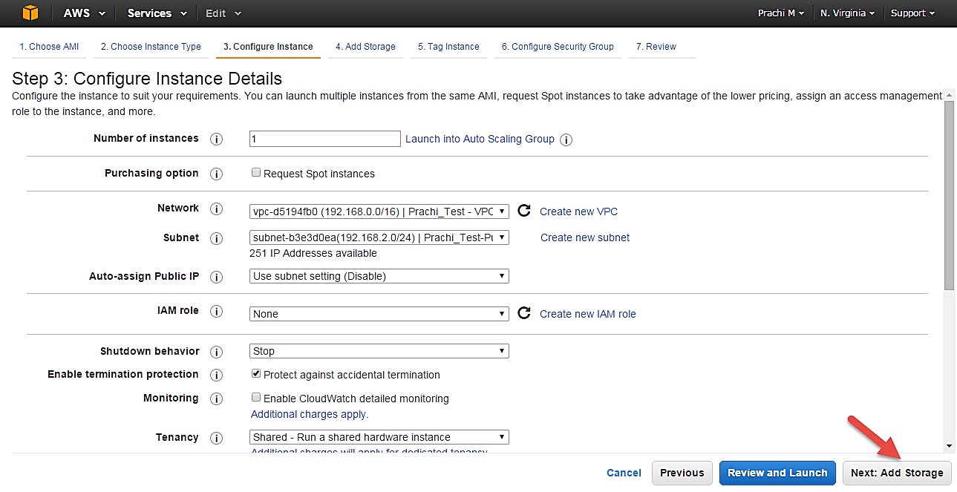

## Add Storage

**Step 1)**In this step we do following things,

* In the Add Storage step, you'll see that the instance has been automatically provisioned a General Purpose SSD root volume of 8GB. ( Maximum volume size we can give to a General Purpose volume is 16GB)
* You can change your volume size, add new volumes, change the volume type, etc.
* AWS provides 3 types of EBS volumes- Magnetic, General Purpose SSD, Provisioned IOPs. You can choose a volume type based on your application's IOPs needs.

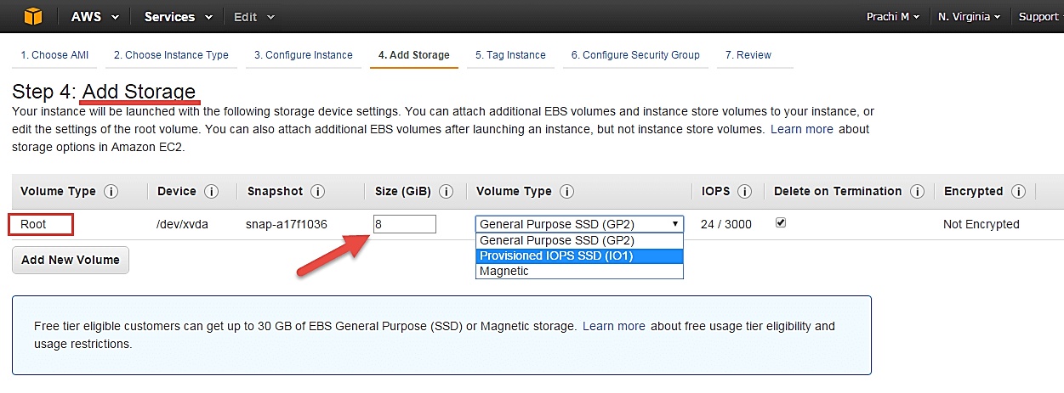

## Tag Instance

**Step 1)**In this step

* you can tag your instance with a key-value pair. This gives visibility to the AWS account administrator when there are lot number of instances.
* The instances should be tagged based on their department, environment like Dev/SIT/Prod. Etc. this gives a clear view of the costing on the instances under one common tag.

1. Here we have tagged the instance as a **Dev_Web server 01**
2. Go to configure Security Groups later

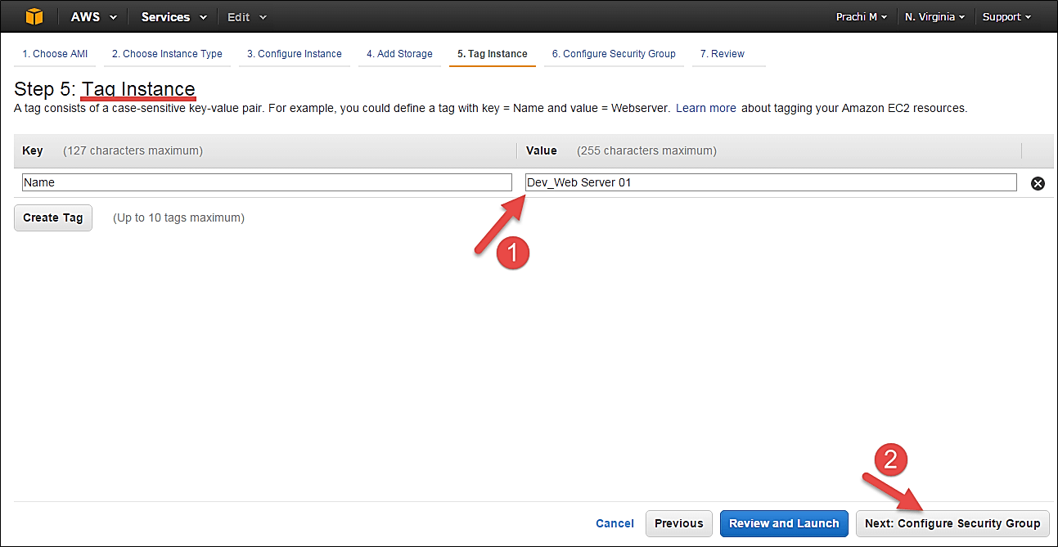

## Configure Security Groups

**Step 1)**In this next step of configuring Security Groups, you can restrict traffic on your instance ports. This is an added firewall mechanism provided by AWS apart from your instance's OS firewall.

You can define open ports and IPs.

* Since our server is a webserver=, we will do following things

1. Creating a new Security Group
2. Naming our SG for easier reference
3. Defining protocols which we want enabled on my instance
4. Assigning IPs which are allowed to access our instance on the said protocols
5. Once, the firewall rules are set- Review and launch

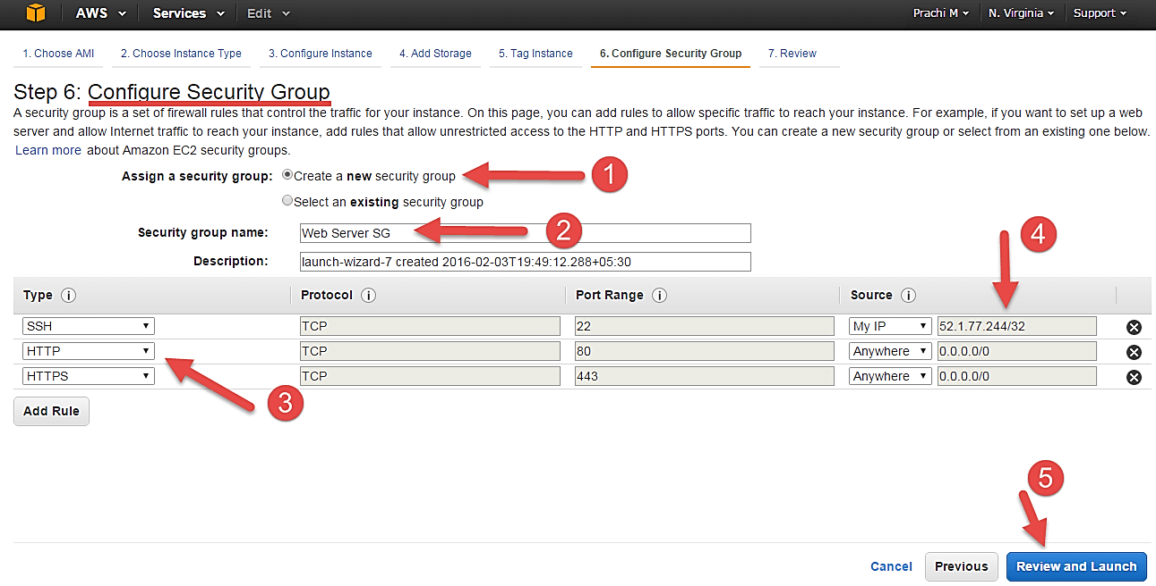

## Review Instances

**Step 1)** In this step, we will review all our choices and parameters and go ahead to launch our instance.

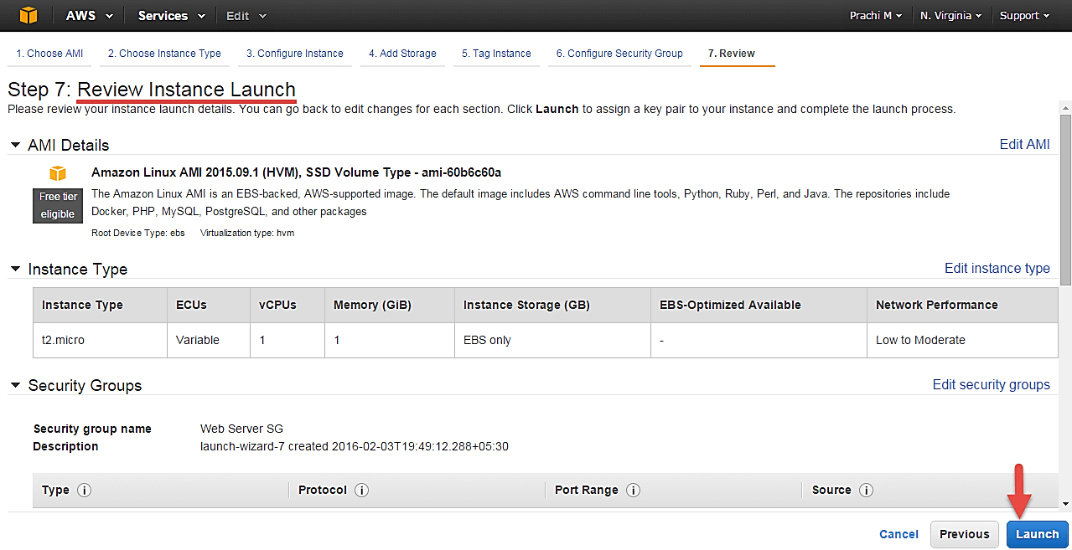

**Step 2)** In the next step you will be asked to create a key pair to login to you an instance. A key pair is a set of public-private keys.

AWS stores the private key in the instance, and you are asked to download the private key. Make sure you download the key and keep it safe and secured; if it is lost you cannot download it again.

1. Create a new key pair
2. Give a name to your key
3. Download and save it in your secured folder

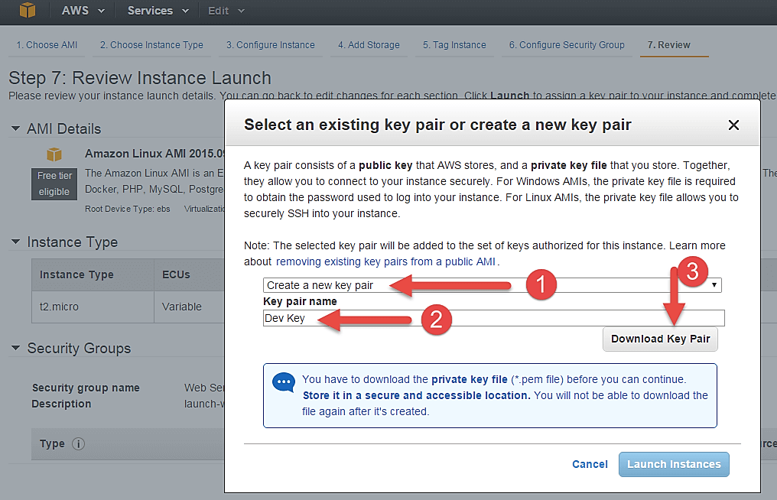

When you download your key, you can open and have a look at your RSA private key.

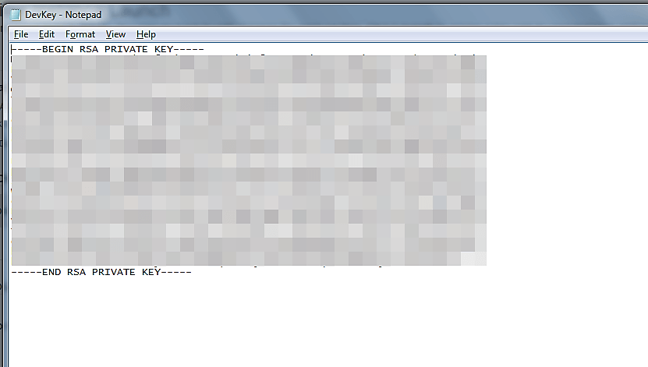

**Step 3)** Once you are done downloading and saving your key, launch your instance.

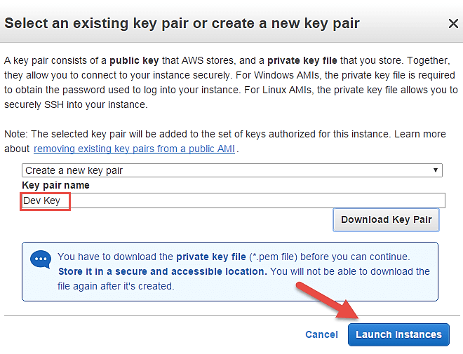

You can see the launch status meanwhile.

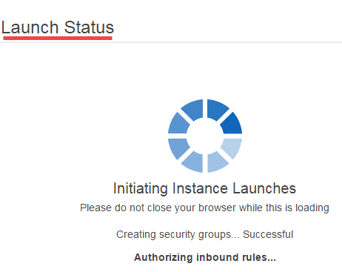

You can also see the launch log.

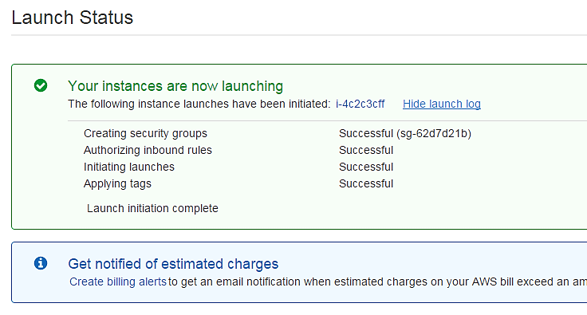

Click on the 'Instances' option on the left pane where you can see the status of the instance as 'Pending' for a brief while.

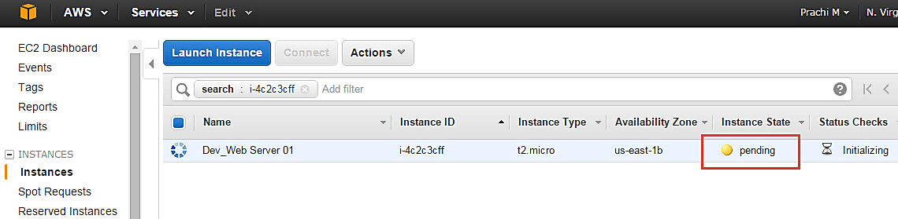

* Once your instance is up and running, you can see its status as 'Running' now.
* Note that the instance has received a Private IP from the pool of AWS.

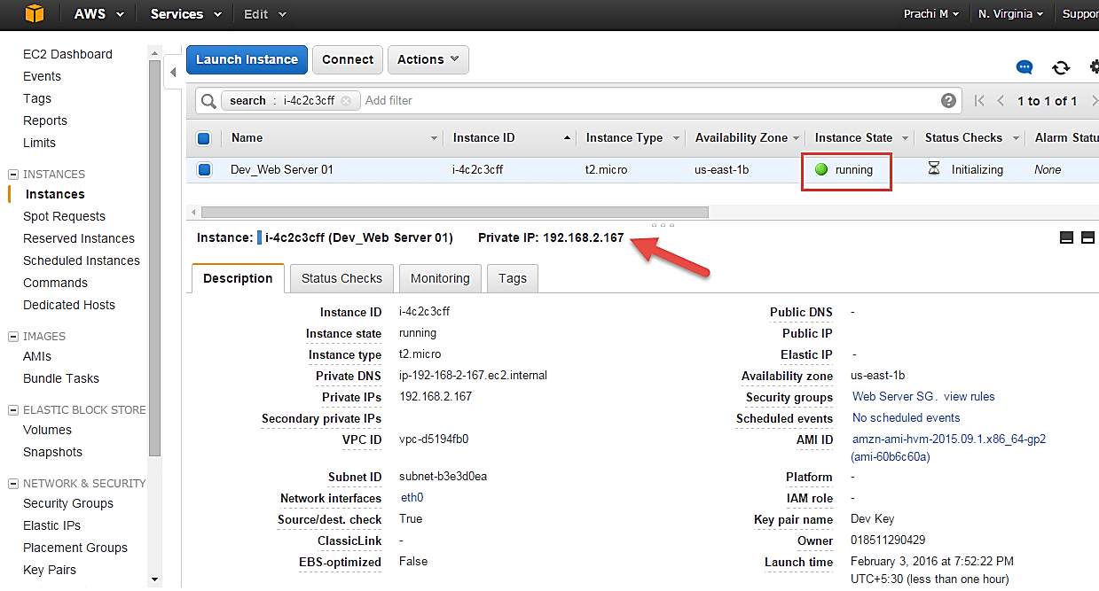

## Create a EIP and connect to your instance

An EIP is a static public IP provided by AWS. It stands for Elastic IP. Normally when you create an instance, it will receive a public IP from the AWS's pool automatically. If you stop/reboot your instance, this public IP will change- it'dynamic. In order for your application to have a static IP from where you can connect via public networks, you can use an EIP.

**Step 1)** On the left pane of EC2 Dashboard, you can go to 'Elastic IPs' as shown below.

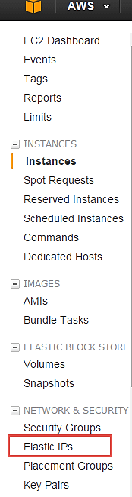

**Step 2)** Allocate a new Elastic IP Address.

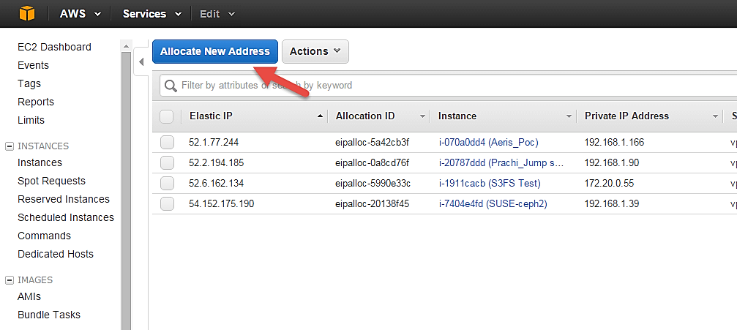

**Step 3)**Allocate this IP to be used in a VPC scope.

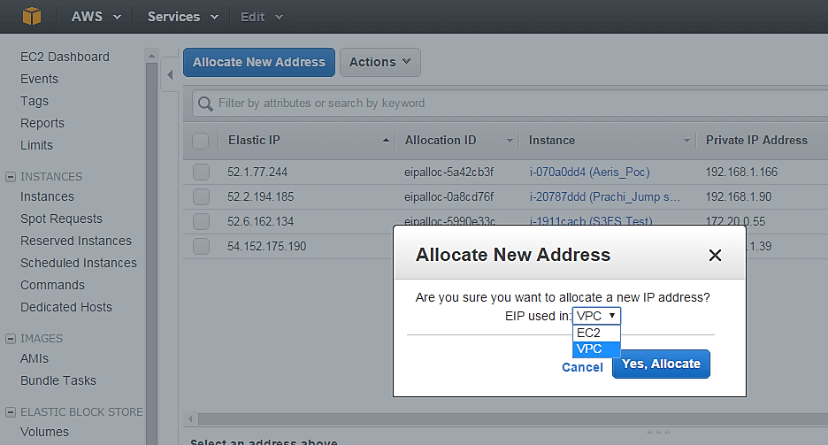

Your request will succeed if you don't have 5 or more than 5 EIPs already in your account.

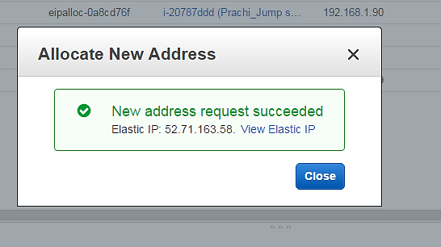

**Step 4)**Now assign this IP to your instance.

1. Select the said IP
2. Click on Actions **->** Associate Address

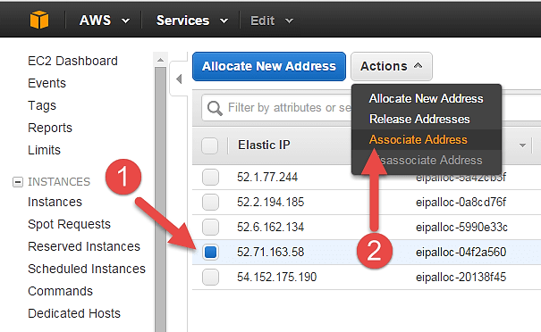

**Step 5)** In the next page,

1. Search for your instance and
2. Associate the IP to it.

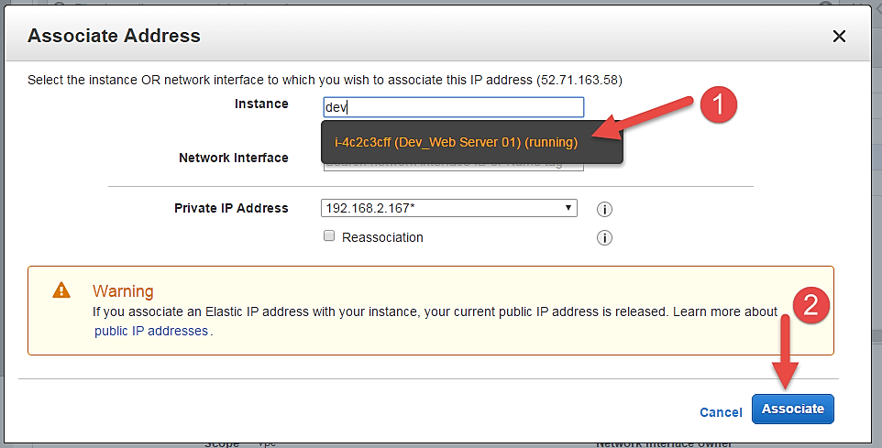

**Step 6)**Come back to your instances screen, you'll see that your instance has received your EIP.

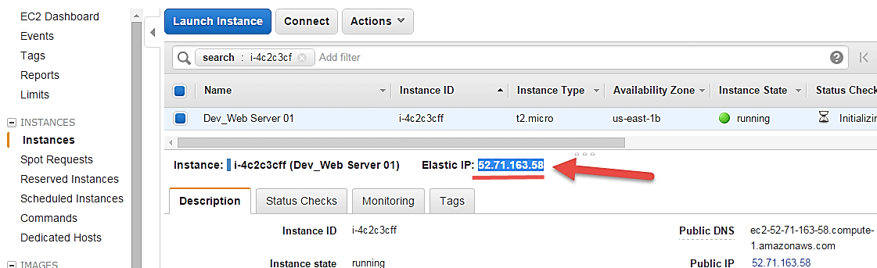

**Step 7)**Now open putty from your programs list and add your same EIP in there as below.

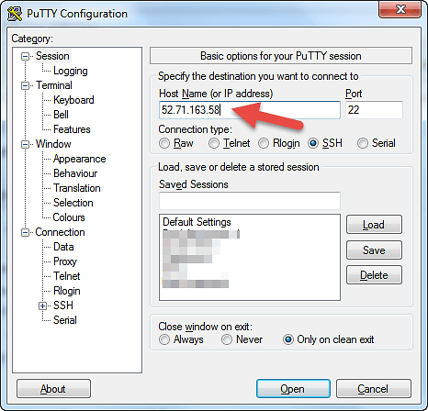

**Step 8)**In this step,

Add your private key in putty for secure connection

1. Go to Auth
2. Add your private key in .ppk (putty private key) format. You will need to convert pem file from AWS to ppk using puttygen

Once done click on "Open" button

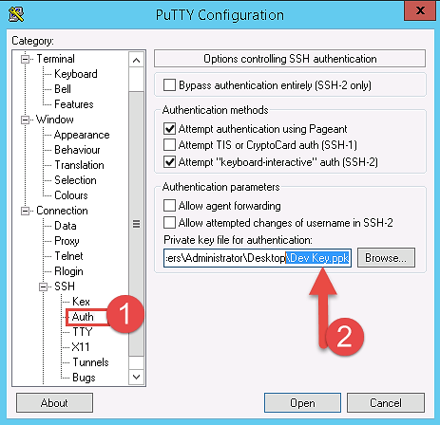

* Once you connect, you will successfully see the[Linux](https://www.guru99.com/unix-linux-tutorial.html)prompt.
* Please note that the machine you are connecting from should be enabled on the instance Security Group for SSH (like in the steps above).

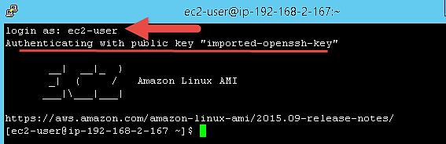

Once you become familiar with the above steps for launching the instance, it becomes a matter of 2 minutes to launch the same!

You can now use your on-demand EC2 server for your applications.

### What is Spot Instance?

A spot Instance is an offering from AWS; it allows an AWS business subscriber to bid on unused AWS compute capacity. The hourly price for a Spot instance is decided by AWS, and it fluctuates depending on the supply and demand for Spot instances.

Your Spot instance runs whenever your bid exceeds the current market price. The price of a spot instance varies based on the instance type and the Availability Zone in which the instance can be provisioned.

When your bid price exceeds the market spot price of the instance called as the ‘spot price,' your instance stays running. When the spot price overshoots the bid price, AWS will terminate your instance automatically. Therefore, it is necessary to plan the spot instances in your application architecture carefully.

### Create a Spot Request

In order to launch a spot instance, you have to first create a Spot Request.

Follow the steps below to create a Spot Request.

1. On the EC2 Dashboard select 'Spot Requests' from the left pane under Instances.
2. Click on the button 'Request Spot Instances" as shown below.

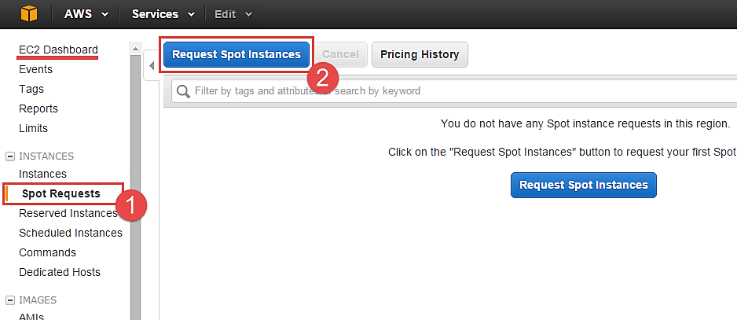

Spot instance launch wizard will open up. You can now go ahead with selecting the parameters and the instance configuration.

#### Find Instance Types

The first step for spot instance is to "Find instance types."

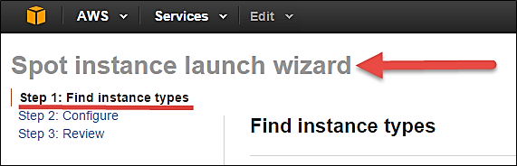

**Step 1)** Select an AMI- an AMI is a template consisting of the OS platform and software to be installed in the instance. Select your desired AMI from the existing list. We are selecting Amazon Linux AMI for this tutorial.

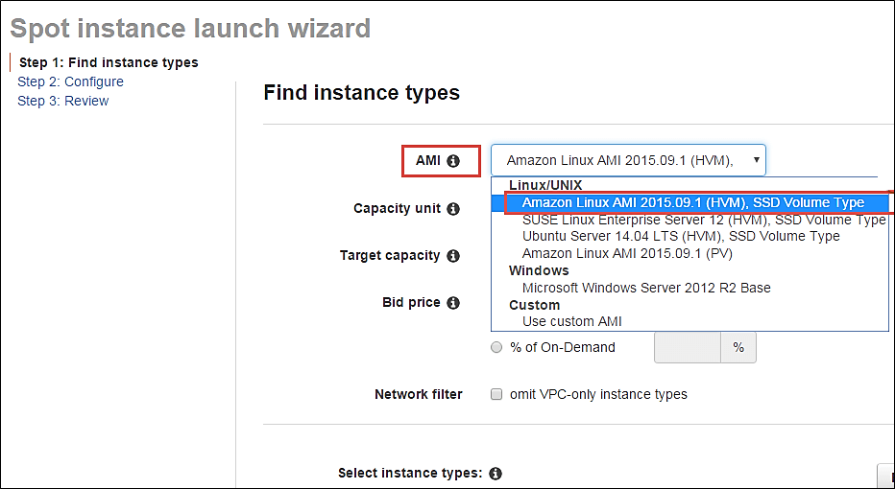

**Step 2)** Capacity Unit- a Capacity Unit is your application requirement. You may decide to launch an instance based on the instance type, vCPU or custom configuration like your choice of vCPU/memory/storage requirements. Here we are selecting an Instance.

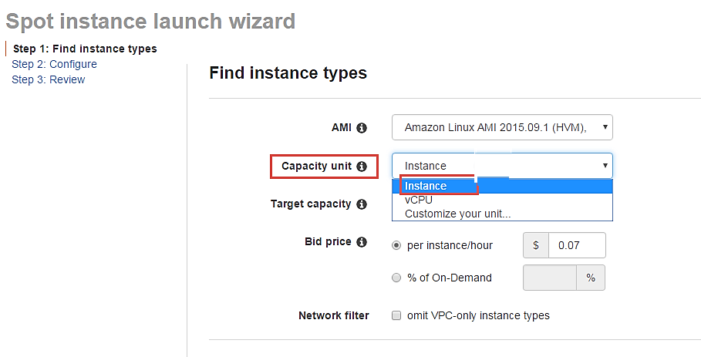

If you wish to customize the capacity, you can add your choice of

1. vCPU,
2. Memory and
3. Instance storage as below.

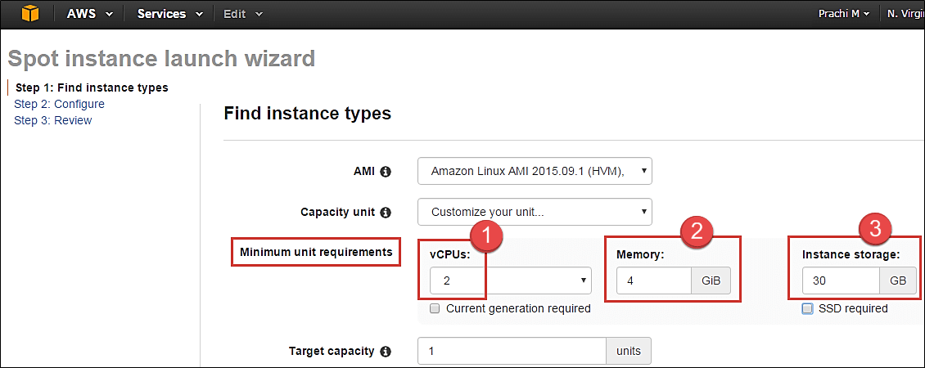

**Step 3)** Target Capacity depicts how many spot instances you wish to maintain in your request. Here we are selecting one.

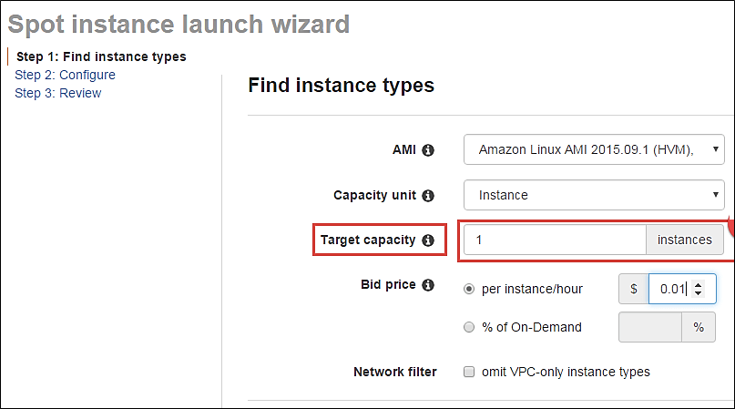

**Step 4)** Bid Price – this is the maximum price we are ready to pay for the instance. We are going to set a particular price per instance/hour. This is the simplest to calculate based on our business requirement. We will see ahead how we should determine the bid price so that our bid price always remains high and doesn't exceed the spot price so that our instance keeps running.

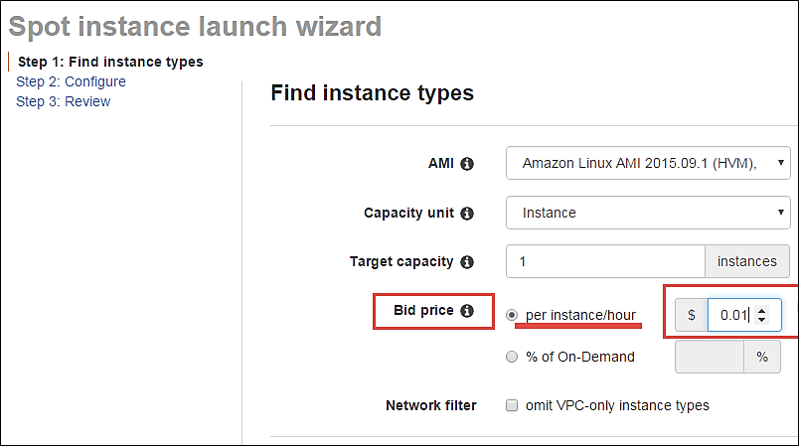

**j**ust below the bid price you can see a button of Pricing History. Click on that as shown below.

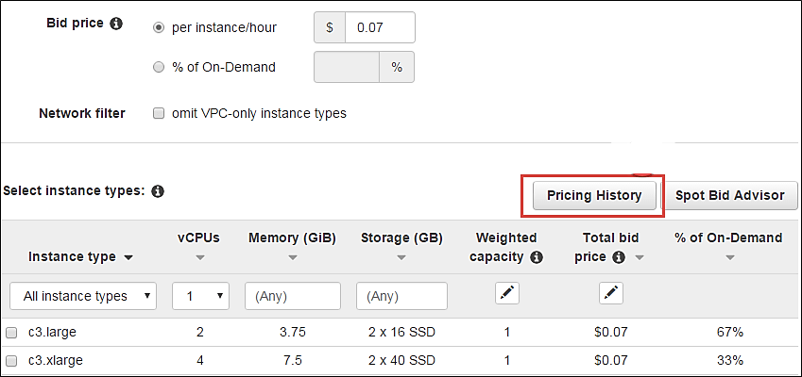

Here in Pricing History, we can see a graph depicting instance pricing trends with historical data. You can select the parameters and get an idea of the pricing of our desired instance over a period of time.

1. Select the product. We have selected our Linux AMI.
2. Select the instance type. We have selected m3.medium.
3. Note the average prices for over a day here.

Thus, from the chart below, we can see that the instance type that we are planning to provision lies in the pricing range of $0.01xx, and it seems that Availability Zone 'us-east 1a' has the lowest price.

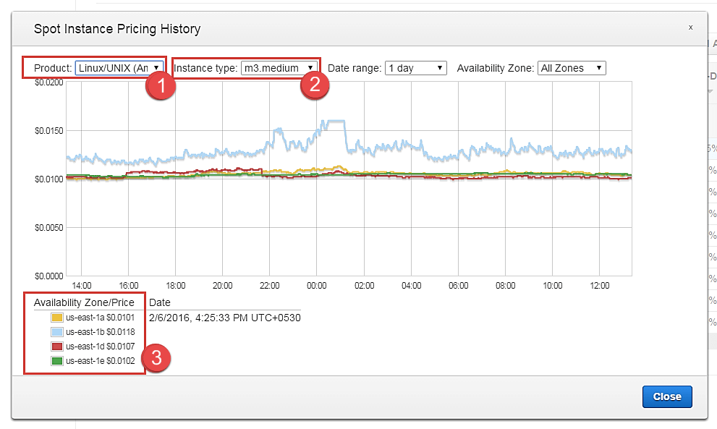

cont. to step 4.

So let's come back to our step of quoting a bid price.

For the sake of maintaining our instance always available and if it falls within our budget, we can quote a higher bid price. Here we have quoted a slightly higher price of $0.05.

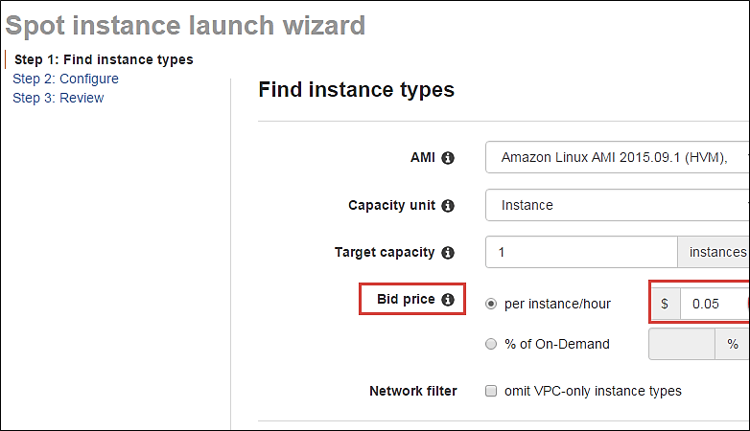

You can see some trends in the wizard itself.

1. Note the instance types section
2. Select the instance type that we are planning to provision
3. Note the price that we are planning to bid. % of on-demand shows us that our quoted price is 75% of the on-demand price for the same instance type. This means we are saving 25% per hour as compared to an on-demand instance. You can further lower the price and save costs drastically.

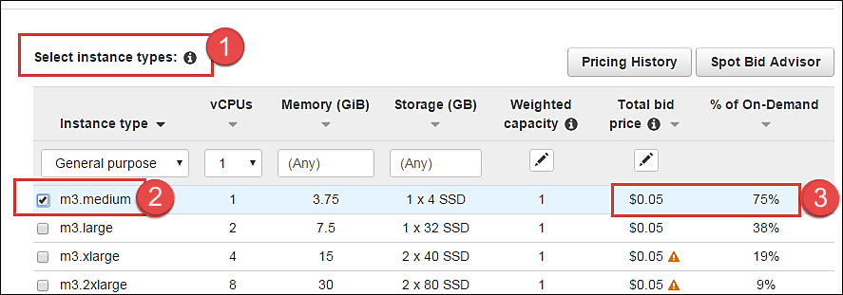

**Step 5)** Once we are done looking at the trends and quoting our bid price, click on next.

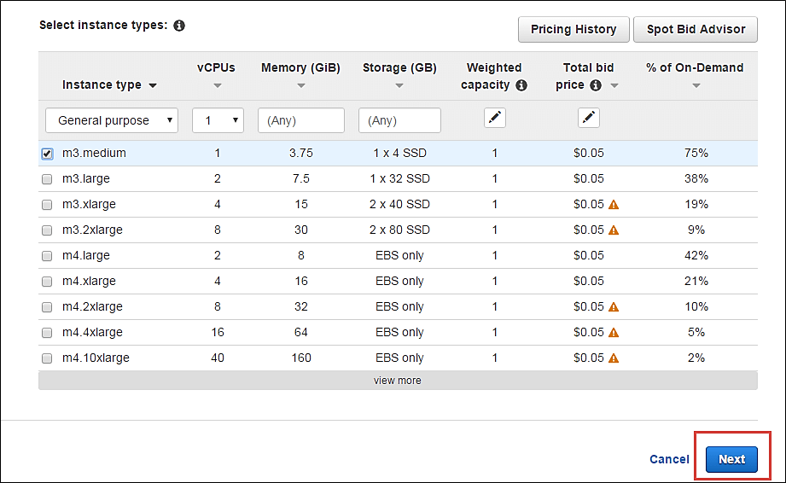

#### Configure the Spot instance

Our next step is to configure the instance, in this step of the wizard, we'll configure instance parameters like VPC, subnets, etc.

Let's take a look.

**Step 1)**Allocation Strategy – it determines how your spot request is fulfilled from the AWS's spot pools. There are two types of strategies:

* Diversified – here, spot instances are balanced across all the spot pools
* Lowest price – here, spot instances are launched from the pool which has lowest price offers

For this tutorial, we'll select Lowest Price as our allocation strategy.

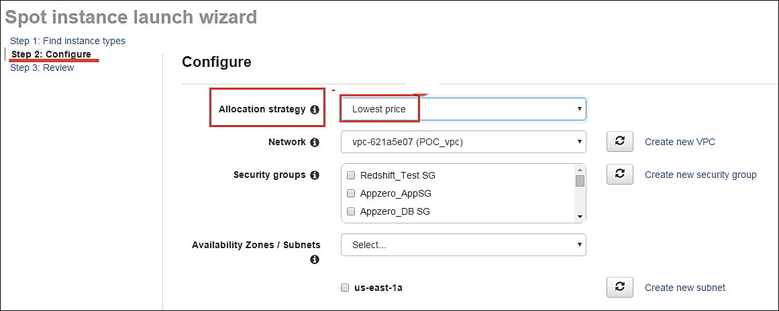

**Step 2)**Select the VPC- we'll select from the list of available VPCs that we have created earlier. We can also create a new VPC in this step.

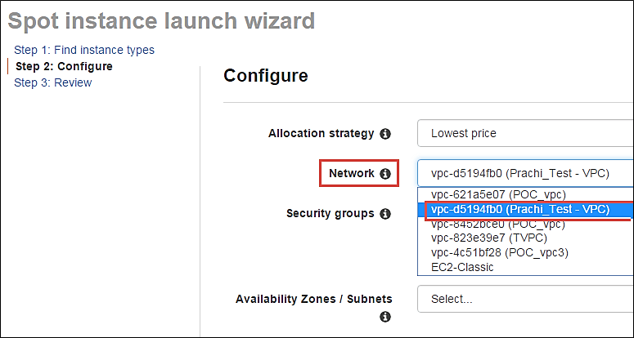

**Step 3)** Next we'll select the security group for the instance. We can select an already existing SG or create a new one.

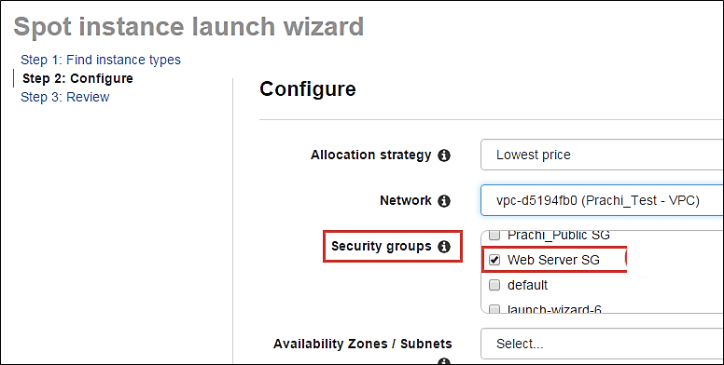

**Step 4)** Availability Zone- we'll select the AZ where we want to place our instance based on our application architecture. We are selecting AZ- us-east-1a.

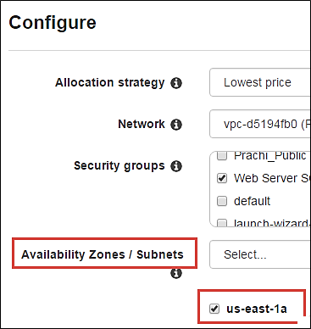

**Step 5)** Subnets- we are going to select the subnet from our list of already available list.

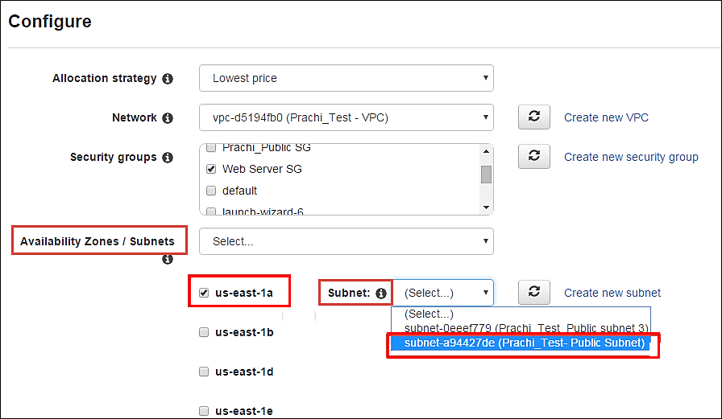

**Step 6)** Public IP- we'll choose to assign the instance a public IP as soon as it launches. In this step, you can choose if you want AWS to assign it an IP automatically, or you want to do it manually later. You can enable/ disable 'Auto assign Public IP' feature here likewise.

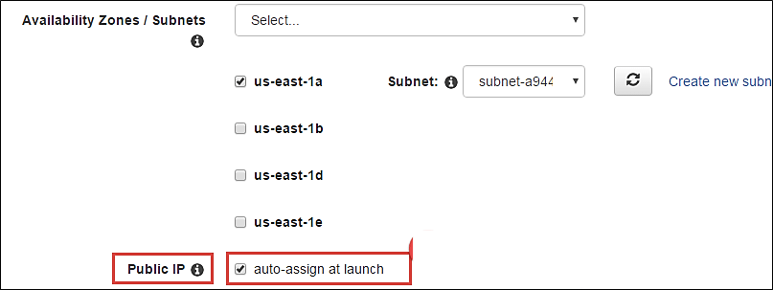

**Step 7)** Key pair- A key pair is a set of public-private keys.

AWS stores the private key in the instance, and you are asked to download the private key. Make sure you download the key and keep it safe and secured**; if it is lost you cannot download it again.**

After selecting public IP, here we are selecting a key which we already have created in our last tutorial.

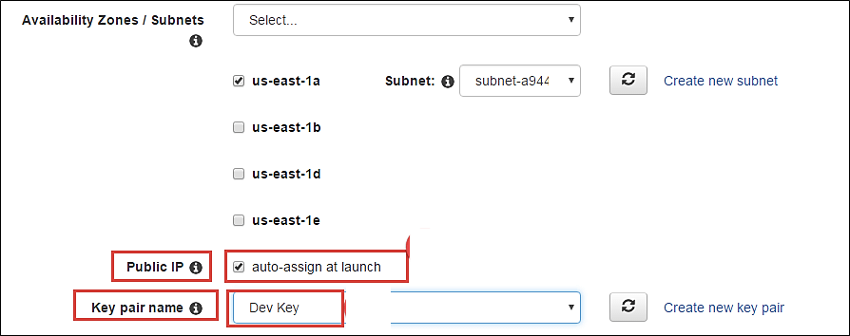

#### Review your Spot instance

Once we are done configuring our spot instance request in the 2 steps earlier in our wizard, we'll take a look at the overall configuration.

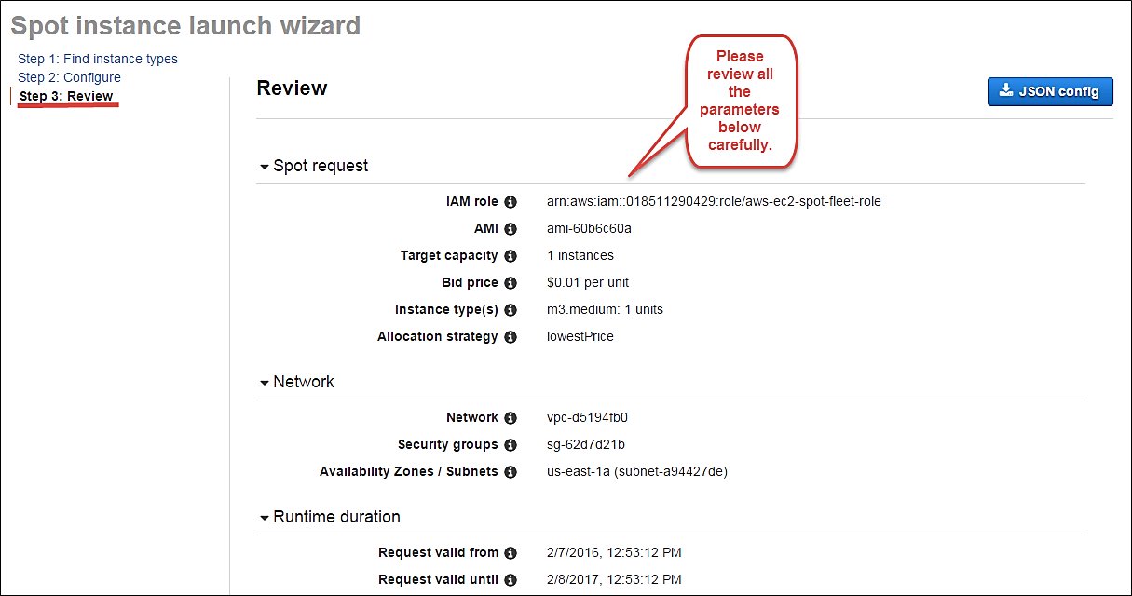

1. **We can also download a JSON file with all the configurations. Below is our JSON file.**

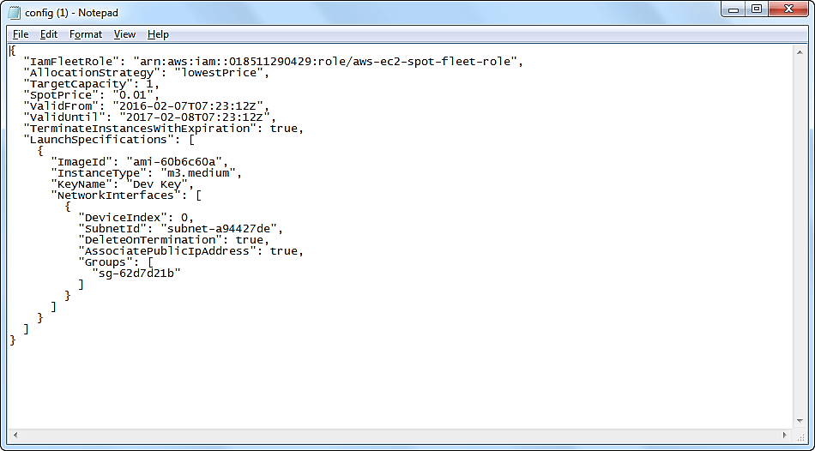

After we are done reviewing, we can proceed with the launching by clicking the Launch button as shown below.

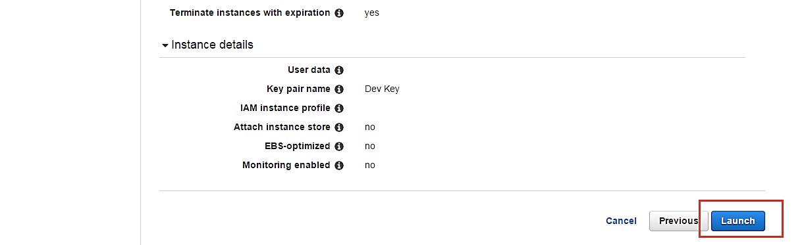

Once we select Launch, we can see a notification about the request getting created.

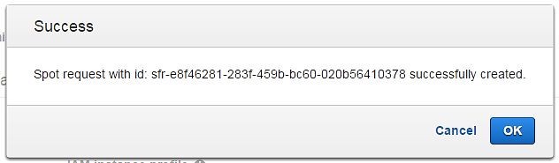

The spot request creation wizard will close, and the page will automatically direct back to the EC2 Dashboard.

You can see as shown below that the State of our request is 'open' which means that it is getting evaluated from the AWS's side. AWS EC2 will check if the required instance is available in its spot pool.

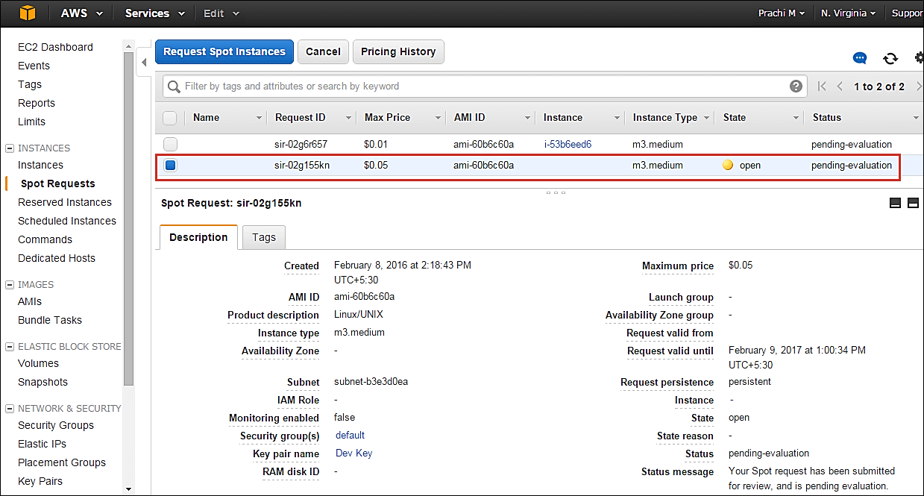

After a couple of minutes, you can see that the state is changed to 'active', and now our spot request is successfully fulfilled. You can note the configuration parameters below.

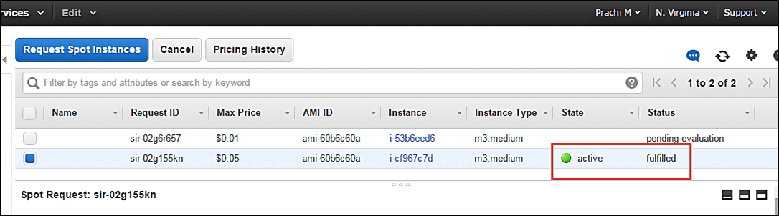

**Summary:**

Thus, we saw in detail how to create an on-demand EC2 instance in this tutorial. Because it is an on-demand server, you can keep it running when in use and 'Stop' it when it's unused to save on your costs.

You can provision a Linux or Windows EC2 instance or from any of the available AMIs in AWS Marketplace based on your choice of OS platform.

If your application is in production and you have to use it for years to come, you should consider provisioning a reserved instance to drastically save on your CAPEX.

Here, we saw how to create a Spot Instance request successfully by determining our bid price.

Spot instances are a great way to save on costs for instances which are not application critical. A common example would be to create a fleet of spot instances for a task such as image processing or video encoding. In such cases, you can keep a cluster of instances under a load balancer.

If the bid price exceeds the spot price and your instance is terminated from AWS's side, you can have other instances doing the processing job for you. You can leverage Auto scaling for this scenario. Avoid using Spot instances for business critical applications like databases etc.

**3. Change Instance Type, Security Group, Termination Protection: AWS EC2**

EC2 stands for Elastic Compute Cloud. It is the compute service offering from the IaaS (Infrastructure as a Service) area of AWS.

Once an EC2 instance is provisioned, it is very handy to update/modify many of the instances configuration parameters using AWS Management Console.

Let's take a look at each of them.

**What You Will Learn:** [hide]

* [Login and access to AWS services](https://www.guru99.com/modifying-amazon-ec2-instance-parameters.html#1)
* [Checke the modification parameters](https://www.guru99.com/modifying-amazon-ec2-instance-parameters.html#2)
* [View the connection details](https://www.guru99.com/modifying-amazon-ec2-instance-parameters.html#3)
* [Launch multiple instances with the similar configuration](https://www.guru99.com/modifying-amazon-ec2-instance-parameters.html#4)
* [Change the instance state](https://www.guru99.com/modifying-amazon-ec2-instance-parameters.html#5)
* [Change instance settings](https://www.guru99.com/modifying-amazon-ec2-instance-parameters.html#6)
* [Create tags](https://www.guru99.com/modifying-amazon-ec2-instance-parameters.html#7)
* [Attach to Auto Scaling Group](https://www.guru99.com/modifying-amazon-ec2-instance-parameters.html#8)
* [Change instance type](https://www.guru99.com/modifying-amazon-ec2-instance-parameters.html#9)
* [Enable termination protection](https://www.guru99.com/modifying-amazon-ec2-instance-parameters.html#10)
* [Change User Data](https://www.guru99.com/modifying-amazon-ec2-instance-parameters.html#11)
* [Change the shutdown behavior](https://www.guru99.com/modifying-amazon-ec2-instance-parameters.html#12)
* [View System Log](https://www.guru99.com/modifying-amazon-ec2-instance-parameters.html#13)
* [Create an instance AMI](https://www.guru99.com/modifying-amazon-ec2-instance-parameters.html#14)
* [Change the instance network settings](https://www.guru99.com/modifying-amazon-ec2-instance-parameters.html#15)
* [Change the Security Group](https://www.guru99.com/modifying-amazon-ec2-instance-parameters.html#16)
* [Add a Network Interface](https://www.guru99.com/modifying-amazon-ec2-instance-parameters.html#17)
* [Dissociating EIP](https://www.guru99.com/modifying-amazon-ec2-instance-parameters.html#18)
* [Change Source/Destination check](https://www.guru99.com/modifying-amazon-ec2-instance-parameters.html#19)
* [Manag private IP addresses](https://www.guru99.com/modifying-amazon-ec2-instance-parameters.html#20)
* [Enable/disable ClassicLink to a VPC](https://www.guru99.com/modifying-amazon-ec2-instance-parameters.html#21)
* [Enable detailed CloudWatch monitoring](https://www.guru99.com/modifying-amazon-ec2-instance-parameters.html#22)

## Login and access to AWS services

**Step 1)**In this step, you will do

* Login to your AWS account and go to the AWS Services tab at the top left corner.
* Here, you will see all of the AWS Services categorized as per their area viz. Compute, Storage, Database, etc. For creating an EC2 instance, we have to choose Computeà EC2 as in the next step.

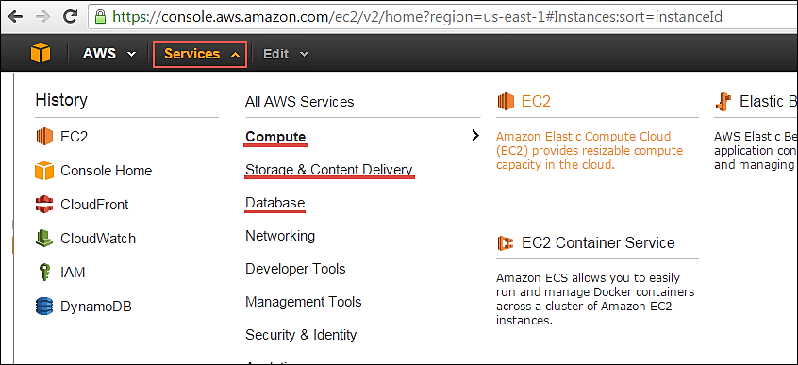

Open all the services and click on EC2 under Compute services. This will launch the dashboard of EC2.

Here is the EC2 dashboard. Here you will get all the information in gist about the AWS EC2 resources running.



**Step 2)** On the top right corner of the EC2 dashboard, choose the AWS Region in which you want to provision the EC2 server.

Here we are selecting N. Virginia. AWS provides 10 Regions all over the globe.



**Step 3)**

Once your desired Region is selected, come back to the EC2 Dashboard.

### Checke the modification parameters

**Step 1)** On the EC2 Dashboard, select the instance whose configuration parameters you want to modify and Click on the "Actions" button as shown below.

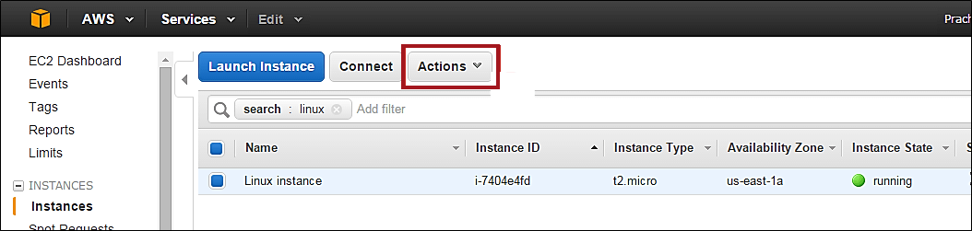

**Step 2)**As you click the button, the drop- down will show us all the areas where we can modify the instance characteristics.

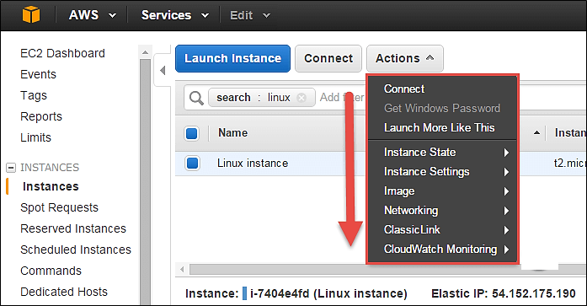

### View the connection details

Connect option below will show us ways in which we can connect to an EC2 instance.

**Step 1)** Click on option 'Connect.'

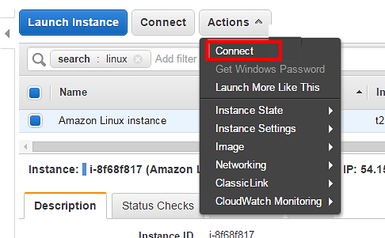

You may choose to connect with a standalone SSH client or a[Java](https://www.guru99.com/java-tutorial.html)client. You will get a step-by-step procedure on how you can connect to your instance.

For this tutorial, we can see the connection methods for a[Linux](https://www.guru99.com/unix-linux-tutorial.html)instance.

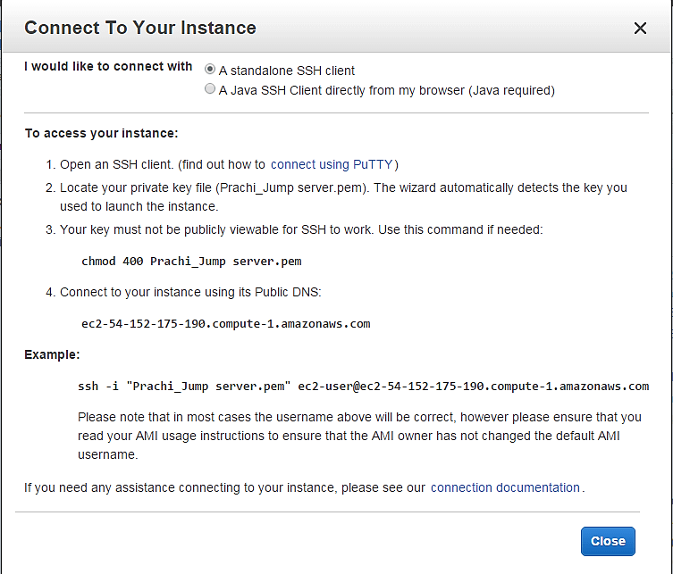

### Launch multiple instances with the similar configuration

If you have a single EC2 instance running with a particular configuration, and you wish to quickly launch another instance in a one-click deployment, then 'Launch More Like This' option helps us do that.

**Step 1)** Click on 'Launch More Like This.'

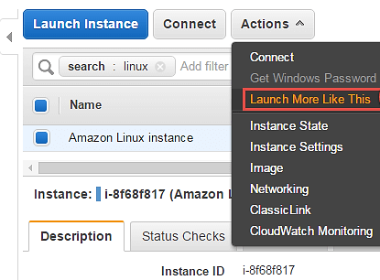

You will be straightaway directed to the review instance details page of the launch instance wizard. Here we can verify all the details once more.

**Step 2)** On review instance details page Click on button 'Launch.'

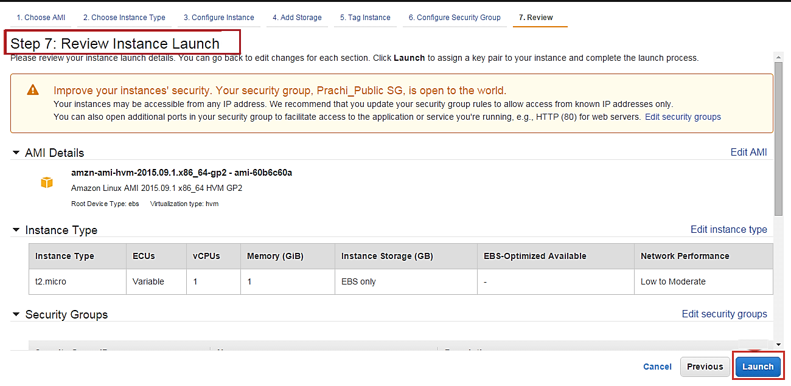

**Step 3)** In this window,

1. Select an existing key pair
2. Click on "Launch Instance."

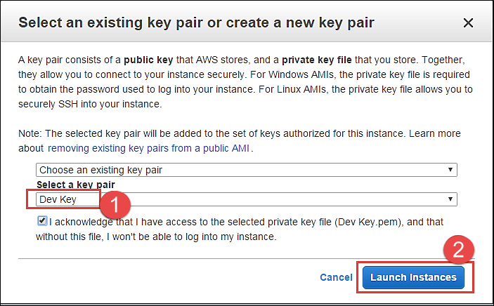

Instance launch progress can be seen as below.

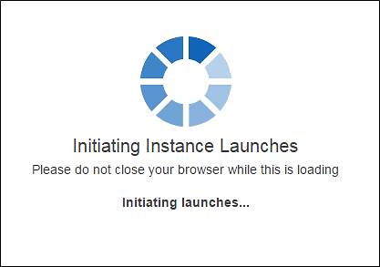

You can see below that a new instance is in a pending state before creation.

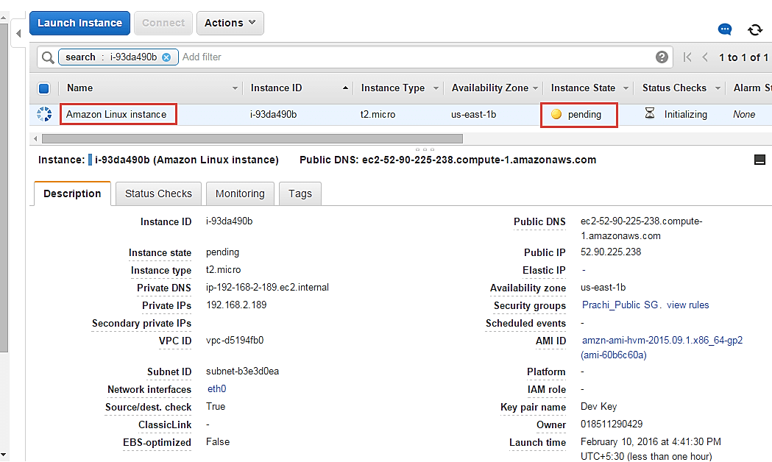

You can see that the new instance has the same tag as well.

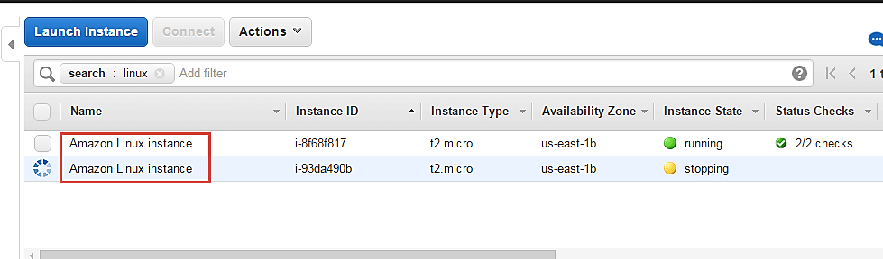

### Change the instance state

You can change the instance state on the fly from the Management Console on a single click.

**Step 1)** In this step, Click on 'Instance State' under actions.

* Stop – you can stop the running instance
* Reboot – you can reboot the instance
* Terminate – you can delete the instance permanently

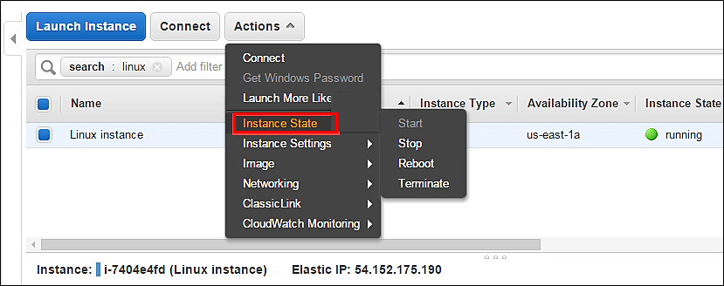

## Change instance settings

Here you can change a lot of instance settings like security groups, termination protection, etc.

Let's us see each one in detail.

### Create tags

Add/Edit Tags – You can add or edit the tags assigned to the instance. Tagging makes it easier for the business owner of the AWS account to keep a track of the instances especially if there are multiple environments.

AWS admins should assign each instance a tag based on the segregation e.g.: tagging all the instances in the production environment as 'Prod' or tagging the instances belonging to a department with the department initials etc. Tagging is a very effective method to track the costing of the instances as well.

Let's see how to change tags

**Step 1)** In this step,

1. Click on instance setting
2. Click on 'Add/Edit Tags.'

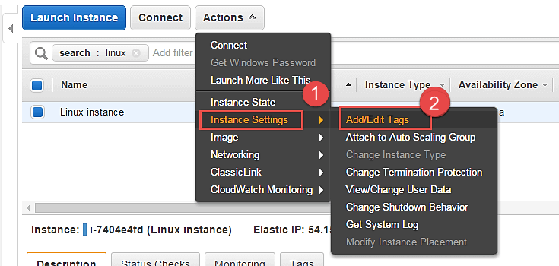

**Step 2)** A tag is just a key-value pair.

1. So we have assigned a new tag as Department and added its value as Cloud.
2. Click on Save

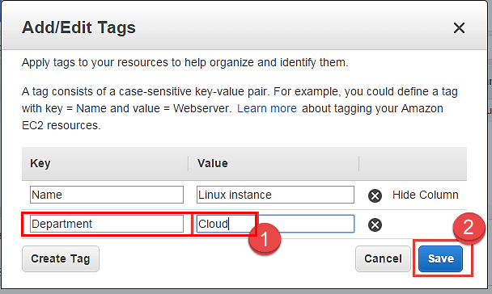

**Step 3)** Come back to the EC2 Dashboard and

1. Select your instance again
2. Select the tab of 'Tags'

Note that the new tag as "Department" with value as Cloud has appeared under Tags.

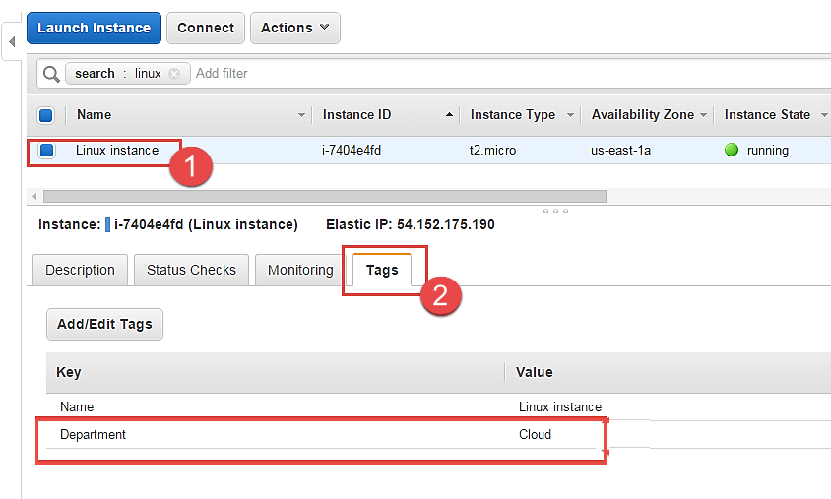

### Attach to Auto Scaling Group

An EC2 instance can be attached to an Auto Scaling Group on the fly.

**Step 1)** In this step, we do following things

1. Click on 'Instance Settings'
2. Click on 'Attach to Auto Scaling Group.'

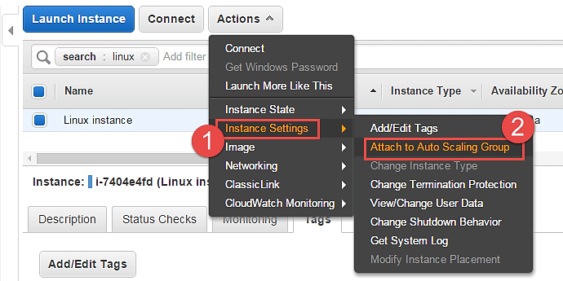

**Step 2)** In this step,

1. Attach an instance to an existing AS group. You can also create a new AS group in this step.
2. Select one AS group from the list of already existing groups.
3. Click on 'Attach'.

This action will attach your instance to an auto-scaling group in your environment.

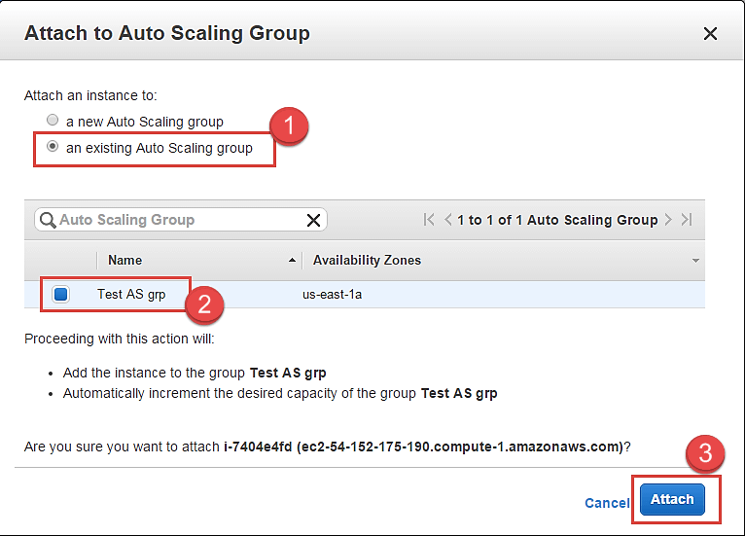

### Change instance type

You can change the instance-type of your instance if you desire higher configuration instance as per your application requirement. This can be done to vertically scale your instance and provide you with more compute/memory capacity.

Let's see how to do this.

You cannot change an instance type if it's a running server. You have to stop it before doing so.

**Step 1)** In this step,

1. Go to 'Instance State'
2. Click on 'Stop'. This will stop the instance.

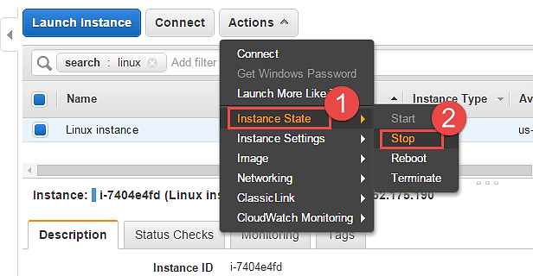

Note that the instance state is now in "stopping" mode on the EC2 Dashboard. You change an instance type now.

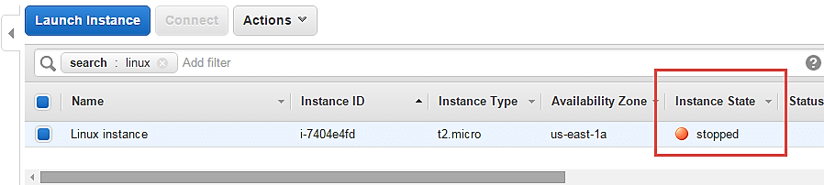

**Step 2)** In this step,

1. Go to 'Instance Settings'
2. Click on 'Change Instance Type'

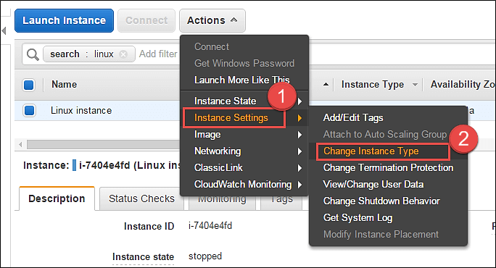

A Change Instance Type pop-up will appear.

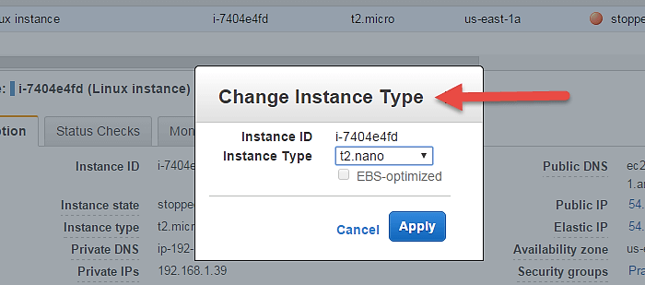

**Step 3)** You can select from a range of EC2 available instance types. For this tutorial, we are changing it to t2.nano just for the sake of demonstration.

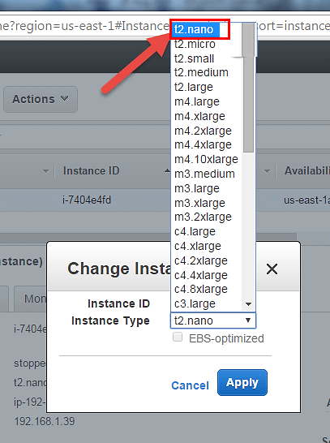

**Step 4)** Select t2.nano and hit 'Apply'.

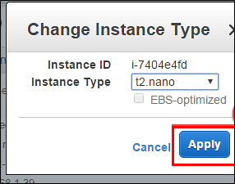

Notice on the EC2 Dashboard, your instance type has been changed to the said type automatically.

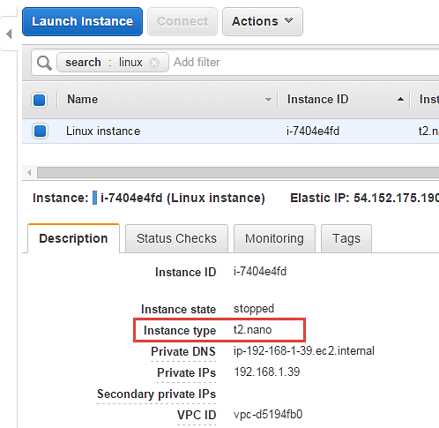

You can now start your instance and continue on the operations on that. There will be no change in other configuration parameters and also your existing installations on the server will remain intact.

### Enable termination protection

An instance should always have termination protection enabled especially on production servers. This will ensure that your EC2 instance is not getting accidently terminated.

AWS will add an additional level of security in case you happen to accidently hit the instance terminate option.

Let's see how to enable termination protection.

**Step 1)** In this step,

1. Go to 'Instance Settings.'
2. Click on 'Change Termination Protection.'

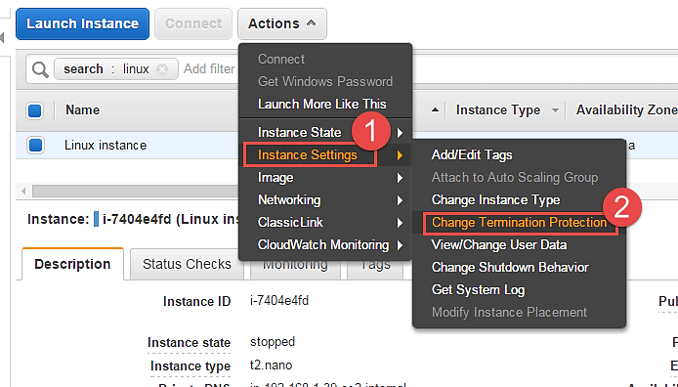

**Step 2)** Notice that the current setting on our instance is disabled. Click on "Yes,Enable".

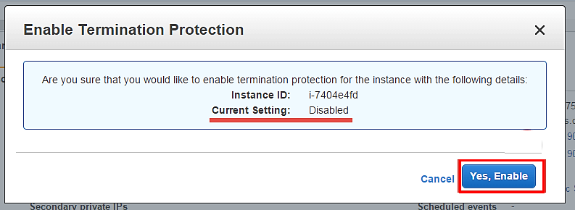

This has enabled Termination protection on our instance. We'll check to see if our instance gets deleted when we hit Terminate.

**Step 3)** In this step,

1. Select option 'Instance State' and then
2. Click on 'Terminate.'

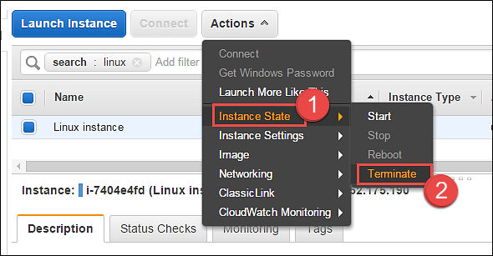

AWS will immediately notify you that the EC2 instance has "termination protection enabled" and you will not be able to delete it. The 'Terminate' button below is disabled.

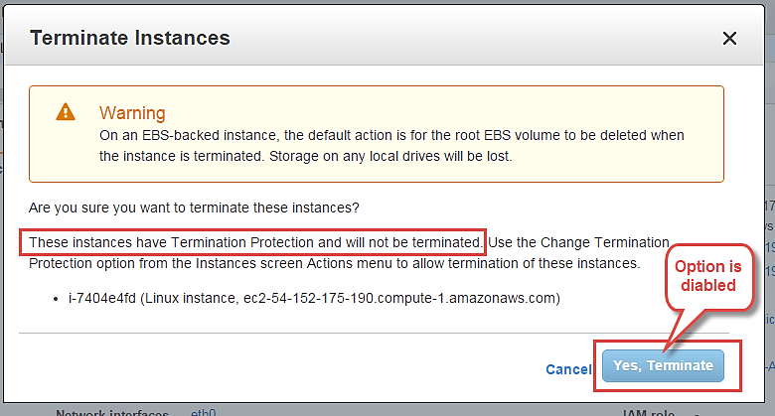

### Change User Data

When you launch a new EC2 instance, you have the option to pass user data to an instance to run tasks at boot time automatically e.g. common configuration tasks, init scripts, etc.

You can pass the user data in the form of shell scripts or cloud-init directives. This can be either plain text, as a file or as base64 encoded text for API calls.

Here we will see how we can edit these scripts.

You will have to stop the instance first, you will not be able to edit the instance userdata if it's running. On a stopped instance, perform below steps.

**Step 1)** In this step, do the following things

1. Go to 'Instance Settings'.
2. Click on 'View/Change User Data'.

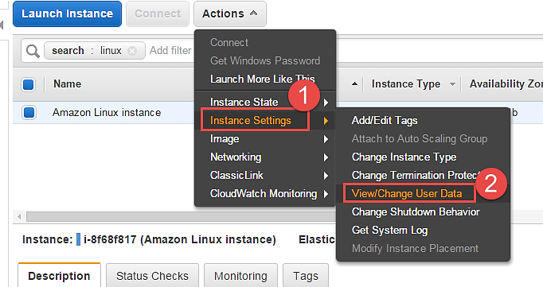

Here for the purpose of demonstration, we have a shell script which installs LAMP stack on the server.

**Step 2)** In this step,

1. View/ modify your user data field.
2. Click on "Save" tab.

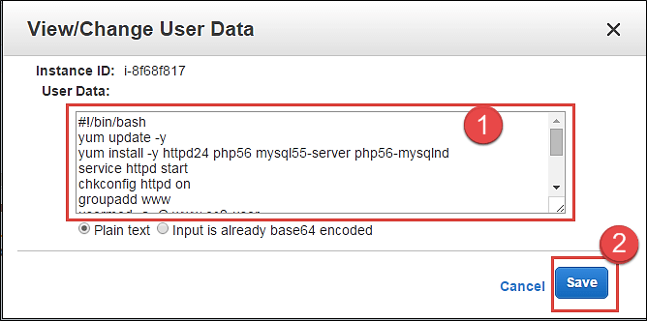

### Change the shutdown behavior

If ever you have accidently shutdown the instance via the OS console, you don't want AWS EC2 to actually terminate the instance.

For that, we can set up the shutdown behavior as 'Stop' instead of 'Terminate'. We can also do vice versa if the application requirement is as such.

Let's see how to achieve this.

**Step 1)** In this step,

1. Go to 'Instance Settings'.
2. Click on 'Change Shutdown Behavior.'

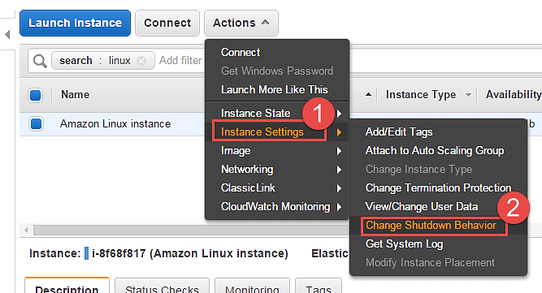

**Step 2)** In this step, click on 'Stop' and then hit apply. The setting will be applied to the instance accordingly.

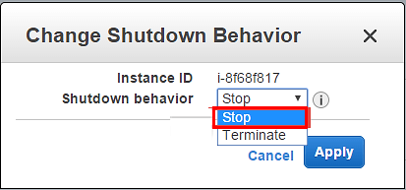

**Step 3)** Now when "stop" shutdown is initiated in the instance console via putty, it will not get terminated. It will simply shutdown normally.

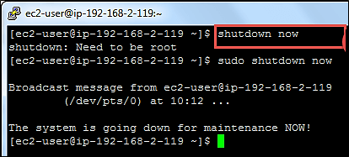

### View System Log

You can see the system log for any EC2 instance for troubleshooting purposes etc.

**Step 1)** In this step,

1. Go to 'Instance Settings'.
2. Click on 'Get System Log'.

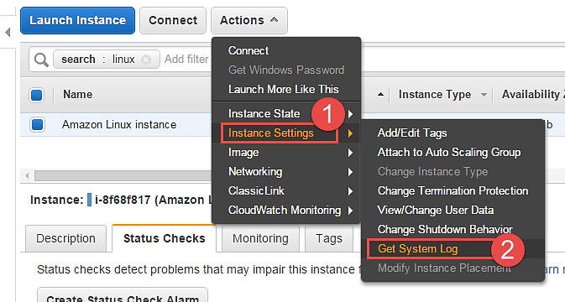

You can see a separate window depicting the instance log details. Here we can see a snap of log when the instance was restarted.

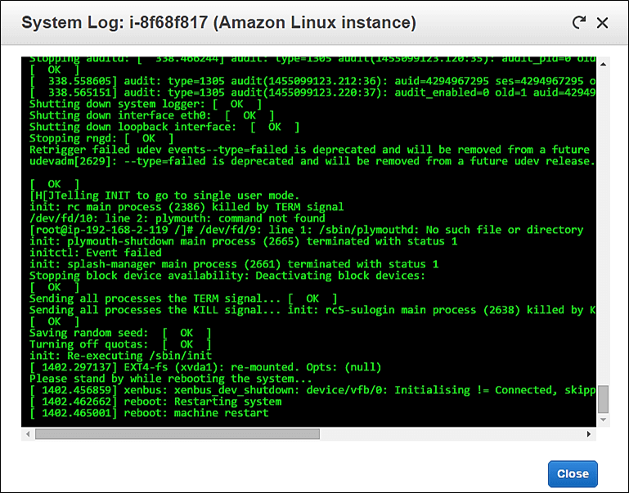

## Create an instance AMI

You can create an AMI of your EC2 instance for backup.

**Step 1)** In this step,

1. Go to 'Image'.
2. Click on 'Create Image'.

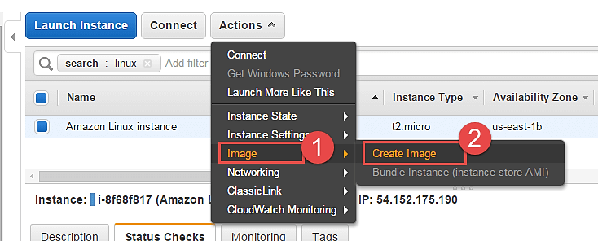

An image creation wizard will open.

**Step 2)** In this step,

1. Add the image name
2. Give some friendly description for the AMI
3. Check the volumes and then hit 'Create Image' button.

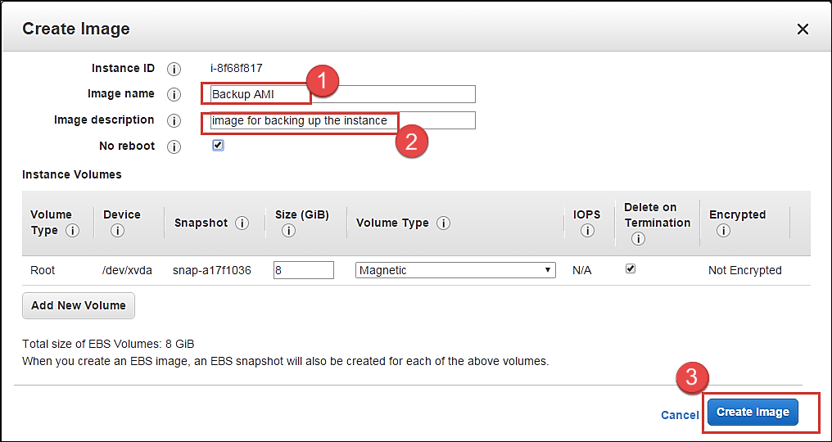

AWS will receive your create image request and will send a notification immediately.

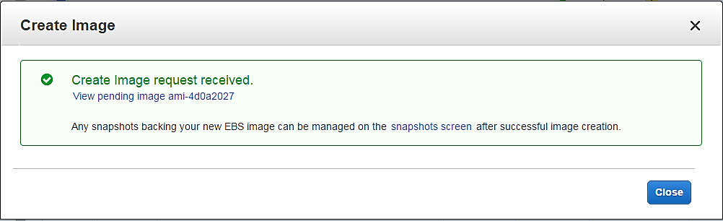

You can check the status of the request on the EC2 dashboard as 'pending' just like what is shown below.

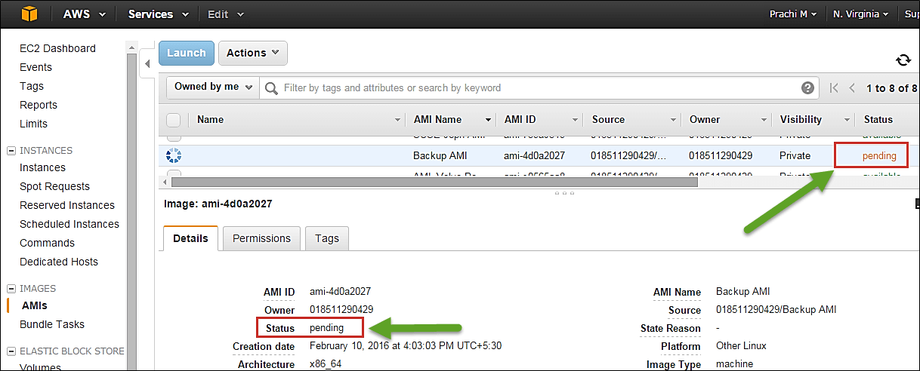

After a while the status is "available" and you will have your AMI ready as a backup.

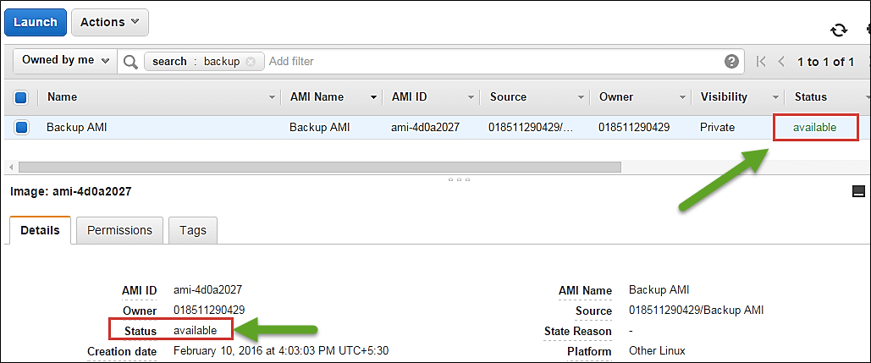

You can also de-register it from the dashboard once the backup is old.

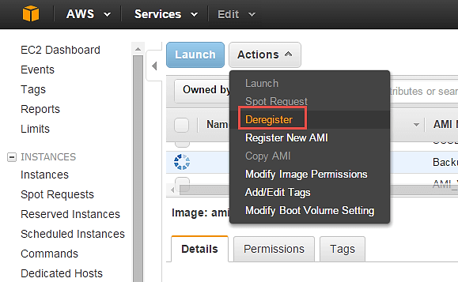

## Change the instance network settings

### Change the Security Group

You can change the SG (Security Group) of an instance anytime. If you have another security group with different firewall rules, you can easily do so using the console.

Let's see how.

**Step 1**) In this step,

1. Go to 'Networking'.
2. Click on 'Change Security Groups'.

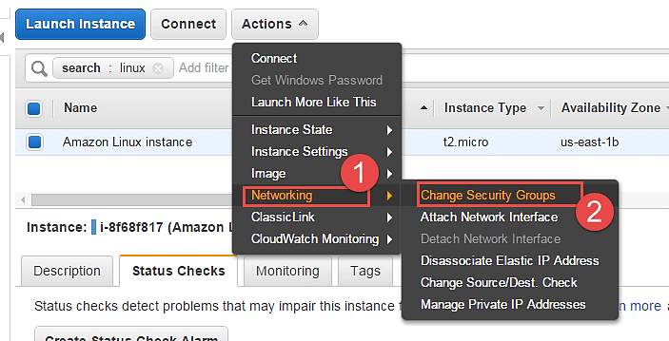

**Step 2)** In the change security groups wizard, it will show the already existing SG on the instance along with a list of all the security groups in the region.

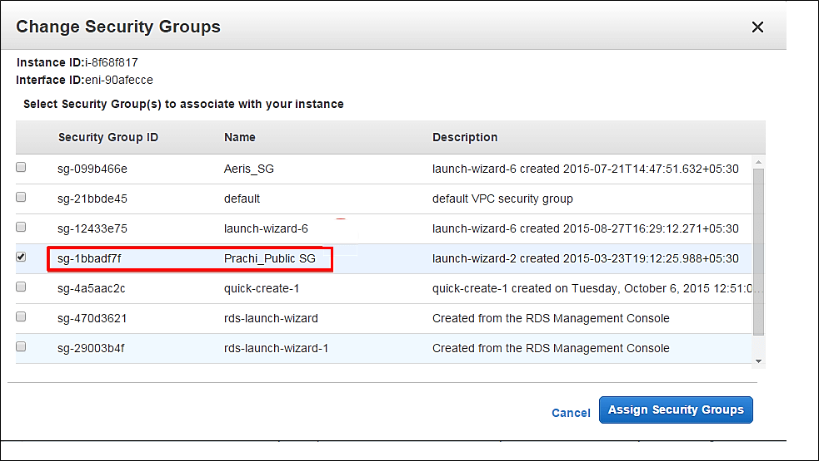

**Step 3)** In this step,

1. Tick the box against your desired SG
2. Click on 'Assign Security Groups' button.

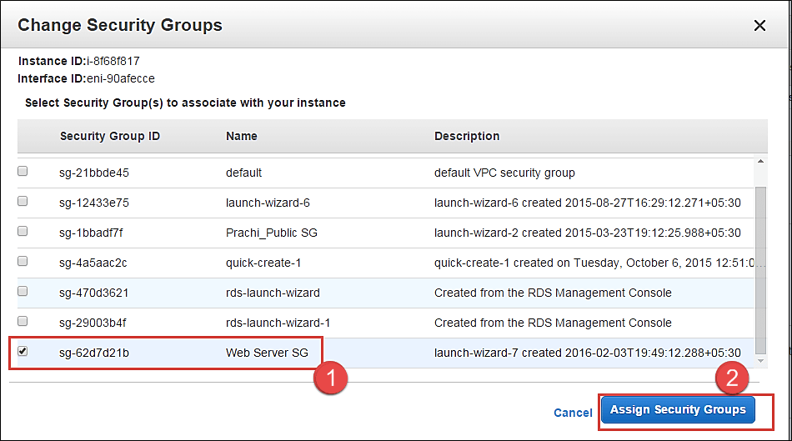

**Step 4)** On the EC2 Dashboard, you can see that the SG of the instance has been changed. The instance will now send/receive traffic based on the new SG settings.

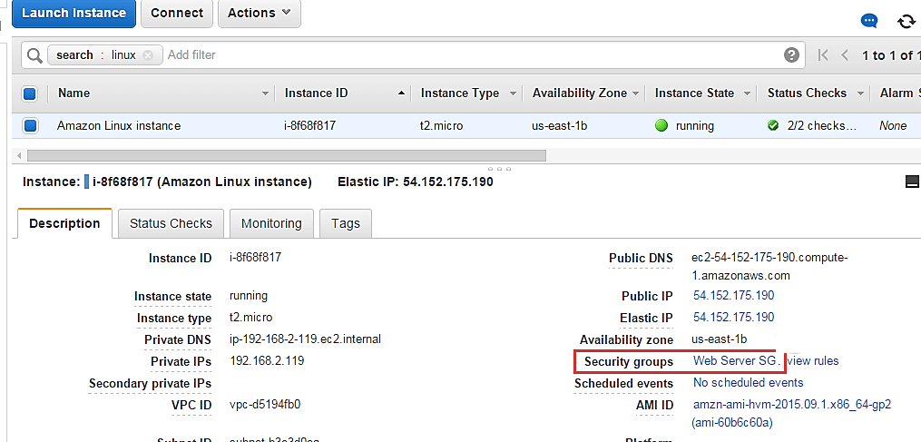

You can also add multiple security groups.

### Add a Network Interface

A network interface is like another NIC card to an instance. It will have another set of IPs additional to the already existing primary Network Interface.

**Step 1)** In this step,

1. Go to 'Networking'.
2. Click on 'Attach Network Interface'.

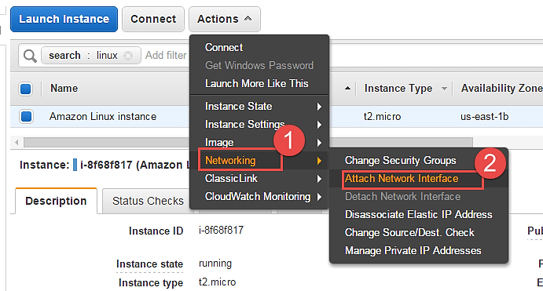

You will get an error prompt if you don't have a Network Interface already created.

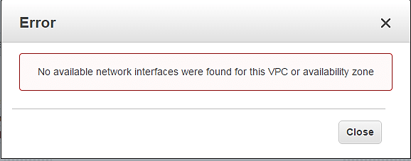

Let's see how to create a Network Interface quickly.

**Step 2)** In this step,

1. Go to EC2 Dashboard, and click on 'Network Interfaces' on the left pane.
2. Click on 'Create Network Interface' button.

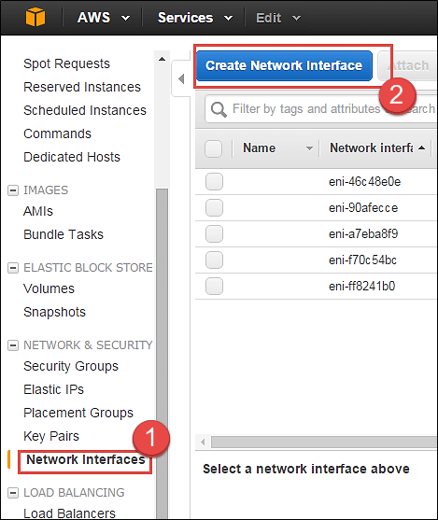

**Step 3)** In this step,

1. Add a description for your network interface
2. Select the subnet where you want to create your network interface. Keep the auto assign the private IP option default
3. Security groups are applied to a network interface of an instance, so here you will get an option for the same. Select your desired SG
4. Once you're done entering the details, click on 'Create.'

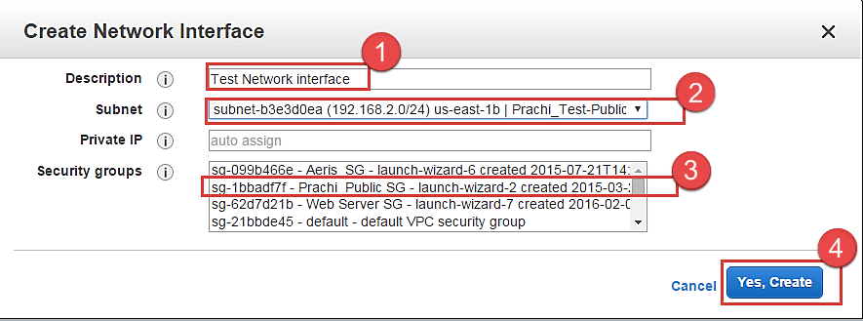

Now you can come back to the EC2 Dashboard and check that your network interface is getting created.

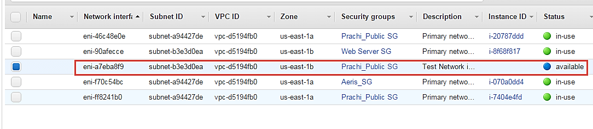

Now come back on Step 2) and go ahead with selecting your available interface which we just created and attach it to the instance.

Now as you can see the network interface which we just created is enlisted below automatically.

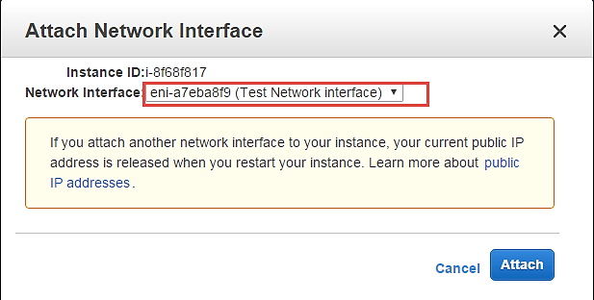

Your network interface will be attached to the instance immediately.

We can come back to the EC2 Dashboard and check our instance now. Note that the instance has 2 private IPs belonging to 2 network interfaces.

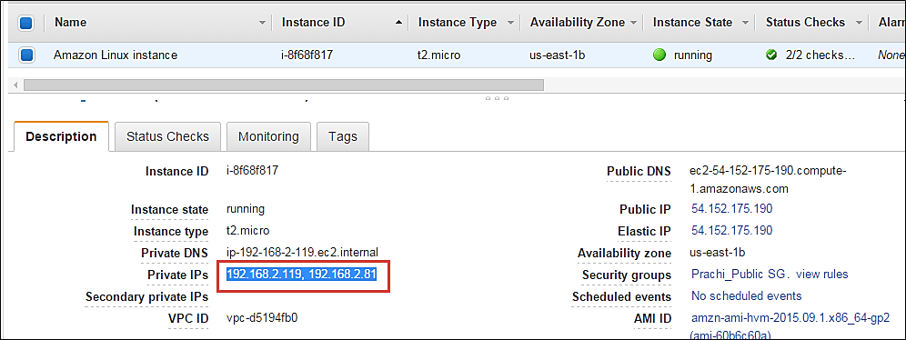

### Dissociating EIP

An Elastic IP is a static Public IP.

You can dissociate an EIP directly from the instance dashboard.

**Step 1)** In this step

1. Click on 'Networking.'
2. Click on 'Dissociate Elastic IP Address.'

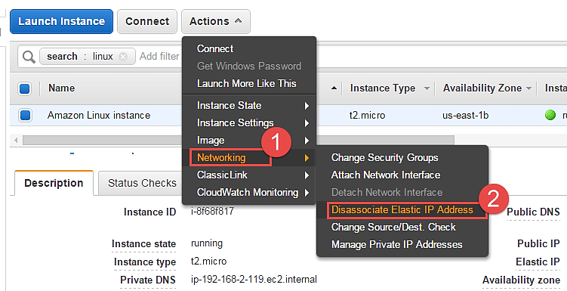

**Step 2)** Click on the button of dissociate, once we have verified the instance id and the EIP.

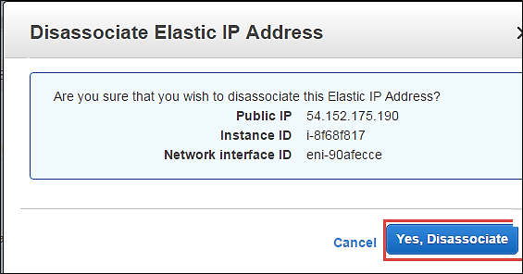

Check below that the instance dashboard now shows the EIP field blank.

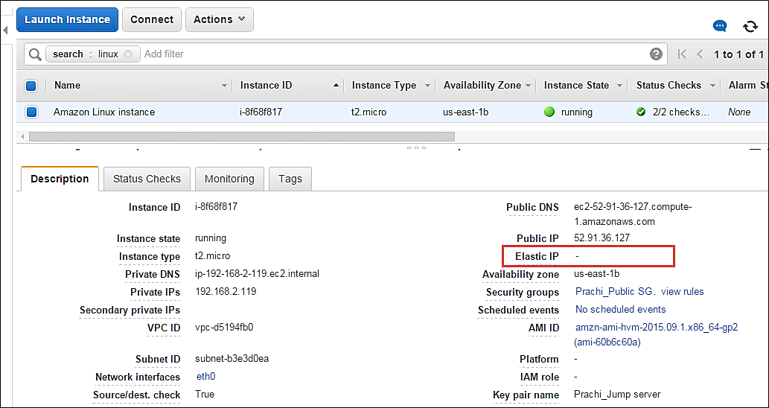

### Change Source/Destination check

The Source/Destination Check attribute controls whether source/destination checking is enabled on the instance. Disabling this attribute enables an instance to handle network traffic that isn't specifically destined for the instance. For example, instances running services such as network address translation, routing, or a firewall should set this value to disabled.

**Step 1)** In this step,

1. Click on 'Networking.'
2. Click on 'change Source/Dust. Check'

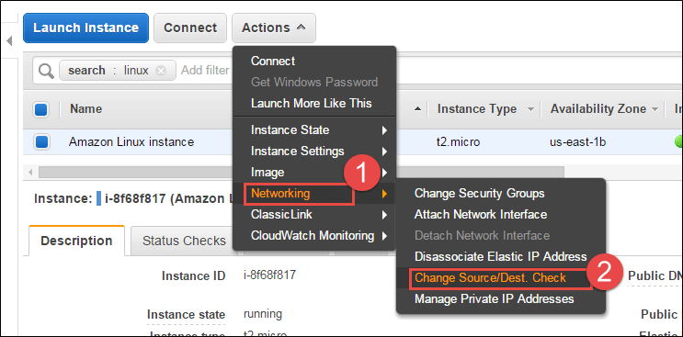

**Step 2)** Click on 'Disable'. If it is disabled already, you can enable it in this step.

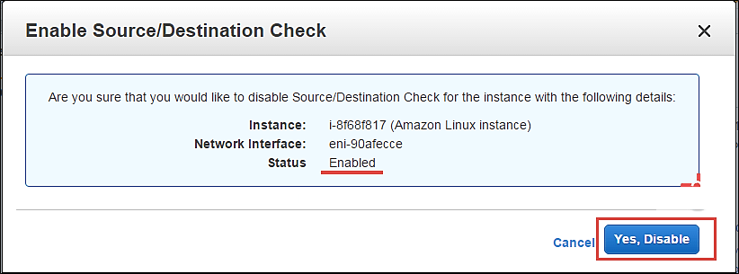

### Manage private IP addresses

You can assign multiple private IP addresses to a single instance if that is your application architecture's design. The maximum no of IPs you can assign of course depends on the EC2 instance type.

**Step 1)** In this step,

1. Click on 'Networking.'
2. Click on 'Manage Private IP addresses.'

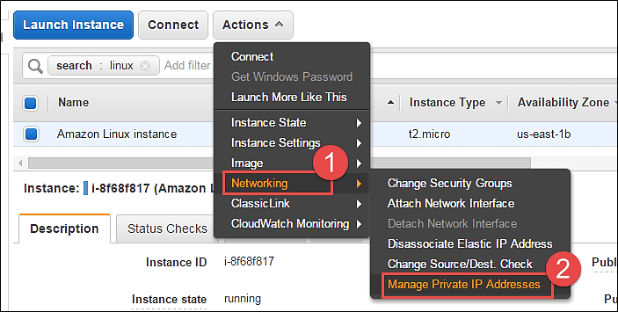

You will be redirected to a new window to assign a secondary IP address to your instance.

**Step 2)** In this step,

1. Here we are leaving the field blank. This will enable AWS to auto-assign any available private IP to our instance.
2. Click on 'Update.'

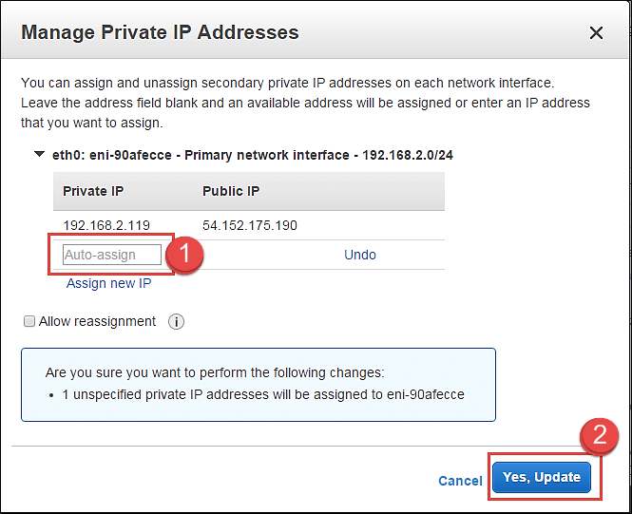

Note that an IP has been automatically assigned here.

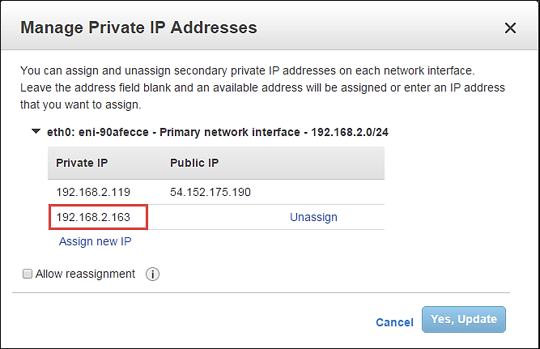

Also, come back to the EC2 dashboard and notice the 2 private IPs assigned. These are 2 IPs on a single network interface.

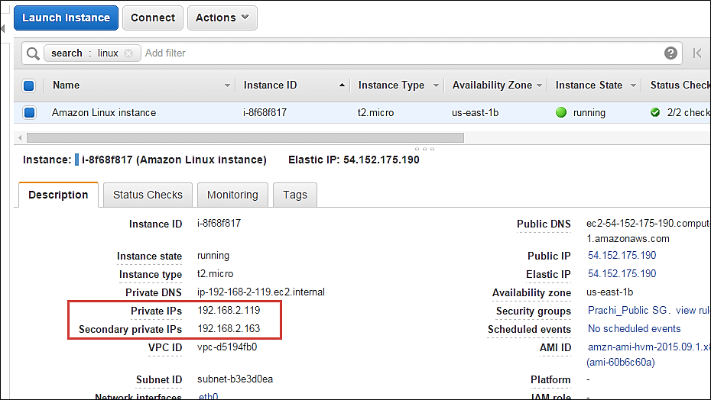

### Enable/disable ClassicLink to a VPC

If your instance is provisioned in EC2 – Classic, which is a deployment mode in AWS where resources are provisioned out of a VPC; then you can link your instance to a VPC environment as shown below.

The options below are disabled for us as our instance is already in a VPC.

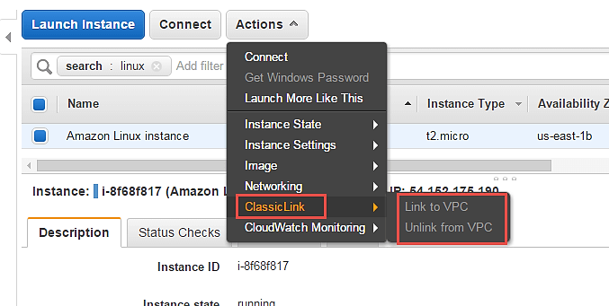

### Enable detailed CloudWatch monitoring

AWS will by default have basic CloudWatch monitoring enabled on all its resources. However, if our instances are production instances, we may wish to enable detailed monitoring on them with additional costs of course.

**Step 1)** In this step,

1. Click on 'CloudWatch Monitoring'
2. Click on 'Enable Detailed Monitoring'

You can also add/edit alarms to alert you for attributes in your CloudWatch monitoring metrics.

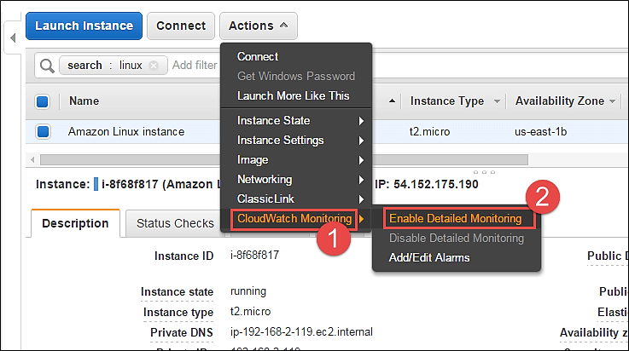

**Summary**

Thus, we saw in this tutorial, how to enable/modify various attributes in AWS for the instance configuration from the Management Console after it is launched.

AWS provides many more configuration options via CLI/API.

**4. What is AWS Lambda? Lambda Function with Examples**

Before AWS Lambda, let's understand:

## What is Serverless?

Serverless is a term that generally refers to serverless applications. Serverless applications are ones that don't need any server provision and do not require to manage servers.

## What is AWS Lambda?

AWS Lambda is one such serverless compute service. Therefore you don't need to worry about which AWS resources to launch, or how will they manage them. Instead, you need to put the code on Lambda, and it runs. However, a lambda can only be used to execute background tasks.

In AWS Lambda the code is executed based on the response of events in AWS services such as add/delete files in S3 bucket, HTTP request from Amazon API gateway, etc.

AWS Lambda also helps you to focus on your core product and business logic instead of manages operating system (OS) access control, OS patching, right-sizing, provisioning, scaling, etc.

In this AWS Lambda tutorial for beginners, you will learn:

* [What is Serverless?](https://www.guru99.com/aws-lambda-function.html#1)
* [What is AWS Lambda?](https://www.guru99.com/aws-lambda-function.html#2)
* [How does AWS Lambda work?](https://www.guru99.com/aws-lambda-function.html#3)
* [Events that Trigger AWS Lambda](https://www.guru99.com/aws-lambda-function.html#4)
* [AWS Lambda Concepts](https://www.guru99.com/aws-lambda-function.html#5)
* [AWS Lambda VS AWS EC2](https://www.guru99.com/aws-lambda-function.html#6)
* [AWS Lambda VS AWS Elastic Beanstalk](https://www.guru99.com/aws-lambda-function.html#7)
* [Use Cases of AWS Lambda](https://www.guru99.com/aws-lambda-function.html#8)
* [Best practices of Lambda function](https://www.guru99.com/aws-lambda-function.html#9)
* [When not to use AWS Lambda](https://www.guru99.com/aws-lambda-function.html#10)
* [Advantages of using AWS Lambda](https://www.guru99.com/aws-lambda-function.html#11)
* [Limitations of AWS Lambda](https://www.guru99.com/aws-lambda-function.html#12)

## How does AWS Lambda work?

The following block diagram explains the working of AWS Lambda in a few easy steps:

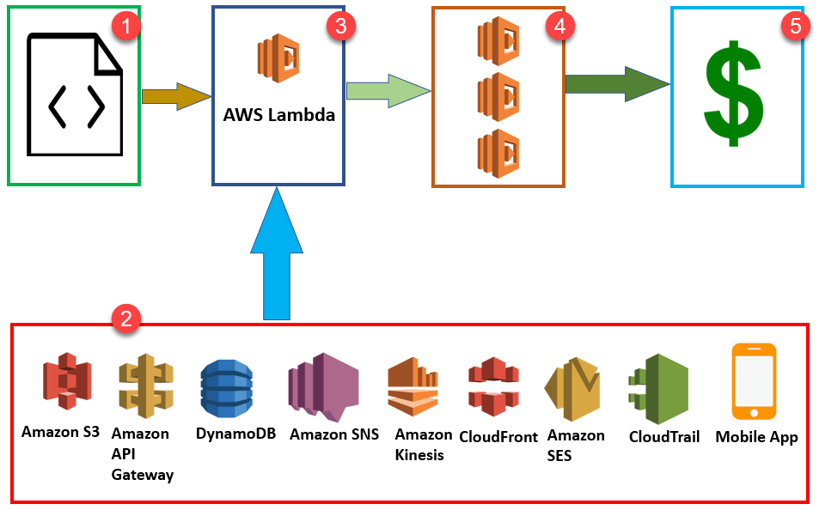

**Step 1:** First upload your AWS Lambda code in any language supported by AWS Lambda. Java, Python, Go, and C# are some of the languages that are supported by AWS lambda.

**Step 2:**These are some AWS services which allow you to trigger AWS Lambda.

**Step 3:** AWS Lambda helps you to upload code and the event details on which it should be triggered.

**Step 4:** Executes AWS Lambda Code when it is triggered by AWS services:

**Step 5:** AWS charges only when the AWS lambda code executes, and not otherwise.

This will happen in the following scenarios:

* Upload files in an S3 bucket
* When HTTP get/post endpoint URL is hit
* For adding/modifying and deleting Dynamo DB tables
* In the process of data streams collection
* Push notification
* Hosting of website
* Email sending

**Note:**You should remember that you will charge for AWS services only when the AWS Lambda code executes, else you don't need to pay anything.

## Events that Trigger AWS Lambda

Here, are Events which will be triggered when you use AWS Lambda.

* Insert, updating and deleting data Dynamo DB table
* To include push notifications in SNS
* To search for log history in CloudTrail
* Entry into an S3 object
* DynamoDB can trigger AWS Lambda whenever there is data added, modified, and deleted in the table.
* Helps you to schedule the event to carry out the task at regular time pattern.
* Modifications to objects in S3 buckets
* Notifications sent from Amazon SNS.
* AWS Lambda can be used to process the CloudTrail logs
* API Gateway allows you to trigger AWS Lambda on GET/POST methods.

## AWS Lambda Concepts

**Function:**

A function is a program or a script which runs in AWS Lambda. Lambda passes invocation events into your function, which processes an event and returns its response.

**Runtimes:**

Runtime allows functions in various languages which runs on the same base execution environment. This helps you to configure your function in runtime. It also matches your selected programming language.

**Event source:**

An event source is an AWS service, such as Amazon SNS, or a custom service. This triggers function helps you to executes its logic.

**Lambda Layers:**

Lambda layers are an important distribution mechanism for libraries, custom runtimes, and other important function dependencies. This AWS component also helps you to manage your development function code separately from the unchanging code and resources that it uses.

**Log streams:**

Log stream allows you to annotate your function code with custom logging statements which helps you to analyse the execution flow and performance of your Lambda functions.

## How to use AWS Lambda

**Step 1**) Goto <https://aws.amazon.com/lambda/> and Get Started

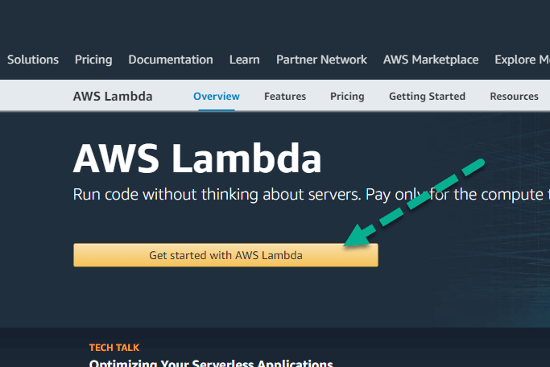

**Step 2**) Create an account or sign in with your existing account

**Step 3**) In the next Lambda page,

1. Edit the code
2. Click Run

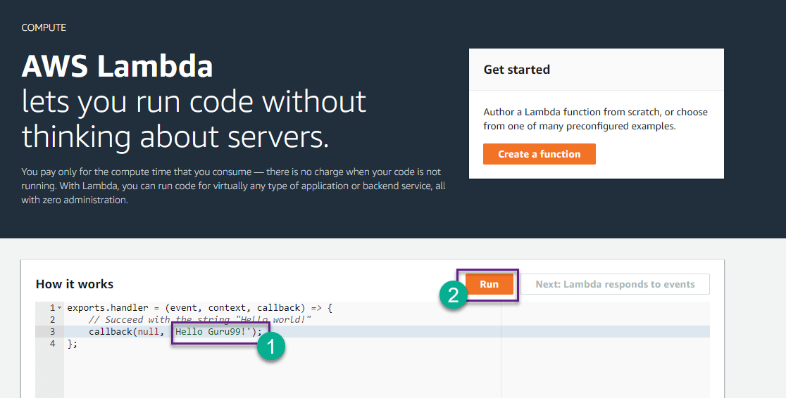

**Step 4**) You will see output

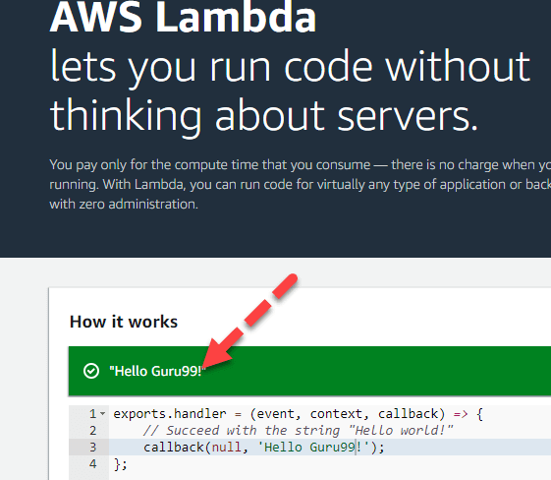

## AWS Lambda VS AWS EC2

Here, are some major differences between AWS Lambda and EC2.

|  |  |  |
| --- | --- | --- |
| **Parameters** | **AWS Lambda** | **AWS EC2** |
| Definition | AWS Lambda is a Platform as a Service (PaaS). It helps you to run and execute your backend code. | AWS EC2 Is an Infrastructure as a Service (laaS). It provides virtualized computing resources. |
| Flexibility | Does not offers any flexibility to log in to compute instances. It allows you to choose a customized operating system or language runtime. | Offers the flexibility to select the variety of instances, customoperating systems, security patches, and network, etc. |
| Installation process | You need to select your environment where you want to runthe code and push the code into AWS Lambda. | For the first time in EC2, you have to choose the OS and install all the software required and then push your code in EC2. |
| Environment restrictions | It is restricted to fewlanguages. | No environment restrictions. |

## AWS Lambda VS AWS Elastic Beanstalk

Here, are some major differences between AWS Lambda and Elastic Beanstalk.

|  |  |  |
| --- | --- | --- |
| **Parameters** | **AWS Elastic Beanstalk** | **AWS Lambda** |
| Main task | Deploy and manage the apps on AWS Cloud without worrying about the infrastructure which runs those applications. | AWS Lambda is used for running and executing your Back-end code. You can't use it to deploy an application. |
| Selection of AWS resources | It gives you a Freedom to select AWS resources; For example, you can choose EC2 instance which is optimal according to your application. | You can't select the AWS resources, like a type of EC2 instance, Lambda offers resources based on your workload. |
| Type of system | It is a stateful system. | It is a stateless system. |

## Use Cases of AWS Lambda

AWS Lambda used for a wide range of applications like:

* Helps you for ETL process
* Allows you to perform real-time file processing and real-time stream processing
* Use for creating web applications
* Use in Amazon products like Alexa Chatbots and Amazon Echo/Alexa
* Data processing (real-time streaming analytics)
* Automated Backups of everyday tasks
* Scalable back ends (mobile apps, loT devices)
* Helps you to execute server-side backend logic
* Allows you to filter and Transform data

## Best practices of Lambda function

Here, are important best practices of Lambda functions:

* Use the right "timeout."
* Utilize the functions of local storage which is 500MB in size in the /temp folder
* Minimizing the use of start-up code which is not directly related to processing the current event.
* You should use built-in CloudWatch monitoring of your Lambda functions to view and optimize request latencies.

## When not to use AWS Lambda

Following are the situation where Lambda is surely not an ideal option:

* It is not appropriate to use AWS Lambda software packages or applications which rely on calling underlying Windows RPCs
* If is used for custom software applications with licensing agreements like MS-Office document processing, Oracle databases, etc.
* AWS Lambda should not be used for custom hardware process such as GPU acceleration, hardware affinity.

## Advantages of using AWS Lambda

Here, are pros/benefits of using AWS lambda:

* AWS Lambda is a highly flexible tool to use
* It helps you to grant access to resources, including VPCs
* Author directly with WYSIWYG editor in console.
* You can use it as a plugin for Eclipse and Visual Studio.
* As it is serverless architecture, you don't need to worry about managing or provisioning servers.
* You do not need to set up any Virtual Machine.
* Helps developers to run and execute the code's response to events without building any infrastructure.
* You just need to for the compute time taken, only when your code runs.
* You can monitor your code performance in real time through CloudWatch.
* It allows you to run your code without provisioning or to manage any other server
* Helps you to execute the code only when needed
* You can scale it automatically to handle a few requests per day and even support more than thousands of requests per second.
* AWS Lambda can be configured with the help of external event timers to perform scheduled tasks.
* AWS Lambda should be configured with external event and timers so; it can be used for scheduling.
* Lambda functions are stateless so that it can be scaled quickly.
* AWS Lambda is fast so it will execute your code within milliseconds.

## Limitations of AWS Lambda

Here are the cons/disadvantages of using AWS Lambda:

* AWS Lambda tool is not suitable for small projects.
* AWS Lambda entirely relies on AWS for the infrastructure, so you can't install any additional software if your code demands it.
* Concurrent execution is limited to 100
* AWS Lambda completely depended on AWS for the infrastructure; you cannot install anything additional software if your code demands it.
* Its memory volume can vary between 128 to 1536 MB.
* Event request should not exceed 128 KB.
* Lambda functions help you to write their logs only in CloudWatch. This is the only tool that allows you to monitor or troubleshoot your functions.
* Its code execution timeout is just 5 minutes.

#### Summary

* Serverless is a term that generally refers to serverless applications.
* AWS Lambda is one such serverless compute service. Therefore, you don't need to worry about which AWS resources to launch, or how will they manage them.
* A function is a program or a script which runs in AWS Lambda.
* Runtime allows functions in various languages which runs on the same base execution environment.
* An event source is an AWS service, such as Amazon SNS, or a custom service.
* Lambda layers are an important distribution mechanism for libraries, custom runtimes, and other important function dependencies.
* Log stream allows you to annotate your function code with custom logging statements which helps you to analyse the execution flow and performance of your Lambda functions.
* AWS Lambda is a Platform as a Service (PaaS). It helps you to run and execute your backend code.
* AWS EC2 Is an Infrastructure as a Service (laaS). It provides virtualized computing resources.
* Deploy and manage the apps on AWS Cloud without worrying about the infrastructure which runs those applications.
* AWS Lambda is used for running and executing your Back-end code. You can't use it to deploy an application.
* AWS Lambda helps you for the ETL process.
* The best practice of Lambda function is to use the right "timeout.
* It is not appropriate to use AWS Lambda software packages or applications which rely on calling underlying Windows RPCs
* AWS Lambda is a highly flexible tool.
* AWS Lambda tool is not suitable for small projects.
* A common event which will be triggered when you use AWS Lambda is Insert, updating and deleting data Dynamo DB table.

1. **AWS Certification Guide: Cost, Courses, Salary, Exam Details**

## What is AWS certification?

AWS Certification helps professionals to build credibility and confidence by validating their cloud expertise with an industry-recognized credential. It helps skilled professionals to obtain the various type of AWS certificate according to his/her skill.

Amazon offers a certification for different IT professionals like Cloud Practitioner, Architect, Developer, and Operations roles. Moreover, it also provides certain Specialty certifications to validate advanced skills in specific technical areas.

In this tutorial, you will learn:

* [What is AWS certification?](https://www.guru99.com/aws-certification-course.html#1)
* [Benefits Of AWS Certificate](https://www.guru99.com/aws-certification-course.html#2)
* [Types Of AWS Certifications Courses](https://www.guru99.com/aws-certification-course.html#3)
  + [AWS Certified Cloud Practitioner](https://www.guru99.com/aws-certification-course.html#4)
  + [AWS Certified Solutions Architect – Associate](https://www.guru99.com/aws-certification-course.html#5)
  + [AWS Developer -Associate](https://www.guru99.com/aws-certification-course.html#6)
  + [AWS sysops Administrator- Associate](https://www.guru99.com/aws-certification-course.html#7)
  + [AWS solution Architect- Professional](https://www.guru99.com/aws-certification-course.html#8)
  + [AWS Certified DevOps Engineer – Professional](https://www.guru99.com/aws-certification-course.html#9)
  + [AWS Certified Big Data – Specialty](https://www.guru99.com/aws-certification-course.html#10)
  + [AWS Certified Advanced Networking – Specialty](https://www.guru99.com/aws-certification-course.html#11)
  + [AWS Certified Security – Specialty](https://www.guru99.com/aws-certification-course.html#12)
* [Learning Objective Of AWS Certification](https://www.guru99.com/aws-certification-course.html#13)
* [How To Start For AWS Certifcaiton?](https://www.guru99.com/aws-certification-course.html#14)
  + [Exam Content](https://www.guru99.com/aws-certification-course.html#15)
* [Current Salary for AWS Certified Professionals](https://www.guru99.com/aws-certification-course.html#16)

## Benefits Of AWS Certificate

Here are pros/benefits of AWS certificate.

* AWS Certification helps any professional to demonstrates their technical expertise and advance their career
* It helps employers find skilled cloud professionals.
* AWS certification allows you to verify your technical understanding and skills.
* Helps to gain access to the AWS Certified LinkedIn Community.
* Allows you to gather latest knowledge about your domain
* Owning AWS certification open door for new opportunities
* Allows you to boost your self-esteem
* You can validate your skills and knowledge in the preeminent cloud computing platform.
* Helps you to demonstrate credibility and dedication to your cloud computing career path.
* It provides access to a network of like-minded peers and AWS thought-leaders.
* Allows you to leverage the AWS shared security responsibility model.

## Types Of AWS Certifications Courses

Here, are some most important AWS certification which helps you boost your career.

* AWS Certified Cloud Practitioner
* AWS Certified Developer – Associate
* AWS Certified SysOps Administrator – Associate
* AWS Certified Solutions Architect – Associate
* AWS Certified Solutions Architect – Professional
* AWS Certified DevOps Engineer – Professional
* AWS Certified Big Data – Specialty
* AWS Certified Advanced Networking – Specialty
* AWS Certified Security – Specialty

Let's see each of AWS certification along with with exam its exam details:

### [AWS Certified Cloud Practitioner](https://aws.amazon.com/certification/certified-cloud-practitioner/)

This certification course helps you to gain knowledge about various types of cloud technology roles with a method to validate their AWS Cloud knowledge to enhance your credibility as an IT professional.

**Exam details:**

* Prerequisites: Minimum of six months of general AWS cloud experience in any role is recommended.
* Exam Format: Multiple choice questions
* Exam Duration: 90 minutes
* Exam Language: Available in English, Japanese, Korean, and Simplified Chinese
* Cost: 100 USD

After the End, of this course, you will learn,

* Understanding of most fundamental AWS architectural principles
* The value proposition of the AWS cloud
* Important AWS cloud services and their applications
* Underlying security and compliance and shared responsibility model for security
* Core cloud deployment and operating principles

### AWS Certified Solutions Architect – Associate

It is an associate certification course which helps you to validate your ability to effectively demonstrate knowledge of how to build and deploy a secure and robust application using AWS technologies.

* Prerequisites: Knowledge and some experience in designing distributed applications
* Format: Multiple choice questions and multiple answers
* Exam Duration: 130 minutes
* Cost: 150 $

After the End, of course, you will learn,

* About the network technologies and how they work in AWS and how client interfaces connect to the AWS platform.
* AWS-related data security practices, disaster recovery methods, and troubleshooting.
* You will also know the concept of to build secure and reliable applications on the AWS platform.
* Deploying hybrid systems on-premises data center and AWS components
* This exam AWS course includes the design of highly available and scalable systems and its implementation and deployment in AWS server.

### [AWS Developer -Associate](https://aws.amazon.com/certification/certified-developer-associate/)

The AWS certified Developer is an associate exam. The course for this exam teaches you how you can developer and maintaining AWS-based applications. You will able to learn how to write actual code which used AWS software to in your business.

* Prerequisite: One or more years of hands-on experience using AWS.
* Format: Multiple choice and multiple answers
* Exam Duration: 130 minutes
* Exam Cost: $150

At the End of this course, you will learn,

* You will understand the underlying AWS architecture and the core AWS service
* Hands-on experience in designing, developing, deploying, and maintaining AWS applications.
* AWS services like AWS databases, notifications, workflow services, and services for storage and change management services.

### [AWS sysops Administrator- Associate](https://aws.amazon.com/certification/certified-sysops-admin-associate/)

The AWS Certified SysOps Administrator Associate is only a certification exam which is entirely geared toward system administrators. Passing this exam is quite tricky as you need both technical expertise as well as conceptual understanding about the operational aspect of the AWS platform.

Exam Details:

* Prerequisite: Previous experience as a Linux or Windows administrator will be a plus.
* Format: Multiple choice and multiple answers
* Duration: 130 minutes
* Exam Cost: $150
* Exam Language: Available in English, Japanese, Korean, and Simplified Chinese

After the End of this course, you will learn,

* How to deploy applications for the AWS platform
* Learn how you can send and receive data between data centers and AWS
* Selecting the appropriate AWS services to meet the requirement of your business
* Provisioning, managing, maintaining, and securing systems in an AWS environment

### [AWS solution Architect- Professional](https://aws.amazon.com/certification/certified-solutions-architect-professional/)

A professional AWS architect is an AWS certification course for someone who needs to evaluate an organization's demands and make architectural recommendations for implementing and deploying applications on AWS.

Exam Details:

* Prerequisites: You should be Certified Solutions Architect – Associate to attain this exam.
* At least two years of hands-on experience designing and deploying cloud architecture on AWS and best practice knowledge of multi-application architectural design is strongly recommended.
* Format: Multiple-choice, multiple-answer
* Time: 170 minutes
* Cost: 300 USD

After the End of this course, you will learn,

* Learn about best practices for architecting and the designing of applications on AWS
* Techniques for migrating complex application systems to AWS
* Picking the right AWS service for the requirements of an application
* Knowledge of cost optimization strategies

### AWS Certified DevOps Engineer – Professional

The DevOps Engineer certification course is all about operating, managing, and build on the AWS platform. The course mainly two fundamental concepts of Develops continuous delivery and automation of processes.

Exam Details:

* Prerequisites: It is an associate-level certification and a minimum of five years of relevant experience
* Format: Multiple-choice, multiple-answer
* Exam time: 170 Minutes
* Cost: 300 USD

At the End of this AWS certification, you will learn,

* The concept of continuous developer and modern CD methodologies
* Techniques for implementing CD systems
* Set up, monitoring, and logging and maintaining systems on AWS server

### AWS Certified Big Data – Specialty

The AWS certified Big Data- specialty certification is suited for those who have a background in data analytics and experience using various types of AWS service for designing the most reliable big data solutions.

* Prerequisite: At least two years of hands-on experience using Amazon web services.
* Exam Duration: 170 minutes
* Format: Multiple choice questions and multiple-answer
* Exam Fees: 300 USD

At the End of this AWS certification, you will learn,

* AWS Architecting best practices for implementing big data services solutions offered by AWS
* AWS tools for automating data analysis
* You will learn how to access control to secure the data.
* The course covers how to design and to maintain big data applications.
* AWS services covered include: Kinesis, Athena, Quick sight, and Recognition

### [AWS Certified Advanced Networking – Specialty](https://aws.amazon.com/certification/certified-advanced-networking-specialty/)

This AWS certification course is designed to validate a candidate's skills and experience in connection with performing complex networking tasks on AWS.

Exam Details:

* Prerequisite: Candidates should have a background in architecting and implementing network solutions.
* Format: Multiple-choice and multiple-answer
* Duration: 170 minutes
* Exam Language: Available in English, Japanese, Korean, and Simplified Chinese
* Exam Cost: 300 USD

At the End of this AWS certification, you will learn,

* Designing, developing, and deploying AWS cloud solutions
* Implementing core services as per the architectural best practices
* Automation of AWS tasks for network deployments
* Security and compliance design and implementation
* Learn about network optimization and troubleshooting

### [AWS Certified Security – Specialty](https://aws.amazon.com/certification/certified-security-specialty/)

The AWS security -the course covers topics that security pros and teams need to master security fundamentals. It follows best practices and builds in-depth knowledge of key services unique to the AWS platform.

It covers topics like protection and encryption, infrastructure security, access management, monitoring, and logging, etc.

Exam Details:

* Prerequisite: At least two years hand-of-experience sourcing AWS workloads. Security control for the workload on AWS. At least five years of experience of designing and implementing security solutions
* Exam Format: Multiple choices, Multiple-answer
* Exam time; 170 minutes
* Exam Cost: 300 USD
* Exam Language: Available in English, Japanese, Korean, and Simplified Chinese

At the End of this AWS certification, you will learn,

* Concept of specialized data classifications and AWS data protection mechanisms.
* Helps you to understand data encryption methods and AWS mechanisms to implement them.
* How to manage secure Internet protocols and AWS mechanisms for implementation.
* You will able to take a right with regard to cost, security, and deployment complexity given a set of application requirements.
* Implement logging and monitoring to detect and analyze security vulnerabilities within your infrastructure

## Learning Objective Of AWS Certification

Here, are the most important objective of learning AWS course:

* Allows you to Identify the security and compliance benefits of by using the AWS Cloud.
* Allows you to understand the access control and management features of AWS.
* You can learn about data encryption methods to secure all types of sensitive data.
* Get knowledge about the important steps for managing various AWS resources.
* You can use AWS services to protect network security.
* You will get the knowledge about how to audit an AWS environment.
* Explain the AWS compliance and assurance programs.
* Formulate solution plans and learn about AWS architectural best practices

## How To Start For AWS Certifcaiton?

While there are not standard define steps to start AWS certification, below-given steps are the most straight-forward.

**Step 1)**

* First of all, you need to Enroll yourself in an AWS training class.
* Select the desired module that you wants to take.

**Step 2)**Review all the available study materials and Exam Guides related to selected AWS module.

**Step 3)** Read multiple AWS whitepapers. It offers plenty of crucial information regarding topics. These hold some useful information, which may answer your questions.

**Step 4)** Next, you need to take regular practice. A practice test will help you to become free of stress about the AWS certification exams.

**Step 5)** Schedule the final AWS certification exam once you are ready. It generally takes around 80-120 hours of practice/studying to be prepared for the exam. However, it depends on your experience and the certification course that you have selected.

### Exam Preparation

These training courses and materials will help with exam preparation:

* Architecting on AWS instructor-led, live or virtual 3-day course
* AWS Whitepapers faws.amazon.com/whltepapers, Kindle.pdf, and Other Materials
* Identify AWS services which help you to automate, monitor, and manage security operations on AWS.
* AWS Well-Architected web page (various whitepapers linked)

### Exam Content

There are mainly two types of questions on the examination:

* Multiple-choice: It has one correct and three incorrect responses
* Multiple-response: Has two correct responses out of five options.

## Current Salary for AWS Certified Professionals

Here, is the latest salary by AWS certificate in USA

* AWS Certified Solutions Architect – Associate: $121,292
* AWS Certified Solutions Architect – Professional: $142,160
* AWS Certified Developer – Associate: $114,148
* AWS Certified DevOps Engineer – Professional: $118,395
* AWS Certified SysOps Administrator – Associate: $142,160

1. **Azure vs. AWS: Key Differences**

## What is Azure?

Azure is an open source and flexible cloud platform which helps in development, service hosting, service management, and data storage. The Azure cloud computing tool hosts web applications over the internet with the help of Microsoft data centers.

In this tutorial, you will learn

* [What is Azure?](https://www.guru99.com/azure-vs-aws.html#1)
* [What is Aws?](https://www.guru99.com/azure-vs-aws.html#2)
* [Comparison between Azure and AWS](https://www.guru99.com/azure-vs-aws.html#3)
* [Popularity Index with Market Share](https://www.guru99.com/azure-vs-aws.html#4)
* [Advantages of AWS](https://www.guru99.com/azure-vs-aws.html#5)
* [Advantages of Azure](https://www.guru99.com/azure-vs-aws.html#6)
* [Disadvantages of AWS](https://www.guru99.com/azure-vs-aws.html#7)
* [Disadvantages of Azure](https://www.guru99.com/azure-vs-aws.html#8)
* [Which one is better?](https://www.guru99.com/azure-vs-aws.html#9)

## What is Aws?

Amazon Web Services is widely used secure cloud services platform, offering computing power, content delivery, database storage, and other functionality to help businesses scale and grow.

## Comparison between Azure and AWS



|  |  |  |
| --- | --- | --- |
| **Parameters** | **AWS** | **Azure** |
| Launched Date | Launched in 2006. | Launched In 2010. |
| Market Share | 31% Share of the global computing market | 11% Share from the worldwide market. |
| Availability Zone | 61 Availability Zone | 140 Availability Zones |
| Storage services | * S3 * Buckets * EBS * SDB * domains * Easy to use * SQS * CloudFront * AWS Import/Export | * Blob Storage * Containers * Azure Drive * Table Storage * Tables * Storage Stats |
| Databases Services | * MySQL * Oracle * DynamoDB | * MS SQL * SQL Sync |
| Deployment Services | * Amazon Web Services * Amazon Machine Instance (AMI) * Traditional Deployment Models * Fine-grained updates * Elastic Beanstalk * Cloud Formation | Cspkg (fancy zip file) Upload via portal or API via blob storage Course-grained updates "click to scale." More magic |
| Networking Services | * IP/Elastic IP/ELB * Virtual Private Cloud * Route 53 * ELB * Firewall heavily configurable | * Automatic IP assignment * Load-balancing * Azure Connect * Balancing * Endpoints defined in csdef/cscfg |
| Price | Per hour- rounded up | On-demand reserved spot. |
| Customers | Adobe, Airbnb, Expedia, Yelp, Nokia, Netflix, Novartis. | Pearson, 3M, Towers Watson, NBC, Essar, Serko, etc. |
| Type of Cloud | Virtual Private Cloud (VPC) | Virtual Network |
| Connection type | Direct Connect | ExpressRoute |
| Pricing models | * Free Tier * Per Hour * Free Trial Per Minute * No change for stopped * Pay for EBS volume | * Free Trial * Per Minute |
| Government Cloud | AWS has an edge as far as government cloud offerings. | Limited reach for government cloud offerings. |
| Support for Hybrid cloud | Does not offers the best of hybrid cloud support. | With Hybrid Cloud, organizations can integrate onsite servers with Cloud instances. |
| Ecosystem | AWS has a software marketplace with an extensive partner ecosystem. | With very few Linux options, Azure doesn't' have a big ecosystem. |
| Support for Big Data | EBS storage is ideal for handling big data. | Standard storage has many issues for big data, and therefore you need premium storage. |
| Maturity | More mature cloud environment for big data. | The less mature environment for big data. |
| Machine access | In AWS machine can be accessed separately. | Machines are grouped into cloud service and respond to the same domain name with various ports. |
| Salary | The average salary for "AWD engineer" is approximately $141,757 per year for Software Architect. | The average salary for "Microsoft Azure" ranges from approximately $113,582 per year. |
| Key features | Zero setups, Detail Monitoring, Auto-scaling groups. | Startup friendly, High performance, Low cost. |
| Long term data archiving | Allows long term data archiving and retrieval. | Does not offer any long term data archiving and retrieval option. |
| Security | Security is provided using defined roles with permission control feature. | Provides security by offering permissions on the whole account. |

## Popularity Index with Market Share

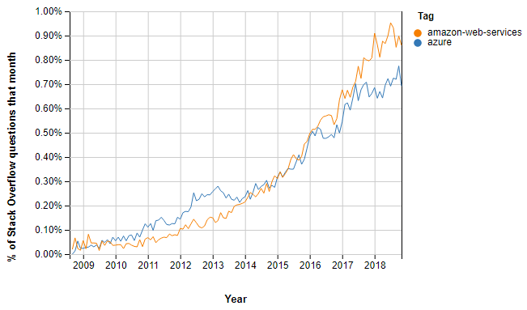

Stack Overflow Questions AWS vs. Azure

AWS continues to dominate a global cloud-infrastructure services industry which is likely to hit proximately $70 billion last year. Today, it enjoys market share which is better than some top public cloud providers.

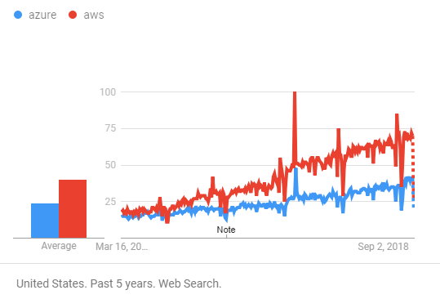

Google Trends Azure vs. AWS

In the past year, Azure's cloud adoption rate is almost 85 percent that of AWS', up from 70 percent last year.

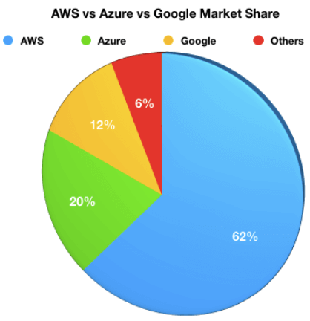

## Advantages of AWS

Here, are significant advantages of adopting AWS cloud services:

* Compute Cloud allows you to increase or decrease storage according to the need of your organization
* AWS enables you to select an operating system, programming language, database of your choice.
* Broad & deep service offerings
* Robust partner ecosystem
* Trusted by high-profile customers
* High Transfer Stability
* Minimal information is lost during server and storage transfer
* Offers more data centers for availability and low latency
* Better DevOps support
* Simpler licensing method
* Stronger support for Bl and analytics

## Advantages of Azure

Here, are some major advantages of using Azure cloud services:

* Capability for developers and users to create, maintain and deploy applications
* Fully scalable cloud computing platform offers open access across multiple languages, frameworks, and tools
* Total support for Microsoft legacy apps
* Greater awareness of enterprise needs
* Easy one-click migrations in many cases
* Conversion of on-prem licenses to the cloud
* Support for mixed Linux/Windows environments
* Offers inbuilt tool like Azure stack to help the organization deliver Azure service from the own data center

## Disadvantages of AWS

Here, are few drawbacks of Amazon Web Services:

* Less hybrid- cloud-friendly
* AWS elastic load balancer is not equipped to handle as many requests as it receives
* AWS lacks customer support, so it more suitable for a technically savvy group of consumers and those companies who have their inbuild tech support team
* The number of choices offered by AWS is confusing to those who may not speak the language of technology.
* Incompatible and Weak Hybrid Strategy
* AWS is a less open private cloud. This makes it an unpopular storage option for sensitive industries like banking
* AWS has too many products which makes the selection process much harder

## Disadvantages of Azure

The major Drawbacks of Azure cloud services are:

* Customer service is not transparent, and data is hosted globally. So, if you have data restrictions where it must be stored in a specific country, at that time you need to verify/specify with Microsoft
* You will be charged extra for paying as you go
* Azure cloud-based services are full of glitches. To fix these bugs, you will need to spend additional money
* Less flexibility about non-Windows server platforms, when compared to AWS

## Which one is better?

Microsoft Azure has increased its market share in the last couple of years, but not to an extent where there is a real contest between the two companies at least for the near future.

Moreover, both companies introduce new products, new integrations, and new pricing structures. Therefore, the final selection will be depend on the need of your organization.

1. **Heroku vs AWS: 10 Most Important Differences You Must Know!**

## What is AWS?

Amazon web service is a platform that offers flexible, reliable, scalable, easy-to-use and cost-effective cloud computing solutions.

AWS has a massive collection of cloud services that build up a fully-fledged platform. It is known as a powerhouse of storage, databases, analytics, networking and deployment/delivery options offered to developers. AWS Cloud is available in 16 different geographic regions, and the number is increasing.

In this tutorial, we will learn,

* [What is AWS?](https://www.guru99.com/heroku-vs-aws.html#1)
* [What is Heroku?](https://www.guru99.com/heroku-vs-aws.html#2)
* [Why use Heroku?](https://www.guru99.com/heroku-vs-aws.html#3)
* [Why choose Amazon Web Services?](https://www.guru99.com/heroku-vs-aws.html#4)
* [AWS vs. Heroku comparison table](https://www.guru99.com/heroku-vs-aws.html#5)
* [Disadvantages of Heroku](https://www.guru99.com/heroku-vs-aws.html#6)
* [Disadvantages of AWS](https://www.guru99.com/heroku-vs-aws.html#7)
* [The Verdict](https://www.guru99.com/heroku-vs-aws.html#8)

## What is Heroku?

Heroku is a cloud service provider and software development platform which facilitates fast and effective building, deploying and scaling of web applications. It has 140 inbuilt add-ons, ranging from alerts, analytic tools security services which are used for purpose like monitoring, caching and mailing or networking add-ons.

The tool can provide you with built-in instant run-time application services. Moreover, you don't need to think about infrastructure because it managed automatically by the software itself. Heroku is owned by Salesforce.

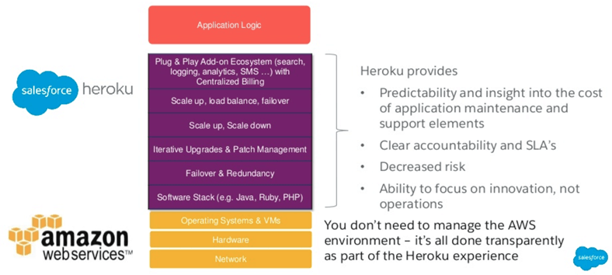

Heroku is a Platform as a Service built on Top of AWS

## Why use Heroku?

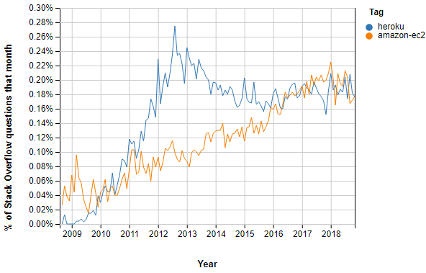

Stack Overflow Questions Heroku vs Amazon

Here are pros/benefits of using Heroku:

* Allows the developer to focus on code instead of infrastructure
* Enhance the productivity of cloud app development team
* Offers single billing for all projects broken down by team
* Monitor and enhance performance though rich application monitoring
* Helps your development, QA, and business stakeholders create a unified dashboard.
* Support form Modern Open Source Languages
* High-performance Salesforce integration
* Simple Horizontal & Vertical Scalability
* Heroku operation and security team is instantly ready to help you 24/7
* Leading Platform tools and Services Ecosystem
* Helps you to focus on innovation, not operations
* The Heroku Enterprise architecture offers minimal or no downtime during the system updates.
* Fast application lifecycle management and permissions
* Allows you to remove friction from the development
* Offers a powerful dashboard and CLI
* Integrates with familiar developer workflows
* Predictability and insight into the cost of application development and maintenance
* A bunch of supportive tools
* Beginner and startup-friendly
* It allows you to create a new server in just 10 seconds by using the interface of Heroku Command Line.
* This cloud computing platform takes care of patching systems and keeping everything healthy.
* A range of automated functionalities including the scaling, configuration, setup, and others
* Easy integration with other AWS products
* Medium learning curve
* Offers best-in-class Developer Experience
* Secure connectivity to Salesforce data to build a single view of the customer
* Flexibility to customize and support unique DevOps workflow needs

## Why choose Amazon Web Services?

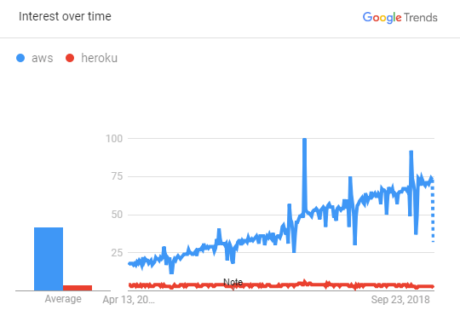

Google Trends AWS vs. Heroku

Here are the pros/benefits of selecting AWS web services:

* You should opt for AWS when you have DevOps teams who can configure and manage the infrastructure
* You have very little time to spend on the deployment of a new version of your web or mobile app.
* AWS offers easy deployment process for an app
* AWS web service is an ideal option when your project needs high computing power
* Helps you to improve the productivity of the application development team
* A range of automated functionalities including the configuration, scaling, setup, and others
* Use AWS you have full control over the resources.
* AWS allows organizations to use the already familiar programming models, operating systems, databases, and architectures.
* It is a cost-effective service that allows you to pay only for what you use, without any up-front or long-term commitments.
* You will not require to spend money on running and maintaining data centers.
* Offers fast deployments
* You can easily add or remove capacity.
* You are allowed cloud access quickly with limitless capacity.
* Total Cost of Ownership is very low compared to any private/dedicated servers.
* Offers Centralized Billing and management
* Offers Hybrid Capabilities
* Allows you to deploy your application in multiple regions around the world with just a few clicks

## AWS vs. Heroku comparison table



| **Parameters** | **Heroku** | **AWS** |
| --- | --- | --- |
| Owner | Salesforce.com | Amazon.com |
| Hosted on | Amazon's data centers | Proprietary servers laaS (Amazon EC2 instances) |
| Type of Service | PaaS | IaaS, PaaS, SaaS |
| Pricing | Heroku costs $0.05 per hour. | Starting plan cost you $0.013 per hour. |
| Languages | Node.js, Java, Ruby, PHP, Python, Go, Scala, Clojure | .NET, Ruby, NodeJS, Go, Docker, PHP, Python |
| Geographic Regions | Europe, USA, Australia, Japan, etc. | USA, Canada, South America, Europe, Asia-Pacific, China, etc. |
| Features | * Fully flexible runtime environment with smart containers (dynos) system. * Allows manual horizontal and vertical scaling * Allows you to roll back your database or code in no time. * App monitoring system to keep track of metrics, like response time, throughput, memory, etc. | * Multiple deployment options and the ability to roll back to the previous version * Quick restart of all app servers by using a single command * Automatic scaling of web apps based on their specific needs and defined conditions. |
| Best for | Startups, Medium Businesses, Large Enterprises | Medium Businesses, LargeEnterprises |
| Companies using | Toyota, Citrix, Westfield, Yesware, etc. | BMW Group.Airbnb, Coursera. Atlassian, etc. |
| Complexity | It's software some time too simple, even for professional developers. | Suitable for sophisticated products build by professionals. Not easy for beginners |
| Built-in Tools for Management and Monitoring | * Heroku Command Line * Heroku Application Metrics * Heroku Connect * Heroku Status | AWS Management Console AWS Command Line Interface (AWS CLI). |
| Heroku Service Level Agreements | Available for Enterprise projects | Available for Elastic Compute Cloud |
| Rapid deployment | Heroku offers you a ready-to-use environment which allows you to push your code and make a few configuration changes to get your application running. | The deployment process of AWS service is quite hard. |
| Need DevOps Engineer | Not at all | Must |
| Development of server | The creation of a server is a simple process. | The creation of a server is a relatively complicated process. |
| Computational demands | Low | High |

## Disadvantages of Heroku

Here, are cons/drawbacks of using Heroku:

* Heroku dynos are frequently unreachable for various reasons
* Inbound and outbound latency is high.
* It offers low network performance.
* Heroku does not allow you to run any other services on dynos.
* To purchase additional dynos/workers, you need to pay $35 a month which is quite costly.
* It proves to be expensive for large and high-traffic apps.
* Limited in types of instances
* Not ideally suited for heavy-computing projects.

## Disadvantages of AWS



* Unreliable deployment with no error description
* AWS deployment process is not easy and very lengthy which can take up to 15 to 20 minute for a simple website
* AWS is not an ideal option for start-ups that are **not** tech-savvy
* Less frequent updates and new stack versions.
* You need to deploy your application yourself using recipes, Capistrano, or manually.
* Launching multiple app instances is not an easy process in AWS.

## The Verdict

Heroku and AWS both are excellent platforms. However, you need to understand what kind of feature your organization needs and how much you are ready to pay for them. You also need to ascertain the skills sets (especially DevOps) in your team before you make a choice. The right platform is one which helps you achieve your business goal and at the same time keeps your developers productive.

1. **Digitalocean vs AWS: 10 Most Important Differences You Must Know!**

## What is DigitalOcean?

DigitalOcean is a simple cloud service provider. It has a simple set-up and very affordable in price. It allows developers to accomplish a task like spinning up a server(droplet) in a fraction of time it takes on other platforms.

In this tutorial, you will learn,

* [What is DigitalOcean?](https://www.guru99.com/digitalocean-vs-aws.html#1)
* [What is AWS?](https://www.guru99.com/digitalocean-vs-aws.html#2)
* [Why DigitalOcean?](https://www.guru99.com/digitalocean-vs-aws.html#3)
* [Why Amazon?](https://www.guru99.com/digitalocean-vs-aws.html#4)
* [History of DigitalOcean](https://www.guru99.com/digitalocean-vs-aws.html#5)
* [History of Amazon](https://www.guru99.com/digitalocean-vs-aws.html#6)
* [DigitalOcean Vs. Amazon](https://www.guru99.com/digitalocean-vs-aws.html#7)
* [Disadvantages of DigitalOcean](https://www.guru99.com/digitalocean-vs-aws.html#8)
* [Disadvantages of AWS](https://www.guru99.com/digitalocean-vs-aws.html#9)
* [Who is the winner?](https://www.guru99.com/digitalocean-vs-aws.html#10)

## What is AWS?

Amazon Web Service(AWS) is a platform which offers flexible, reliable, scalable, easy-to-use, and cost-effective cloud computing solutions.

Amazon Web Services is a huge collection of cloud-computing services that build up a fully-fledged platform. It is known as a powerhouse of storage, databases, analytics, networking, and deployment/delivery options for developers. AWS Cloud is available in 16 different geographic regions.

## Why DigitalOcean?

Here, are the most prominent advantages/benefits for using DigitalOcean:

* Allows you to create multiple server instances using the same account
* Offers great performing servers
* Easy to set up and provides support of various operating systems
* DigitalOcean is an ideal option for those people who provide managed hosting services for web applications or websites in shared environments
* Great tool for tech-savvy start-ups
* Works on What You See Is What You Pay model
* User-friendly management interface
* Pricing is very affordable and scalable
* Offers well documented FAQ and tutorials

## Why Amazon?

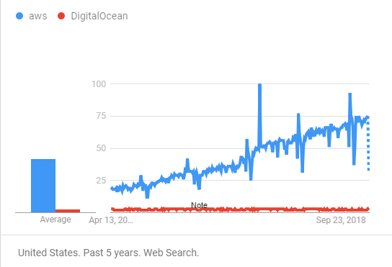

Google Trends Digital ocean vs. AWS

* AWS Compute Cloud allows you to increase or decrease storage as per the requirement of your organization
* AWS enables you to select an operating system, programming language, database of your choice.
* Broad and deep service offerings
* Robust partner ecosystem
* Simple and transparent licensing method
* High network reliability with low latency
* Minimal information is lost during the process of server and storage transfer
* Better DevOps support
* Support for Business Intelligence and analytics

## History of DigitalOcean

* In 2003, Moisey Uretsky and Ben founded ServerStack, a managed web hosting business.
* In 2011 the Uretskys founded DigitalOcean. This firm offered server provisioning and cloud hosting services.
* In August 2012, the company got traction and launched around 10,000 cloud server instances.
* By May 2015, DigitalOcean expanded further with a new data center in Toronto, Canada.
* In May 2018, the DigitalOcean announced the launch of Kubernetes-based container service.

## History of Amazon

* 2002- A launch of AWS services
* 2006- Launched its cloud products
* 2015- Able to achieve revenues of $4.6 billion
* 2016- Surpassed 10 billion dollar revenue target
* 2016- Release snowball and snowmobile
* 2019- Offers More than 100 cloud services

## DigitalOcean Vs. Amazon



| **Parameters** | **DigitalOcean** | **Amazon** |
| --- | --- | --- |
| Focus area | Developers andsmall applications | Everybody who can afford bigscalable applications |
| Best feature | Best pricing andquicker serverdeployments | A high variety ofservices to integratewith the servers |
| Security | DigitalOcean offers physical security in their data centers, which is a plus. Their centers are secured infrastructures protected from physical threat to prevent unauthorized entry. | AWS has plenty of tools which helps you to secure your data. Like GuardDuty which is AWS service which allows you to detect threats. It also helps you to monitors unusual APIs and activity. |
| Type of Cloud | DigitalOcean is Infrastructure as a Service (IaaS). It allows you to manage security, databases, and even operating system. | AWS is Platform as a Service or PaaS. It helps you to support managed services. It controls everything on its own except applications. |
| Compatibility With Windows Operating System | Digitalocean is not compatible with Microsoft Windows OS. It works only with predefined Linux installation. | Amazon EC2 is fully compatible with any OS. |
| Who it for? | If you want a MySQL instance, then you should opt for DigitalOcean. | If you are a DevOps professional working for an enterprise, you don't have spare time for installing patches and updates then Amazon is the right option for you. |
| Accepted forms of Payment | Credit cards, Paypal. | Only Credit Card |
| Mobile Friendly UI | Yes | No |
| Company using the Technology | Airbnb, Medium, Pinterest,Reddit,etc. |  |
| Key Features | Auto-scaling, reliable, easy management. | Simple dashboard, Great community, Easy Configuration, etc. |
| Pricing | Pricing starts from $5 to $640 per month for entry-level server | Pricing starts from $14 to $2500 a month for entry-level server |

## Disadvantages of DigitalOcean

Here, are cons/drawbacks of using DigitalOcean:

* You can't install the system by yourself or provide your ISO
* Security issues may occur with SSH host keys.
* Does not have a SAN but instead uses local storage in RAID
* DigitalOcean has fewer regions, compared to AWS.
* DigitalOcean does not offer any cloud computing instances that have GPUs. Useful for AI, machine learning, and Data sciences training.
* Errors and bugs were not appropriately addressed.

## Disadvantages of AWS

Here, are cons/drawbacks of using AWS services:

* AWS is not an ideal option for start-ups that are **not** tech-savvy
* Lots of hidden costs
* AWS best suited for companies who want a datacentre, not a server
* Less hybrid-cloud friendly. Incompatible and weak hybrid strategy
* Unreliable deployment with no error description
* Launching multiple app instances is not an easy process in AWS.
* AWS is a less open private cloud. This makes it an unpopular storage option for sensitive industries like finance and banking.
* Customer Support is expensive.

## Who is the winner?

In reality, DigitalOcean can't be considered a competitor of Amazon as its target market is a small development team who wants to stage up small high-performance instance quickly. Many select AWS because of its popularity.

However, If you are looking for a cost-effective cloud computing solution, then DigitalOcean is undoubtedly the best option for you. But, if you want multiple tools for your business, then you should opt for AWS services.

1. **Google Cloud vs AWS: (2019 Comparison)**

## What is AWS?

Amazon web service is a platform that offers flexible, reliable, scalable, easy-to-use, and cost-effective cloud computing solutions.

AWS cloud computing platform offers a massive collection of cloud services that build up a fully-fledged platform. It is known as a powerhouse of storage, databases, analytics, networking, and deployment/delivery options offered to developers.

In this tutorial, you will learn

* [What is AWS?](https://www.guru99.com/google-cloud-vs-aws.html#1)
* [What is Google Cloud?](https://www.guru99.com/google-cloud-vs-aws.html#2)
* [Why AWS?](https://www.guru99.com/google-cloud-vs-aws.html#3)
* [Why Google Cloud?](https://www.guru99.com/google-cloud-vs-aws.html#4)
* [Features of AWS](https://www.guru99.com/google-cloud-vs-aws.html#5)
* [Features of Google Cloud](https://www.guru99.com/google-cloud-vs-aws.html#6)
* [AWS vs. Google Cloud Platform (GCP)](https://www.guru99.com/google-cloud-vs-aws.html#7)
* [Disadvantages of AWS](https://www.guru99.com/google-cloud-vs-aws.html#8)
* [Disadvantages of Google Cloud](https://www.guru99.com/google-cloud-vs-aws.html#9)
* [How to Pick Your Cloud](https://www.guru99.com/google-cloud-vs-aws.html#10)

## What is Google Cloud?

Google launched the Google Cloud Platform(GCP) in 2011. This cloud computing platform helps a business to grow and thrive. It also helps you to take advantage of Google's infrastructure and providing them with services that is intelligent, secure, and highly flexible.

## Why AWS?

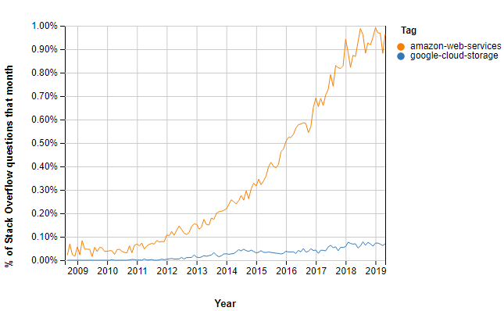

Stack overflow questions AWs vs. Google Cloud

Here are the important pros/benefits of selecting AWS web services:

* AWS offers easy deployment process for an app
* You should opt for AWS when you have DevOps teams who can configure and manage the infrastructure
* You have very little time to spend on the deployment of a new version of your web or mobile app.
* AWS web service is an ideal option when your project needs high computing power
* Helps you to improve the productivity of the application development team
* A range of automated functionalities including the configuration, scaling, setup, and others
* It is a cost-effective service that allows you to pay only for what you use, without any up-front or long-term commitments.
* AWS allows organizations to use the already familiar programming models, operating systems, databases, and architectures.
* You are allowed cloud access quickly with limitless capacity.

## Why Google Cloud?

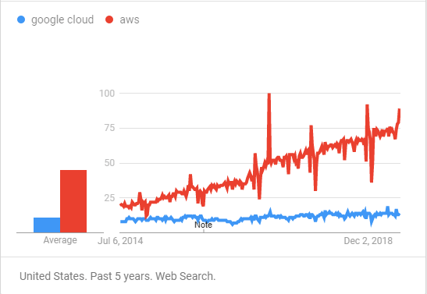

Google Trends Google Cloud vs. AWS

Here are the pros/benefits of selecting Google cloud services:

* Offers higher productivity gained through Quick Access to innovation
* Employees can work from Anywhere
* Future-Proof infrastructure
* It provides a serverless environment which allows you to connect cloud services with a large focus mainly on the microservices architecture.
* Offers Powerful Data Analytics
* Cost-efficiency due to long-term discounts
* Big Data and Machine Learning products
* Offers Instance and payment configuration

## Features of AWS

Important features of AWS are:

* Total Cost of Ownership is very low compared to any private/dedicated servers.
* Offers Centralized Billing and management
* Offers Hybrid Capabilities
* Allows you to deploy your application in multiple regions around the world with just a few clicks

## Features of Google Cloud

Important features of Google Cloud are:

* Constantly including more Language & OS.
* A better UI helps you to improves user experience.
* Offers an on-demand self-service
* Broad network access
* Resource pooling and Rapid elasticity

## AWS vs. Google Cloud Platform (GCP)



Here are major differences between AWS and Google Cloud.

| **Parameters** | **AWS** | **Google Cloud** |
| --- | --- | --- |
| Age | 11 years | 6 years |
| Pricing | Per hour basis | Per-minute basis |
| What is? | AWS is a secure, cloud servicethe platform developed and managed byAmazon. | Google Cloud Platform is a suite ofGoogle's public cloud computingresources and services. |
| Containers | Docker, Kubernetes | Kubernetes Only |
| Best feature | It dominates the public cloud market by offering a range of cloud-based products and services. | It specializes in high computeofferings like Big Data but is fairlynew to the cloud scene. |
| Main service | The flagship compute service of AWSis Elastic Compute Cloud, or EC2. | Google's primary service isCompute Engine. |
| Cost | It's on a little higher end in terms ofcompute and storage costs. | It's a clear winner with itscompetitive pricing as compared toAWS. |
| Object Storing | Amazon Simple Storage Services also called (AWS S3) | Google Cloud Storage |
| VM disk storage | Amazon Elastic Block Store (Amazon EBS) | Persistent Disk (both HDD and SSD) |
| File storage | Amazon Elastic File System (Amazon EFS) | Cloud Filestore |
| Archive Storage | S3 One Zone- Infrequent Access. Amazon Glacier offers data querying capabilities. | Archival Cloud Storage. |
| Bulk Data Transfer | AWS Import/Export Disk: Shipping disk drives AWS Snowball (device-based) AWS SnowMobile: Exabyte- scale data transfer via ruggedized shipping container AWS is the clear winner herr. | Nearline (low frequency) Coldline (lowest frequency) |
| Hybrid support | AWS Storage Gateway offers managed virtual tape infrastructure for a hybrid environment. | Relies on partners such as Egnyte for Hybrid support. |
| Disaster Recovery Management | Offers cloud-based disaster recovery services. | Offers out-of-the-box DR or backup services |
| Backup | Amazon S3 is used for secondary backup storage | Has its own built-in Google Cloud |
| Serverless computing | AWS Lamba | Container Engine |
| Volume Sizes | 500GB to 16TB | 1 GB to 64 TB |
| Max IOPS per volume | 500 | 3000 read 15000 write |
| AI service and Machine Learning | AWS has its own Al service, called SageMaker. Compared to Google, the AI offering of AWS is limited. | Google cloud used AI chips called TPU which can run TensorFlow and other AI Libraries. The speed andperformance is quite faster compares to other similar services. |
| Networking framework | AWS has no tiered networking framework. | GCP has its tiered networking framework |
| Data transmission format | In general format. | In a fully encrypted format. |
| Big data support | AWS has its own big data analysis tool which is called AWSLambda. | Google Cloud Platform has its AI known as AI Firstfor data management for its servers. |
| Available zones | AWS services are available in 21 different zones. | Google Cloud Platform services are available in 20different regions. |
| Companies using | AppDirect, Eat with Ava, Icarros, Valera, etc. | Bugsnag, Atomcert, Policygenius, PointsHound, etc. |

## Disadvantages of AWS

Here, are drawbacks/cons of using AWS cloud:

* AWS deployment process is not easy and very lengthy which can take up to 15 to 20 minute for a simple website
* Unreliable deployment with no error description
* AWS is not an ideal option for start-ups that are **not** tech-savvy
* You need to deploy your application yourself using recipes, capistrano, or manually.
* Launching multiple app instances is a very difficult process in AWS.

## Disadvantages of Google Cloud

Here, are drawbacks/cons of using Google Cloud:

* Small components, difficult to start
* Out of Free Tier, everything costs.
* Lacks features compared to AWS.

## How to Pick Your Cloud

Google Cloud and AWS both are good platforms. So, before deciding you should understand what type of feature your organization needs and how much you want to pay for them. Remember that, the right cloud service provider helps you achieve your business goal by enhancing the functioning of your organization. Since, AWS is the market leader in features and reliability our vote will tilt towards them.

1. **20 BEST AWS Competitors & Alternatives in 2019**

AWS is Amazon's cloud computing platform that offers fast, flexible, reliable, and cost-effective solutions. It also offers a service in the form of building blocks which can be used to create and deploy various types of applications in the cloud.

However, AWS services set default limits on a resource which differ from region to region. Also, hardware-level changes happen to your application, which might not offer the best performance and usage of your application.

Here, is a list of Top 20 AWS alternatives which are good enough to replace AWS cloud computing services. This list consists of paid and open-source tools with important features and the latest link.

### 1) [Kamatera](https://bit.ly/2VEnOPQ)

[](https://bit.ly/2VEnOPQ)

A cloud server tool developed by [Kamatera](https://bit.ly/2VEnOPQ) is very much similar to a physical server. It operated in a virtual infrastructure cloud, making it highly flexible and cost-effective. This cloud server pricing is based on pay as you use model a standard in the industry.

**Features:**

* 13 Data Centers across four continents for ultimate performance and availability
* Customized and Tailored Made VPS Hosting to fit your needs
* Scalability: Allows you to quickly add load balancers, firewalls, private networks and apps such as: pfSense, Docker, CPanel, Drupal, Jenkins, WordPress, Magento, node.JS and many more.
* All SSDs with UNLIMITED TRAFFIC. 99.95% Up-Time Guaranteed
* Scale across hundreds of servers in seconds
* Billing options – Per Month or Per Day
* 24/7/365 Tech Human Support
* 30 Day Free Trial to test the services

### 2) [Cloudways](https://bit.ly/2KTuzFM)

[](https://bit.ly/2KTuzFM)

[Cloudways](https://bit.ly/2KTuzFM) provides managed cloud hosting to agencies, stores, and SMBs. The platform has partnered with top cloud providers including AWS, Google Cloud, DigitalOcean, Vultr and Linode. Experience the freedom to build, deploy and manage applications including PHP, Laravel, WordPress, and Magento without requiring any knowledge of cloud server management. Cloudways users can focus on business growth without worrying about the technical complexities of server management, security, and maintenance.

**Popular features include:**

* PHP 7 Ready Servers
* Simple 1-Click App Installation
* Pre-configured PHP-FPM and Redis
* Free SSL Certificates
* Automated Backups
* Staging Environment
* 24/7/365 Support

### 3) [DigtialOcean](https://bit.ly/2YDemsK)

[](https://bit.ly/2YDemsK)

[Digitalocean's](https://bit.ly/2YDemsK) droplet is a scalable computer service. It is more than just virtual machines. This cloud platform offers add-on storage, security, and monitoring capabilities to run production applications easily.

**Features:**

* Allows you to deploy your custom image, one-click app, or standard distribution
* You can deploy Droplets and get a reliable connection and flat pricing across 8 data center regions
* Option to select Standard Plans or Performance Plans according to your business needs

### 4) [Rackspace](https://bit.ly/2JWR7Wq)

[](https://bit.ly/2JWR7Wq)

[Rackspace](https://bit.ly/2JWR7Wq) is another useful cloud computer service tool. It offers services like hosting web applications, cloud files, cloud backup, database, and cloud server, etc.

**Features:**

* Fast-migrating to the Cloud
* Helps you to prepare your business for the worst-case scenario
* Work on pay as you go model, so you are charged base on your usage
* It helps you to use a combination of solid-state drives and hard drives to deliver high performance

### 5) [MassiveGrid](https://bit.ly/2w9MBvI)

[](https://bit.ly/2w9MBvI)

[MassiveGrid](https://bit.ly/2w9MBvI) offers Virtual and Dedicated Private Clouds. With Virtual Private Clouds, helps users to have the flexibility to manage their resources in their environment according to their business needs.

**Features:**

* Offers fast & reliable Network Infrastructure
* Private cloud clients a secure web control panel, it can be used 24x7x365 to manage their clouds
* Offers high availability services with building a state of the art infrastructure
* Extremely Fast and dedicated Hardware

### 6) [Alibaba Cloud](https://bit.ly/2WcbLJ0)

[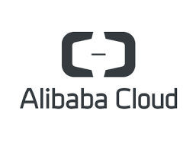](https://bit.ly/2WcbLJ0)

[Alibaba](https://bit.ly/2WcbLJ0) is the largest Chinese cloud computing company. It is a new platform which created a global footprint with over 1500 CDN Nodes worldwide of 19 regions and 56 availability zones across more than 200 countries.

**Features:**

* Helps you to achieve faster results
* Helps you to protect and backup your data
* Full management permissions and multiple management methods
* Highly stable applications and reliable data storage

### 7) [LiquidWeb](https://bit.ly/2wlurHH)

[](https://bit.ly/2wlurHH)

[The liquid web](https://bit.ly/2wlurHH) offers cloud Sites which is a managed hosting platform which offers creatives freedom to build and launch websites without the need to learn cPanel or server management.

**Features:**

* It allows you to manage your sites quickly and effortlessly
* Host Unlimited Sites & Apps with a single Account
* Not require any server management skill
* The tool can easily be integrated with WordPress, Drupal, Joomla, etc.

### 8) Microsoft Azure

[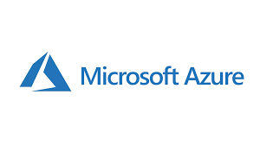](https://www.guru99.com/images/1/030119_1316_Top21CloudC3.png)

Azure is a cloud computing platform which is launched by Microsoft in February 2010. This open source and flexible cloud platform which helps in development, data storage, service management & hosting solutions.

**Features:**

* Windows Azure offers the most effective solution for your data needs
* Provides scalability, flexibility, and cost-effectiveness
* Offers consistency across clouds with familiar tools and resources
* Allow you to scale your IT resources up and down according to your business needs

**Download link:** <https://azure.microsoft.com/en-in/>

### 9) Google Cloud Platform

[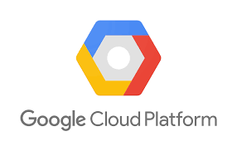](https://www.guru99.com/images/1/030119_1316_Top21CloudC4.png)

Google Cloud is a set of solution and products which includes GCP & G suite. It helps you to solve all kind of business challenges with ease.

**Features:**

* Allows you to scale with open, flexible technology
* Solve issues with accessible AI & data analytics
* Eliminate the need for installing costly servers
* Allows you to transform your business with a full suite of cloud-based services

**Download link:** <https://cloud.google.com/>

### 10) VMware

[](https://www.guru99.com/images/1/030119_1316_Top21CloudC5.png)

VMware is a comprehensive cloud management platform. It helps you to manage a hybrid environment running anything from traditional to container workloads. The tools also allow you to maximize the profits of your organization.

**Features:**

* Enterprise-ready Hybrid Cloud Management Platform
* Offers Private & Public Clouds
* Comprehensive reporting and analytics which improve the capacity of forecasting & planning
* Offers additional integrations with 3rd parties and custom applications, and tools.
* Provides flexible, Agile services

**Download link:** <https://www.vmware.com/in/cloud-services/infrastructure.html>

### 11) Salesforce

[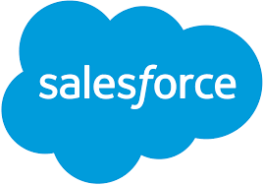](https://www.guru99.com/images/1/030119_1316_Top21CloudC7.png)

Salesforce cloud computing offers multiple cloud services like Sales Cloud, Service Cloud, Marketing Cloud, etc. Helps you to accelerate production of your environment.

**Features:**

* Salesforce Service Cloud offers 24 * 7 support
* Allows you to take a right and decisive decisions about your business
* Helps in managing the customer's contact information, automating the business processes, etc.

<https://www.salesforce.com/in/cloudcomputing/>

### 12) Oracle Cloud

[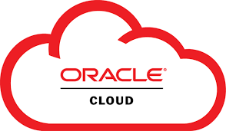](https://www.guru99.com/images/1/030119_1316_Top21CloudC8.png)

Oracle Cloud offers innovative and integrated cloud services. It helps you to build, deploy, and manage workloads in the cloud or on premises. Oracle Cloud also helps companies to transform their business and reduce complexity.

**Features:**

* Oracle offers more options for where and how you make your journey to the cloud
* Oracle helps you realize the importance of modern technologies including Artificial intelligence, chatbots, machine learning, and more
* Offers Next-generation mission-critical data management in the cloud
* Oracle provides better visibility to unsanctioned apps and protects against sophisticated cyber attacks

**Download link:** <https://www.oracle.com/cloud/>

### 13) Verizon Cloud

[](https://www.guru99.com/images/1/030119_1316_Top21CloudC9.png)

Verizon Cloud computing platform allows you to control your infrastructure with advanced set-up and customization options from a single user interface.

**Features:**

* Expand any workload quickly to help grow your business with less risk
* Helps you to build the right cloud with performance, support, and flexibility to make your business successful
* Allows you to select flexible service need according to your organizations
* You can trim down the risk and retain the data integrity across the apps

**Download link:** <http://www.verizonenterprise.com/welcome-to-verizon-cloud/>

### 14) Navisite

[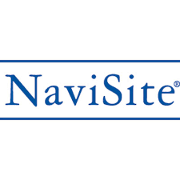](https://www.guru99.com/images/1/030119_1316_Top21CloudC10.png)

NaviSite provide cloud services for enterprises and mid-sized businesses by using the best IT technologies.

It offers a range of cloud service solutions like Cloud Infrastructure services, Cloud desktop, and hosting services.

**Features:**

* NaviSite simplifies application management services which include Managed Office 365 services
* It offers cloud-based Infrastructure-as-a-Service (IaaS) solutions that include managed cloud and self-service cloud solutions
* It helps you to simplify desktop management and administration

**Download link:**<https://www.navisite.com/>

### 15) IBM Cloud

[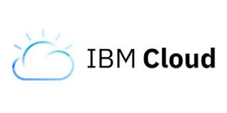](https://www.guru99.com/images/1/030119_1316_Top21CloudC11.png)

IBM cloud is a full stack cloud platform which spans public, private and hybrid environments. It is built with a robust suite of advanced and AI tools.

**Features:**

* IBM cloud offers infrastructure as a service (IaaS), software as a service (SaaS) and platform as a service (PaaS)
* IBM Cloud is used to build pioneering which helps you to gain value for your businesses
* It offers high performing cloud communications and services into your IT environment

**Download link:** <https://www.ibm.com/cloud/>

### 16) OpenNebula

[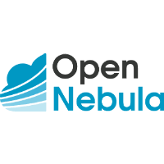](https://www.guru99.com/images/1/030119_1316_Top21CloudC12.png)

OpenNebula is a cloud computing platform. It allows you to manage heterogeneously distributed data center infrastructures. It helps you to manages the data center's virtual infrastructure to build private, public and hybrid implementations.

**Features:**

* Easy to install, use, maintain, and operate
* Provides greater functionality for private & hybrid clouds
* Highly-scalable, reliable, and commercially supported

**Download link:** <https://opennebula.org/>

### 17) Pivotal

[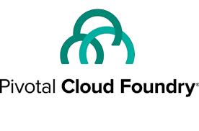](https://www.guru99.com/images/1/030119_1316_Top21CloudC13.png)

Pivotal cloud foundry which is shortly known as PCF is a proven digital solution for businesses. It helps you to move faster toward a software-driven future.

**Features:**

* Accelerate feature delivery
* Specially designed tool for zero-downtime deployments
* Helps you to reduce risk in your app portfolio
* Deliver enterprise SLAs (Service level agreement) at scale

**Download link:** <https://pivotal.io/>

### 18) CloudSigma

[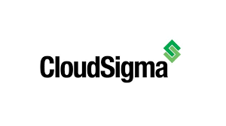](https://www.guru99.com/images/1/030119_1316_Top21CloudC15.png)

Cloudsigma is a flexible cloud server, and virtual private server hosting solutions. It offers a straightforward and transparent approach for pricing. You can easily stream at multiple gigabit speed from their cloud servers.

**Features:**

* Helps you to achieve complete control and flexibility over your cloud environment
* Allows you to mix & match all SSD and magnetic storage
* This cloud computing service tool is certified as compliant with the highest ISO 27001 requirements for security and data privacy

**Download link:** <https://www.cloudsigma.com/>

### 19) Dell Cloud

[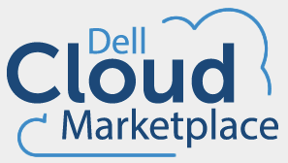](https://www.guru99.com/images/1/030119_1316_Top21CloudC16.png)

Dell offers a cloud platform, cloud-enabled infrastructure, models, and serves in a single place. It allows your own or selects from reference architecture, integrated and public cloud platforms.

**Features:**

* Cloud that works with your existing operations
* Cloud consumption using Dell Financial Services
* Accelerate your transformation with expert cloud services

**Download link:** [https://www.dellemc.com/en-us/cloud/hybrid-cloud computing/index.htm](https://www.dellemc.com/en-us/cloud/hybrid-cloud%20computing/index.htm)

### 20) LimeStone

[](https://www.guru99.com/images/1/030119_1316_Top21CloudC18.jpg)

OnePortal Rapid is built with the latest open source technology to offer fast, feature rich, highly scalable cloud platform.

**Features:**

* Helps you to build and deploy applications with standard OpenStack based API libraries
* OpenStack Horizon web dashboard allows easy tracking and managing your cloud
* Flexible billing method ensures you only pay for the resources you use
* Scale quickly with additional compute and storage resource

**Download link:** <https://www.limestonenetworks.com/cloud/servers.html>

### 21) Quadranet:

[https://www.guru99.com/images/1/030119_1316_Top21CloudC201.png](https://www.guru99.com/images/1/030119_1316_Top21CloudC201.png)

If a cloud which was developed by Quadranet is fully scalable and reliable cloud infrastructure, the tool is billed hourly based on your line resource size which you can view a break down of the cost associated with each resource.

**Features:**

* QuadraNet's uptime SLA comes default with all cloud configurations
* The InfraCloud supports a wide variety of OS like CentOS to FreeBSD to Windows
* The custom interface helps you to manage your InfraCloud instances

**Download link:** <https://www.quadranet.com/infracloud>