**Lab Practice 6 – Database Systems (Joining)**

**Roll No: ________________ Name: __________________________________**

**Practice Question 1**

Write SQL query to show following output from **EMPLOYEES** and **DEPARTMENTS** tables using equi-join

**See output below**

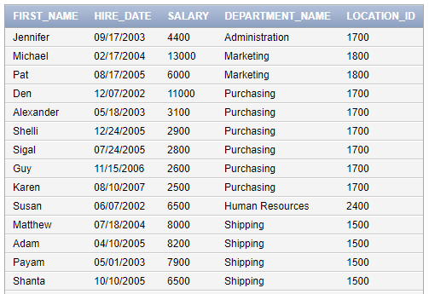

….

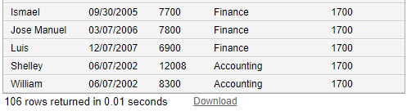

Answer:

SELECT e.first_name,e.hire_date,e.salary,d.department_name,d.location_id

FROM employees e, departments d

WHERE e.department_id = d.department_id;

____________________________________________________________________________________________________________________________________________________________________________________________________________________________________________________________________________________________________________________________________________________

**Practice Question 2**

Write SQL query to show following output from **EMPLOYEES, DEPARTMENTS** and **LOCATIONS** tables using **equi-join**

**See output below**

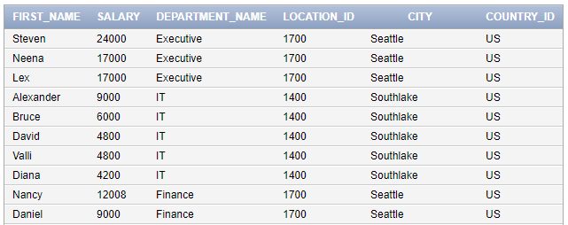

….

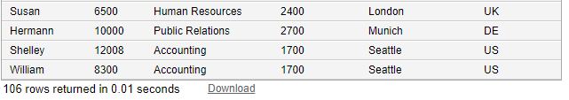

Answer:

SELECT Distinct e.first_name,e.salary,department_name,d.location_id,city,l.country_id

FROM employees e, departments d,locations l

WHERE e.department_id = d.department_id

and d.department_name in ('Executive','IT','Finance','Human Resources','Public Realations','Accounting')

and l.country_id in ('US','UK','DE'); ______________________________________________________________________________________________________________________________________________________________________________________________________________________________________________________________________________________________________________________________________________________________________________________________________________________________________________________________________________________________________________________________

**Practice Question 3**

Write SQL query to show following output from **COUNTRIES** and **REGIONS** tables using **INNER JOIN**

**See output below** 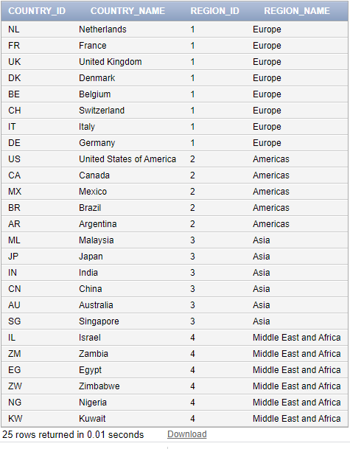

Answer:

select country_id,country_name,region_id,region_name

from countries

NATURAL JOIN regions;

_________________________________________________________________________________________________________________________________________________________________________________________________________________________________________________________________________________________________________________________________________________________________________________________________________________________________________

**Practice Question 4**

Write SQL query to show following output from **LOCATIONS**, **COUNTRIES** and **REGIONS** tables using **INNER JOIN** (**hint: use two inner joins**)

**See output below** 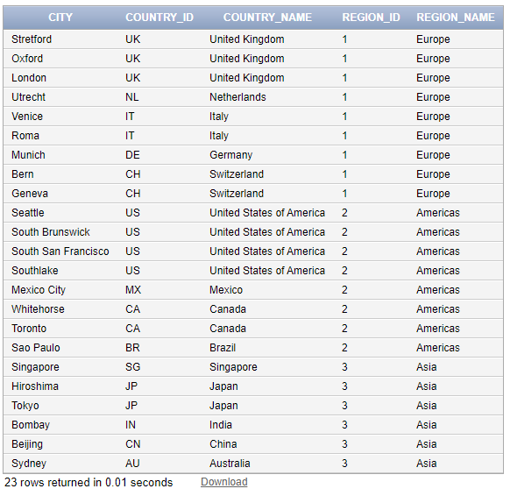

Answer:

SELECT DISTINCT locations.city, countries.country_id, countries.country_NAME,regions.region_id,regions.region_name FROM locations

_______________________________________________________________________________________________________________________________________________________________________________________________________________________________________________________________

**Practice Question 5**

Write SQL query to do show **Cartesian Product** of **Employees**, **Departments** and **Locations** Tables.

See output below

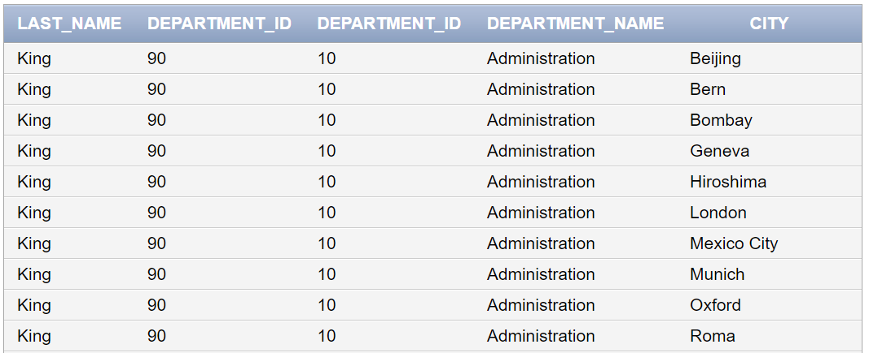

…

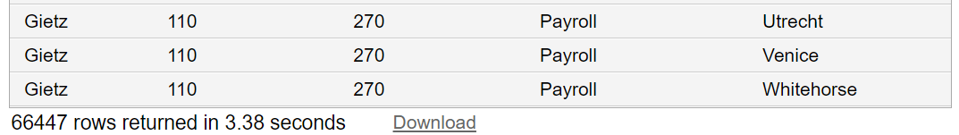

Answer:

select last_name,employees.department_id,departments.department_id,department_name,city

from employees,departments,locations; _________________________________________________________________________________________________________________________________________________________________________________________________________________________________________________________________________________________________________________________________________________________________________________________________________________________________________

**Practice Question 6**

Write SQL query to do show **Employee’s Last Names** whose name start with ‘**K**’ also show and **Department Names** against each name of employee

(Hint: Use Joining between **Employees** and **Departments** tables and also apply condition)

For details see output below

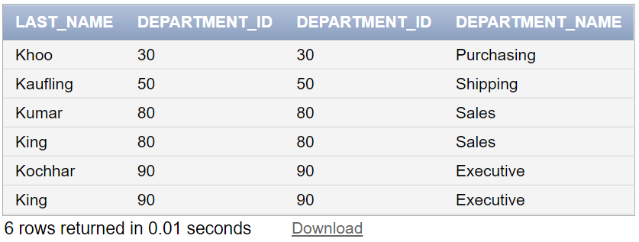

Answer:

SELECT last_name,employees.department_id,departments.department_id, department_name

FROM employees, departments

WHERE employees.department_id = departments.department_id

AND last_name LIKE 'K%'; _________________________________________________________________________________________________________________________________________________________________________________________________________________________________________________________________________________________________________________________________________________________________________________________________________________________________________