

NED University of Engineering & Technology
Computer Science & Information Technology
:Project Name:
Agriculture Expert System
:Deployed Url:
https://syedmuhammadhunain-expert-system-app-bjg0e0.streamlit.app/
:Course Name:
Introduction to Artificial Intelligence (CT-262)
:Name:
Syed Muhammad Hunain (CT-24281)
Agriculture Expert System

Table of Contents
• 1. Introduction .......................................…………………………... 2
• 2. Problem Statement .......................................……………….. 3
• 3. Requirements .......................................……………………….. 4
• 3.1 Functional Requirements .......................................….. 4
• 3.2 Non-Functional Requirements ....................................5
• 4. High Level Design .......................................…………………. 6
• 5. Code Explanation .......................................………………….. 7
• 6. Results ....……..................................………………………….… 11
• 7. Summary .......................................………………………….…. 13

1. Introduction
The Pakistan Agriculture Expert System is an easy-to-use digital assistant created to help local farmers quickly identify crop problems and protect their harvest. Agriculture is the backbone of Pakistan's economy, yet many farmers struggle to get timely advice when their crops face sudden diseases, destructive insect pests, or poor soil fertility across major crops like Wheat, Cotton, Rice, Sugarcane, and Maize. By asking simple questions about visible symptoms and soil conditions, this system uses built-in agricultural rules to give farmers instant diagnosis, safe treatment recommendations, and exact fertilizer quantities directly through any web browser.
2. Problem Statement
Smallholder farmers across Pakistan experience severe yield losses because access to qualified agricultural extension officers is scarce and laboratory testing remains slow and expensive.
Without timely diagnostic support, growers routinely misidentify foliage infections, spray incorrect chemical pesticides, and misjudge soil macronutrient deficiencies.
This uncontrolled chemical application raises farm operational expenses, accelerates insect pest immunity, and leaves hazardous pesticide residues in food grain crops. Consequently, there is an urgent need for an automated, accessible expert advisory tool that delivers immediate, validated agronomic guidance to protect national crop production.

3. Requirements
3.1 Functional Requirements
The following are the functional requirements:
Requirement | Description
Disease Identification | App identifies disease of crop.
Disease Solution | App provides disease solution after identification.
Disease Input Form | App takes crop disease information from farmer.
Pest Identification | App identifies pest.
Pest Solution | App provides pest solution after identification.
Pest Input Form | App takes pest information from the farmer.
Nutrient Deficiency | App identifies soil deficiencies from foliage signs.
Fertilizer Prescription | App calculates exact fertilizer dosage (NPK) and soil fix.
Nutrient Input Form | App takes leaf discoloration patterns, crop stage, and soil pH.

3.2 Non-Functional Requirements
Following are the Non Functional requirements:
Requirement | Description
Performance & Latency | Inference engine evaluates rule chain in < 1.0 second.
Fault Tolerance & Robustness | Malformed inputs trigger friendly error alerts without Python traceback crashes.
UI Responsiveness | Streamlit page reloads in < 500ms.
Scalable | In future, if new features planned, easy to scale.

4. High Level Design
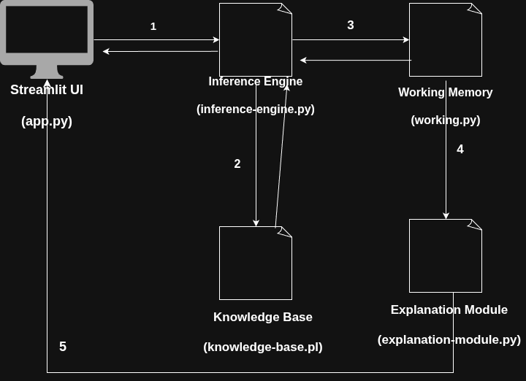

5. Code Explanation
5.1 Streamlit UI (app.py)
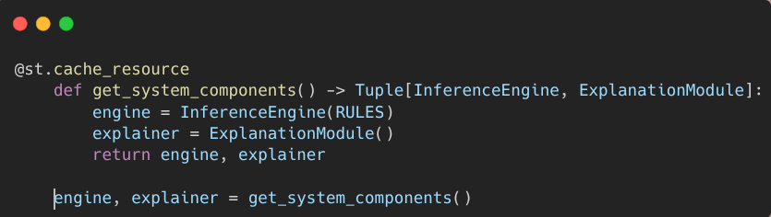
Explanation: This initializes the expert system engine and explainer modules once inside the Streamlit web interface. It makes the system ready to accept user inputs from forms, trigger reasoning, and render diagnostic reports.
5.2 Explanation Module (explanation_module.py)
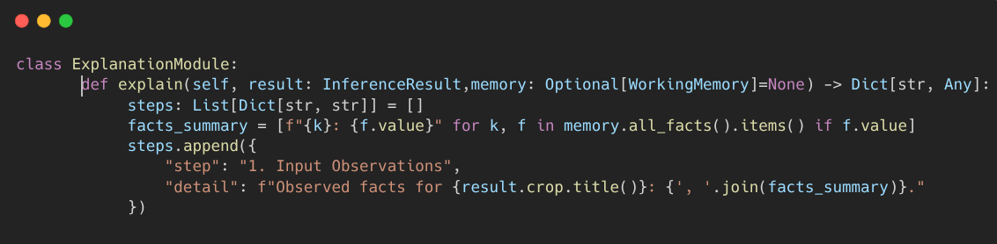
Explanation: The explanation facility translates internal rule firings and math into step-by-step human explanations. It shows inputs observed, rules fired, reasoning steps, and boundary limitations for transparency.

5.3 Inference Engine (inference_engine.py)
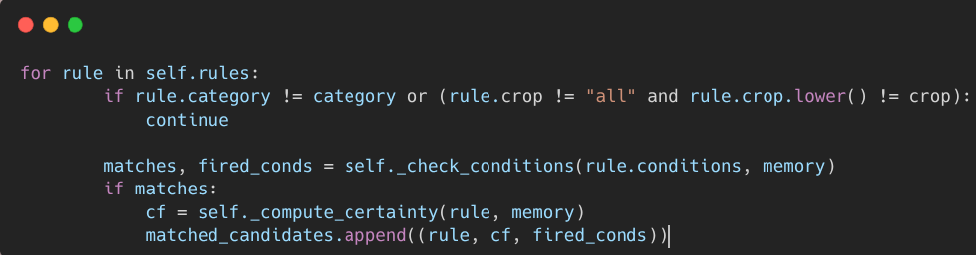
Explanation: This is forward-chaining matching logic. It loops through domain rules, compares rule prerequisites against working memory facts, and calculates final certainty scores for satisfying rules.

5.4 Working Memory (working_memory.py)
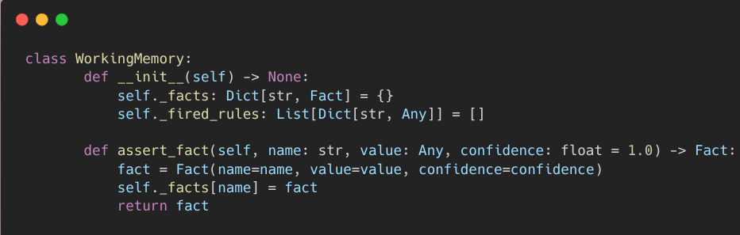
Explanation: Working memory acts as dynamic scratchpad memory during consultation. It stores user observations like crop type or leaf symptoms as asserted facts and tracks which rules have triggered.

5.5 Knowledge Base (knowledge_base.py)
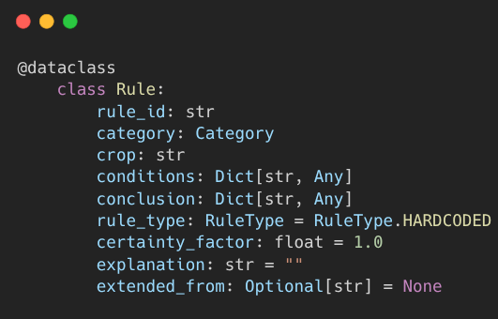

Explanation: This chunk defines how agricultural domain knowledge is stored as IF-THEN rules. Each rule specifies symptoms to match in conditions, diagnosis and remedies in conclusion, and a certainty factor showing how confident the system is.

5.6 MYCIN Certainty Factor Combination (inference_engine.py)
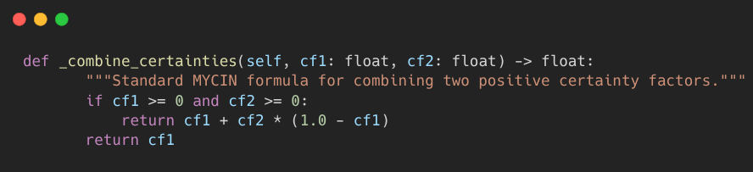
Explanation: Calculates confidence when multiple symptoms or rules point to the same crop disease. It applies standard expert system probability mathematics so confidence grows logically as corroborating evidence increases.

6. Results
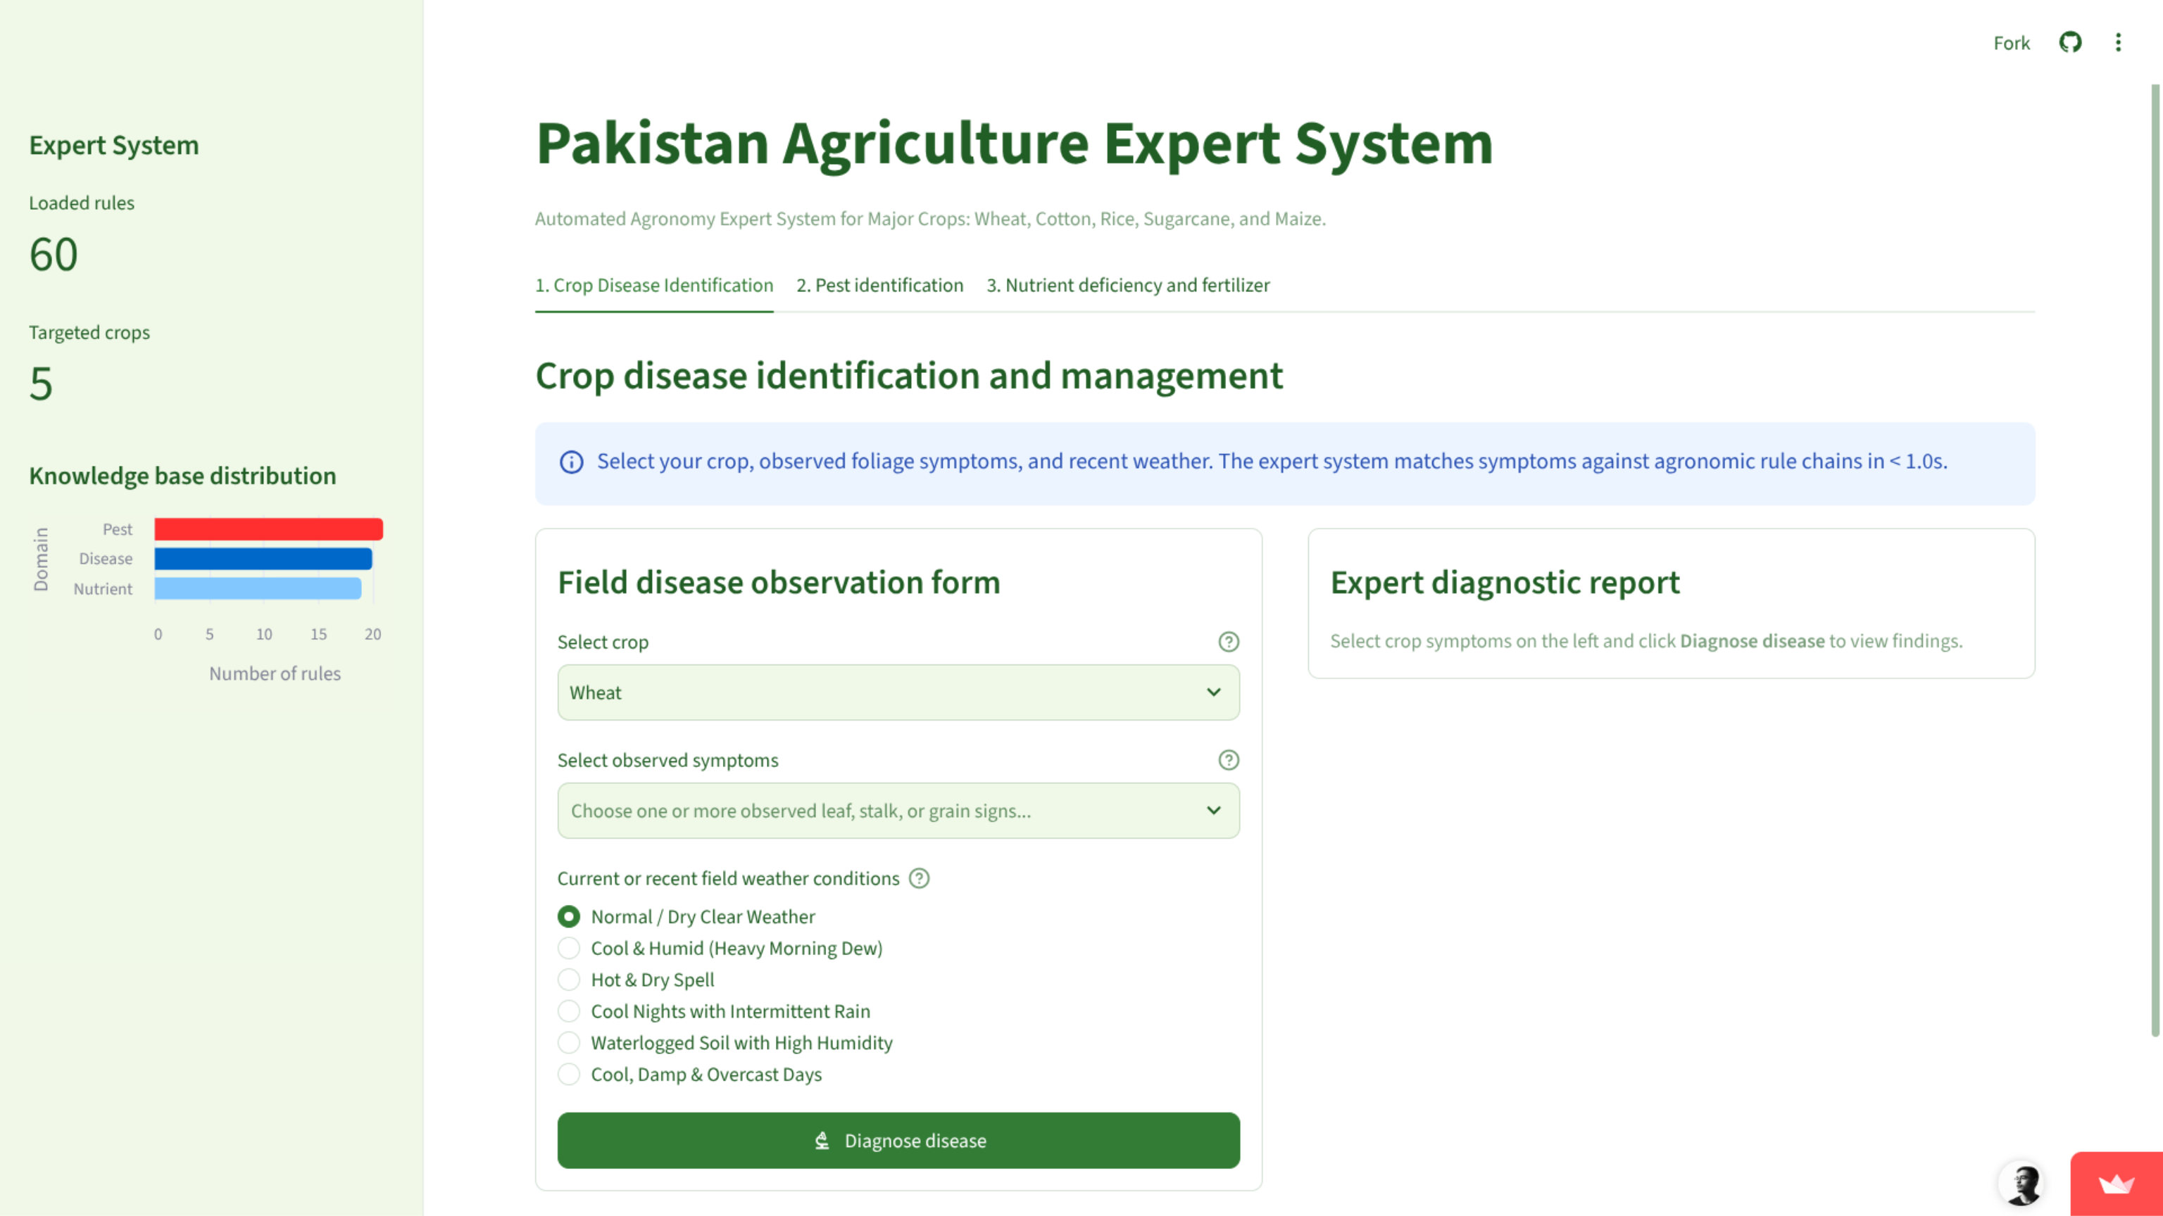

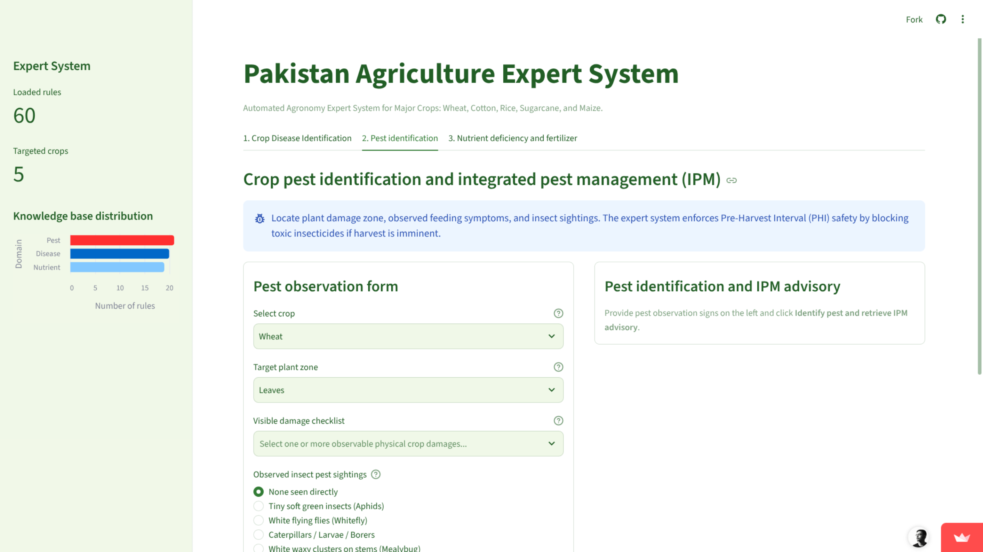

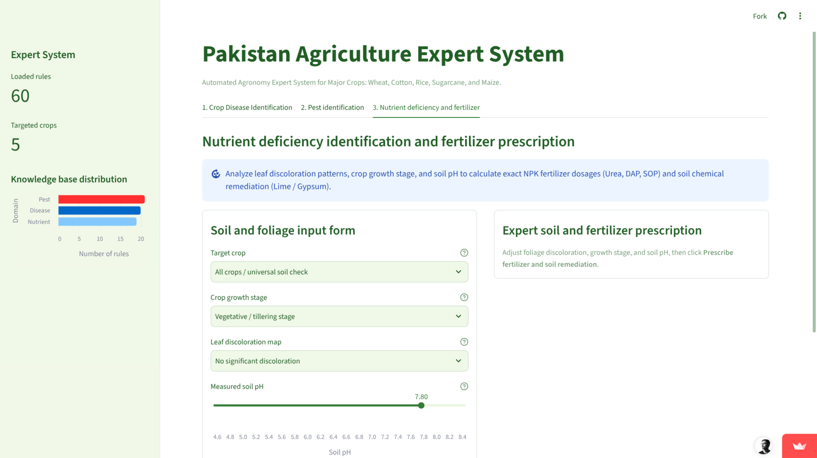

7. Summary
The Pakistan Agriculture Expert System provides an intelligent, accessible diagnostic platform tailored for Pakistani farming conditions across five major economic cash and food crops.
By implementing a modular forward-chaining inference engine in pure Python, the system evaluates more than sixty codified agricultural rules in sub-millisecond execution times.
The intuitive Streamlit web interface guides farmers through disease identification, pest management with pre-harvest safety controls, and precise soil nutrient prescriptions.
Its transparent four-step explanation module and calibrated certainty factor scoring build user trust while maintaining strict adherence to known system boundaries.
Ultimately, this digital agronomy assistant empowers rural growers with expert decision support, reducing unnecessary crop loss and optimizing chemical input sustainability.

