

NED UNIVERSITY OF ENGINEERING AND

TECHNOLOGY

Computer Science & Information Technology

:COURSE NAME

Object Oriented Analysis & Design (CT-263)

Semester: Fall 2026 | Batch: 2024 | Section: “A”

:PROJECT:

Social Media Content Analysis System

:SUBMITTED BY :
SYED MUHAMMAD HUNAIN [CT-24281]
MUHAMMAD AFZAL [CT-24263]
AYESHA [CT-24309]

SOCIAL MEDIA CONTENT ANALYSIS SYSTEM

Table of Contents

• 1. Introduction…………………………………………………….…..…….5

◦ 1.1 Background…………………………………………………...……..5

◦ 1.2 Relevance………………………………………………………..…...6

• 2. Objectives…………………………………………………...………...….7

• 3. Problem Statement……………………………………………….…...7

• 4. Requirements……………………………………………….…………...8

◦ 4.1 Functional Requirements……………………………………....8

◦ 4.2 Non-Functional Requirements……………………….…....10

◦ 4.3 Architecture Requirements……………………………..…....11

• 5. Capacity Estimation…………………………………………..……...12

◦ 5.1 Throughput Estimation………………………………………….12

• 5.2 Storage Estimation……………………………………….………….13

• 6. API Design………………………………………………………………......15

• 7. High Level Design…………………………………………………...…...18

• 8. Database Selection……………………………………………...……...26

◦ 8.1 Database Decision Table…………………………...……………...26

• 9. Data Modeling…………………………………………...……………….30

• 10. Methodology……………………………………………………………..33

◦ 10.1 Use Case Diagram……………………………………………...…33

◦ 10.2 Sequence Diagram………………………………………...…….34

◦ 10.3 Class Diagram……………………………………….……………..35

◦ 10.4 Communication Diagram…………………….………………..36

◦ 10.5 Component Diagram………………………..…………………...37

◦ 10.6 Activity Diagram…………………………..……………………....38

◦ 10.7 Deployment Diagram………………..……………………….....38

• 11 Conclusions………………………………...……………………………..39

◦ 11.1 Results………………….……………………………………………..39

◦ 11.2 Summary………………...…………………………………………..41

1. Introduction

1.1 Background
The Social Media Platforms operate at massive scale, supporting hundreds of millions of active users who interact continuously throughout the day. These users produce diverse media content including text posts, photos, and videos while executing billions of interactions such as likes / unlike, comments, and follow / unfollow.
Beyond core networking features, modern platforms must continuously monitor and analyze user engagement. Delivering these capabilities requires a robust distributed system that can process massive write workloads, serve personalized chronological news feeds with sub-second latency, and update analytical dashboards without bottlenecking primary user workflows.

1.2 Relevence
• Actionable Creator Insights
It provides users with immediate feedback through visual analytics dashboards, including Follower Graph, like/unlike Graph, and post engagement Graph.
• Scalable Architecture
It demonstrates how to handle extreme operational demands (500M DAU, 2.5 billion daily interactions, and 216 TB/day storage) by combining microservices, event-driven workflows, and schema-less NoSQL databases.
• Low-Latency User Experience
It applies practical distributed patterns such as precomputed news feed fan-out, pre-signed direct media uploads, and decoupled asynchronous background services to maintain high availability and fast response times.

2 . Objectives
The Objective of the Social Media Content Analysis System is to develop a Social Media Content Analytic System in which there is a dedicated Analytical Dashboard that provides users with real-time Visual Feedback on their content performance and audience engagement.

3. Problem Statement
Social Media Platforms fail to provide everyday users with Realtime Visual Analytics on their, likes / unlikes, comments and follower graphs, while existing architectures struggle to deliver these live insights alongside high-volume social networking workflows without latency bottlenecks.

4. Requirements

4.1 Functional Requirements
Below are the requirements and their description:
Requirements | Description
Authentication | The user can register and login account in software.
Create Social Media Posts | Users can create / edit / delete social media posts. A social media post can be a Text Post, Image Post, or a Video Post.
Like / Unlike Posts | Users can like / unlike other people's posts.
Follow / Unfollow | Users can follow / unfollow other users.
Comment on Posts | Users can comment on each other's posts.
News Feed | Users can view news feed. The feed shows posts from people they follow, listed from newest to oldest.
Direct Messaging & Chat | Users can send and receive direct real-time chat messages with text, images, and videos. Saved persistently in MongoDB Atlas with unread counts and conversation history.
Notifications System | Users receive persistent in-app notifications for likes, comments, follows, and direct messages, navigable directly to target resources.

Like / Unlike Graph | Users can see users like / unlike graph in dashboard.
Followers Graph | Users can see followers increasing / decreasing graph in dashboard.
Engagement Graph | Users can see comments / engagements graph (comments directly proportional to engagements).
4.2 Non-Functional Requirements
Below is the structured table displaying the nonfunctional requirements:
Requirement | Description
Eventual Consistency | If a user posts something, it should show up within 2 seconds on the News Feed.
Like / Unlike Update | If a user likes / unlikes a post, it should update the like / unlike graph in the dashboard within 2 seconds.
Follow / Unfollow Update | If a user follows another user, it should update the follow / unfollow graph in the dashboard within 2 seconds.
Engagement Update | If a user comments on a post, it should update the user's engagement graph in the dashboard within 2 seconds.
Usability | The rendering should be fast. Example: It's frustrating if a post loads in parts (like the

 | image first, then text, etc.). The post should appear almost instantly.
Load Latency | The News Feed should load within 1-2 seconds.

4.3 Architecture Requirements
Below is the structured table displaying core architectural principles:
Requirement | Description
Extensibility | The design of our system should be such that it is easier to extend it in the future.  Example: If we need to add features like replying to a comment, post recommendations, or ads.
Modularity | The system should be split into small, independent modules.
Cohesion and Coupling | The system should maintain

 | high cohesion and low coupling across components.
Microservices | The system should use small, independent services where each runs on its own and focuses on a single responsibility.

5. Capacity Estimation
To ensure robust system performance and scalability, capacity and throughput requirements are calculated based on user activity metrics.
User Scale Baseline:
• Daily Active Users (DAU): 500 million
• Monthly Active Users (MAU): 2 billion

5.1 Throughput Estimation
Writes:
• Create a Social Media Post:
Assume 10% of DAU create social media posts
a. Total DAU = 500 million
b. 10% of DAU create post = 50 million
c. This results in 50 million create post requests per day.
• Like / Unlike:
Assume user likes 5 posts per day.
a. Total DAU = 500 million.
b. 500 million x 5 = 2500 million
c. This results in 2500 million requests per day.

• Follow / Unfollow:
Assume 5% of DAU perform follow / unfollow actions.
a. Total DAU = 500 million
b. 500 million x (5 / 100) = 25 million requests per day.
c. This results in 25 million requests per day.
• Comment on Posts:
Assume 2 comments by user
a. Total DAU = 500 million.
b. 500 x 2 = 1000 million requess per day.
c. This results in 1 billion requests per day
Reads:
• News Feed Viewing:
Assume an average user reads 100 posts per day.
a. Total DAU = 500 million
b. Each user reads 100 posts per day.
c. 500 million x 100 = 50000 million read requests per day.

1.2 Storage Estimation
Post breakdown and daily storage requirements:
• Average Post Sizes: Text posts (~100 KB), Image posts (~0.5 MB), Video posts (~20 MB).
• Post Distribution: 20% text posts, 60% image posts, 20% video posts.
• Text Data Storage: (0.2 × 50M) × 100 KB = 1 TB/day
• Image Data Storage: (0.6 × 50M) × 0.5 MB = 15 TB/day
• Video Data Storage: (0.2 × 50M) × 20 MB = 200 TB/day
• Total Daily Storage: 1 TB + 15 TB + 200 TB = 216 TB/day

6. API Design
Communication across clients and services is standardized using REST APIs. Below are the endpoints, methods, and request payloads

Action | HTTP Method | Endpoint | Request Body
Register | POST | /v1/auth/signup | {"username": "string", "email": "string", "password": "string"}
Login | POST | /v1/auth/login | {"email": "string", "password": "string"}
Text Post | POST | /v1/posts | {"userId": "Your unique identifier", "text": "The content of your post", "hashtags": ["The tags you include in your post"]}
Image/Video Post | POST | /v1/posts | {"userId": "Your unique identifier", "mediaUrls": "The web address (URL) where your uploaded image or video is stored.", "description": "The caption you write under your

 |  |  | image or video", "hashtags": ["The tags you include in your post."]}
Like Post | POST | /v1/like | {"userId: "Your unique identifier", "postId": "The unique identifier of the post you are liking on"}
Unlike Post | DELETE | /v1/unlike | {"userId": "Your unique identifier", "postId": "The unique identifier of the post you are unliking on"}
Comment | POST | /v1/comment | {"userId": "Your unique identifier", "postId": "The unique identifier of the post you are commenting on", "comment": "The text of your comment"}
Follow User | POST | /v1/follow | {"followerId": "Your unique identifier", "followeeId": "The unique identifier of the user you want to follow"}
Unfollow User | DELETE | /v1/unfollow | {"followerId": "Your unique identifier", "followeeId": "The unique identifier of the user
Send Direct Message | POST | /v1/chat/messages | {"recipientId": "string", "text": "string", "media": []}
Get Messages | GET | /v1/chat/messages?with={userId} | NONE (Query parameter)
Get Notifications | GET | /v1/notifications/{userId} | NONE (Path variable)

 |  |  | you want to unfollow
Read  News  Feed | GET | /v1/feeds/ {userId} | NONE (Query parameters)

7 . High Level Design
The high-level architecture defines how services, load balancers, message queues, and databases interact for core workflows.

1. Create a Social Media Text Post
• When the user writes a text post and clicks submit, a POST Request is sent with the details of the text post.
• The API Gateway handles the incoming request and routes it to the Post Writer Service.
• The Post Writer Service saves the new post in the Posts Database (Posts DB).
• The Client receives confirmation of the successful post.
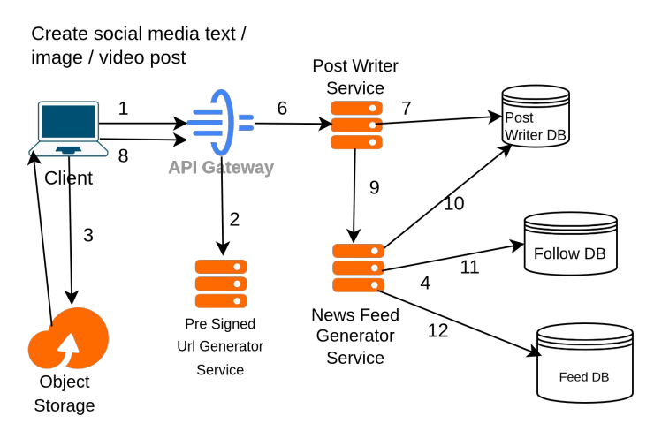

2. Follow / Unfollow Workflow
• When the user follows another user, a POST request is sent to the /v1/follow endpoint.
• API Gateway Handling The API Gateway handles the incoming request and routes it to the Follow Service.
• The Follow Service updates the Follow Database (Follow DB) to reflect the new follower / followee relationship in dashboard graph.
• The client receives confirmation of the successful follow request.

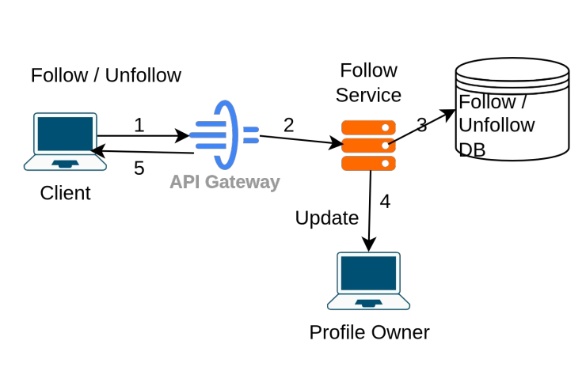

3. Like / Unlike Workflow
• When the user likes another user, a POST request is sent to the /v1/like and so on endpoint.
• API Gateway Handling The API Gateway handles the incoming request and routes it to the Like / Unlike Service.
• The Like / Unlike Service updates the Like / Unlike Database to reflect the new like-unlike relationship in dashboard graph.
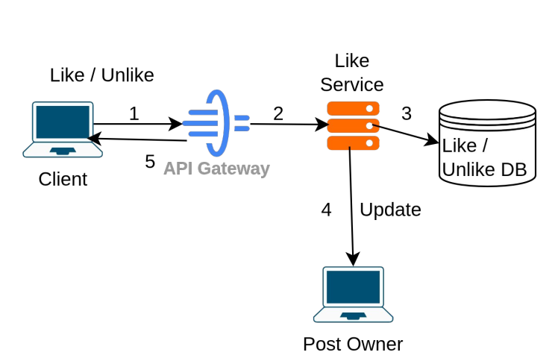
• The client receives confirmation of the successful like / unlike request.

4. Read News Feed
• When the user tries to load their news feed, a GET request is sent to the API Gateway on the /v1/feeds/{userId3 endpoint.
• The API Gateway receives the request and forwards it to the NewsFeed Reader Service.
• The NewsFeed Reader Service fetches the pre-built news feed from the FeedDB.
• The NewsFeed Reader Service sends the news feed back to the user.
• The news feed only contains the URLs for the images and videos, not the actual media files. The client fetches the actual images and videos from theObject Storage using these URLs.
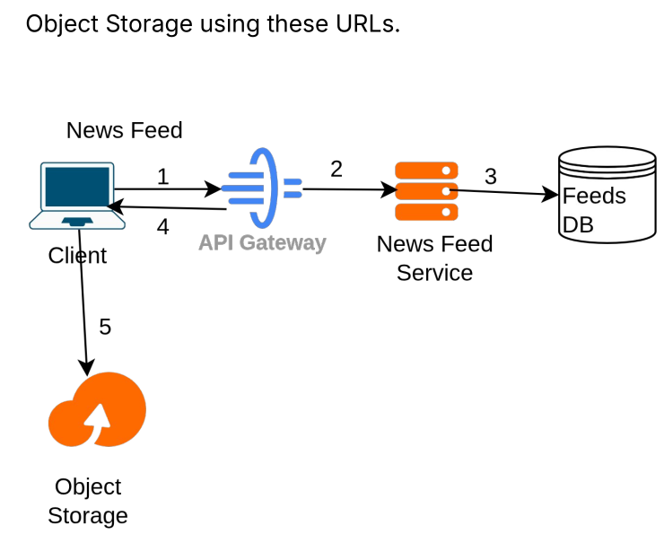

5. Create Image or Video Post
• The client requests a pre-signed URL from the API Gateway to upload the image/video.
• API Gateway receives this request and routes it to the Pre-Signed URL Generator Service. The Pre-Signed URL Generator Service generates the pre-signed URL and returns it to the client.
• The client uploads the image/video directly to Object Storage using the pre-signed URL.
• Object Storage returns the URL of the
uploaded image/video to the client.
• The client uses this uploaded image/video URL in the request body & sends a POST request to the API Gateway.
• The API Gateway handles the incoming request and routes it to the Post Writer Service.
• The Post Writer Service saves the new post in the Posts DB.
• The client receives confirmation of the successful post.
• The News Feed Generator Service fetches the new post data from the Posts DB using postId.
• The News Feed Generator Service finds all followers for this user using Follow DB.
• The News Feed Generator Service adds the new post to all followers' feeds. This information is stored in the Feeds DB. Each entry in the Feeds DB maps UserId to their News FeedUserId → { Post1, Post2, Post3 … }.

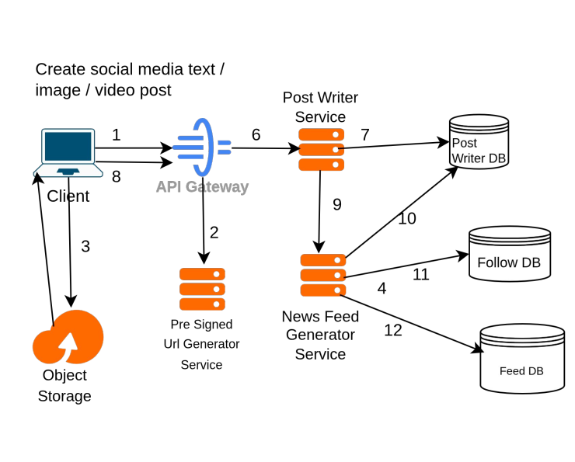

6. Commment on Post Workflow
• The user writes a comment and submits it. A POST request is sent to /v1/comments with the comment data.
• The API Gateway handles the incoming request. It routes the request to the Comment Service.
• Thise Comment Service processes the comment. It stores the comment in the Comments Database.
• The Comment Service then fetces the postId and post owner and update the engagement graph in dashboard of the followeeId (owner).
• The client receives confirmation that the comment was successfully posted.
7. Direct Messaging & Notification Workflow
• A user sends a direct message via client interface. A POST request is dispatched to /v1/chat/messages with recipientId, text, and optional media.
• The API Gateway authenticates the sender via JWT token and routes the payload to the Chat Service.
• The Chat Service persists the message into ChatMessagesDB with a deterministic conversation ID (conv_{userA}_{userB}) and compound indexes for fast chronological retrieval.
• Simultaneously, an in-app Notification is generated and stored in NotificationsDB for the recipient user with type MESSAGE.
• When the recipient opens the application or switches to the Notifications tab, the notification is retrieved from NotificationsDB; clicking it navigates directly to the chat conversation.
• Both users sync conversations and receive direct messages with sub-second delivery.
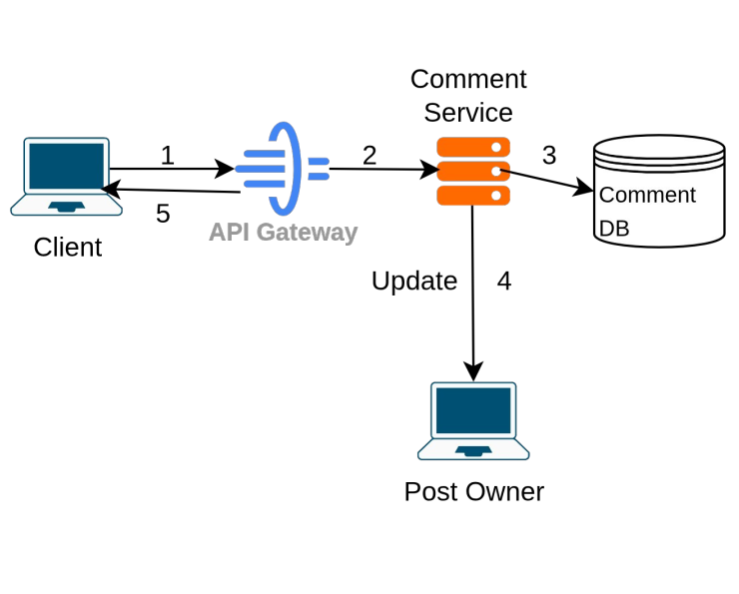

8 . Database Selection
The system adopts a NoSQL database architecture to fulfill requirements for extreme scalability, unstructured media metadata, high throughput, and flexible schema evolution.

Database: No-SQL
• Extensibility: Easily accommodates new media types, such as audio support, as the application scales.
• Schema Flexibility: Offers a schema-less structure, allowing documents to store varied and unstructured data without rigid predefined tables.
• Fast Access: Optimized for fast data reads and writes, meeting the performance requirements of the system.
• Simple Queries: Eliminates the need for complex multi-table joins by keeping related data together in documents.
• Frequent Evolving Data Changes: Easily adapts to shifting data requirements and new attributes over time without requiring heavy database migrations.

Database Decision Table
Database architecture selection per service component:
Database Component | Deciding Factors | Selected Decision
LikesDB | • Extremely high scale and throughput (~2.5B activities/day).  • No fixed schema (supports future like types / reactions like funny, love, sad). | NoSQL

FollowDB | • Stores user relationship graphs (follower and followee connections).  • Efficient querying of follower/followee networks. | NoSQL
CommentsDB | • Extremely high scale and throughput (~1B activities/day).  • No fixed schema (supports nested comments / replies). | NoSQL
PostsDB | • Unstructured post data (text, images, videos, metadata).  • Simple query pattern reading posts by PostId. | NoSQL
PostsDB | • Stores Precomputed feeds mapped as  UserId  → [Post1, Post2, ...].  • High scale and simple query pattern reading by userID. | NoSQL
ChatMessagesDB | • Real-time direct chat history and metadata.  • Compound indexed by sender, recipient, and createdAt.  • Flexible media attachments array. | NoSQL
NotificationsDB | • In-app user notifications for likes, follows, comments, and messages.  • Chronological retrieval by recipient and read status. | NoSQL

9 .DataModeling
Detailed schema definitions for NoSQL document stores:

i. Post Schema
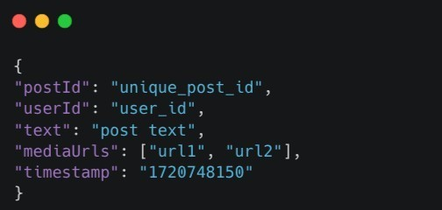

ii. Like Schema
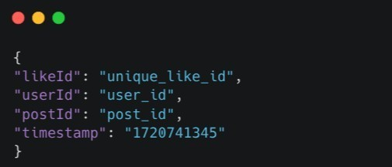

iii. Comments Schema
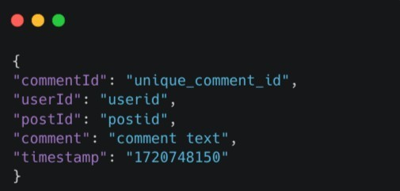

iv. Follow Schema
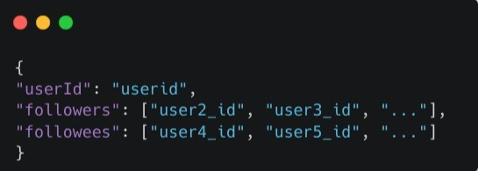

v. Feed Schema
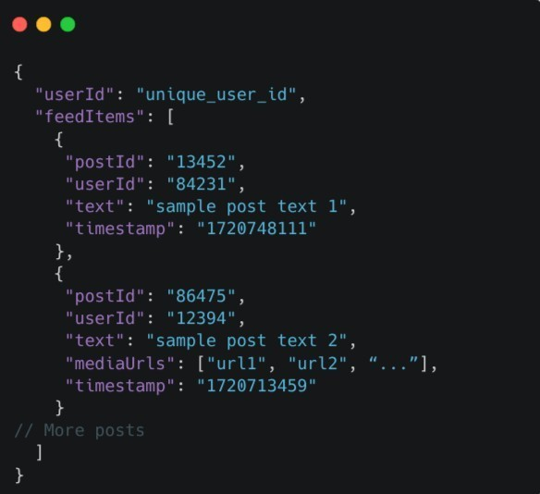
vi. Chat Message Schema
{ id: String, conversationId: String, senderId: String, recipientId: String, text: String, media: [ { url: String, type: String, name: String, size: Number } ], read: Boolean, createdAt: ISODate }
vii. Notification Schema
{ id: String, recipientUserId: String, actorUserId: String, actorName: String, actorAvatar: String, type: String ("LIKE"|"COMMENT"|"FOLLOW"|"MESSAGE"), targetPostId: String, message: String, read: Boolean, createdAt: ISODate }

10 . Methodology

10.1 Use Case Diagram
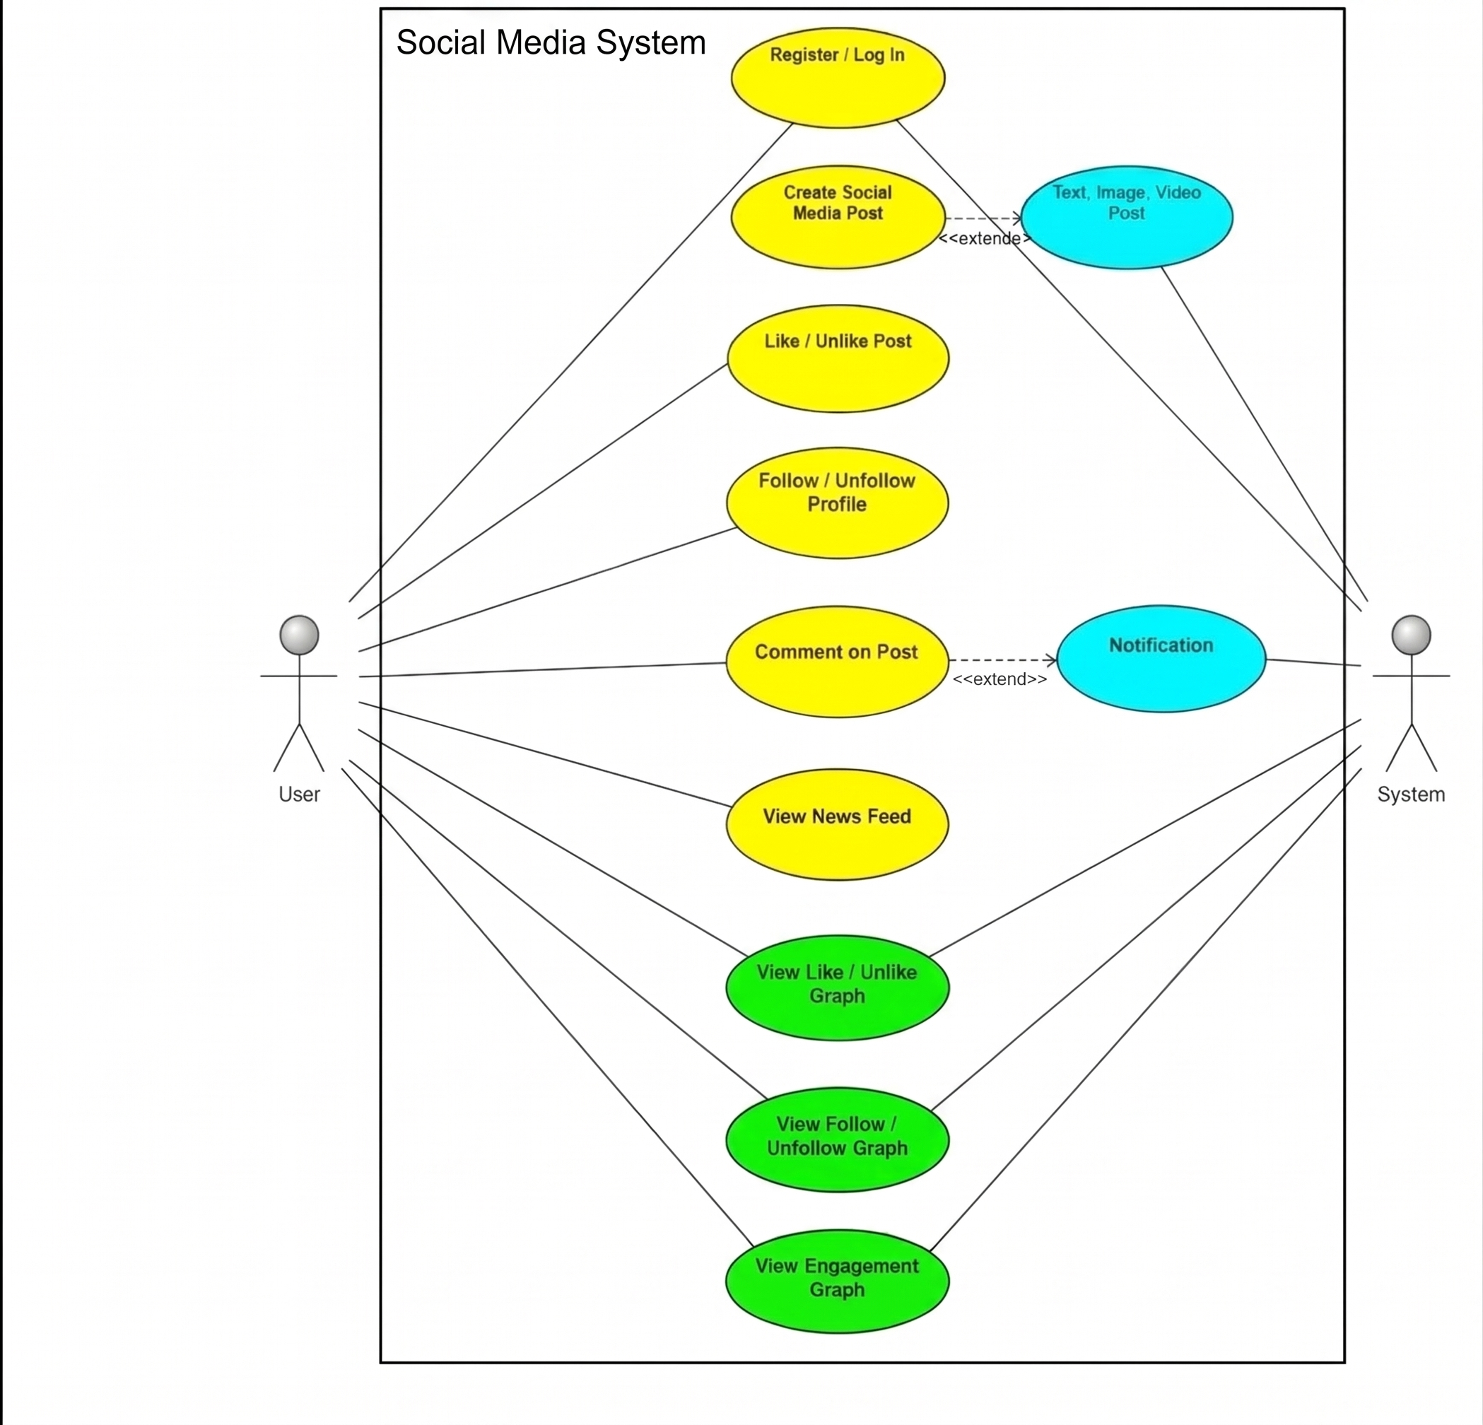

10.2 Sequence Diagram
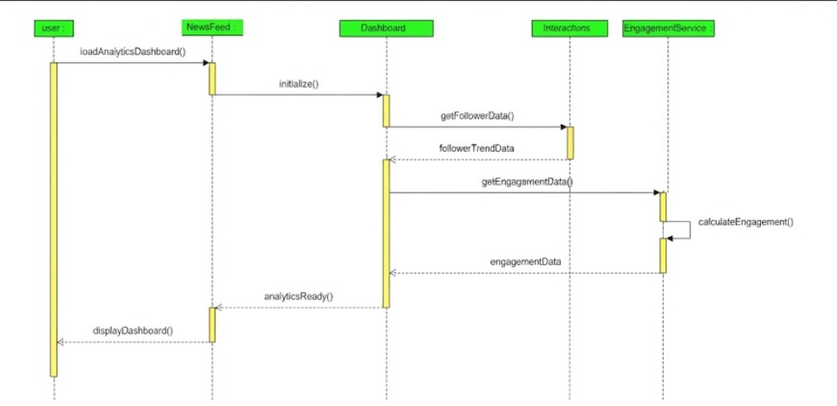

10.3 Class Diagram
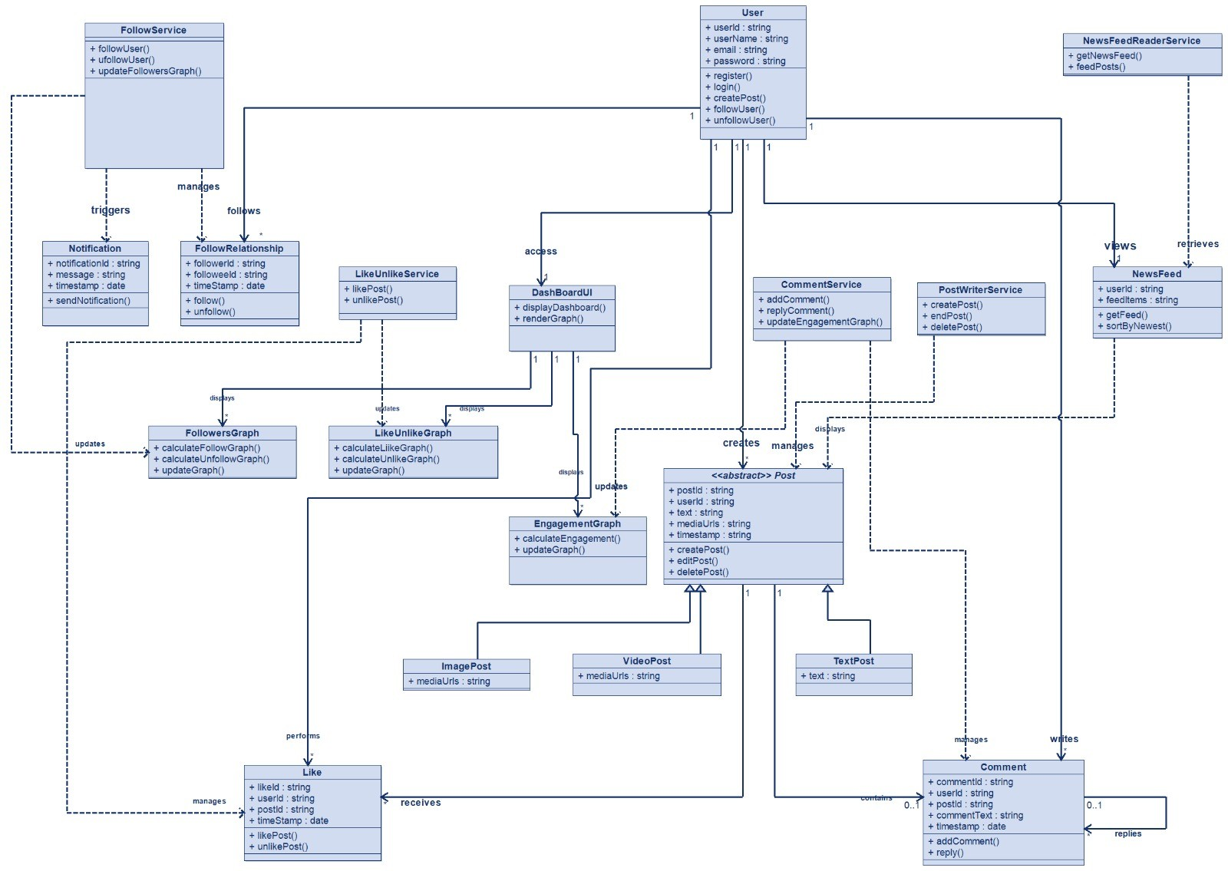

10.4 Communication Diagram
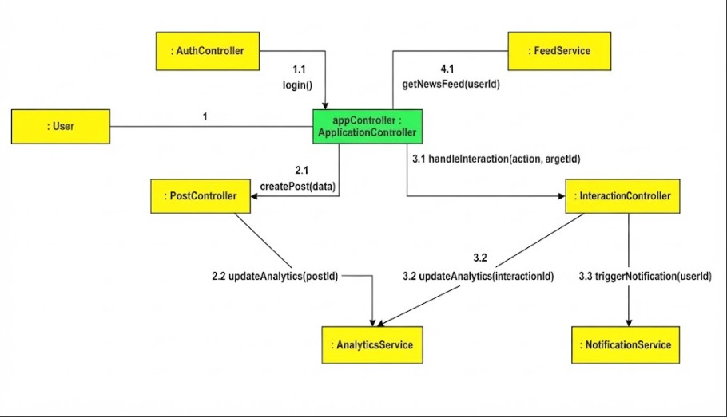

10.5 Component Diagram
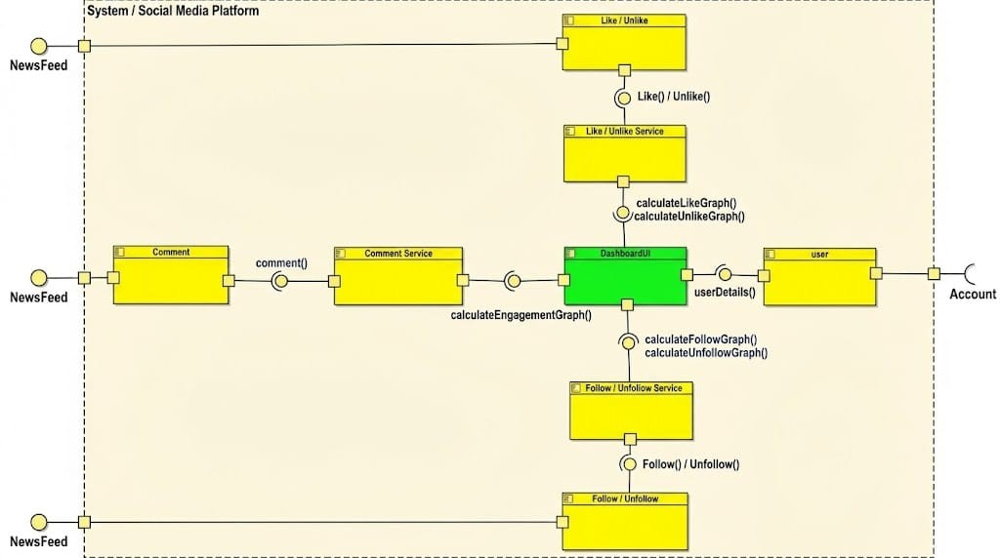

10.6 Activity Diagram
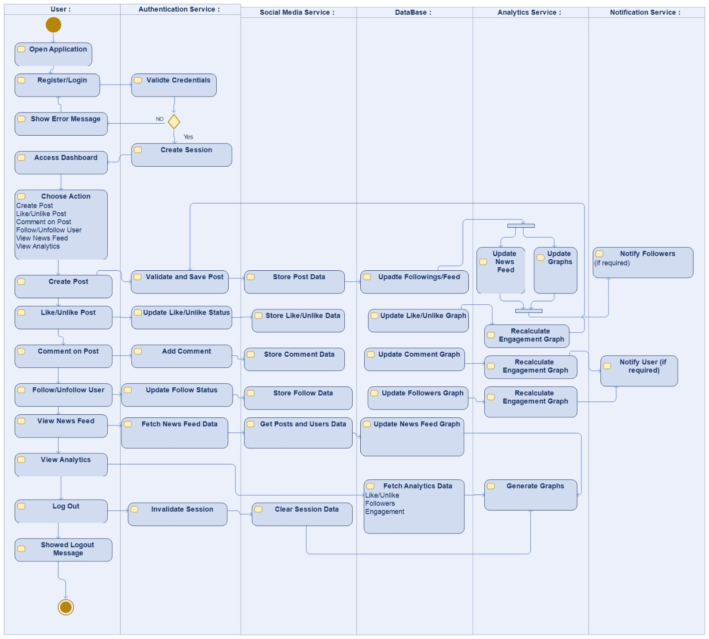

10.7 Deployment Diagram
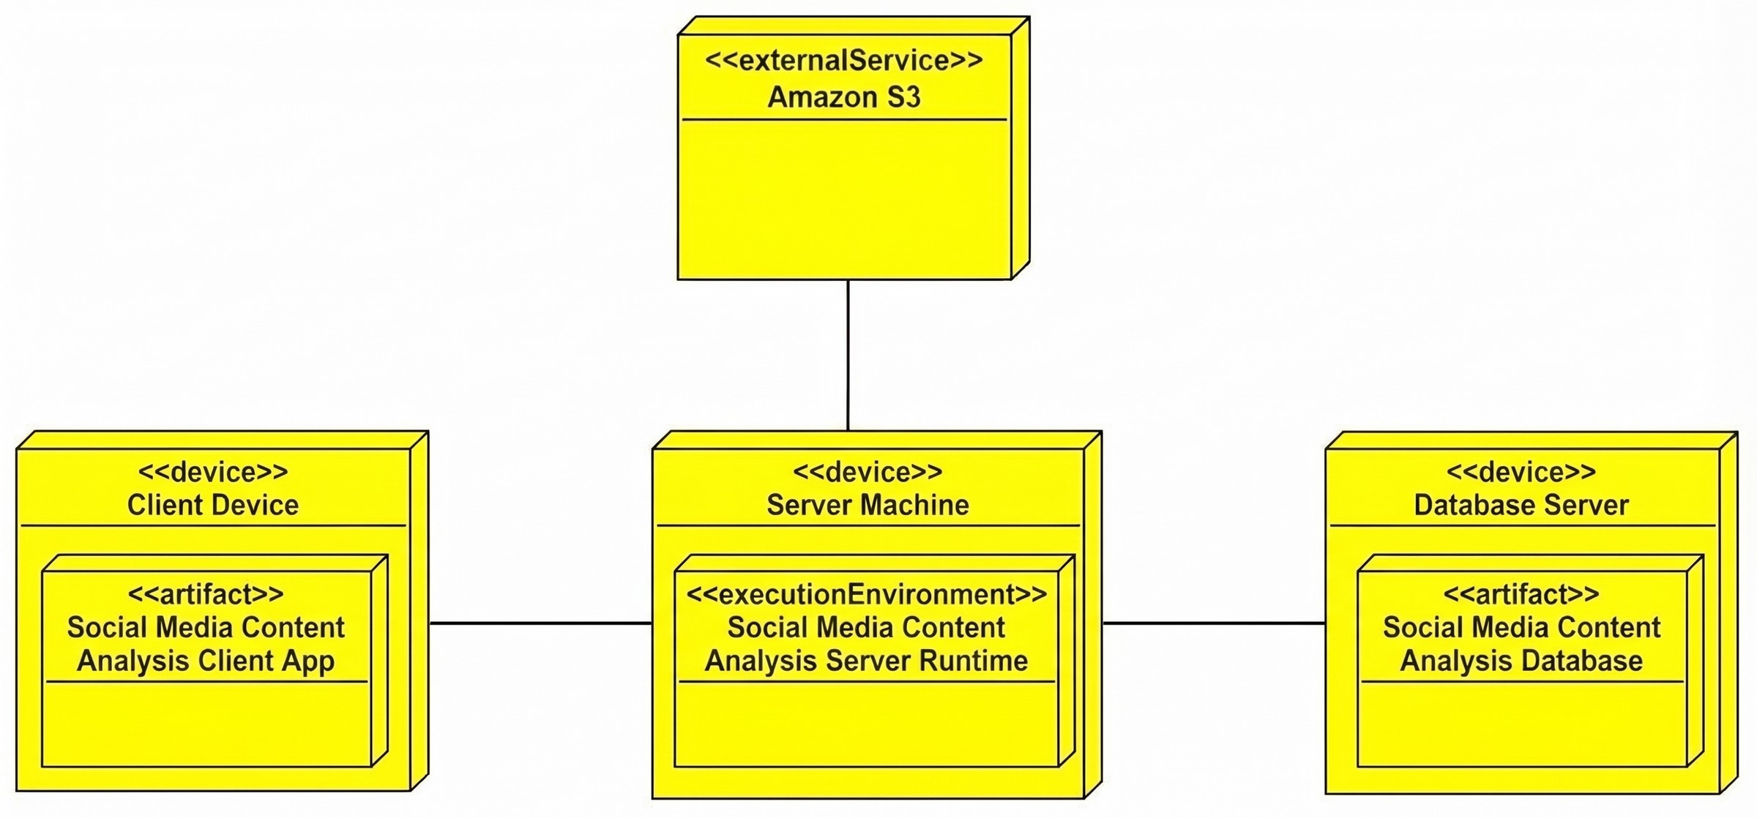

11 . Conclusions

11.1 Results & System Verification
Figure 11.1: User Authentication & Split-Card Registration View
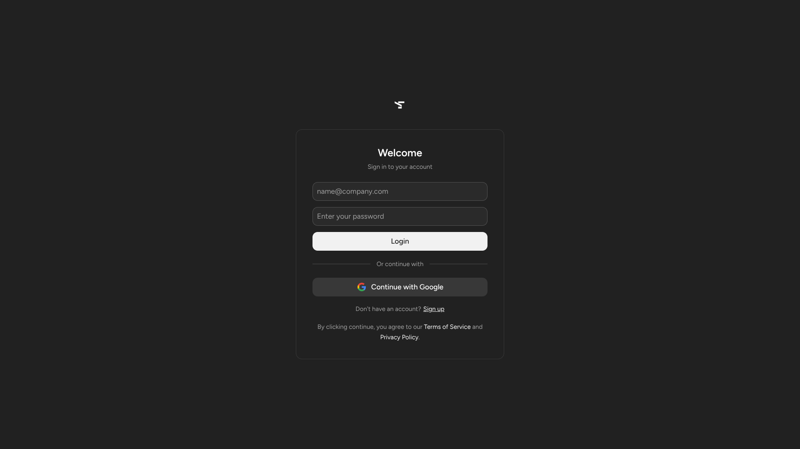

Figure 11.2: 3-Column Responsive Newsfeed & Left Navigation Rail

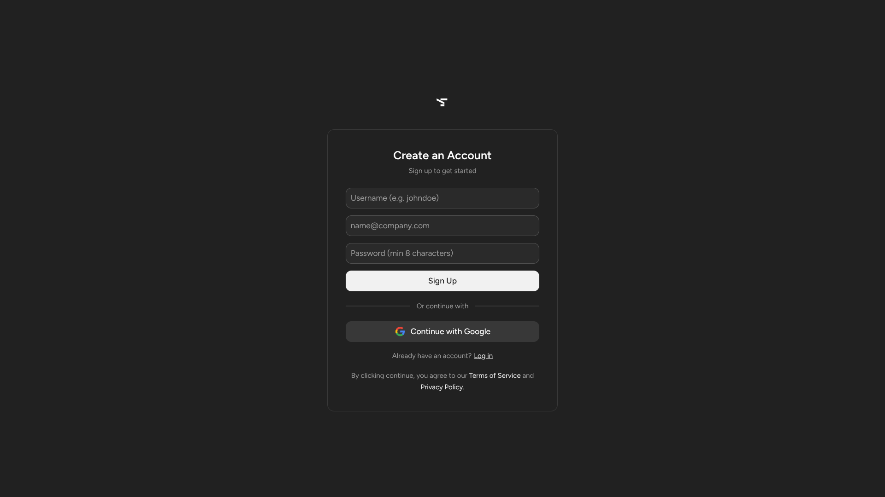
Figure 11.3: Real-Time Creator Analytical Dashboard & Follower Growth Telemetry

Figure 11.4: Post Engagement Breakdown & Interaction Trends

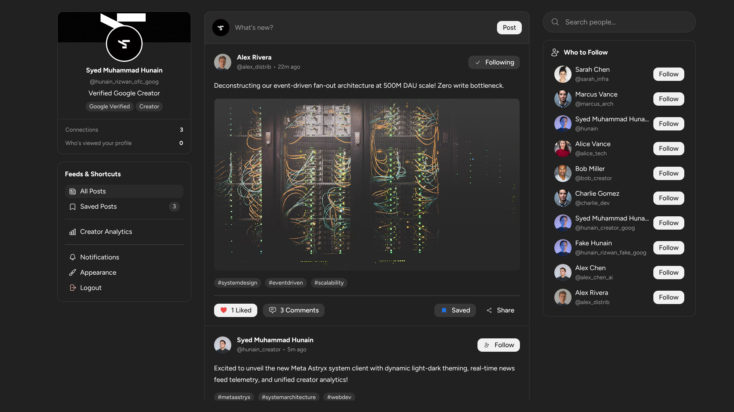
Figure 11.5: User Profile View & Follower Network Management

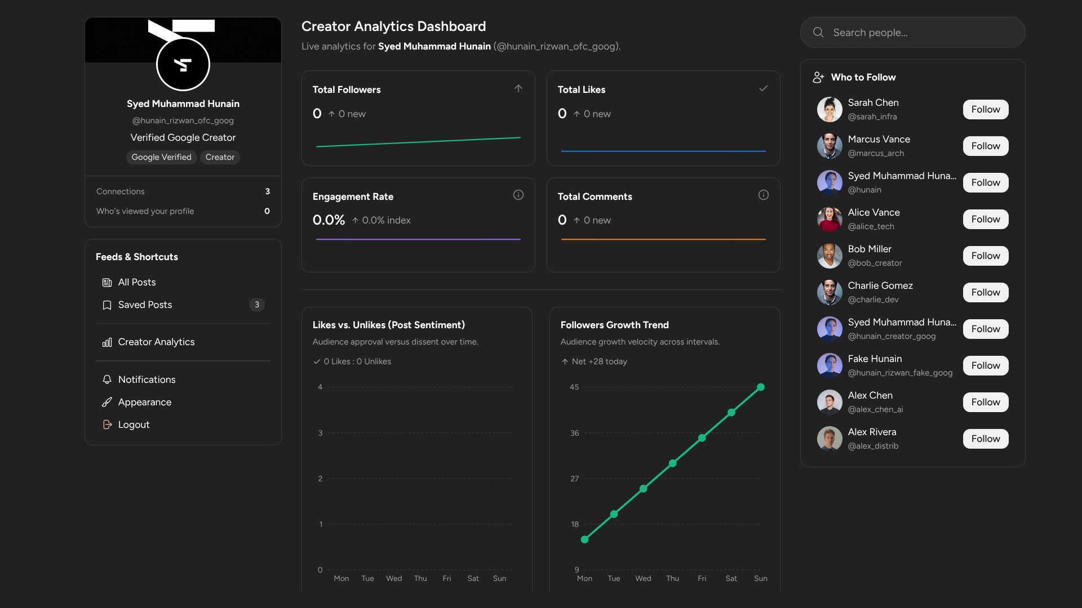

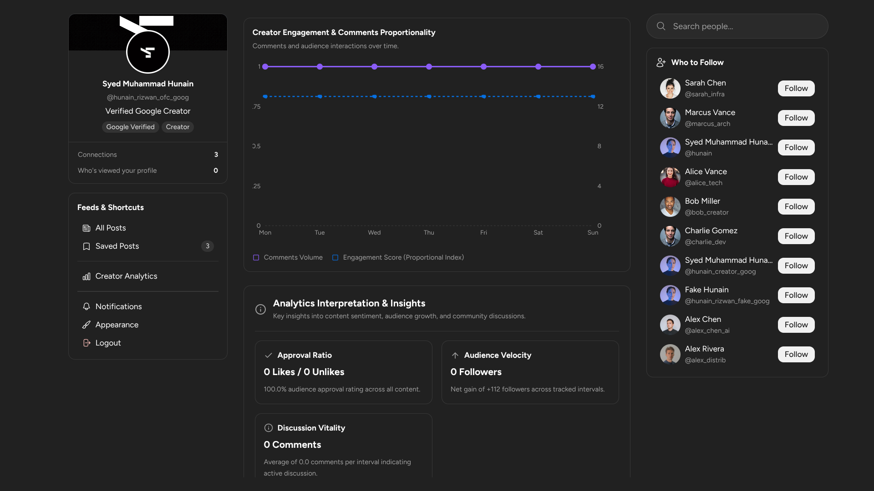

Figure 11.6: Unified Post Composer & Azure Direct Media Upload Pipeline

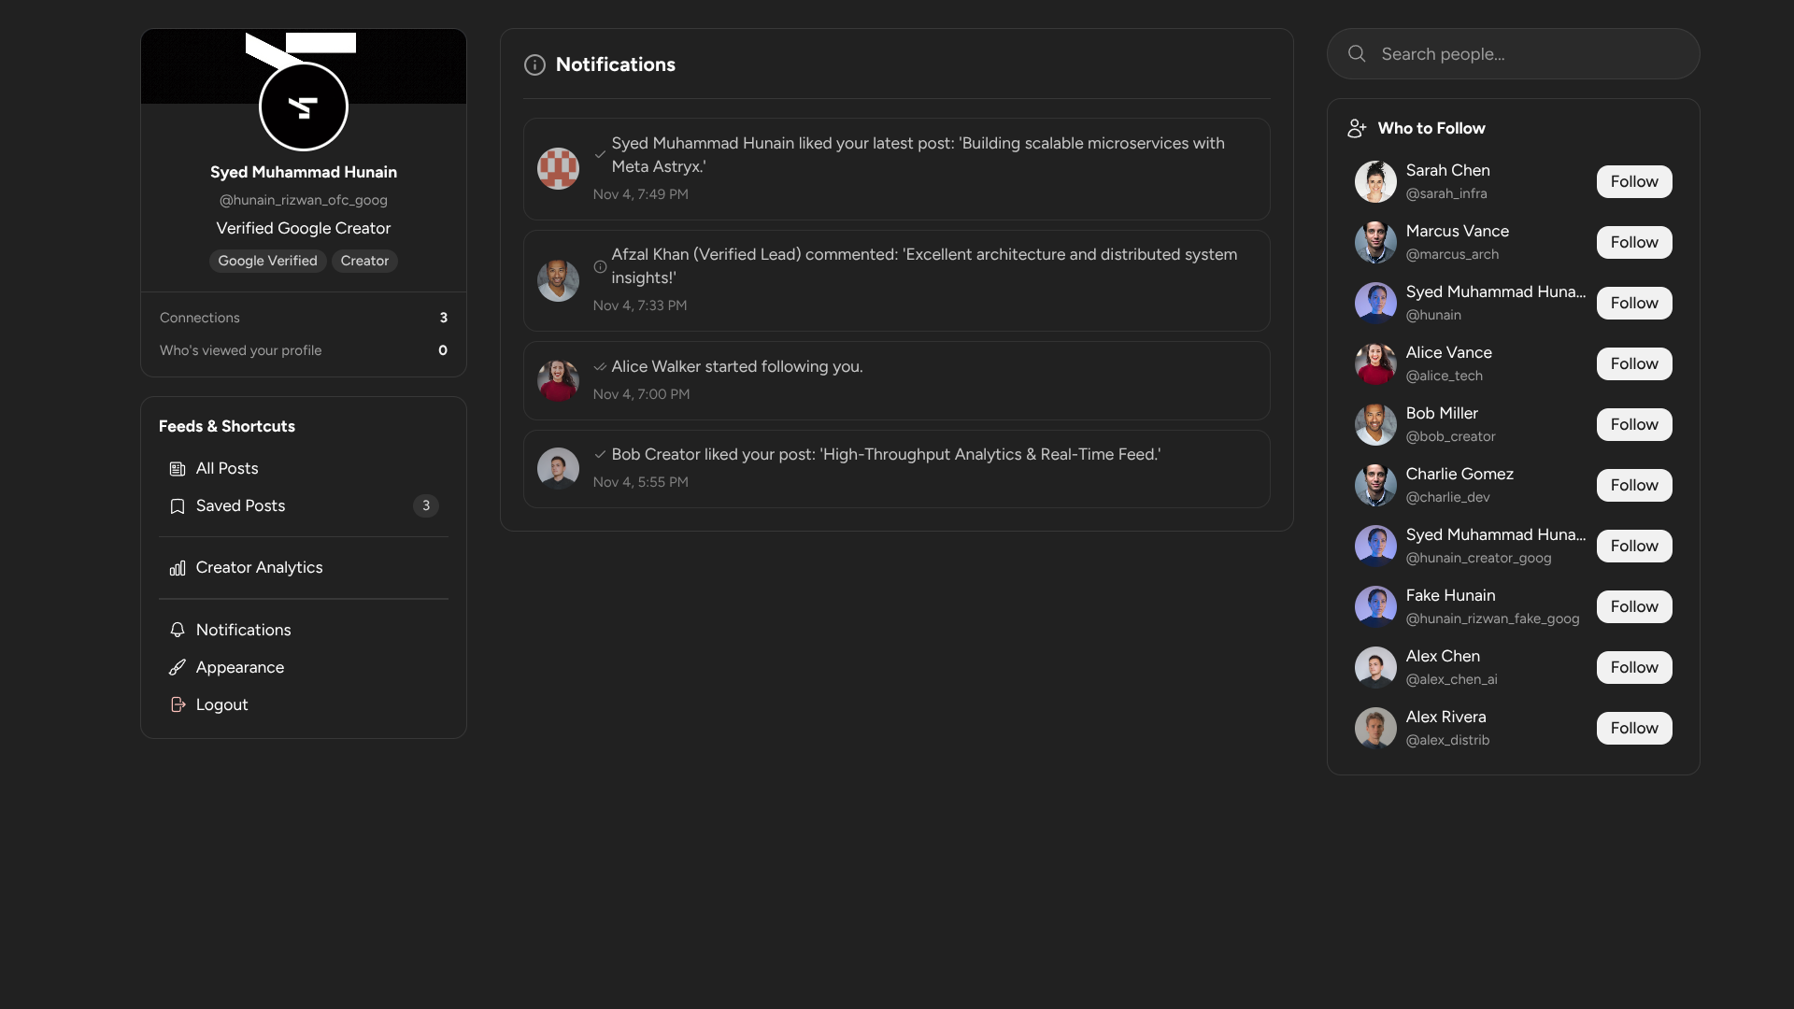
Figure 11.7: Post Interaction, Rich Comments & Media Playback
Figure 11.8: Real-Time Direct Messaging Chat Thread & Profile Presentation
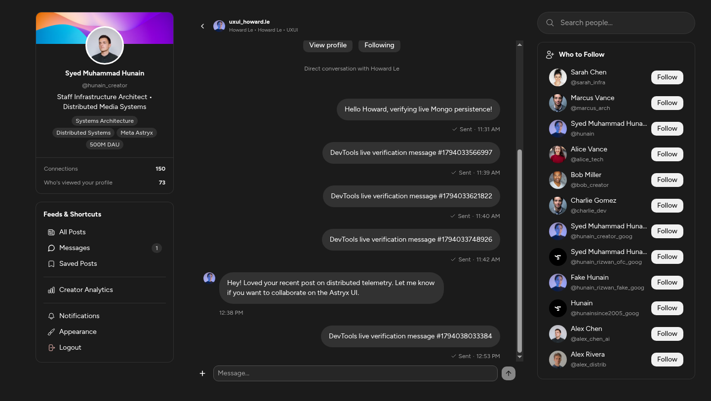
Figure 11.9: Android Responsive Mobile Layout & Direct Chat Viewport (390px)
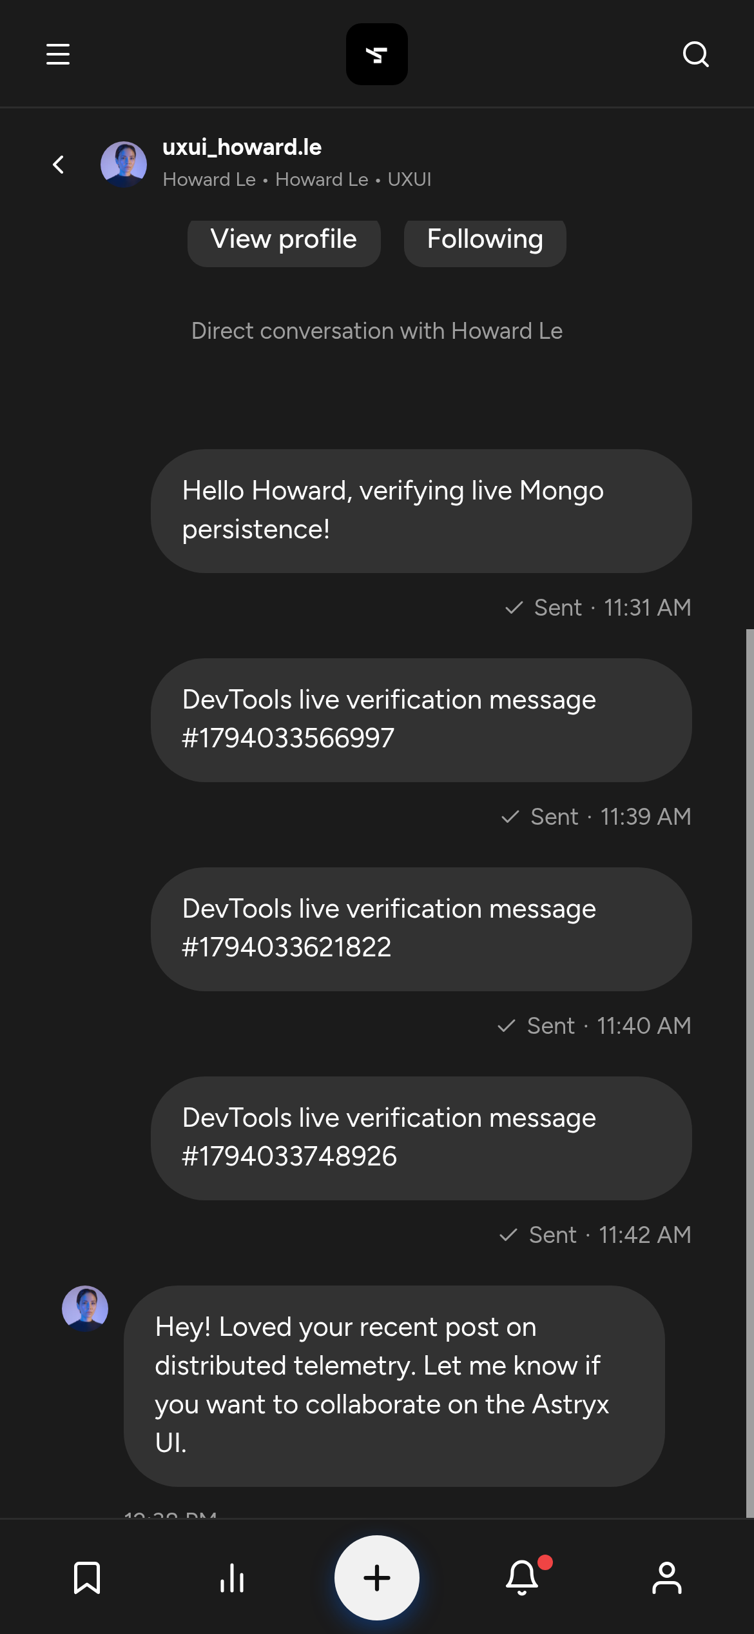
Figure 11.10: Chrome DevTools Protocol (CDP) Automated Test Verification Summary
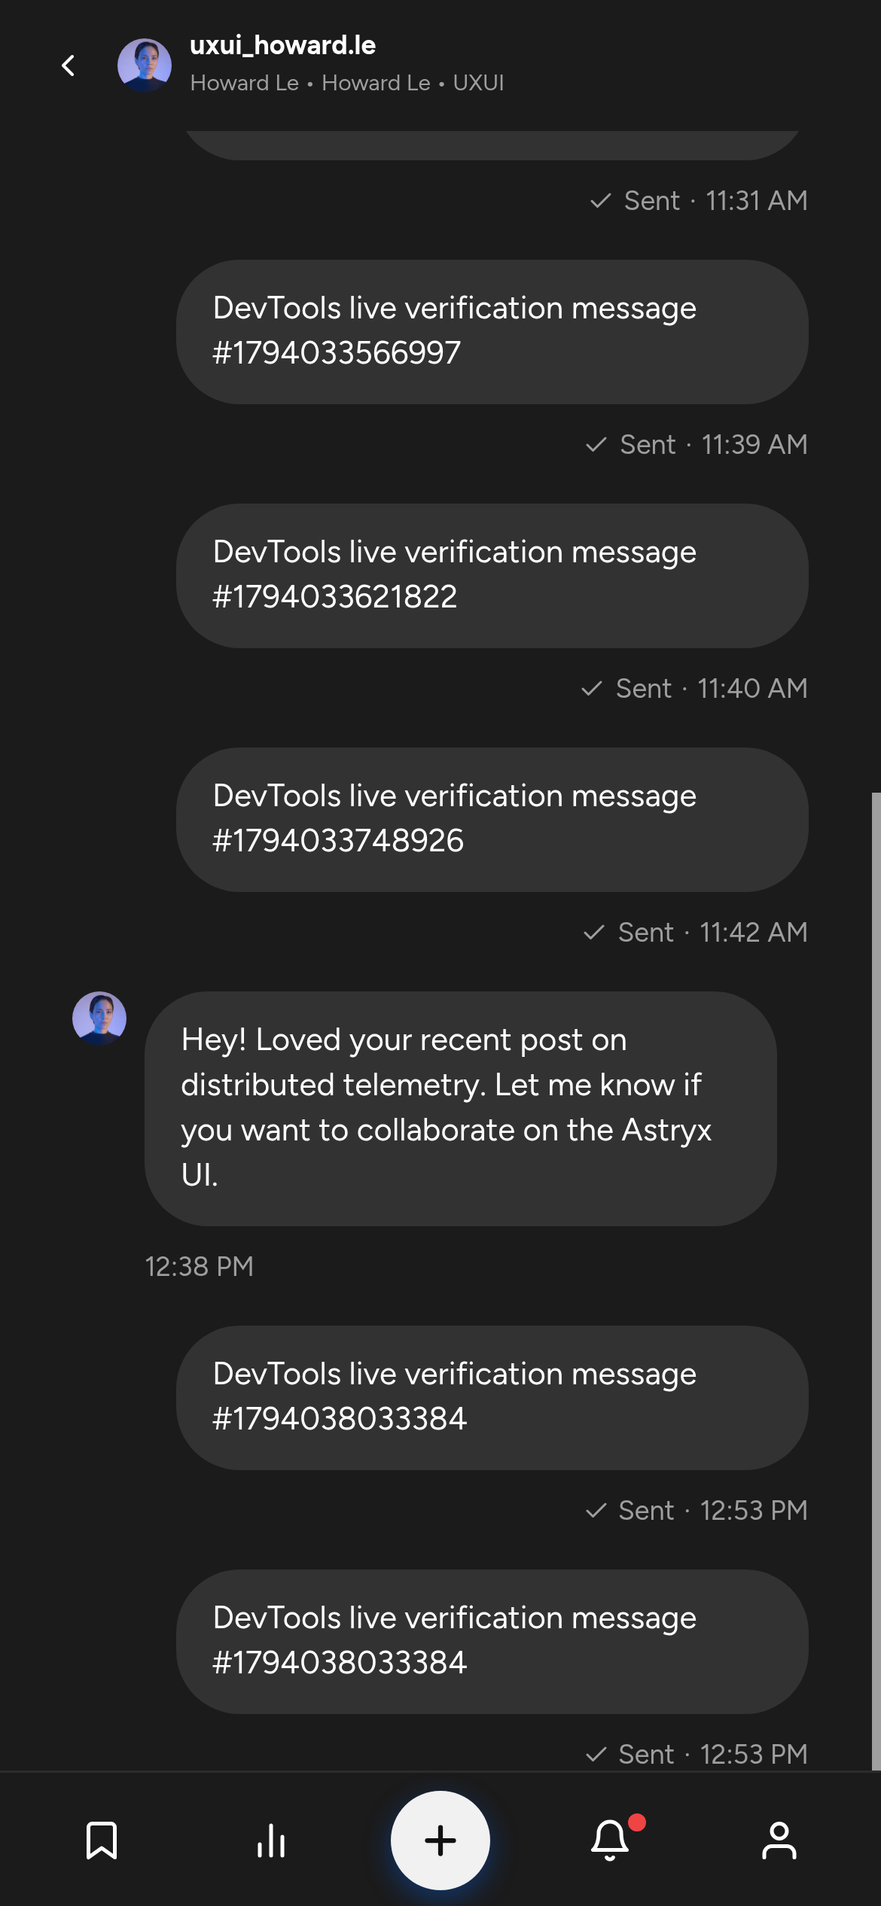

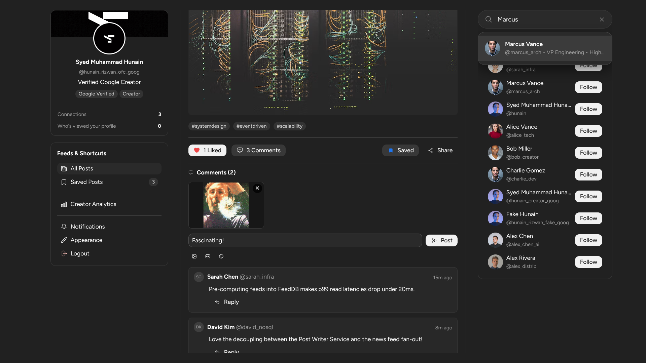

11.2 Summary
The Social Media Content Analysis System is a scalable, modular platform designed to support 500 million DAU and 2 billion MAU. It leverages microservices with NoSQL databases, pre-computed news feeds, and asynchronous updates to ensure high performance and eventual consistency. Additionally, it features a dedicated analytical dashboard that delivers real-time visual feedback on user content performance and engagement.

