Principal Component Analysis (PCA)

What is PCA?
PCA is a dimensionality reduction technique used in machine learning and statistics.
It transforms high-dimensional data into a smaller number of new variables called principal components while keeping as much of the original information (variance) as possible.
- Helps simplify data.
- Removes noise/redundant features.
- Makes visualization possible (e.g., plotting high-dimensional data in 2D or 3D).

Why do we need PCA?
- Many datasets have too many features (high-dimensional).
- High-dimensional data → harder to visualize, can cause overfitting and slower computations.
- Features may be correlated (redundant). PCA helps remove this redundancy.
- PCA reduces dimensions while preserving variance (information).

Applications of PCA
- Data visualization (reduce to 2D/3D).
- Noise reduction (remove low-variance components).
- Feature extraction for ML models.
- Image compression (e.g., reducing pixel data).
- Genomics, finance, face recognition, NLP (word embeddings).

Code using scikit learn: LINK

Importing

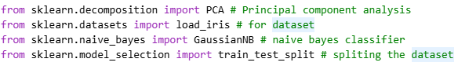

Loading Dataset

Train, Test Split

Naïve Bayes classifier without using PCA

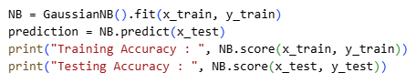

Accuracy without using PCA

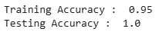

Applying PCA

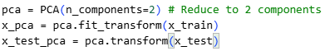

Naïve Bayes using PCA

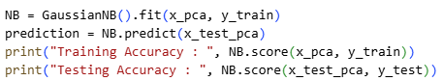

Accuracy with using PCA

