Name: Syed Najiullah

VGG16 Architecture – Simple & Formal Explanation

Introduction
VGG16 is a Convolutional Neural Network (CNN) architecture developed by the Visual Geometry Group (VGG) at the University of Oxford. It is widely known for its simplicity, uniform design, and strong performance on image classification tasks. The '16' in VGG16 refers to the 16 layers that contain learnable parameters.

Key Characteristics of VGG16
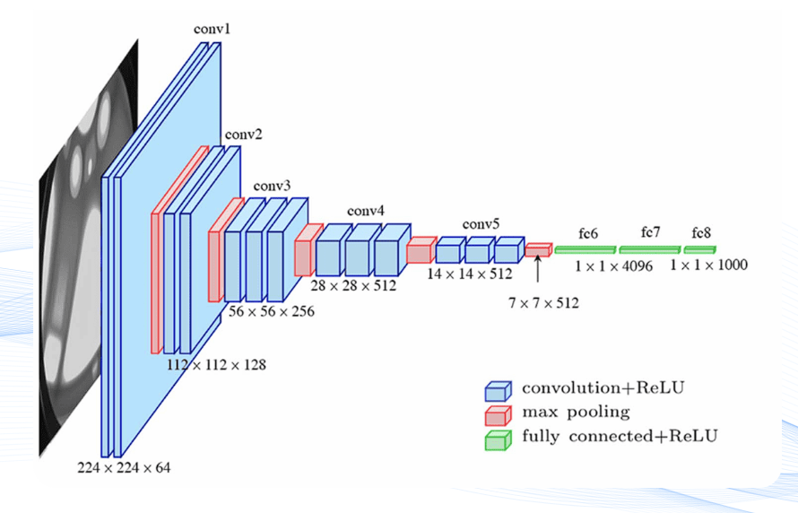
• Uses only 3×3 convolution filters throughout the network.
• Organized into five sequential convolutional blocks.
• Uses ReLU activation after every convolution layer.
• Uses Max Pooling to reduce spatial dimensions after each block.
• Includes three fully connected layers at the end.
• Designed for image sizes of 224×224×3.

Architecture Overview
The VGG16 architecture consists of the following stages:
• Block 1: Two 3×3 convolution layers with 64 filters each, followed by Max Pooling.
• Block 2: Two 3×3 convolution layers with 128 filters each, followed by Max Pooling.
• Block 3: Three 3×3 convolution layers with 256 filters, followed by Max Pooling.
• Block 4: Three 3×3 convolution layers with 512 filters, followed by Max Pooling.
• Block 5: Three 3×3 convolution layers with 512 filters, followed by Max Pooling.

Fully Connected Layers
After the convolutional blocks, VGG16 includes three fully connected layers:
• Fully Connected Layer with 4096 neurons
• Fully Connected Layer with 4096 neurons
• Output Layer with Softmax activation for classification

Total Parameters
VGG16 contains approximately 138 million parameters, making it a large and computationally expensive model.

Advantages of VGG16
• Simple and consistent architecture.
• Strong performance on image classification tasks.
• Excellent for transfer learning.
• Easy to understand and modify.

Disadvantages of VGG16
• Very large model size.
• High memory and computational requirements.
• Slower training compared to modern architectures like ResNet.

Code using pytorch
