Bias-Variance
Bias: This refers to the error introduced by approximating a real-world problem (which might be very complex) with a simplified model. A model with high bias is too simple; it “underfits” the data, meaning it fails to capture the underlying patterns in your training data, and thus performs poorly on both training and test data. Think of it as always missing the target in the same direction.
- Bias simply means making the model so simple that it underfits the data.
Variance: This refers to the error introduced by a model being too sensitive to the small fluctuations or noise in the training data. A model with high variance is too complex; it “overfits” the training data, meaning it learns the training data (and its noise) too well, resulting in excellent performance on the training data set but poor performance on unseen data. Think of it as hitting the target all over the place, but not consistently.
- Variance simply means making the model so complex that it overfits the data.

Bias-Variance Tradeoff

- Low Bias + High Variance: Overfitting (Darts are scattered everywhere, some hit the bullseye, but inconsistent).
- High Bias + Low Variance: Underfitting. (All darts land far from the bullseye, but close to each other. (Consistently wrong).
- Goal: Darts are tightly clustered near the bullseye: Best model.
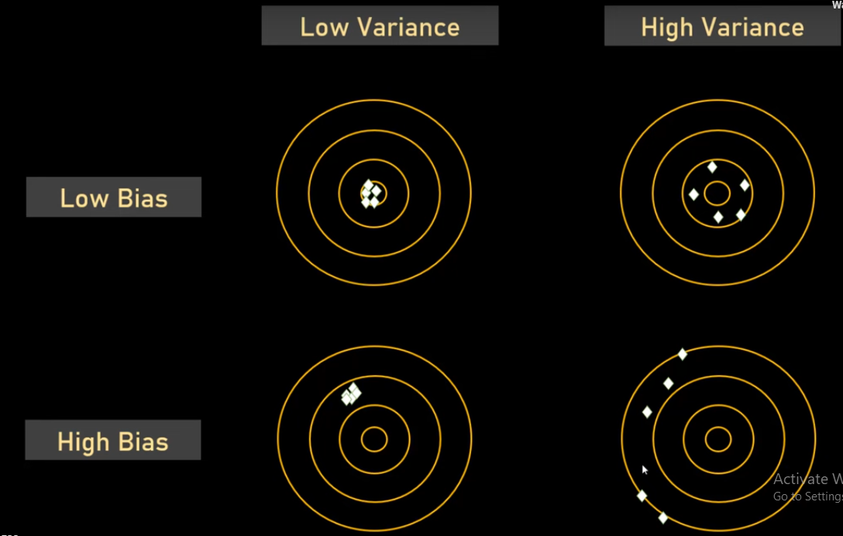
- The graph of overfitting and underfitting may look like this:
