K Fold Cross Validation
- Normally in order to train a model we train test split the data into some ration of 80 to 20 or maybe 70 to 30. Majority of the data is given to the model for training and what remains will be given to test the model.
- In K Fold Cross Validation all of the dataset is divided into K number of parts.
- If you have a dataset of 100 samples and you want to divide it into 5 (K) samples. Then there will be 5 folds and each sample be divided into 5 parts with 20 elements being in them.
- The model will go through all of the sample with different training and test splits and generate a score for each fold. At the end calculate the average of all of the models and that will be considered as final score of the model.
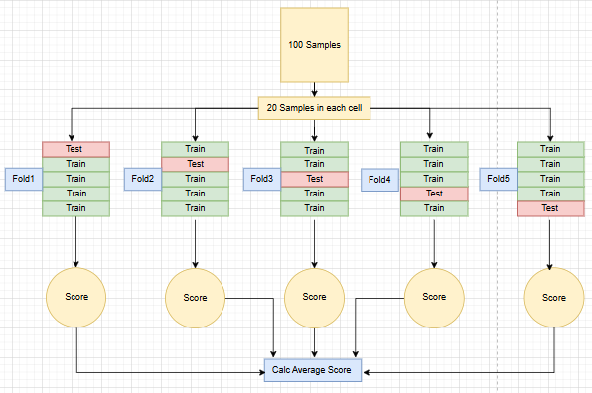

Code using scikit learn
Link to K fold | Link to cross validation
- Importing
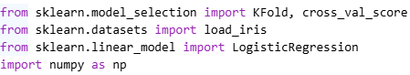
- Loading and splitting data
- Model
- K folds with 5 splits
- Cross validation score and accuracy
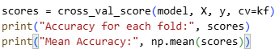
- Results

