Clustering K-Mean Clustering

Clustering
- Clustering is an unsupervised learning technique.
- It groups similar data points together into clusters without using predefined labels.
- Example: If you have customer data, clustering can group them into “high spenders,” “medium spenders,” and “low spenders,” without being told these labels.
- YouTube link: https://www.youtube.com/watch?v=EItlUEPCIzM
Clustering Uses
- To find hidden patterns in data.
- To reduce complexity by grouping.
- To understand data better when labels are not available.
- Common applications:
- Customer segmentation (marketing)
- Document or text grouping
- Image compression (grouping colors)
- Anomaly detection (detecting unusual data)

K-Mean Clustering
- K-Means is the most popular partitioning clustering algorithm.
- It divides data into K clusters (K is a number you choose).
- Each cluster is defined by its centroid (center point).
- Goal: Minimize the distance of points from their cluster centroid.

K-Mean Clustering Steps
- Choose K → Decide how many clusters you want. Assume we want 2.
- Initialize centroids → Randomly pick K points as cluster centers.
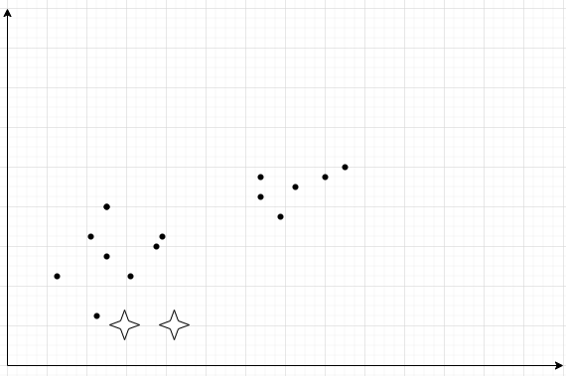
- Assign points → Each data point is assigned to the nearest centroid (using Euclidean distance, sum of Squared Error or any other).
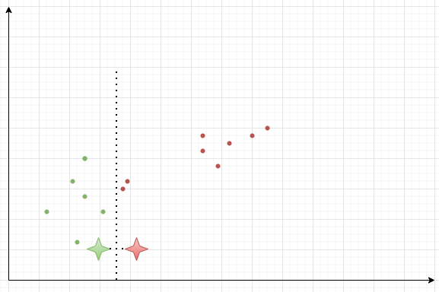
- Update centroids → Recalculate centroid as the average of all points in that cluster.
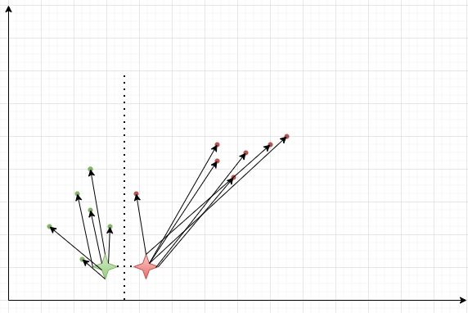
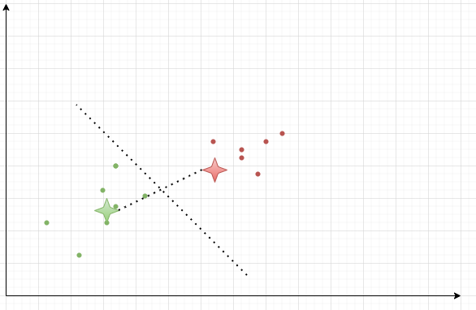
- Repeat steps 3 & 4 until:
- Centroids don’t change much, or
- A maximum number of iterations is reached.
- The end result might end up looking like
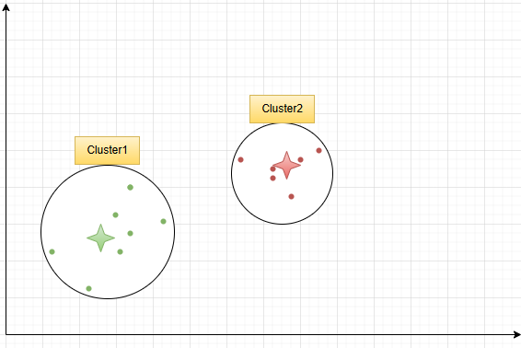

Deciding number of clusters
- Use the “Elbow” method.
- Look at the graph find an elbow and that is the best clusters numbers.
- The graph is between sum of squared error and number of clusters.
- I our case 4 is the best as shown in the diagram because at point 4 there is the maximum bent which is called elbow as well.
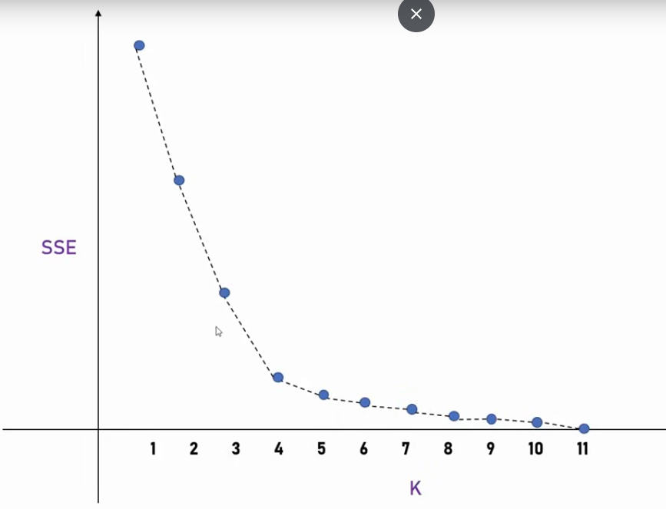

Code using scikit learn: LINK
- Importing
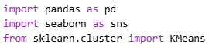
- Data
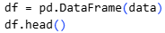
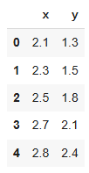
- Current Visualization
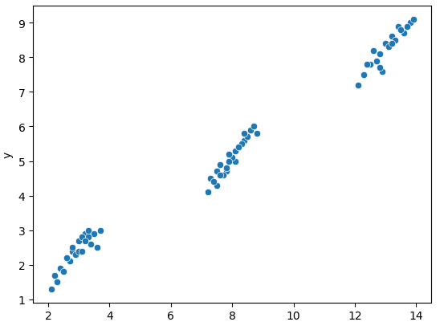
- Model prediction and training
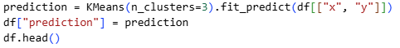
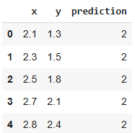

- Scatter Plot on prediction
